

Individual Report on
The International Marketing strategies and comparative analysis of Marcedes-Benz between Uk and Bangladesh

Programme: Master of Business Administration
Module Name: International Marketing: Principles and Practices
Module Code: LCMB7026

Lecturer Name: Tushara Balendran

Student Name: Durjoy Kumar Kundu
Student ID: 2503600

Submission Date: 23rd April 2026

Acknowledgement of AI Tool Use
I acknowledge the use of ChatGPT (https://chatgpt.com/) on various dates between March and April 2026 to assist with refining and structuring my international marketing report on Mercedes-Benz strategy in the Bangladesh and UK. I used the following prompts:
- Compare PESTEL analysis of Marcedes-Benz between UK and Bangladesh.
- What are the similarities and differences of Marcedes-Benz in UK and Bangladesh.
- Please check the following paragraph for grammar, clarity, academic tone, and suggest improvements.
I confirm that I have not presented any AI generated text as my own work. All AI‑assisted outputs were critically reviewed, adapted, and integrated into my own analysis. I confirm that I have copies of my drafts, notes, and other resources I used before and after the use of AI tools, which I may be asked to provide in evidence.

Table of Contents
1. Introduction 5
2. Company Background 5
3. PESTEL Analysis of the Market in Two Countries 6
3.1 Political Factors 7
3.2 Economic Factors 8
3.3 Social Factors 9
3.4 Cultural Factors (Hofstede Model of Cultural Dimensions: Advantages & Disadvantages) 9
3.5 Technological Factors 11
3.6 Legal Factors 11
3.7 Environmental Factors 12
3.8 Similarities and Differences in PESTEL for the UK and Bangladesh 12
4. STP and Marketing Mix (7Ps) 13
4.1 Segmentation (United kingdom vs Bangladesh) 13
4.2 Targeting (United Kingdom vs Bangladesh) 14
4.3 Positioning (United Kingdom vs Bangladesh). 14
4.4 Similarities and Differences in STP for the UK and Bangladesh 16
5. Marketing Mix 17
5.1 Product (United Kingdom vs Bangladesh) 17
5.2 Price (United Kingdom vs Bangladesh) 18
5.3 Place (United Kingdom vs Bangladesh). 18
5.4 Promotion (United Kingdom vs Bangladesh). 19
5.5 People (United Kingdom vs Bangladesh). 20
5.6 Process (United Kingdom vs Bangladesh) 20
5.7 Physical Evidence (United Kingdom vs Bangladesh). 20
5.8 Similarities and Differences in Marketing Mix for the UK and Bangladesh 22
6. Brand’s Directional Development Strategy: Ansoff’s Matrix for Bangladesh 22
7. Evaluation of the Ethical aspects in the marketing mix of the brand in one country. 23
8. Suggestions for Future Strategic Directions for the Company 24
8. Conclusion 24
9. Section 2 - Reflective Account 25
Introduction to the Reflective Account. 25
Description of the Research and Writing Process 26
Personal Feelings and Reactions During the Assignment 26
Evaluation of Strengths and Weaknesses 27
Analysis of Challenges and Problem-Solving Approaches 27
Conclusion and Key Learning Points 28
Future Application of Learning and Skills 28
References 29

1. Introduction
Mercedes-Benz is a well-respected company in the world in terms of luxury automobiles and the most innovative, well-engineered and high-quality cars. Mercedes-Benz has been in the business of integrating the performance, safety, comfort, and modern technology in its vehicles (Macfarlane, 2023). The brand is present worldwide nowadays and still has a powerful impact on the luxury automotive market. The current report is devoted to the activities of Mercedes-Benz in two markets, the United Kingdom and Bangladesh. The United Kingdom is a developed and competitive car market with the luxury car brands established and sought after in the market. The UK consumers tend to give priority to technology, sustainability and high design in cars (da Rosa Ferreira, 2021). Conversely, Bangladesh is a developing market whose consumers and business people have the need to buy luxury cars due to the increasing demand. The comparison of these two markets gives an opportunity to compare a mature and a developing market in the automotive industry. The report will cover the PESTEL framework, cultural dimensions as laid out by Hofstede, STP, the Marketing Mix, and strategic development within the framework of international marketing activities of Mercedes-Benz. It will also assess the moral implications of the brand strategies. Besides, a reflective response will be given on the basis of Gibbs Reflective Cycle, which offers the insights of the research and writing process and an assessment of the personal learning and problem-solving strategies during the assignment.

2. Company Background
Mercedes-Benz is a luxury car manufacturer with worldwide recognition and is famed for the production of high-quality cars and vehicles with advanced technology and innovative engineering. It is a company which functions under the Mercedes-Benz Group AG, and it has a good reputation in the world of the automobile industry. It has a variety of automobiles such as luxury sedans, SUVs, sports cars, and commercial cars. Mercedes-Benz emphasises integrating performance, safety, and comfort with premium quality care (Andreeva, and Petikhin, 2022). The company has been able to remain one of the best luxury car brands through constant innovation and internationalisation. Mercedes-Benz has its roots to the year 1886 when Karl Benz came up with the first gasoline-powered car, which was the Benz Patent Motorwagen, which was the first gasoline-powered automobile in the world. It was also during the same period that Gottlieb Daimler was working on automobile engines. Their firms would later be merged in 1926 to make Daimler-Benz. The Mercedes-Benz brand name was coined and soon was linked to innovation, engineering perfection and luxury cars in the automobile sector across the world. Mercedes-Benz has a mission statement that is to provide quality cars with a combination of luxury, safety, performance, and innovation (Schell, 2021). The firm is focused on offering a high driving experience to customers with high automotive technology and design. Its mission is to be the mobility pioneer by creating sustainable mobility, such as electric cars and smart mobility, in the future, and retain the image of a luxurious automobile brand on the global market.
Mercedes-Benz is a company that enjoys a very good presence across the world as it operates in over 100 countries. It aims to be the future of mobility by incorporating both innovation and sustainability into its cars. The company has a vision of being the most valuable and innovated luxury car brand in the world with a great consideration being given to electric mobility and sustainable technologies. Mercedes-Benz strives to provide superior experiences and adopt environmentally friendly approaches, so that the performance and luxury should be accompanied by sustainability and current technology.

3. PESTEL Analysis of the Market in Two Countries
PESTEL stands for Political, Economic, Social, Technological, Environmental, and Legal factors, which are used in strategic management and market analysis. It is a framework that helps companies evaluate the macro-environmental factors that could impact their business (Kolios, and Read, 2013).
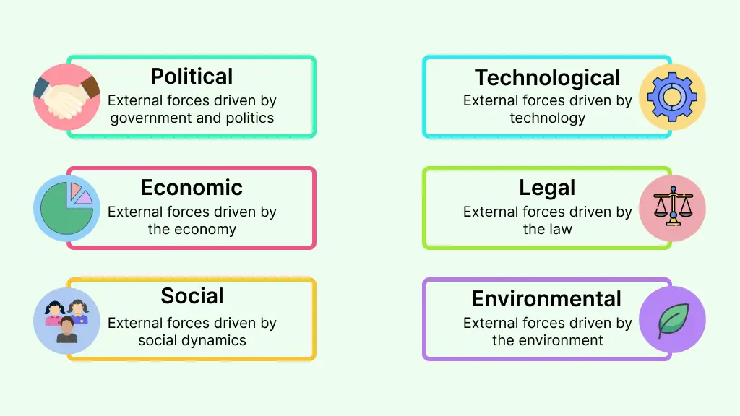
Figure 1 PESTEL Analysis Framework

3.1 Political Factors
United Kingdom - More Favourable.
Mercedes-Benz has a good environment in the UK, which is backed by a stable government and a good legal system. The evident laws on emissions and safety of vehicles make the luxury car makers a foreseeable and friendly market in the country (Schöneburg, and Baumann, 2022). Moreover, the UK membership in international trade agreements is a guarantee of easy access to markets, which makes it a favourable location to luxury automobile brands.
Bangladesh – Favourable but Unpredictable
Although Bangladesh is rated as a good place to carry out business because the government is concerned with increasing foreign capital inflow and enhancing infrastructure, it is associated with a number of challenges. Political environment in Bangladesh can be volatile and changes in policies and other regulatory changes can be frequent as a result of which companies such as Mercedes-Benz will be faced with a more uncertain environment. Nonetheless, the emerging economy and rising demand of luxury cars in the country offers great opportunities to the company, despite the political uncertainty.

3.2 Economic Factors
United Kingdom – More Favourable
The UK has offered a good economic climate to Mercedes-Benz with a well-developed and stable economy. The UK consumers have the purchasing power and financial ability to invest in luxury products such as high-quality cars due to their high level of per capita income. The automobile industry is mature and government policies that encourage green technologies and sustainability are consistent with the brand eco-friendly practices. Moreover, good exchange rates, low inflation rates, and economic stability in the UK make it a good venture and destination of luxury brands.
Bangladesh – Favourable but Unstable
The economic environment in Bangladesh is positive because of the growing middle class and growing disposable income which translates to an increase in the demand of luxury products, including luxurious vehicles such as Mercedes-Benz. Nevertheless, the luxury car brands in the market are not favourable in some areas, including low per capita income and economic inequality. Even as it expands, the economy is experiencing issues like inflation, currency devaluation and political instability which have the potential to influence the purchasing capacity and financial stability of the luxury car market.
Economic factors play a critical role in shaping the performance of Mercedes-Benz in both the United Kingdom and Bangladesh. The UK boasts a high GDP of approximately $3.1 trillion USD in 2025, with a stable economic environment, while Bangladesh's growing GDP of $507 billion USD reflects its developing economy. In terms of GNP, the UK stands at $3.2 trillion USD, while Bangladesh's GNP is around $525 billion USD, showing an expanding national income. Inflation in the UK remains steady at 2.5%, whereas Bangladesh faces a higher inflation rate of 6.3%. Currency exchange rates also differ, with 1 GBP = 1.35 USD in the UK and 1 USD = 122 BDT in Bangladesh. In terms of sales, Mercedes-Benz sold 120,000 units in the UK in 2024, showcasing its dominance in the luxury car market, while in Bangladesh, Mercedes-Benz sold 1,200 units, with potential for significant growth driven by an increasing affluent class.

3.3 Social Factors
United Kingdom - More Favourable.
The social factors in the United Kingdom favour the luxury car brands such as Mercedes-Benz. The UK consumers are highly aware of sophisticated automotive technology, safety and sustainability. Premium cars are in high demand due to the increasing interest in environmentally friendly cars and consumers are now more and more content with environmentally friendly cars. The luxury products are socially accepted and there is a well-developed market for luxurious cars. Moreover, the multicultural society of the UK creates a wide range of consumers, enlarging the possibilities of such brands as Mercedes-Benz.
Bangladesh – Favourable but Developing
The social environment in Bangladesh is good and the market is underdeveloped in terms of consumer behaviour. There is an increasing demand in luxury cars, particularly on the rising wealthy group and entrepreneurs. Nevertheless, the luxury car industry is niche because of the relatively few wealthy buyers (Uddin, 2020). The consciousness of high-technology and sustainability is growing, though at an early level in comparison with the developed nations, such as the UK. The social factors are positive, and the luxury car market is not as established.

3.4 Cultural Factors (Hofstede Model of Cultural Dimensions: Advantages & Disadvantages)
Cultural factors impact consumer behaviour and marketing strategies. Comparing the UK and Bangladesh using Hofstede’s model:

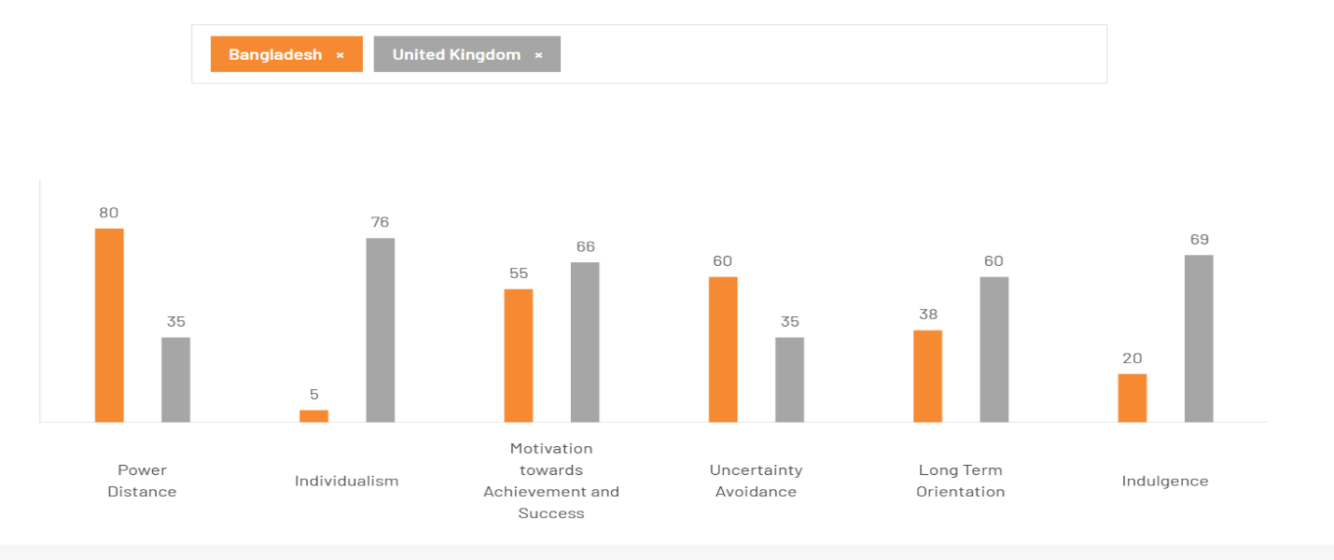
Figure 2 Hofstede’s Cultural Dimensions comparison between Bangladesh and UK
United Kingdom – More Favourable
The cultural aspects of the United Kingdom are positive to Mercedes-Benz because the luxury character of the brand and innovative technology correspond to the values of British consumers. UK people are rated high in individualism on Hofstede culture dimensions, which indicates that individuals appreciate personal attainment and individual success and therefore they tend to buy luxury products such as expensive cars. The British also highly appreciate innovation and quality and this fits well into the characteristics that are provided by Mercedes-Benz, including high-tech technology and sustainability. The uncertainty avoidance levels in the country are also high, so the consumers will tend to use the brands that have a good reputation of being reliable and safe.
Bangladesh – Favourable but Different
The culture in Bangladesh is favourable, but it has various challenges with that of the UK. According to the Hofstede model, the country is collectivistic with social groups and family playing a major role in consumer decisions. In Bangladesh, luxury goods are treated as a sign of prestige and wealth and this gives Mercedes-Benz a chance. Nevertheless, the power distance is rather high, implying that luxury brands are perceived differently in various income groups in the cultural gap. Consumer behaviour may be less predictable due to the absence of a general culture of individualism and brand loyalty in Bangladesh.
The advantages of Hofstede’s Model: It analyses cultural differences across six dimensions, useful for tailoring strategies but has limitations, such as oversimplification and neglecting cultural changes.

3.5 Technological Factors
United Kingdom - More Favourable.
The technological environment in the United Kingdom is conducive to the growth of Mercedes-Benz because the nation is characterised by high quality infrastructure and emphasis on innovation. UK leads the way in the adoption of electric vehicles (EVs), facilitated by government subsidies and the development of EV charging infrastructure. Mercedes-Benz enjoys such technological innovations and this means that its products have been aligned with increasing demand of sustainable mobility solutions (Schell, 2021).
Bangladesh – Favourable but Developing
In Bangladesh, the technological environment is good, and the market is developing. Although there is a growing concern towards technological innovations, including electric cars and intelligent mobility, the penetration rate is not as high as in the UK. The infrastructure of the country, both in EV charging stations and technology-oriented research and development, is yet to be developed, so it is not so favourable towards the fast implementation of new technologies.

3.6 Legal Factors
United Kingdom – More Favourable
Mercedes-Benz has a good legal environment in the United Kingdom because the country has a well-established legal system that safeguards intellectual property rights, contracts and consumer rights. There are strict laws governing vehicle safety standards, the emission laws and the environment laws in the country, which makes the companies strive to innovate and meet the international standards.
Bangladesh – Favourable but Less Developed
The legal environment in Bangladesh is also conducive in regard to attracting foreign investment, however it is not as well developed as the UK. Although there are laws governing consumer protection, intellectual property and environmental regulations, there is inconsistency in implementation. Absence of a well-developed legal system may cause ambiguities to the operations of Mercedes-Benz, especially on contract enforcement and environmental laws.

3.7 Environmental Factors
United Kingdom - More Favourable.
The United Kingdom has an attractive environmental outlook to Mercedes-Benz due to the high governmental encouragement of sustainability efforts. The UK is driven by the aim to cut carbon emissions and promote the use of electric vehicles (EVs), which serves as the strategic thrust of Mercedes-Benz to go green in its innovations such as electric and hybrid vehicles.
Bangladesh – Favourable but Challenging
The environmental conditions in Bangladesh are positive regarding the awakening of sustainability awareness, although there are still problems. The nation has major pollution problems, and it is affecting the air quality and health of people. Although the government partially supports the environmentally friendly efforts, the infrastructure for electric vehicles and green technologies are still in the process of development (Uddin, 2024).

3.8 Similarities and Differences in PESTEL for the UK and Bangladesh
The UK and Bangladesh PESTEL factors have some similarities and great differences. The two markets are in an upward trend in terms of consumer demand, along with growing concerns around sustainability and environmental impact. The UK however is a more mature market due to stable political environment, increased economic stability and sophisticated technological infrastructure. Bangladesh, on the contrary, is a highly-growing nation with unstable politics and economy. The UK is more individualistic socially, whereas Bangladesh is collectivist. Such disparities require different marketing approaches in different countries that have different circumstances.

4. STP and Marketing Mix (7Ps)
STP stands for Segmentation, Targeting, and Positioning. It is a marketing framework used to identify and target specific customer segments, develop tailored marketing strategies, and position a product effectively in the market (Mogaji, 2025).

4.1 Segmentation (United kingdom vs Bangladesh)
In the UK, Mercedes-Benz focuses on the market segmentation based mainly on income since it aims at high-net-worth, executive, and professional customers who appreciate luxury, technology, and sustainability. It also uses lifestyle segmentation, targeting environmentally-friendly consumers who are interested in electric cars. In Bangladesh, the market is segmented with high income urban customers, business owners, and entrepreneurs who need prestige and social status (Li, 2025).

VALS is a psychographic segmentation instrument that dictates consumers in terms of values, attitudes and lifestyles. It breaks down the market into groups like Innovators, Thinkers, Achievers, Experiencers and others, which give clues on the responsiveness of the various consumer groups to products and marketing messages. The strategy aids businesses to know more about what motivates people other than demographics and this results in more focused and efficient marketing.
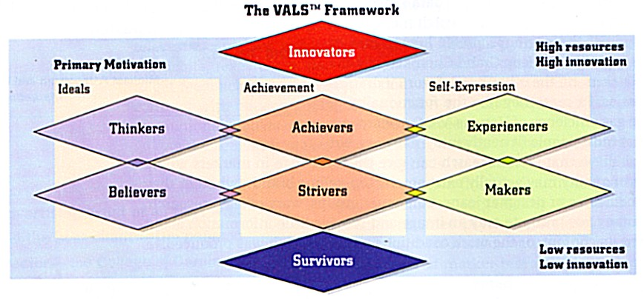
Figure 3 The VALS Framework: Psychographic Segmentation
VALS is a psychographic segmentation system that categorizes consumers in terms of their values, attitude and lifestyles. It breaks down the market into categories like Innovators, Thinkers, Achievers, Experiencers and others, and gives information about the reaction of various consumer segments to products and marketing messages. This method assists firms to learn about motivations that do not rely on demographics that result in creating more focused and efficient marketing programs.

4.2 Targeting (United Kingdom vs Bangladesh)
Mercedes-Benz in the UK is focusing on high-income professionals and executives who value the latest technology, sustainability, and performance. It is targeted at the early adopters of electric and hybrid vehicles with a focus on innovation and environmental awareness. In Bangladesh, the brand will be aimed at rich people in urban canters who are interested in luxury, exclusiveness and status. The most important segment is aspirational buyers who tend to buy them to show success and prestige (Pillai, 2024).

4.3 Positioning (United Kingdom vs Bangladesh).
Mercedes-Benz is a technologically advanced, sustainable, and high-performance luxury brand of automobiles in the United Kingdom. The focus is on electric mobility, innovation, and high quality design, which attracts consumers who attach importance to being environmentally responsible and luxury. It is viewed as a brand of quality, safety, and sophistication, which is related to the British preference of quality cars, which are eco-friendly. The advertising messages are emphasized on technological leadership, safety, and sustainability programs and support the image of a modern luxury pioneer of Mercedes-Benz.
Advantages:
- Competitive Differentiation: Helps the brand stand out in the crowded marketplace.
- Customer Loyalty: Establishing a clear positioning often fosters stronger emotional connections with consumers.
- Value Proposition: Clear positioning clarifies the value of the product, helping consumers understand its benefits.
Disadvantages:
- Risk of Over-Saturation: Over-positioning in one category can limit broader market appeal.
- Market Changes: Positioning may become outdated with shifting market trends or consumer preferences.
- Costly and Time-Consuming: Developing and maintaining a strong market position often requires significant investment.
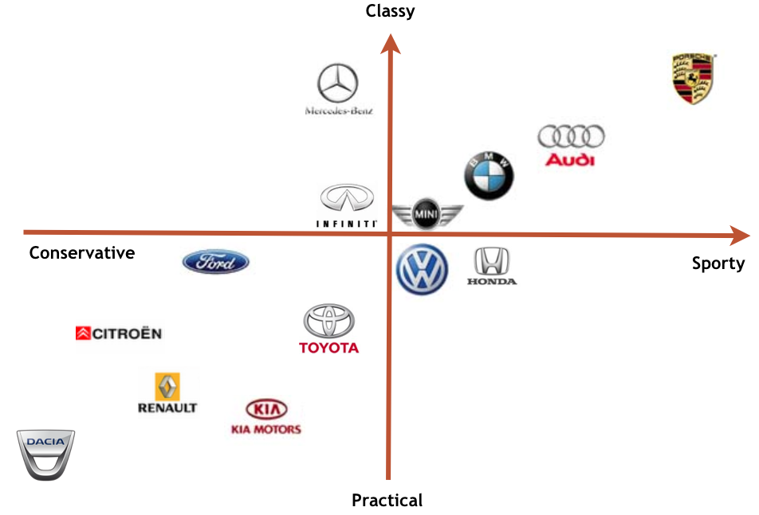
Figure 4 Perceptual Map: Positioning of Car Brands Based on Classiness and Sportiness
This perceptual map reveals the placement of the various car brands based on two key dimensions Classy to Sporty and Conservative to Practical. Mercedes-Benz is positioned as a high-end and traditional brand, and it symbolizes the luxurious and timeless fashion. Brands such as BMW and Audi are considered sport, yet sophisticated, which underlines the focus on speed, and luxury. Less expensive, more traditional brands, however, like Toyota and Ford, have a broader audience, emphasizing functionality and reliability in their daily use. This map will help to visualize the ways in which these brands are unique in the competitive auto market.

4.4 Similarities and Differences in STP for the UK and Bangladesh
Mercedes-Benz in the UK and Bangladesh apply the concept of segmentation to appeal to the high-income consumer, whereby it addresses the luxury and status. The targeting in the UK is however more specific to the tech-savvy, environmentally conscious professionals, whilst in Bangladesh, it is aimed at affluent consumers who are after prestige. In the UK, the focus of positioning is on technological innovation and sustainability whereas in Bangladesh, positioning is on the brand as a luxury and social status. These plans point out the cultural and economic distinctions of the two markets.

5. Marketing Mix
The 7Ps framework includes Product, Price, Place, Promotion, People, Process, and Physical Evidence. These elements are used to develop strategies that meet customer needs and achieve business success.
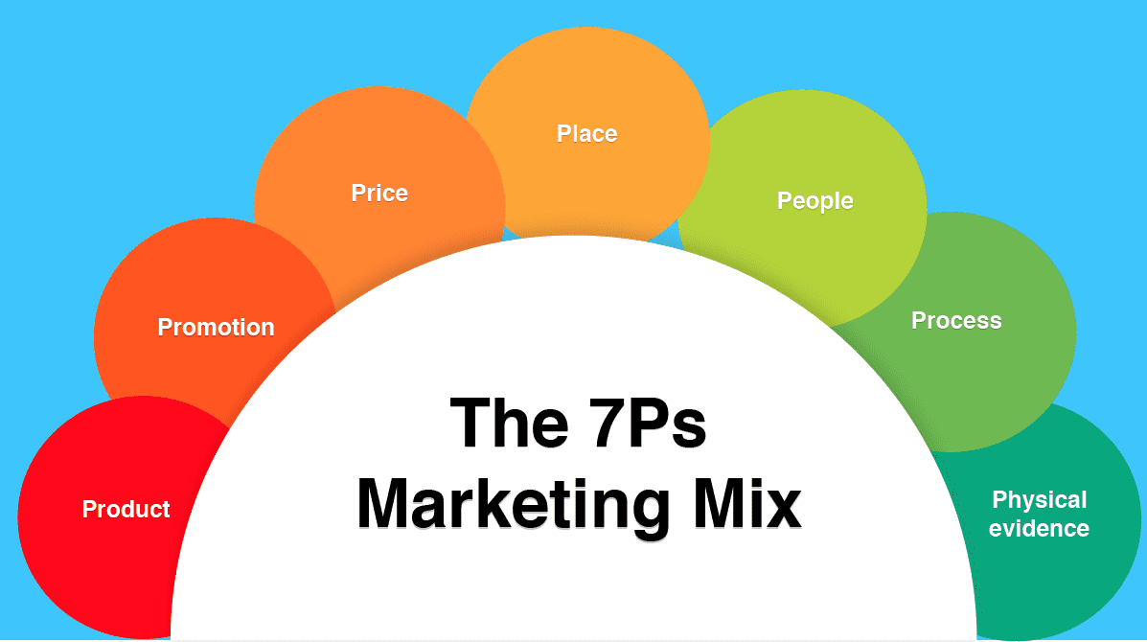
Figure 5 The 7Ps Marketing Mix

5.1 Product (United Kingdom vs Bangladesh)
Mercedes-Benz in the United Kingdom has a variety of luxury sedans, SUVs, sports cars, and electric or hybrid cars that combine innovative technology, safety, and sustainable solutions. EV and hybrid models are especially advertised to attract the environmentally conscious market. The product line in Bangladesh is geared towards luxury, comfort and prestige; high-end sedans and premium SUVs.
In the UK as well as in Bangladesh, Mercedes-Benz has many varieties of products in order to satisfy different customers. The depth measures the number of models in each category, e.g. luxury sedans, SUVs and electric vehicles, whereas width measures the total number of categories. The company has also diversified its products by brand extension, including entry into the electric vehicle market, to meet the new trends in the industry. The marketing materials of each market have pictures and elaborate descriptions of these product offerings.

5.2 Price (United Kingdom vs Bangladesh)
Mercedes-Benz in the UK adheres to the premium pricing strategy, which can be attributed to the fact that the company is a luxury and technologically advanced brand. Pricing of vehicles and EVs, alike, is on par with the strong purchasing power of the British consumer, and financing and incentives are used to facilitate sales. In Bangladesh, the prices are much more expensive because of the importation and taxation, and scarce supply, which supports the exclusivity and prestige of the brand (Pereira, 2024). It is oriented on aspirational pricing, which is a marker of social status and success.

5.3 Place (United Kingdom vs Bangladesh).
Mercedes-Benz sells its vehicles in the UK through a comprehensive network of dealerships, service centres, and online, providing customers with test drives, online configurators, and delivery options to ease customer convenience. Dealerships are placed in prime areas in big cities and high-income territories. In Bangladesh, it is distributed in urban centres with authorised dealerships and service centres to high-income city shoppers.
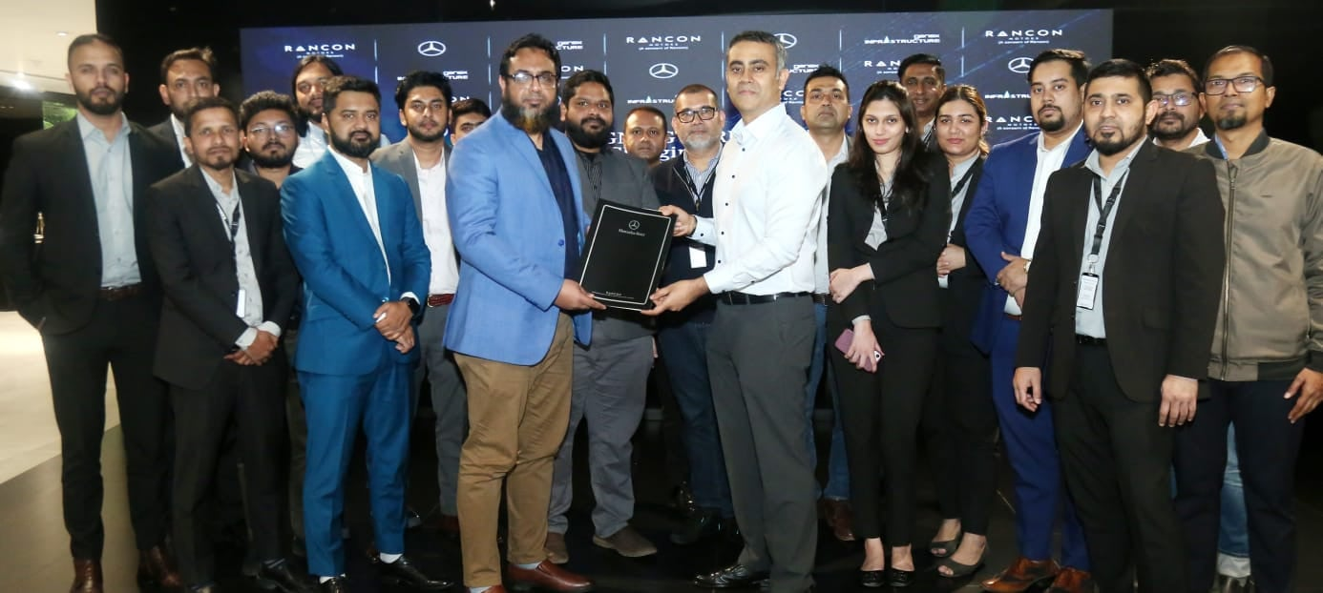
Figure 6 Rancon Motors Limited: Authorized Dealer for Mercedes-Benz in Bangladesh
Mercedes-Benz has employed a direct channel of distribution which is an authorized dealership in the UK and in Bangladesh. LSH Auto has dealerships in the Midlands, North West and London of the UK dealing with Mercedes-Benz and providing high quality customer experience. Rancon Motors Limited is the official general distributor of Mercedes-Benz in Bangladesh with showrooms in Dhaka and Chittagong.

5.4 Promotion (United Kingdom vs Bangladesh).
Mercedes-Benz markets itself in United Kingdom using a combination of online marketing, television, print and a presence at auto shows. The campaigns focus on the technological innovation, sustainability, and electric mobility to attract environmentally conscious and tech-savvy consumers. In Bangladesh, marketing approaches are aimed at luxury, prestige, and aspirational. The brand uses celebrity endorsement, high-end events, and auto shows to target wealthy urban consumers. Digital campaigns on social media reach out to high-income people, and the personal invitations to showroom visit and test drive provide a personalised luxury experience.
Integrated Marketing Communication (IMC) refers to a strategic process of integrating all marketing tools, channels and sources to create a clear, consistent and persuasive message about a brand (Kitchen, and Burgmann, 2015). IMC is aimed at making sure that any communication with the customer is integrated in a way that it is consistently aligned within advertising, social media, sales promotions, public relations and direct marketing. Mercedes-Benz employs IMC to align advertising (TV, print), social media campaigns, events, and dealer promotions to consistently convey the luxury image and focus on innovation so that the message is consistently the same at all customer touchpoints.

5.5 People (United Kingdom vs Bangladesh).
In the UK, Mercedes-Benz has well-trained sales and service personnel that are conversant with advanced technology, EVs, and sustainable mobility. Employees offer a high-end customer experience and guarantee customer-focused attention. Employees in Bangladesh are service-oriented, but the service offered is high-touch and luxurious, with the target group being the richer urban clients and the service being based on exclusivity, prestige, and status (Micucci, 2025).

5.6 Process (United Kingdom vs Bangladesh)
.Mercedes-Benz has a consistent customer compliance process that guarantees a smooth customer experience. This involves the checking of customer information, legal compliance of sales and service and adherence to stringent quality standards. This is facilitated by a seamless online and in-store experience that enables customers to access vehicle information easily, request services, and update in time. Another aspect of quality dealerships is the structured feedback system of Mercedes-Benz dealerships, where any concerns related to compliance are promptly resolved in order to keep the customers satisfied.

5.7 Physical Evidence (United Kingdom vs Bangladesh).
In the UK, the showrooms of Mercedes-Benz are contemporary, spacious, and technologically advanced to offer a premium brand experience to its customers. There are EV charging stations, interactive display as well as luxury lounges, which manifest the innovation, sustainability, and comfort-oriented nature of the brand. In Bangladesh, showrooms are luxury, exclusive, and high-end design-oriented to attract high-income customers, with luxurious interior design and customised services. In both countries, Mercedes-Benz makes sure that the physical evidences such as showrooms, service centres, brochures and digital interfaces, support the premium image of the brand, with the physical evidences giving tangible proof of quality, innovation and luxury that would help in supporting customer confidence and overall ownership experience.
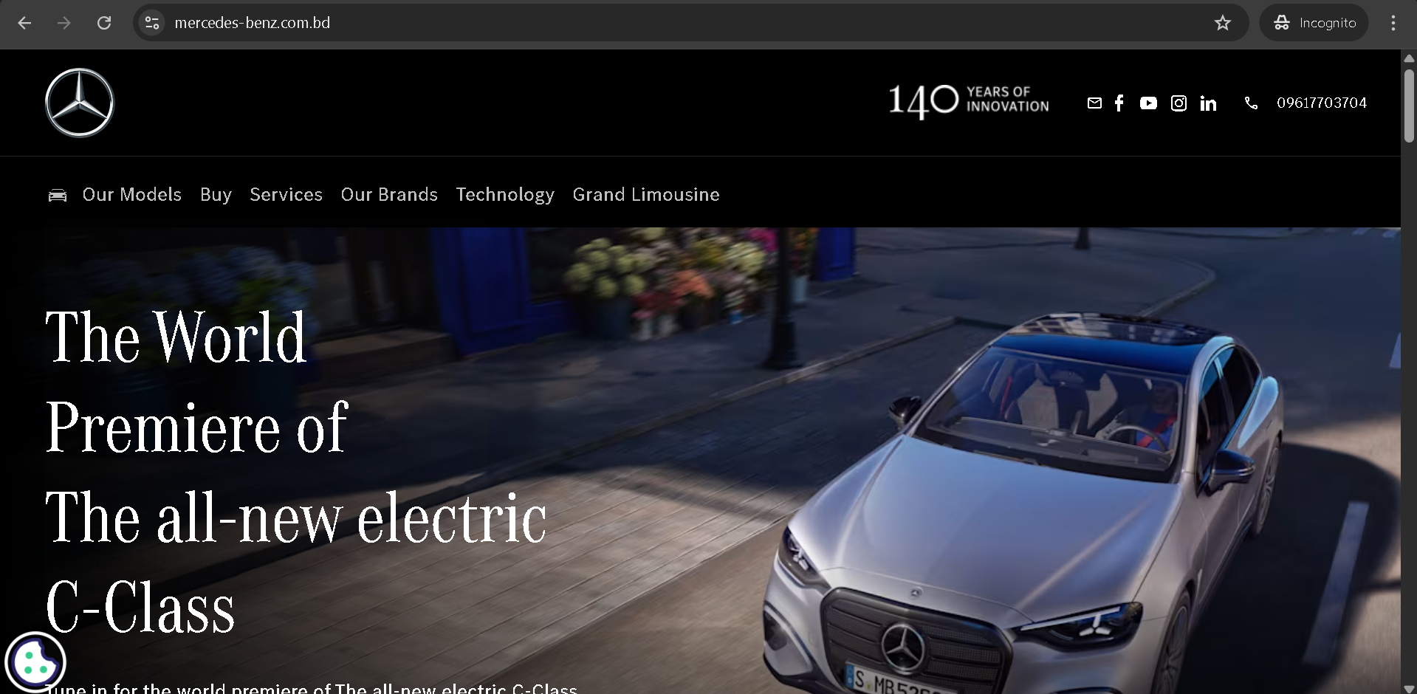
Figure 7 Mercedes-Benz Bangladesh: The World Premiere of the All-New Electric C-Class
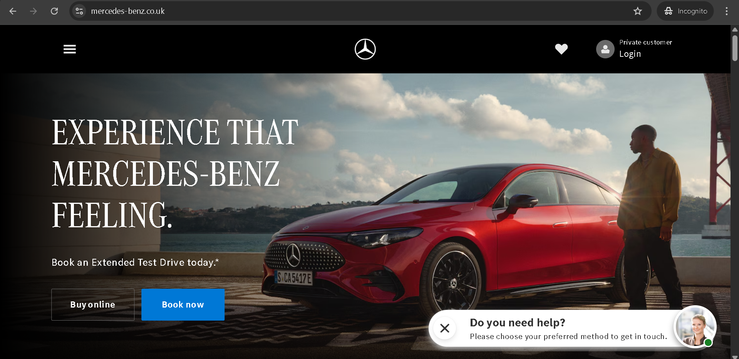
Figure 8 Mercedes-Benz UK: Explore the World of Luxury, Innovation, and Performance

5.8 Similarities and Differences in Marketing Mix for the UK and Bangladesh
Both the UK and Bangladesh see Mercedes-Benz focusing on premium pricing, a strong brand image, and high-quality products. However, in the UK, the focus is on eco-friendly innovation and technology, while in Bangladesh, there is more emphasis on luxury and status. Distribution channels are similar, with authorized dealerships, but promotional strategies vary, reflecting local market preferences and consumer behaviour.

6. Brand’s Directional Development Strategy: Ansoff’s Matrix for Bangladesh
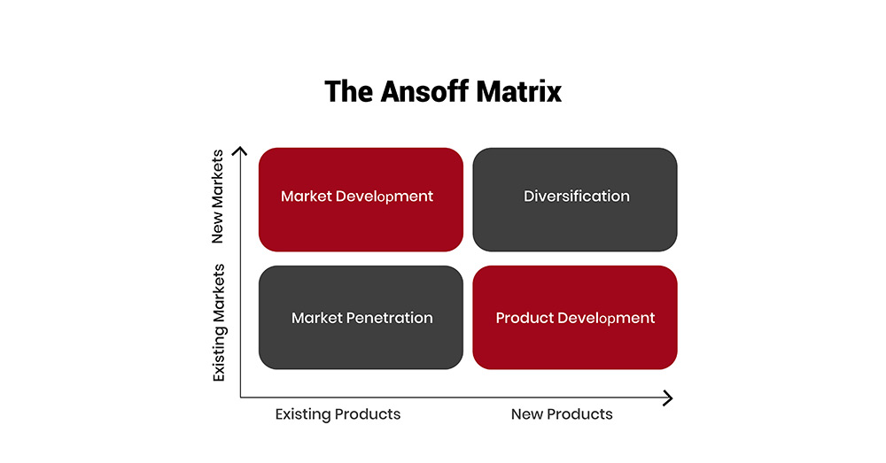
Figure 9 The Ansoff Matrix: Strategic Growth Options
Ansoff’s Matrix is a strategic tool that helps businesses determine their growth strategy based on product and market dimensions. For Mercedes-Benz in Bangladesh, the following strategies are applied:
Market Penetration: Increasing sales of existing luxury vehicles through enhanced marketing efforts and expanding the number of dealerships in major cities like Dhaka.
Market Development: Entering new regions in Bangladesh, including secondary cities, to target emerging affluent customers.
Product Development: Introducing electric vehicles (EVs) and other new models to meet growing demand for sustainable luxury cars.
Diversification: Expanding into related services like premium car leasing and financing in Bangladesh.

7. Evaluation of the Ethical aspects in the marketing mix of the brand in one country.
Mercedes-Benz in the United Kingdom puts a great value on ethical marketing, where all marketing mixes are oriented towards social responsibility and consumer confidence. The company focuses on safety, sustainability and transparency in its automobiles in terms of product. Electric and hybrid models are offered to minimize the environmental impact, and full disclosure of vehicle performance, emission, and energy consumption is to make sure that customers are informed and can make responsible decisions. Promotions and campaigns emphasize sustainability and innovation without resorting to manipulative tactics and exaggerating the benefits of the products (Lamm, 2024).
Ethical Examples:
Sustainability Efforts: Mercedes-Benz’s commitment to electric vehicles (EVs) reflects ethical behaviour by promoting environmental sustainability.
Fair Labor Practices: The company adheres to ethical standards in labour conditions across its global supply chain, ensuring fair wages and working conditions.
Unethical Examples:
Misleading Advertising: Any attempt to exaggerate vehicle features in advertisements without clear disclaimers can be considered unethical.
Environmental Impact: Companies producing vehicles with high emissions without any action to reduce them might be criticized for contributing to environmental damage.

8. Suggestions for Future Strategic Directions for the Company
Recommendations to the UK Market:
In the case of Mercedes-Benz in the UK, the company needs to persist in keeping with its sustainability and innovation, especially as the demand for electric cars increases. This will be in line with the growing concern of customers to environmental concerns by increasing the number of EVs and marketing environmentally friendly features. Also, it is possible to improve on digital marketing approaches to capture younger and more tech-savvy customers that will tend to research and make online purchases. Working with local environmental projects may enhance the brand image as an environmentally friendly leader.
Recommendations to the Bangladesh Market:
Mercedes-Benz needs to focus on status and luxury in Bangladesh as the country is composed of wealthy consumers who appreciate high-quality products. The firm may come up with cheaper entry- level products to reach out to the increasing middle-income populations still have their high-end product segments (Li, 2021). Also, it can be made more accessible by strengthening the networks of dealerships in secondary cities and providing financing opportunities. Since family is a cultural value, the marketing campaign, which emphasizes family-cantered aspects and safety, might appeal to the target audience.

8. Conclusion
This report has compared the international marketing of Mercedes-Benz in the United Kingdom and Bangladesh with regard to the distinctions and similarities in consumer behaviour, market conditions and cultural factors. The PESTEL analysis revealed that the UK has a stable, developed and technology based market, whereas Bangladesh offers growth potential in a developing economy where luxury cars are on the increase in demand. The STP and the 7Ps strategies are a manifestation of prudent adjustment to the local taste, striking a balance between innovation, luxury, and sustainability. The UK directional growth of Mercedes-Benz aims at technological leadership and electric mobility, ethical marketing guarantees consumer confidence and brand integrity. The strategic proposals focus on the diversification of EV, the use of digital solutions, and enhancing corporate social responsibility. In general, Mercedes-Benz is successful in maintaining global consistency of the brand and localizing to fit the markets, which has ensured that the company remains a top luxury car brand in the global market.

9. Section 2 - Reflective Account

Introduction to the Reflective Account.
This reflective piece is an analysis of my learning experience when researching, analysing and preparing the individual report about Mercedes-Benz in the United Kingdom and Bangladesh. I have also analysed every part of the assignment process with the help of the reflective cycle of Gibbs to determine my thought patterns, decision-making styles, and weaknesses (Oliveira, 2025). The reflection is intended to critically evaluate my interaction with the literature, the use of theoretical frameworks and the way I organized the report, but also emphasizing the skills that I gained during the assignment. Such an introduction preconditions the further analysis of my research practices, personal responses, and lessons that I have gained in the process.
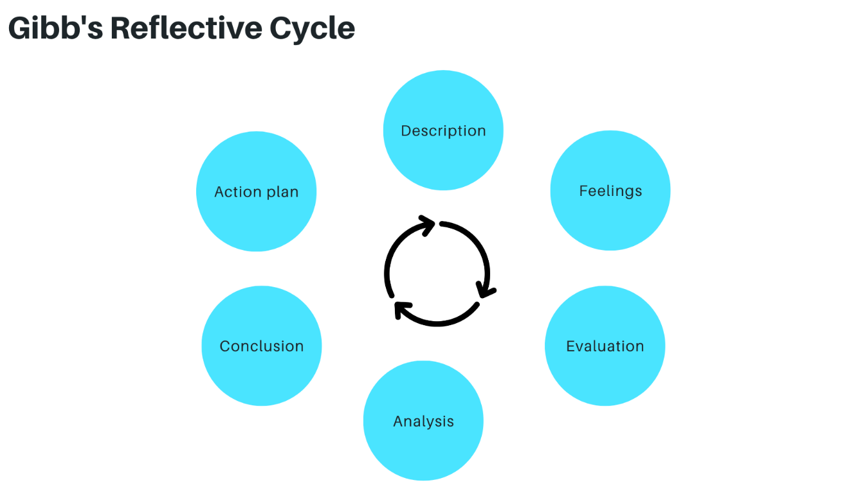
Figure 10 Gibb's Reflective Cycle: A Framework for Reflective Learning

Description of the Research and Writing Process
The research process entailed an intense investigation of the scholarly journals, industry reports, and reliable online sources to acquire data on the operations of Mercedes-Benz in the UK and Bangladesh. I applied the frameworks of PESTEL, Hofstede cultural dimensions, STP, and 7Ps to analyse the differences in the markets and marketing strategies in a systematic way. Consumer behaviour, cultural preferences and economic conditions were gathered to aid a comparative analysis. The organisation of the findings was conducted through the creation of tables, charts and structured outlines to make the findings clear and logical.

Personal Feelings and Reactions During the Assignment
I was challenged and motivated during the assignment. First, it appeared daunting to collect and generalise vast amounts of data about two different markets. Nevertheless, I liked to compare the two countries, the UK and Bangladesh, especially in the realms of culture and economy, and translate theoretical concepts into real-life situations. The organisation of the report and matching the content with the word count improved my organisation skills. Sometimes, I felt undecided about the choice of pertinent sources, yet I was able to overcome those obstacles and it gave me a better self-esteem in academic research. In general, the work was thought-provoking and offered a feeling of achievement with having written a full and organized report.

Evaluation of Strengths and Weaknesses
One of my strengths was that I was able to critically evaluate and compare markets with structured frameworks like PESTEL, STP, and the 7Ps which gave clear information on the international strategy of Mercedes-Benz. My ability to research enabled me to reach reliable and topical sources, and proper planning created a consistent organisation and maintenance of word counts. There was a weakness of sometimes over-reliance on secondary sources instead of primary market data which restricted real world depth (Sadri, and Aprianingsih, 2025). Another issue that was faced during data collection and drafting was time management. The identification of these weaknesses also helped identify areas to improve such as trying to get more primary data and better use of time when dealing with complex tasks.

Analysis of Challenges and Problem-Solving Approaches
A major problem encountered in the assignment was the synthesis of huge amounts of data on different sources of information in both UK and Bangladesh markets. It was necessary to balance the depth of analysis and the word limits and use data selectively. To solve this, I designed detailed outlines and tables to group important points so as to make comparisons concise and pertinent. I also ensured that I used credible academic and industry sources so as to be accurate and reliable.
The other task was the translation of the theoretical frameworks, including PESTEL, STP, and the 7Ps, into the real-life situations and the need to simplify the material and keep it within a manageable size. I conquered this by counterchecking case studies and examples of Mercedes-Benz in other similar markets to confirm my analysis. Self-reviews and writing several drafts enabled me to polish arguments, enhance clarity, and provide a professional, evidence-based report that satisfied assignment criteria.

Conclusion and Key Learning Points
This assignment has helped me to combine theory and practice especially on studying international marketing strategies of Mercedes-Benz in developed and developing markets. I was taught of the value of comparative analysis, systematic structures, and culturally appropriate methods of global business. The most important skills that were reinforced during the process were time management, source evaluation, and succinct academic writing. The reflection also brought to light how I am able to apply frameworks to real-life scenarios and the importance of ethical considerations in marketing.

Future Application of Learning and Skills
The competencies acquired during this assignment will aid in future academic and professional endeavours in international marketing. I will be able to use systematic analytical models, including PESTEL, STP and 7Ps, to evaluate new markets. Improved research and critical review skills will help me to collect and integrate information effectively and experience in cross-market comparison will enhance my cultural and strategic awareness (Savicki, 2023). Skills in time management and structuring the report will help deliver the project on time and in a well-organised manner. Lastly, the knowledge of ethical marketing and sustainability activities makes sure that future marketing strategies are responsible and globally viable to ensure business success is in balance with the social and environmental aspect.

References
- Andreeva, S. and Petikhin, D., 2022. Research on the marketing of technological innovations for car safety: case company: Mercedes-benz.
- Ashraf, Z., 2021. Branding and marketing in automobile industry of Bangladesh: focusing on Ford and Jeep-brands distributed by Anwar Group automobile division.
- Chauhan, P., 2022. Fundamentals of academic writing: A literature review. Journal of NELTA, 27(1-2), pp.161-180.
- da Rosa Ferreira, C., 2021. Field lab–technology strategy with mercedes eq improvement of mercedes-benz-s brand image in the topic of sustainability. PQDT-Global.
- de Caires, D.D., 2025. Equity Valuation: Mercedes-Benz Group AG (Master's thesis, Universidade NOVA de Lisboa (Portugal)).
- Lamm, M.O., 2024. Mercedes Benz Group AG Equity Research–Reaching for the Stars in the New Era of Automobiles (Master's thesis, Universidade NOVA de Lisboa (Portugal)).
- Li, S., 2021. How Does Digital Transformation Improve Customer Experience?. In The Palgrave Handbook of FinTech and Blockchain (pp. 473-502). Cham: Springer International Publishing.
- Li, X., 2025. Ways to Improve the Competitiveness of Mercedes-Benz E-Class Sedan in Luxury Car Market Segment.
- Macfarlane, A., 2023. The Mercedes Benz Midibus. Pen and Sword Transport.
- Micucci, L., 2025. Electric vehicles: Actual market and future prospects, with a focus on battery technology (Doctoral dissertation, Politecnico di Torino).
- Oliveira, M.M., 2025. Intercultural Dynamics in the Mercedes-Benz Narrative: Perceptions vs reactions in business & commerce communication “Your perception of me is a reflection of you. My reaction to you is an awareness of me.”. E-Revista de Estudos Interculturais, (13).
- Pereira, M.B., 2024. Mercedes-Benz Group AG Equity Research Are Luxury Electric Vehicles Its Future? (Master's thesis, Universidade NOVA de Lisboa (Portugal)).
- Pillai, K., 2024. A Comparative Analysis of R&D Strategies and Their Impact on BMW and Mercedes-Benz's Market Dominance. Available at SSRN 4850759.
- Sadri, I. and Aprianingsih, A., 2025. Strategic Marketing Approaches Leveraging the 7P Marketing Mix Framework to Overcome Sales Challenges and Enhance Purchase Intention for IELTS Programs at Athena English Course. Journal of Research in Social Science and Humanities, 5(1), pp.120-125.
- Savicki, V. ed., 2023. Developing intercultural competence and transformation: Theory, research, and application in international education. Taylor & Francis.
- Schell, R., 2021. Exploring the digital transformation in the automotive industry to design an improved mobility service ecosystem for Mercedes-Benz (Doctoral dissertation, University of Worcester).
- Schöneburg, R. and Baumann, K.H., 2022. What the car industry can do: Mercedes-Benz’view. In The Vision Zero Handbook: Theory, Technology and Management for a Zero Casualty Policy (pp. 727-754). Cham: Springer International Publishing.
- Uddin, B., 2020. Consumers' purchase behavior in Bangladesh: green products perspectives. Journal of Sustainable Tourism and Entrepreneurship, 1(4), pp.305-320.
- Uddin, M.K., 2024. Environmental education for sustainable development in Bangladesh and its challenges. Sustainable Development, 32(1), pp.1137-1151.
- Kolios, A. and Read, G., 2013. A political, economic, social, technology, legal and environmental (PESTLE) approach for risk identification of the tidal industry in the United Kingdom. Energies, 6(10), pp.5023-5045.
- Mogaji, E., 2025. Market Segmentation, Targeting, and Positioning. In Strategic Marketing Management: Principles and Practice (pp. 103-133). Cham: Springer Nature Switzerland.
- Kitchen, P.J. and Burgmann, I., 2015. Integrated marketing communication: Making it work at a strategic level. Journal of Business Strategy, 36(4), pp.34-39.

