
University of Wales Trinity Saint David
School of Engineering
2D Diffusion Equation model
using the Explicit Finite
Difference Method
Callum Thomas
2004500
Bachelor of Engineering, Mechanical & Manufacturing Engineering
12/03/2024
Computational Methods
ACMA4007

Contents
Contents 2
1. Introduction 3
1.1 Goals and Objectives 3
• Explain the 2D heat equation and its theoretical basis for a numerical model. 3
• Use the Explicit Finite Difference Method (EFDM) with finite difference method (FDM) discretisation for an accurate and stable numerical solution of the heat equation. 3
• Vary grid spacing, time step, and thermal tolerance are used to analyse model sensitivity, optimise output, and improve fidelity. 3
• Identify and address model limitations and propose enhancements for future developments. 3
2 Background information 3
2.1 Definition of the Heat Equation 3
3. Explicit Finite Difference Method (EFDM) 4
3.1 Talor Series 4
• Derivation of Difference from Taylor Series 4
3.2 Spatial Discretion $Sd$ 5
3.3 Temporal Discretisation $Td$ 5
Implementation Steps 6
4. Initial & Boundary for Thermal Distribution 6
4.1 Initial Domain 6
5. Codes’ Details & Explanations 7
5.1 Clearing the Workspace and Command Window 7
5.2 Domain Setup & Grid Initialisation 7
5.3 Temp Matrix Initialisation & Boundaries 7
5.4 Main Simulation Loop 8
5.5 Analytical Solution and Error Analysis 9
5.6 Assessment and Adjustment Suggestions 9
5.7 Final Remarks and Function Definitions 10
6. Validation 10
6.1 Temperature Distribution 10
6.2 Observing the Analytical and Numerical 11
6.3 Future Enhancement 11
7. Analysis Code Sensitivity 11
8. Improvements & Future Developments 13
8.1 Robust Modelling of Thermal Equilibrium 13
8.2 Integrating Advanced Computational Techniques 13
10. References 14
11. Appendix 16

Table of Equations
Equation 1: Rooted in Fourier's Law 3
Equation 2: Temperature Distribution Equation 3
Equation 3: Thermal Diffusivity Formula 4
Equation 4: Taylor Series Expansion 4
Equation 5: Forward Difference Formula 4
Equation 6: Central Difference Formula 4
Equation 7: Explicit Finite Difference Scheme for Heat Equation 5
Equation 8: Second spatial derivatives 5
Equation 9: Bounded Linear Growth Function 6
Equation 10: Decreasing Linear Adjustment Function 7

Introduction
Accurate predictions of thermal behaviour in materials and systems rely heavily on numerical simulations. The diffusion equation is often employed to model heat distribution over time. However, its precision and efficiency depend on carefully selecting numerical parameters such as grid spacing and time step. The Explicit Finite Difference Method (EFDM) is a numerical model that simulates heat diffusion in a flat plate and uses Dirichlet boundary conditions to verify accuracy. By identifying the optimal combination of these parameters, we can increase our confidence in using EFDM for thermal simulations and pave the way for exploring new numerical techniques.

1.1 Goals and Objectives

Explain the 2D heat equation and its theoretical basis for a numerical model.

Use the Explicit Finite Difference Method (EFDM) with finite difference method (FDM) discretisation for an accurate and stable numerical solution of the heat equation.

Vary grid spacing, time step, and thermal tolerance are used to analyse model sensitivity, optimise output, and improve fidelity.

Identify and address model limitations and propose enhancements for future developments.

2 Background information
Explanation of the Heat Equation and Its Importance
It models how temperature changes throughout a given space over time, derived from Fourier's Law, which postulates that the heat transfer rate through a material is proportional to the negative gradient of the temperature field and the material's thermal conductivity. [1],[4]

2.1 Definition of the Heat Equation
$$\frac{∂T\left(x,y,t\right)}{∂t}= α \left(\frac{∂^{2}T\left(x,y,t\right)​}{∂x^{2}}+\frac{∂^{2}T\left(x,y,t\right)}{∂y^{2}}\right)$$
Equation 1: Rooted in Fourier's Law
$$T\left(x,y,t\right)$$
Equation 2: Temperature Distribution Equation
signifies the temperature at a particular point in a two-dimensional (2D) space at a given time, while α denotes the material's thermal diffusivity—a measure of the rate at which heat spreads through a material, expressed as:
$$α =\frac{k}{p_{c}}$$
Equation 3: Thermal Diffusivity Formula
Its thermal properties are specified by:
- Conductivity, $k=\frac{143W}{m}⋅C$
- Density, p = $2.8 ×\frac{{10}^{3}kg}{m^{3}}$
- Specific Heat, $c=795\frac{J}{kg}⋅C$

3. Explicit Finite Difference Method (EFDM)

3.1 Talor Series
The EFDM is the primary computational tool for discretising the heat equation for a two-dimensional domain. [24] The point $\left( x_{0}\right)$for a function $f\left(x\right)$ is fundamental in deriving difference approximations for derivatives. For a small step size $h$, the series is: [5]
$$f\left(x_{0}+h\right)=f\left(x_{0}\right)+hf^{'}\left(x_{0}\right)+\frac{{\left(h\right)}^{2}}{2!}f^{''}\left(x_{0}\right)+\frac{{\left(h\right)}^{3}}{3!}f^{'''}\left(x_{0}\right)+⋯$$
Equation 4: Taylor Series Expansion

Derivation of Difference from Taylor Series
- Forward Difference (for first derivative $\left(f^{'}\left(x\right)\right)$):
$$f^{'}\left(x_{0}\right)≈ \frac{f\left(x_{0}+h\right)-f\left(x_{0}\right)​}{h}+O\left(h\right)$$
Equation 5: Forward Difference Formula
- Central difference (for second derivative $\left(f^{''}\left(x\right)\right)$:
For the second derivative, the central difference approximation can be obtained by considering the expansion of $f$ about $x$ at points $x+h$ and $x-h,$and then eliminating the higher-order terms: [5],[22]
$$f^{''}\left(x\right)≈\frac{f\left(x+h\right)-2f\left(x\right)+f\left(x-h\right)}{h^{2}}+O\left(h^{2}\right)$$
Equation 6: Central Difference Formula
$O\left(h^{x}\right)$ The error term's order is ignored in finite difference approximations..
The central difference method is more accurate than the forward difference for approximating the second derivative because it uses information from both sides of the point $x_{0}$.


3.2 Spatial Discretion $S_{d}$
This method is anchored in thermal diffusivity, denoted by a, which helps predict temperature changes over time within the material. The simulation area is segmented into a grid, and each intersection point on the grid is considered a node, analogous to a geographical point with its own "thermal coordinate."
In the grid, for example, Point B is the central node where the temperature calculations are made at the next time step. Surrounding Point B, imagine points [5], corresponding to the cardinal directions: North, South, East, and West. Each points have its temperature value, represented as $T_{North}, T_{South}, T_{East} T_{West}$
The EFD method calculates the temperature at Point B for the next time step $T_{Next}$, the EFD by using the current temperature at Point B $T_{Current}$ along with the temperatures of the surrounding points. [22], [24]
$${T_{next}=T}_{current}+Δt×a\left(\frac{T_{East}-{2T}_{current}+ T_{West}}{Δx^{2}}+ \frac{T_{North}-{2T}_{current}+T_{South}}{yx^{2}}\right)$$
Equation 7: Explicit Finite Difference Scheme for Heat Equation
The values $Δx$ & $Δy$ represent the distance between points in the East-West and North-South directions. The term $Δt$ is the time step used in the simulation.
$$\frac{∂^{2}T​}{∂x^{2}} ≈\frac{T_{East of current}-{2T}_{current}+T_{West of Current }}{h^{2}}$$
Equation 8: Second spatial derivatives

The heat transfer analysis involves discretising the spatial domain and approximating spatial second derivatives to create a computational grid. Accurate heat diffusion simulation requires approximating the heat equation's spatial second derivatives ($\frac{∂^{2}T​}{∂x^{2}}+\frac{∂^{2}T}{∂y^{2}}$ ) at these discrete points. [17],[18]

3.3 Temporal Discretisation $T_{d}$
It refers to dividing the progression of time into discrete, uniformly spaced intervals, commonly referred to as time steps $\left(Δt\right)$ this is analogous to breaking up a long journey into a series of short, consistent steps. As a traveller would mark progress point by point, temperature evolution over time is captured at these discrete intervals. Just as $S_{d}$partitions the material landscape into a grid of nodes with 'thermal coordinates,' $T_{d}$ schedules 'thermal events' at regular intervals. Each time step is when the temperature at each node can ‘check in’ with its neighbours (Cardinal Coordinates) to update its temperature based on the heat they share. These time steps are captured frame-by-frame evolutions of the temperature distribution, akin to watching a film of thermal movement over time. The time step size $\left(Δt\right)$ is chosen to balance the detail of the temperature change captured at each frame with the computational effort required to process the entire film.
Application Example: Aluminium Plate Analysis The method is applied to a 6x6 cm² aluminium plate modelled on a 7x7 grid. The temporal resolution is set at second, which aligns with the stability requirements and allows for a detailed temporal analysis. [18}

Implementation Steps
- Boundary Conditions Setup: The plate's initial temperature conditions are uniformly set, with specific boundary conditions at the northern edge simulating a gradient heat source.
- Model Validation: An analytical comparison confirms the fidelity of the numerical simulation, which is essential for practical engineering predictions. [24]

4. Initial & Boundary for Thermal Distribution
In the simulation of heat diffusion through a square plate, defining initial and boundary conditions is crucial for solving the heat equation and predicting the temperature distribution over time. For the given geometry, a square plate [0, 6] x [0, 6], the following conditions are established: [10], [11]

4.1 Initial Domain
At the outset, equation 2 =$0$ for all points where $0 < x < 6 and 0 < y < 6.$ This represents a starting point for the heat diffusion process.
The boundaries of the domain are maintained at constant temperatures, with two types of conditions applied: [10], [11]
Dirichlet Conditions:
Dirichlet conditions, like the ones specified for the west and north boundaries in the simulation, define a scenario where the temperature at the boundary is fixed and known. These conditions tell the simulation, "No matter what happens, the temperature at these edges will always be this specific value."
Dirichlet conditions are used to represent real-world scenarios very effectively. For example:
- The West Boundary: Setting the temperature to 0°C, is like saying one edge of the plate is in contact with ice or something similarly cold, and it stays that way.
- The North Boundary: The changing temperature along this edge is designed to simulate a more dynamic situation, like having a heating element that varies in temperature along its length.
    - Linear increase; $f(x)=12.5x for 0≤x≤\frac{2}{3}×6$
Equation 9: Bounded Linear Growth Function
This segment denotes a gradual rise in temperature from the western side towards the east. One can visualise a mild incline that ascends towards the eastward direction.
    - Linear decrease; $f\left(x\right)=-25x+150 for\frac{2}{3} ×6<x≤6$
Equation 10: Decreasing Linear Adjustment Function
Here, after reaching the two-thirds mark on the boundary, the temperature starts to decrease. This is like a slope dipping down as you continue moving eastward.
Dirichlet conditions are preferred over Neumann or Robin conditions when simulating fixed temperature values at boundaries. Neumann specifies the rate of temperature change at the boundaries, while Robin combines fixed temperature and heat flow.

5. Codes’ Details & Explanations

5.1 Clearing the Workspace and Command Window
The code's initial segment prepares the MATLAB environment by clearing any previous data that might interfere with the simulation. This step is crucial for debugging and avoiding discrepancies arising from residual variables in the workspace. [7]
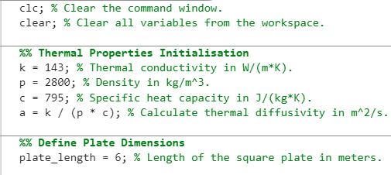
- Initialising Thermal Properties
These values determine how heat propagates through aluminium to calculate its thermal diffusivity. Thermal diffusivity $\left(Equation 3\right)$ Is crucial for EFDM as it determines the heat spread rate. Accurate heat simulation requires a precise representation of material properties, including thermal conductivity, density, and specific heat capacity. [3], [12], [13]

5.2 Domain Setup & Grid Initialisation
- Plate Dimensions
The code section will define the size of the square plate using a variable that sets the edge length in meters. This parameter is crucial as it determines the spatial extent for solving the heat diffusion equation and sets the maximum values for the computational grid points.
- Computational Grid
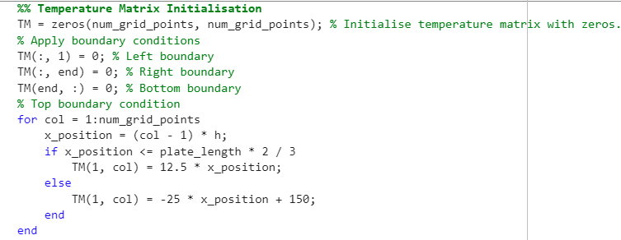
The user defines the grid setup based on the plate's dimensions. The grid spacing (h) determines the simulation's spatial resolution and computational intensity. The $number_of_grid_ points$ is calculated to delineate the temperature matrix's grid. The grid spacing and dimensions are crucial for stability and accuracy in numerical schemes. [3], [12], [13]

5.3 Temp Matrix Initialisation & Boundaries
This sets up temperature distribution on a grid with boundary conditions. Accurate boundary conditions are essential for FDM stability and convergence using the ‘piecewise’ function $f(x)$. They capture thermal behaviour as dictated by the heat equation and problem setup. [7]
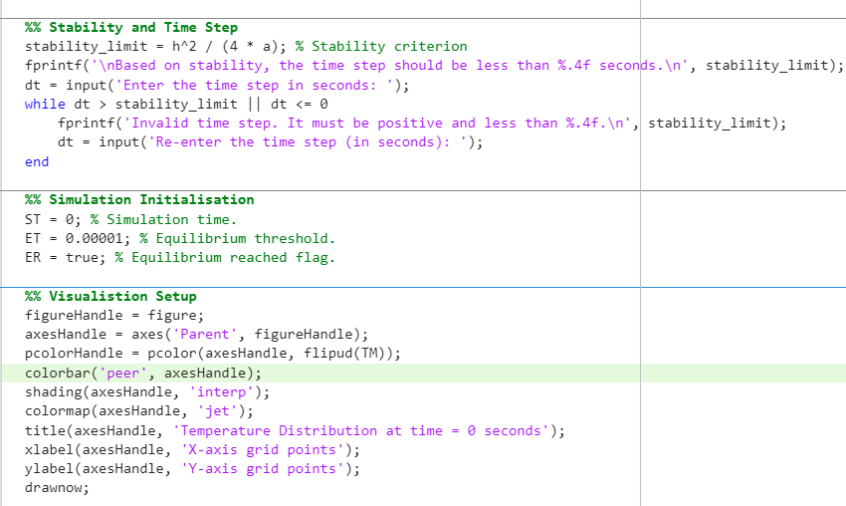
- Initialising Simulation Parameters
Essential parameters for the simulation loop are set up here, including the simulation time (ST) and a minimal equilibrium threshold (ET), which serve as a stop criterion when temperature changes fall below this value. The ER flag controls the simulation flow, indicating if an equilibrium is reached, ensuring logical progression. [3], [12], [13]

- Time Step Configuration
This section ensures the simulation's stability, which is determined by time step size (dt) and depends on grid spacing and thermal diffusivity (a). The stability limit is calculated as $\frac{h^{2}}{\left(4 * a\right)}$ based on von Neumann stability analysis, which informs the user-selected time step (dt). The script ensures stable and physically accurate simulation results following the CFL condition. [3], [12], [13]

- Preparing the Visualisation Setup
Real-time visualisation is a powerful tool for understanding complex phenomena. MATLAB's plotting functions can create visualisations of temperature distribution across a plate. This provides immediate feedback for debugging and interpreting results, enhancing comprehension, and aligning with simulation goals. [3], [12], [13]
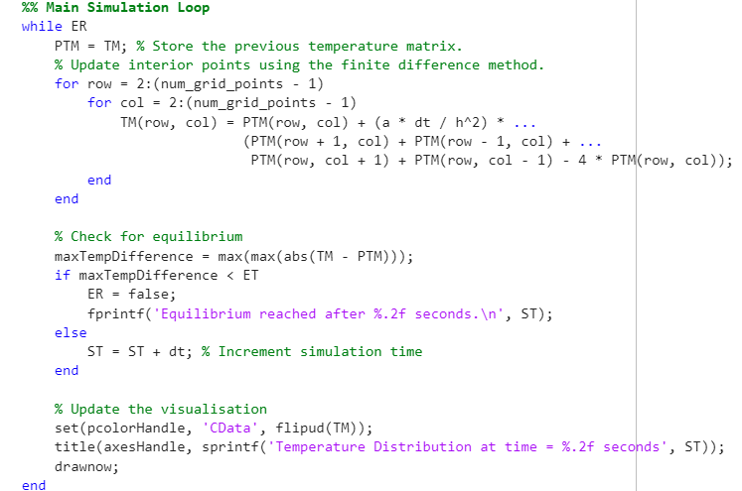

5.4 Main Simulation Loop
The script updates the temperature using EFDM. It stores previous values in a temporary matrix to calculate new ones. Nested for-loops iterate over interior grid points, avoiding edges with boundary conditions.
The interior temperatures are updated using finite difference, which simulates heat diffusion by leveraging neighbour point data $a × dt\frac{dt}{h^{2}}$. The simulation progresses (ST) with each iteration, checking whether the temperature change across the grid is below the predetermined equilibrium threshold (ET). If it is, the loop terminates, indicating that the system's temperature distribution no longer changes significantly with time, which is the steady-state condition for the heat equation. [7] , [5], [24]

- Visualisation Update
The simulation updates and visually monitors temperature distribution, identifying potential issues or confirming expected behaviour. EFDM approaches the heat equation's steady-state solution, with equilibrium as the stopping criterion. The main loop simulates material response to thermal conditions over time. Visualisation helps analyse and communicate results. [3], [12], [13]

5.5 Analytical Solution and Error Analysis
- Compared with the Analytical Solution
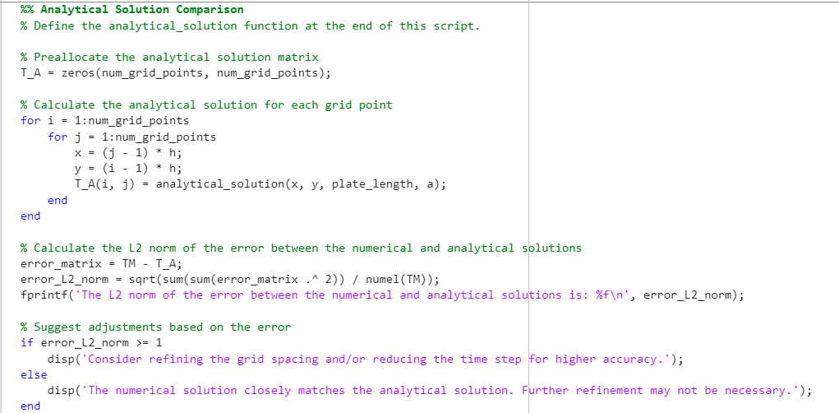
The solution models temperature distribution with precise conditions and is a benchmark for comparing accuracy with the numerical method. The heat equation is a PDE that can be solved using different conditions-based methods.
- Visualising Simulation Results
The script compares numerical and analytical solutions and provides a graphical representation to reveal discrepancies or agreements between the two. This tool verifies and helps understand heat distribution dynamics within the modelled domain. [3], [13]

5.6 Assessment and Adjustment Suggestions
Error analysis is crucial for assessing simulation accuracy. Norms like L2 measure the difference between numerical and analytical solutions, providing a single metric summarising the deviation of the numerical solution from the analytical one. This is important for validating and adjusting numerical simulations, ensuring accuracy and reliability.
- Performance Assessment:
The script assesses whether the numerical solution approximates the analytical solution within an acceptable margin of error and informs if any adjustments are needed in the simulation setup.

- Adjustment Suggestions:
If the error is too high, the script suggests adjusting the model parameters. This includes reducing the grid spacing (h) or decreasing the time step (dt). However, this comes at the cost of increased computational effort, highlighting the trade-off between accuracy and resource usage. [3], [7]

5.7 Final Remarks and Function Definitions
- Concluding the Simulation
The script concludes the simulation process and defines functions used throughout, focusing on the analytical solution function. This section serves multiple essential purposes.
Final Remarks:
- The final remarks summarise the simulation outcomes and highlight significant findings. They guide the user in interpreting the results and reflecting on the simulation process.
Function Definitions:
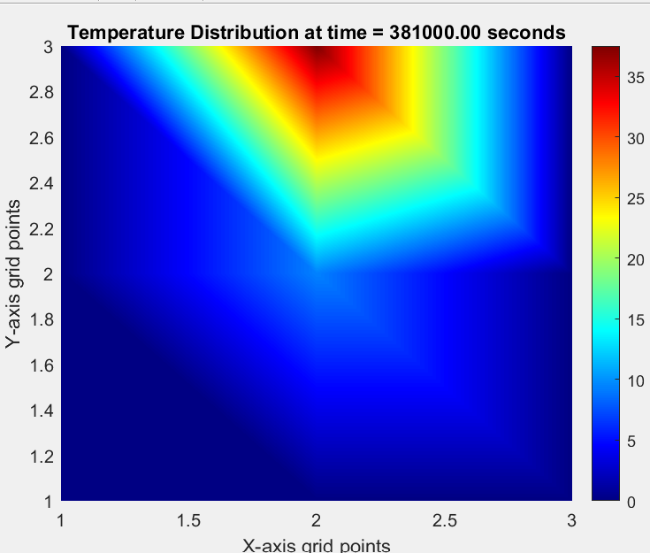
- The analytical solution function simplifies computational tools and validates numerical methods for heat diffusion. It involves mathematical principles to determine temperature distribution over space and time, approximated by numerical simulations for accuracy assessment. [3], [12], [13], [7]

6. Validation

6.1 Temperature Distribution
The numerical code's precision was verified by comparing its temperature distribution at thermal equilibrium to an analytical benchmark. After 381,000 seconds, the temperature map established equilibrium and showed a heat transfer gradient consistent with expectations. The L2 norm was employed to measure differences, yielding a value that gauged the simulation's accuracy. Based on the L2 norm, refinement recommendations, including grid spacing and time step adjustments, were offered to enhance the model's precision. [3], [13], [22]

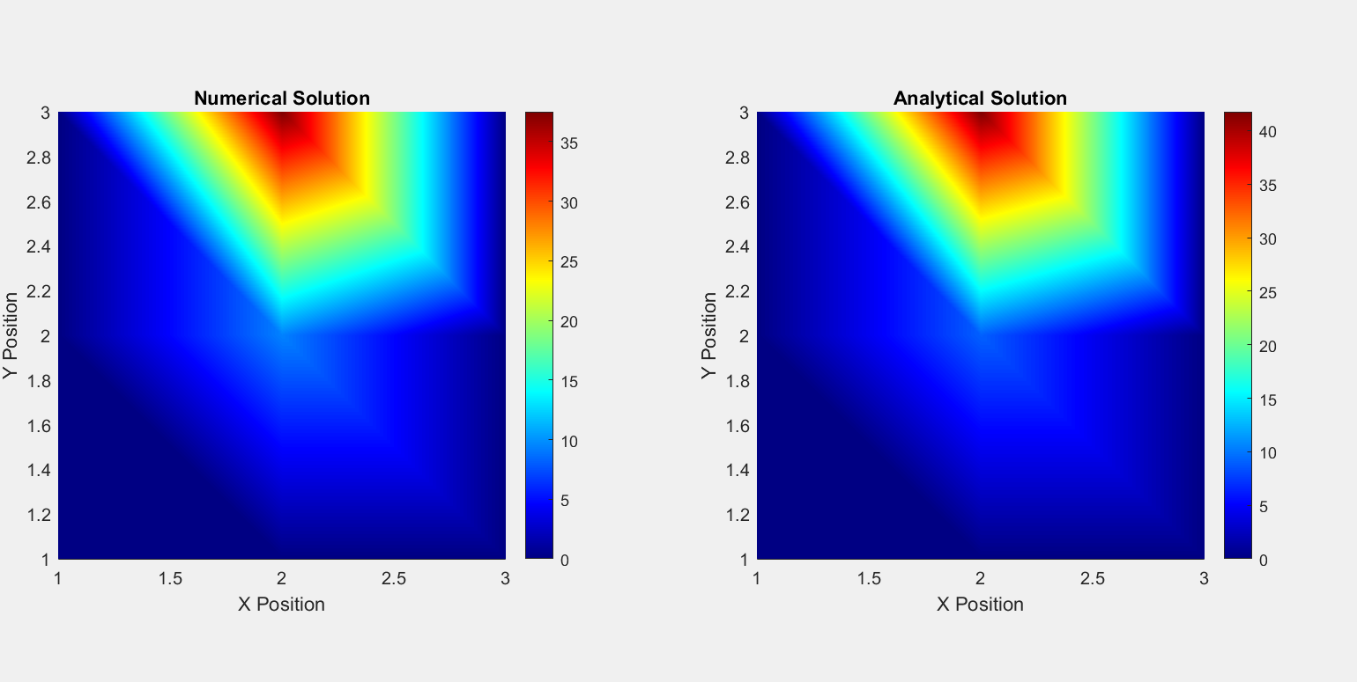
6.2 Observing the Analytical and Numerical
The alignment observed between the numerical solution and the analytical model affirms the effectiveness of the simulation code in capturing the essential patterns of thermal behaviour. Despite this success, observed discrepancies highlight areas where the model could be further refined to improve precision, which is especially critical in thermal analysis applications. These applications often require exacting standards due to the potential for significant real-world implications, such as in the design of thermal management systems or predicting material behaviour under thermal stress. [13]
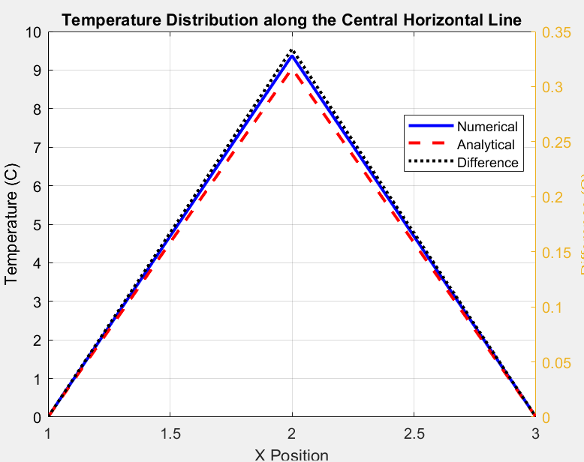
The validation exercise serves a dual purpose: it provides confidence in the simulation's current state and illustrates the necessity for ongoing enhancements. Pursuing enhanced accuracy is a continuous endeavour. This is necessitating regular updates and adjustments to the model as new data becomes available and computational techniques evolve. This process ensures the simulation remains relevant and reliable for decision-making in complex engineering scenarios. [3] [20]

6.3 Future Enhancement
In future enhancements of this simulation, the primary objective will be to minimise the error margin demonstrated by the L2 norm calculations. Efforts will include fine-tuning the mesh granularity through more refined grid spacing and optimising the time step size to better capture the subtle nuances of heat transfer dynamics. By achieving a lower error margin, the simulation is expected to yield results that are quantitatively accurate and qualitatively representative of actual thermal processes, thereby improving the model's utility in practical engineering applications where predictive accuracy is paramount. [6]

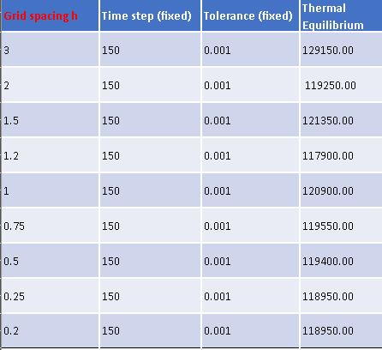
7. Analysis Code Sensitivity
7.1 Gird Spacing Variation
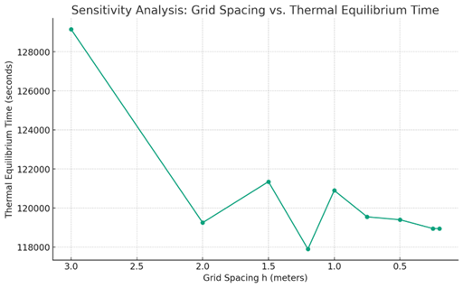
In thermal simulations, selecting an appropriate grid spacing is essential for balancing detail with efficiency, profoundly influencing the model's accuracy and the potential for truncation errors. Truncation errors occur when exact mathematical procedures are approximated due to the discretization of the simulation space. A smaller grid spacing, which involves positioning points of temperature measurement closer together, can reduce truncation errors, improving the precision of temperature readings. It amplifies the accumulation of truncation errors due to increased approximations.
The data reveals a clear trend: the simulation achieves thermal equilibrium more swiftly as grid spacing decreases. This observation is consistent with numerical analysis principles, where finer spatial resolutions yield a more detailed portrayal of temperature gradients, enabling the model to detect and adapt to temperature changes more promptly. More calculations mean a more significant computational load, necessitating a careful choice of grid spacing to ensure the most accurate simulation within the available computational power and time constraints.
7.2 Temporal Discretising (tp)
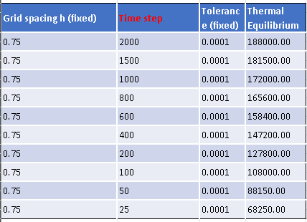
In thermal simulations, selecting the appropriate time step size is critical for capturing temperature changes efficiently and accurately. Each time step acts like a snapshot, updating the simulation with the latest temperature data. Influential time steps can miss transient thermal behaviours, compromising the model's ability to depict rapid temperature changes accurately. The data indicates that while more Significant time steps can initially reduce the time to reach thermal equilibrium beyond a certain threshold, they no longer expedite the process. This observation points to an optimal time step size beyond which efficiency gains level off.
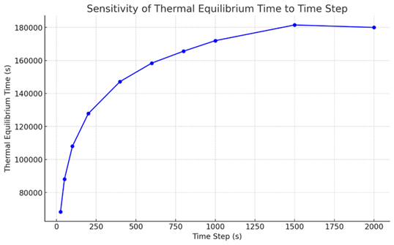
However, minimal time steps can increase in both truncation and roundoff errors. Truncation error arises when the simulation disregards specific temporal details due to larger intervals between readings, whereas roundoff error can accumulate when numerous small calculations introduce slight numerical inaccuracies.
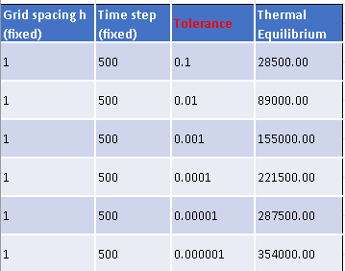
Hence, the optimal time step minimises both truncation and roundoff errors by being sufficiently small to capture the critical fluctuations in temperature, yet not so small that it significantly heightens the computational load or error rate. This judicious time step size enables the simulation to reach equilibrium, ensuring that the simulation is both precise, quick and accurate in reflecting temperature distribution and optimised in computational resource usage.[3]
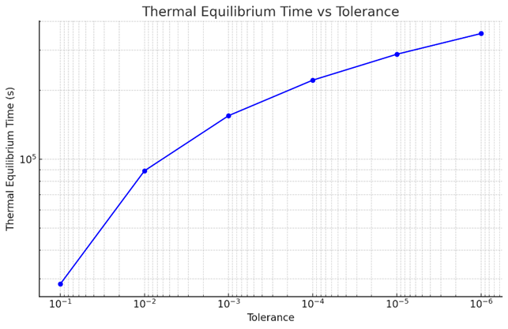
7.3 Tolerance on Thermal Equilibrium Time (ET)
The data provided from the simulation study demonstrates that the time outcome is heavily influenced by the choice of tolerance value, which dictates the precision of a thermal model. Tolerance refers to the degree of closeness required between the model's temperature calculations and actual values for the simulation to be complete. The presented table and corresponding graph indicate that as the tolerance is set to stricter values (numerically smaller), the duration for the system to reach thermal equilibrium notably increases. For instance, with a tolerance of 0.1, equilibrium is achieved in 28,500 seconds. Conversely, a stricter tolerance of 0.000001 prolongs the time to reach equilibrium to 354,000 seconds. This direct correlation indicates that heightened precision demands, indicated by lower tolerance levels, are associated with increased simulation times. The graphical representation of this data further illustrates this trend, with the curve becoming steeper as the tolerance decreases, suggesting that smaller tolerances significantly prolong the duration of simulations. Hence, this pattern solidifies the conclusion that selecting a tolerance level represents a critical balance between minimizing computational time and maximizing the precision necessary for the simulation to yield reliable outcomes. Setting the tolerance too loosely may result in inaccuracies, whereas excessively tight tolerance values can render the simulation process excessively lengthy and potentially infeasible.

8. Improvements & Future Developments
Several avenues for improvement and future development are proposed. Emphasis is placed on adopting more sophisticated numerical schemes that may offer stability and accuracy benefits and embracing methodologies that more naturally accommodate complex geometries.
The ADI and implicit FDM methods offer stable and robust alternatives to explicit schemes, allowing for more significant time steps and reduced sensitivity to discretisation parameters in simulations. Consider numerical methods like FEM, FVM, or BEM instead of FDM for greater flexibility in handling irregular geometries and complex boundary conditions. FEM allows high-precision simulation of thermal distributions in domains of arbitrary shapes. FVM is suitable for simulations involving fluid flow and heat transfer, while BEM simplifies the computational domain for specific problems.

8.1 Robust Modelling of Thermal Equilibrium
In the quest for more robust modelling of thermal equilibrium, it is pertinent to investigate adaptive schemes that dynamically adjust discretisation parameters in response to the evolving solution. Such adaptivity can enhance the simulation's efficiency by concentrating computational resources. Where they are most needed, providing a more accurate depiction of thermal behaviour with reduced computational effort. [19], [6]

8.2 Integrating Advanced Computational Techniques
Integrating advanced computational techniques such as parallel and high-performance computing (HPC) infrastructures is imperative to support these improvements. These technologies can significantly decrease simulation run times and expand the scope of problems that can be tackled [19]. Applying machine learning algorithms for parameter optimisation and predictive modelling also holds promise for future advancements in the field (Jordan & Mitchell,
9. Conclusion
This report analyses a numerical simulation for thermal distribution within a specified domain. It examines the model's sensitivity to variations in grid spacing, time step, and tolerance. The study shows a definitive relationship between grid spacing and thermal equilibrium attainment, a direct correlation between time step variations and equilibrium time, and the impact of tolerance thresholds on simulation convergence. The report confirms the importance of optimising simulation parameters for advancing thermal simulation models and achieving more sophisticated engineering solutions.

10. References
[1] C. Tsallis, H. S. Lima, U. Tirnakli, and D. Eroglu, “First-principle validation of Fourier’s law in d=1,2,3 classical systems,” Physica D, vol. 446, p. 133681, Apr. 2023, doi: 10.1016/J.PHYSD.2023.133681.
[2] L. Cui, “IMPROVED MATRIX MODEL OF SEQUENCE GRID PARTITION BASED ON VECTOR SPACE SAMPLING,” Physical Communication, p. 102334, Mar. 2024, doi: 10.1016/J.PHYCOM.2024.102334.
[3] Z. Mansouri, R. P. Selvam, and A. G. Chowdhury, “Maximum grid spacing effect on peak pressure computation using inflow turbulence generators,” Results in Engineering, vol. 15, p. 100491, Sep. 2022, doi: 10.1016/J.RINENG.2022.100491.
[4] J. Tu, M. A. Haque, D. Baran, and W. L. Ong, “Logarithmic sensitivity ratio elucidates thermal transport physics in multivariate thermoreflectance experiments,” Fundamental Research, Feb. 2023, doi: 10.1016/J.FMRE.2023.01.010.
[5] K. Kumari and D. A. Donzis, “A generalized von Neumann analysis for multi-level schemes: Stability and spectral accuracy,” J Comput Phys, vol. 424, p. 109868, Jan. 2021, doi: 10.1016/J.JCP.2020.109868.
[6] D. Losapio and A. Scotti, “Local Embedded Discrete Fracture Model (LEDFM),” Adv Water Resour, vol. 171, p. 104361, Jan. 2023, doi: 10.1016/J.ADVWATRES.2022.104361.
[7] “An Introduction to MATLAB® Programming and Numerical Methods for Engineers,” An Introduction to MATLAB® Programming and Numerical Methods for Engineers, p. iii, Jan. 2015, doi: 10.1016/B978-0-12-420228-3.00021-X.
[8] D. Piretzidis and M. G. Sideris, “SHADE: A MATLAB toolbox and graphical user interface for the empirical de-correlation of GRACE monthly solutions,” Comput Geosci, vol. 119, pp. 137–150, Oct. 2018, doi: 10.1016/J.CAGEO.2018.06.012.
[9] J. Tremblay et al., “LIONirs: flexible Matlab toolbox for fNIRS data analysis,” J Neurosci Methods, vol. 370, p. 109487, Mar. 2022, doi: 10.1016/J.JNEUMETH.2022.109487.
[10] A. K. Roy and K. Kumar, “2D heat conduction on a flat plate with Ti6Al4V alloy under steady state conduction: A numerical analysis,” Mater Today Proc, vol. 46, pp. 896–902, Jan. 2021, doi: 10.1016/J.MATPR.2020.12.1152.
[11] Y. Kang, Z. Lang, G. Wu, Y. Wang, and Y. Wang, “Analysis and numerical simulation of pool boiling heat transfer in porous medium combined with 2D MCFC composite structure,” Int J Heat Fluid Flow, vol. 107, p. 109339, Jul. 2024, doi: 10.1016/J.IJHEATFLUIDFLOW.2024.109339.
[12] S. Palanisamy et al., “Experimental and computational investigation of heat transfer during quenching of semi-solid aluminum plates under hot cracking condition,” Thermal Science and Engineering Progress, vol. 48, p. 102372, Feb. 2024, doi: 10.1016/J.TSEP.2023.102372.
[13] N. M. Narayan, S. B. Gopalkrishna, B. Mehdi, S. Ryll, E. Specht, and U. Fritsching, “Multiphase numerical modeling of boiling flow and heat transfer for liquid jet quenching of a moving metal plate,” International Journal of Thermal Sciences, vol. 194, p. 108587, Dec. 2023, doi: 10.1016/J.IJTHERMALSCI.2023.108587.
[14] Z. Zou, W. Yang, W. Zhang, X. Wang, and J. Zhao, “Numerical modeling of steady state errors for shielded thermocouples based on conjugate heat transfer analysis,” Int J Heat Mass Transf, vol. 119, pp. 624–639, Apr. 2018, doi: 10.1016/J.IJHEATMASSTRANSFER.2017.11.034.
[15] K. Ishige and Y. Kabeya, “Lp norms of nonnegative Schrödinger heat semigroup and the large time behavior of hot spots,” J Funct Anal, vol. 262, no. 6, pp. 2695–2733, Mar. 2012, doi: 10.1016/J.JFA.2011.12.024.
[16] S. Bagchi and R. Garg, “On L2-boundedness of pseudo-multipliers associated to the Grushin operator,” J Funct Anal, vol. 286, no. 3, p. 110252, Feb. 2024, doi: 10.1016/J.JFA.2023.110252.
[17] K. Tao, X. Zhou, and H. Ren, “The application of an advanced coupled SPH-BEM algorithm to 2D fluid sloshing simulation,” Eng Anal Bound Elem, vol. 138, pp. 280–300, May 2022, doi: 10.1016/J.ENGANABOUND.2022.02.020.
[18] M. Tezer-Sezgin, C. Bozkaya, and Ö. Türk, “BEM and FEM based numerical simulations for biomagnetic fluid flow,” Eng Anal Bound Elem, vol. 37, no. 9, pp. 1127–1135, Sep. 2013, doi: 10.1016/J.ENGANABOUND.2013.04.015.
[19] A. Raizer et al., “A comparative analysis of grounding in different structures: Operational vs. finite element method models,” Electric Power Systems Research, vol. 230, p. 110243, May 2024, doi: 10.1016/J.EPSR.2024.110243.
[20] K. Maleknejad, N. Aghazadeh, and M. Rabbani, “Numerical solution of second kind Fredholm integral equations system by using a Taylor-series expansion method,” Appl Math Comput, vol. 175, no. 2, pp. 1229–1234, Apr. 2006, doi: 10.1016/J.AMC.2005.08.039.
[21] L. Yang, H. Yan, and H. Liu, “An optimal implicit staggered-grid finite-difference scheme based on the modified Taylor-series expansion with minimax approximation method for elastic modeling,” J Appl Geophy, vol. 138, pp. 161–171, Mar. 2017, doi: 10.1016/J.JAPPGEO.2017.01.020.
[22] C. Pantaleón and A. Ghosh, “Taylor series expansion using matrices: An implementation in MATLAB®,” Comput Fluids, vol. 112, pp. 79–82, May 2015, doi: 10.1016/J.COMPFLUID.2015.01.009.
[23] F. Huo, X. C. Xi, and A. N. Poo, “Generalized Taylor series expansion for free-form two-dimensional contour error compensation,” Int J Mach Tools Manuf, vol. 53, no. 1, pp. 91–99, Feb. 2012, doi: 10.1016/J.IJMACHTOOLS.2011.10.001.
[24] J. I. Ramos, “Explicit finite difference methods for the EW and RLW equations,” Appl Math Comput, vol. 179, no. 2, pp. 622–638, Aug. 2006, doi: 10.1016/J.AMC.2005.12.003.
[25] J. Weber, C. Steiert, J. Weber, and L. Shabi, “Investigation of the thermal and energetic behavior and optimization towards smart fluid systems in machine tools,” Procedia CIRP, vol. 99, pp. 80–85, Jan. 2021, doi: 10.1016/J.PROCIR.2021.03.014.
[26] M. J. Hancock, "The Heat and Wave Equations in 2D and 3D," in 18.303 Linear Partial Differential Equations, Fall 2006. https://ocw.mit.edu/courses/18-303-linear-partial-differential-equations-fall-2006/5faa7f7c21719c38fb701bc79ef4a29f_pde3d.pdf
[27] https://www.google.com/url?sa=i&url=https%3A%2F%2Fwww.dreamstime.com%2Ffour-cardinal-directions-points-compass-rose-north-south-east-west-indicated-stock-vector-illustration-isolated-image163800466&psig=AOvVaw2HrP0kb-g7lNZqaQyDqMfu&ust=1710979465300000&source=images&cd=vfe&opi=89978449&ved=0CBIQjRxqFwoTCNCD3avFgYUDFQAAAAAdAAAAABAE Image 1

11. Appendix
clc; % Clear the command window.
clear; % Clear all variables from the workspace.

%% Thermal Properties Initialisation
k = 143; % Thermal conductivity in W/(m*K).
p = 2800; % Density in kg/m^3.
c = 795; % Specific heat capacity in J/(kg*K).
a = k / (p * c); % Calculate thermal diffusivity in m^2/s.

%% Define Plate Dimensions
plate_length = 6; % Length of the square plate in meters.

%% Grid Setup0.3
% Inform user about grid spacing and ask for input
fprintf('The plate length is %d meters. Choose a grid spacing less than %d, positive, and that divides %d evenly.\n', plate_length, plate_length, plate_length);
h = input('Enter the grid spacing in meters: ');
while rem(plate_length, h) ~= 0 || h <= 0 || h >= plate_length
fprintf('Invalid grid spacing. Please enter a positive value less than %d that divides %d evenly.\n', plate_length, plate_length);
h = input('Re-enter the grid spacing (in meters): ');
end
num_grid_points = plate_length / h + 1;

%% Temperature Matrix Initialisation
TM = zeros(num_grid_points, num_grid_points); % Initialise temperature matrix with zeros.
% Apply boundary conditions
TM(:, 1) = 0; % Left boundary
TM(:, end) = 0; % Right boundary
TM(end, :) = 0; % Bottom boundary
% Top boundary condition
for col = 1:num_grid_points
x_position = (col - 1) * h;
if x_position <= plate_length * 2 / 3
TM(1, col) = 12.5 * x_position;
else
TM(1, col) = -25 * x_position + 150;
end
end

%% Stability and Time Step
stability_limit = h^2 / (4 * a); % Stability criterion
fprintf('\nBased on stability, the time step should be less than %.4f seconds.\n', stability_limit);
dt = input('Enter the time step in seconds: ');
while dt > stability_limit || dt <= 0
fprintf('Invalid time step. It must be positive and less than %.4f.\n', stability_limit);
dt = input('Re-enter the time step (in seconds): ');
end

%% Simulation Initialisation
ST = 0; % Simulation time.
ET = 0.00001; % Equilibrium threshold.
ER = true; % Equilibrium reached flag.

%% Visualistion Setup
figureHandle = figure;
axesHandle = axes('Parent', figureHandle);
pcolorHandle = pcolor(axesHandle, flipud(TM));
colorbar('peer', axesHandle);
shading(axesHandle, 'interp');
colormap(axesHandle, 'jet');
title(axesHandle, 'Temperature Distribution at time = 0 seconds');
xlabel(axesHandle, 'X-axis grid points');
ylabel(axesHandle, 'Y-axis grid points');
drawnow;

%% Main Simulation Loop
while ER
PTM = TM; % Store the previous temperature matrix.
% Update interior points using the finite difference method.
for row = 2:(num_grid_points - 1)
for col = 2:(num_grid_points - 1)
TM(row, col) = PTM(row, col) + (a * dt / h^2) * ...
(PTM(row + 1, col) + PTM(row - 1, col) + ...
PTM(row, col + 1) + PTM(row, col - 1) - 4 * PTM(row, col));
end
end

% Check for equilibrium
maxTempDifference = max(max(abs(TM - PTM)));
if maxTempDifference < ET
ER = false;
fprintf('Equilibrium reached after %.2f seconds.\n', ST);
else
ST = ST + dt; % Increment simulation time
end

% Update the visualisation
set(pcolorHandle, 'CData', flipud(TM));
title(axesHandle, sprintf('Temperature Distribution at time = %.2f seconds', ST));
drawnow;
end
%% Analytical Solution Comparison
% Define the analytical_solution function at the end of this script.

% Preallocate the analytical solution matrix
T_A = zeros(num_grid_points, num_grid_points);

% Calculate the analytical solution for each grid point
for i = 1:num_grid_points
for j = 1:num_grid_points
x = (j - 1) * h;
y = (i - 1) * h;
T_A(i, j) = analytical_solution(x, y, plate_length, a);
end
end

% Calculate the L2 norm of the error between the numerical and analytical solutions
error_matrix = TM - T_A;
error_L2_norm = sqrt(sum(sum(error_matrix .^ 2)) / numel(TM));
fprintf('The L2 norm of the error between the numerical and analytical solutions is: %f\n', error_L2_norm);

% Suggest adjustments based on the error
if error_L2_norm >= 1
disp('Consider refining the grid spacing and/or reducing the time step for higher accuracy.');
else
disp('The numerical solution closely matches the analytical solution. Further refinement may not be necessary.');
end

%% Visualisation of Results
% Visualise both the numerical and analytical solutions for comparison

% Visualise Numerical Solution
figure;
subplot(1, 2, 1);
pcolor(flipud(TM));
shading interp;
colormap(jet);
colorbar;
title('Numerical Solution');
xlabel('X Position');
ylabel('Y Position');
axis equal tight;

% Visualise Analytical Solution
subplot(1, 2, 2);
pcolor((T_A));
shading interp;
colormap(jet);
colorbar;
title('Analytical Solution');
xlabel('X Position');
ylabel('Y Position');
axis equal tight;

% Enhance figure properties for better visibility
set(gcf, 'Position', [100, 100, 1200, 600]);

% Assuming TM and T_A are your temperature matrices...

% Extract the central horizontal line of temperatures from both solutions
central_line_numerical = TM(round(end/2), :);
central_line_analytical = T_A(round(end/2), :);
x_positions = 1:size(TM, 2); % Assuming a uniform grid

% Calculate the difference for the line
difference_line = abs(central_line_numerical - central_line_analytical);

% Create a new figure for the line comparison
figure;

% Plot the Numerical and Analytical solutions on the same graph
plot(x_positions, central_line_numerical, 'b-', 'LineWidth', 2);
hold on; % Hold on to plot multiple lines
plot(x_positions, central_line_analytical, 'r--', 'LineWidth', 2);
hold off;

% Enhance the plot
title('Temperature Distribution along the Central Horizontal Line');
xlabel('X Position');
ylabel('Temperature (C)');
legend('Numerical', 'Analytical', 'Location', 'Best');
grid on;

% Plot the difference on a secondary y-axis on the right
yyaxis right;
plot(x_positions, difference_line, 'k:', 'LineWidth', 2);

% Enhance the difference plot
ylabel('Difference (C)');
legend('Numerical', 'Analytical', 'Difference', 'Location', 'Best');

% Assuming error_L2_norm calculation is done

% Current settings
current_h = h; % Current grid spacing
current_dt = dt; % Current time step

% Define the plate length and thermal diffusivity for suggestion logic
plate_length = 6; % Length of the square plate in meters
a = k / (p * c); % Thermal diffusivity from your initial code

% Suggestions based on L2 norm of the error
if error_L2_norm > 1 % Large error, needs refinement
h_suggestions = [current_h/2, current_h*0.6, current_h*0.75, current_h*0.9].*(current_h > 0.1) + [0.5, 0.6, 0.75, 0.9].*(current_h <= 0.1);
dt_suggestions = [current_dt/2, current_dt*0.7, current_dt*0.8, current_dt*0.9];
elseif error_L2_norm > 0.1 && error_L2_norm <= 1 % Moderate error, slight adjustments
h_suggestions = [current_h*0.9, current_h, current_h*1.1, current_h*1.2];
dt_suggestions = [current_dt*0.8, current_dt*0.9, current_dt, current_dt*1.1];
else % Minor error, optimisation
h_suggestions = [current_h, current_h*1.2, current_h*1.5, current_h*1.75];
dt_suggestions = [current_dt, current_dt*1.2, current_dt*1.5, current_dt*1.75];
end

% Filter suggestions based on constraints
h_suggestions = h_suggestions(h_suggestions < plate_length & h_suggestions > 0 & rem(plate_length, h_suggestions) == 0);
dt_suggestions = dt_suggestions(dt_suggestions > 0 & dt_suggestions < h^2 / (4 * a)); % Stability criterion

% Ensure the code doesn't suggest more than 5 values
h_suggestions = unique(min(h_suggestions, 5));
dt_suggestions = unique(min(dt_suggestions, 5));

% Display suggestions
fprintf('\nBased on the L2 norm of the error, we suggest the following adjustments:\n');
fprintf('Grid Spacing (m) suggestions: '); fprintf('%.2f ', h_suggestions); fprintf('\n');
fprintf('Time Step (s) suggestions: '); fprintf('%.4f ', dt_suggestions); fprintf('\n');

% Ensure you replace the parts of the code where `h` and `dt` are defined with these new suggestions logic

%% Final Remarks
fprintf('Simulation complete. Review the visualisations to compare the numerical and analytical solutions.\n');

%% Function Definitions
function T = analytical_solution(x, y, plate_length, ~)
T = 0; % Initialise temperature.
constant_multiplier = 450 / pi^2; % Constant multiplier.
n_max = 100; % Maximum number of terms in the series for approximation
for n = 1:n_max
lambda_n = n * pi / plate_length;
sin_term = sin(lambda_n * x);
sinh_term = sinh(lambda_n * y);

term = sin_term * sinh_term / (n^2 * sinh(lambda_n * plate_length));
T = T + term;
end
T = constant_multiplier * T; % Apply constant multiplier.
end

