
Module Assignment Submission
Student Name: | Tracey Hughes
Student Number: | 2008698
Module Code: | BMSK5002
Module Title: | Developing relationships and workplace achievement.

Statement of Confirmation of Authenticity
By the act of making this submission, the student declares that this is the work of the student named above. The work has not, in whole or in part, been knowingly presented elsewhere for assessment, or where assessment has been built on a previous assessment, this has been identified. Where materials have been used from other sources it has been properly acknowledged. If this statement is untrue, the student acknowledges that an assessment offence has been committed.
Attention is drawn to the plagiarism and unfair practice policies of the University.

Table of Contents

Introduction 3
1.Critically assess the potential benefits to the organisation of developing individuals in the workplace 4
Table 1. Study Results 6
2.Managing an individual’s expectations in respect of personal development. 8
Wellbeing 9
Table 2. Wellbeing Tool 10
Communication 10
3. Critically evaluate development vehicles available to hospitality appropriate to the development needs of the individual 12
Table 3 : Performance Management 12
4. A plan to meet the development needs of an individual and the management of performance. 15
Table 4. Personal Development Plan 17
Table 5 – MBTI Indicator 18
Table 6. Personal SWOT Analysis Worksheet 18
References 20

Introduction

The purpose of this paper will examine how performance management systems function and how they can be enhanced to promote accountability and effectiveness within an organisation. It will introduce how to design and incorporate them within the hospitality industry namely ‘Atlantis Palm Resort’ in Dubai. It will examine the difference in design techniques and proposes the benefits of using the more modern frameworks such as the Management by Objectives (MBO) compared to the more traditional. Additionally, it will also assess an individual Personal development plan (PDP) and ‘SWOT’ analysis to progress into a different role within the company. It will seek to assert whether personality development plays an important role within the hospitality industry and could be linked with success or failure (Ottenbacher and Juergen,2005). Furthermore, it will also ascertain whether management are using their resources properly to gain the best out of their employees, combined with the changes experienced over the last 3 years remain unprecedented together with recent developments with the uncertainty of the world as a whole, could organisations be doing more to protect an employee’s wellbeing.

1.Critically assess the potential benefits to the organisation of developing individuals in the workplace

Personality development is the most important aspect within the hospitality industry and may be linked with success or failure (Ottenbacher and Juergen,2005).
The hospitality industry deals with taking care of the public and thus is important that managers focus on building the right personality that would empower the success of the organisation, without this training it may impact on dissatisfaction of customers. (Coetzer and Perry,2008)
Employee learning is the ongoing process that takes place as employees carry out the tasks and responsibility listed in their job descriptions (Bezuijen, et al,2010). Any task that must be completed successfully requires that the employee gains sufficient knowledge of duties required to do the job at hand. One of the most intangible assets in an organisation is knowledge, where every employee creates, acquires, and shares knowledge with other team members, (Senge,1991). As a result, one of the crucial elements in developing an employee’s core abilities is to meet their objectives. Employee knowledge is one of the most important aspects because it relates to a company’s clients, goods and services, rivals and co- workers and operational processes including KPI’s and ROI’s, (Yang and Wan,2004).
Additionally, previous studies have acknowledged, that knowledge and learning can have a significant impact on employees in a variety of ways. Gjelsvik (2002) concluded that firms that have long term planning and employ their workers for the long term can promote successful learning environments which can eventually result in more effective employees. To pinpoint the critical elements impacting learning from managers perspectives. Coetzwer and Perry,(2008) researched the factors and came to the conclusion that there are four categories influencing worker learning , external environment factors, learning orientation from workers , internal factors that affect employees and managers attitudes .Lancaster and Di milla, (2014) suggests that for organisations to confidently influence employees learning they need to pay attention to providing high quality relevant training programs , ensuring that learning coincides with the organisations mission and guaranteeing managers are being fair in all employees expansion progress .
In addition to fostering individuality, employee creativity plays an important part. A proactive personality including the intention to learn and seek individual knowledge affects employee creativity (Jiang and Gu,2015) and lead to greater performance (Imran, et al,2018). Given that the ‘US Bureau of labour statistics’ indicate there is a high turnover rate within hospitality industry, it seems logical to invest in personal staff development. In addition, training and career development are now ranked the highest factors that determine the attractiveness if a company as a place to work.
According to top hospitality organisations such as the Hilton, Marriot and Claridge’s, who offer on average employees twice as much training. Due to their employee development initiatives, they see a 65% lower rate of staff turnover, additionally 46% of employees feel that their company’s training programs increase their likelihood of staying, it also gives them the feeling of being more valued have better internal relationships and more effective at doing their jobs. (Ertuna and Yu., 2022)

Disadvantages of performance appraisals are mainly due to the time frame as most are performed annually, and most employees are unaware of their performance for 11 months of the year which can cause major issues such as demotivation and being anxious of not doing the job well. One option would be for managers to regularly provide feedback and encouragement, even though employees might not enjoy receiving critical criticism, if it is a regular occurrence, problems can be dealt with swiftly and resolved appropriately. (Forbes, 2018)
According to a Havard Business Review, which states that employees will respond better if the feedback they are given is relevant and based on how they are performing in the time as opposed with feedback from several months ago, as this can cause lack of objectivity. Poor communication or avoiding communication can effectively become a big concern as the employee has no idea how well or poorly, they are doing their job. Leaders cite these issues as being uncomfortable communicating in the proper manner, not being familiar with the employee, and not enough time to effectively manage an employee on a one-to-one basis. According to a 2016 Harris poll (Table 1), it refers to 69% of managers find it difficult to talk to staff, although more revealing 1 in 5 managers admit severe discomfort when citing company policy, this could be due to the fact that the manager in question could also be a new employee, or in fact hasn’t effectively conducted their job role at a satisfactory level,

Table 1. Study Results

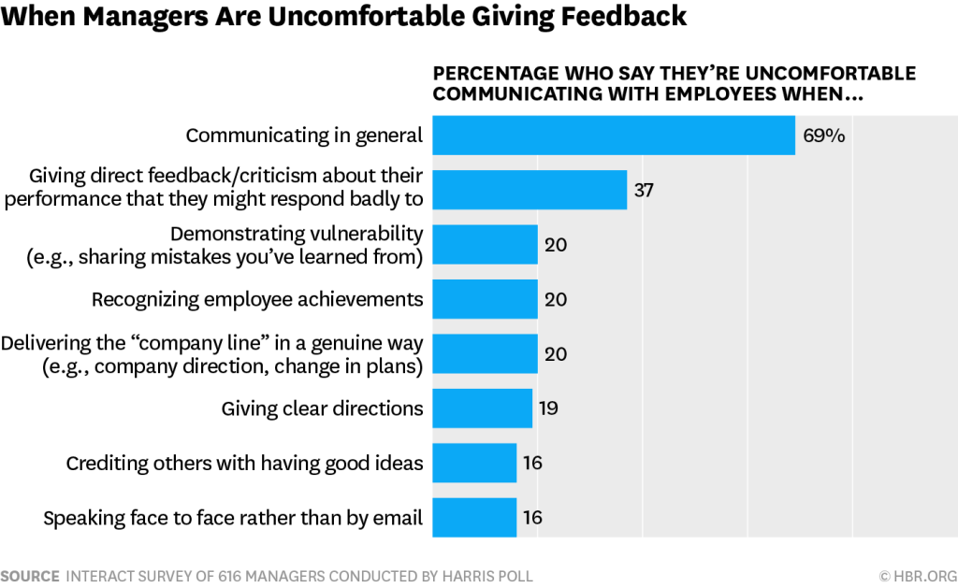

Performance appraisals when properly designed and implemented can be an evaluation of an employee’s performance that can accurately identify their skills and directs them towards increased productivity and professional growth. The lifeblood of a performance appraisal process is a consistently high-quality performance feedback. (Varma, et al.1999).
A study of employees at ‘Atlantis, the Palm hotel ‘(2019) has seen a healthy growth in employee engagement after developing focus groups within departments and urged managers to create SMART action plans with the participation of team members, this gives the employees and management specific goals. This has shown an 8% increase in an employees’ engagement in the last year. The data also revealed a growth of 25-35% in certain divisions ascertaining to customer service and knowledge due to ongoing training developments.
As the 21st century progresses, major changes are beginning to emerge in today's workplace. A growing awareness of inevitable demographics is increasing the desire for leaders everywhere to devote more attention and energy on retaining brilliant people and keeping them actively engaged in their job. New tactics are developing that go far beyond standard solutions and show great promise in the endeavour to retain and engage high-performing individuals. (De Smett et al, 2021)
An article in LinkedIn refers to a new trend of employees ‘quietly quitting’ which is a reference to do just the bare minimum of their job role rather than going ‘above and beyond’. The advice accompanying the article urged management to help employers go ‘above and beyond’ by engaging with their employees about their career paths, giving them the opportunity to progress. Whilst this may work in the short term, this advice really misses the point, if all employers did this it would lead to an unsuccessful business. One of the reasons suggested was the business model they are utilizing are expecting all their staff to go ‘above and beyond’ to ensure their success. The consequences of this way of managing staff is a short term fix for a long term Issue, if the organisation relies on its success by pushing employees to do more, this will result in ‘burn out’ and if this is company strategy the answer will be recruiting new employees, who will also end up being’ burnt out’, while it may be a strategy it is not a very humane one or the most effective as you will be constantly replacing them and training up new employees. Consequently, instead of thinking how you can get more out of your employees another outlook would be, what is the minimum they have been assigned and is it the right minimum. Leaders and management need to challenge the job role assigned and give the more important tasks and a more humane workload that takes away the trivial mundane tasks and concentrate on tasks that will make the business more successful, (Perez, 2022)
To conclude the performance method chosen by an organisation to support the goals and structure can help improve performance and provide growth opportunities across the organisation, when administered properly, performance appraisals can be a good evaluation of an employee’s performance, accurately identifying their skills and direct them towards increased productivity. It is also increasingly important for organisations to evaluate job roles to get the best of employees and not expecting to go ‘above and beyond’ resulting in ‘burn out’. It is easy for managers to forget that the people who work for the organisation have a large influence on how the organisation is seen by other hospitality organisations and customers, and therefore it is imperative that that they are done fairly and without bias.

2.Managing an individual’s expectations in respect of personal development.

Performance appraisals, also known as performance reviews or performance evaluations, are used by organisations to analyse an employee's performance and thank him or her for his or her valuable and committed contribution to the organization's success. Thus, the significance of performance evaluations may be characterised as the process of evaluating an employee's performance and personality in accordance with the organization's set of criteria such as versatility, quality of work, efficiency, collaboration, and teamwork. (CIPD.co.uk)
Employee learning is described as a continuous process that occurs to employees when they are working on specified tasks and responsibilities in their job descriptions and beyond (Gong et al.2009) To do any project successfully, one must get adequate knowledge of the appropriate duties required to carry out the actions required to complete the task. Knowledge is seen as a valued intangible asset within corporations. Learning companies are ones in which all employees frequently gain, develop, and exchange knowledge among themselves (Xander et al,2010). As a result, an employee's knowledge is one of the most important factors within the organisation.
It is therefore characterised that Hotel workers must be intelligent, have professional knowledge and abilities, and be able to manage their time well; yet, without drive, an employee will not grow in his or her career (Wong et al., 1999). Lee-Ross (1995) defined "internal work motivation," which is similar to intrinsic motivation in that the more effort put into the employment, the more driven people become.
While it is difficult to predict what skills will be relevant in 30 years, it is feasible to investigate patterns that have changed the demands of work and living in the recent past and continue to do so. The immersion of the Pandemic came as a big surprise to hospitality and the tourism industry, and the impact to employees which resulted in stress, depression and feeling isolated. (World Health Organisation ,2020)
Research found that the Pandemic (COVID 19) came as a detrimental factor that impacted the wellbeing of staff. Employee wellbeing in hospitality is of greater importance than in some other sectors as the experience of the customer depends on the positive state of employees (Karatepe, 2013). It also sheds light on the impact this has had on employees’ expectations. The pandemic caused isolation and fear to most employees in this sector, some if not all, discovered that a combination of life satisfaction and balance between work and home life received positive and negative effects (Ryan and Deci, 2001) By now understanding these factors managers are able to design practices that increase employee wellbeing (Teo et al,2019)
Wellbeing is a critical construct that organisations must consider, the importance of wellbeing is a necessary precondition for many. Reasons for this is the hotel sector faces particular difficulties with long unsociable hours, dealing with irate customers and sometimes abuse and violence , due to this demanding nature of the profession hospitality workers can become vulnerable if employers don’t seek to give support and have practises for engaging in conflict management together with skills to diffuse situations can give employees peace of mind in able to deal with conflict to the best of their ability .(Ariza-Montes et al.,2019)
Furthermore, these practises are essential since it is a necessary tool for hotels to treat their staff well to deliver a positive guest experience (ford et al, 2012). By using a welcoming culture to their staff and an all-inclusive atmosphere, it is argued that all employers should fulfil several psychological needs, including a humanistic approach (Maslow, 1943). These practises will increase psychological resources in the form of self-efficacy, optimism, hope, resilience, and psychological safety. (Agarwal and Farndale ,2017)
Empirical evidence was collected in a study by CRISIL research database, it examined nine hotels and approximately 4-5 employees from every hotel giving a total of 41 participants the objective of this study was to ascertain whether area management, housekeeping, business development and guest services and corporate social responsibility to ensure diversity as the pandemic might have had different outcomes pertaining to different areas of the hotel.

Wellbeing
Concentrating on the practices that hotels are using during and after covid-19 and the factors that impacted the wellbeing of hotel employees. Results showed, overall, 33 participants reported episodes of fearfulness, stress, frustration, aggression, anxiety, and periods of depression. As mentioned in literature ascertaining that wellbeing has several facets, therefore it is advisable to seek new elements to treat wellbeing instead of treating them as one. A graphical representation of wellbeing is represented below in Table 2.

Table 2. Wellbeing Tool
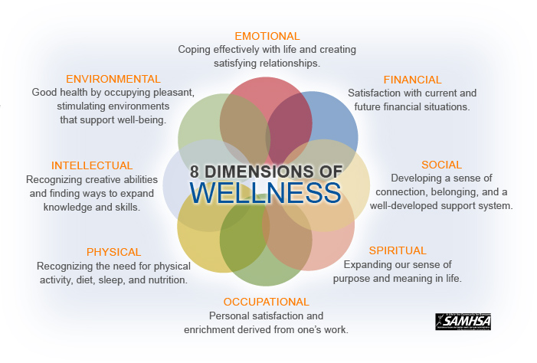

Communication
Employees where there was regular communication showed reduced anxiety, this gave the opportunity to be able to plan and balance work-life balance because of the clarity the communication provided added with positive relationships, authentic leadership, training, coaching and mentoring Employees positive emotional energy increased with the healthy and educational interactions with their managers. Knowledgeable workers experienced greater psychological security, optimism, and reduced dread. However, job insecurity while treated as a stressor, and can affect an employee’s wellbeing it might not impact their performance (Hu et al,2018)

To conclude, the study objective was to understand practises that managers use to manage their employees and its results show that the organisation and employees benefitted when practises went beyond the confines of work and into employees’ personal lives to improve job performance. it shows very distinctive theories that organisations must consider personal lives of employees when giving reviews of their work. furthermore, the results show that these polices concerning wellbeing and learning outcomes of employees it could in the short term be of expense to the company (Legge,2005) although it strongly supports the notion that it may collectively and positively impact both employees and managers in supporting the” mutual gain “perspective. Organizations should consider assisting employees in resolving personal conflicts to improve their performance, Family demands may also be the cause of lack of motivation and participation. It could be suggested that some organisations should allocate resources to helping employees manage their work-life balance, such as councillors who are able to help when the demands of life are too much.

3. Critically evaluate development vehicles available to hospitality appropriate to the development needs of the individual

There has been much debate in recent years whether traditional approaches to appraisals are fit for purpose. So, should businesses completely abandon them, or can they simply be updated to reflect modern business practises. (CIPD.co.uk.)
There are traditional and modern ways of performance assessment, according to Strauss and Sayles, (1977). The main difference between traditional and modern methods of performance appraisal is that traditional methods of appraisal are more work-oriented or goal-oriented and do not pay attention to employee's other strengths, whereas modern methods of performance appraisal focus on employee's personality traits such as creativity or leadership skills, employee learning and knowledge, therefore it is crucial for the service industry to look for strategies to boost employee performance .
ACAS (2016) ascertain that managing employees is a continous process . it ensures that employee performance contributes to the goals and objectives that are non negotiables , and managing a relationship bond between managers and employees which is a key variable to good communication , knowledge and learning outcomes to nurture trust and honest feedback.
Performance Management tools are a long term perspective that is consistent on improving employees performance. If conducted in the correct way and try understand why people are underperforming and adressing issues can increase retention of employees as can be seen in table 3

Table 3 : Performance Management

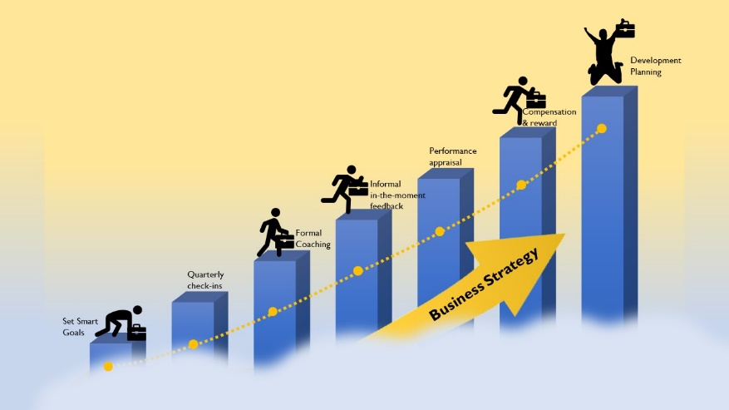
Management by Objective (MBO) is an appraisal that involves both the manager and employee working together to identify goals and new directions and career paths . (Drucker,2007)
Knowledge and education are essential for the growth of various sectors of the Hospitality industry (Waight,2005). To compete with rivals, service organisations are driven by competition and the pursuit of business growth to acquire new skills resources and competitive advantages. Hospitality relies on staff performance and productivity since these factors increase revenue. Thus, it is especially important to seek new ways to improve employee performance. Moreover, employee learning and knowledge is the basic core competency for service development. (Gutierrez-Gutierrez et al,2018)
The hospitality sector is service based where employees are crucial to achieving customer satisfaction as the sector evolves, it undergoes several transformations, including customer behaviour trends and their needs and demands for better services, therefore it is imperative that employees in the hospitality industry are aware and educated in these changes.
Herein, the relationships between learning and knowledge, benefits and performance development and career growth are crucial factors within the hospitality industry (Baeadarani,2017)
Employee learning is an ongoing process that takes place as they conduct their tasks and responsibilities listed in their job descriptions and beyond (Bezuijen et al,2010). Any task that must be completed successfully requires that the employee gains sufficient knowledge of the duties they are expected to perform. One of the most intangible assets in organisations is knowledge and organisations who become a learning environment is a place where every employee regularly creates, acquires, and shares knowledge with other team members (Senge,1991) therefore is a crucial element in developing their core abilities to meet objectives of the organisation.
Empirical research on employee knowledge sharing has shown that by using these learning techniques organisations have benefited and enhanced business innovation (Liao, 2006) Additionally they have provided an important dimension of learning practises where employees within the same organisation can learn from one another. The relationship between learning and employee motivation is crucial because when opportunities for staff decline workers lower their standards. (Lema and Agrusa,2009).
Numerous research studies have stressed the value of employee creativity (Dewett,2004) New knowledge and ideas can sometimes come through shared endeavours with the development of shared ideas. These shared ideas when transmitted back to management, they should be involved in encouraging and supporting their employee’s creativity and given the resources and incentives to do so.
Moreover, from the perspective of employee creativity and performance, it plays a significant part at an individual level and can also result in job fulfilment and personal development for each employee. Employee creativity and knowledge can also aid newcomers to an organisation in adjusting to their unfamiliar environment and focusing on organisational goals. (Janssen et al,2004).
Correlation between employee performance and satisfaction in the hotel industry states that employees should regard their long-term goal to be professional development and creating and maintaining a professional development plan is crucial to our career path. Weng (2014), acknowledged that an employee’s favourable outcome is long term career success, and an opportunity to fulfil their goals and gain career advancement, therefore it is anticipated that individuals with better levels of performance will have greater opportunities for career advancement. This together with a continuous feedback strategy will keep employees on the right path.
To conclude, the confluence of the issues we have investigated results in the shift in what modern workers demand from their jobs. In the simplest terms, people seek to get meaning from it, but meaning does not exist in the universe on its own; it is made - we make it. It is produced via human-to-human interaction, acknowledgment from others, and a sense of shared purpose.

4. A plan to meet the development needs of an individual and the management of performance.

Within the hospitality industry there are several Key performance objectives categorised within a specific job role, these will be measured during an appraisal. The hotel objectives have been designed to ensure an effective achievement of sales, customer services and financial performance
To achieve success and happiness in your career you should continuously improve your knowledge skills and behaviour. This is known as Personal Development plan, which is a continuous lifelong process. If you are making the most of your abilities and skills this will positively impact your life and others around you, learning new skills also improve your mental wellbeing as it gives a sense of purpose. Without a plan, it will make it difficult to focus and you are unlikely to meet your goals.
The Performance appraisal of Jason will be conducted by Tracie, a senior human resource manager within Atlantis, The Palm. Jason has been with the company for 18 months and has worked within the restaurant sector and has recently shown an interest in a customer facing role within the customer relations dept. I firstly Spoke to Jason 4 weeks ago when we organised his appraisal, this gave him enough time to think about his goals and what aspirations he had and would he want to further his career within the hotel.

Table 4. Personal Development Plan
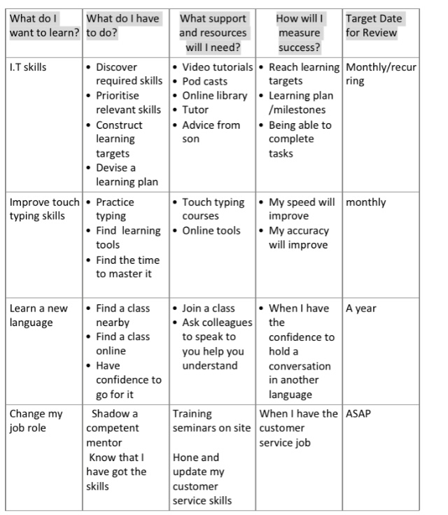

By personally using a Myers-Briggs type indicator (MBTI) which ensures an effective understanding of the relationships that exist among different personalities, this technique focuses on developing individuals as can be seen in Table 5, by observing Jason in his role of server within one of our restaurants, I could see he was an extrovert and was very friendly and had a very pleasant and composed demeanour.

Table 5 – MBTI Indicator

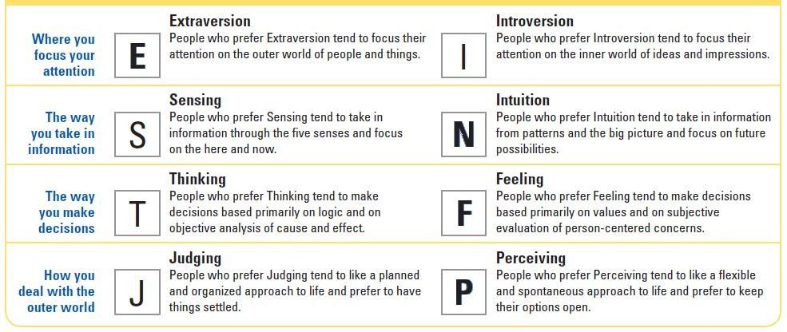

On the day of Jason appraisal, he turned up full of confidence that he had decided by using his personality and strengths he would in fact wish to train as front of house in reception. By working through and discussing his PDP it was apparent that for Jason to be able to do his job well, a swot analysis would be useful to focus on his strengths and weaknesses. As shown below in Table 6

Table 6. Personal SWOT Analysis Worksheet

Strengths  Patient, Empathetic, good communication skills,  Quick learner, Responsible, Professional | Weaknesses  Inadequate training for new job role  Lacking confidence with specific software tools
Opportunities  Training skills, job roles in another department or organisation | Threats  Competition for the job role  Future developments in technology affect job role

Once these were considered an employee performance management plan using the 4 F, s- Frequency, Focus, Feedback, and Future orientated model was put into place. (CIPD.co.uk) Frequency his staff assessments would now occur quarterly specifically for coaching and providing consistent training opportunities. Focused with myself and Jason clear on his performance expectations. Feedback, being consistent. Future-oriented, concentrating on both past and future performances to bridge the gaps in his professional goals with the ongoing process of identifying, measuring, and improving his overall skills, whilst also being consistent with the objectives of the hotel. These are tremendously beneficial for Jason, as they provide him with consistent feedback to assist him in his ambitions.

References

Acas. (2016). How to manage performance. Retrieved from https://www.acas.org.uk/index.aspx?articleid=2927.
Argarwaiu, P., Farndale, E., High Performance work systems and creativity implementation: the role of psychological capital and psychological safety, Retrieved from: https://doi.org/10.1111/1748-8583.12148.
Ariza-Montes, A., Hernandez-Perlines, H. Han, H. Law, R. (2019) Human dimension of the hospitality industry: Working conditions and psychological well-being among European servers. journal of Hospitality and Tourism Management Retrieved from: https://10.1016/j.jhtm.2019.10.013.
Baradarani, S. (2017) Service innovation in the hotel industry: culture, behaviour, performance. Services Industry Journal. Retrieved from: https://doi,org/10.1080/02642069.2017.1420172.
Bezuijen, X. M., Dam, K., Berg, P.T. Thierry, H. (2010) Hoe leaders stimulate employee learning: A leader-member exchange approach. Journal of Occupational and Organizational Psychology. https://doi.org?10.1348/096317909X468099.
Cherces, T. (2022) Quiet quitting: It’s the great resignation, Except They are Staying. Retrieved from: https://www. Linkedin.com.
Coetzer, A., Perry, M. (2008).” Factors influencing employee learning in small businesses” Education and Training, vol 50. Retrieved from: https://doi.org/10.1108/00400910810917037.
Dewett, T. (2014). “Employee creativity and the role of risk”. European Journal of innovative management. Retrieved from: https://doi.org/10.1rtuna108/14601060410565010.
Drucker, P., (2007). The Practice of Management. Routledge.
Ertuna, B., Yu, l., (2022) “A thread connects all beads” Aligning global CSR strategy by hotels MNCs. Retrieved from: https://doi.org/10.1016/j.tourman.2022.104520.
Ford, R.C., Sturman, M.C., Heaton, C.P. Managing Quality Service in Hospitality: How Organisations Achieve Excellence in the guest experience. Retrieved at: https://www.cengage.com.
Gjelsvik, M. (2002) Hotels as Learning Arenas. Scandinavian journal of hospitality and Tourism, https://DOI:10.1080/150222502760347527.
Gutierrez-Gutierrez, L.J., Barrales-Molina, V., Kaynak, H. (2018) The role of human resource-related quality management practices in new product development: A dynamic capability perspective. International Journal of operations & production management. Retrieved from: https://doi.org/10.1108/IJOPM-07-2016-0387
The Harris poll: Hard Data: Human Truths. Retrieved from: https://theharrispoll.com.
Huang, L.C., Ahlstrom, D., Lee, A.Y.P. Chen, S.Y., Hsieh, M.J. (2016) High performance work systems, employee wellbeing and job involvement: an empirical study ISSN:0048-3486
IANS,2020. Coronavirus impact: the impact of COVID-19 on the hospitality sector. Retrieved from: https://timesofindia.indiatimes.com/business/india-business/the=impact-of -covid-19-on-the-hospitality-sector/articles show/75290137.
Imran, M.K., LLyas, M., Aslam, U. and Fatima, T (2018).” Knowledge Processes and firm performance; the mediation effect of employee creativity”. Journal of Organizational Change Management. Retrieved from: Https://doi,org/10.1108/JOCM.
Janssen, O., Van de Vliert, E., West, M. (2004) The bright and dark sides of individual and group innovation: a special issue introduction. Journal of organisational behaviour. Retrieved From: https://doi.org/10.1002/job.242
Jiang, W. and Gu, Q. (2015), “A moderated mediation examination of proactive personality on employee creativity: A person-environment fir perspective “, journal of organisational change management. Retrieved from: https://doi.org/10/.1108/ JOCM-05-2014-0088.
Karatepe, O.M. (2013). High-performance work practices, work social support and their effects on job embeddedness and turnover intentions. International Journal of Contemporary Hospitality Management. Retrieved from: https://doi.org/10.1108/IJCHM-06-2012-0097.
Lancaster, S., Di Milia, L. (2014) “Organisational support for employee learning: An employee perspective “, European journal of training and development. Retrieved from: Https://doi.org/10.1108/EJTD-08-2013-0084.
Legge, K. (2005). Human Resource Management: Rhetoric’s and Realities. Bloomsbury Publishing.
Lema, J.D. (2009) Relationship of WWW usage and employee learning. International journal of Hospitality Management. Retrieved from: https://doi.org/10.1016/j.ijhm.2008.03.010.
Liao, L.F. (2006) A learning organization perspective on knowledge-sharing behaviour and firm innovation. Human System management.
Lock, S., (2022) Number of employees in the hospitality and leisure ndustryin the U.S. 2009-2021. Retrieved from: https://www.statitsta.com.
Maslow, A.H. (1968). Towards a Psychology of being. D Van Nostrand Company, New York.
Ottenbacher, M., Gnoth, J. (2005) How to Develop Successful Hospitality Innovation. Cornell Hotel and Restaurant Administration Quarterly. vol 46. Retrieved from: https:// doi:10.1177/0010880404271097
Ryan, R.M., Deci, E.L. (2001) On happiness and human potentials: A review of research on hedonic and eudemonic well-being. Retrieved from: https://DOI:10.1146.
Teo, S.T.T., Bentley, T., Nguyen, D., (2019) Psychosocial work environment, work engagement, and employee commitment: a moderated, mediation model. Retrieved From: https://doi.org/10.1016/j.ijhm.2019.102415.
Yang, J.T., Wan, C.S. (2003) Advancing organizational effectiveness and knowledge management implementation. Tourism management. https://doi.org/10.1016/J.Tourman.
Waight, C.L. (2005). Exploring connections between human resources development and creativity. Retrieved from: https://doi.org/10.1177/152342274524.23422305
Weng, Q., Mc Elroy, J.C., Morrow, P.C., Lui, R., (2014). The relationship between career growth and organisational commitment. journal of Vocational Behaviour. Retrieved From: https://doi.org/10.1016/j.jvb.2014.10.003.
World Health Organisations, (2020). Physical Mental Health Key to resilience during COVID-19 Pandemic. Retrieved from: https://www.euro.who.int/en/health-topics/health-emergencues/coronavirus-covid-19/stetments/statement/-physical-and-mental-health-key-to-resilience-during-covid-19-pandemic.

Appendix 1

Appendix 2

