Hotel standards, reputation management and service culture

Word Count: 1641
Module: Hospitality and Guest Services
Student Name: Alina Adriana Badea
Student ID: 2234830
Lecturer: Charlotte Joyner

Executive summary
The requirements of the hospitality sector in terms of hotel standards, reputation management procedures, and service culture are being examined in this paper. In order to guarantee visitor happiness, build a positive brand image, and ensure the long-term survival of hotels, the report emphasises the significance of these factors.
The evaluation of hotel standards shows how important they are for exceeding guests' expectations and guaranteeing a constant level of service quality. According to a 2020 study by J.D. Power, the study emphasises the value of cleanliness and effective communication. Hotels that uphold distinct and consistent standards also benefit from a competitive edge, bringing in more visitors and fostering favourable word-of-mouth. The study advises hotels to adjust their standards in accordance with the tastes of their target market, which may include business travellers, boomers, millennials, gen Zers, and event attendees. To establish uniformity, the AA star grading system is advised.
The study highlights the value of reputation management in the digital age, where social media and online reviews have a big impact on a hotel's reputation. For businesses to draw in clients, foster customer loyalty, and lessen the effects of unfavourable events, maintaining a positive reputation is crucial. The study advises hotels to actively manage their reputation by keeping an eye on online forums, reacting to reviews, and keeping lines of communication open. As an illustration, the success of Meliá Hotels in utilising social media for brand exposure and online engagement is highlighted. However, it is advised to respond to feedback on websites like Trustpilot more promptly.
A crucial element in providing great customer service and maintaining a competitive advantage is service culture. Proactive staff members that place the wants and expectations of the client first are indicative of a great service culture. According to the study, Meliá Hotels is an example of a company with a strong service culture that is backed by a customer-centric strategy, empowered personnel, diversity and inclusion, as well as innovation and adaptation.
The study concludes that upholding high standards, managing reputation well, and building a strong service culture are essential to a hotel's success. The paper suggests that hotels create thorough and precise standards, actively seek customer input, provide employees the authority to handle customer complaints, and foster a proactive and customer-focused culture in order to enhance operations.
The following recommendations are made in light of the findings:
- Establish precise, thorough standards that adhere to industry best practises and client expectations.
- Utilise numerous avenues to actively seek out and address client feedback in order to show your commitment to change.
- To improve visitor happiness and take responsibility of the customer experience, give employees the freedom to make decisions within predetermined boundaries.
- Focus on a guest-centric strategy, diversity and inclusion, creativity, and agility to foster a great service culture.
Hotels may improve their operations, satisfy consumer expectations, and guarantee long-term success in the cutthroat hospitality sector by putting these suggestions into practise.
Contents
Introduction 4
Hotel Standards 4
Reputation management 6
Service Culture 9
Conclusion 9
Recommendations 10
References 11

Introduction

This report's goal is to present a thorough examination of the hospitality industry's requirements for hotels, reputation management practises, and service culture. The significance of these three elements and how they interact will be discussed regarding assuring visitor happiness, establishing a positive brand image, and attaining long-term success. This paper seeks to offer useful insights and suggestions for hotels to improve their operations by analysing existing practises and market trends.

Hotel Standards

In order to maintain consistency, quality, and perfection in their operations, hotels adopt a set of rules, regulations, and procedures known as "hotel standards." These requirements encompass a wide range of topics, such as upkeep, amenities, safety, amenities, guest services, and overall guest experience. It is crucial to uphold good hotel standards for several reasons.
As described by Johnston, Clark and Shulver (2012, p. 14) when quoting Mr Ahmed Jihad, who at the time oversaw the luxury resort Baros in the Maldives, in order to ensure every one adheres to the high standards imposed by the business, employees are carefully given specific Standard Operating Procedures, that help create the desired standards.
First, guests today want extraordinary experiences during their stay as a result of greatly raised expectations. Higher guest satisfaction results from consistent adherence to hotel standards, which guarantee that visitors receive the anticipated level of service and comfort. According to a study done in 2020 by J.D. Power, the most important thing for guests when it comes to hotel standards are cleanliness and good communication (J.D. Power, 2020).
Second, accommodations that uphold clear, uniform standards have a competitive edge. These hotels can draw more guests, boost occupancy rates, and create positive word-of-mouth if they provide a greater guest experience (Williams, 2018).
When speaking about hotel standards, each hotel needs to consider who their target audience is, as each type of customer, will look for something different. As described in the Cvent Guest blog, business travellers might look for a stable internet connection, boomers will want to be treated as a VIP, millennials will look for personalised treatment, gen Zers will want to establish an emotional connection and event attendees will look for a way to integrate activities that are specific to the area or location of the hotel (Cvent Guest, 2021).
When considering hotel standards, the easiest way to ensure consistency is to check the hotel’s star rating by the AA. As such, each 5 star hotel should provide luxurious lodgings and public spaces, a variety of extra amenities and a multilingual service and its visitors are welcomed at the hotel lobby and have access to a high-quality wine list and food (The AA, 2023).
As an example of a hotel who manages to maintain high standards, Meliá Hotels is a well-known global hotel brand that has built a solid reputation for offering outstanding service and upholding high standards at all of its facilities. The standards on which they focus are:
- Accommodations: Meliá Hotels guarantees cosy, well-appointed guest rooms with cutting-edge conveniences and opulent features (Meliá Hotels International, 2023).
- Maintenance & Cleaning: To keep the highest standards of hygiene throughout all of its facilities, the chain follows strict maintenance and cleaning procedures.
- Dining and Culinary Excellence: Meliá Hotels offers a variety of eating experiences with a focus on outstanding cuisine, a selection of international and local cuisines, and a range of dining options to suit various guest preferences.
- Facilities and services: Meliá Hotels' extensive offering of facilities and services, which includes gyms, spas, swimming pools, business centres, and meeting rooms, guarantees that visitors have all they need for a pleasurable stay.
- Sustainability: Meliá Hotels is dedicated to sustainable practises. Through programmes like energy saving, trash management, and community involvement, it seeks to reduce its environmental impact.

Reputation management

Online reviews, social media, and other digital platforms have replaced word-of-mouth as the primary influence on a hotel's reputation in the modern day. To keep a good reputation and draw customers, reputation management must be done well. Reputation management entails keeping a close eye on and influencing how visitors and the general public view a hotel.
Reputation management is crucial for several reasons. First off, how prospective customers view a hotel is directly influenced by its reputation. Negative reviews and ratings can turn away potential consumers, while positive ones can draw in new ones.
Second, a hotel with a good reputation gains the patrons' respect and loyalty. Others' positive experiences boost confidence, which encourages repeat business and more referrals.
Finally, a well-managed reputation can aid in minimising the harm and upholding visitor trust in the event of a negative incident or crisis. A hotel that anticipates problems and maintains open communication is more likely to bounce back swiftly from setbacks.
According to Ashhan Unutur, there are 3 different identities a company needs to consider when thinking about their reputation: the one they have currently, the one they wish to have and finally, the image the external and internal stakeholder have on the company (Erdemir, 2018, p.152).
When it comes to Meliá Hotels, they seem to unfortunately lack in the reputation management area, and the best proof for this is the low score of 2.0 score on Trustpilot, but most importantly, the total lack of reply to any of the reviews left by the customer, be it good or bad (Trustpilot, 2023).
However, this is not the case when looking at their Facebook page, for example. In there they interact with their guests, respond to comments promptly and reach out to those making complaint. It tends to show that they place more value on the social media side of their reputation management (MELIÁ Hotels & Resorts, 2023).
According to Hootsuite, Meliá Hotels have managed to become one of the most powerful hotel chains on social media, and they did this by tailoring the guest experience at the hotel to increase brand loyalty, boosting online brand awareness and by raising the volume of quality traffic to their website (Hootsuite, 2023). By focusing on these 3 goals, they achieved the following:
- Had a growth in social media followers by 15% in 6 months
- Saw a raise of 16% in website traffic from European social media
- Managed to reach the top 10 most influential IBEX 35 companies on social media in 2018 (Hootsuite, 2023)
According to The Hotels Network blog, Meliá has incorporated social media as a fundamental part of their digital transformation because they recognise how crucial it is today for boosting traffic and direct bookings, as well as brand awareness. The business is able to modify its social media approach in accordance with changes in the digital consumer market, paving the way for continued success in the global travel sector (The Hotels Network, 2023).
With overall room occupancy across England on the rise again after the pandemic, as described by Visit Britain, business need to focus more and more on attracting customers and to ensure they keep themselves relevant and competitive. As it can be seen in the graph below, demand is getting higher, which automatically means, the offer needs to keep up as customers will be more and more selective, looking at the hotels who best manage their reputation.
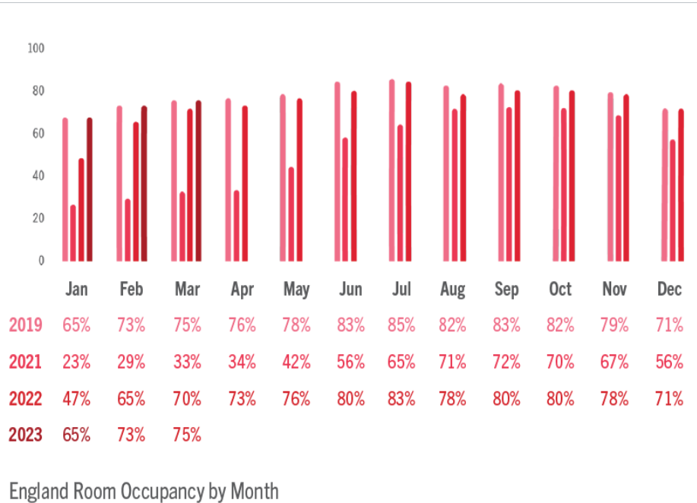
Visit Britain, 2023
With this in mind, looking at the hotel I chose in most of my examples, Meliá hotels are managing to keep their prices moderately high, banking on the recent boost in their image. This is seen in the below graph from Statista, showing the “aggregate revenue per available room of Meliá Hotels International worldwide in 2022, by region (in euros)” (Statista, 2023):
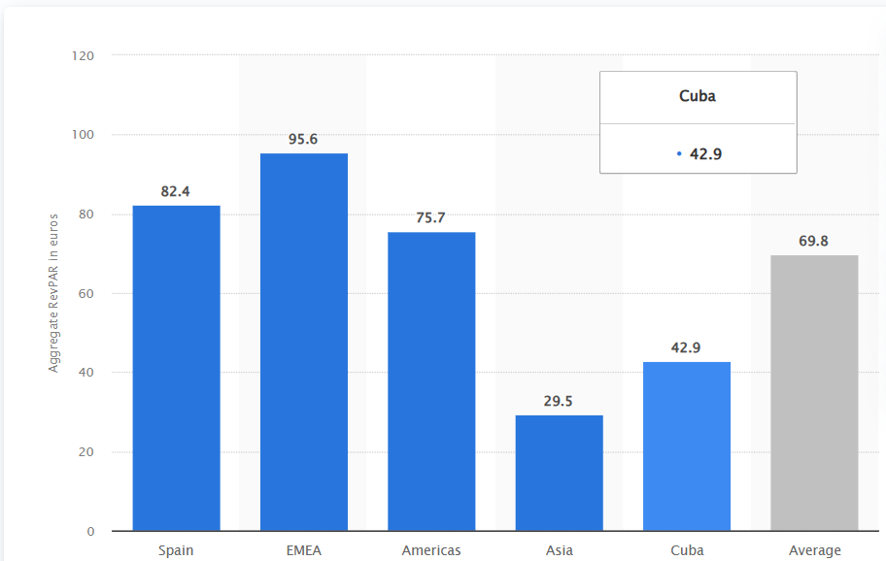
Statista, 2023

Service Culture

Exceptional guest service is prioritised by a hotel's service culture, which is the group of values, attitudes, and behaviours that make up that culture. Customer happiness, employee engagement, and sustaining a competitive advantage all depend on a strong service culture. As described by Elizabeth McLeod Lotardo and Lisa Earle McLeod, a good service culture requires the staff to be proactive and to view their role through the lens of their customer’s needs and expectations (McLeod and McLeod, 2018).
Because it guarantees that every visitor connection is unique, effective, and surpasses expectations, a service culture is crucial. As a result, there is an increase in customer satisfaction, loyalty, and good word of mouth.
Meliá Hotels has developed a strong service culture that permeates every aspect of its business. To quote the Food&Beverage Manager for Meliá White House Hotel: “Here we all share a passion for what we do, that feeling of having placed our mind and heart in agreement. At Meliá Hotels International I have found the place where I can be myself” (Meliá Hotels International, 2023). The following components support the chain's customer-centric culture:
- Guest-Centric Approach
- Empowered Staff
- Diversity and Inclusion
- Innovation and Adaptability

Conclusion

In conclusion, the success of any hotel depends on its service culture, standards, and reputation management. Maintaining high hotel standards makes sure that visitors get the standard of comfort and service. Reputation management done right influences customer perceptions, creates trust, and encourages loyalty. High-quality guest service is prioritised in a company with a strong service culture, which increases customer satisfaction and gives it a competitive edge.

Recommendations

Hotels should create detailed standards that are both clear and comprehensive for each operational area. The expectations of the public and industry best practises should be met by these criteria.
By actively seeking out customer input via surveys, comment cards, or online platforms, hotels may quickly identify issues and implement the necessary modifications. Responding to comments from visitors demonstrates that the hotel values their viewpoint and is dedicated to ongoing improvement.
A proactive and customer-focused culture is promoted by allowing employees to make decisions and address concerns with visitors within predetermined parameters. Employees should be pushed to go above and beyond expectations and take ownership of guest pleasure.

References

Cvent Guest (2021), What Guests Want from a Hotel: The Complete Guide [blog]. Available at: https://www.cvent.com/en/blog/hospitality/what-guests-want-from-hotel. (Accessed: 9th June 2023)
Erdemir, A. (2018), Reputation Management Techniques in Public Relations, Hershey: IGI Global, DOI: 10.4018/978-1-5225-3619-2.ch008.
Hootsuite (2023), Melia Hotels. Available at: https://www.hootsuite.com/en-gb/resources/melia-hotels. (Accessed: 12th June 2023)
J.D. Power (2020), 2020 North America Hotel Guest Satisfaction Index Nagsi Study. Available at: https://www.jdpower.com/business/press-releases/2020-north-america-hotel-guest-satisfaction-index-nagsi-study (Accessed: 9th June 2023)
Johnston, R., Clark, G. and Shulver, M. (2012), Service operations management: improving service delivery, 4th ed, Harlow: Pearson Education Limited
McLeod, E. and McLeod, L. (2018) What is a Culture of Service? [video]. Available at: What is a culture of service? (linkedin.com). (Accessed: 12th June 2023)
Meliá Hotels International (2023), Careers. Available at: https://www.meliahotelsinternational.com/en/careers. (Accessed: 10th June 2023)
Meliá Hotels International (2023), Our Company. About Us. Available at: https://www.meliahotelsinternational.com/en/our-company/about-us. (Accessed: 10th June 2023)
MELIÁ Hotels & Resorts (2023) [Facebook] 12 June. Available at: https://www.facebook.com/Melia.Hotels. (Accessed: 12th June 2023)
Statista (2023), Aggregate revenue per available room of Meliá Hotels International worldwide in 2022, by region. Available at: https://www.statista.com/statistics/776641/melia-hotels-international-revpar-by-region-in-the-world/ (Accessed: 12th June 2023)
The AA (2023), Hotel services. Ratings and Awards. Available at: https://www.theaa.com/hotel-services/ratings-and-awards. (Accessed: 9th June 2023)
The Hotels Network (2023), Meliá Hotels International: Uncovering the Formula to Social Media Success [blog], 20 August. Available at: https://blog.thehotelsnetwork.com/melia-social-media. (Accessed: 12th June 2023)
Trustpilot (2023), Review, Melia. Available at: https://uk.trustpilot.com/review/melia.com. (Accessed: 12th June)
Visit Britain (2023), Accommodation Occupancy: Latest results. Available at: https://www.visitbritain.org/accommodation-occupancy-latest-results. (Accessed: 12th June 2023)
Williams, B. (2018) ‘Wearing the Correct Uniform in Hospitality’, Alliance Online [blog], November. Available at: https://www.allianceonline.co.uk/blog/2018/11/wearing-the-correct-uniform-in-hospitality/. (Accessed: 12th June 2023)

