UNIVERSITY OF WALES TRINITY ST DAVID
BSc HEALTH AND SOCIAL CARE
MODULE: CHANGE MAKERS: CREATIVITY AND VALUE CREATION
MODULE TUTOR: DANIELLE DUNNE
MODULE CODE: BMHP5014
ASSIGNMENT: COMPONENT 2 WRITTEN REPORT
STUDENT NAME: NAUREEN HUSSAIN
STUDENT NUMBER: 2410266

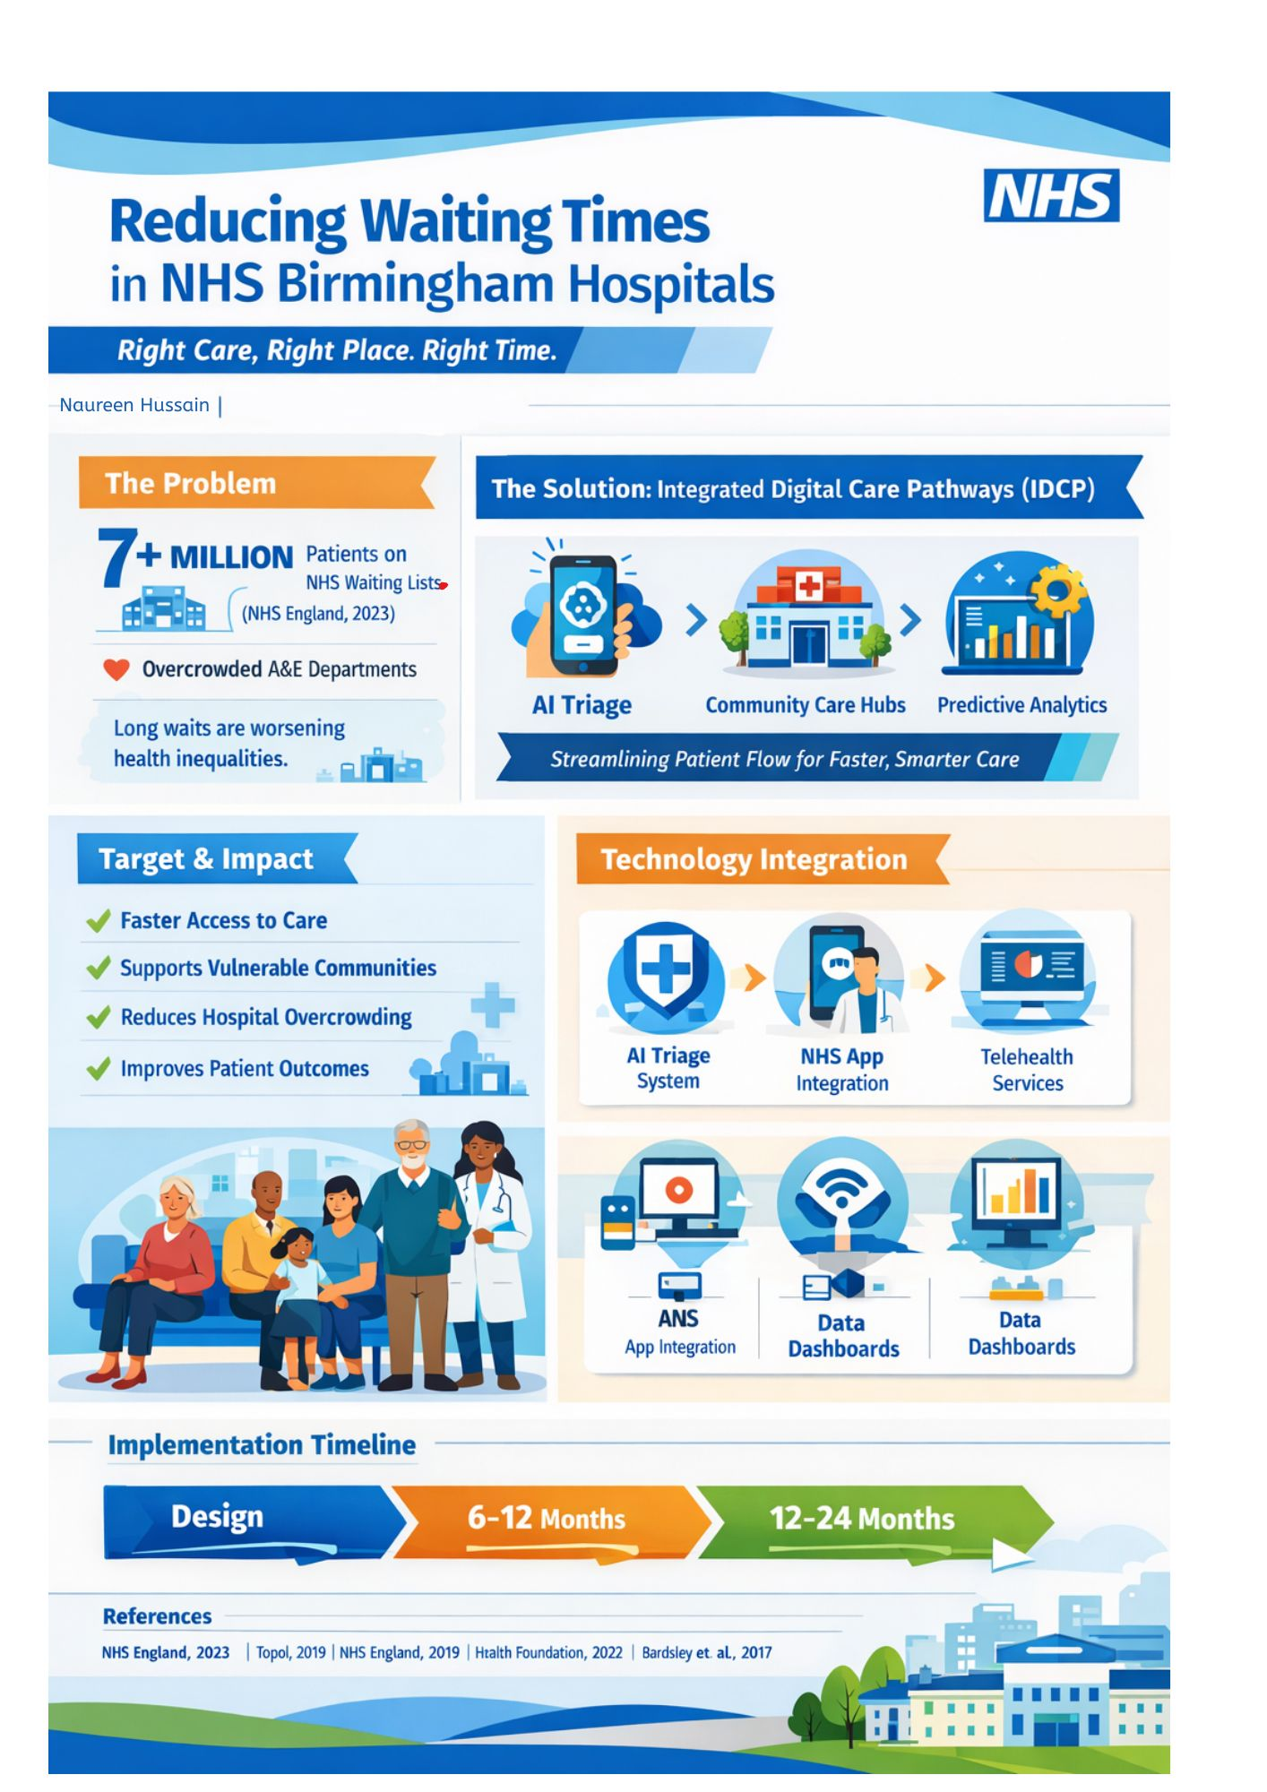

Reducing waiting times in NHS Birmingham Hospitals
I am suggesting an integrated, digitally enabled care pathway model to shorten wait times in Birmingham hospitals because I am extremely concerned about the mounting demands on NHS services. With more than 7 million patients waiting for care in England, waiting lists in the NHS have hit all-time highs (NHS England, 2023). These delays disproportionately impact vulnerable communities in Birmingham, one of the biggest and most diverse urban populations in the UK, aggravating health disparities. In order to improve patient flow, maximise resources, and eventually shorten wait times, my suggested innovation integrates digital triage, community-based care expansion, and predictive data systems.
The Innovation: Integrated Digital Care Pathways (IDCP)
The implementation of Integrated Digital Care Pathways (IDCP), a system that makes use of technology and community healthcare networks to guarantee that patients are seen by the appropriate professional at the appropriate time and location, forms the basis of my proposal.
AI-Powered Digital Triage Systems
Upon entering the system, patients—whether through self-referral, A&E, or GP referral—would first go through a digital triage procedure. Patients' symptoms and urgency levels are quickly evaluated using AI-supported tools, giving priority to those in critical need and rerouting non-urgent cases to alternative care pathways (Topol, 2019).
Hubs for Community Care
Conditions that could be treated outside of acute settings account for a sizable portion of hospital demand. We can cut down on needless hospital visits by bolstering community care centres, which are staffed by pharmacists, physiotherapists, and nurse practitioners. This is consistent with the NHS Long Term Plan's emphasis on bringing care closer to the patient's home (NHS England, 2019).
Capacity Management and Predictive Analytics
Hospitals can better allocate staff and resources and anticipate spikes in demand by using real-time data analytics. This entails enhancing discharge planning, minimising missed appointments (DNAs), and optimising theatre schedules (Health Foundation, 2022).
How It Operates in Real Life
In Birmingham, a patient with non-emergency symptoms would first contact NHS 111 or an online triage platform. Depending on their inputs, the system can either:
- Books them directly into a hospital appointment- if urgent
- Refer them to a local community hub
- Provide self-care guidance
Hospital administrators can make proactive staffing and scheduling decisions by using real-time dashboards that forecast patient inflow. This reduces bottlenecks and ensures smoother patient throughput.
Expected impact and relevance
The main causes of lengthy wait times—ineffective triage, overworked hospitals, and inadequate resource allocation—are directly addressed by this innovation. Research indicates that digital triage systems can cut down on needless GP and hospital visits by up to 20% (Bardsley et al., 2017). Furthermore, it has been demonstrated that community-based care lowers hospital admissions and increases patient satisfaction (The King's Fund, 2020).
This intervention's timing is crucial. The NHS urgently needs to implement creative solutions due to post-pandemic backlogs, labour shortages, and growing demand. Birmingham is a perfect pilot site because of its sizable population and established healthcare system.
Implementation plan
Phase 1: design (0-6 months)
- Consult with stakeholders, such as patients, GPs, and hospital trusts.
- Create a digital triage platform in collaboration with tech companies.
- Determine the locations of community care centres.
Phase 2: Pilot and testing (6–12 months)
- Pilot IDCP in a few Birmingham hospitals, such as Queen Elizabeth Hospital Birmingham
- Educate employees on new workflows and digital systems.
- Gather information about waiting times and patient outcomes.
Phase 3: Complete Rollout (12–24 months)
- Scale for every NHS Trust in Birmingham
- Connect with the NHS's current digital platforms (such as the NHS App).
- Constant observation and improvement
Timeline overview:
- Months 0–6: Planning & Design
- Months 6–12: Pilot Testing
- Months 12–24: Full Implementation
Key Stakeholders and Resources
- NHS Trust Leaders: Strategic oversight and funding allocation
- Integrated Care Boards (ICBs): Coordination across services
- Technology Partners: Development of AI and data systems
- Community Healthcare Providers: Delivery of local care services
- Patients and Advocacy Groups: Ensuring accessibility and trust
Resources required include funding for digital infrastructure, workforce training, and expansion of community facilities.
Regulatory Considerations
- Compliance with GDPR and NHS data governance policies
- Adherence to NICE guidelines for clinical decision-making
- Alignment with NHS Digital standards and interoperability frameworks
Value, feasibility and recommendations
This plan is in line with the NHS's current priorities, which include lowering health disparities, integrating care systems, and digital transformation (Department of Health and Social Care, 2022). IDCP provides better patient outcomes and cost savings by increasing patient flow and decreasing needless hospital demand.
Barriers and solutions
- Digital Exclusion: Some patients might not have access to digital resources.
Solution: Offer phone or in-person triage support as an alternate method of access
- Staff resistance: Workflow modifications may encounter opposition.
Solution: Early staff engagement, training, and benefit demonstration
- Initial Expenses: The initial outlay could be substantial.
Solution: Draw attention to potential government funding for innovation as well as long-term savings.
Future scaling
Once proven in Birmingham. This model can be scaled nationally, particularly in other high-demand urban areas. It can be changed for specific pathways such as mental health or chronic disease management.
Conclusion and call to action
The NHS is in a precarious situation. Patient outcomes will deteriorate and waiting times will continue to increase in the absence of daring innovation. By utilizing technology and community care, the Integrated Digital Care Pathway model provides a workable, evidence-based solution that revolutionizes the way patients navigate the system.
I implore policymakers and NHS executives to start testing this model in Birmingham right away. We can create a more effective, just, and sustainable NHS for the future by investing in smarter systems now.

References:
Bardsley, M., Steventon, A., Smith, J. and Dixon, J. (2017) Evaluating integrated and community-based care. London: The King’s Fund.
Department of Health and Social Care (2022) Health and Care Act 2022: policy framework. London: DHSC.
Health Foundation (2022) Using data analytics to improve hospital flow. London: The Health Foundation.
NHS England (2019) The NHS Long Term Plan. London: NHS England.
NHS England (2023) Consultant-led referral to treatment waiting times data. Available at: https://www.england.nhs.uk (Accessed: March 2026).
The King’s Fund (2020) Delivering community-based care: evidence and challenges. London: The King’s Fund.
Topol, E. (2019) The Topol Review: Preparing the healthcare workforce to deliver the digital future. London: NHS Health Education England

