
University of Wales Saint David
Wales Institute of Science & Art

Electronic Ignitions & Fuel Injection Systems
Module code: ACHA4010
Module: Electrical Control Systems

Name: Odysseas Androutsos
Student No: 2005263

April – 2022
Abstract
This report investigates the Abstract motronic engine managements system and the emotronic Bosch LE3 engine management system after the collection of live data. The objectives of this report are to compare the test results with the manufacturer’s values, identify any faults and recommend improvements to one of the EMS. The test results showed that the are some faults associated with both engines and some of these faults might need further investigation in order to be confirmed. Improvements to motronic engine management system were recommended and was concluded that any changes to the engine need to be confirmed by a dynamometer test.

Contents
1 Introduction 8
1.1 Objectives 8
2 Literature review 8
3 Test equipment, H & S and Test Procedure 10
3.1 Test Equipment 10
3.2 Health and Safety 11
3.3 Test Procedure 12
3.3.1 ECU Static Voltage Testing 12
4 Test Results and discussion 12
4.1 LE3 Engine Management System – Test results and discussion 13
4.1.1 Results from ECU Static Voltage Testing (LE3) 13
4.1.2 Results from Engine Components Testing (LE3) 14
4.2 Motronic EMS – Test results and discussion 25
5 Conclusions 40
6 References 42

List of figures
Figure 1 – Bosch LE3 Jetronic Fuel Injection System Components (‘Chapter 4 Part B: Fuel and exhaust systems-Bosch LE3 Jetronic injection Air cleaner’, no date) 6
Figure 2 – Motronic Engine Management System Components (Bosch, 2002) 7
Figure 3 – Engine Temperature Vs Resistance of the CTS 12
Figure 4 – Injectors ON time Vs Engine Temperature 12
Figure 5 - LE3 Primary Coil Circuit Wave Scope Pattern 14
Figure 6 - LE3 Spark Advance Signal and Primary Circuit Wave Patterns 15
Figure 7 – LE3 Secondary Coil Circuit Wave Scope Patern 16
Figure 8 - LE3 Crank Signal Wave Pattern 17
Figure 9 - LE3 Injector on Time (idle) 18
Figure 10 - LE3 Injector on Time (acceleration) 19
Figure 11 - LE3 Injetors on Time (deceleration) 20
Figure 12 - LE3 Hall Effect 21
Figure 13 - LE3 - 12V Supply and Earth Scope Wave Patterns 22
Figure 14 – Engine Temperature Vs Oxygen Sensor resistance 25
Figure 15 – Engine Temperature Vs Injectors On time 25
Figure 16 - Motronic Primary Wave form Pattern 28
Figure 17 - Motronic Secondary Wave Scope Pattern 29
Figure 18 – Monotronic Rotary Idle Valve Scope Pattern 29
Figure 19 - Motronic 12V Supply and Earth 30
Figure 20 - Motronic throttle Potesiometer (Pin 53) and air flow signal (Pin 7) 31
Figure 21 - Motronic Injector Banks 32
Figure 22 - Motronic Injection on Time Scope Pattern (idle) 33
Figure 23 - Motronic Injection on Time Scope Pattern (acceleration) 34
Figure 24 - Motronic Injection on Time Scope Pattern (deceleration) 35
Figure 25 - Motronic Lambda Sensor Pattern 36
Figure 26 - Motronic Crankshaft Sensor 37

List of Tables
Table 1– Static Voltage Results for LE3 Engine management System 10
Table 2 – Static Voltage Results for LE3 EMS Amplifier 11
Table 3 - Dynamic Testing Results for LE3 Engine Management System 11
Table 4 - Throttle Position Switch Resistance - Comparison 13
Table 5 - Fuel Injectors Resistance - Comparison 13
Table 6 - Aux Air Valve Resistance - Comparison 13
Table 7 - Static Voltage Results for Motronic Engine Management System 23
Table 8 - Dynamic Testing Results for Motronic EMS 24
Table 9 - Throttle Potensiometer Resistance -Comparison 26
Table 10 - Air Flow Sensor Resistance – Comparison 26
Table 11 - Injectors Resistance – Comparison 26
Table 12 - HT Leads Resistance – Comparison 27
Table 13 - Ignition Coil Resistance 27

Introduction
The ignition and the fueling systems of an engine are two of the important factors in the overall performance of the engine. This report is focusing in two engine management systems, Bosch LE 3 engine management system and motronic engine management system. Using live data which were obtained from testing these two management systems, an effort was made in achieving the following objectives.

1.1 Objectives
The objectives of this report are the following:
- Collect live data from a Bosch LE3 engine management system and a motronic engine management system.
- Compare the values which will obtained with the manufactures values and identify and possible faults.
- Recommend improvements to one of the engine management systems.

Literature review
“Jetronic” is a trademark for the engine management systems developed by Robert Bosch GmbH. He started in 1967 with the development of D-Jetronic (1967-1979), the K-Jetronic (1973-1994), the K- Jetronic (Lambda) the KE-Jetronic (1985-1993), the L-Jetronic (1974-1989) the LE-1, LE2 and LE-3 Jetronic (1981-1991) LU1, LU2, (1983-1991), LH-Jetronic (1982-1998) and mono-Jetronic (1988-1995) (Jetronic - Wikipedia, no date)
The reasons of having so many versions of the Jetronic technology is due to the development in this field and the new technologies developed through time that allow the improvement on existing technologies.
Since in this report the LE3 Jetronic management system and the motronic engine management systems will be investigated, focus will be given to the description of these systems.
Bosch LE3 Jetronic engine management system is an advancement of the L-Jetronic management system. “L” is the first letter of the German word “Luft” which means air. With this system the fuel pump, pumps the fuel through the fuel filter to the fuel injectors through the fuel pressure regulator. The ECU obtains signals from the temperature sensor, the speed and load sensor, the air flowmeter electronic control unit and the throttle switch. Based on this information and the algorithm that is stored in the ECU the necessary calculations are made and the ECU sends signal to the fuel injectors when to open for how long and also a signal to the ignition system when ignition to occur in the cylinders. This system does not control effectively fuel air mixture especially at high speeds but the existence of the supplementary air control valve helps in the cold start. Figure 1 shows a schematic of LE3 EMS.
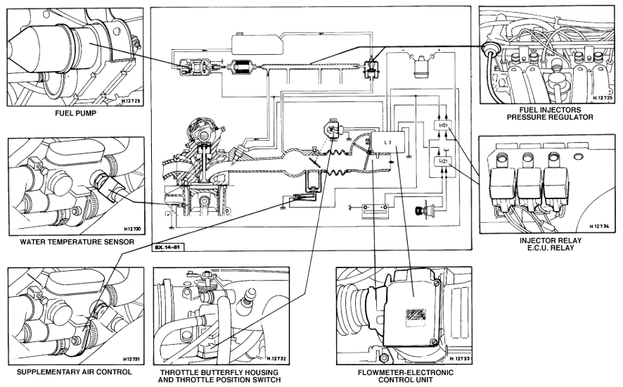
Figure 1 – Bosch LE3 Jetronic Fuel Injection System Components (‘Chapter 4 Part B: Fuel and exhaust systems-Bosch LE3 Jetronic injection Air cleaner’, no date)
The motronic engine management system was also developed by Robert Bosch GmbH and combines the fuel injection system and the ignition system in one unit. This system provides improved power performance to the engine, better fuel economy, less emissions and improved drivability. The input which is collected by ECU form the two Oxygen sensors before and after the primary catalytic converted, the temperature sensor, the speed sensor, the knock sensor, the throttle device, the hot-film air mass meter are processed with the algorithm that is in ECU and give accurate signals to the injectors, to the electronic throttle valve positioner, to the ignition coils and spark plugs with the aim to achieve the ideal air/fuel ratio by mass (14.7:1) under the various operating conditions. This results in better fuel economy and less emissions. (Bosch, 2007) A schematic diagram of the motronic engine management system with direct injection is shown in Figure 2.

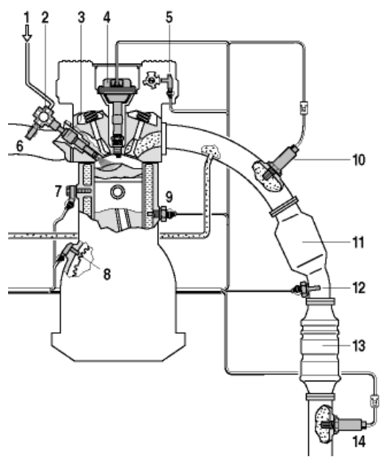
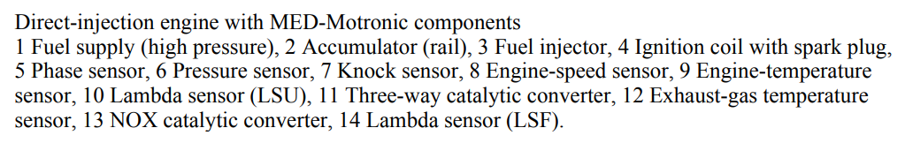
Figure 2 – Motronic Engine Management System Components (Bosch, 2002)

Test equipment, H & S and Test Procedure

3.1 Test Equipment
In order to achieve the objectives of this report the following equipment was necessary to be used:
- Vauxhall Engine Omega-A/Carlton 1.8 with LE-3 Engine management System
- Vauxhall Engine 2.0 Petrol Engine with Motronic Engine Mangement System
- A Multimeter to measure the voltage amperage and resistance. This is required in order to confirm that the circuits have the expected voltage amperage and resistance as the values set by the manufacturer of the engine management system. If this is not the case then this helps is identifying where the fault is.
- Oscilloscope to obtain the voltage patterns is respect to time at various locations of the engine management system circuits in order to identify if the patterns which will be obtained are the expected ones or if the patterns are not as expected. This signifies the location and the type of the fault.

3.2 Health and Safety
During the testing is circuits required to follow all the health and safety regulations associated with the work which will be carried out. Since the engines are in the university workshop, it is necessary before starting the engines to switch on the exhaust extraction system so that all the exhaust gasses from the engines to be removed from the workshop environment. It is also necessary to switch on the workshop ventilation system because heat will be generated from the engines and also air/oxygen will be used from the engines during combustion. That is why it has to be ensured that fresh air enters the workshop.
It is necessary to study the guidance’s related to the use of the multimeter and the oscilloscope in order to avoid injuries, electric shocks or damages to the instruments.
All students involved with the testing should wear overalls, in order to protect their cloths, goggles to protect their eyes from any oil of fuel spillages, safety shoes to protect their feet from any falling objects (like tool spare parts or testing equipment) and proper gloves to protect their hands from contact with oil or fuel.
Long hair, neck chains or long sleeve are not allowed as these might get catch in the rotating parts of the engine and might result in serious injuries. All must have in might that during testing should have their hands away from the rotating parts of the engine and from any deteriorated wire. That is why it is also recommended not to wear any rings during testing because in case of electric shock the ring might cause serious burns to the fingers.
All should be aware of the hot parts of the engine and the areas where there is high voltage.
As a last source of defence, it is necessary to have a fire extinguisher (powder type) in case of fire and a first aid kit in case of injury. These are necessary to provide the first aids to the injured person until the emergency services arrive. All should be aware that in case of emergency to call 112.

3.3 Test Procedure
Taking in to account at the above-mentioned H & S precaution the testing of the engines was carried out as it is described below:

3.3.1 ECU Static Voltage Testing
Having the ignition switch in the off position and using the multimeter with the black lead of the multimeter connected to the battery negative pole and the red lead to each individual pin of that was connected to the ECU the voltage at each pin was measured and recorded. Then the ignition switch was turned to the on position and the voltage reading at each pin was measure again and recorded.
    - Engine component Testing
During the warm up phase of the testing the following components where applicable were tested:
- Injection on time
- NTC2 Voltage and resistance values
- Rotary idle valve keying ratios
- Tank vent valve switching
- Lambda switching
- Engine Temperature
    - Resistance Testing Vs Factory Resistance
The resistance of the following components was measured where applicable.
- Throttle Potentiometer
- Air Flow Sensor
- Injectors
- HT Leads
- Ignition Coil
- Aux Air Control Valve
- Coolant Temperature Sensor
- Throttle switch
3.3.4 Oscilloscope Patterns
With the use of an oscilloscope the wave patterns of the some of the components
Described above were recorded. These are presented in the test results section below.

Test Results and discussion
Following the procedure that was described above the test results for the LE3 and the motronic management systems are presented and discussed below:

4.1 LE3 Engine Management System – Test results and discussion
In this section the results for the LE3 EMS are presented.

4.1.1 Results from ECU Static Voltage Testing (LE3)
The results for the ECU static voltage testing are shown in table 1 below. As it can be seen from table 1, when the ignition switch is the below off position the voltage on all the pins of the ECU is zero. These results are as expected and confirms that there are no deteriorated wires that might result in bypassing the ignition switch. Once the ignition switch was in the on position the voltage on Pin 2 and 12 was 12.11V & 12.15V respectively. This signifies the power straight from the battery goes to these pins as expected and the voltage of the battery is satisfactory since is above 12V. The voltage on the battery was measured separately and was found to be 12.27V. The slight drop that was observed in the values for pins 2 and 12 is due the voltage drops in the wires. The voltage to other pins is below 5V. These values are within the expected voltages to the sensors or actuators.
Table 1– Static Voltage Results for LE3 Engine management System
Pin Number | Components | Ignition off (V) | Ignition on (V)
1 | Ignition Control Module | 0 | 0.06
2 | Engine control relay | 0 | 12.11
3 | Injectors | 0 | 0
4 | Earth | 0 | 0.02
5 | Earth | 0 | 0.03
6 | Non in use | 0 | -
7 | Not in use | 0 | -
8 | Engine Coolant temperature sensor | 0 | 0.67
9 | Not in use | 0 | 0
10 | Ignition Control Module | 0 | 0.15
11 | Not in use | 0 | -
12 | Engine control relay | 0 | 12.15
13 | Not in use | 0 | -
14 | Throttle position | 0 | 4.98
15 | Throttle position | 0 | 0.02

Table 2 shows the static voltage results for the amplifier. The voltage reading on the pins of the amplifier, with the ignition on the ON and the OFF position are as expected.

Table 2 – Static Voltage Results for LE3 EMS Amplifier
Pin Number | Components | Ignition off (V) | Ignition on (V)
1 | From coil (-ve) | 0 | 12.02
2 | To Earth | 0 | 0.02
3 | From Coil (+ve) | 0 | 12.02
4 | From Pulse Generator | 0 | 0.13

4.1.2 Results from Engine Components Testing (LE3)
As it can be seen from table 3 and Figure 3 as the engine temperature rises the restance of the coolant temperature sensor drops. Almost all of the resistance values for the coolant temperature sensor do not fall within factory values. This might be due to the errors during the test or might be due to faulty engine temperature sensor. The engine temperature sensor needs to be tested again separately in order to confirm if is fauty or not. Faulty engine temperature sensor gives wrong signals to the EMS which this will result in a non-optimum engine operation.
The Voltage on the coolant temperature sensor drops as the engine temperature rises.
As it can be seen from table 3 and Figure 3 during cold start the temperature of the engine was 19.3 ºC. The engine temperature sensor sends a signal to EMS and the EMS sent a signal to the injectors so that their on time of the injectors to be longer (75.3ms). This results in a rich air/fuel mixture and enables the engine to start easier.
°C | CTS  (Ω)  Pin 8 | Factory Resistance  CTS (Ω) | NTC2  Pin 8  (V) | Injector  Pin 3  ( ms)
-10 |  | 7000-11600
20 | 1940 | 2100 - 2900 | 1.7 | 3.7
30 | 1018 |  | 1.2 | 3.1
40 | 762 |  | 0.9 | 3
50 | 500 |  | 0.7 | 2.7
80 | 375 | 270 - 390 | 0.5 | 2.6
19.3 | Cold Cranking |  |  | 75.3
Table 3 - Dynamic Testing Results for LE3 Engine Management System

Figure 3 – Engine Temperature Vs Resistance of the CTS

Figure 4 – Injectors ON time Vs Engine Temperature

Table 4 shows the Ms resistance of the throttle Position Switch in Ohms with the throttle in the close position between pins 2 &15 and pins 3 & 15. As it can be seen the tested value between pin 2 & 15 is slightly above the value specified by the manufacturer. This means that the throttle switch does not function as it was designed and needs to be changed otherwise this will affect the proper operation of the engine.

Table 4 - Throttle Position Switch Resistance - Comparison
Pins | Manufacturer  (Ohms) | Tested  (ohms)
2 & 15 (Throttle Closed) | 0 | 0.2
3 & 15 (Throttle closed) | Infinity | infinity

Table 5 shows the resistance of the fuel injectors. The resistance of all the fuel injectors is within the limits set by the manufacturer and they do not deviate more than 5 ohms from each other. This means that the fuel injectors performed satisfactorily.
Table 5 - Fuel Injectors Resistance - Comparison
Pins | Manufacturer  (ohms) | Tested  (ohms)
1 | 15-17 | 15.7
2 | 15-17 | 15.6
3 | 15-17 | 15.6
4 | 15-17 | 15.7

As it can be seen from Table 6 the resistance of the Aux Air Valve was found to be 45.6 ohms. This value is 4.5 ohms higher than the one stated by the manufacture. This might affect the cold start of the engine and therefore this valve needs to be replaced, if there are any issues with the cold start of the engine. The Aux Air valve is used to enable the cold start of the engine by providing additional air to the carburetor though a by-pass port across the throttle valve.
Table 6 - Aux Air Valve Resistance - Comparison
Pins | Manufacturer  (ohms) | Tested  (ohms)
Aux Air Valve | 40 | 45.7

Figure 5 shows the wave scope pattern of the primary ignition circuit. This is a typical wave pattern for the Primary circuit of the ignition coil. As it is shown in Figure 5 the primary coil is supplied with a voltage of 12.5V for a certain period of time then the voltage is interrupted suddenly for 5ms. This has a result the magnetic field to collapse and create a voltage of 175V in the primary circuit which drops down to about 40V in 1.5ms and them after some coil oscillations the primary circuit is supplied again with 12.5V. The wave pattern and the voltage values obtained, confirm the proper operation of the primary circuit of the coil.

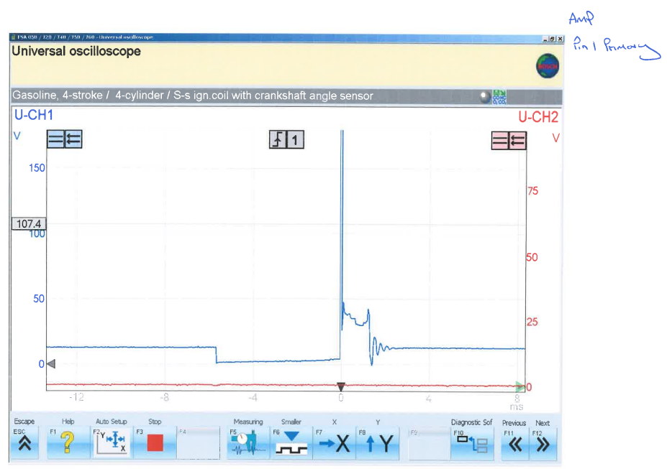
Figure 5 - LE3 Primary Coil Circuit Wave Scope Pattern

Figure 6 shows the wave patterns of the primary circuit of the ignition coil together with the wave pattern of the spark advance signal. This figure shows that the spark advance signal starts when primary the primary circuit of the coil is off and it last as long as the primary circuit of the coil is off. This signal initiates the spark to ignite just before the piston reaches the TDC during the compression cycle and prevents detonation. It also helps in achieving maximum power.(Advancing and retarding ignition timing | Spark advance and retardation, no date)

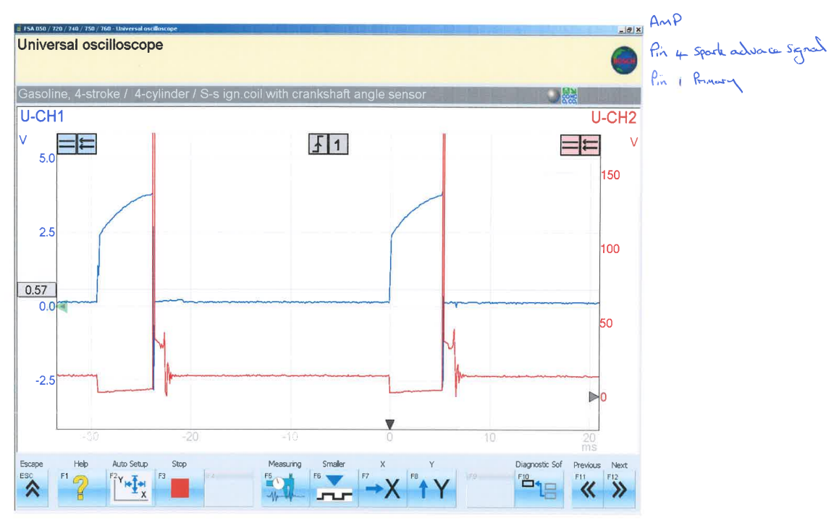
Figure 6 - LE3 Spark Advance Signal and Primary Circuit Wave Patterns

Figure 7 shows the wave pattern of the secondary ignition circuit of the coil. As is can be seen from figure 7 once the collapse of the magnetic field in the primary circuit of the coil occurs, a very high voltage of 11KV is created in the secondary circuit of the coil which drops down to 1.7KV for a short period of time and then to 0V. Then approximately 1KV negative voltage is created in the secondary circuit when primary circuit is supplied with power which gradually with some oscillations goes back to 0V. With the collapse of the magnetic field in the primary circuit this pattern is repeated again. The values obtained and the wave pattern of the secondary circuit of the coil confirms its proper operation.

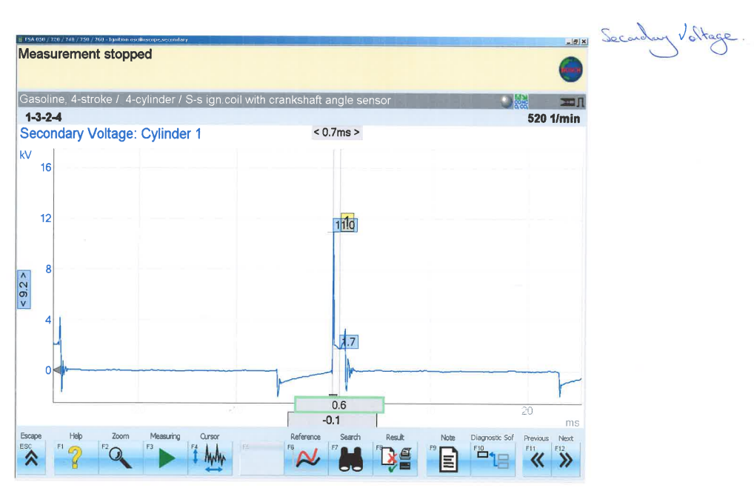
Figure 7 – LE3 Secondary Coil Circuit Wave Scope Pattern

Figure 8 shows the wave patten for the position of the crank shaft and this sign is send to spart advance control until in order to fire the advance spark at the right time.
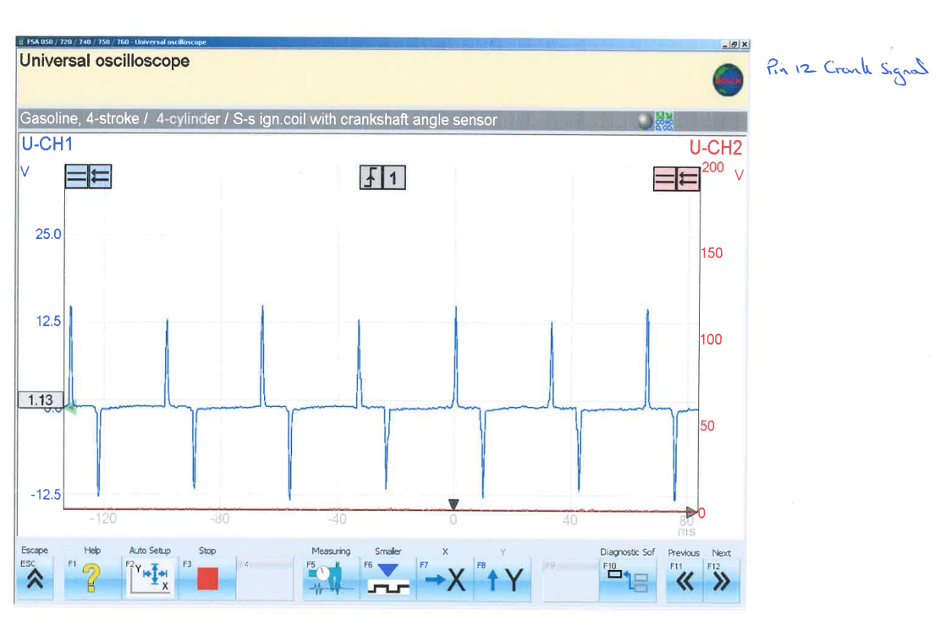
Figure 8 - LE3 Crank Signal Wave Pattern

Figure 9 shown the Injector on Time scope pattern during idle (pin 3) which represent the pulse to the fuel injector. The injector has a constant voltage of 12V when the valve of the injector is close and when the injector is grounded the voltage drop to 0V for 2.5ms. This is the time the injector injects fuel in the manifold. This means that during idle, the fuel which is injected in the manifold is just enough to keep the engine running efferently and the air/fuel mixture should be close to optimum. The voltage in the injector increases rabidly to the approximately 60V and then droops back to 12V. The rabid voltage occurs in order to close the injector faster and achieve more precise on time for the injectors.

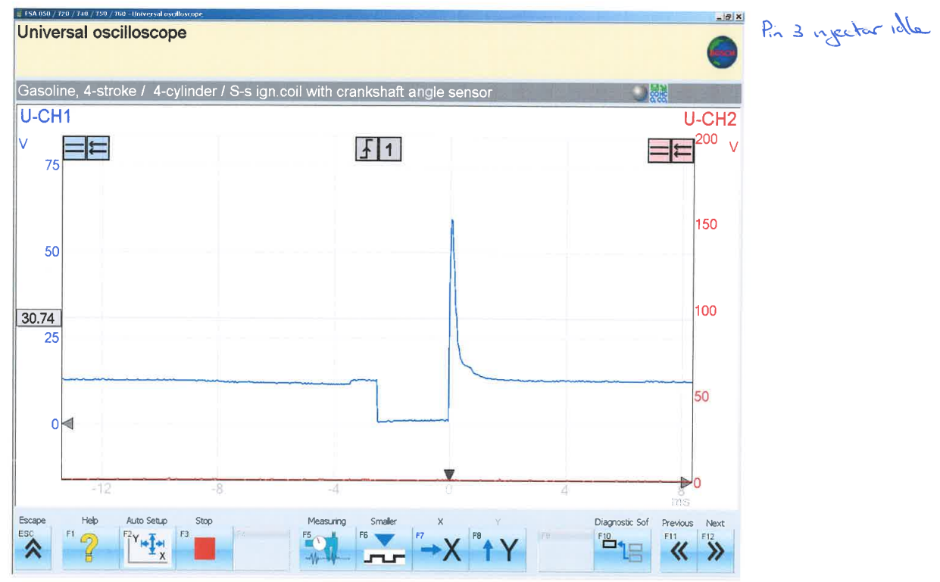
Figure 9 - LE3 Injector on Time (idle)

Figure 10 shown the Injector on Time scope pattern during acceleration. As it can be seen the injection has a constant voltage of 12V when the pin of the injection is close and then the injector is grounded the voltage goes to 0V for 7.2ms. This is the time the injection injects fuel in the manifold. This means that during acceleration the fuel which is injected in the manifold is more and this signifies that a rich air/fuel mixture occurs during acceleration. The voltage in the injector increases rabidly to the approximately 70V and then droops back to 12V.

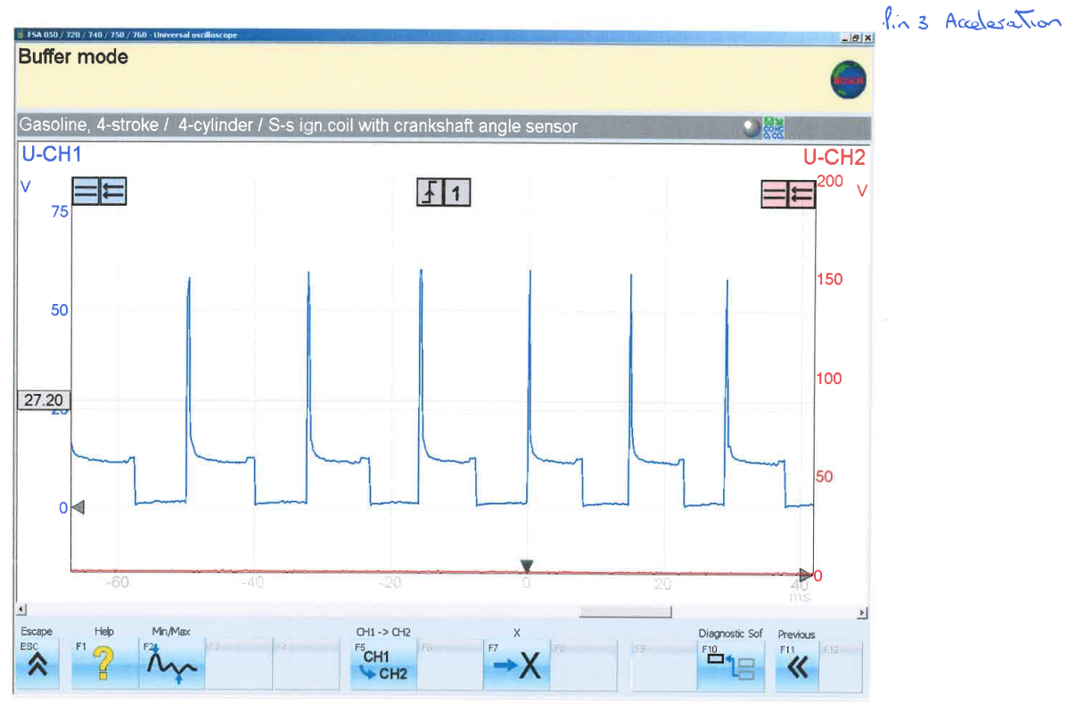
Figure 10 - LE3 Injector on Time (acceleration)

Figure 11 shown the Injector on Time scope pattern during deceleration. As it can be seen the injection has a constant voltage of 12V when the valve of the injection is close and then the injector is grounded the voltage goes to 0V. As the engine decelerates the on time of the injectors drop from 3.2ms to 1.9ms. This is the time the injection injects fuel in the manifold. This means that during deceleration the fuel which is injected in the manifold and this signifies that a lean air/fuel mixture occurs during deceleration. The voltage in the injector increases rabidly to the approximately 70V and then droops back to 12V.

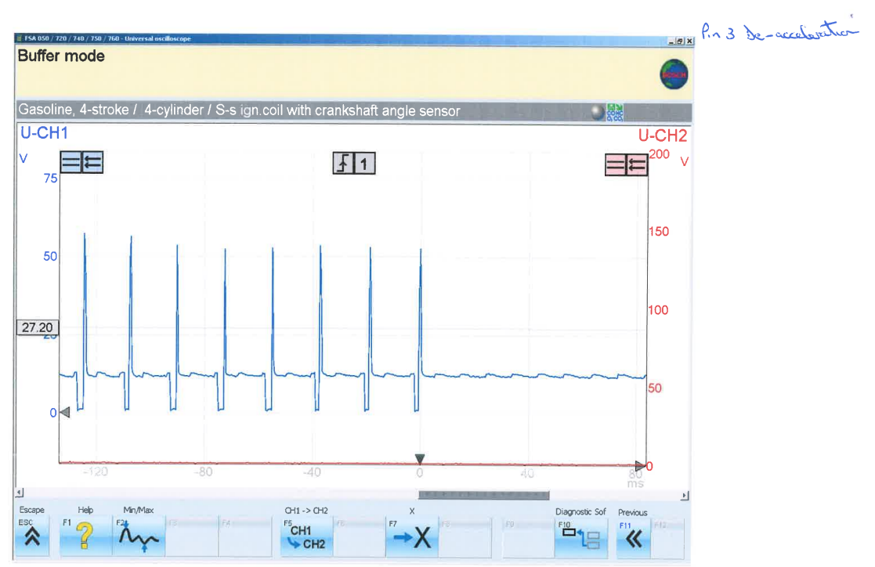
Figure 11 - LE3 Injectors on Time (deceleration)

Figure 12 shows the wave pattern of Hall switch which gives a signal to the ignition module and triggers the primary circuit of the coil. (Bosch, 2002)

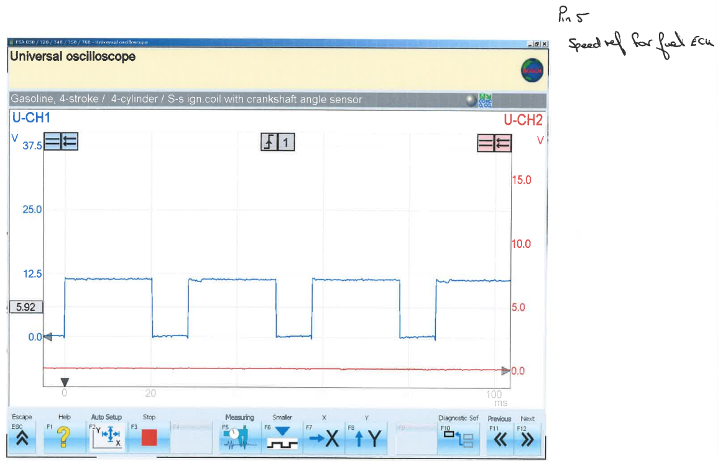
Figure 12 - LE3 Hall Effect

Figure 13 Shows the scope pattern on the voltage for the power supply (Pin 3) and the Earth return (Pin 2). As it can be seen from this Figure the power supply is 12.25V but when the coil draws power, it drops to 11V and then goes back to 12.25V after an instantaneous sight increase of the voltage. From this pattern it can be concluded that the battery is healthy. The pattern of the Earth return from the coil is mirror to the pattern of the supply to the coil. The ignition voltage is almost 0V and when the coil draws power rises to 0.7V after an instantaneous voltage drop of approximate -0.6V.

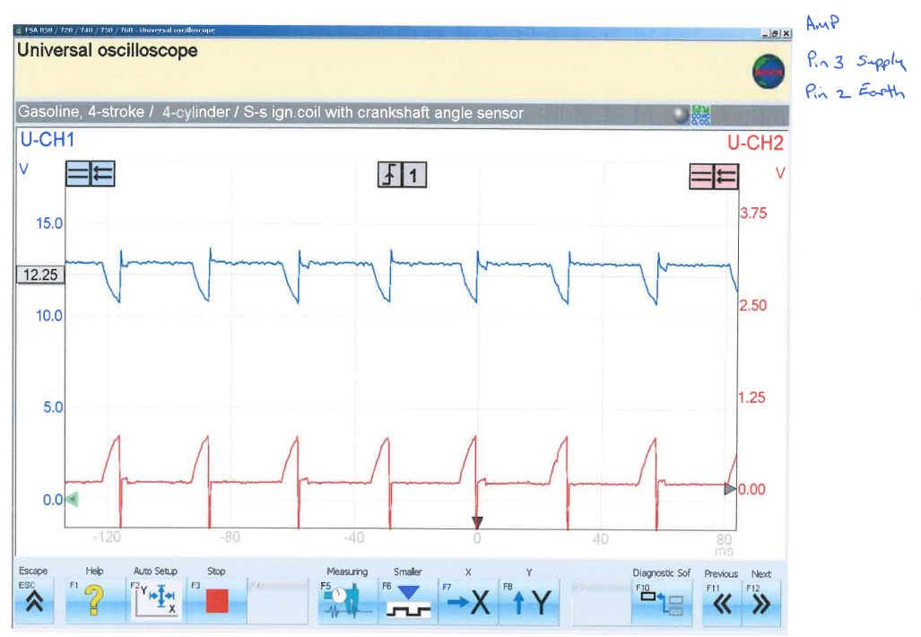
Figure 13 - LE3 - 12V Supply and Earth Scope Wave Patterns

4.2 Motronic EMS – Test results and discussion
The test results for the motronic engine management system are presented and discussed in the following sections.
    - Results from ECU Static Voltage Testing (Motronic)
The results for the ECU static voltage testing are shown in table 7 below. As it can be seen from this table, when the ignition switch is in the off position the voltage on the pins 18 and 36 is 12.38V and 12.06V respectively. In all the other pins the readings are zero. This is normal because power should by on for the memory and the other auxiliary car functions that are controlled by ECU. Once the ignition switch is in the on position the voltage on Pin 1, 3, 5, 16, 17, 18, 27 and 37 are above 12V. This is normal because power is required to these circuits which it comes straight from the battery. In pins 4, 6, 13, 32, and 55 is 9.74V, 11.33V, 10.11V, 11.3V and 10.9V respectively and this is because of the voltage drop that occurs when the current is passing through long wire or other resistances. The voltage on the other pins is lower than 5V which are within the expected voltages to the sensors or actuators. Some pin Nos are not shown on the table below because these pins are unused pins and have not been included in the table for clarity reasons.

Table 7 - Static Voltage Results for Motronic Engine Management System
Pin Number | Components | Ignition off (V) | Ignition on (V)
1 | Negative side of coil | 0 | 12.2
2 | Earth | 0 | 0.03
3 | Control circuit for fuel pump | 0 | 12.06
4 | Pulsed side of Rotary Idle Valve | 0 | 9.74
5 | Pulsed side of Tank Vent Valve | 0 | 12.03
6 | 4WD ECU - A/T ECU -Fuel tell-tale lamp | 0 | 11.33
7 | Load signal output from air-flow meter | 0 | 0.31
10 | Earth | 0 | 0
12 | 5V Supply to air-flow meter & throttle potentiometer | 0 | 5.05
13 | Diagnostic socket supply | 0 | 10.11
14 | Earth | 0 | 0.02
16 | Pulsed side of Injectors (1) | 0 | 12.03
17 | Pulsed side of Injectors (2) | 0 | 12.02
18 | Permanent live (memory) | 12.38 | 12.01
19 | Earth | 0 | 0.03
22 | Engine tell-tale warning light | 0 | 0.93
24 | Earth | 0 | 0.03
26 | Earth | 0 | 0.06
27 | Ignition feed | 0 | 12.15
28 | Output from Lambda Sensor | 0 | 0.45
32 | Output to on board computer | 0 | 11.3
36 | Control circuit for supply to auxiliaries and ECU | 12.06 | 0.3
37 | Supply to ECU and on-board computer | 0 | 12.03
40 | Air Con | 0 | 0.06
41 | Air Con | 0 | 0.06
42 | Earth for manual transmission | 0 | 0.02
44 | Output from NTC 1 | 0 | 3.76
45 | Output from NTC 2 | 0 | 3.73
46 | Octane Plug input | 0 | 5.05
48 | Output from crankshaft sensor | 0 | 0.06
49 | Output from crankshaft sensor | 0 | 0.09
53 | Output from throttle potentiometer | 0 | 0.62
55 | Earth for diagnostic socket | 0 | 10.9

    - Results from Engine Component Testing (Motronic)
Table 8 shows the resistance values of the engine temperature sensor (NTC2) and is compared with the factory values, the voltage on the NTC2 and NTC1 sensors as the engine temperature rises, the timing of the injectors, the percentage the rotary idle is on, the lambda sensor if is on or off and the tank vent if is on or off.

As it can be seen from table 8 and Figure 14 as the engine temperature rises the resistance of the engine temperature sensor drops. Some of the resistance values for the engine temperature sensor though do not fall within factory values. This might be due to the errors during the test or might be due to faulty engine temperature sensor. The engine temperature sensor needs to be tested again separately in order to confirm is faulty or not. Faulty engine temperature sensor gives wrong signals to the EMS which this will result non optimum engine operation.
The Voltage on the NTC2 sensor drops as the engine temperature rises. The voltage of the air intake sensor NTC1 drops slightly and this signifies that the air intake temperature was not affected much from the engine temperature. The ON time of the rotary idle valve start with 48% during cold start and drops to about 45% as the engine temperature increases. As with other actuator this is controlled by EMU after getting signals from the other sensors.

Table 8 - Dynamic Testing Results for Motronic EMS
°C | NTC2  (Ω) | Factory Resistance  NTC (Ω) | NTC2  (V) | NTC1  (V) | Injector  (ms) | Rotary idle  % on | Lambda | Tank Vent
20 | 2587 | 2200 to 2800 | 3.7 | 3.76 | 4.6 | 48 | off | off
30 | 1890 |  | 3.1 |  | 3.5 | 46 | on | off
40 | 717 | 1000 to 1400 | 2.1 |  | 2.9 | 45 | on | off
50 | 454 |  | 1.6 |  | 2.5 | 45 | on | on
60 | 327 |  | 1.3 |  | 2.5 | 44 | on | on
70 | 356 |  | 1.4 |  | 2.7 | 45 | on | on
80 | 256 | 270 to 360 | 1 | 3.3 | 2.3 | 43 | on | on
17.8 | Cold Cranking |  |  |  | 20

Figure 14 – Engine Temperature Vs Oxygen Sensor resistance

As it can be seen from table 8 and Figure 15 during cold start the temperature of the engine was 17.8 ºC. The engine temperature sensor sent a signal to EMS and the EMS sent a signal to the injectors so that their on time to be longer (20ms) this result in a rich air/fuel mixture and enables the engine to start easier. The lambda sensor and the tank vent sensor stayed off until a temperature of 30 ºC and 50 ºC was reached respectively. From this is can be concluded that the EWC does not get any signals from these sensors until these above temperatures are reached. EMU receives signals for the various engine sensors and sends signals to the actuators so that optimum air/fuel mixture to be achieved which this will result in fuel economy and in lesser emissions.

Figure 15 – Engine Temperature Vs Injectors On time
    - Results from Resistance Testing of various sensor (Motronic)
Table 9 shows the which resistance of the throttle in Ohms with the throttle in open and close position as it can be seen the tested values are above the range specified by the manufacturer. This means that the throttle does not function as it was designed and needs to be changed otherwise this will affect the proper operation of the engine.

Table 9 - Throttle Potentiometer Resistance -Comparison
Throttle Position | Manufacturer | Tested
Throttle Closed | 1900 to 2000 | 2107
Throttle Open | 1000 to 2000 | 2702

Table 10 shows the resistance in Ohms between the pins 4 and 2 and 4 and 3. As it can be observed from this table the resistance of the air flow sensor between pins 4 and 2 are within the range specified by the manufacturer but the resistance between pin 4 and 3 is out of the range specified by the manufacture. Pin 3 is the pin to the control circuit of the fuel pump. Since this resistance is outside the range this means that the fuel pump is faulty.
Pins | Manufacturer  (ohms) | Tested  (ohms)
4 & 2 | 8 to 2500 | 35
4 & 3 | 300 to 550 | 566
4 & 1 | 270 to 520 | N/A
Table 10 - Air Flow Sensor Resistance – Comparison

Table 11 shows the resistance of the fuel injectors. All of the fuel injectors are within the limits set by the manufacturer and they do not deviate more than 5 ohms from each other. This means that the fuel injectors performed satisfactorily.
Table 11 - Injectors Resistance – Comparison
Pins | Manufacturer  (ohms) | Tested  (ohms)
Injector 1 | 15 - 17 | 16.3
Injector 2 | 15 - 17 | 16.1
Injector 3 | 15 - 17 | 16.3
Injector 4 | 15 - 17 | 16.1

Table 11 shows the resistance of the leads deviate from each other and the king and their value is much higher than the recommended one which 6000 Ohms lead is faulty. The value of the resistance of the HT leads should have be 6000 Ohms (Why do HT leads have high resistance?, no date) It is recommended the HT leads and the king lead to be replaced.

Table 12 - HT Leads Resistance – Comparison
Lead Number | Resistance  (ohms)
1 | 19600
2 | 18440
3 | 14950
4 | 21300
King lead | Faulty

Table 13 shows the resistance of the primary and the secondary circuits of the ignition coil. The resistance of the primary circuit is 0.8 which is within the recommended range of 0.4 to 2 ohms. (Why do HT leads have high resistance?, no date) The resistance of the secondary ignition was found to be 7450 ohms which is within the acceptable limits. (What is a secondary ignition coil?, no date)
Table 13 - Ignition Coil Resistance
Coil | Resistance
Primary | 0.8
Secondary | 7450

    - Oscilloscope Patterns Obtained for Motronic EMS
Figure 16 shows the wave scope pattern of the primary ignition circuit. This is a typical wave pattern for the Primary circuit of the ignition coil. As it is shown in Figure 16 the primary coil is supply with a voltage of 13.3V for a certain period of time than the voltage is interrupted suddenly for 6.29ms. This has a result the magnetic field to collapse and create a voltage of 129.2V in the primary circuit which drops down to about 40V in 1.49ms and them after some coil oscillations the primary circuit is supplied again with 13.3V. The wave pattern and the voltage values obtained confirm the proper operation of the primary circuit of the coil.
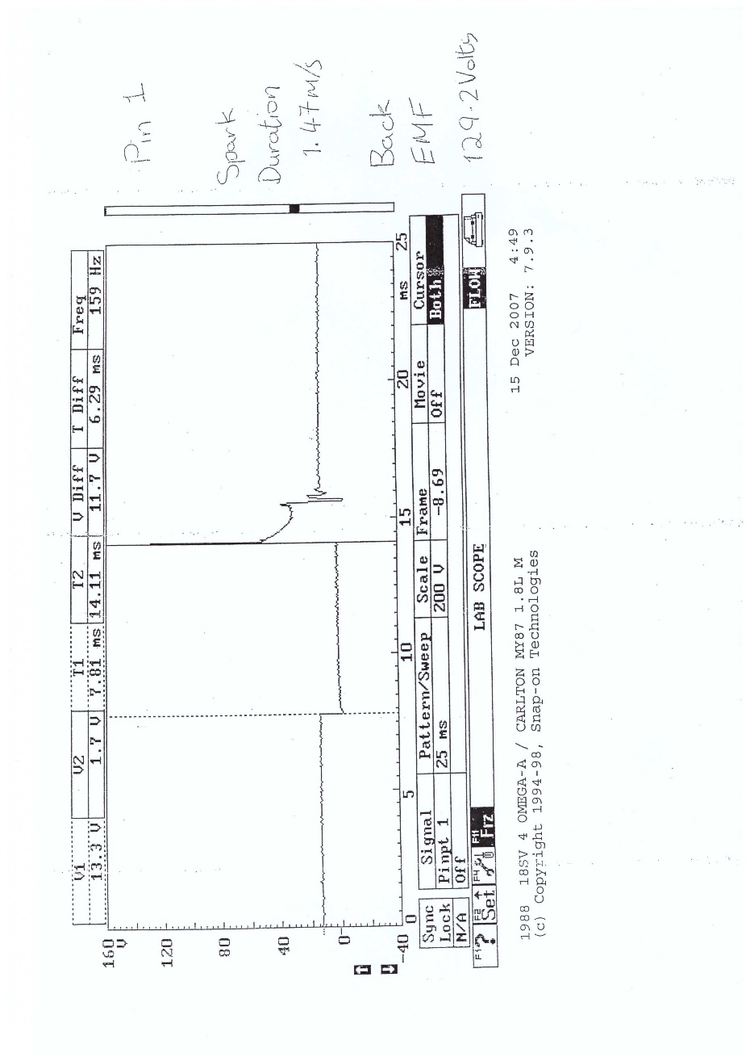
Figure 16 - Motronic Primary Wave Scope Pattern

Figure 17 shows the wave pattern of the secondary ignition circuit of the coil. As is can be seen from figure 17 once the collapse of the magnetic field in the primary circuit of the coil occurs a very high voltage of 6.63KV is created in the secondary circuit of the coil which drops down to 1.69KV for a short period of time and then to 0V. Then approximately 1KV negative voltage is created in the secondary circuit when primary circuit is supplied with power which gradually with some oscillations goes back to 0V. With the collapse of the magnetic field in the primary circuit this pattern is repeated again. The values obtained and the wave pattern of the secondary circuit of the coil confirms its proper operation.

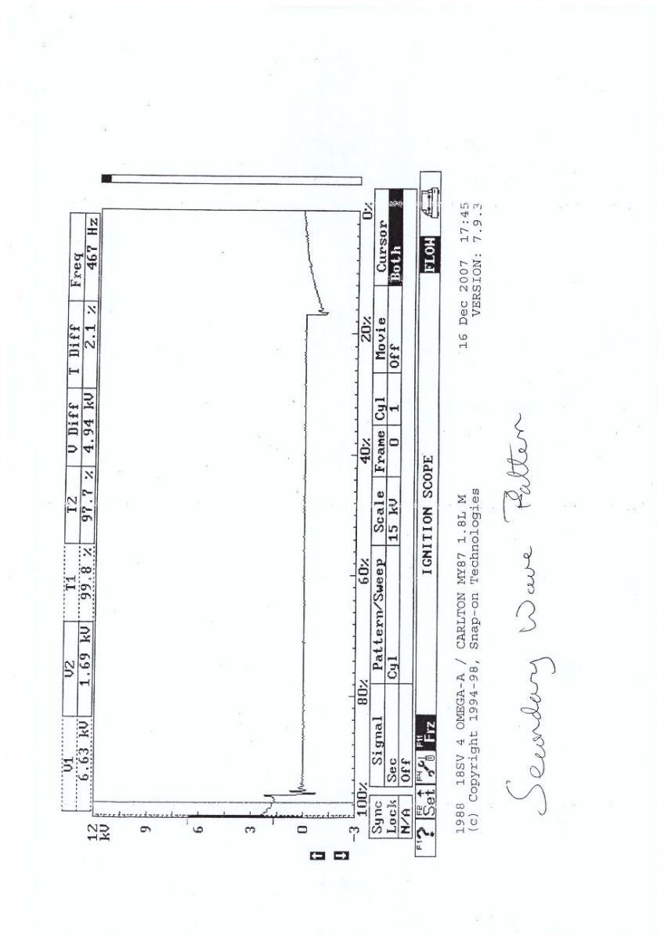
Figure 17 - Motronic Secondary Wave Scope Pattern
Figure shows the scope pattern of the rotary idle control valve at idle speed when the temperature of the engine is at 80 ºC. This pattern signifies the type of the idle control valve. According to this figure the idle control valve on time at 80 ºC is about 45%.
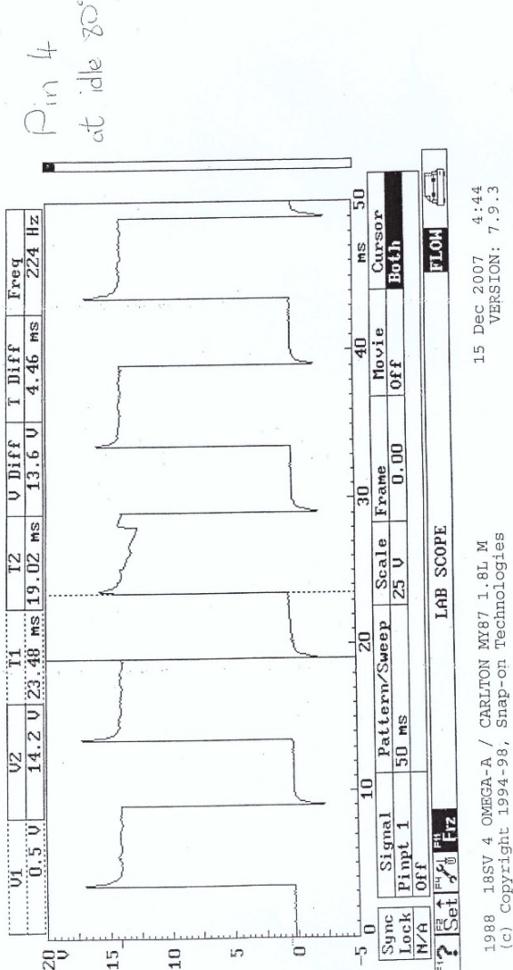
Figure 18 – Motronic Rotary Idle Valve Scope Pattern
Figure 19 shows the scope pattern of the voltage for the supply to the ignition (Pin 27) and to the Earth return (Pin 2). As it can be seen from this Figure the power supply is 13.6V but when the ignition is on it drops to 12.3V and then goes back 13.6V. This signifies that the battery is healthy. The pattern of the Earth return from the ignition is mirror to the pattern of the supply to the ignition. The ignition voltage is 0.02V and when the ignition is on rises to 0.24V.

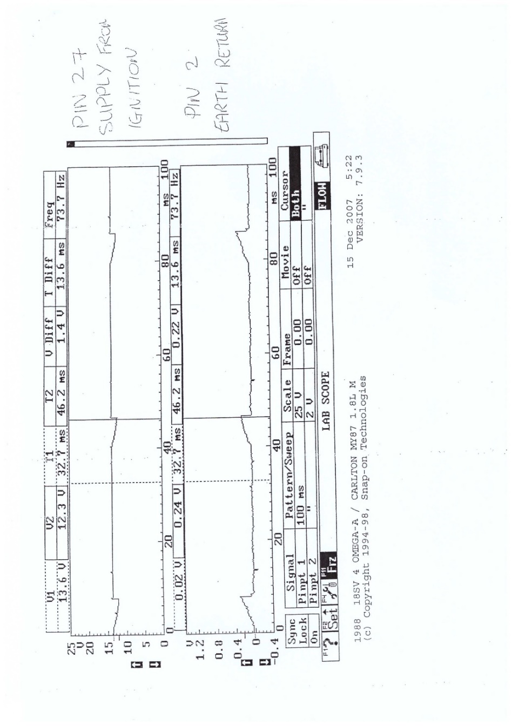
Figure 19 - Motronic 12V Supply and Earth
Figure 20 shows the scope pattern of the throttle potentiometer (Pin 53) and the air flow meter (pin 7). As it can be seen from figure 20 their pattern is almost identical. During idle voltage on the throttle piezometer is 0.59V and on the air flow meter 0.91V. As the throttle opens the voltage on the throttle potentiometer on the flow meter rises and drops back to normal values when the throttle goes back to the idle position. From the figure it can be concluded that the throttle potentiometer and the air flow sensor are working as expected but the resistance reading which are presented in table 9 and 10 suggest that are not as specified by the manufacturer and therefore the need to be checked again in order to confirm if they are in need of replacement.

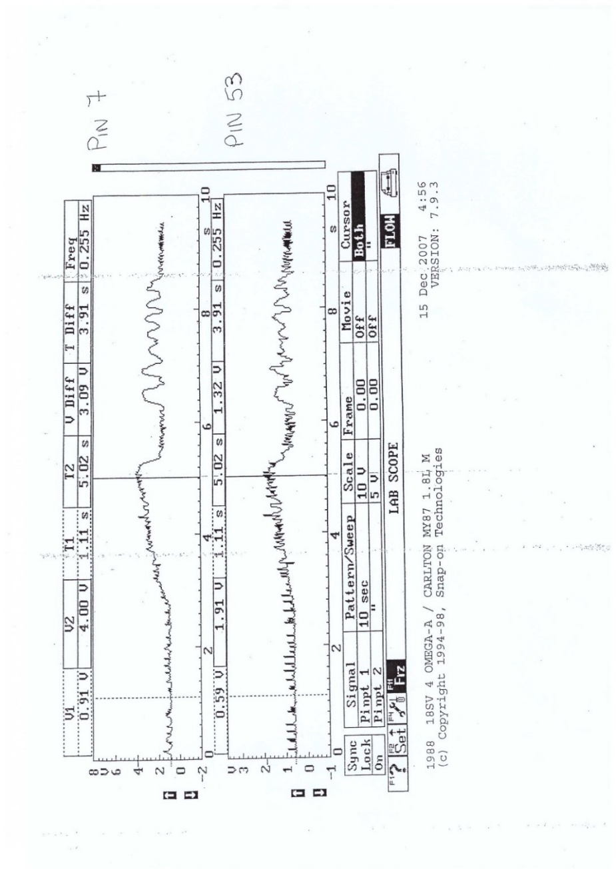

Figure 20 - Motronic throttle Potentiometer (Pin 53) and air flow signal (Pin 7)

Figure 21 shown the Injector on Time scope pattern during idle for pines 16 and 17 which represent the pulse to the fuel injectors 1 and 2 respectively. As it can be seen the patterns are identical. The injectors have a constant voltage of 12V when the valve of the injectors is close and then the injectors are grounded the voltage goes to 0V for 3.0ms. This is the time the injection injects fuel in the manifold. This means that during idle the fuel which is injected in the manifold is just enough to keep the engine running efferently and the air/fuel mixture should be close to optimum. The voltage in the injector increases rabidly to the approximately 70V and then droops back to 12.5V. The rabid voltage occurs in order to close the injector faster and achieve more precise on time of the injectors. The fact then the on time of the injectors are the same this signifies the proper operation of the injectors.

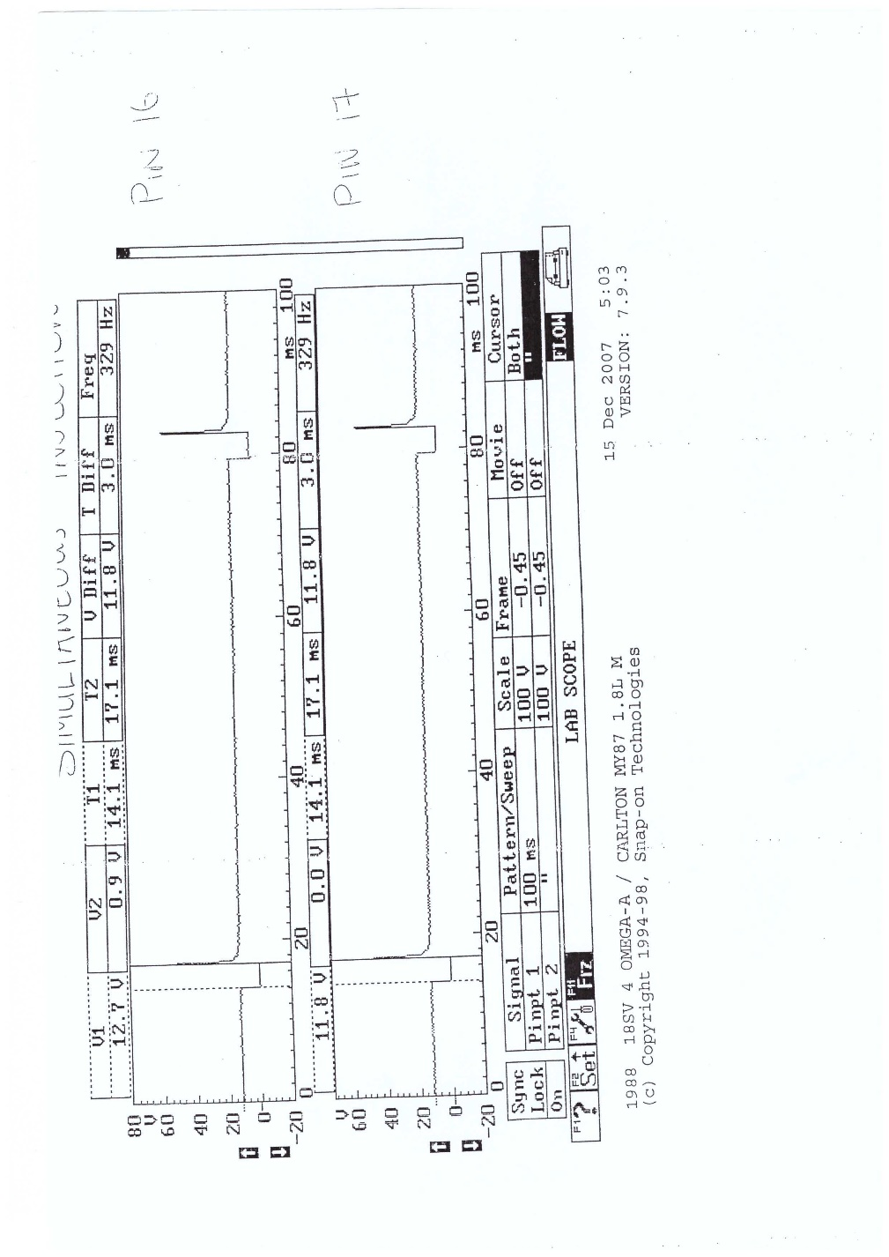
Figure 21 - Motronic Injector Banks

Figure 22 shown the Injector on Time scope pattern during idle for pines 16 and 17 which represent the pulse to the fuel injectors 1 and 2 respectively. As it can be seen the patterns are identical. The injector has a constant voltage of 12V when the valve of the injectors is close and then the injectors are grounded the voltage goes to 0V for 3.0ms. This is the time the injection injects fuel in the manifold. This means that during idle the fuel which is injected in the manifold is just enough to keep the engine running efferently and the air/fuel mixture should be close to optimum. The voltage in the injector increases rabidly to the approximately 70V and then droops back to 12.5V. The rabid voltage occurs in order to close the injector faster and achieve more precise on time of the injectors. The fact then the on time of the injectors are the same this signifies the proper operation of the injectors.

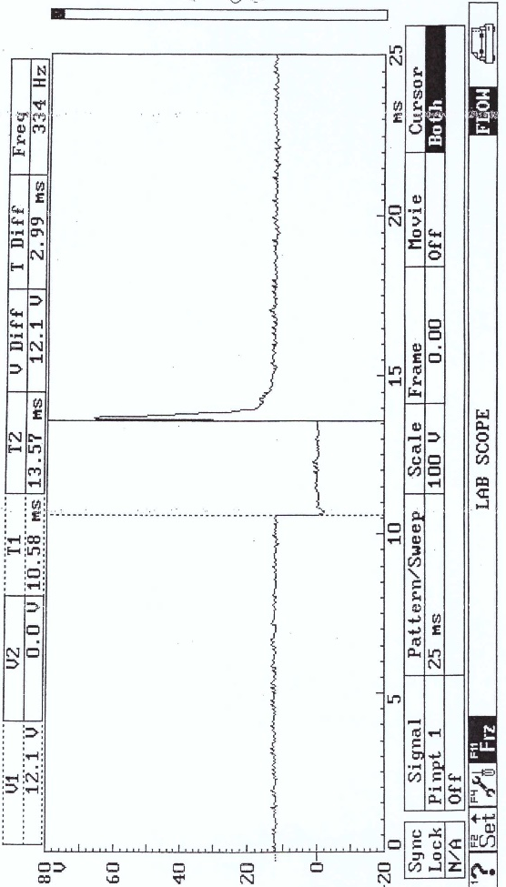
Figure 22 - Motronic Injection on Time Scope Pattern (idle)
Figure 23 shown the Injector on Time scope pattern during acceleration. As it can be seen the injection has a constant voltage of 12.5V when the valve of the injection is close and then the injector is grounded the voltage goes to 0V for 8.66ms. This is the time the injection injects fuel in the manifold. This means that during acceleration the fuel which is injected in the manifold is more and this signifies that a rich air/fuel mixture occurs during acceleration. The voltage in the injector increases rabidly to the approximately 70V and then droops back to 12.5V. The rabid voltage occurs in order to close the injector faster and achieve more precise on time of the injectors.

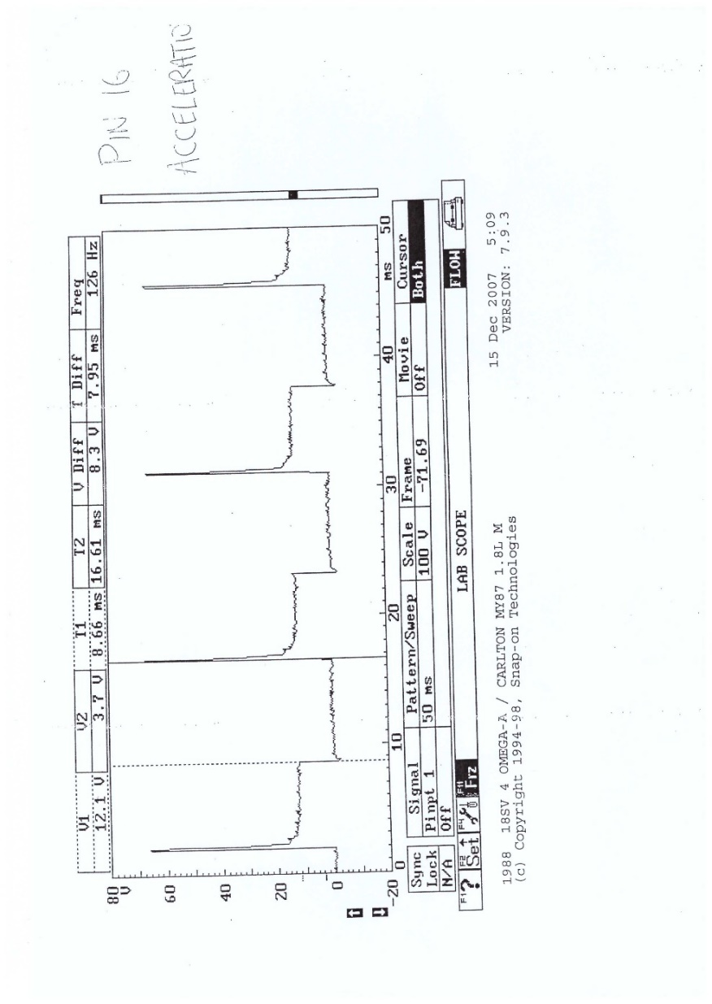
Figure 23 - Motronic Injection on Time Scope Pattern (acceleration)

Figure 24 shown the Injector on Time scope pattern during deceleration. As it can be seen the injection has a constant voltage of 12.5V when the valve of the injection is close and then the injector is grounded the voltage goes to 0V for 1.46ms. This is the time the injection injects fuel in the manifold. This means that during deceleration the fuel which is injected in the manifold is less this signifies that a lean air/fuel mixture occurs during deceleration. The voltage in the injector increases rabidly to the approximately 70V and then droops back to 12.5V. The rabid voltage occurs in order to close the injector faster and achieve more precise on time of the injectors.

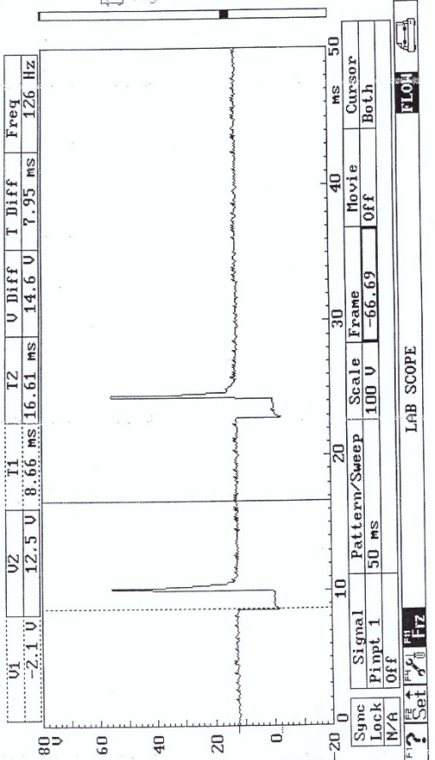
Figure 24 - Motronic Injection on Time Scope Pattern (deceleration)

Figure 25 Shows the scope pattern for the Motronic EMS. The pattern is more or less the same and the voltage varies between 79mV to 708mV. This range is not very far away from the acceptable range for the Lambda sensor which is 0.1 to 0.9V.(What are lambda sensors and how do I test them, no date)
Exhaust gas emissions test can be carried out with an exhaust gas emissions analyser to confirm its performance.

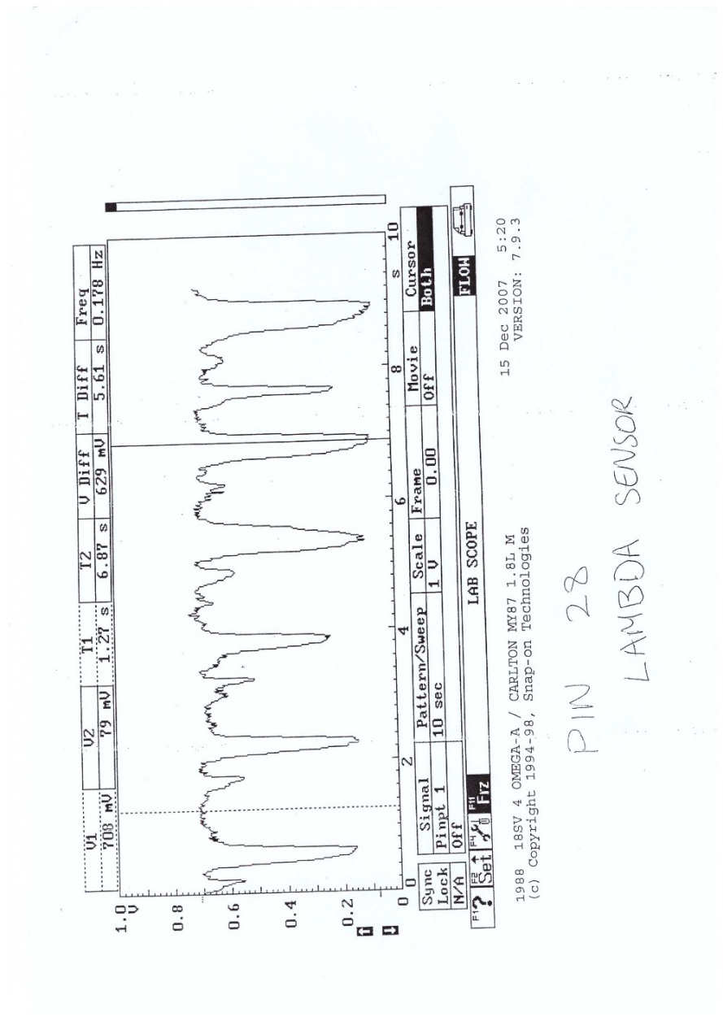
Figure 25 - Motronic Lambda Sensor Pattern
Figure 26 shows the voltage pattern from the crankshaft sensor of the Motronic Management system. The use of the crankshaft sensor it to tell the EMS the position of the crank shaft so that it time the ignition fire, the injection of the fuel and calculate the RPM of the engine. (How Crankshaft Position Sensors Work :: EFI Explained by Matt @ M-Tech Automotive - YouTube, no date) The voltage range is approximately between 11 to -11V and the spacing between the peak values is 1.25ms except where the missing tooth of the flywheel is passing Infront of the crankshaft sensor. The missing tooth helps the EMS to calculate the time it takes for the crankshaft to make a round and this helps also in the calculation of the RPM of the engine. The pattern that is shown in figure 26 is as expected and this signifies that the sensors is not faulty.

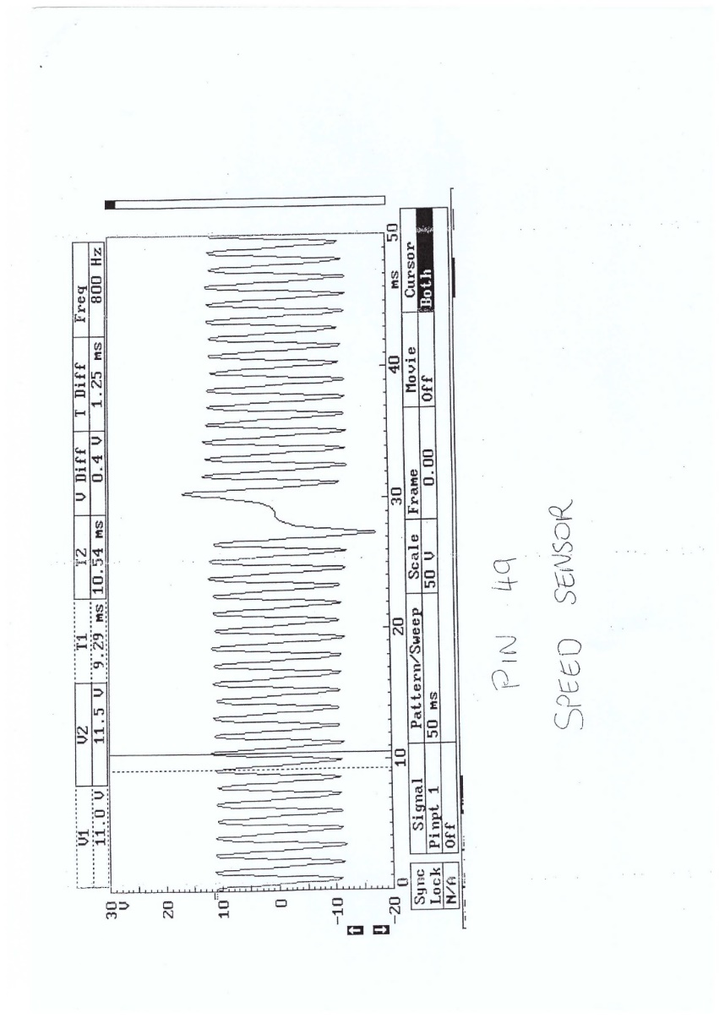
Figure 26 - Motronic Crankshaft Sensor

Conclusions
Engine testing is important in vehicles maintenance and repair. The use of the multimeter and the oscilloscope provided vital information in the identification of faults related to the fuel and ignition systems of engines which were tested. Prerequisite though in the use of this equipment apart from how to use this equipment is a good knowledge of the systems which are tested.
The motronic Engine management system provides better fuel control in the injectors and better ignition timing because there are more sensors that provide vital information to the ECU that control the actuators more precisely in order the ignition to occur at the right time with the optimum air/fuel mixture. His systems provide better fuel economy and less exhaust gas emissions.
Apart from replacing the faulty spare parts identified through this testing for the engines tested the systems can be improved by using more accurate air flow sensor, by using injectors with faster opening and closing times, by using injectors with multiple holes (this will help in atomising the fuel and improve the fuel combustion) and by using higher fuel pressure and higher are pressure. This last comment can be considered as a major change to the system which affects the integrity of other parts of the engine which might engine have not been designed for this change.
Finally changes to the system have to be verified by a dynamometer test which this will indicate if the changes that were proposed are contributing positively in the performance of the engine and in the fuel consumption and the exhast gas emissions which is an important environmental factor nowadays.

References
Advancing and retarding ignition timing | Spark advance and retardation (no date). Available at: https://mechcontent.com/advancing-retarding-ignition-timing/ (Accessed: 24 April 2022).
Bosch, R. G. (2002) Automotive Handbook.
Bosch, R. G. (2007) Bosch Automotive Electrics and Automotive Electronics. 5th edn.
‘Chapter 4 Part B: Fuel and exhaust systems-Bosch LE3 Jetronic injection Air cleaner’ (no date).
How Crankshaft Position Sensors Work :: EFI Explained by Matt @ M-Tech Automotive - YouTube (no date). Available at: https://www.youtube.com/watch?v=ol1G7QPE1jQ (Accessed: 23 April 2022).
Jetronic - Wikipedia (no date). Available at: https://en.wikipedia.org/wiki/Jetronic (Accessed: 3 April 2022).
What are lambda sensors and how do I test them (no date). Available at: https://club.autodoc.co.uk/magazin/what-are-lambda-sensors-and-how-do-i-test-them (Accessed: 23 April 2022).
What is a secondary ignition coil? (no date). Available at: https://askinglot.com/what-is-a-secondary-ignition-coil (Accessed: 23 April 2022).
Why do HT leads have high resistance? (no date). Available at: https://askinglot.com/why-do-ht-leads-have-high-resistance (Accessed: 23 April 2022).

