Provide a detailed analysis of what the surviving evidence can tell us about the legacy of Greek culture in Ancient Bactria and historic north west India
Alexander the Great invaded the areas of Bactria, in modern day Afghanistan, and parts of the north west Indian sub-continent in the 320s and after his death in 323 BC Bactria and north western India was ruled by a series of Greek kings whom each controlled differing amounts of territory, such as Diodotus I and Eucratides. Over a prolonged period of time the areas of Bactria and India which were controlled by these Hellenic kings were gradually over run and taken over by nomadic tribes from the north These Hellenistic kings and the Hellenic population that were with then left a profound effect on the culture that followed which will be examined in this essay.
This essay shall examine the legacy of Greek culture by analyzing the available evidence. Starting by examining statues and then examining more personal objects such clasps and so called “Toilet trays” before finally looking at coinage. It is worth pointing out that we have no written history like that of Herodotus or Polybius which covers this area. This means that we are entirely dependent on archeological evidence such as statues and coinage. This lack of literary sources can be problematic as it causes issues interpreting archeological evidence such as the “toilet trays” as we have no record of what these may have been used for and it is entirely down to interpretation.
Before this essay properly starts it is worth noting the problematic idea of “Greek” culture as “Greek” culture will have been very different depending on which part of the Greek world you go to. For example, both the culture of eastern Sicily and that of Bactria could be described as “Greek” however these areas are a significant distance apart and we cannot assume that “Greco-Bactrian” culture was anything like “Greco Sicilian” culture. This being said there are some universals in “Greek culture” such as the deities and having these represented on their coinage, however the representations of the deities varies greatly for example the representation of Athena on Athenian coinage is completely different to that on coinage from India and Bactria and we can only tell that they are the same deity because of the common symbols associated with them such as Athena’s Spear, Agis and Helmet. For the purposes of this essay I shall be discussing Greek culture by examining the portrayl of deities and creatures which are associated with Greek mythology in Indian art such as Satyrs and Dionysus.
Firstly this essay examines statues and the legacy of “Greek” culture and how this is shown in statues. Statues give us an insight into how the rulers and important religious people in the area wanted to be seen and what they wanted to show as these are the people who commissioned this statues, this is useful as it shows us aspects of “Greek” culture that were adopted by the ruling elite who took over after the fall of the Greco-Bactrian and Indo-Greek kingdoms. In this section this essay also discusses temple reliefs as although slightly different to statues they can be analyzed in a similar way as they were commissioned for public display by the political and religious elite.
During the following Indo-Scythian period strong Hellenistic influences in statues can clearly be seen and some are almost entirely Hellenistic with very little other influence obvious. For example, the statue of a Satyr from Taxila which was probably made during the indo-Parthian period (See appendix 1). This is obviously a very Greek statue and appears to show a Greek legacy and a reverence for Greek culture in this part of the Indian subcontinent however statues like this are problematic as they are nearly impossible to accurately date and the approximate date is given based on the time the building was in use, this could mean the statue was actually made earlier in a time when Greeks ruled, furthermore the identification by Huntingdon of this as a Satyr is problematic as though it does appear to look like that, with only a head it is impossible to tell, additionally without a written source describing it we do not know how this statue was interpreted by the local people. It is also unclear weather this statue represents a statue because the person who commissioned it had any idea of what a Satyr was or weather, he just saw Greek statues and wanted to imitate them.
This statue of a “Satyr” was found with statues which are very Indian looking (Huntingdon 1985: 116) this shows a creolisation of Greek and Indian cultures as having Greek and Indian style statues both around the same time suggests that the commissioner was influenced by the Legacy of Greek culture and the traditional culture of India.
This Satyr is not a one off in fact there are many Greek themes represented in statues in India another example is that in the British museum there is a fragmentary relief depicting scenes which appear to be the Greek sack of troy, this shows that even after the Greek no longer rule the area they have left a legacy which is shown by the continued use of their deities and mythology on public works such as statues and reliefs. This demonstrates that the rulers and elite clearly want to publicly show Greek symbols, this could be to appeal to the Greek minority living in the area or just that they revere the Greeks and adopt their deities and mythological characters.
Secondly statues and Reliefs can only give us a small window into how the elite want to be viewed and what statues they commission in the public eye. This essay now looks at smaller personal items that will have been used by elite individuals in their everyday life such as the clasp (See appendix 3) this clasp would have been used to hold on a cloak or other similar item of clothing. This clasp is an item which embodies the hybridized culture which existed in the north western area of the Indian subcontinent as the iconography of cupids riding dolphins is a very Hellenistic motif and is seen across the Greek world however the style of the dolphins is not very Greek and appears to be more reminiscent of Oriental style art. This style is not unique for example there is another object which features Dionysius and Ariadne, riding some sort of creature however in this the people look like a very Indian style with an oriental style creature. This shows that there was a large melting pot of influences and that although there is a Greek legacy, particularly in the scenes which are depicted, it has been merged with other artistic styles to create something unique.
Finally this essay will examine coinage and how the legacy of the Greek kingdoms is represented on these, whereas statues have provided us with an insight into how the ruling elite display the Greek Legacy publicly and personal items have shown us how Greek legacy took hold in peoples private lives, coins can provide us with a middle ground as these coins were used by private people and will very much been a part of peoples normal life, especially bronze coinage which would likely have been used for day to day purchases (Holt 1999: 114). However the designs on the coinage were controlled by the rulers of the time and therefore this shows us a Greek legacy both in every day life and in the Rulers and public representation. Frölich states that the Indo-Scythians directly copied Greek images and deities on some of their coins and this is very apparent in the coin of king Azes II (see appendix 2) who very clearly depicts Athena on the reverse of his coin, we can tell that this is Athena because of her Agis, Spear and Helmet. This shows that the Indo Scythians were using ancient Greek deities on coinage and this suggests that that there was a direct legacy of Greek Culture on the indo-scythians and they started acknowledging Greek gods. However it is also possible that they imitated the coin designs because these would have been recognizable to the local populace and if they just change the obverse then the change will not be as dramatic. However Greek influence is only part of the influence on coinage and many symbols will have been weird or unrecognizable for the Greeks for example King Maues, on some of his coins, has Zeus’ thunderbolt being personified (Frölich 2009) however this is very much unique and is not known anywhere else in the Greek world this shows how other influences, either eastern or Indian would alter Greek images to create something unique.
We can clearly see the Greek legacy on the coinage of the Indo-scythians and Indo Parthians. However with only the limited information that we have it is impossible to tell to what extent this was a deliberate act, caused by reverence for Greek culture or merely just a case of adopting the designs used by the previous rulers.
In conclusion the evidence which we have available gives us very patchy information and without a written narrative to follow or use to explain how these Greek influenced artifacts were viewed by the local population it is impossible to know how deep the reverence of ancient Greek culture went or whether it was just a case of copying things which were already there, however what is clear is that Greek symbols, deities and iconography continued to be prevalent in the society and that there was a long lasting legacy of Greek culture, the full extent of which will likely never be known.
Appendices
Appendix 1
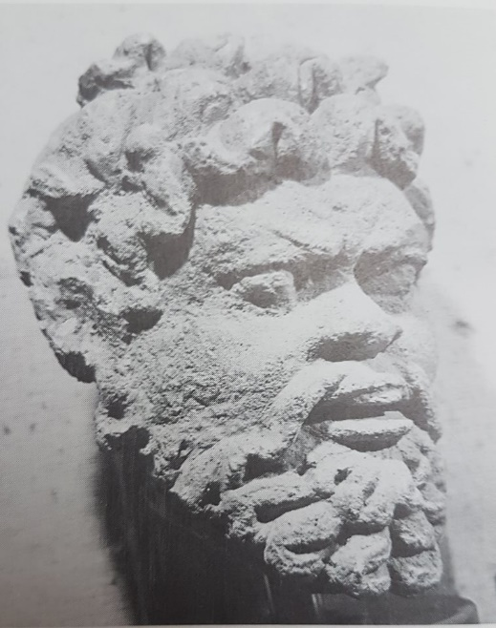
Head, Possibly of a Satyr. From Aspidal temple. Sirkap. Taxila, Pakistan. Ca.first half of first century AD (Found in Huntingdon 1985: 117)

Appendix 2
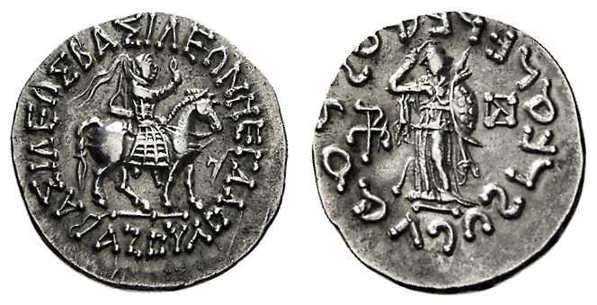

Coin of King Azes II (found on Wildwinds)

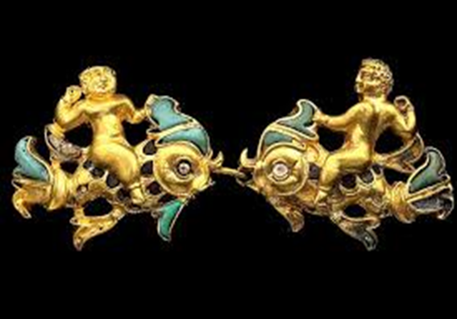

A pair of clasps – Cupids on dolphins found in (Schiltz 2011)

Bibliography
Frölich, C., 2009. A Study of some Deities in Indo- Scythian and Indo-Parthian coinage, in: Frölich, C.. (Eds.), Migration, Trade and Peoples part 2 Gandharan Art London; The British Acadamy.
Holt, F. (1999). Thundering Zeus. Berkeley, Calif.: Univ. of California Press.
Huntingdon, S.L. 1985 The art of ancient India: Buddhist, Hindu, Jain New York, Weatherhill
Mairs, R. 2014 The Hellenistic far East. Oakland, California.
Wildwinds. 2002 Ancient Coinage of Indo Scythians http://www.wildwinds.com/coins/greece/indo_scythians/i.html (Accessed 12/20/2018)
Schiltz, V. (2011) ‘Tillya Tepe, the Hill of Gold: A Nomad Necropolis’, in Afghanistan: Crossroads of the Ancient World, Hiebert, F. and Cambon, P. (eds.), The British Museum Press: 219-293.

Mairs 2014: 146

