Name: Angharad Abbott
Student number: 2219680
E-portfolio report
Learning in the Digital Era – BMPL4007/BMPS4009

Table of Contents

Task 1 – Written summary 2
Task 2 – Mind map 3
Task 3 – Presentation 4
Task 4 – Reflection 5
Reference list 6

Task 1 – Written summary

Preparing for higher education.

There are a few factors to consider when embarking on a journey in higher education be it a student’s environment, peer relationships, upcoming assessments, and study skills – it is important that students are prepared to be curious, creative and apply themselves.
It is important that students are well organised and regularly check their emails, students should expect several pre-arrival materials from their universities including invitations to welcoming events and induction days. In addition, a lot of the communication regarding student's studies and upcoming assessments will be communicated via email. It is advisable that students look at what the university has to offer to allow themselves to meet likeminded individuals, this will allow students to enhance their peer relationships, this can be done through enriching in university teams and societies. (UCAS 2022)
A student’s study skills should include the use of short breaks when studying. Scientists have discovered that the brain has the ability to recall compacted memories of what was recently practiced whilst it is at rest, enabling students to digest more information when resting more frequently during studies. (Thomas,2021)
It is important that students are creative and curious throughout their studies and apply themselves to their research and assignments with interdisciplinary instruction. Adjusting learning environments and learning with peers has proven to work well and allows students to also learn from one another. (Gleason,2018)
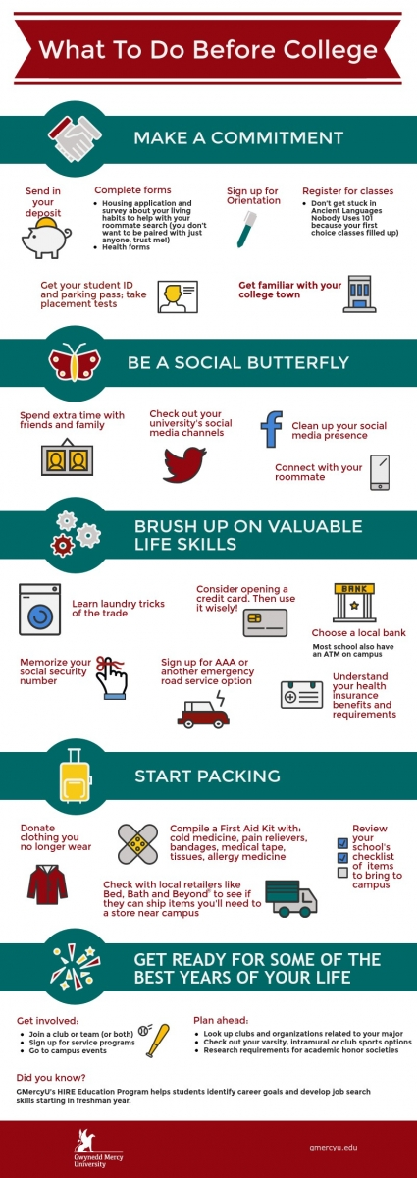
Many universities and colleges will provide advice and recommendations on how they feel their students should prepare for higher education and provide ways in which students can fully enrich in higher education. These tend to be tailored to each individual establishment, it is important that students look out for these or contact their university/college for what they need to do to be prepared. (Anon, 2021)

Task 2 – Mind map
Becoming a digital learner.pdf

Task 3 – Presentation
Please follow this link to view my presentation: Presentation.pdf

Task 4 – Reflection
Reflection on starting university
Starting university is an exciting time for most students. It is a new adventure to embark on, to learn all about your new chosen career path, a time to make friends, gain work experience and learn new skills. As a mature student who works and has a child the biggest question, I had for myself was “when will I have time?” How could I fit in an entire day of lectures on top of having time for online learning, assessments, and essays in my already busy and hectic schedule? But even with this question in mind I joined, I started university and was going to work hard and somehow make it work.
Since joining I have had to get to grips with online learning- using Moodle, teams and the university’s library which has all been easy to grasp by watching the online tutorials. The struggles I have had since joining university are getting back into the routine of being a student, creating time for online learning, juggling work, home, and university life. And my biggest issue so far has been my lack of sleep which resulted in me falling asleep during a lesson.
The lesson I learnt from this was I needed a structured routine if I was going to improve this situation and stick to a set workspace. Having a daily or weekly routine can benefit you massively, your stress levels will fall, and you will feel more in control. Having a good bedtime routine will help you sleep better and give you a psychological boost. (Web MD editorial contributors. 2021).
What I need to do now is to stick to a routine, create a plan, write lists, and adhere to them whilst also giving myself time for breaks. “Improving time management can benefit both your personal life and reduce stress. It will free you to do more of the things you like.” (Hill, January 2020).

Reference list
Anon 2021., Gwynedd Mercy University. [online] Available at: https://www.gmercyu.edu/academics/learn/preparing-for-college-tips-on-getting-ready-for-freshman-year?fbclid=IwAR2Y_xRGHU-jmrPciytaNxw0JojcFApIp-HOdg5SmGviFNbtdWxADXR2wbI [Accessed 6th November 2022].
CFI team (2022) Communication skills, Corporate Finance Institute. Available at: https://corporatefinanceinstitute.com/ (Accessed: November 10, 2022).
Cherry, K. (2020) What is personality?, Verywell Mind. Verywell Mind. Available at: https://www.verywellmind.com/ (Accessed: November 11, 2022).
Medically reviewed by David Susman PhD
Dooley, S. (2022) what does it mean to be a good team player, BBC Bitesize. BBC. Available at: https://www.bbc.co.uk/bitesize (Accessed: November 10, 2022).
Geller, S. (2016) The Psychology of self motivation, TED. Available at: https://www.ted.com/talks (Accessed: November 11, 2022).
Gleason, N.W. ed., 2018. Forewood In ‘Higher Education In The Era Of The Fourth Industrial Revolution. Singapore: Yale-NUS College, Pp. 6-7
Hill, S. (2021) Productivity is not activity, GOV.UK. Available at: https://www.gov.uk/government/organisations/civil-service-government-communication-service (Accessed: November 7, 2022).
Prossack, A. (2020) 6 easy ways to overcome work from home distractions, Forbes. Forbes Magazine. Available at: https://www.forbes.com/ (Accessed: November 9, 2022).
Thomas, C. G., 2021. Study shows how taking short breaks may help our brains learn new skills, Maryland: National Institutes of Health.
UCAS, 2022. Education. [online] Available at: https://www.ucas.com/undergraduate/results-confirmation-and-clearing/gettingready=highereducation [Accessed 5th November 2022].
Walters, R. (2021) The importance of taking a break when working from home, Business Wales. Available at: https://businesswales.gov.wales/ (Accessed: November 6, 2022).
Web MD Editorial contributors (2021) psychological benefits of routines, WebMD. WebMD. Available at: https://www.webmd.com/default.htm (Accessed: November 11, 2022).
Medically reviewed by Dan Brennan

