TASK 2 - Illustrated Book Project Proposal Task
500 words, due 5pm Feb 12th, submitted via moodle.
Formatting: please use the headings below making use of the advice and resources provided. References should be made using the Harvard format.

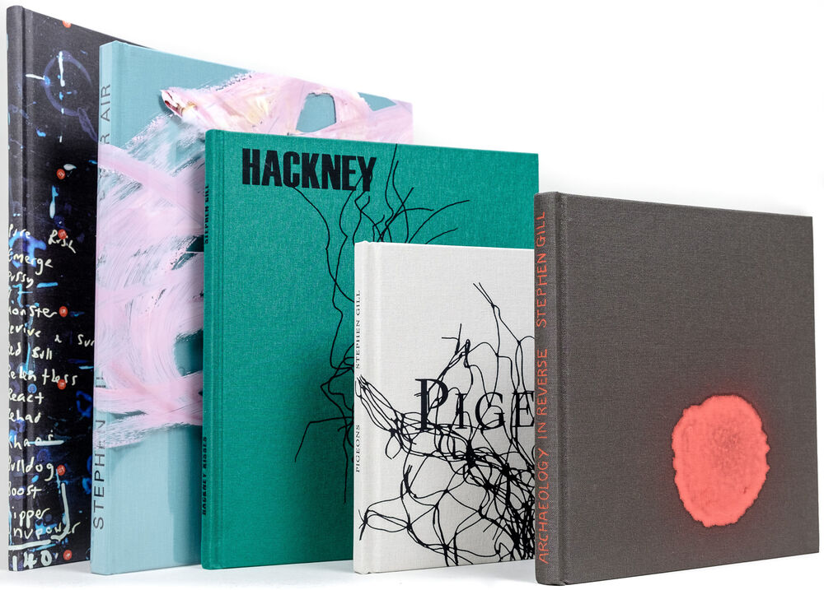
Name: Malachi

Theme/Context
Provide a brief summary of the theme or subject you want your work to focus on. You might include details about the impact you hope to achieve, how the book format will help you connect with your audience, and what will make your work stand out. (300 – 500 words)
Within my book I intend to present a mixture of different mediums and textures within the work, making work that shows images with a second commentary applied. This commentary will be shown with ink, paint, wax, water colours, etc. The different mediums, to overlay or go along side of the images, will show a range of different themes and emotions, to give context to images. These marks would be overlapping each other repeatedly. A handcrafted book, created to be strong and sturdy, will help bring the viewer into appreciating the work displayed inside the book. Small details and high quality are what makes the viewing experience more personal and engaging to the audience. Using the best quality materials only goes so far when the book is held together by a single staple, so making sure that the viewer is comfortable handling the work. By enhancing the durability, will help hold up the standard of what work being presenting as well. The same as any frame of an image at an exhibition.

Influence
Highlight the work of a photographer who currently inspires your work. Analyse an image of theirs and explain your interest in their work. Consider style, theme, context, practical technique. (300 – 500 words)

Linder Sterling, aka Linder, is an artist who primarily uses images and photography, overlaying cutouts, creating a collage of a range of different images from magazines. In Linder’s exhibition: Danger Came Smiling, with involvement in the punk scene, a vast range of her works were displayed, from the artists 50 years creating works.
Cutting and reshaping meaning in images, Linder’s work shows both a fascination in glamor, seeing past gender norms, the body, and criticising the male gaze and how women are treated in adult magazines. By quite literally cutting out the middleman between images of female models and the adverts within the adult magazines, by putting products targeted at men over the women’s faces, Linder clearly shows how these women are being used to attract and advertise products, leaving the final work showing a strange figure, without individuality, having different objects replacing the heads of the models.

I find it inspiring the way that her work has been expressed, although the work displayed at a first glance looks strange, that is the point. The longer you sit with the ideas of what the work is, you can feel the intent and emotion behind them. The physical medium used to create the work adds to the depth of intent as well. In her exhibition interview, Linder talks about how being ‘good’ at art is just being able express emotions and showing the world from her own perspective.

Glynn Vivian (2026) Linder: Danger Came Smiling. Available at: https://youtu.be/opW5U9f25WM?si=k3rJhDZeitQuwRoZ (Accessed: 10 Feb 2026).

Book Form
Referencing the session PowerPoint on Moodle (or another relevant source), discuss at least one book that has influenced you. Explore its visual and aesthetic qualities, social or historical context, impact, or practical methods relevant to your theme. You may also evaluate its overall effectiveness. (300 – 500 words)
While not a contemporary ‘photobook’, Radiohead’s CD album, The Bends, comes with a small booket that unfolds into a straight printed graphic. The way the book is laid out has warped and distorted images on one side, with song lyrics and small illustrative graphics on the other. It has been made cheaply by using very little other than folding to create the book itself, which is to keep the costs low, as well as presenting the book in a more unique manner.
Over these distorted images are inclusions of drawing overlayed atop, adding depth and meaning that coincide with the meaning and themes of the songs. The distorted images have different bright lights and colours that look digital in nature, like extreme close ups of different imagery and camera footage displayed through a monitor. This work is effective in showing a strange arrangement of textures and ideas in one space without it feeling too cluttered, compared to the music it is presented alongside with; however, I think that this work does stand alone when viewed without that added context, which is why I am so drawn to it.

