Discuss the representation of disability (physical or mental) in either Greek or Roman literature and art.

In this essay, I will discuss the representation of physical disability in Greek Art and Literature. I have chosen three individuals from the mythology to focus on. Those being Hephaestus, Oedipus and Polyphemus. While there are others who had physical disabilities, it is these three which I wish to focus on as one is a god, one a mortal and one a monster, thus giving a range of how disability was represented within the mythology of ancient Greece through the mediums of literature and art.
Firstly, Hephaestus, who is the Greek god of fire, he is associated with the forge and is known as the black smith of the gods often creating weapons for the other gods some even to gift to mortals such as the armour of Achilles. Hephaestus is commonly associated as being married to Aphrodite, to prevent discord among the gods over possessing the goddess of love but other stories lead it to be believed to be a punishment for the goddess of love due to her meddling with the affairs of Zeus. Within literature, Hephaestus is referred to as the lame god. In Hesiod’s Theogony he is said to have been born lame then thrown from Olympus by his mother Hera upon her seeing him, further damage was caused to him by Zeus who flung him from the heavens. Hephaestus is depicted in art as having his feet on backwards to show his disability. While in some representations it seems as if he has no disability but is recognised by his affinity with the forge. However, in literature Hephaestus is mocked for his disability and not being as perfect as the other gods upon Olympus as described in Homer’s Iliad ‘Then he poured wine for all the other gods from left to right, drawing forth sweet nectar from the bowl. And unquenchable laughter arose among the blessed gods, as they saw Hephaestus puffing through the palace.’ The fact that Hephaestus was mocked by those seen as his equal suggests that because within the literature that those who were seen as disabled were mocked and taunted that the society shunned them and had not place for those less that their belief of perfection.

Secondly, there is Oedipus, the son of Laius and Jocasta the king and queen of Thebes was left on a mountain side to die after and oracle predicted that he would kill his father and marry his mother. However, he did not die but was adopted by King Polybus of Corinth and his wife. In later life he visited Delphi where the prophecy was voiced to him, causing him to leave Corinth and to travel towards Thebes. While on the journey he encountered Laius, and killed him after a disagreement. When in Thebes he defeated the Sphinx, and married the widowed Queen, Jocasta having four children with her: Eteocles, Polyneices, Antigone, and Ismene. When the truth was discovered Jocasta committed suicide and Oedipus to blind himself and go into exile to live with his shame. ‘Oedipus Child of a blind old man, Antigone, to what region have we come, ... what city of men? Who will entertain the wandering Oedipus today with scanty gifts? Little do I crave, and... we hear. Antigone Father, toil-worn Oedipus, the towers that ring the city, to judge by ... a long way for an old man. Oedipus Seat me, then, and watch over the blind. Antigone If time can teach, I need not learn that.’ Oedipus can be seen as a world wearied old man whose only company is that of his two daughters. Oedipus in art is depicted as a young man defeating the sphinx rather than him in later life. Which shows that disability was not commonly depicted within Greek literature and art.

Thirdly, Polyphemus the cyclops, the son of Poseidon, god of the sea and the nymph, Thoösa. He was deceived by Odysseus of Ithaca after he was washed up on his island and got Polyphemus drunk and then blinded by Odysseus and his men, so they could escape him. Polyphemus is often depicted within art at the moment of his blinding. The emphasis is on the heroism of Odysseus not the pain and disablement of Polyphemus. Homer uses the disablement of Polyphemus to create an antagonist in the form of Poseidon ‘it is Poseidon, the earth-enfolder, who is ever filled with stubborn wrath because of the Cyclops, whom Odysseus blinded of his eye— even the godlike Polyphemus’ this shows while Polyphemus’ blinding is portrayed within literature and art it only portrays the event and the consequences of the actions of Odysseus rather than how Polyphemus lived with his disability.

Therefore, in conclusion, while physical disability is portrayed within Greek art and literature it is not represented extensively due to the fact that it goes against the Greek idea of perfection and heroism. This is also due to the idea the Greeks had against weakness deformed children were often left to die from exposure rather than families having to take care of them for life.

Bibliography

Primary Sources

Hesiod: The Theogony

Homer: The Iliad

Homer: The Odyssey

Sophocles: Oedipus at Collonus

Art Works

Hephaestus -
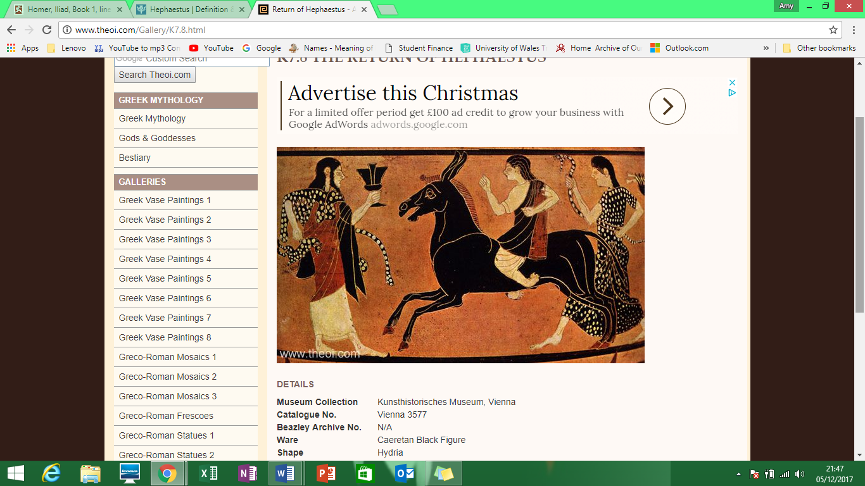 Dionysus and Hephaestus riding donkey, Caeretan black-figure hydria C6th B.C., Kunsthistorisches Museum
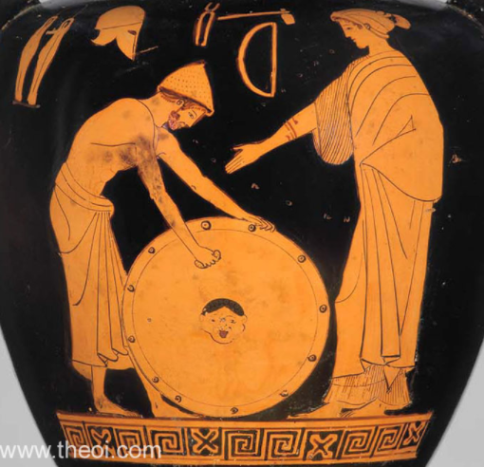 Hephaestus, Thetis and the armour of Achilles, Athenian red-figure Nolan amphora C5th B.C., Museum of Fine Arts Boston

Polyphemus –
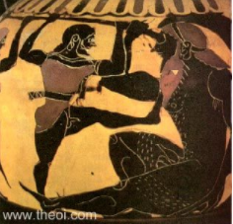 Odysseus & Polyphemus, Chalcidian Black Figure Vase Painting C6th B.C., British Museum, London

Secondary Sources

Aphrodite, Greek Gods, [online] Available: https://www.greek-gods.org/olympian-gods/aphrodite.php Accessed 28th November 2017

Hephaestus, Britannica Encyclopaedia, [online] Available:
https://www.britannica.com/topic/Hephaestus Accessed 26th November 2017

Oedipus, Britannica Encyclopaedia, [online] Available: https://www.britannica.com/topic/Oedipus-Greek-mythology Accessed 27th November 2017

Polyphemus, Britannica Encyclopaedia, [online] Available: https://www.britannica.com/topic/Polyphemus-Greek-mythology Accessed 28th November 2017

Hephaestus, Britannica Encyclopaedia, [online] Available: https://www.britannica.com/topic/Hephaestus
Aphrodite, Greek Gods, [online] Available: https://www.greek-gods.org/olympian-gods/aphrodite.php
Hesiod: Theogony
Dionysus and Hephaestus riding donkey
Hephaestus, Thetis and the armour of Achilles
Homer: Iliad
Oedipus, Britannica Encyclopaedia [online] Available: https://www.britannica.com/topic/Oedipus-Greek-mythology
Oedipus, Britannica Encyclopaedia [online] Available: https://www.britannica.com/topic/Oedipus-Greek-mythology
Polyphemus, Britannica Encyclopaedia [online] Available https://www.britannica.com/topic/Polyphemus-Greek-mythology
Polyphemus, Britannica Encyclopaedia [online] Available https://www.britannica.com/topic/Polyphemus-Greek-mythology
Odysseus & Polyphemus
Homer: The Odyssey

