

Name student-Francesco Antropoli
Student number-1917727
Module-Human Resource Management
Lecturer-Dt. Gladius Kulothungan

The internal response to external factors By IBM corporation

Table of Contents
Introduction…………………………………………………………………………………………………………………….2
1 Economic Factor 3
2 Technologic factor 4
2.2 Strategic Human Resource 4.0 5
3 IBM case study ..........................................................................................................................7
3.1 IBM…………………………………………………………………………………………………………………….7
3.2 the internal response to covid 19 by IBM……………………………………………………………………8
3.3 the internal response to technological impact by IBM…………………………………………………..10

Conclusion………………………………………………………………………………………………………..13
Bibliography……………………………………………………………………………………………………..14

INTRODUCTION
External factors inside and outside the organization exert a major influence on how the organization functions. Organizations are also influenced by the state of the financial and labour markets, economic and social trends, development in new technology, and government interventions in the shape of legislation and regulation. (Armstrong, 2020). The worldwide crisis triggered by the coronavirus pandemic has no parallel in modern history. This pandemic has had an unprecedent impact of business, society and economy and is likely to accelerate the shift to digital towards of the fourth industrial revolution. The IBM is responding to this environmental change by creating some digital solutions that will represent one of the pioneers of the big techs that is adapting to industry 4.0 by implementing new advanced tools such as artificial intelligence to recruit the people. In the pre-pandemic era, new artificial intelligence were being gradually introduced to automate some of tasks performed by human employees. However, The covid 19 crisis, has suddenly accelerated this process of innovation which will be the core of businesses going forward.

1 ECONOMIC FACTOR

An shock economic refers to any change of variables macroeconomics or relantionship which has the effect on economic performance by provoking unemployment, consumption and inflation. (Investopedia, 2019)the enormous impact of covid 19 has changed utterly our economy by creating a dangerous and volatile period on multiple fronts, politically, socially, geopolitically (Schwab, 2020) . As a result OF Pandemic:
-1.6 billion informal workers lost 60% of their income by pushing a lot of people into extreme poverty (Deloitte, 2020)
-In the US, It is estimated that official rate unemployment could reach a peak of 25% in 2020- a level equivalent of the great depression (Schwab, 2020)
-Most countiries plunged into recession with per capita income contracting in the largest fraction of countries globally since 1870 (Bank, 2020)
-In the US and in Europe the governments supported the businesses providing income support for those who lost their job such us the furlough scheme in the UK which provide 80% of salary to employees. (Schwab, 2020)

As a result of the lockdowns , the pandemic had immediate effect on every possible industry around the world. however, Some businesses have been devasted by the economic hibernation triggered by the lockdown and social distancing measures. For the majority of businesses stepping into the post coronavirus future, the key issue will be to find the balance between what functioned before and what is needed now to prosper in the new normal.

2 TECNOLOGIC FACTOR

Technology can be defined as a converting of resources into outputs or advanced equipment developed from the scientific knowledge.. New technologies stemming from innovation have effects on the economy, and on society more generally, that are proportional to how widely they are adapted. The taylor review noted that technology advancements and the automation of individual tasks result in job creation (Taylor, 2017). Covid 19 has undeniably led to an acceleration of new technologies which will change the world of work and the human behaviour. Technology will represent the future of work which will be integrate alongside the workforce such as A.I, Robots, augmented reality, ect. (Deloitte, understanding covid-19's impact on the technology, 2020). The CIPD observed that A.I and automation are potentially deskilling and disempowering but they are more likely to free people to do more value-added, higher skilled tasks and exercise more discretion in decision making (CIPD, 30 april 2019). In the last few years the businesses are using the A.I in the HRM, Because the A.I can generate data that informs decision making on people management issues. This new generation system which is being deployed from some big tech company such as IBM and Microsoft will become the new way to recruit the people.
In account of the covid 19, technological progress has moved impressively fast bringing the businesses to adapt themselves. Automation and robots are reconfiguring the way businesses operate with staggering speed and returns on scale inconceivable just a few years ago. The pandemic will fast-forward the adoption of automation in the workplace. From the lockdowns, it became apparent that robots and A.I were natural alternative when human labour was not available. Furthermore, they were used whenever possible to reduce the health risks to human employees. The A.I is being used even in HRM by enhancing the organizations’ ability to recruit the right talent at just right time.

2.2 Strategic human resource(SHR) 4.0

The fourth industrial revolution(4.I.R)
The fourth industrial revolution is the new digital era in which new technologies such as automation, cloud computing and artificial intelligence will change radically the society and businesses .These changes will redefine economies, societies and the future of work regard the human resources. (schwab, 2016). Joe Kaeser said” the fourth industrial revolution is not just about technology or business, it’s about society. As a previous the 4 industrial revolution will eliminate million of jobs and create million of new jobs” (Kaeser, 2018). A recent study released by Mckinsey report that the fourth industrial revolution could decrease the numbers of full time staff about 800 millions across the world by 2030 (Mckinsey, 2020).
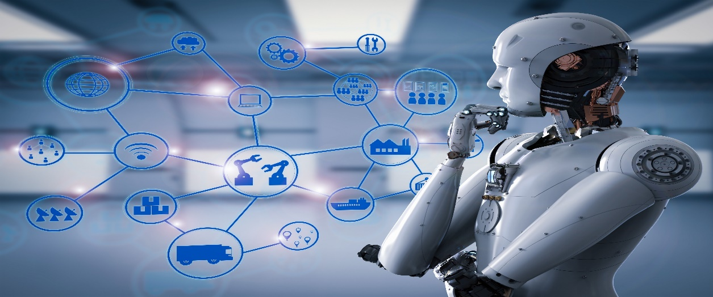

The fourth industrial revolution is characterised by a fusion of technology, such as artificial intelligence and advance robotics that will disrupt nearly every industry by creating new opportunities and challenges for people, places and businesses.

Human Resource 4.0
The businesses community must act to this change straight forward by preparing youths to excel in fourth industrial revolution aligning across education, workforce development, programs, young people and public policy. It must be a collective effort aimed at improving the potential employment outcomes. (Deloitte, September 2018).
in this new digital Era of the fourth industrial revolution the organization have to adopt new technologies by supporting the human resources through this transition by integrating them to this turning point to build attractive and inclusive workplaces. The world economic forum with Saudi Aramco company, lay out six imperatives that business leader will need to implement (World economic forum, December 2019 ). These includes:
- -Developing New Leadership capabilities for fourth industrial revolution : The businesses have to create new patterns by adopting the new technologies and innovate human resource strategies for the future work
- -Managing the integration of technology in the workplace: the organization have to draw new solutions to manage the integration of new technologies and the human resources so that they can develop new digital skills required by the fourth industrial revolution
- -Enhancing for employee experience: the HRM have to take into account the experience of employees by enhancing it through new patterns
- -Building an agile and personalized learning culture: the new skills will bring a radical change on the organizational learning and development. Thus, the organization have to built an agile learning culture so that the employees can adapt at new digital skills
- -Establishing Metrics for valuing Human capital:
- -Embedding diversity and inclusion:

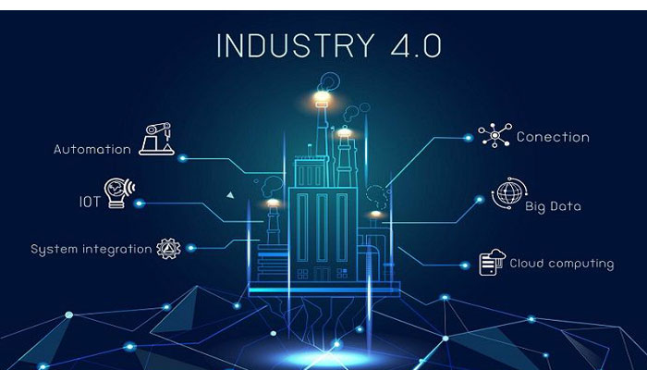
This Photo by Unknown Author is licensed under CC BY

These six imperatives will be the guidelines for the managers that will drive the organizations during the transition for the future work.
HR 4.0 is focused in qualified talents, improved organizational climate and any approach that contribute to the company’s strategic result. The hr 4.0 Is oriented towards new technologies which are in line with the new scenario. Yet, the new technologies allow to optimize the time tasks which HR used to make, by using new generation tools such as artificial intelligence, cloud computing ,and big data.

3 IBM CASE STUDY

3.1 Ibm
International Business Machines Corporation (IBM) is an American multinational technology based in New York in the Unites States. The company produce hardware, software and middleware as well as to provide new technology such as artificial intelligence and advanced products with nanotechnology. As a global information technology, IBM has many stakeholders in different areas which have interests in the different aspect of business that requiring a various corporate social responsibility strategy that involves: environment: communities: suppliers: investors: employees. in 0addition, the company has 350.000 employees serving clients in 17 countries
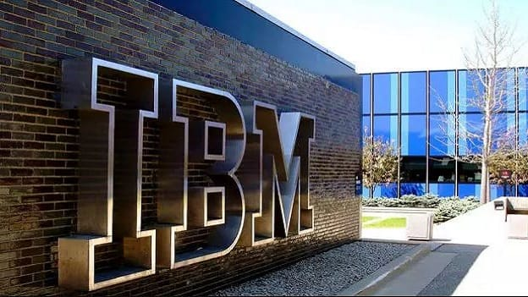
This Photo by Unknown Author is licensed under CC BY-SA-NC

3.2 The internal response to the covid 19 by IBM
Strategic human resource management(SHRM) deploy activities and human resources in an organization to achieve its goals(Wright,1992) the purpose of strategic management is to make a present action for the future changes. The IBM corporation has acted to these new changes stemmed from the covid 19 by creating:
- -an health and safety programme to allow their employees to carry out their task in a safety way

- -motivation practices for managers during the covid 19 crisis.

-health and safety programme
Health and safety policies provides for employees well-being by protecting employees against accidents and risk of ill-health (Armstrong, 2020). There are 2 kind of health programmes:
- -Safety programmes: to cope the prevention of accidents by minimizing injures and damage to people. They relate more to system of work than the working environment
- -Occupational health programmes:deal with the prevention of ill health and the reduction of stress in the working environment

According to corporate governance report IBM, To cope the pandemic, IBM has built a safety programme pandemic plan that provide the right guidelines to safeguard the employees to avoid the spread of virus. Apart from, to provide the health safety measures, the plan give advanced smart-working tool for maintaining employee engagement, productivity and emotional support during uncertain times with effective working norms, policies and practices which IBM itself has built and provided to other companies as a new technologic tool that will be used in the new world of digital-based work. (ibm corporate, June, 2019).

-motivation programme
The motivation refers to drive human resource to external change (Latham, 1979).The managers need to motivate their teams to cope this time in account of the external changes provoked of covid 19. In the case of IBM, the company offers to different headquarters’ manager the daily update to support their managers so that they can drive and help the employees during this unprecedent time (Starner, 2020).

The programme consist:
- -leadership training and tips on how to boost resiliency in the current public-health crisis
- -personal blogs by IBM leaders on how they are addressing challenges within their teams
- -virtual discussion groups with experts, such as IBM’s chief medical officer and epidemiologists
- -online forums with outside leadership experts on how to manage during crises
- -important informations on mental-wellness benefits to help the managers to cope with stresses during the pandemic.

the Covid 19 has created an unprecedent time in which the businesses are forced to motivate their employees through the motivation strategies to held an high-performance from employees and keeping them safe by creating a new kind of workplace in total safety through the new technology tools .The businesses’ adaption has created a new industry reset which is changing the concept of work we were used to that represents the beginning of the industry 4.0.

3.3 the internal response to technological impact by IBM

The pandemic will-fast forward the adoption of automation in the workplace, it became apparent that robots and A.I were a natural alternative when human labour was not available.The artificial intelligence is transforming the way that HR contributes to an organization’s competitive advantage.
The artificial intelligence in human resource management has some specific uses: (Armstrong, 2020)
- HR Analytics; analysing data and information on people and HRM process to guide decision making
- Recruitment and selection: matching candidates located In a database to job/person specifications
- Talent management : identifying eligibility for inclusion in a talent development programme by providing information on performance histories
- Learning and development: developing and operating performance support system which provide the right informations learning material regards procedures and techniques
- Employee sentiment analysis: identify attidute, mood and sentiment of employee by analysing for example email.

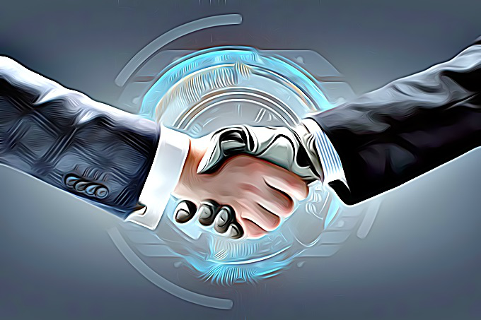

The IBM’s HR team and IBM’s client services expert have developed A.I solution that allowed the company to recruit the right people faster by evaluating skills for roles, predict the probability of future success and estimating the expected time to fill any given role. Furthermore, the IBM utilise A.I not just to augment The HR role, but also ensure employees are up to speed with the technology itself to develop new skills for the future work.
the IBM’s A.I consist (Nigel Guenole, 2018) :
-Watson Recruitment- the HR department analyse the company’s entire employment history. After that the A.I can combined external data and used key attributes desired for an position. A.I can then scan applicants, to find the right candidates for the next stage of the recruitment process.
-Watson Canditate assistant- the A.I Analyse candidate’s CV, their qualification and work experience and then match the right person to the most appropriate role.
-Watson career coach- help employees develop their career in the most effective manner possible. The A.I construct personalized career development plans by considering employees’ strength, weaknesses and goals.

IBM’s artificial intelligence on HRM

Strategy in HR is about continuity and change and anticipating when the circumstances change (Purcell, 2001) .According to pre-pandemic IBM research as many as 120 million workers need to be reskilled in spite of A.I and automation in the next 3 years by preparing the future human resources 4.0. in line with the second imperative of world economic forum i.e “the organizations have to manage the integration of new technology”. Thus, the IBM is preparing the future workers and reskilling their employees through the IBM skills academy that provides skills by covering latest technologies and industry practices understanding the natural language of A.I patterns. (academy, n.d.).

The artificial intelligence will be the new core of the businesses which will be the new way to recruit new talents as well as carry out the administration tasks that were being done from HRM. However the artificial intelligence could replace thoroughly the human resources by leaving space to new kind of jobs whereby the businesses will have to arrange to be ready at new industry 4.0.

CONCLUSION
The Covid 19 pandemic has triggered momentous changes that have already reset our economy. No industry or business will be spared from the impact of these changes by raising deep concerns about the environment and also extending the reach of technology into our lives. Technological advancements sparked mostly of Covid 19 will change job description and job design in the future. HR managers will be able to use A.I to measure individual employees performance and to recruit future talents easier. The organization will have to require a successful SHR 4.0 strategy to cope up with industry 4.0 transformation challenge. Furthermore, Emerging technologies such as Big data ,A.I and robot will automate most of the work which could replace the workforce utterly by 2030 decreasing the number of full time staff about 800 million according to Mckenzie report. This is a question mark which the companies will have to be able to respond more in the future perspective of what the new labor market will be and how adapt the automation with the human resources.

Bibliography
IBM accademy . IBM skills academy,www.03.ibm.com/services/weblectures/dlv/gate.wss
Armstrong, M., 2020. Armstrong's handbook of human resource management practice. s.l.:KonanPage.
Bank, T. W., 2020. the global economic outlook during the covid 19 pandemic:: a changed world
CIPD, Nov.2020. Responsible business through crisis ,www.cipd.co.uk./knowledge/strategy/corporate-responsibility -business-through -crisis
CIPD, 30 april 2019. People and machines: from hype to reality. www.cipd.co.uk/knowledge/work/technology/people-machines-report
CIPD, September, 2020. Embedding New Ways Of Working. [Online]
Available at: www.cipd.co.uk/images/embedding-new-ways-working-post-pandemic
IBM corporate responsibility report ,2020. transforming the workplace through employee experiences,cultural leadership, and sustainable diversity. www.ibm.com/blogs/services/transforming-the-workplace-employee-experiences-cultural-leadership-and-sustainable-diversity/.
IBM corporate responsibility report , June, 2019. IBM and good tech: modelling responsible steweardship in the digital age, www.ibm.org/responsability/2019/IBM-2019-crr
Deloitte, 2020, March 25. Understanding covid-19's impact on the technology sector
Deloitte, 2020. covid 19, workforce strategies for a post covid 19 recovery workbook, .
Deloitte, September 2018. Preparing tomorrow's workforce for the fourth industrial revolution,
World Economic Forum , 20 october 2020. The Future Of Jobs, Davos: ences drive employee engagement. [Online]
Investopedia, 2019. Economic shock. [Online]
Available at: www.investopedia.com/economic-shock
Kaeser, j., 2018. the world is changing : how companies must adapt, s.l.: World economic forum .
Kanter, 1984. the change master. London: Harpercollins publisher .
Latham, ,. A. L., 1979. What shoud we do about motivation theory?.,Academy of management Review.
Mckinsey, 2020. The fourth industrial revolution and manufacturing's great reset. [Online]
Available at: mckinsey.com/business-function/operations/our-insights/the-fourth-industrial-revolution-and-manufacturing-great-reset
Purcell j., 2001. The meaning of strategy in human resource management. Inj.storey , pp. pp 59-77.
schwab, k., 2016. the fourth industrial revolution. Davos: world economic forum .
Schwab, K., 2020. Covid 19 the great reset ,World economic forum.
Starner, T., 2020. human resource executive.com. [Online].
MJV Team2019. HR 4.0: how the technology is trasforming people management. [Online]
Available at: mjinnovation.com/ HR 4.0: how the technology is trasforming people management
ibm institute for business value ., 2020. Covid 19 action guide:beyond the great lockdown
World economic forum,, December 2019 . HR 4.0: Shaping people Strategies in the fourth industrial revolution ,
Wright, 1992, theoretical perspectvies for strategic human resource management , journal of management,18, pp.295-320.
www.gov.uk, 2020. forlough scheme. s.l.:s.n.

