
Habib Muin (P150191) | P150191 | December 17, 2018

Internet Technology & Security
  - ACCA4018

Introduction
As and IT Security Consultant. I have been hired by a company called Hyper-fort, to recommend guidelines on a comprehensive security policy. This policy will cover all aspects of its enterprise network. This includes online and offline. I will also be creating a comprehensive BYOT framework, a data flow diagram followed by a mobile devices management software that I have chosen. I will be explaining the reason why I chose it. Lastly, I will be discussing the advantages and dis-advantages of BOYT, creating an argument if the advantages outweigh the dis-advantages and finish it off with a conclusion.
________________________________________________________________________
Data flow diagram
This is a data flow diagram displaying the architecture of the company’s system of BOYT.
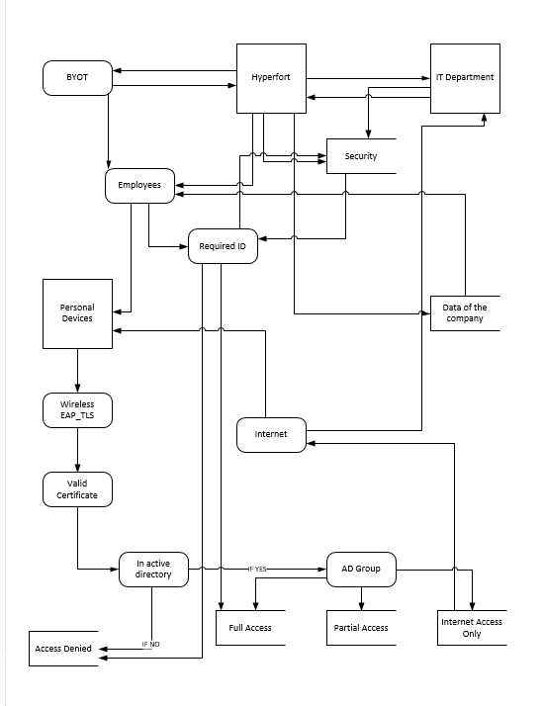
Interfaces
- Hyperfort
- IT Department
- Personal Devices
Processes
- BYOT
- Employees
- Internet
- AD Group
Data Storage
- Security
- Data of the company
- The accesses (Full access, Partial access and internet access depending on the person)

________________________________________________________________________

Mobile device management software
A mobile device management is a security type software which is utilized by a computing department to manage, secure as well as monitor their employees’ smart phones which are installed across various smart phone service providers and wide spread through various mobile operating systems all that are being utilized in the business.
Frequently the mobile management software is joined with more security services and tools. For example, mobile application management. This is to make a mobile device as well as security enterprise mobility management solution.

For the BYOT I have chosen a mobile device management software called ‘Cisco Meraki’. This software is a popular software being rated a 4.4 star. The reason why I chose this is because this software allows every single device to be managed in Hyperfort for BOYT all simply from just one dashboard. It can range from a mobile phone/ tablets or iPad with various companies such as Android, IOS etc.…. all the way to a computer with a various operating systems including Linux machines.
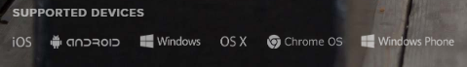
Centralized device management
This software also allows the management of the software to be unified and the control of numerous mobile devices as well as desktop just simply in the dash board of the Cisco Meraki securely. This would allow the company a very simply and easy access of onboarding innovative devices and thus making automation of applications of he security policies.
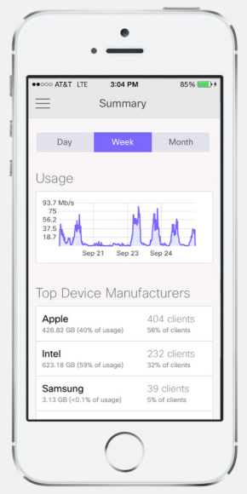
I have personally taken into account that every user is unique as well as every device. So, choosing Cisco Meraki is beneficial because the system manager will keep the network in a loop about any sort of changes in devices, it will then automatically track the devices posture and make adjustments to the security policies to match the devices in a fast period of time.
The software allows seamless user enrollment. Meaning that there is no more need of manual user to device assignment with the enrolment of the software. Hyperfort will find this useful because it ties individuals with their devices. This is done by integrating enrollment with ‘Active Directory’. The software is also security compliant. Meaning that it allows the customization of the polices for each user group within the company. It is also a benefit because the software will make a requirement of a passcode on the device/devices before making any changes to the settings, as well as limiting any rooted all jailbroken devices into the guest network. Lastly, if an employee is found violating any of the security polices with their devices, they will be revoked of the privileges immediately.
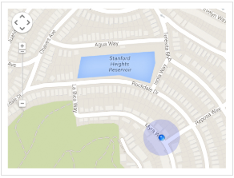
Monitoring
Cisco Maraki will for manage every aspect for BOYT thoroughly as well as enforcing device security policies. Installing apps and software, remote performing, it also has a live troubleshooting, this would help if any issues occurred for BOYT. The software will also monitor calls too. Each device that is managed and monitored is observed as an individual device, even if the devices are linked. So, for example, Hyperfort can allow the people for BOYT to run specific apps on say their smart phone but not on their laptop or tablet.

The software has a ‘360° support for enterprise mobility’ meaning that it contains numerous functions such as it is quick to bring devices under management. So, for example, it has an easier authentication and enrollment for BOYT and corporate devices. It ensures that the devices are compliant with the policies. Meaning that it will configure the profiles to enact policies for a virtual private network (VPN), the WI-FI and pretty much any other parameters.
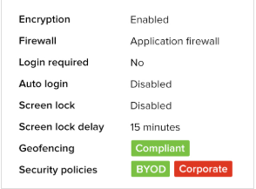
For security purposes of the software, it ensures that the security for mobile device management from devices right through to the network policies. The security features that it has are that it will make sure that the devices and their data is protected with an encryption enforcement, meaning it wouldn’t be the easiest task to set a virus or hack it. It also has an enterprise remote wipe, meaning if anything did happen, they company has the ability to completely remote wipe the system before it leads to further harm and lastly for the security, it has an integrated network access control.
With Cisco Maraki there is a deep combination with the social media app called Facebook. It lets the employees or customers connect to the wireless internet simply just by checking in on Facebook. So, for example if customers entered in Hyperfort and the company had a Facebook page, they could use it to check in though the company’s page as a splash page. Allowing WIFI with the Facebook login will initially allow the company then to access to amassed and unidentified demographic information that Facebook provides about the visitors. You also wouldn’t need to fuss with any complicated modifications of the application of the source code within the software because the ‘Systems Manager’ tool would provide a secured containerization. This is all done by using, as they call, “a native OS tools”. Thus allowing secure data to be shared between the apps eliminating complexity.
The access points of the software are all built from the highest-grade components. This results in faster connections, more range cover, better user capacity and lastly way less support calls. One of the reason of the build of the software is purely to maximize the performance. It also has a dedicated security radio. The radio will constantly do scans and it protects against any security threats, it senses the RF environment and then quickly adapts to the interference and also the security radio automatically configures the RF settings to initially increase the performance to its full potential.
Over all choosing this software will be beneficial for BOYT because initially the software, Cisco Meraki, will allow all these actions to occur via the network. This meaning that if you are trying to manage remote and individual’s device it becomes multiple times simpler. The website contains a choice of either having a free trial on the premises meaning that you are able to has a taster of what the software is actually like or you can have a free trial and download it onto a cloud-based server.
________________________________________________________________________
Advantages and disadvantages of BYOT/ BYOD
With BYOT, also known as bring your own technology, states the utilization of consumer devices and applications in a workplace. It has become an increasing trend in employee owned devices within a business. Usually employee devices are authorized by the company and then it is reinforced in conjunction with technology that is currently possessed by the business. In different cases, technology that is owned by the employees are a part of a whole parallel system. The system is known as ‘shadow IT’ software or even hardware that is in an enterprise which isn’t supported by the organizations IT department.
Here bellow I will be discussing the advantages and dis-advantages of BYOT:
Decreased hardware investment – Many businesses may not see cost savings from having a BYOT but personally they will be saving a lot money. Reason being because, for example, Hyperfort wouldn’t have to buy their employees devices. Additionally, there is a higher chance that the employees are generally going to take care of their own devices. This would cut costs on repairs too. I came across an article from ‘CloudTweaks’ which stated that the BOYT saves a business substantial amount of money than simply the cost of the initial purchases of the equipment.
Another way that it will reduce cost is if the businesses purchased mobile device that have plans such as data and voice for their employee, it would help them from any additional cost savings because these days when it comes to purchasing smartphones, they come with a package for a data plan as such.
How much can the business actually save - This can usually depend on the IT budget that the company may currently have as well as the number of employees that may utilize their own devices, versus the hardware that is provided by the company. There have been studies that have suggested that a company can savings can range from £350 a year per employee to around £3000 a year per employee. With the money that is saved the company could make improvements or upgrade on technology over the years which is a huge advantage.
Increase of flexibility – BOYT offers a flexibility which is also another advantage. Reason why is because it offers a new mobile workforce opportunities. This meaning that the employees are able to work where ever they desire at any time that they like. Businesses would benefit from this a lot because with the increased flexibility there is more of a chance that the business is going to get more noticed and start attracting employees that are perform more.
Increase employee productivity – increased productivity of and employee is also another advantage. It is all because the employees are a lot more familiar as well as comfortable with their own personal devices that they have. With the employees features and devices, they then comfortable to take full advantage. Reason being they have become more known to navigate through the devices. Thus, the employees will also become a lot happier because they would have the chance to choose the device which they prefer the most instead on being chosen for them. This would lead there being a greater chance that the employees would work during the night as well as reviewing things such as their email for example, only if they are on their personal devices.
Here bellow I have displayed a screengrab from ‘Syntonic’ showing their studies of how much BOYT has increased the productivity:
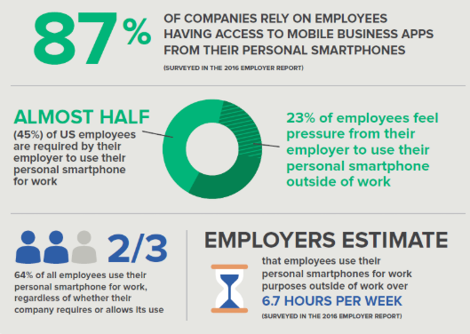

Even though there may be great advantages of BOYT such as increased satisfaction and productivity by employees, decreased hardware investments and increase of flexibility. I will now be assessing the risks and discussing the dis-advantages of it. Here are the following dis-advantages:
Scalability – For BOYT, a common encounter is the problem of scalability. It has become more popular of the use of various devices that are personally owned by employees, thus resulting to the companies not having the network infrastructure that is need in order to handle so much of the additional traffic.
Security – For BOYT, one of the main uncertainties that a company has is about the security. A survey that has been done by a security intelligence discussed that the main security concern is the risk of the loss of enterprise data. These possibilities can come in different forms such as:
- Any threats/ attacks. For example, scams, any fake apps and also malware.
- Theft, such as devices being stolen.
- Loss off devices as well as unauthorized access.
- Complying of the employee’s personal devices which is accessed by the network of the company
- Security endpoint
When considering the infographic published statistics by the magic blog, so the issues of security became more relevant. Here is the statistic that they have published bellow:
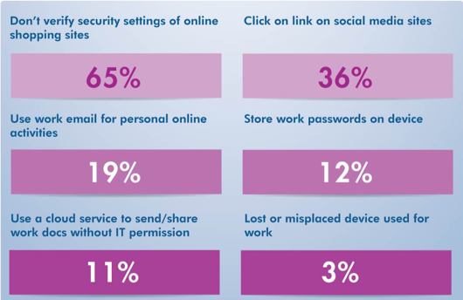
Reviewing the statistics, it is not hard to tell that the businesses have to really think about their networks security when it comes to BOYT. I will be discussing more things that a business would need to consider with BOYT and the security of it,
- Server-side security measures. Subsequently, there is not guaranteed that there is full control of the devices of the employees, businesses would consider looking into the server-side security approaches which have the ability to limit any certain access to the more important and classified data of the business. Another thing to look into is monitoring what the employees may download from the businesses network.
- The use of devices by employees at work. Things to consider by the company to help with the security is taking into consideration what the employees would use their devices for. Such as the use of their devices to access any company resources, the companies email or even any important documents. I would suggest that the company manages any access that the employees could have with the company’s resources or even establish a general security strategy.
- Security protocols for the devices. Minimalistic ally, for BOYT, the employee’s own devices should necessitate a password to have any access. It is mandatory that it has anti-virus as well as any anti spyware software’s and lastly utilize an operating system that has been approved in order to have any use of the resources of the company.
Supporting multiple devices – With companies, when it comes to possessing their personal devices, they have the advantage of choosing a selected number of devices to support. This does lead to simplifying things for the IT department. Reason being is because it is easier to be more familiar with the devices. With the company needing to support numerous devices as well as operating systems, there will become an increase in IT department staff for all the extra support for the devices. It will defiantly lead to length consumption of hours because there will be an increase in downloading updated software’s as well as quickly and efficiently downloading the security patches for the numerous devices.

Conclusion
There is no point ignoring the fact that there has been a large increase over the years of personal devices being used within a business. When it comes to BYOT, there are multiple positive reasons to do BYOT as well as negatives. It usually depends on the individual’s company. By weighing in the advantages and dis-advantages, it gave me a better idea on how to implement a more successful BYOT program.
Personally, for Hyperfort, I have come across a hybrid type option. This would become a more flexible option for the company. With the hybrid option, the employees would receive devices that are owned by the company while others are permitted to utilize their own devices. This would benefit the company by reducing the cost even further because that way they wouldn’t have to make larger expenditures on devices for the employees but have a selected few. This would also allow Hyperfort to make devices available for their employees that might be required to access important documents but the employees who don’t really need to access those types of documents can use their personal devices. This would then reduce the risks of security.

marking criteria and Student FEEDBACK

This section details the assessment criteria. The extent to which these are demonstrated by you determines your mark. The marks available for each criterion are shown. Lecturers will use the space provided to comment on the achievement of the task(s), including those areas in which you have performed well and areas that would benefit from development/improvement.

Common Assessment Criteria Applied (Assignment 1) | Marks available | Marks  awarded
1. Research-informed Literature
Extent of research and/or own reading, selection of credible sources, application of appropriate referencing conventions.
No referencing used. The content produced show some level of background reading was done but it was not referenced. (Grade mark: 33.33%) | 15 | 5
2. Knowledge and Understanding of Subject
Extent of knowledge and understanding of concepts and underlying principles associated with the discipline.
The content produced show some level of background reading was done and some level of understanding. (Grade mark: 33.33%) | 15 | 5
3. Analysis
Analysis, evaluation and synthesis; logic, argument and judgement; analytical reflection; organisation of ideas and evidence
A very good DFD. The report produce demonstrated level of discussion and analysis. No policy done. (Grade mark: 42.50%) | 40 | 17
4. Practical Application and Deployment
Deployment of methods, materials, tools and techniques; application of concepts; formulation of innovative and creative solutions to solve problems.
A very basic working implementation (Grade mark: 45.00%) | 20 | 9
5. Skills for Professional Practice
Attributes in professional practice: individual and collaborative working; deployment of appropriate media; presentation and organisation.
Could do with formatting. Spell out all acronyms used first time. (Grade mark: 45.00%) | 10 | 4.5

Assignment Mark (Assessment marks are subject to ratification at the Exam Board. These comments and marks are to give feedback on module work and are for guidance only until they are confirmed. ) | Late Submission Penalties (tick if appropriate) |  | 40.5%
 | Up to four weeks late |  | 40.5%
 | First Attempt? |  | 40.5%

