  Component One: Student Journal (learning log) 750 words +/- 10%  Contribution to Overall Module Assessment: 25% | Student No: | 2026381
 | Module Title: | Hotel Administration and Front Office
 | Module Code: | BMIH4004
 | Lecturer: | Natalie Brailsford
Essential Skills for Hotel Housekeeping Professionals
Communication Skills
I recognize that the ability to communicate efficiently is one of the most critical elements of working in the Housekeeping of a hotel. This consists of clean speech, meeting patron needs as well as presenting data in the proper manner (Hu et al., 2022). I have found that establishing efficient communication channels with visitors, colleagues, and different departments is vital for the overall success of the housekeeping department. Verbal communication is very important in housekeeping department ensures the satisfaction of guests and effectively solves the problems.
Customer Service Orientation
Employees at the housekeeping department of a hotel should be able to show signs that they can focus on customer services (Akgunduz et al., 2022). This includes a virtual reality to satisfy the needs of visitors, solve their problems in addition to attain excellent guest satisfaction. I found that employees of housekeeping staff should be polite, clean and assist directly upon making amazing customer experiences during their stay.
Problem-Solving Skills
A vital task of the hotel housekeeping is adapting to such problems that arise from sudden changes in environmental settings (Ushakov et al., 2020). I think employees should be able to identify problems, evaluate situations and make appropriate responses. Developing problem-solving skills has allowed me to identify issues, evaluate situations, and respond appropriately. This competency ensures the effectiveness of operations and improves client satisfaction with some help from quick offers dealing away arising issues.
Team Working Skills
According to Fu et al. (2020), collaboration is a key element in the hotel housekeeping department, where staff members from various departments work together to create a seamless guest experience. I have learned the significance of effective teamwork in creating a seamless guest experience. Team working skills include communication within the team, supporting colleagues and working together to accomplish objectives such as proper check-ins and check-outs.
Technical Proficiency
Technological acuity is an imperative for employees of the Housekeeping in hotels. This involves knowledge of hotel management systems, reservation software among other technological tools used in daily operations (Tewan, 2009). Patience and a warm personality and the ability to function under pressure are important skills in housekeeping department.
Reflect on your own skills, experience and link to theoretical principles along with industry examples of the key skills identified.
The placement experience at IBIS Styles Birmingham Airport in the housekeeping department has been a transcendent journey for me which brought valuable knowledge of the hospitality industry. Applying the framework of Gibbs Model of Reflection (1988), I will shed light on my experience within the housekeeping area, diving into tasks, emotions, difficulties, and their implications for personal development as well professional progress.
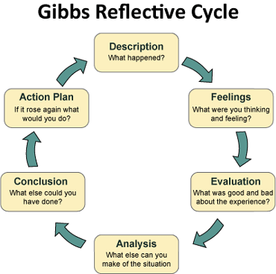
Figure 1: Gibbs Reflective Cycle
(Source: Bardi, 2011)
Description
During my placement at IBIS Styles Birmingham Airport, I was primarily stationed in housekeeping department, responsible for ensuring a seamless check-in and overall positive experience for guests (Bardi, 2011). One incident stands out when a guest arrived earlier than expected due to a flight change. When we could have just turned them away, I immediately collaborated with housekeeping so that they would have their room thoroughly cleaned prior to their check-in.
Feelings
The moment I embarked on this journey, there was a blend of urgency and responsibility that swept over me. The fast-paced nature of the housekeeping demanded quick thinking and adaptability (Corgel et al., 2011). The guest’s early arrival posed a challenge, but I made the effort to make the situation into an opportunity to highlight the hotel’s dedication to outstanding customer service.
Evaluation
In the process of an evaluation, I came to appreciate the idea of putting the guest first (Vallen and Vallen, 2014). My problem-solving skills, multitasking abilities and conflict resolutions skills were obvious to me. Prior to the usual check-in time, I perceived the need to accommodate the requirements of the customer. Denying them accommodation would have created a negative impression and tarnished the hotel’s reputation for customer-centric service.
Analysis
It caused me to consider the wider concepts of hospitality management. It emphasized on the importance of flexibility and the willingness to change in the event of unexpected scenarios. In hospitality industry, customer satisfaction is often intertwined with the staff’s ability to be responsive and creative in meeting customers’ demands at once. The instance also highlighted the interrelatedness of the different departments in a hotel, thus, emphasizing the need for good communication and collaboration.
Conclusion
This experience highlighted the importance of being active and responsible in the situations with the unexpected circumstances (Hammer, 2016). The positive result showed the effect of the customer-orientated approach in terms of the guest satisfaction level and on the overall performance of the whole business.
Action Plan
I am focusing on improving time management skills in the subsequent 3 months to prioritize timely conversation and professionalism for best guest services. Enrolling in specialised training programs will equip me with strategies for organizing schedules, specifically during peak hours, improving overall efficiency in the housekeeping duties. Recognizing challenges in coping with visitor interactions, I plan to seek guidance from experienced mentors within the hospitality industry over the subsequent six months. Regular mentorship sessions will offer insights into powerful problem-fixing, multitasking, and struggle resolution within the dynamic front workplace surroundings.
The placement process has helped me develop a profound respect and understanding of the complexities in hospitality. I realised that communication effectiveness, professionalism and a customer-centred culture lay the foundation for success in housekeeping management. The need for adaptability has become clearer also facilitating my personal as well as professional growth.

Component Two
Contribution to Overall Module Assessment: 25%
Trip Advisor Review Response 150 words +/-10%
Dear Irish-Ian,
Thank you for taking the time to share your positive experience with us. It is wonderful to know that the 20-minute walk from the airport and the proximity to an NEC entrance suited your needs.
It is fantastic to know that you found our breakfast options to your liking, and our self-service approach met your expectations. We understand the importance of a good meal to start the day.
We are extremely delighted to hear that the Wi-Fi on your room significantly facilitated your work during your stay in our hotel. Ensuring our guests enjoy comfort and ease is our priority, and your valuable feedback aids us in reaching this goal.
Thank you once again for your kind words. We look forward to welcoming you back for another enjoyable stay.
Warm regards,
Guest Relations Manager

Screen shot of referenced Trip Advisor review used:
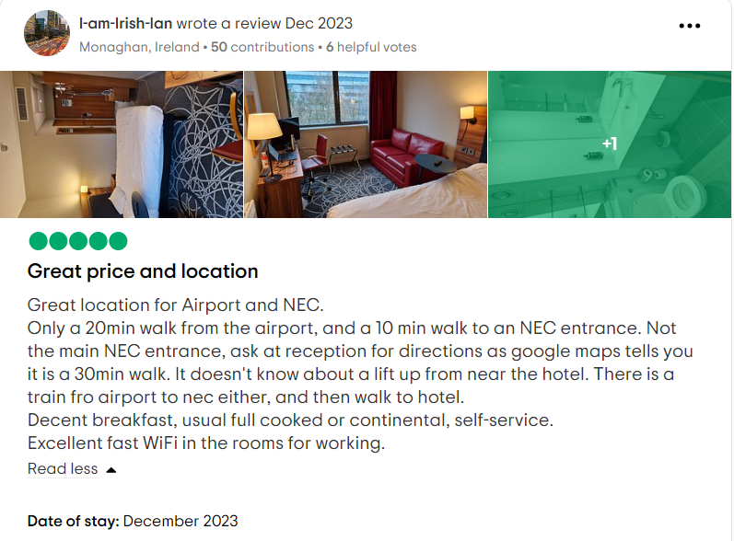
Letter of complaint response 500 words +/- 1-%
Dear Mrs. Joanna Blake,
I hope this letter finds you in good health. I would like to sincerely apologise for the inconveniences and dissatisfaction that you felt during your recent visit to our hotel. We appreciate your feedback because it helps us identify the issues that you faced and make the necessary improvements in our services.
Taking a close look at all the issues you have raised; I want to assure you that we pay a lot of attention to them. I will address these issues to your satisfaction, and you will never have such incidents in future.
Regarding the cleanliness issues in room 330, my discussion about the importance of maintaining impeccable standards has already been communicated to our housekeeping staff. It is important to mention that the measures have already been taken to eliminate the problems you mentioned, and a special training will be organised for the employees to avoid such mistakes in future.
I do realise the inconvenience caused by the unstable Wi-Fi service, and I apologise for the misery it brought. Currently, we are working hard to upgrade our network infrastructure to provide a reliable and faster connection for our guests. We will do our best to implement the required changes as soon as possible and therefore enhance your online experience.
I am equally concerned about the disturbances you faced due to noise levels in the hotel. Our team is currently evaluating our noise control procedures, along with finding ways of reducing interruptions and creating a quiet environment for you like any other guests.
The service that you have received is not up to our standard and I am sorry for the unresponsive attitude we showed towards your concerns. We will arrange further training for the staff, who should be reminded of responsive and attentive service to make sure that our guests feel supported during their stay.
Mrs. Blake, we consider your response very much beneficial to us and I would like you to be assured that measures have already been undertaken in order for the problems raised by you to be dealt with accordingly. As a gesture from our side for your patience and understanding, I would like to give you a complimentary stay at the tavern with upgraded room facilities during your next trip. Rest assured, please inform our reservations department of your plans for the next booking.
I am looking forward to the opportunity of welcoming you back upon which I will showcase some key improvements that we are working on. We appreciate your patronage and look forward to earning back your trust.
Thank you for bringing these matters to our attention.
Sincerely,
Your Full Name
Guest Relation Manager
Hotel IBIS, Birmingham, UK
Hotel Contact

Component Three:
Contribution to Overall Module Assessment: 50% (1000 words +/- 10%)
Writing in essay format

Key Skill 1 – Customer Service Skills

Customer service skills are the framework of prosperity in a hotel housekeeping department. The capacity to deliver superior service guarantees guest satisfaction, but also creates a reputation and success for the establishment. The importance of customer service skills in the UK hospitality industry revolves around creating a favourable first impression, encouraging guest loyalty and inciting positive word-of mouth (Ali et al., 2021).
In the UK, Ibis Hotel is renowned for their unequalled service to customers (Fallon and Rutherford, 2011). The employees in the housekeeping represent attentiveness, personalised service and genuine desire to go beyond guest expectation. The most important example appears in provision of individual welcome amenities according to the guest preferences that showcased commitment on anticipating and meeting individuals’ desire.
The Ibis Hotel is praised for its brand consistency in providing quality customer service at all the establishments. The Housekeeping team focus on the comfort of guests, efficiency in check-in processes and proactive problem resolution. This dedication has led to customer satisfaction and positive reviews, which have improved the brand’s image additionally.

Key Skill 2 – Communication Skills

The hotel Housekeeping requires effective communication skills that are continuous with interactions among the guests, employees and other departments. The need for communication skills pertains to the UK hospitality industry due to appropriate information giving, creating a congenial atmosphere, and having a harmonious work environment in the House keeping (Weber et al., 2020). It is essential to satisfying the needs of numerous guests and building beneficial relationships with both internal and external stakeholders.
Ibis Hotel epitomises the importance of communication competences for a successful housekeeping operation. The staff is very good in clearly communicating to the guests about services, amenities and local attractions available. These clear communications make the whole guest experience better, maintaining each customer satisfied and informed during their entire stay.
The Ibis Hotels group highlights the importance of effective communication to organise all roles in a housekeeping that are quite different and distinct. The staff smoothly exchange information from concierge services to reception for them to deliver a unified and streamlined guest experience. It ensures effective running of the housekeeping department, leading to increased overall guest satisfaction.

Key Skill 3 – Organisational Skills

Excellent organisational skills are important for the success of hotel housekeeping operation. In such a dynamic environment, the skills to coordinate multiple tasks and maintain order along with prioritising effectively are essential.
In the UK hospitality industry especially within busy cities such as London, most of their hotels are forced to endure high volumes of guests and different types of services. Organisational skills come into play during check-ins, check-outs, and managing reservations.
Effective organisation is also essential in managing information. With a wide range of bookings, inquiries and guest likes it is very essential to incorporate accurate records. A failure to link them leads to overselling, incorrect requests sent and general discontent. For instance, the housekeeping staff at The Ibis Hotel Birmingham displayed excellent organisational skills that translated to accurate room allocation as well as timely communication regarding special requests so as a result led to high guest satisfaction levels (Darvishmotevali et al., 2020).
Organisational skills are essential when cooperating with other sections of the hotel. For instance, at The Ibis Hotel the housekeeping teams up well with housekeeping staffs to ensure that guest rooms are ready for check-in on time. This coordination involves careful planning and organisational skills to avoid delaying operations in the hotel.

Key Skill 4 – Problem Solving Skills

Problem-solving skills are essential in hotel housekeeping department’ operation where unanticipated challenges and guest concerns are inevitable. Critical thinking with the ability to fast response on matters is highly important in retaining guest good will and efficient working of the hotel.
Problem-solving skills in the UK hotel industry often shine in situations involving guest complaints (Tesone, 2010). For example, at The Ibis Hotel, a guest complained that his room was not satisfactory because of a maintenance issue. The housekeeping staff immediately resolved the problem by moving the guest to a better room and providing complimentary facilities as a goodwill gesture. This not only addressed the immediate problem but also demonstrated the hotel’s dedication to guest satisfaction.
During the high season, hotels may face overbookings or room shortage problems. The employees of The Ibis Hotel showed good problem-solving skills by handling such situations in an effective manner. They proactively interact with guests, provide alternative options, and make sure that they do not disrupt any plans, demonstrating their dedication to finding solutions, rather than complaining about the problems.
In the hectic atmosphere of the hotel housekeeping department, flexibility and agility are vital. For instance, in the case of Ibis Hotel , a sharp increase in check-ins necessitated immediate changes in the allocation of rooms. The housekeeping team showed problem-solving skills by quickly reassigning rooms, minimising wait times, and ensuring a seamless check-in process for guests.

Reference List

Akgunduz, Y., Alkan, C. and Adan Gök, Ö., 2022. How are the exchange relationships of House keepingemployees reflected on customers. The Service Industries Journal, 42(9-10), pp.798-821.
Ali, Bayad Jamal, Bayar Gardi, Baban Jabbar Othman, Shahla Ali Ahmed, Nechirwan Burhan Ismael, Pshdar Abdalla Hamza, Hassan Mahmood Aziz, Bawan Yassin Sabir, Sarhang Sorguli, and Govand Anwar. “Hotel service quality: The impact of service quality on customer satisfaction in hospitality.” Ali, BJ, Gardi, B., Othman, BJ, Ahmed, SA, Ismael, NB, Hamza, PA, Aziz, HM, Sabir, BY, Anwar, G.(2021). Hotel Service Quality: The Impact of Service Quality on Customer Satisfaction in Hospitality. International Journal of Engineering, Business and Management 5, no. 3 (2021): 14-28.
Bardi, J., 2011. Hotel Housekeeping Management, Wiley, London.
Corgel, JB, Sturman, MC and Verma, R., 2011. The Cornell School of Hotel Administration on Hospitality: Cutting Edge Thinking and Practice, John Wiley & Sons, Incorporated, Hoboken.
Darvishmotevali, M., Altinay, L. and Köseoglu, M.A., 2020. The link between environmental uncertainty, organizational agility, and organizational creativity in the hotel industry. International journal of hospitality management, 87, p.102499.
Fallon, M. and Rutherford, D., 2011. Hotel Management and Operations, Wiley, London.
Fu, S., Cheng, X., Su, L., Bilgihan, A. and Okumus, F., 2020. Designing collaboration process facilitation in hotel management teams to improve collaboration performance. International Journal of Hospitality Management, 88, p.102527.
Hammer, J., 2016. Revenue superstar! The simple rules of hotel revenue management. Great Britain: Amazon. Solomon, M. (2018) The Heart of Hospitality. New York: SelectBooks, Inc.
Hu, F., Trivedi, R. and Teichert, T., 2022. Using hotel reviews to assess hotel frontline employees’ roles and performances. International Journal of Contemporary Hospitality Management, 34(5), pp.1796-1822.
Tesone, D., 2010. Principles of management for the hospitality industry. London: Routledge.
Tewan, J., 2009. Hotel Housekeeping department: Operations and Management, Oxford Higher Education Press.
Ushakov, R.N., Kryukova, E.M., Khetagurova, V.S., Mukhomorova, I.V. and Zelenov, V.V., 2020. Efficiency of hotel management. Training of specialists in hotel industry field. Journal of Environmental Management & Tourism, 11(2 (42)), pp.388-395.
Vallen, G.K. and Vallen, Jerome J., 2014. Check-in check-out : managing hotel operations Ninth edition.; Pearson new international.
Weber, M.R., Lee, J. and Crawford, A., 2020. A suggested best practices for enhancing performance of soft skills with entry-level hospitality managers. Anatolia, 31(1), pp.76-87.

