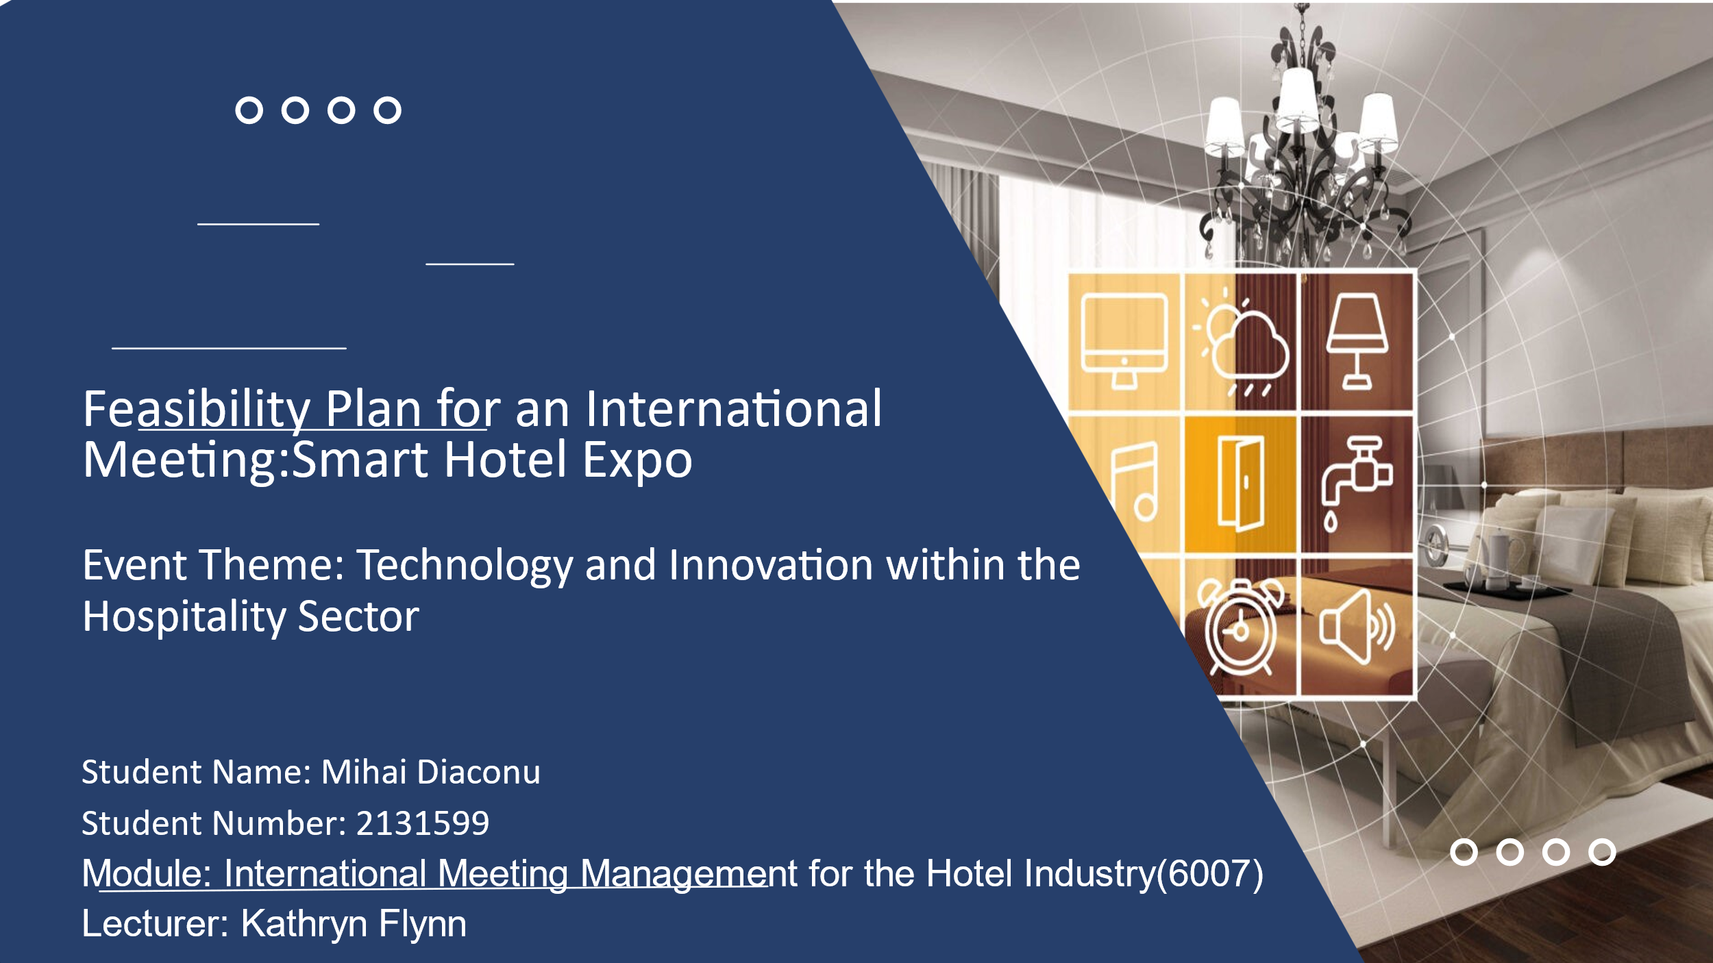

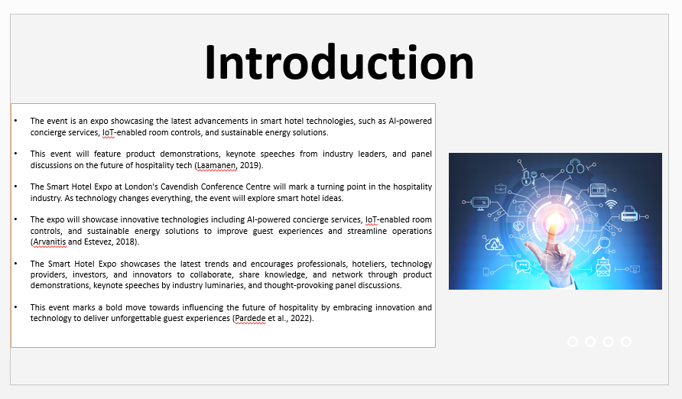

Introduction
The event is an expo showcasing the latest advancements in smart hotel technologies, such as AI-powered concierge services, IoT-enabled room controls, and sustainable energy solutions. This event could feature product demonstrations, keynote speeches from industry leaders, and panel discussions on the future of hospitality tech (Laamanen, 2019). The Smart Hotel Expo at London's Cavendish Conference Centre will mark a turning point in the hospitality industry. As technology changes everything, the event will explore smart hotel ideas. The expo will showcase innovative technologies including AI-powered concierge services, IoT-enabled room controls, and sustainable energy solutions to improve guest experiences and streamline operations (Arvanitis and Estevez, 2018). The Smart Hotel Expo showcases the latest trends and encourages professionals, hoteliers, technology providers, investors, and innovators to collaborate, share knowledge, and network through product demonstrations, keynote speeches by industry luminaries, and thought-provoking panel discussions. This event marks a bold move towards influencing the future of hospitality by embracing innovation and technology to deliver unforgettable guest experiences (Pardede et al., 2022).

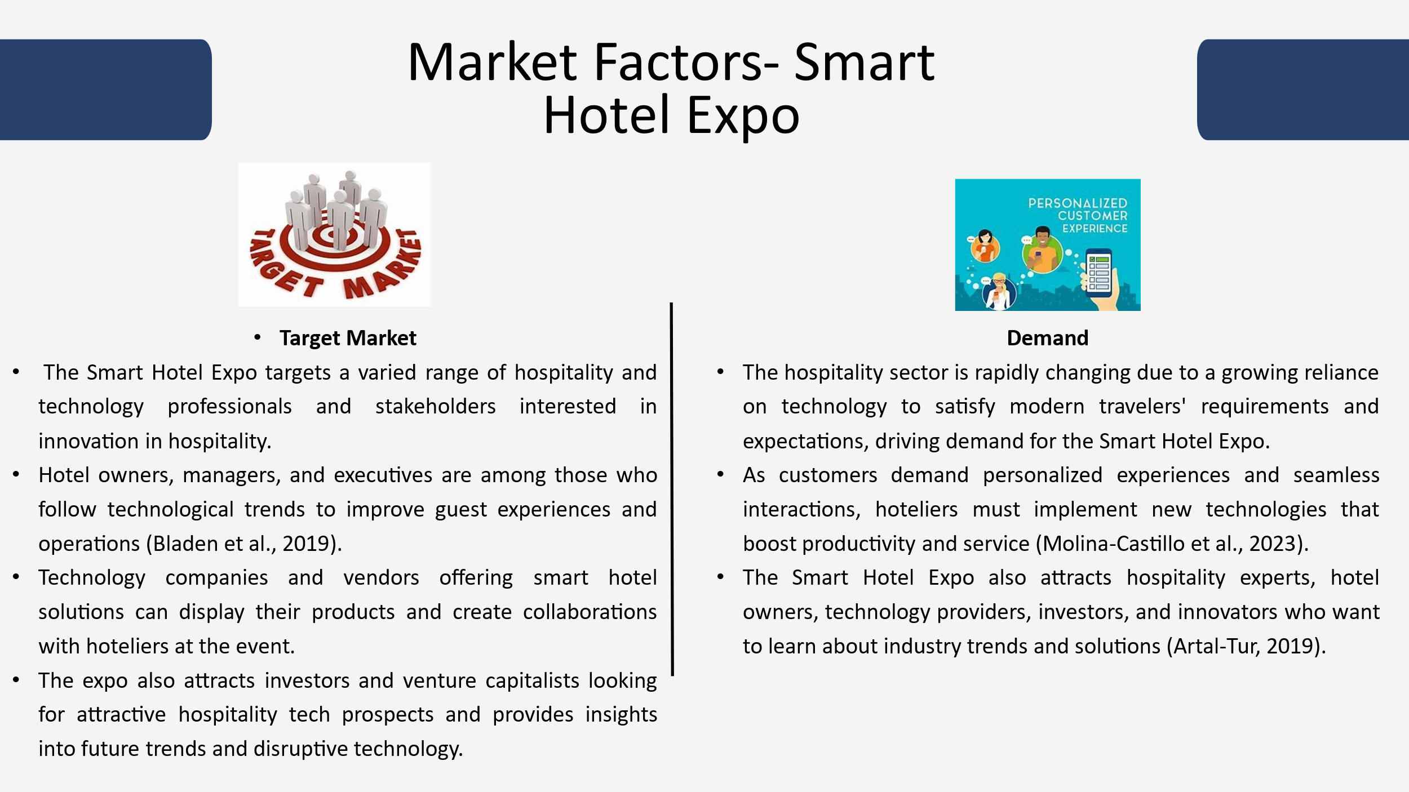

Market Factors
Target Market: The Smart Hotel Expo targets a varied range of hospitality and technology professionals and stakeholders interested in innovation in hospitality. Hotel owners, managers, and executives are among those who follow technological trends to improve guest experiences and operations (Bladen et al., 2019). Here, technology companies and vendors offering smart hotel solutions can display their products and create collaborations with hoteliers at the event. Also, the expo also attracts investors and venture capitalists looking for attractive hospitality tech prospects and provides insights into future trends and disruptive technology where industry analysts, researchers and academics interested in technology's impact on hospitality benefit from the event's expertise and networking possibilities (O'Toole, 2020).
Demand: Also, the hospitality sector is rapidly changing due to a growing reliance on technology to satisfy modern travelers’ requirements and expectations, driving demand for the Smart Hotel Expo where as customers demand personalized experiences and seamless interactions, hoteliers need to implement new technologies that boost productivity and service (Molina-Castillo et al., 2023). Then, the growing awareness of sustainability and the desire to reduce environmental footprints makes energy-efficient technologies and eco-friendly practices more appealing. Also, the Smart Hotel Expo also attracts hospitality experts, hotel owners, technology providers, investors, and innovators who want to learn about industry trends and solutions (Artal-Tur, 2019). Thus, the exhibition is a hub for knowledge sharing, cooperation, and networking, giving guests the chance to discover new innovations, form strategic relationships, and learn from industry professionals. Also, the lack of smart hotel technology events highlights the need for a platform specialized to this sector whereas the Smart Hotel Expo will draw a large audience interested in technology-driven hospitality innovations as it fills this market gap. Also, the industry's embrace of technical advances and stakeholders' eagerness for leveraging these technologies for competitive advantage and sustainable growth show great demand for the exhibition (Kazandzhieva et al., 2019).

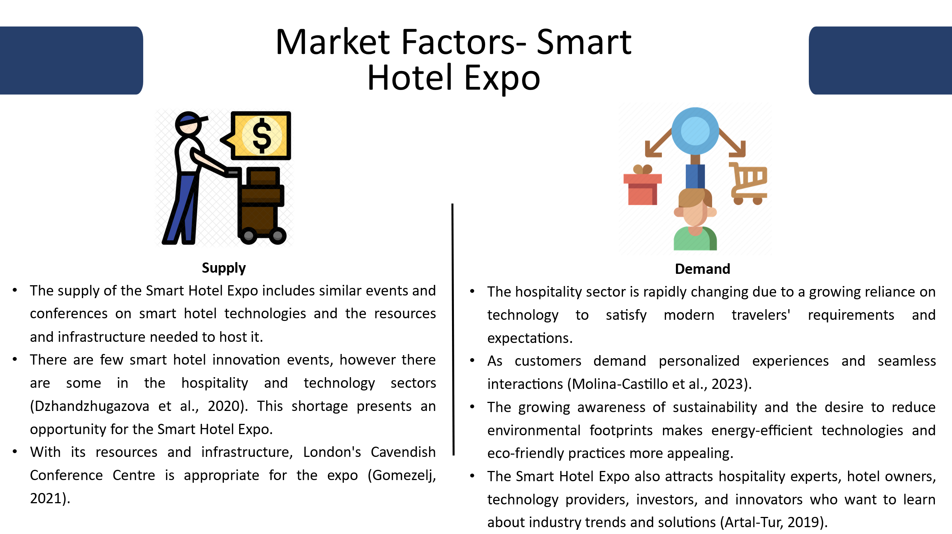

Supply: Here, the supply of the Smart Hotel Expo includes similar events and conferences on smart hotel technologies and the resources and infrastructure needed to host it. Also, there are few smart hotel innovation events and however, there are some in the hospitality and technology sectors (Dzhandzhugazova et al., 2020). Thus, this shortage presents an opportunity for the Smart Hotel Expo to address a market gap with a unique venue for hospitality technology specialists. Then, London's Cavendish Conference Centre is appropriate for the expo with its resources and infrastructure. Also, the center's modern amenities, ample space, and convenient location make it ideal for exhibitors, presenters, and guests to network (Gomezelj, 2021). The venue's technical capabilities allow audiovisual and other technology setups for product displays and panel discussions to be seamlessly integrated. Skilled event planners, technologists, and support workers also help supply the Smart Hotel Expo. These experts in logistics management, marketing, and hotel services help the event run smoothly and improve participant satisfaction. Thus, while specialized events and resources are scarce, the Smart Hotel Expo uses them to provide a compelling and powerful venue for studying hospitality technology and innovation (Radu and Vasile, 2022).
Competition: The Smart Hotel Expo competes with events, hospitality, and technology events. While there may not be direct competitors offering identical events, various factors could affect the Expo's performance and distinction. The hospitality industry has many trade fairs, conferences, and exhibitions on hotel management, guest experience, and sustainability. (Tian, 2024) The target audience may be interested in hospitality trends, but these events may not focus on smart hotel technologies. Technology conferences and expos also cover AI, IoT, and renewable energy. These events may address smart hotel topics, however the Smart Hotel Expo covers them more thoroughly (Mair, 2022). In light of global events and travel restrictions, internet platforms and virtual events may indirectly compete with the Expo. Virtual conferences and webinars are becoming more popular internationally due to their convenience and accessibility. The Smart Hotel Expo must highlight its unique value proposition—its focus on smart hotel technologies, curated program featuring industry leaders, hands-on product demonstrations, and meaningful networking and collaboration—to stand out and compete. Thus, the Expo can become a leading hospitality technology event as it explains these benefits and engaging its target audience through targeted marketing and smart collaborations (Shone and Parry, 2019).

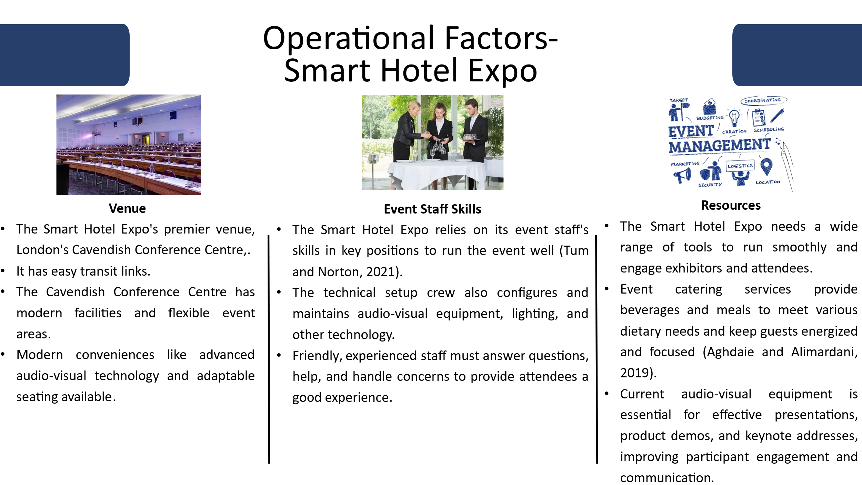

Operational Factors
Venue: Here, the Smart Hotel Expo's premier venue, London's Cavendish Conference Centre, suits its goals and audience. Also, local and international attendees can easily attend the location in central London because to its easy transit links (Aghdaie and Alimardani, 2019). Then, the Cavendish Conference Centre has modern facilities and flexible event areas for displays, presentations and networking. Also, modern conveniences like advanced audio-visual technology and adaptable seating accommodate the expo's dynamic needs and thus, enables exhibitors and spectators to interact meaningfully. Then, the venue's competence and professionalism match the expo's goals of showcasing cutting-edge technologies and fostering hospitality innovation (Fleisher and Bensoussan, 2019). The Cavendish Conference Centre is ideal for elevating the Smart Hotel Expo to a top industry event due to its refinement, accessibility, and functionality.
Event Staff Skills: The Smart Hotel Expo relies on its event staff's skills in key positions to run the event well. The expo's success depends on event coordination, which involves careful planning, scheduling, and logistics (Tum and Norton, 2021). The technical setup crew also configures and maintains audio-visual equipment, lighting, and other technology for product demos, presentations, and interactive exhibitions. Friendly, experienced staff must answer questions, help, and handle concerns to provide attendees a good experience. Logistics management optimizes resource allocation and minimizes disruptions by organizing transportation, storage, and distribution of goods, equipment, and supplies. The event staff's expertise also includes event planning, which includes strategic decision-making, budget management, and vendor coordination; technical support, which ensures technology runs smoothly; marketing, which boosts attendance and engagement through effective promotions; and hospitality, which provides excellent service and experiences (Fleisher and Bensoussan, 2019). Event staff's various skills and knowledge ensure the Smart Hotel Expo exceeds expectations and provides unmatched value to exhibitors and attendees.
Resources: The Smart Hotel Expo needs a wide range of tools to run smoothly and engage exhibitors and attendees. Event catering services provide beverages and meals to meet various dietary needs and keep guests energized and focused (Aghdaie and Alimardani, 2019). Current audio-visual equipment is essential for effective presentations, product demos, and keynote addresses, improving participant engagement and communication. Signage also helps attendees and exhibitors navigate the site and maximizes sponsor and exhibitor exposure. Well-designed seating maximizes comfort and visibility, allowing participants to actively participate in presentations and discussions (Ahmed, 2022). Car-traveling attendees need enough parking for ease and accessibility. Catering, audio-visual equipment, signage, seating, and parking can help the Smart Hotel Expo foster networking, learning, and collaboration, improving the experience for all participants and stakeholders.

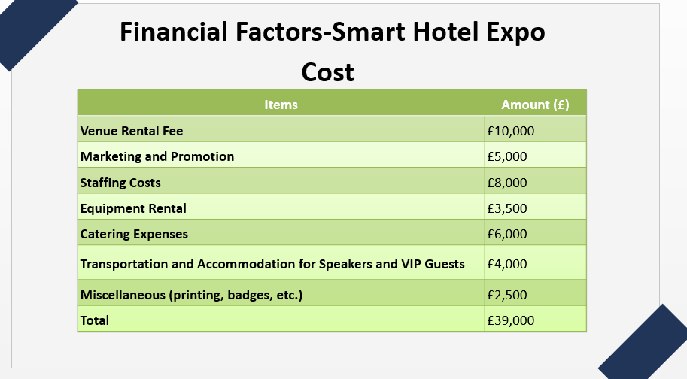

Financial Factors

Costs

Items | Amount (£)
Venue Rental Fee | £10,000
Marketing and Promotion | £5,000
Staffing Costs | £8,000
Equipment Rental | £3,500
Catering Expenses | £6,000
Transportation and Accommodation for Speakers and VIP Guests | £4,000
Miscellaneous (printing, badges, etc.) | £2,500
Total | £39,000

The Smart Hotel Expo costs are strategically allocated to provide a high-quality and meaningful event experience. £10,000 for venue rental is the biggest expense, highlighting the necessity of finding a reputable and well-equipped facility like the Cavendish Conference Centre in London (Jones and Butler, 2022). Targeted advertising and promotional strategies cost £5,000 to raise awareness, attract attendees, and maximize the event's reach and impact. The expo runs smoothly thanks to £8,000 in event organizer, technical support, and customer service pay. Audio-visual, lighting, and other technical infrastructure for presentations and displays cost £3,500 to hire. Catering costs £6,000, providing beverages and food to attendees, improving their experience. Transportation and lodging for speakers and VIP guests cost £4,000, reflecting the expenditure in getting high-profile speakers and facilitating their attendance. Miscellaneous expenses of £2,500 cover printing, badges, and other logistical needs. These costs are wise investments in a successful and memorable Smart Hotel Expo (Rompf et al., 2019).

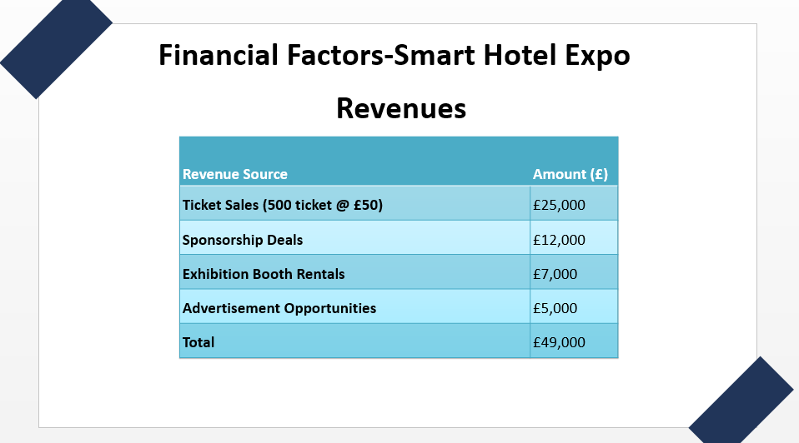

Revenues
Revenue Source | Amount (£)
Ticket Sales (500 ticket @ £50) | £25,000
Sponsorship Deals | £12,000
Exhibition Booth Rentals | £7,000
Advertisement Opportunities | £5,000
Total | £49,000

Smart Hotel Expo revenue is broad and skillfully nurtured to achieve financial sustainability and profitability. With 500 £50 tickets sold, the event raised £25,000. This income stream gives guests access and measures expo demand (Tian, 2024). Sponsorship arrangements with technology businesses, hospitality brands, and industry stakeholders seeking to match with the expo's subject and audience have raised £12,000. Exhibition booth rentals generate £7,000 as exhibitors present their products and services to industry professionals and decision-makers. Advertisements also generate £5,000 in revenue by exposing brands to guests (Ahmed, 2022). The Smart Hotel Expo maximizes revenue and benefits sponsors, exhibitors, and attendees by diversifying revenue sources and utilizing its value proposition.
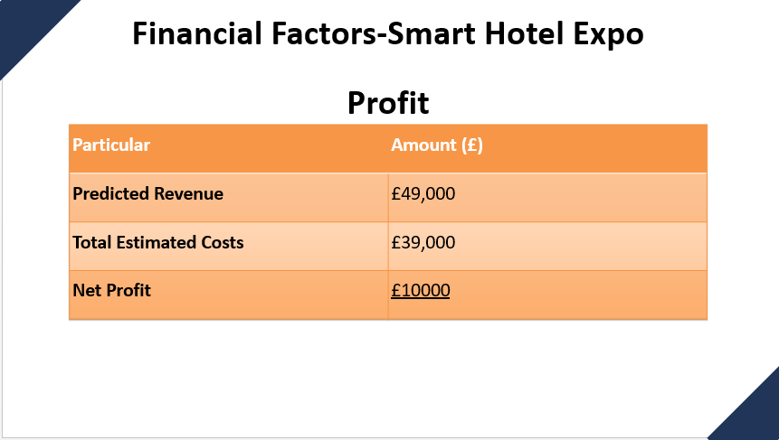

Profit
Particular | Amount (£)
Predicted Revenue | £49,000
Total Estimated Costs | £39,000
Net Profit | £10000
The Smart Hotel Expo's £10,000 net profit shows its financial feasibility and target achievement. The expo exceeded its financial goals by carefully balancing income and cost management, resulting in a good ROI. The event's £49,000 expected revenue from ticket sales, sponsorship partnerships, exhibition booth rentals, and advertising shows its capacity to attract people and engage stakeholders, monetizing its value offer (Radu and Vasile, 2022). The £39,000 expected costs include venue rental, marketing and promotion, staffing, equipment rental, catering, transportation, housing and miscellaneous charges, demonstrating solid financial planning and resource utilization. The expo's £10,000 net profit shows its potential to create surplus cash above operational expenses and thus, allow for contingencies, future investments, or reinvestment in its services and impact (Artal-Tur, 2019). The net profit shows that the Smart Hotel Expo delivered value to stakeholders and ensured financial sustainability and growth for future editions.
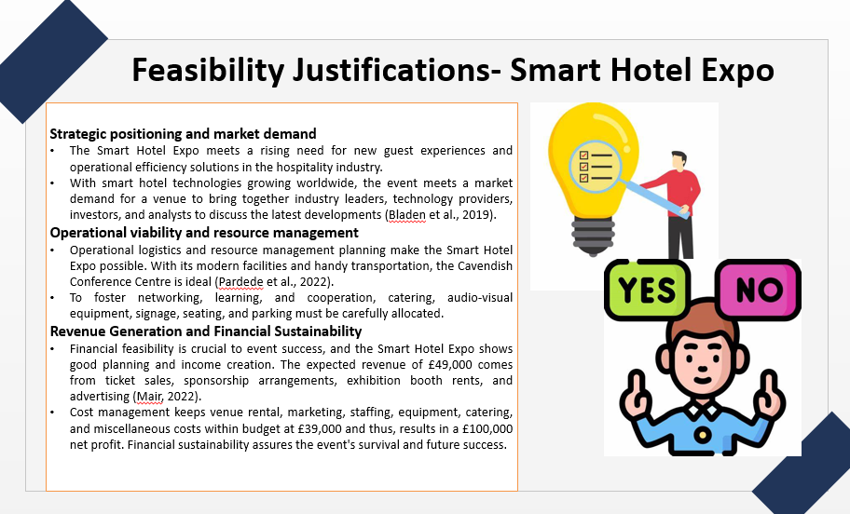

Feasibility Justification
Strategic positioning and market demand: The Smart Hotel Expo meets a rising need for new guest experiences and operational efficiency solutions in the hospitality industry. With smart hotel technologies growing worldwide, the event meets a market demand for a venue to bring together industry leaders, technology providers, investors, and analysts to discuss the latest developments (Bladen et al., 2019). The expo's strategic location in London, a technology and hospitality hub, makes it more appealing and accessible to a diverse audience, maximizing engagement and participation.
Operational viability and resource management: Operational logistics and resource management planning make the Smart Hotel Expo possible. With its modern facilities and handy transportation, the Cavendish Conference Centre is ideal (Pardede et al., 2022). Event operations run well with enough event coordinators, technology setup technicians, customer support reps, and logistics managers. To foster networking, learning, and cooperation, catering, audio-visual equipment, signage, seating, and parking must be carefully allocated.
Revenue Generation and Financial Sustainability: Financial feasibility is crucial to event success, and the Smart Hotel Expo shows good planning and income creation. The expected revenue of £49,000 comes from ticket sales, sponsorship arrangements, exhibition booth rents, and advertising (Mair, 2022). Cost management keeps venue rental, marketing, staffing, equipment, catering, and miscellaneous costs within budget at £39,000 and thus, results in a £100,000 net profit. Financial sustainability assures the event's survival and future success.

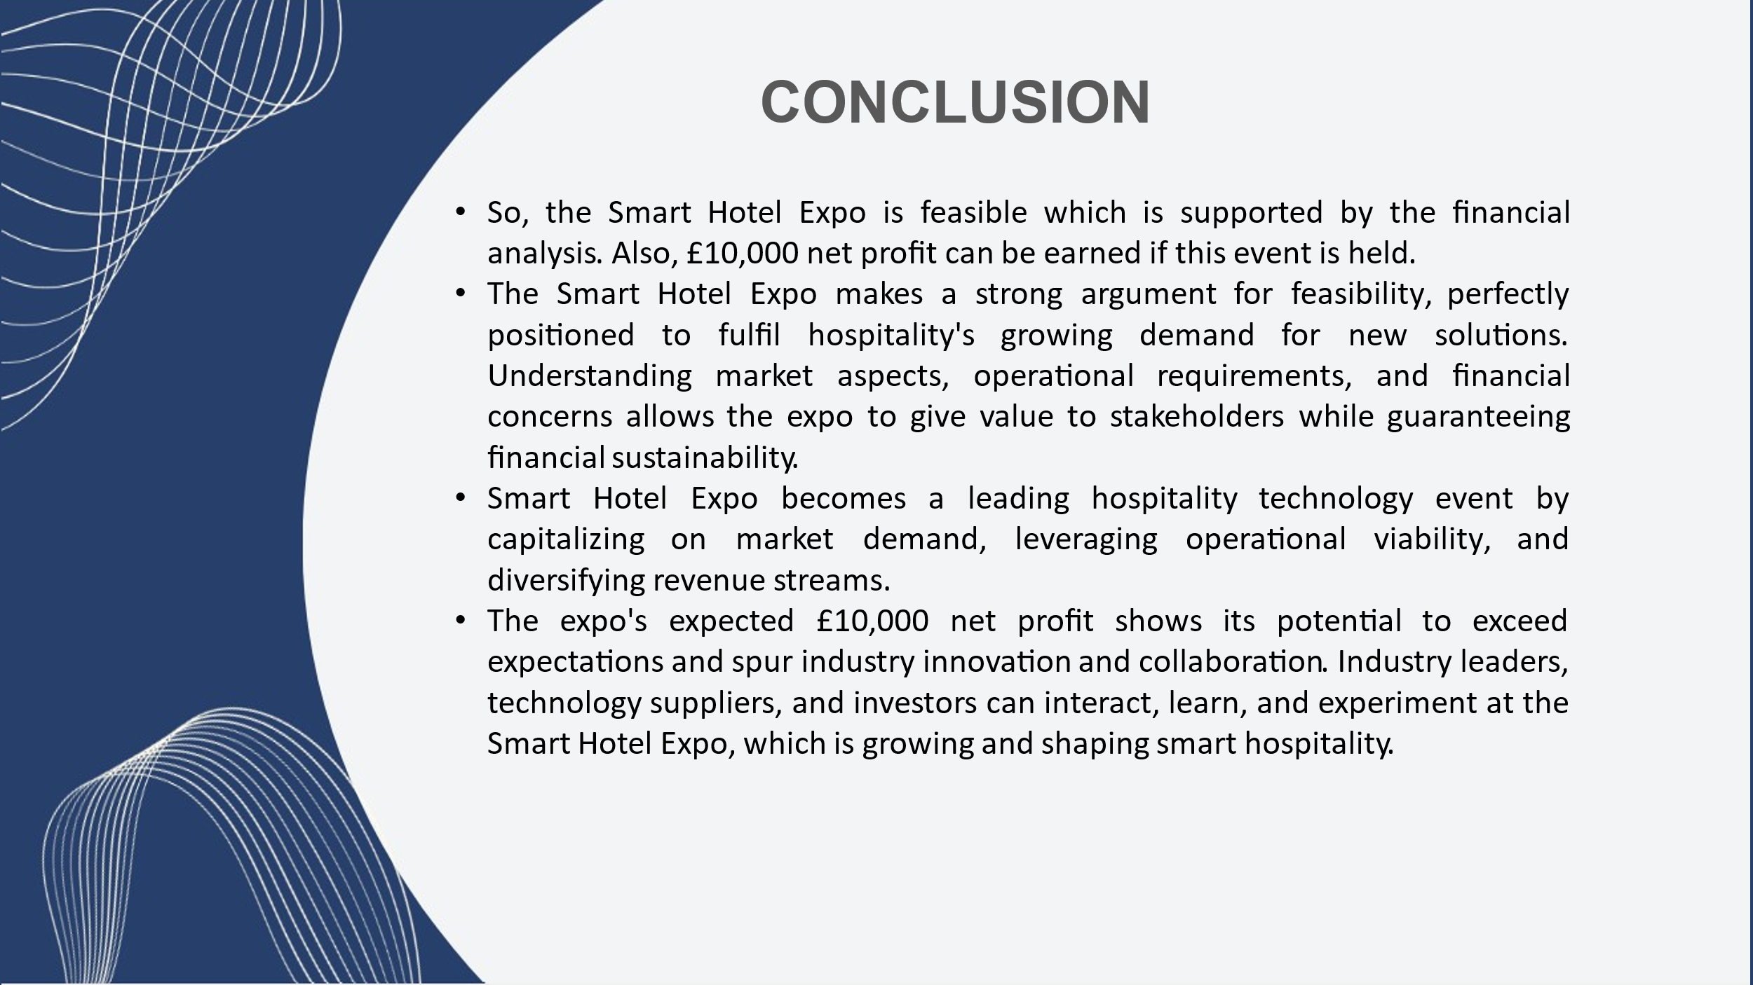

Conclusion
So, the event on Future of Dining Symposium is feasible which is supported by the financial analysis. Also, £15,000 net profit can be earned if this event is held. The Smart Hotel Expo makes a strong argument for feasibility, perfectly positioned to fulfil hospitality's growing demand for new solutions. Understanding market aspects, operational requirements, and financial concerns allows the expo to give value to stakeholders while guaranteeing financial sustainability. Smart Hotel Expo becomes a leading hospitality technology event by capitalising on market demand, leveraging operational viability, and diversifying revenue streams. The expo's expected £10,000 net profit shows its potential to exceed expectations and spur industry innovation and collaboration. Industry leaders, technology suppliers, and investors can interact, learn, and experiment at the Smart Hotel Expo, which is growing and shaping smart hospitality.

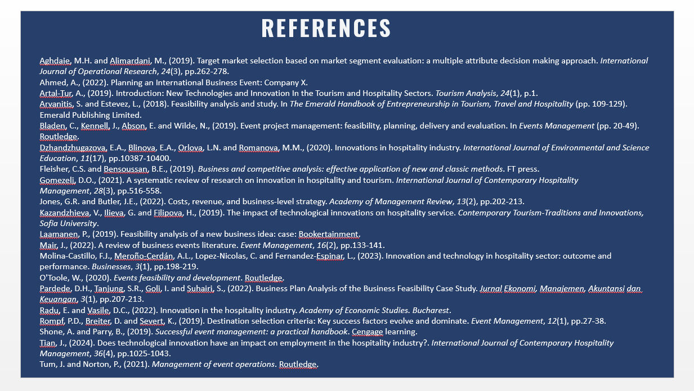

References
Aghdaie, M.H. and Alimardani, M., (2019). Target market selection based on market segment evaluation: a multiple attribute decision making approach. International Journal of Operational Research, 24(3), pp.262-278.
Ahmed, A., (2022). Planning an International Business Event: Company X.
Artal-Tur, A., (2019). Introduction: New Technologies and Innovation In the Tourism and Hospitality Sectors. Tourism Analysis, 24(1), p.1.
Arvanitis, S. and Estevez, L., (2018). Feasibility analysis and study. In The Emerald Handbook of Entrepreneurship in Tourism, Travel and Hospitality (pp. 109-129). Emerald Publishing Limited.
Bladen, C., Kennell, J., Abson, E. and Wilde, N., (2019). Event project management: feasibility, planning, delivery and evaluation. In Events Management (pp. 20-49). Routledge.
Dzhandzhugazova, E.A., Blinova, E.A., Orlova, L.N. and Romanova, M.M., (2020). Innovations in hospitality industry. International Journal of Environmental and Science Education, 11(17), pp.10387-10400.
Fleisher, C.S. and Bensoussan, B.E., (2019). Business and competitive analysis: effective application of new and classic methods. FT press.
Gomezelj, D.O., (2021). A systematic review of research on innovation in hospitality and tourism. International Journal of Contemporary Hospitality Management, 28(3), pp.516-558.
Jones, G.R. and Butler, J.E., (2022). Costs, revenue, and business-level strategy. Academy of Management Review, 13(2), pp.202-213.
Kazandzhieva, V., Ilieva, G. and Filipova, H., (2019). The impact of technological innovations on hospitality service. Contemporary Tourism-Traditions and Innovations, Sofia University.
Laamanen, P., (2019). Feasibility analysis of a new business idea: case: Bookertainment.
Mair, J., (2022). A review of business events literature. Event Management, 16(2), pp.133-141.
Molina-Castillo, F.J., Meroño-Cerdán, A.L., Lopez-Nicolas, C. and Fernandez-Espinar, L., (2023). Innovation and technology in hospitality sector: outcome and performance. Businesses, 3(1), pp.198-219.
O'Toole, W., (2020). Events feasibility and development. Routledge.
Pardede, D.H., Tanjung, S.R., Goli, I. and Suhairi, S., (2022). Business Plan Analysis of the Business Feasibility Case Study. Jurnal Ekonomi, Manajemen, Akuntansi dan Keuangan, 3(1), pp.207-213.
Radu, E. and Vasile, D.C., (2022). Innovation in the hospitality industry. Academy of Economic Studies. Bucharest.
Rompf, P.D., Breiter, D. and Severt, K., (2019). Destination selection criteria: Key success factors evolve and dominate. Event Management, 12(1), pp.27-38.
Shone, A. and Parry, B., (2019). Successful event management: a practical handbook. Cengage learning.
Tian, J., (2024). Does technological innovation have an impact on employment in the hospitality industry?. International Journal of Contemporary Hospitality Management, 36(4), pp.1025-1043.
Tum, J. and Norton, P., (2021). Management of event operations. Routledge.

