

Global Business Environment

Name : Bianca Petronela Paunescu

Student ID : 2024896

Date : 12.01.2022

TESLA INC

Table of Contents

- About TESLA……………………………………..……………..2
- PESTLE Analysis……….………..…………….…………..……3
- Porter's 5 Forces Analysis….. ……………….……………………..3
- SWOT Analysis……………………….………….……...……....5
- Conclusion……………………………………………………….6
- Reference list……………………………….…..………………..7

Tesla, Inc. is an electric vehicle and energy storage company based in California that designs, manufactures, develops, and sells fully electric cars and energy storage solutions all over the world. Tesla was formed in 2003 by engineers with the purpose of proving that driving an electric automobile does not have to be a sacrifice. Tesla aspires to build automobiles that are superior to gasoline-powered vehicles in every way. Model S, the world's first premium all-electric vehicle, debuted in 2008. Model X, an electric sports vehicle, was added to the company's product line in 2015 and in 2016 they launched a low prices electric vehicle, Model 3. (Marshall, Davies & Stockton 2019). Tesla Inc is the only electric vehicle manufacturer that sells, services, and charges its own automobiles. Customers can charge their Tesla automobiles and have them serviced at those locations. New stations are being added all the time in the United States, Europe, and Asia. (Statistic, 2021).
Tesla Incorporated has a variety of strengths that have aided in the company's stance in the electric vehicle market. Most people are aware that Tesla is the industry leader in electric vehicles, because they were the first to introduce a fully electric sport vehicle in 2008. Tesla's first model, the Roadster, was the first completely automated electric vehicle to hit the market, propelling the company to its current position in the electric vehicle market. Being the first firm to introduce this innovative technology was a strength for Tesla because it established their brand, despite unveiling the Tesla Roadster during one of the worst economic downturns in history. A Tesla may even be customised and bought online, making it very convenient for the customer.

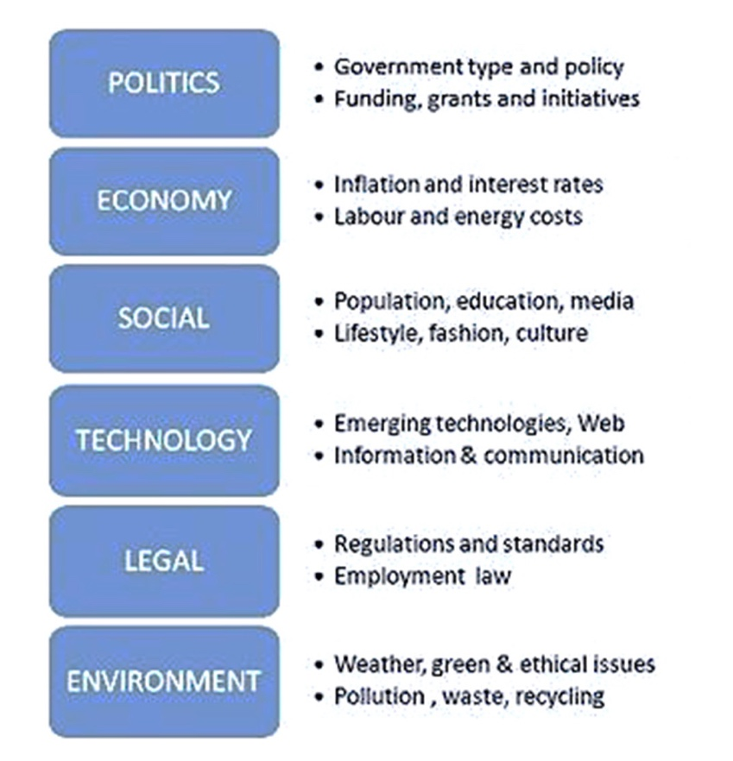

PESTLE is a tool for analysing a company's external environment. It is used to examine how a company's political, economic, social, technological, legal, and environmental factors influence its operations.
Governments have a significant influence on businesses and industries. In terms of political issues, government encouragement towards electrical cars is beneficial for Tesla. On the other side, trade agreement restrictions could impact Tesla's performance. Economic factors that influence Tesla are market changes and trade levels. Tesla's potential is based on lower battery and renewable energy costs. Because the costs are reduced, this has a direct impact on Tesla's business performance.
Tesla's performance is influenced by the social conditions of its employees, customers, and investors. By maximising the benefits of these groups, the hazards of sociocultural variables can be reduced. Tesla's severe workplace safety and health infractions that have been discovered pose a threat to the company's success. Workers require safe working circumstances in order to be productive, and the public is interested in their working conditions.
Tesla's products are linked to technology advancements. As the popularity of mobile services develops, so does the possibility of incorporating them into autos and energy products. (Kissinger, 2019). Laws and regulations are important factors. Tesla could face restrictions on energy consumption and sales laws at its dealerships.
Trends in the environment may have a huge impact on Tesla's success. The availability of materials used in the manufacturing process is affected by these patterns. Climate change, enhanced environmental programmes, and expanding waste disposal regulations all present opportunities for Tesla. These factors make it easier to sell environmentally friendly vehicles.
Tesla's global businesses have a lot of potential because there are so many options for growth. This can be accomplished by stepping up marketing efforts. Additionally, by promoting more vigorously, the abroad market share should be enhanced.
Porter's 5 Forces is an analytical model that helps business managers and marketers to examine the balance of power in a market between different businesses, as well as the potential profitability of an industry sector.
Every industry is shaped by five forces:
1. Competition in the sector
2. Potential for new entrants
3. Supplier power
4. Customer power
5. Threat of replacement products
Understanding these five forces allows a company to make necessary changes to its strategy to become more lucrative. 'Lumby' (1995) is a term used to describe a person who is the threat of new entrants is the sole weak force in this Five Forces analysis, as establishing a new car manufacturing firm requires a significant amount of capital. (2019, Kissinger)
Tesla is one of the largest firms in the electric car market, and in order to achieve its goals of increasing market share and becoming a mass-producing electric vehicle company, it must focus on these external factors.
Companies working in the global automobile industry are influenced by a variety of external variables. The industry is quite competitive. Suppliers use a moderate amount of force in their negotiations. (Kissinger, 2019) The following Five Forces Analysis is used to determine Tesla's potential competitive strategy. Below is a full breakdown of each section.
The threat of new entrants is modest, as evidenced by the following characteristics. The technical requirements of electric vehicles are fairly high as a new business. Electric vehicles have a high manufacturing cost and require significant financial support. (Tesla Inc, 2020). First, hybrid cars and fuel cell electric vehicles are their primary options in terms of environmental preservation and energy utilisation (Jr, V. 2019). Automobiles have been in development for a long time, and while the technology is more mature, reliable, and safe, and there is a high level of market awareness, there is little potential for automotive innovation (Chappell, 2010).
Customers' bargaining power for cars is relatively poor in the context of electric vehicles, mostly due to the following reasons. Individuals that buy electric automobiles are a distinct category of people; they are either wealthy or noble, which are looking for a unique driving experience. (Stein, 2020). Due to a lack of competition for electrical cars and a lack of a point of reference for customers looking to buy them, electrical vehicle firms are forced to set their own prices. From a broad view, suppliers' bargaining strength is poor. The technology, battery management system, is made by Tesla; as a result, Tesla has a technical edge over other firms, and suppliers have little bargaining power. (Irwin, 2016 ; Undercoffler, 2016). At the moment, there are only a few producers of electric vehicles, and the market is still in its early days. (Burke, 2017). Power batteries have been highly valued and the competition is becoming increasingly fierce. (Dixon, 2017).
Tesla’s SWOT Analysis shows the company’s strengths and weaknesses, as well as the opportunities that may arise and threats the can encounter.
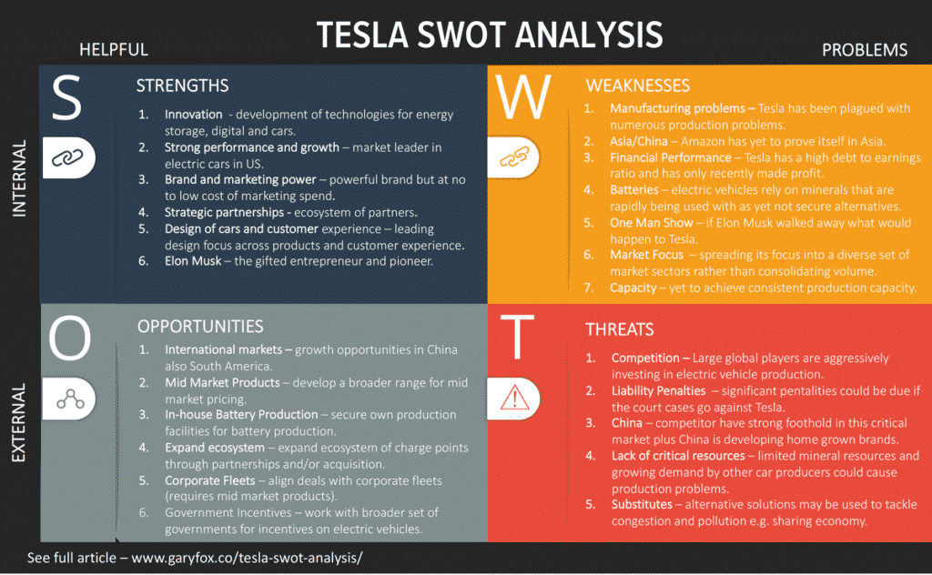

Tesla's strength lies in the concept: luxury electric vehicles that can be affordable. Tesla was the first company to produce a fully electric sports vehicle. Tesla sells their own vehicles. This allows them to communicate directly with its customers, resulting in a more efficient procedure (Tesla Inc, 2019). Tesla's position in the new electric car market in terms of luxurious design, as well as the models' long-range capacity is their biggest asset. In terms of affordability, luxury, and vehicle longevity, they currently offer electric car models that appeal to a wide spectrum of buyers. The Tesla Model S, which costs between $70,000 and $80,000, and their most expensive model, the Tesla X, which costs between $130,000 and $140,000, are two of their more luxurious cars, but they come at a premium price. Tesla vehicles are offered in luxury configurations equivalent to Mercedes-Benz and BMW, and are available in three power levels and three charging methods, allowing customers to enjoy a choice of experiences. The traditional economy is stagnant, whereas the new economy, which encompasses the internet, renewable energy, and electric vehicles, is rapidly evolving. One of the strengths for Tesla is its autonomous driving technology. This new vehicle feature can change the perspective and future of how we travel and use cars.
One of the company’s problems is the automobile prices. Even people who support Tesla and would like to purchase one find the products too expensive. Tesla Model S starts at $76,000, while the Tesla Model X costs $82,000. Model 3 is the more inexpensive model, starting at $35,000 (Tesla Inc., 2019). However, reducing the pricing of the automobile will not generate a profit for the company. The main dangers to Tesla, according to the SWOT analysis, are competitive threats inside the automotive industry. Bigger automakers, such as Nissan and Ford develop more advanced electric vehicles for more affordable prices (Ford Motors, 2019). Another thing to think about is the battery's safety. Due to a series of fires, Tesla's stock price dropped by over 28% in November 2013. Despite having various advantages over other electric vehicles, its battery falls short of the public standard. Another strength, which could also be a weakness, is the presence of Tesla’s pioneer, Elon Musk. Despite the fact that Tesla spends very little money on advertising, its controversial CEO has sparked a lot of interest and anticipation for the firm. This controversial persona has the power to change stock prices over night and influence a whole world, which could start worry the investors, if Elon Musk ever decided to leave Tesla. Tesla appears to be attempting to emulate IT start-ups like as Facebook and Amazon, which operate on digital platforms. By going public, these companies have been able to expand into multibillion-dollar businesses. When they reach a certain size, they receive everything, while others receive nothing. But Tesla is a manufacturing company that must overcome potential manufacturing challenges and compete with established automobile manufacturers with a long track record.
Despite its youth, Tesla has already established itself as one of the world's top ten most valuable vehicle manufacturers. Tesla's mission is to make electric cars more accessible and affordable to a broader variety of people while also developing clean energy generation. They intend to combine their current electric vehicles, batteries, and renewable energy generation and storage in the future. In conclusion, Tesla’s main advantages are its charging and battery technology and a strong brand name. The problem Tesla faces includes production bottlenecks, shortage of cash, high cost and competitions. The direction that Tesla should go for is to expand its market share and increase profitability.

Reference list:
- Annual Report (n.d.). Ford Motor Company - 2019. [online] annualreport.ford.com. Available at: https://annualreport.ford.com/Y2019/default.aspx [Accessed 5 Jan. 2022].
- Carlier, M. (2021). Topic: Tesla. [online] Statista. Available at: https://www.statista.com/topics/2086/tesla/#dossierKeyfigures [Accessed 3 Jan. 2022].
- Chappell, L. (2010). Tesla stores: No dealers, no service. Automotive News.
- David Undercoffler. (2016). Imitating Tesla will be tough; Direct-sales model faces state barriers. Automotive News.
- Irwin, J. (2016). Tesla exec criticizes Michigan, EV rivals. Automotive News.
- Jason Stein. (2020). Q&A: MUSK; Tesla CEO outlines manufacturing domination through efficiency. Automotive News.
- Jr, V. (2019). Sedan is still top choice among minority buyers; Tesla Model 3 is No. 1 registered by Asians. Automotive News.
- Katie Burke. (2017). Ambitious, well-funded Volvo turns up the heat on Tesla; Swedish brand threatens the U.S. upstart’s status as the king of cool EVs. Automotive News.
- Kissinger, D. (2019a). Tesla Inc. Five Forces Analysis (Porter’s Model) & Recommendations - Panmore Institute. [online] Panmore Institute. Available at: http://panmore.com/tesla-motors-inc-five-forces-analysis-recommendations-porters-model [Accessed 4 Jan. 2022].
- Kissinger, D. (2019b). Tesla, Inc. PESTEL/PESTLE Analysis & Recommendations - Panmore Institute. [online] Panmore Institute. Available at: http://panmore.com/tesla-motors-inc-pestel-pestle-analysis-recommendations [Accessed 4 Jan. 2022].
- Lauren Dixon. (2017). For innovation ideas, Tesla a model company to emulate. Rochester Business Journal.
- Marshall, A. (n.d.). Tesla’s Model 3 Is Now Selling for $35,000. [online] Wired. Available at: https://www.wired.com/story/tesla-model-3-35000-price-autopilot-self-driving-stores-closing [Accessed 10 Jan. 2022].
- Proactive investors. (2020). Proactive Investors: Tesla Inc: Will Plaid be in fashion for 2021? In Newstex Finance & Accounting Blogs. Newstex.
- Rechtin, M. (2012). Tesla line is rolling; real test begins; EVs must go beyond early adopters to broader market. Automotive News.
- Tesla (2019). Supercharger | Tesla. [online] Tesla.com. Available at: https://www.tesla.com/supercharger [Accessed 4 Jan. 2022].
- Tesla (2021). About Tesla. [online] Tesla. Available at: https://www.tesla.com/about [Accessed 3 Jan. 2022].
- Tesla Annual Report 2020. Form 10-K (NASDAQ:TSLA). (2020). [online] Available at: https://annualreport.stocklight.com/NASDAQ/TSLA/20606921.pdf [Accessed 5 Jan. 2022].

