University of Wales Trinity St David
School of Applied Computing

Worksheet 2: Deploying A Network Directory Service & Creating and Understanding Active Directory Network Objects
Network Operating Systems and Services
ACCA5023

Richard Lamnea
1802749
10/03/2021



Deploying A Network Directory Service & Creating and Understanding Active Directory Network
Richard Lamnea
School of Applied Computing, University of Wales Trinity St David, Swansea, Wales
1802749@student.uwtsd.ac.uk

ABSTRACT
This report outlines the deployment of Microsoft Active Directory Network Service and discusses research about the Domain Name System (DNS) and Active Directory objects.
TABLE OF CONTENTS
1) INTRODUCTION 1
2) IMPLEMENTATION 1
1) Task 1 - Preparation for deployment. 1
2) Task 2 – Deployment of Active Directory, role or feature based installation. 3
3) Task 3 - Create user account object via Active Directory Users and Computers application 4
4) Task four – Object attributes within Active Directory 5
5) Task five – Adjoining the domain and testing user logins. 6
3) OBSERVATIONTIONAL TASKS 10
1) An overview of DNS and its significance within Active Directory Domain Services. 10
2) Other critical roles of Active Directory other than Active Directory Domain. 12
i. DHCP 12
ii. Web Server (IIS) 12
3) The importance of access roles within a built in Network and user account groups. 12
4) Recommendations on AGDLP and AGUDLP for use with assigning permissions. 12
4) CONCLUSION 13
5) REFERENCE LIST 13

TABLE OF FIGURES
Figure 1 - Statically defined IP address. 3
Figure 2 - Firewall disabled. 3
Figure 3 - Set Computer name. 4
Figure 4 - Active Directory Domain Controller. 4
Figure 5 - Administrator Login to domain, 5
Figure 6 - Active Directory Domain Controllers. 5
Figure 7 - Added new user object to Domain admins security group. 6
Figure 8 - New user added to Domain Users group. Figure 9 - User logon hours altered. 6
Figure 10 - User denied password change. 7
Figure 11 - New computer object created within Active Directory. 8
Figure 12 - Client computer network adapter configuration for DNS server. 8
Figure 13 - Client computer name changed, and domain added. 9
Figure 14 - Client logon to domain. 9
Figure 15 - User logon to server unauthorized 10
Figure 16 - DNS Hierarchy Diagram 12

INTRODUCTION
Students were given 6 tasks to complete. The first task was to prepare a Virtual Machine (VM) to deploy Microsoft Active Directory Network Service. The second task was to deploy Active Directory as a role or feature-based installation. The third task set was to create user accounts objects using the Active Directory Users console. The fourth task set was to implement objects of interest, to enforce limitations and policy control via these objects. The fifth task was to implement the account objects within Active Directory and ensure that users can connect to the domain. The final task was to research and describe four observational tasks regarding Active Directory and some of its features.

IMPLEMENTATION
The Implementation of the required tasks are described below:

Task 1 - Preparation for deployment.
Before deployment of Active Directory Network Service, the system needs to be prepared, and in this case, a statically defined IP address of 192.168.100.1 was entered. At this point, the DNS server has not been defined which can be seen in Fig 1. Once the IP Address had been defined, the firewall was disabled to prevent connectivity issues arising from misconfiguration of the firewall which can be seen in Fig 2. And finally, the computers name was set to DC1-NWT which can be seen in Fig 3.
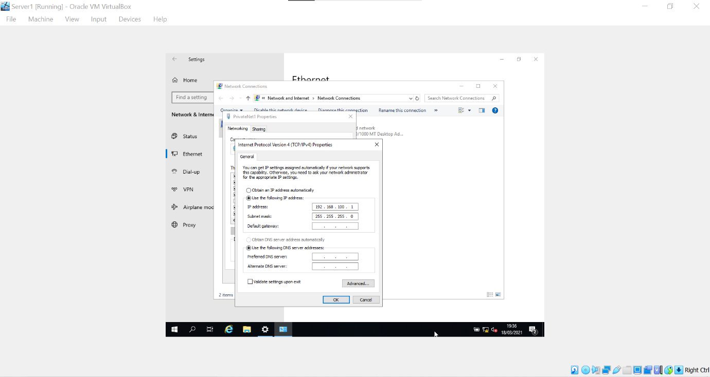Figure 1 - Statically defined IP address.
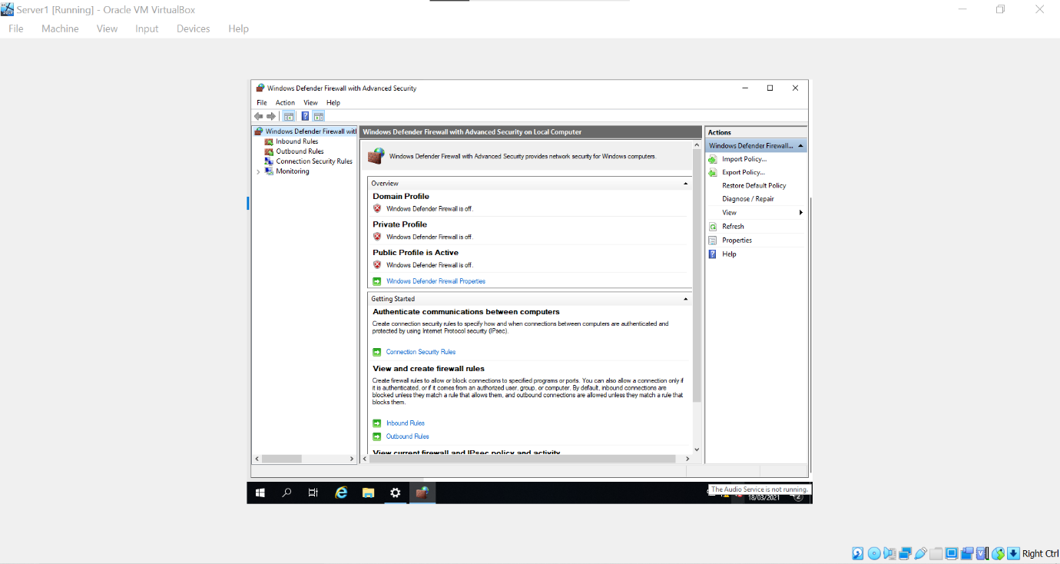
Figure 2 - Firewall disabled.
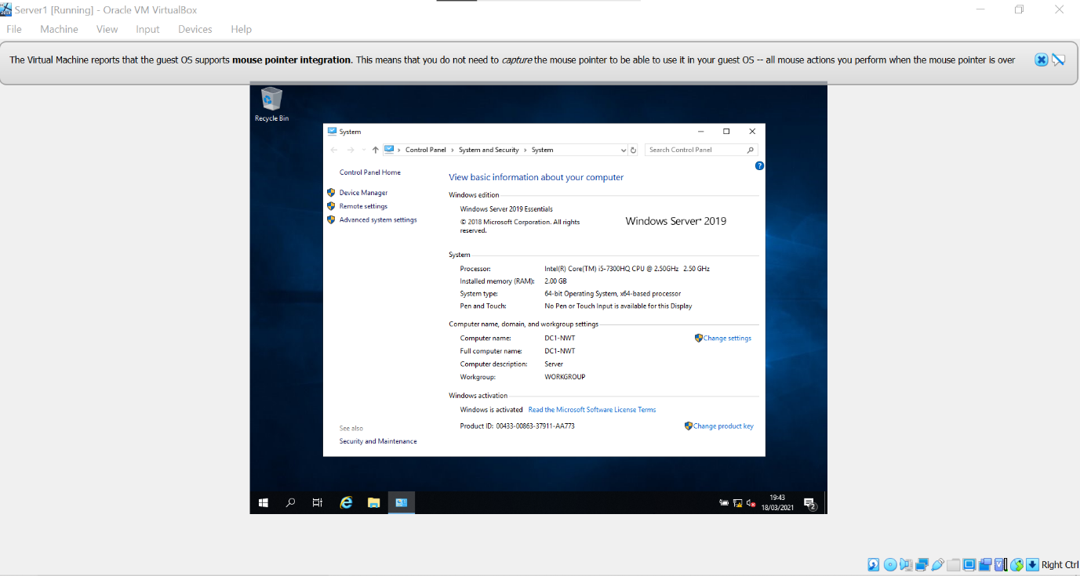
Figure 3 - Set Computer name.

Task 2 – Deployment of Active Directory, role or feature-based installation.
To deploy Active Directory Domain Services (ADDS) and other features of Active Directory, the Server manager was used to install these features on the Windows Server 2019 Operating system. When the installation was complete of AD DS, the Server manager was used to promoted to Domain Controller and a forest was configured which can be seen in Fig 4. On completion of the configuration of the ADDS, the Administrator Login to the domain was tested, this proved to be successful which can be seen in Fig 5.
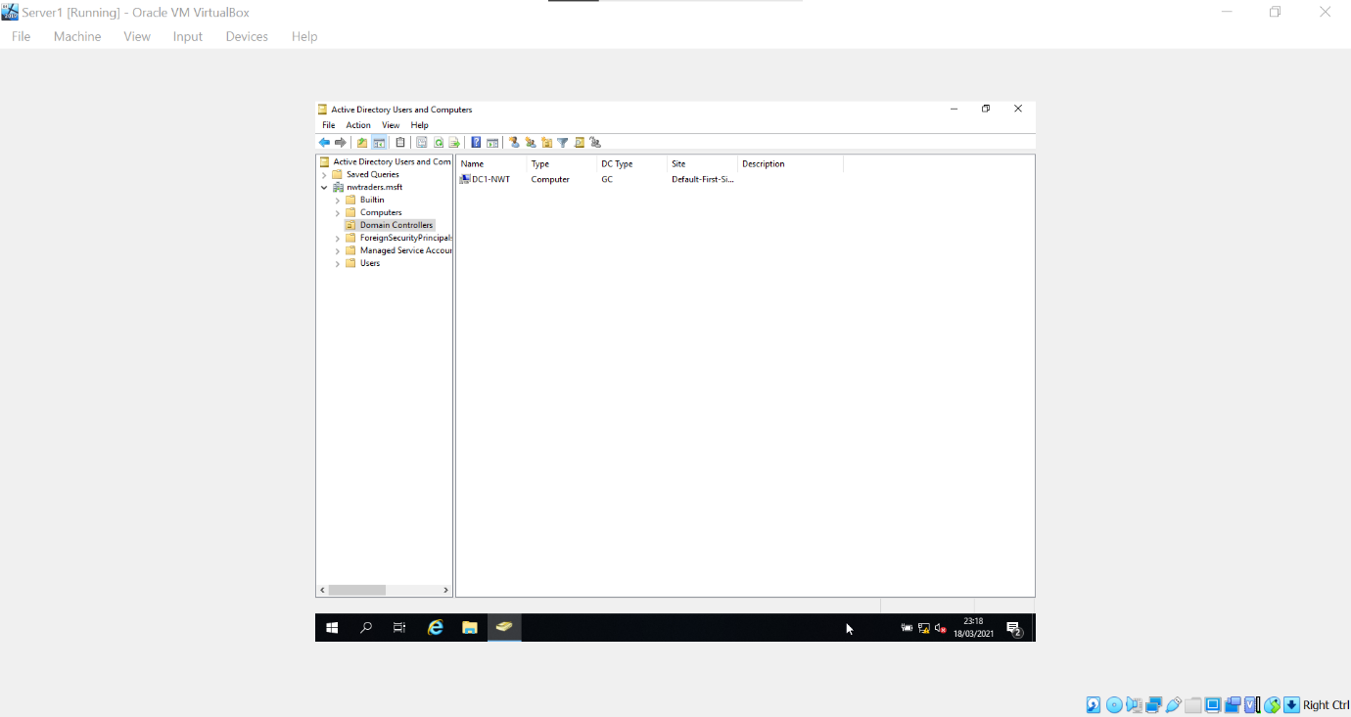
Figure 4 - Active Directory Domain Controller.
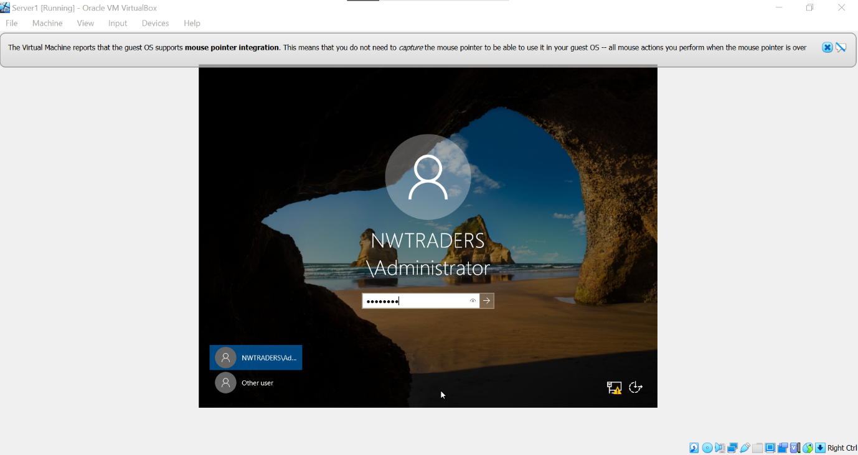
Figure 5 - Administrator Login to the domain,

Task 3 - Create a user account object via the Active Directory Users and Computers application
For failsafe reasons, and for the understanding of how objects work within Active Directory, the Active Directory Users and Computers application was opened to check whether the server computer object was located within the Domain controller’s container window which can be seen in Fig 6. Once located a new user object was created within the user’s container and added to the Domain Admins Security Group object which can be seen in Fig 7.
Figure 6 - Active Directory Domain Controllers.
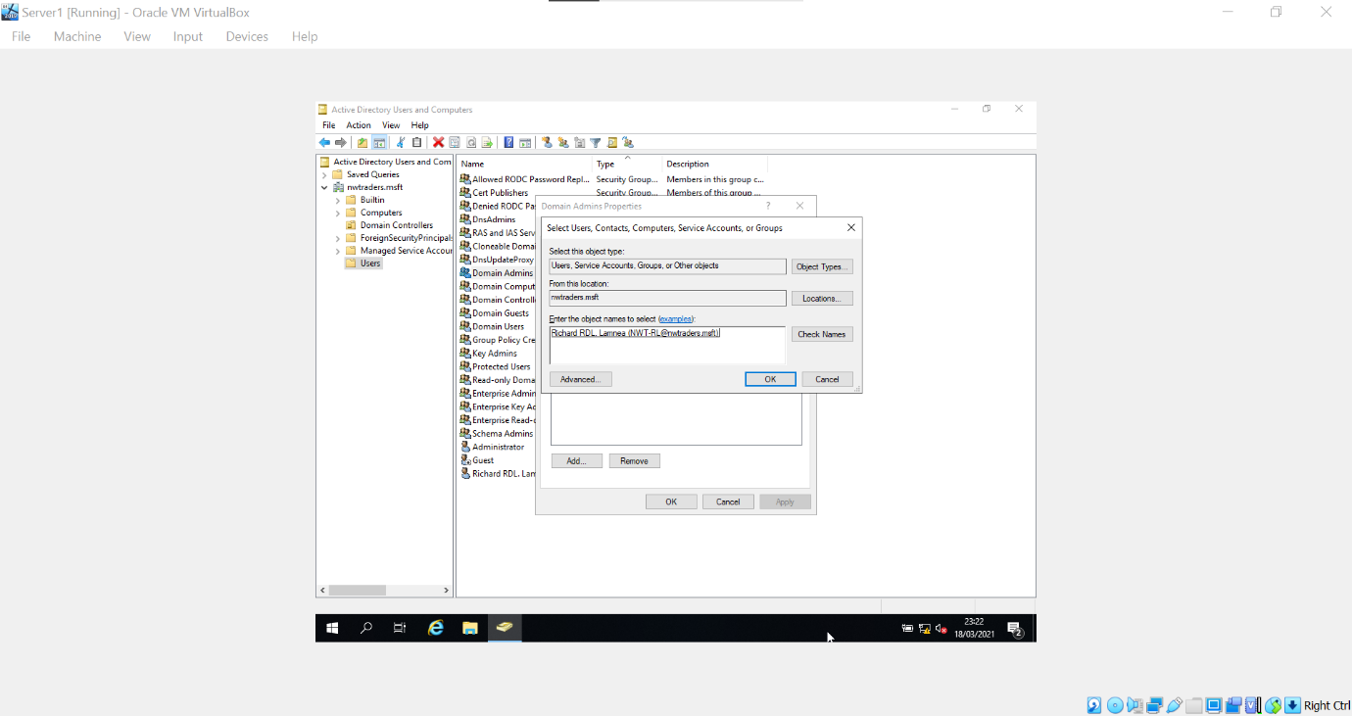
Figure 7 - Added new user object to Domain admins security group.

Task four – Object attributes within Active Directory
To optimise the management of user objects within Active Directory, a new user was created and added to the Domain Users group which can be seen in Fig 8. The user’s login hours were altered to be permitted to logon between Monday 8 am and Thursday at 5 pm which can be seen in Fig 9. The user was defined access from changing their password which can be seen in Fig 10.
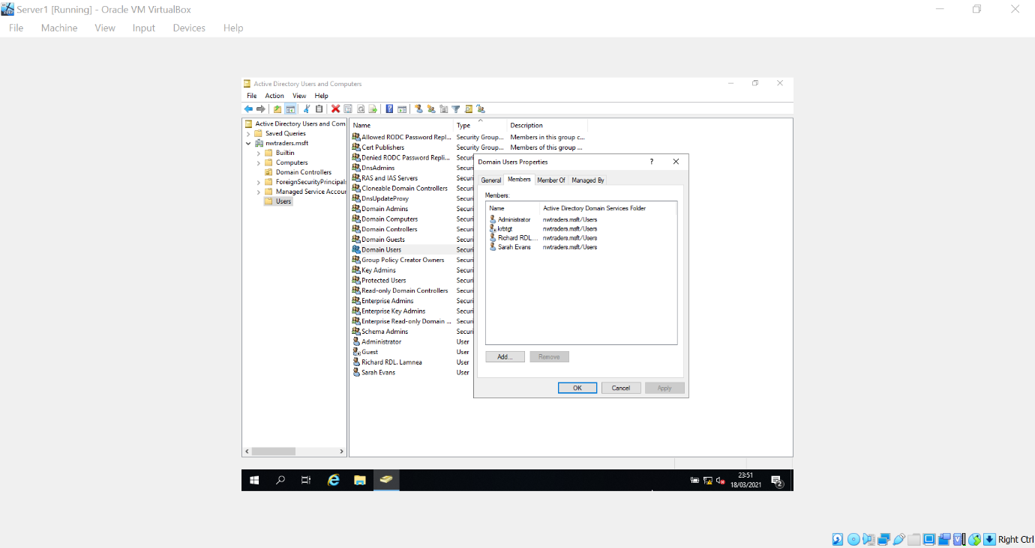
Figure 8 - New user added to Domain Users group.
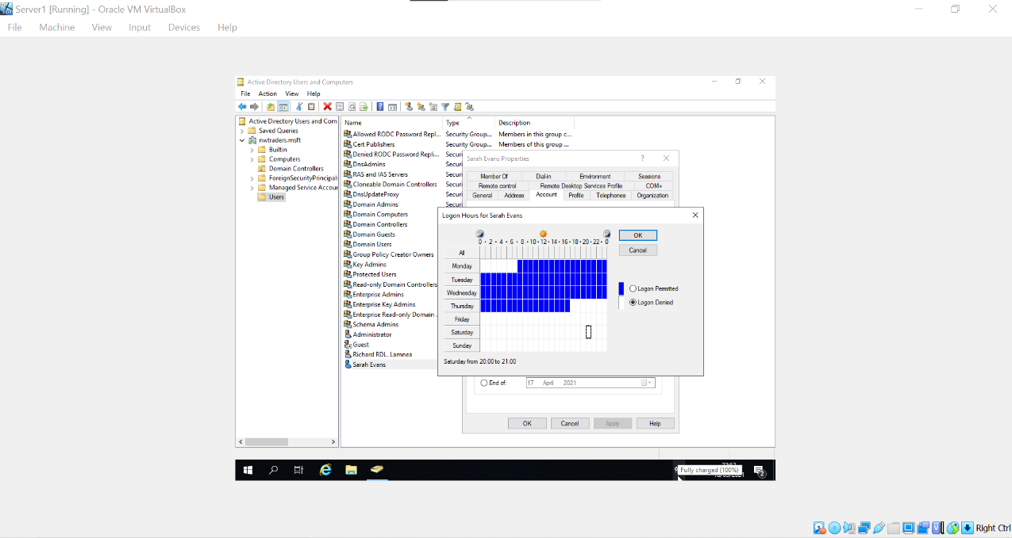
Figure 9 - User logon hours altered.
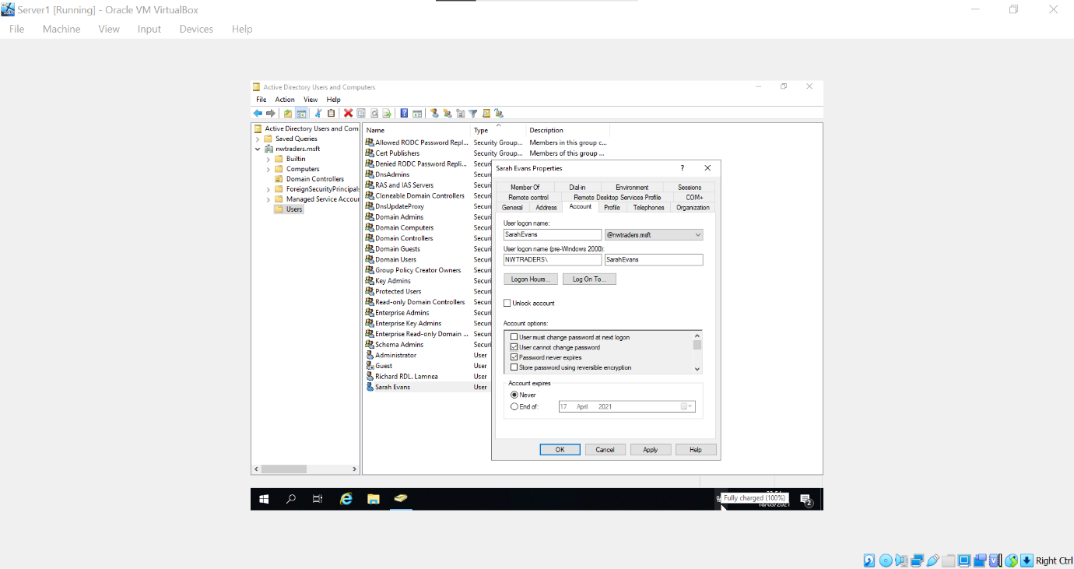
Figure 10 - User denied password change.

Task five – Adjoining the domain and testing user logins.
This task required a client computer object to be created within Active Directory and for the client to be able to logon to the domain controller via the DNS server. Using Server1 VM the client computer was created using the Active Directory Users and Computers window which can be seen in Fig 11. The Client1 VM was used to configure the network adapter PrivateNet1 with its Default gateway IP address and DNS Server IP addresses which can be seen in Fig 12. The Client computer was named WS-NWT, which coincides with the name given within the Active Directory Computers container which can be seen in Fig 13. Once complete, the user-created within task 4 was able to login to the domain controller via NWTRADERS active domain which can be seen in Fig 14. To test if the user could logon to the server, the user login details were entered into the Server via the domain, however, this declined as users without domain admin level security policies cannot access these services which can be seen in Fig 15.
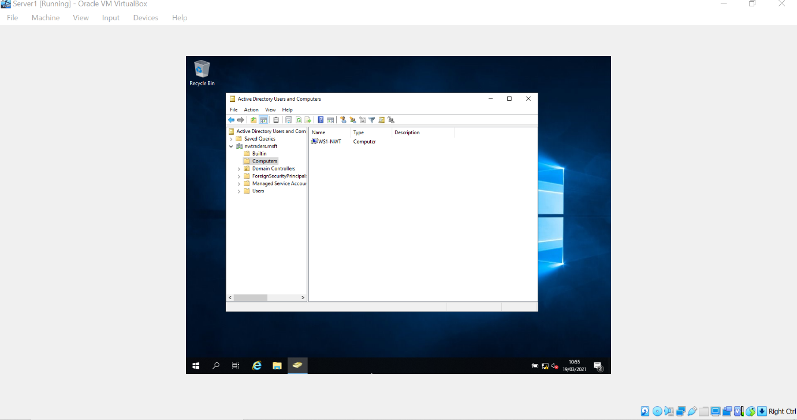
Figure 11 - New computer object created within Active Directory.
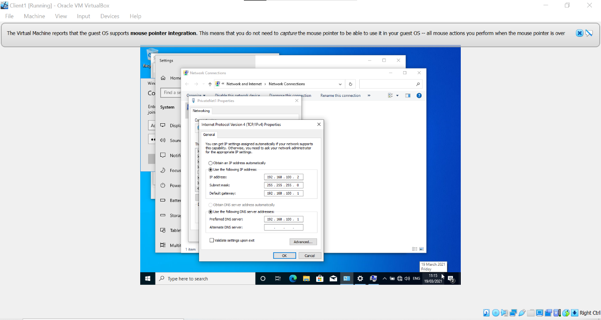
Figure 12 - Client computer network adapter configuration for the DNS server.
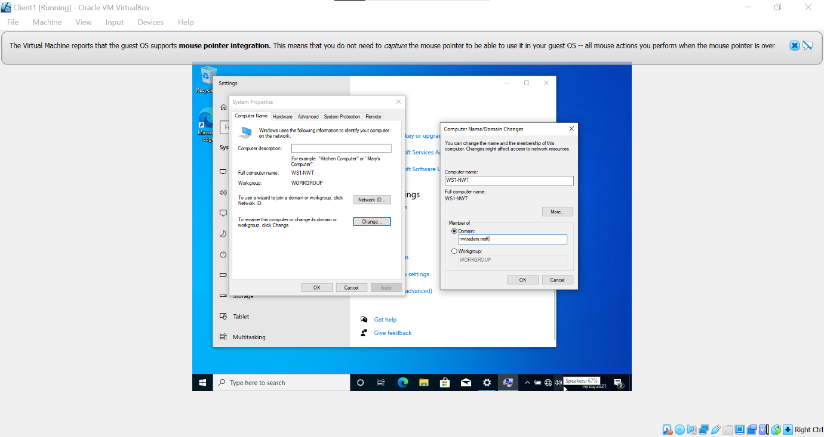
Figure 13 - Client computer name changed, and domain added.
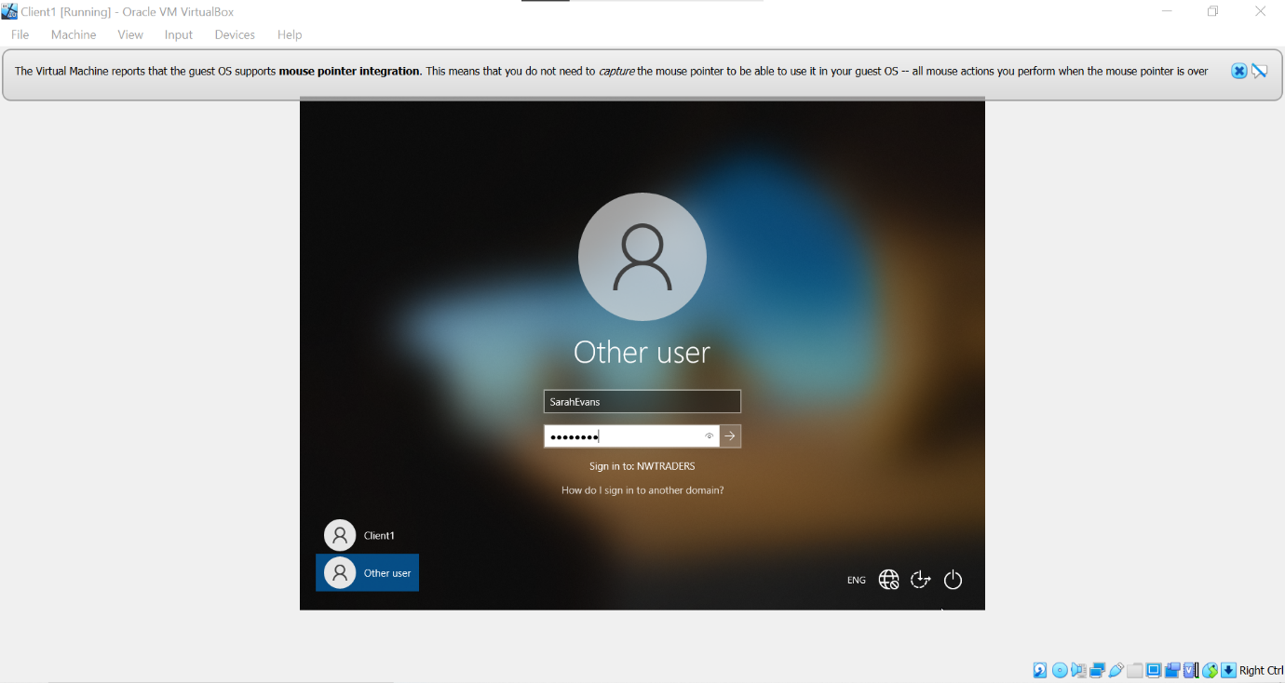
Figure 14 - Client login to the domain.
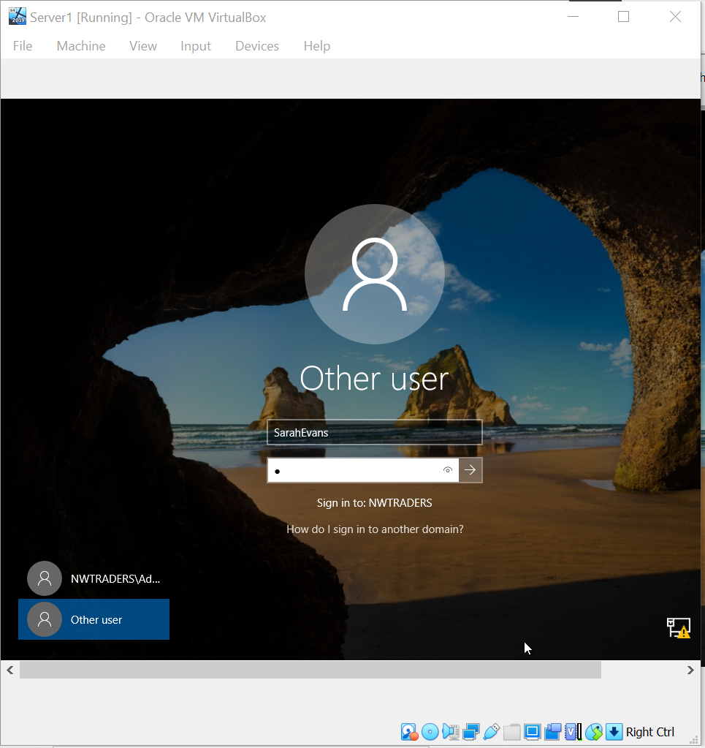
Figure 15 - User login to server unauthorized

OBSERVATIONTIONAL TASKS
The student in this case was asked to answer four observational tasks which can be seen below:

An overview of DNS and its significance within Active Directory Domain Services.
The Domain Name System (DNS) is one of the fundamental protocols of how the internet works, the DNS is a directory of names that match with devices IP addresses in which allow devices on a network to communicate with each other and devices on other networks [1]. When a device requires access to an IP address that is associated with a domain name, it requests the IP address from a recursive DNS server that provides the IP address from its directory [2]. This domain name system allows a web host to change its underlying IP address without the user needing to know the servers updated IP address [3].
Recursive DNS servers are typically operated by Internet Service Providers (ISP) or third-party providers. The recursive DNS server requests up to date domain names / IP addresses from authoritative DNS servers which provide the correct information requested [4]. DNS servers are distributed around the world and communicate with each other to regularly update this directory. Google DNS Server address is located at the IP address 8.8.8.8 and is a recursive DNS server [5].
Cloudflare also has a public DNS server at the IP address 1.1.1.1 [6].
For example, if a user searches for google.com in his web browser, the browser will send a query to a DNS server for the websites IP addresses. The server will return this domain name’s IP address, which will allow the browser to request data from the website’s web host which will in turn return the necessary data required to display the webpage.
DNS uses a hierarchy to manage its distributed directory which is called the domain name space, and it is presented as an inverted tree like structure [7]. The DNS tree structure starts with the root domain which is a dot (.) that separates a second-level domain from the top-level domain [8]. For example, google.com consists of the second-level domain (google). dot (.) represents the root domain and (com) represents the top-level domain. A top-level domain name represents the type of organization and the second level domain displays the individual organization. The DNS hierarchy also includes a third-level domain, also referred to as a subdomain. The subdomain also plays an important role in the DNS as it enables the use of local authoritative DNS control [4]. An illustration showing the DNS hierarchy can be seen in Fig 16 below.
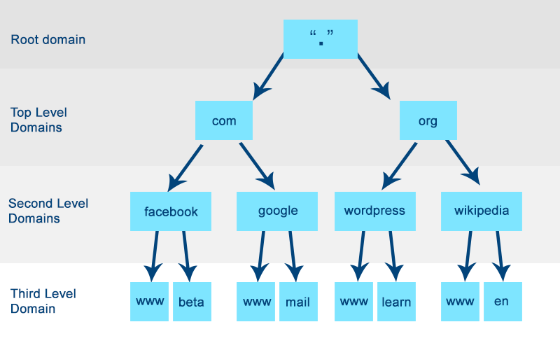
Figure 16 - DNS Hierarchy Diagram
DNS records are zone files that are located within an authoritative DNS server and provide information regarding a domain, including its IP address and how to handle requests for the domain [9]. These records contain text files written in DNS syntax, which are commands that instruct the DNS server on how to respond to the request [9]. All DNS records also require a Time-to-live value (TTL) and will instruct the DNS server when to refresh the record [9]. Common types of DNS record include: -
- A record
  - Stores the IP address of the domain [9].
- CNAME record
  - Forwards a domain to another domain [9].
- MX record
  - Forwards mail to a mail server [9].
- NS record
  - Stores the name for the DNS entry [9].
- SRV record
  - Specifies accessible ports for services [9].
- PTR record
  - Provides the domain name for reverse lookups [9].

Active Directory Domain Services (AD DS) uses the DNS service to enable clients to locate domain controllers within a network and allows the controllers that host the active directory service to communicate with each other [10]. AD DS allows for the integration of Active Directory namespace into the DNS namespace allowing for easier deployment of DNS zones within the local network [10].

Other critical roles of Active Directory other than Active Directory Domain.
Two other critical roles listed when configuring Active Directory through Server Manager
were DHCP Server and Web Server (IIS)
- DHCP
DHCP Server or Dynamic Host Configuration Protocol automatically assigns an IP address for devices within the network, without this, each device needs a statically defined IP Address [11]. The DHCP is fundamental for use within enterprise networks for its automation of IP address assignment, Default gateway generation, DNS server address assignment etc [12]. Active Directory allows the implementation of DHCP with its configuration[13].
- Web Server (IIS)
IIS is an acronym for Internet Information Services for Windows Server [14]. This service can be installed and configured on a server to provide web hosting for most files and programs found on the internet. This service allows users to access files hosted on the server to be accessed remotely, however, the server needs Windows Authentication to be configured with Active Directory to be operable[15].

The importance of access roles within a built-in Network and user account groups.
It is important to have different levels of access/roles within a ‘Built in’ Network to minimize security risks within the enterprise. This can be done by following The Administrator Accounts Security Planning Guide and implementing the Least-Privilege Administrative Model [16]. This model outlines the importance of creating roles for users to mitigate damage. Following the Least-Privilege Administrative Model reduces the risk for an employee or local user to cause damage outside of their scope, for instance, if a non-administrator account has no restrictions, this user could run a virus program leading to the possibility of damage to the infrastructure of the network and organisation [16]. In another example, a non-administrator could compromise sensitive data and break the law where the enterprise would become liable for the financial costs [17].
Another reason outlined within this model pertains to employee’s responsibilities within the workplace. If an employee is responsible for handling financial accounts, then does this person need access to the DHCP features of Active Directory? Implementing this model can be difficult however, it is incredibly important to diminish security risks within the organization wherever possible [18].

Recommendations on AGDLP and AGUDLP for use with assigning permissions.
AGDLP refers to Microsoft’s recommended procedure from the implementation of role-based access controls within the Windows domain[19]. Users and Computers must be members of global groups which represent roles within the Active directory. These role groups which are members of the domain groups are maintained for access control and have permissions.
This increases the ease when implementing group object permissions. This also allows users to be quickly moved to different groups within the Active Directory console for their needed permissions. However, creating these groups, and restricting access to specific groups can be extremely time-consuming. It leaves the question, could there be predefined groups to ease the intensity of this setup?

CONCLUSION
The Active Directory Domain Services implementation was concluded successfully and showed how user objects can be created and how group objects were modified to contain these users. Once user objects had been created, and domain services were configured, this allowed for the client to server logon via Active Directory. Research into DNS, DHCP and IIS showed how these protocols and services work. Overall this report provided some insight into the understanding of Active Directory, and Active Directory containers and objects.

REFERENCE LIST
[1] JasonGerend, ‘Domain Name System (DNS)’. https://docs.microsoft.com/en-us/windows-server/networking/dns/dns-top (accessed Mar. 19, 2021).
[2] H. Gao et al., ‘Reexamining DNS From a Global Recursive Resolver Perspective’, IEEE/ACM Transactions on Networking, vol. 24, no. 1, pp. 43–57, Feb. 2016, doi: 10.1109/TNET.2014.2358637.
[3] ‘Domain Name System - an overview | ScienceDirect Topics’. https://www.sciencedirect.com/topics/computer-science/domain-name-system (accessed Mar. 19, 2021).
[4] J. Bushart and C. Rossow, ‘DNS Unchained: Amplified Application-Layer DoS Attacks Against DNS Authoritatives’, in Research in Attacks, Intrusions, and Defenses, Cham, 2018, pp. 139–160, doi: 10.1007/978-3-030-00470-5_7.
[5] ‘Get Started | Public DNS’, Google Developers. https://developers.google.com/speed/public-dns/docs/using (accessed Mar. 19, 2021).
[6] 1.1.1.1, ‘1.1.1.1 — the Internet’s Fastest, Privacy-First DNS Resolver’. https://1.1.1.1/dns/ (accessed Mar. 19, 2021).
[7] M. Pope, M. Warkentin, L. Mutchler, and R. Luo, ‘The Domain Name System: Past, Present, and Future’, Communications of the Association for Information Systems, vol. 30, pp. 329–346, May 2012, doi: 10.17705/1CAIS.03021.
[8] ‘Fig. 1. The tree structure of Domain Name System’, ResearchGate. https://www.researchgate.net/figure/The-tree-structure-of-Domain-Name-System_fig3_2563251 (accessed Mar. 19, 2021).
[9] ‘DNS records | Cloudflare UK’, Cloudflare. https://www.cloudflare.com/en-gb/learning/dns/dns-records/ (accessed Mar. 19, 2021).
[10] iainfoulds, ‘DNS and AD DS’. https://docs.microsoft.com/en-us/windows-server/identity/ad-ds/plan/dns-and-ad-ds (accessed Mar. 19, 2021).
[11] E. Ancillotti, R. Bruno, M. Conti, and A. Pinizzotto, ‘Dynamic address autoconfiguration in hybrid ad hoc networks’, Pervasive and Mobile Computing, vol. 5, no. 4, pp. 300–317, Aug. 2009, doi: 10.1016/j.pmcj.2008.09.008.
[12] W. Panek, ‘Configuring DHCP’, 2018, pp. 467–513.
[13] openspecs-office, ‘[MS-DHCPE]: Windows DHCP Server Authorization in Domain Joined Scenario’. https://docs.microsoft.com/en-us/openspecs/windows_protocols/ms-dhcpe/56f8870b-a7c1-4db1-8a86-f69079fe5077 (accessed Mar. 19, 2021).
[14] ‘Home : The Official Microsoft IIS Site’. https://www.iis.net/ (accessed Mar. 19, 2021).
[15] Rick-Anderson, ‘Windows Authentication <windowsAuthentication>’. https://docs.microsoft.com/en-us/iis/configuration/system.webserver/security/authentication/windowsauthentication/ (accessed Mar. 19, 2021).
[16] iainfoulds, ‘Implementing Least-Privilege Administrative Models’. https://docs.microsoft.com/en-us/windows-server/identity/ad-ds/plan/security-best-practices/implementing-least-privilege-administrative-models (accessed Mar. 19, 2021).
[17] ‘What responsibilities and liabilities do controllers have when using a processor?’, Jan. 01, 2021. https://ico.org.uk/for-organisations/guide-to-data-protection/guide-to-the-general-data-protection-regulation-gdpr/contracts-and-liabilities-between-controllers-and-processors-multi/responsibilities-and-liabilities-for-controllers-using-a-processor/ (accessed Mar. 19, 2021).
[18] R. Bojanc and B. Jerman-Blažič, ‘A Quantitative Model for Information-Security Risk Management’, Engineering Management Journal, vol. 25, no. 2, pp. 25–37, Jun. 2013, doi: 10.1080/10429247.2013.11431972.
[19] ‘AGDLP | tenfold’, tenfold Security. https://www.tenfold-security.com/en/wiki/agdlp/ (accessed Mar. 19, 2021).

