Contents
Game Information 2
Platforms 2
Demographic 2
Pegi Rating 3
Competitors & Similar Products 3
Game Outline 3
Story Summary 3
Game Flow 4
Main Characters & Player Controls 4
Characters (Merfolk) 4
Side Characters (Merfolk & Quest givers) 5
Player Controls 6
Visal Design 7
Gameplay 7
Sequence of Play 7
Unique Selling Points 7
Platform Features 8
Game World 8
Locations Appearance 9
Locations Detail 11
Game Flow 14
Game Experience 14
Experience & Feeling 14
Special Modes & Interfaces 14
Evoked Emotions 17
Music & Sound 17
Shell Menus 17
Gameplay Mechanics 18
Mechanics 18
Hazards 19
Power Ups 20
Economy 21
Enemies 21
Basic Enemies 21
Mini-Boss 21
Boss 22
Cutscenes 23
Cutscene Details 23
Bonus Materials 24
Achievements 24
Replay Value 24
Bibliography 25

Paige Hodgson- 2305278
Game Theory & Design- Your Game Idea: Game
Design Documentation

Veil of Tides
A 3D fantasy single player open-world role-playing game based on underwater merfolk exploration.​

Game Information

Platforms
Intended platforms for Veil of Tides are:
Windows 10 [1]
PlayStation 5 [2]
Xbox One [3]

Demographic
The primary audience for Veil of Tides includes individuals aged 12 to 25 who have a love for underwater exploration and a fascination with fantasy merfolk lore. While the game may hold a particular appeal for female players, it is designed to be inclusive and welcoming to all genders.
Veil of Tides is perfect for players seeking a laid-back adventure that combines immersive storytelling with exploratory gameplay and straightforward turn-based combat. Fans of open-world exploration and role-playing games are likely to find the experience intriguing and engaging. The humour in the game is light and relatable, ensuring it resonates across these age groups. My aim is to captivate players who enjoy exploring new environments.

Pegi Rating
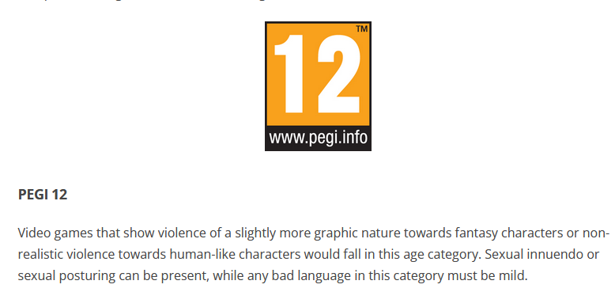 [4] The listed Pegi 12 rating for Veil of Tides contains the following: Fantasy violence and mild swearing.

Competitors & Similar Products
The Sims4: Island Living- A mermaid DLC extension to a stylised life simulation game​. [5]
Mermaid World- An elemental mermaid gachapon game that featured a variety of unique designs for the player to collect​. [6]
Baldur’s Gate 3- A Fantasy open-world RPG game based on Dungeons & Dragons​. [7]
Subnautica- An explorative alien sea-life survival experience. [8]

Game Outline

Story Summary
Blair is the main character they will choose from one of the four elements within the game. The first welcome they receive is a tutorial from General Llŷr of the underwater kingdom Tevia. He teaches the player basic attacks and elemental fight mechanics. Llŷr is the primary ques giver and explains through various dialogue options about the brief history of the waging war between Queen Mareen of Tevia and the power-hungry Sea Serpent King Tenebris. The story develops once the player begins their journey through various locations that surround the kingdom, interacting with multiple characters and NPCs to make relationships, dependant on the factors of their chosen dialogue options and personal character element. There are five distinct locations in total, defeating sea serpents in battles around the kingdom will gain experience points to level up, increasing elemental damage and health points.

During the concluding chapter of the game the player is given the opportunity to gather additional inventory or health item buffs that will help them in the fight against Tenebris before engaging in the last battle. Llŷr attempts to sabotage the player from engaging within the fight against the King, revealing that he was working in alliance with the king the entire time. This engages a mini-boss battle against the player. Once Llŷr is defeated the player’s strength and resilience are put to the test with an ultimate battle against the Serpent King himself, he reveals that he is powerful enough to conjure and fight with the advantage of all four elements during battle. Queen Mareen steps in to aid the player, providing a temporary buff that gives the player an extra ability for each element. Once defeated, both Tenebris and Llŷr are banished from the kingdom, allowing its merfolk to thrive in peace whilst the player is promoted as the new General. This is where the game ends.

Game Flow
3D fantasy single player open-world role playing game that uses elemental buffs within turn based battles. It is the player’s purpose to interact with the NPC’s and find out information that can lead them onto the right trail of the evil sea-serpent King to defeat him and diverge his evil plans.

Main Characters & Player Controls

Characters (Merfolk)
APPEARANCE
A customisable main character that allows input of the player’s name, gender, age, colour and style of skin, eyes, hair, tail, clothes, and most importantly one permanent element.

MAIN CHARACTER DOSSIER
NAME: | Blair (Default)/ Player choice
GENDER: | Neutral (Default)/ Player choice
LOCATION: | Central Kingdom of Tevia
HEALTH POINTS: | 100 (Default)
ELEMENT: | Water (Default)/ Player choice
OCCUPATION: | Newly recruited warrior

BACKSTORY
Little to no provided backstory for Blair as the name meaning suggests, they are intended to be a plain field for the player to input.

CHARACTER
NAME: | General Llŷr
GENDER: | Male
LOCATION: | Central Kingdom of Tevia
ELEMENT: | Magma
OCCUPATION: | General to the Queen of Tevia and a spy for the sea serpent King.

BACKSTORY
Originating from Thermo Badlands, his quick witted and stubborn personality lead him through a life of dominating power struggles, climbing up the ranks to become a fearless warrior of the kingdom, it's not until King Tenebris sways his mind with the promise of strengthened power that he begins to secretly work in an alliance with the enemy.

Side Characters (Merfolk & Quest givers)
Mareen- The graceful queen of Tevia with the power of all four elements.
Seirus- A hot headed Magma glass blower within the Thermo Badlands.
Yara- An intuitive Ice student architect from the Burnished Glacier.
Lily- A compassionate Nature botanical doctor residing in the Kelp Forest.
Wade- A melancholic Water instrumentalist musician living in Chloral Falls

Player Controls
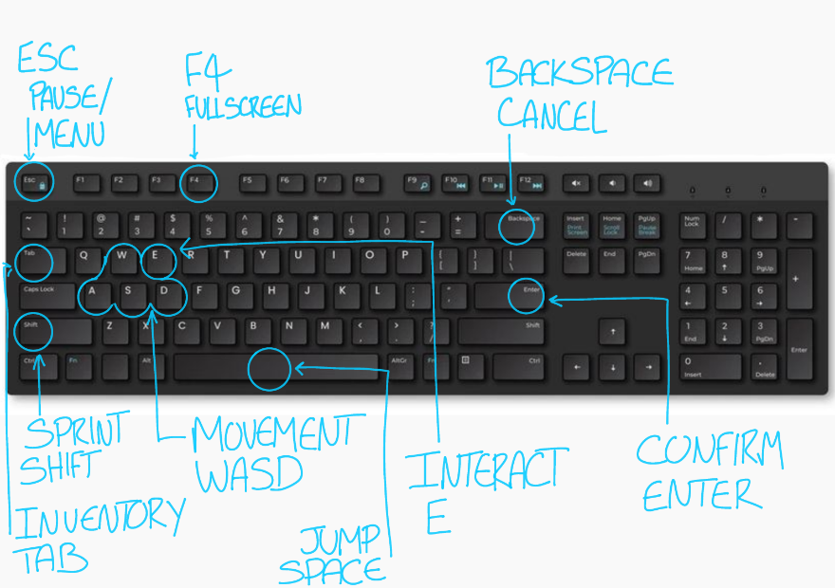 [9]
Windows Keyboard.
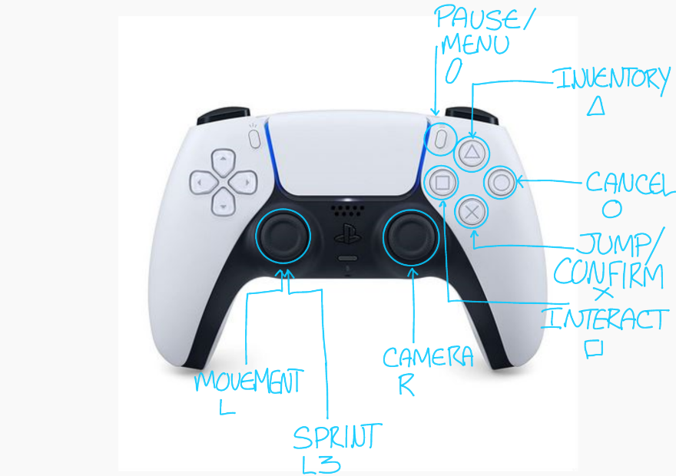[10]
PlayStation 5 Controller.
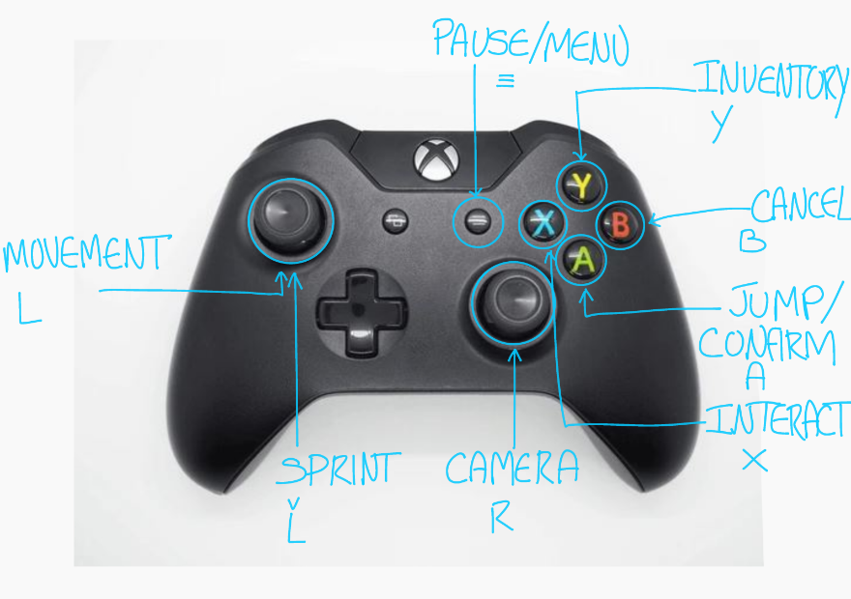[11]
Xbox One Controller.

Visal Design
3D Retro Cel shaded visual design inspired by games such as:
Hades [12]
The walking dead [13]
Jet set radio [14]
Ni no Kuni: Wrath of the white witch [15]

Gameplay

Sequence of Play
A save and load system that can be accessed through the main menu and pause menu. Each one of the discoverable locations is considered a chapter, starting from the central heart of the kingdom of Tevia, to the Burnished Glacier, then Kelp Forest, Into Chloral falls, following Thermo Badlands, which then circles the player back to the heart of the kingdom of Tevia. Once progressed through various battles within each location, the last fight will take place within the Kingdom walls.

Unique Selling Points
The focus is to provide the player with full control over the appearance of their character, immersing themselves into the game and providing unique fighting styles.

Platform Features
The PlayStation 5 platform includes the feature for a colour reactive light bar on the controller depending on the enemy element during a battle. (Will slowly cycle through all four colours if all are present.)
Ice: Aqua
Nature: Bright Green
Water: Deep Blue
Magma: Burnt Orange

Game World

Locations Appearance
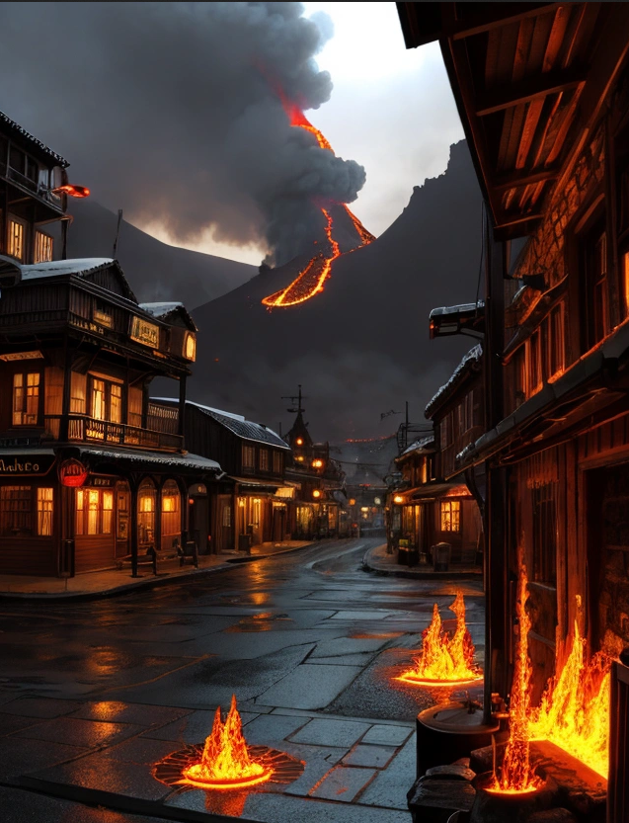 [16] Thermo Badlands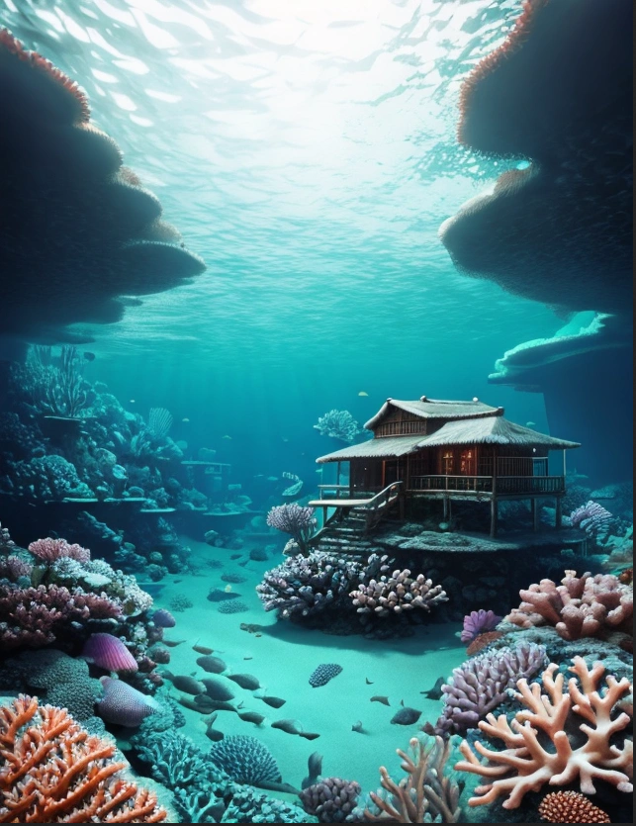 [17] Chloral Falls
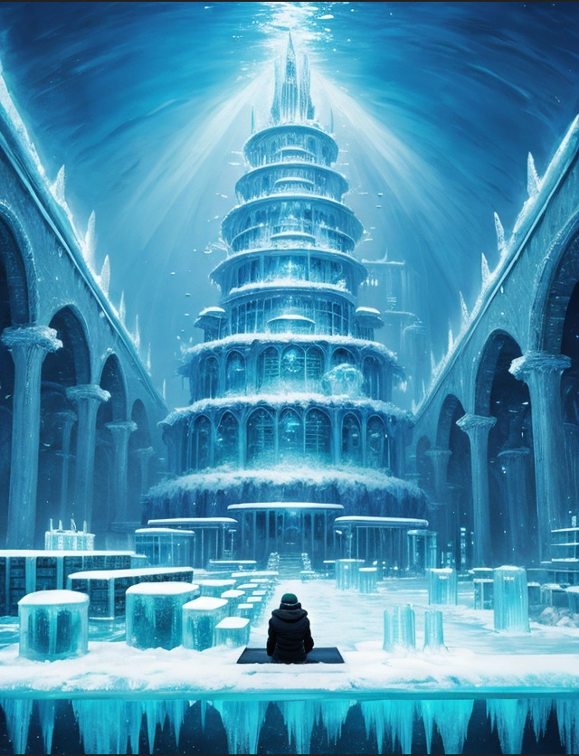 [18] Burnished Glacier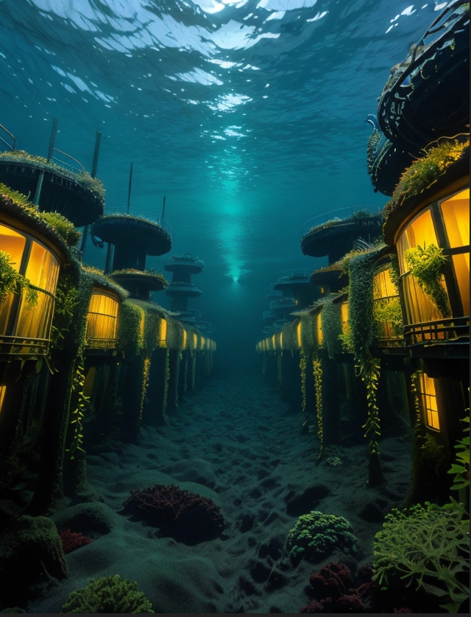[19] Kelp Forest
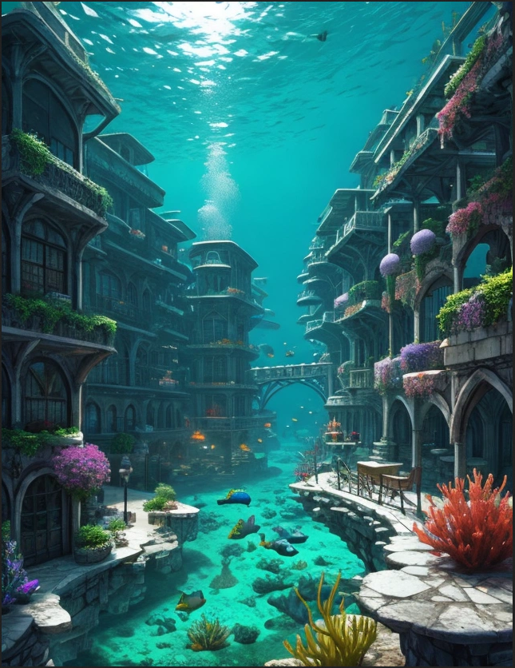[20] Central Kingdom of Tevia

Locations Detail
NAME: | Central Kingdom of Tevia
APPEARENCE: | An underwater thriving kingdom. Filled with colourful coral skyscrapers and buildings. The architecture blends natural oceanic materials with mosaics stand out under the light. Merfolk swim and thrive through the streets and archways around the central Plaza.
MOOD: | The player should feel welcome, the inhabitants are openly friendly and prosperous, a general positive greeting to the players introduction to the game as a starting location and central hub.
MUSIC: | Tracks that portray a sense of wonder with orchestral music to highlight the busyness from the heart of the kingdom.
CONNECTION: | Central Kingdom of Tevia acts as a primary hub for the player, they will be able to access each location once accepting their respective side quests.

NAME: | Burnished Glacier
APPEARENCE: | An underwater location with a thriving set of bustling infrastructure that is hollowed out from the ice. The glacier's exterior consists of jagged, towering ice cliffs with tones of blue, silver, and purple. Intricate tunnels carved into the ice over the years by its residents.
MOOD: | A mixture of architectural beauty and uneasy expectation. Players should feel both captivated by the serene, glistening buildings and its reflections of light through the surface ice.
MUSIC: | Slow but peaceful tracks that use high-pitched sounds to mimic the crystal nature of the ice. Instruments like xylophones and synthesizers with ethereal ambiance.

NAME: | Kelp Forest
WHAT DOES IT LOOK LIKE? | A large community woven into the centre of the kelp biome. Its buildings blend seamlessly with the natural green and yellow environment, crafted from living kelp, and seashells. Homes are nestled within the towering kelp strands, suspended like pods. Bridges of braided seaweed connect different buildings.
WHAT MOOD IS BEING INVOKED IN THIS LOCATION? | Tranquil harmony within a sense of community and belonging, where the merfolk lives in tune with their environment. At the same time, the dense kelp surroundings contain light and shadow, inviting players to explore its secrets while feeling safe among its inhabitants.
WHAT KIND OF MUSIC WILL BE USED FOR THIS LOCATION? | Melodic and calming, featuring soft, flowing tones that reflect the harmony of the merfolk and their surroundings. Instruments such as flutes and piano are used.

NAME: | Chloral Falls
APPEARENCE: | A series of natural aquatic waterfalls formed by strong ocean currents flowing over tiered coral steeps. A vibrant cluster of tiered levels, colourful structures and secluded huts built from seashells and corals. Streams of glowing plankton follow the currents, illuminating the waterfalls and casting a soft glow throughout the settlement.
MOOD: | Dynamic serenity. The constant motion of water currents invokes an atmosphere of energy and life, a contrast to its otherwise low merfolk population. It provides peaceful moments of reflection in its secluded grottos and secret nooks.
MUSIC: | Flutes, and soft string instruments will create flowing melodies that mimic the underwater currents. Gentle percussion will convey the serenity of its overall atmosphere.

NAME: | Thermo Badlands
APPEARENCE: | An underwater settlement that glows with a fiery red and orange hue, molten magma seeps through the cracks in the ground. Structures in Thermo Badlands are forged from volcanic rock and black obsidian, giving the town a primal aesthetic. Steam vents are channelled through intricate tunnel systems, powering machinery, and creating a steampunk-like industrial vibe.
MOOD: | A sense of intensity with resilience. A place where life has adapted to thrive against all odds in a harsh, extreme environment. The merfolk there carry a sense of defiant vitality, and players should feel a mix of tension and fascination from this.
MUSIC: | Low-pitched drums, gongs, and didgeridoos. The music will shift between brooding and energetic, emphasizing the lively resilience of its merfolk.

CONNECTION: | Majority of locations are unlocked by early side quests, allowing the player to explore and level up within their chosen favourite elemental biome.

Game Flow
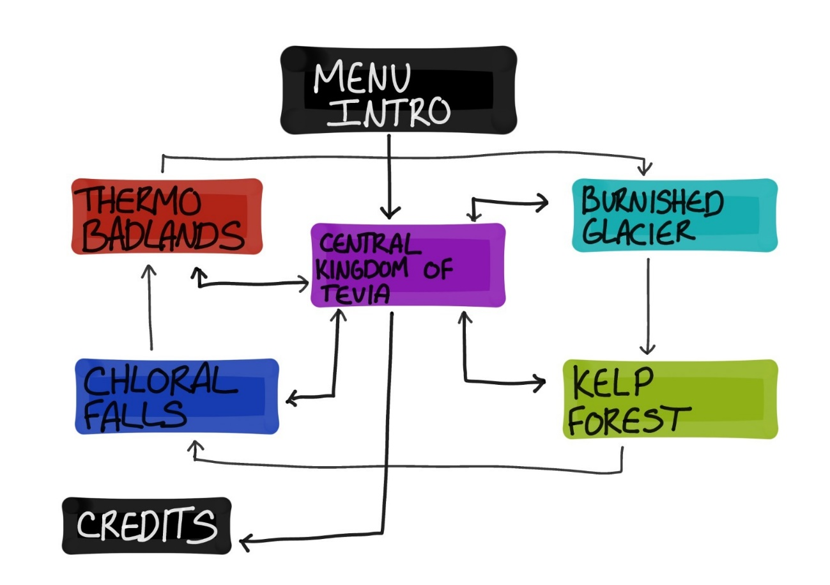

Game Experience

Experience & Feeling
An aesthetic heavy, turn-based fantasy game but also notable on the side of forming meaningful connections throughout some of the characters dialogue. Exploration that utilises the use of colour themes and emotions to its atmosphere that target the player’s mindset accordingly to each location.

Special Modes & Interfaces
Three difficulty settings:
Story- Elements are not affected by stress tactics, meaning all abilities are the same combat style balance wise.
Advanced- Intended style of gameplay where each element has a unique set of strengths and weaknesses, forcing the player to stick to a typical fighting style e.g. water elementals deal excessive amounts of damage but have fewer health points, meanwhile magma have much more Health points but take two turns to deal an attack during a battle.
Expert-For players who want a challenge against the odds. A combined mixture of gameplay style from the advanced difficulty but with the addition that all enemies and boss health points are doubled.
Battle interfaces that allow moves against the enemy on each turn. It shows a set of options to use within the fight such as ability, physical, items and strategies. An Inventory interface that can be accessed at any point out of battle. It shows the player how many pearls and level experience they have acquired, how many health points they have, what items and element they have.

Battle Interface
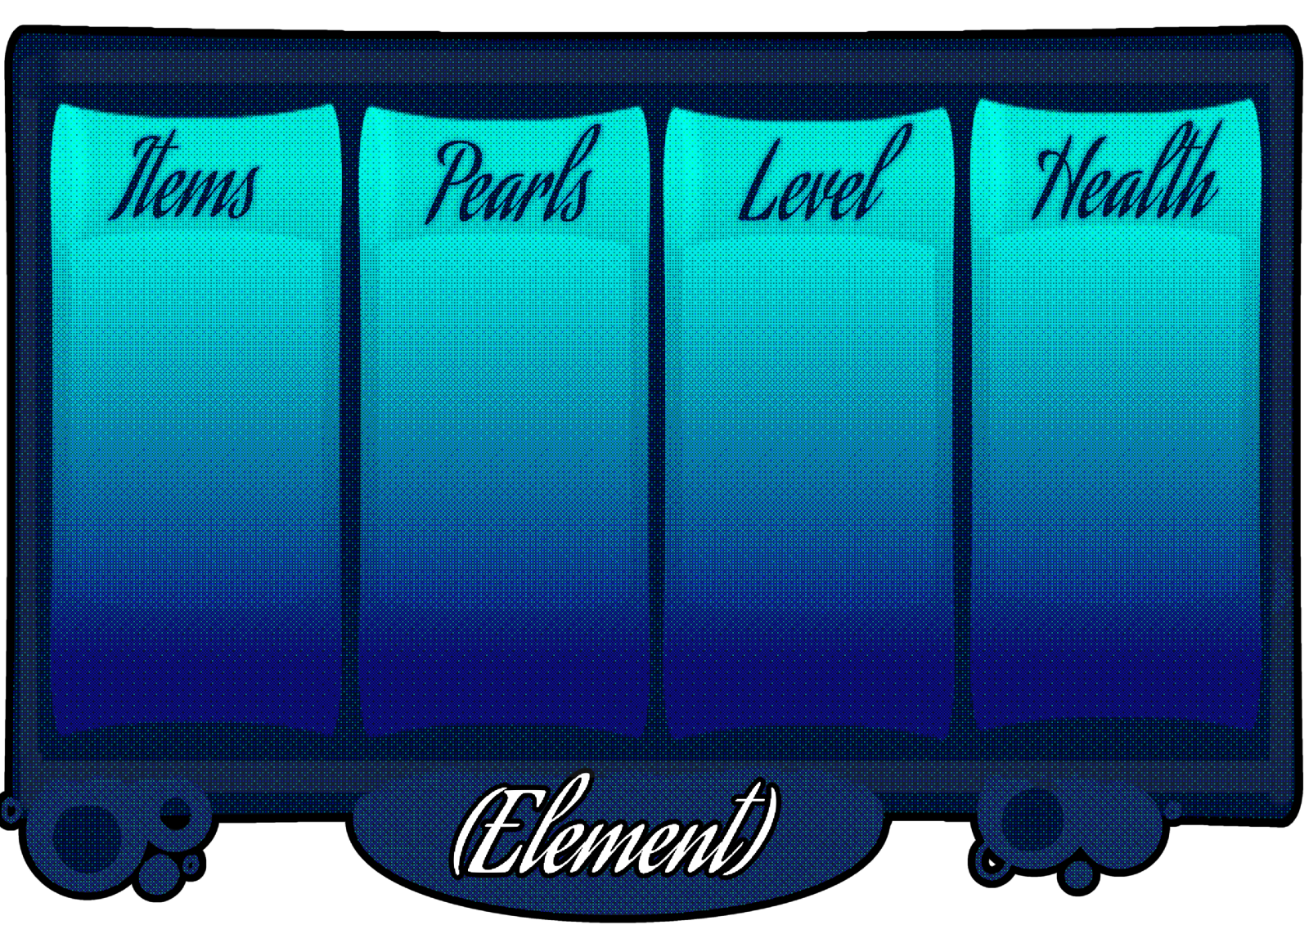
Inventory Interface
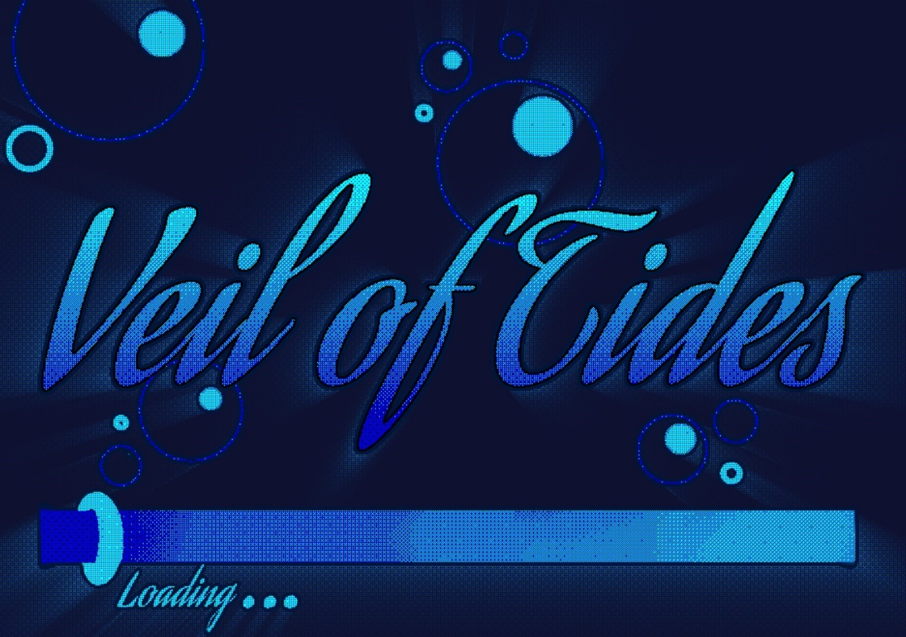
Title/ Loading Screen

Evoked Emotions
Mysterious Brooding
Strong Energetic
Calming Serenity
Pleasing harmony
Ethereal peace
All to convey happiness, pensiveness, curiosity, insecurity and even fear in some cases.

Music & Sound
A wide range of instrumental soundtracks branching out from instruments such as piano, xylophone, triangle, flute and even synthesizers. The sound ambiance for each location needs to include an underwater bubbly sound for player’s movements such as jumping, sprinting or even falling.
Glacier music inspiration- Stardew Valley Nocturne of Ice. [21]
Kelp Forest music inspiration- Stardew Valley Raven’s descent. [22]

Shell Menus
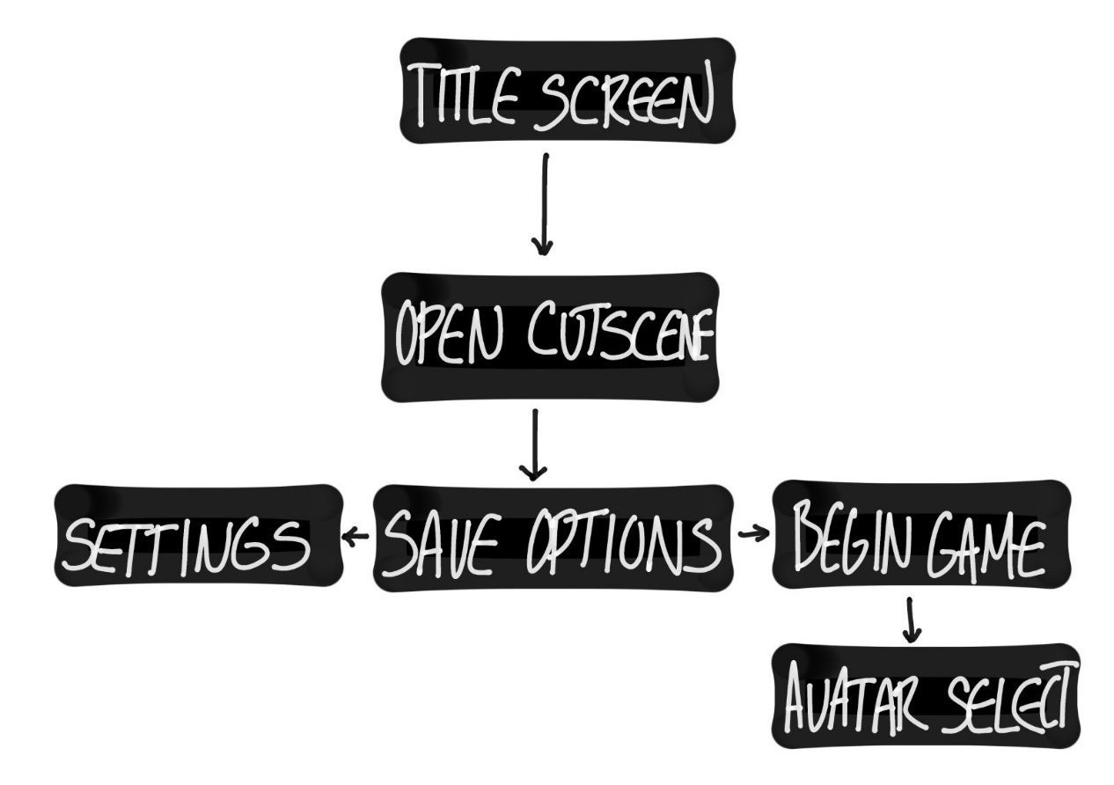
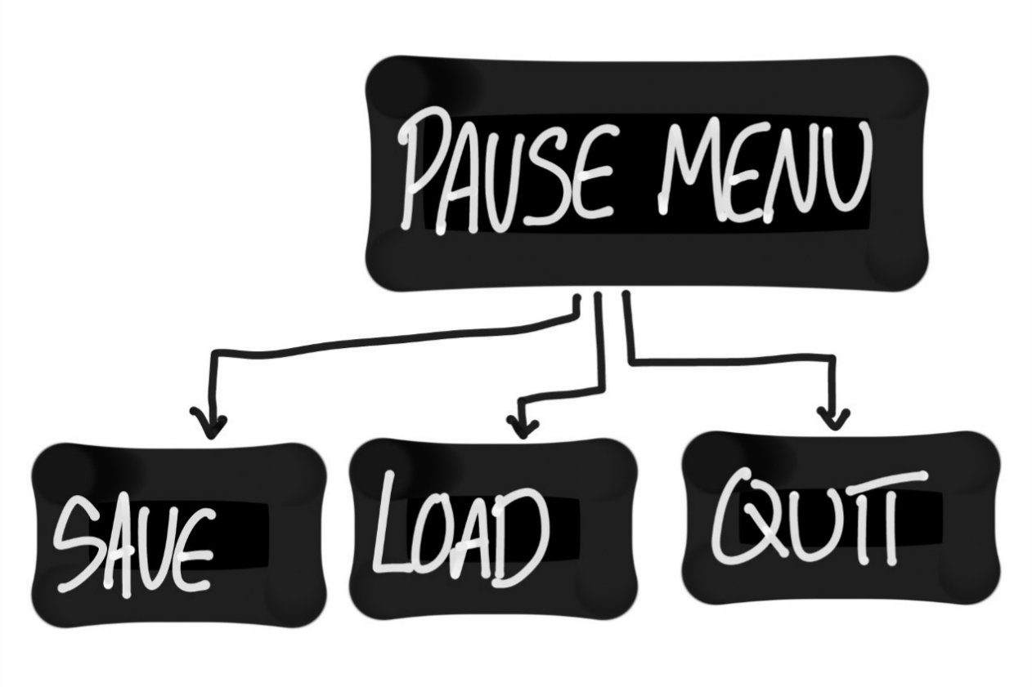

Gameplay Mechanics

Mechanics
Reading bottled Notes
Sinking on magma bubbles
Climbing up kelp vines
Double jumping on water bubbles
Speeding on ice
MECHANIC DETAILS
NAME: | Treasure Chest
APPEARENCE: | A pirate's treasure chest.
EFFECT ON PLAYER: | Rewards the player with 100 Pearls and 250 Experience Points when interacted with and opened.
FEATURED: | Hidden in multiple areas around each location.

Hazards
A Deep sea abyss on the outskirts of Tevia and its kingdom to encourage the player to stick to the connecting pathways that lead in and out of each location.
HAZARD DETAILS
NAME: | Magma pools
APPEARANCE: | Bubbling magma pools that sit on the floor in out of bounds areas.
EFFECT ON PLAYER: | Acts as a knockback barrier that deals 25 health points of damage each time the player makes contact.
FEATURED: | Within Thermo Badlands.

HAZARD DETAILS
NAME: | Ice Spikes
APPEARANCE: | Jagged ice spikes that protrude from the floor in out of bounds areas.
EFFECT ON PLAYER: | Acts as a knockback barrier that deals 25 health points of damage each time the player makes contact.
FEATURED: | Within Burnished Glacier.

HAZARD DETAILS
NAME: | Spiky Corals
APPEARANCE: | Sharp edged corals that sit on the seabed in out of bounds areas.
EFFECT ON PLAYER: | Acts as a knockback barrier that deals 25 health points of damage each time the player makes contact.
FEATURED: | Within Chloral Falls.

HAZARD DETAILS
NAME: | Thorny Brush
APPEARANCE: | Thorny sea shrubbery that grows on the floor in out of bounds areas.
EFFECT ON PLAYER: | Acts as a knockback barrier that deals 25 health points of damage each time the player makes contact.
FEATURED: | Within Kelp Forest.

Power Ups
Laver Bread- A purchasable consumable from Kelp Forest that applies +50% Nature damage for the next 5 attack turns, 100 Pearls
Flavoured Shaved Ice- A purchasable consumable from Burnished Glacier that applies +50% Ice damage for the next 5 attack turns, 100 Pearls
Plankton Pudding- A purchasable consumable from Chloral Falls that applies +50% Water damage for the next 5 attack turns, 100 Pearls
Kelp Curry- A purchasable consumable from Thermo Badlands that applies +50% Magma damage for the next 5 attack turns, 100 Pearls
Clam Chowder- A purchasable consumable from Central Kingdom of Tevia that applies +50% to a random elemental damage for the next 5 attack turns, 25 Pearls
NAME: | Elemental Tide
APPEARENCE: | A random temporary stormy water current that can take on the visual effect of any element within a location.
EFFECT ON PLAYER: | Causes the player to gain a +10% damage buff of the specified tidal element that lasts for 5 real time minutes.
FEATURED: | Any location for short periods of time.

NAME: | Royal Blessing
APPEARENCE: | A ball of pulsing Elemental light
EFFECT ON PLAYER: | Provides the player with the temporary ability to use a range of all four elemental attacks during the entirety of a battle.
FEATURED: | Endgame, Provided by Queen Mareen just before the player engages in the fight against King Tenebris

Economy
The Game’s economy revolves around the use of Pearls as currency. They are awarded with every quest completion or can be found by looting secret areas within each location. The pearls can be exchanged in shops for healing items or temporary elemental buff items. Experience points are awarded after each successful battle to level up.

Enemies

Basic Enemies
Sea serpent Lackey names and attacks:
Frost Serpent- Ice Crunch
Lush Serpent- Thorn Whip
Hydro Serpent- Drench Blast
Lava Serpent- Molten Pierce

Mini-Boss
NAME: | Llŷr
APPEARANCE: | 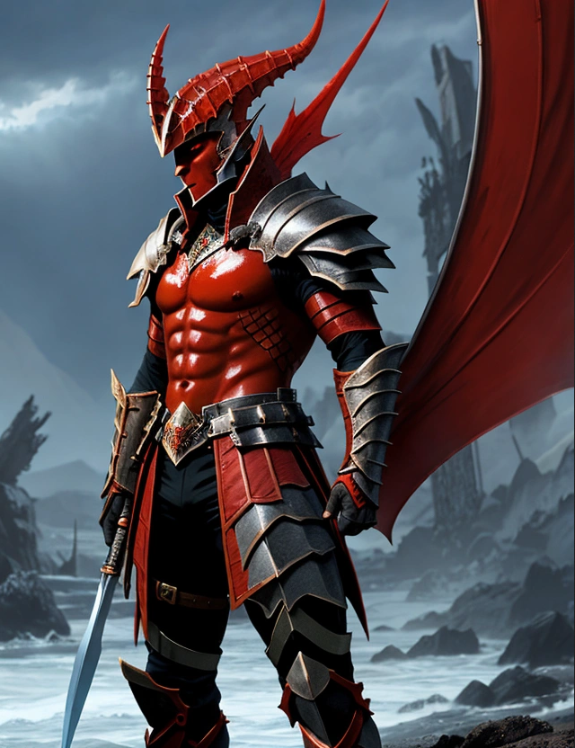[23]  Magma merfolk warrior with a large scar over his left eye, sharp features, and battle-worn platinum armour.
ABILITIES: | Eruption Strike- surge of molten magma from the ground  Molten Core Blast- concentrated beam of piercing rock debris  Inferno Armour - Obsidian shell defence
FEATURED: | Endgame, The centre of the kingdom of Tevia
WEAKNESS: | Water abilities or heavy physical attacks.
REWARD: | 500 Experience points
HEALTH POINTS: | 700

Boss
NAME: | King Tenebris
APPEARENCE: | 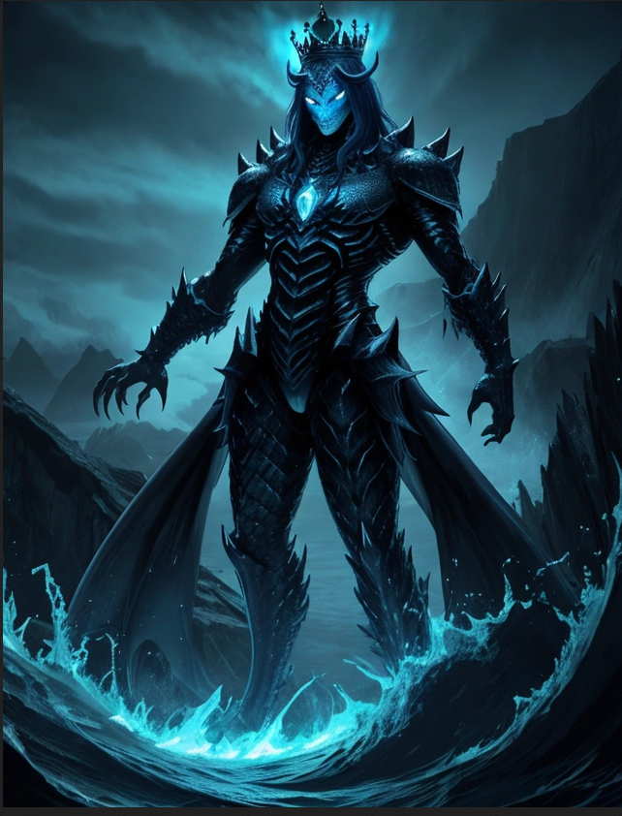[24]  Large, dark blue humanoid sea serpent with long fangs, glowing eyes, and a platinum crown.
ATTACKS: | Permafrost Veil- Steals health points from the player  Vine Snare - Stops the player from attacking next turn  Tidal Strike- A heavy hitting wave that deals high damage  Inferno Armour -Obsidian shell defense
FEATURED: | Endgame, The centre of the kingdom of Tevia.
WEAKNESS: | Through a given buff that provides the player their own set of elemental attacks or heavy physical attacks.
REWARD: | 1000 Experience points
HEALTH POINTS: | 1250

Cutscenes

Cutscene Details
VISUAL STYLE: | 2D pre-rendered retro style animated cutscene.
BRIEF DESCRIPTION OF SCENE: | The camera pans down from a stormy sky with dark clouds looming at the edges until it sinks beneath the surface of rough ocean waves. Beneath the water it shows a stark contrast with a bird's eye view of the Kingdom of Tevia at its bustling friendly environment, eventually zoning in on the default main character design and into the customisation screen.
FEATURED: | Once the player Loads into a new save before starting the main gameplay.
PURPOSE: | Sets the scene and overall theme of gameplay for the player, a nice introduction into the character customisation section.

VISUAL STYLE: | 2D pre-rendered retro style animated cutscene.
BRIEF DESCRIPTION OF SCENE: | The camera cuts into a worms eye view from the seabed where the ground rumbles, following Queen Mareen’s pursuit towards the player, She sends an almost blindingly bright orb of elemental light towards the player that they immediately absorb during the cutscene.
FEATURED: | Just before the player takes their first turn within the battle against king Tenebris.
PURPOSE: | To emphasis the impact of power that the Queen of Tevia is supplying to the player in the final battle against the Sea Serpent King.

VISUAL STYLE: | 2D pre-rendered retro style animated cutscene.
BRIEF DESCRIPTION OF SCENE: | The camera pans out from a mid-shot of the Sea serpent King as he takes the final attack, causing him to fall and sink into the deep sea depths below the edge of the kingdom, dooming Llŷr to sink with him in a last attempt to save himself from the edge.
FEATURED: | Just after the players deals the final attack to King Tenebris
PURPOSE: | To visually finalise the competition of the story to the player, marking the end of the game.

Bonus Materials

Achievements
Long-term and short-term gameplay goals include:
First steps- Complete the tutorial
BFF- Acquire a positive friendship with an NPC
You are a pirate- Find the hidden loot from all locations
Light snack- Purchase a healing Item
About time- Complete the game in under 3 hours
Silence, Serpentine- Defeat 50 Sea serpents
A piece of cake- Defeat King Tenebris in battle
I can’t believe you’ve done this- Defeat General Llŷr in battle
Challenge accepted- Don't die throughout the entire game
Take a chance on me- Avoid taking damage for 5 turns

Replay Value
Four Different elements to play through. As well as a difficulty option within the settings that provide three different modes of gameplay relating to the elements.

Bibliography
Platforms
[1] Microsoft, Windows 10, operating system, Microsoft, Redmond, WA, Jul. 29, 2015.
[2] Sony Interactive Entertainment, PlayStation 5, gaming console, Sony Interactive Entertainment, Tokyo, Japan, Nov. 12, 2020.
[3] Microsoft, Xbox One, gaming console, Microsoft, Redmond, WA, Nov. 22, 2013.

Age rating
[4] Pegi, “Pegi Public Site,” Pegi.info, 2017. https://pegi.info/ (accessed Dec. 09, 2024).

Game Competitors
5[] Maxis, The Sims 4: Island Living, downloadable content, Electronic Arts, Redwood City, CA, Jun. 21, 2019.
[6] Crowdstar, Mermaid World, mobile application, Crowdstar, Burlingame, CA, Dec. 12, 2012.
[7] Larian Studios, Baldur's Gate 3, video game, Larian Studios, Ghent, Belgium, Aug. 3, 2023.
[8] Unknown Worlds Entertainment, Subnautica, video game, Unknown Worlds Entertainment, San Francisco, CA, Dec. 16, 2014.

Control templates
[9] “Black Keyboard Vector Like Illustration High Stock Illustration 2200842873 | Shutterstock,” Shutterstock, 2020. https://www.shutterstock.com/image-illustration/black-keyboard-vector-like-illustration-high-2200842873 (accessed Dec. 09, 2024).
‌[10] “Play Game Station Vector Gamepad Controller Stock Vector (Royalty Free) 1831649926 | Shutterstock,” Shutterstock, 2020. https://www.shutterstock.com/image-vector/play-game-station-vector-gamepad-controller-1831649926 (accessed Dec. 09, 2024).
[11] “29122017 Xbox One S Gamepad Xbox Stock Photo 783196273 | Shutterstock,” Shutterstock, 2017. https://www.shutterstock.com/image-photo/29122017-xbox-one-s-gamepad-game-783196273 (accessed Dec. 09, 2024).

‌Visual game inspirations
[12] Supergiant, Hades, video game, Supergiant Games, San Francisco, CA, Sep. 17, 2020.
[13] Telltale Games, The Walking Dead, video game, Telltale Games, San Rafael, CA, Apr. 24, 2012.
[14] Smilebit, Jet Set Radio, video game, Sega, Tokyo, Japan, Jun. 29, 2000.
[15] Level-5, Ni no Kuni: Wrath of the White Witch, video game, Bandai Namco Entertainment, Tokyo, Japan, Nov. 17, 2011.

AI Location images
[16] Adobe, AI Prompt: “A heated lava steampunk town”, Adobe AI, Adobe Inc., San Jose, CA, (accessed Dec. 09, 2024).
[17] Adobe, AI Prompt: “Coral waterfalls and seashell huts underwater”, Adobe AI, Adobe Inc., San Jose, CA, (accessed Dec. 09, 2024).
[18] Adobe, AI Prompt: “Underwater ice city”, Adobe AI, Adobe Inc., San Jose, CA, (accessed Dec. 09, 2024).
[19] Adobe, AI Prompt: “Tall kelp forest with organic pods”, Adobe AI, Adobe Inc., San Jose, CA, (accessed Dec. 09, 2024).
[20] Adobe, AI Prompt: “Thriving Underwater kingdoms with plaza”, Adobe AI, Adobe Inc., San Jose, CA, (accessed Dec. 09, 2024).

Music inspirations
[21] Concerned Ape, Nocturne of Ice. Stardew Valley, 2016 (accessed Dec. 09, 2024).
‌[22] Concerned Ape, Raven’s Descent. Stardew Valley, 2016 (accessed Dec. 09, 2024).

AI Boss images
[23] Adobe, AI Prompt: “A magma merfolk warrior with a large scar over his left eye, sharp features, and battle-worn platinum armour.”, Adobe AI, Adobe Inc., San Jose, CA, (accessed Dec. 09, 2024).
[24] Adobe, AI Prompt: “Large, dark blue humanoid sea serpent with long fangs, glowing eyes, and a platinum crown”, Adobe AI, Adobe Inc., San Jose, CA, (accessed Dec. 09, 2024).

‌

