Research in Context: ADAD5003
Student Name: Eleisha Katherine Price
Student Number: 2005610
BA Course Title: Surface Pattern Design
Word Count: 2766
Tutor’s Name: Julia Lockheart

The purpose of this text is to grasp some of the ethical dimensions surrounding sustainable design, biophilic design and the curiosity established to achieve these creative titles, linking relevant practitioners and makers to evidence the boundaries between the keywords. My conclusive results will highlight the key values to form a research question that I will investigate further in my dissertation. I formulated my three key words from a ‘value mind-map’ which I generated prior to my research. This indicates my personal values which drive my creative outcomes.
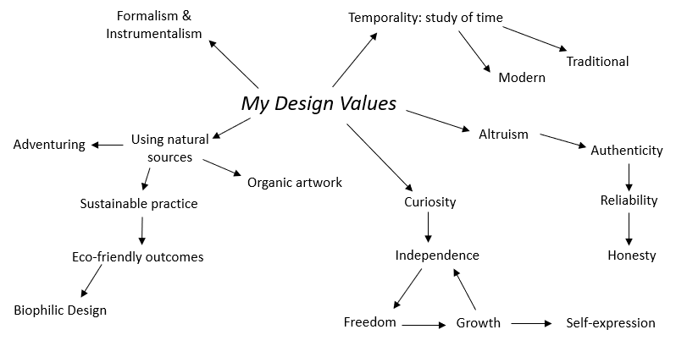
Fig 1. My ‘Value’ mind-map, highlighting three key words.
It is curiosity that has lent itself to a design process in which we take an idea (the thing in which we want to design), an aim (how we expect this design to work or be used), and an outcome (how the design has fit itself into its implied tasks through its physical or technical values or elements). However, the designs usefulness for a task lies in particular facets of certain elements; having a particular form lends those elements – as opposed to others – to being more useful for that particular task. Use is a term coined by humans to describe a notion involving a product before its possible consumption, and it is a term often troubling to philosophers because it appears to be a quality merely imposed on things. In this sense, design is a sort of constructivism wherein the implication of the design’s sources can not be of an independent existence – that these things come to fruition almost impossibly. User-centered design makes clear that the constructivism of the products’ appearance to be more useful is inherently a social constructivism. The editors of ‘Tricky Design’ suggest that, “Usability can only be identified experimentally rather than in principle.” (Fisher, T. et al., 2019, p. 92), and it is often a designer’s job to play with materials and discover their inclinations and resistances to find new uses for those materials. Our motivation to know how something works proposes to explain the process of curiosity-driven learning. We are keen on ‘discovering the world through optimized and adaptively rational learning mechanisms akin to scientific process of knowledge discovery by trial-and-error.’ (Bazhydai, M. et al., 2020, p. 3), in sum, curiosity’s mechanisms are actively enabled from behavioural manifests that become more complex and sophisticated with the development of our cognitive capacities and communicative repertoire.
A time-based continuum of curiosity suggests that our tendencies towards the subject seem to decelerate over our lifetimes; we start to lose our appetite for exploration and discovery as we get older. To some extent we keep playing this convoluted trick on ourselves that is only noticeable through our lack of curiosity. We seem to live charmed lives, surrounded by objects that do things for us. We insist that these objects and environments are just neutrally material, denying the processes behind what creates these products so we can keep living comfortably and conveniently. Tom Fisher and Lorraine Gamman ask, “Why are we denying these animisms? Why take pleasure in what they deliver without acknowledging how they do so?” (2020, p. 82), correspondingly, all of our efforts in creative disciplines to do good-quality work depends on our curiosity about the materials at hand. We inherit a conscious domain where it is better to focus on what makes objects and artworks interesting – to ponder on words in the way we feel a material – and to have independent consciousness of the things themselves. Richard Sennett proposes that “we become particularly interested in the things we can change” (2008, p. 120), as it is natural that we invest thought into changeability, similarly as it is natural to be curious. Such thinking revolves around three key issues: metamorphosis, presence and anthropomorphosis. Sennett describes metamorphosis as being a direct change in procedure, presence is registered through leaving a maker’s mark, and anthropomorphosis occurs when we impute human qualities into a raw material (2008, p. 120). Heraclitus and Parmenides, ancient materialists, believed that all physical reality is an endless recombination of material, an unceasing metamorphosis. They believed that all natural processes moved towards entropy, the decay of matter back into its simplest elements. The problem we brought within our cycle of making was a cultural challenge of how to combat this decay, bringing into existence combinations of raw materials that generated objects that would decay more slowly but ultimately keeping their form, causing the issue of less environmental sustainability.
Curiosity has been said to arise through several theoretical perspectives. Among these are drive, incongruency, information gap and learning progress approaches. Behaviourist approaches saw curiosity as being motivated by anticipated reward. One’s response to new stimuli can be explained in more orienting reflexes. A modern approach to the explanation behind preference for novelty, surprise and complexity was to adopt an incongruency detection perspective. Upon the detection of a mismatch between existing knowledge and incoming information, this approach explains how the process of curiosity allows us to update our existing knowledge. The information gap theory proposed by Loewenstein (1994) illustrates that curiosity arises when an individual encounters a gap in their knowledge and by Marina Bazhydai’s definition, is then “motivated to fill it with new and relevant information.” (2020, p. 2), whereas the learning progress theories presume that the goal behind curiosity is to maximize information acquisition by minimizing uncertainty. Learning is an intrinsically motivating process which fuels the curiosity process, thus creating a positive, rewarding cycle for driving knowledge acquisition.
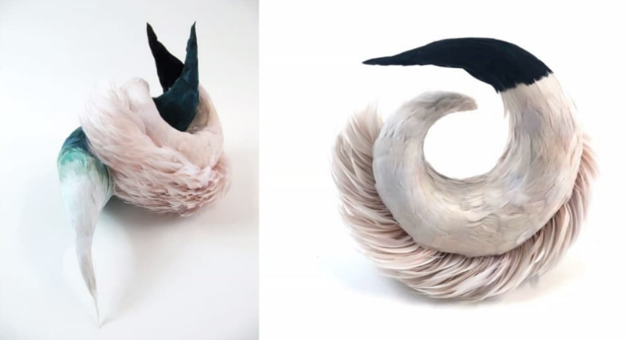
Designers each have a specific niche that derives from a unique curiosity, revealing to them a personal world of experiences. If we took my surface pattern design studies as an example - viewing specific colours solicit a certain way of expression; allowing themselves to be palpated by a specific movement of my perception. I tend to gravitate towards green tones, a commonly biophilic hue that lends itself to my natural methodology. As Donald A. Landers phrased it, seeing a certain colour “involves responding to the spectacle in a certain way” (2012, p. xliii), and this poses to me as a designer a sort of confusing problem in that I must find in myself a curious attitude that will provide my work with the means to become determinate and to become green. It is also this type of perception that opens up a visual communication between designer and viewer, or material and imitation. As a designer I do not perceive an idea as an existence, it is an innovative field that includes a depth of latent intentions and sedimentations that orients me and gives the idea its purpose. A perception led by curiosity hereby suggests that an idea can not be limited to its explicit content, in the sense that a material isn’t limited in potential as it seems to be upon visual examination. The intentional structure of perception itself condemns us to illusions of objective thought. By withdrawing an
object from the objective world, it will reveal threads that unite it to its surroundings and that in itself will open up a perceivable subject as well as the perceived objective elements.
Fig 2. An example of Anna Lewis’ work that begins a curious and creative dialogue, presented on Teams 17/03/2022.
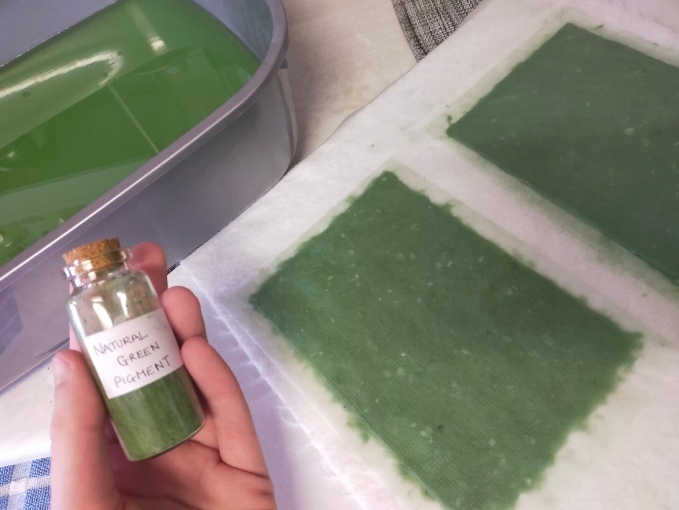
In an online lecture featuring Anna Lewis, she describes her way of approaching the subject of curiosity in her own works. She explained it to be ‘a link to the bizarre’, and of elements that drew her into questions and confusion – essentially, thinking objects – an example of which can be seen in figure 2. She also draws a link between curiosity and ‘collections’: an array of curious objects that she has gathered from around the world, whether those being cultural artefacts or simple materials. She delves into her curiosities for the materials and their possible combinations. Lewis also points out that the history, stories and magic behind the objects and how they may have the power to hold emotional investment could explore memories, sentiment, superstition, amulets and luck charms. Her personal works aim to portray objects that are unnerving but never gory; dark but not terrifying, and hold a sense of the uncanny to confuse or unsettle the viewer all in turn to spark curiosity. Lewis, like other designers working with a curious practice explore dimensions of skill, commitment and judgement in correlation with the intimate connection between head and hand. Every creative individual conducts a dialogue between their fixed practice and a way of thinking; this dialogue evolves into sustaining behaviours, and our habits establish a rhythm between problem solving and problem discovery. Senett states that our “curiosity about transitional objects evolves into definitions of what they should be” (2008, p. 9), giving way to the subject of reforming materials to become a part of a sustainable source of practice. Sustainable art is defined as a movement whose aims are to adjust our perception and ignite discussion about the way we purpose our resources. Art has the ability to communicate relevant issues and educate the viewer, spreading awareness about the importance of topics such as climate change, political policy and social injustice.
Fig 3. Handmade paper using collected recycled papers, organic green pigment and natural elements.
As a designer, I have a strong desire to know about my subject matter and different media. I am constantly being bombarded with pervasive powerful messages encouraging me to inquire and explore, discover and innovate. My choices highlight how I want to express myself and how I want to answer questions; to ask why and/or what, to wonder how my subject matter works, or how deep I should go to learn about my topic and inevitably, how I can use information to inspire viewers to be curious and start asking their own questions. I impose a subject to essentially generate additional information from other perspectives. My current work involves the exploration of paper-making and how it links to sustainable design methodology. It also covers biophilic design in its inclusion of natural materials: a naturally sourced green pigment to colour the material and inclusion of plant-based fibres. The issue I have uncovered in my work is that the handmade paper can not fully contribute to the advancement of sustainable design without fully comprehending the implications of the designing of the design; in simpler terms this would be a question of how to avoid gathering materials that have caused deforestation. Thomas Malthus once queried, “What do we gain by playing environmental roulette?” (Braungart, M., et al., 2008, p. 48), and this is where we ask as to what will happen if we keep up these habits. While my way of designing temporarily exists to reduce time, my methodology is currently limited in its approach to the design values of repurposing, recycling and reusing materials that have already been through unsustainable design.
Biophilia insinuates an innate desire to connect with the natural world, or as Erich Fromm described it, “the passionate love of life and of all that is alive” (Holt, R., et al., 1973, p. 366) , and there are many benefits to bringing natural elements into our creative works, not just because we feel the need to use them for what they are and what they can provide. Nature itself displays incredible diversity in ways most of us would perhaps never realise. It avoids all the ways we oppress, stigmatize, and belittle one another; opposingly, nature is kind, calm, and accepting. It reveals eco systems that embody harmony and balance: trees grow to heights that reflect how much water and nutrients are immediately available. Quietly witnessing this balance is like salve in the wound of our over-consumptive behaviour. Henry Matisse once said, ‘An artist must possess Nature. He must identify himself with her rhythm, by efforts that will prepare the mastery which will later enable him to express himself in his own language.’, proposing that nature provides us with endless inspiration and raw mediums for us to utilize in a way that expresses our origins but also encourages a unique form of growth. Ralph Waldo Emerson proposed that there was a certain beauty about nature in that we can pull from it a means of expressing ourselves, but we can never truly express nature itself, as he phrases it, “The stars awaken a certain reverence, because though always present, they are inaccessible.”, he also goes on to explain that natural objects will manifest a kindred impression when the mind is open to their influence. Emerson also once said that, “Material objects are necessarily kinds of scoriae of the substantial thoughts of the Creator, which must always preserve an exact relation to their first origin; in other words, visible nature must have a spiritual and moral side.”, and this moral side is outlined in the subject of sustainment (1996).
Sustainment is a practical philosophy needing many thinkers’ opinions, and makers willing to explore ways in which we can take responsibility for our anthropocentric defuturing selves. Tony Fry details that this philosophy “recognizes that entropy/unsustainability/destruction are unavoidable”, but also says that sustainment “registers that our being is finite and that our collective existence is directly related to the sustain-ability of our futuring actions.” (2009, p. 185), structurally announcing that it has something in common with enlightenment: an idea that travels ahead of the material forms it aims to author but without the sense of reaching an idealized result. However, Fry also states that “anthropocentrism is a direct confrontation with oneself to generate a collective thereafter.” (2009, p. 195), meaning that we must first sustain ourselves to reach any level of sustainment. Sustainment is neither mono-directional nor a vision. What it adds up to is maintaining a condition of imminence while being bonded to continually building something – and thereby ensuring we remain with potentialities. In this respect, sustainment can be seen as a way of thinking about our potential in the light of our continuity. Industrial society proposed a problem to our sustainable aims. Early into the Industrial Revolution, a utopian recoil from these problems gained momentum. Utopians Charles Fournier, Robert Owen and Peter Kropotkin proposed solutions to the environmental and social damage based on the creation of a culture and economy of escape. In modern society, this has been adapted not through a politically idealized vision but via a faith that technology will provide a new sustainment. But some of us proved that an alternate starting point to reducing the industrial problems would be a demand for reduction in machine use. Fry narrates this issue as “faith in the redemptive power of technology trades on the illusion that human agency has the ability to direct technology as if it were independent from human being… at one extreme the toolmaker is equally partly made by the tool… and at the other extreme, the technology, the environment and the human are not totally disconnected from each other – they interpenetrate.” (2009, p. 186), this also suggests that we are reliant on our experiences and thus our limited state of awareness folds into our resulting unsustainable behaviour. Our habits are dangerous in the way that we unknowingly keep throwing problems into our future by failing to deal with problems of the present. The problems that the machine brings into our lives is that through technological philosophy, the character of technology is being negated by the reality of it being embraced by the broader population. At the same time, those voices who are critical of technology are being contained within the academic enclave.
To summarise the information, we can see that there is a confluence of curiosity that highlights two examples of activity: curiosity as a cognitive mechanism and curiosity as an exploratory behaviour. It is active exploration that allows us to construct knowledge of the existing world. We explore through visual scanning of our environments, then through object manipulation, and approach things through preferential interests, as well as querying others and sharing information by means of tools available to us. The contemporary approaches discussed in the above text agree that the existing state of knowledge and the ability to obtain new information dynamically interact with one another to give rise to curiosity. Curiosity in the creative field teaches us many benefits, Vincent Messina specifically describes it as a lack of knowledge about ‘someone or something’, with a need ‘to do something to learn’ (Longwell, T., 2014). This goes hand in hand with aspects of sustainability and biophilic design. Design for sustainability travels under the headings of: materials from which it is made, the amount of energy it embodies, and its ability to be recycled. These factors aforementioned may be significant, but they do not ensure that a contribution to environmental sustainment is being generated by the object. The task, and my question, therefore becomes: How can the designing of the ‘object of design’ under the influence of curiosity generate sustainable design relations and effects to which form and function become subordinate?

List of Figures:
Figure 1. ‘My ‘Value’ mind-map, highlighting three key words.’ My own work, created on 20/04/2022.
Figure 2. ‘An example of Anna Lewis’ work that begins a curious and creative dialogue, presented on Teams 17/03/2022.’ Anna Lewis. (2022). Available at: https://www.annalewisdesign.com/ [Accessed 20 April 2022].
Figure 3. ‘Handmade paper using collected recycled papers, organic green pigment and natural elements.’ My own work, created on 21/04/2022.
Bibliography:
Berger, J., 2008. Ways of seeing. 2nd ed. London: Penguin Books Ltd, pp.7-9.
Braungart, M. and McDonough, W., 2008. Cradle to cradle. 1st ed. London: Vintage, pp.27-49.
Chapman, J., 2015. Emotionally durable design. 2nd ed. New York: Routledge, pp.7-10.
Fromm, E., 1973. The Anatomy of Human Destructiveness. New York: Holt, Rinehart and Winston, p. 366.
Fisher, T. and Gamman, L., 2019. Tricky design. 1st ed. London: Bloomsbury Publishing Plc, pp.82-93.
Fry, T., 2018. Design futuring. 3rd ed. London: Bloomsbury Publishing Plc, pp.185-205.
Sennett, R., 2008. The craftsman. 1st ed. London: Penguin Books Ltd, pp.9-159.
Merleau-Ponty, M. and Landes, D., 2012. Phenomenology of perception. 1st ed. London: Routledge, p.xxv-xlv.
Online:
Bazhydai, M. and Westermann, G., 2020. From Curiosity, to Wonder, to Creativity: A Cognitive Developmental Psychology Perspective. [online] ResearchGate.net. Available at: https://www.researchgate.net/publication/342342193_From_Curiosity_to_Wonder_to_Creativity_a_Cognitive_Developmental_Psychology_Perspective [Accessed 17 April 2022].
Campbell, E., 2015. Six Surprising Benefits of Curiosity. [online] Greater Good. Available at: https://greatergood.berkeley.edu/article/item/six_surprising_benefits_of_curiosity [Accessed 14 April 2022].
EcoWatch. 2014. 10 Reasons Why You Feel So Good in Nature - EcoWatch. [online] Available at: https://www.ecowatch.com/10-reasons-why-you-feel-so-good-in-nature-1881977943.html [Accessed 12 April 2022].
Emerson, R., 1996. Nature, a Ralph Waldo Emerson Essay - Ralph Waldo Emerson. [online] Ralph Waldo Emerson. Available at: https://emersoncentral.com/texts/nature-addresses-lectures/nature2/chapter1-nature/ [Accessed 11 April 2022].
invaluable. 2019. What Does Sustainability Mean for the Art World?. [online] Available at: https://www.invaluable.com/blog/sustainability-and-art/ [Accessed 9 April 2022].
Longwell, T., 2014. Curiosity, How it Benefits the Artist. [online] Longwell Art Studios. Available at: https://longwellart.com/curiosity-benefits-artists/#:~:text=As%20an%20artist%2C%20one%20needs,why%20and%2For%20what.%E2%80%9D [Accessed 15 April 2022].
Molokhia, D., 2018. The Importance Of Being Curious - Harvard Business Publishing. [online] Harvard Business Publishing. Available at: https://www.harvardbusiness.org/the-importance-of-being-curious/ [Accessed 13 April 2022].
McArdle, T., 2008. Nature in Art: Detailed Discussion of Nature Inspired Art and Artists — Art is Fun. [online] Art is Fun. Available at: https://www.art-is-fun.com/nature-in-art [Accessed 13 April 2022].
National Environmental Treasure. 2021. 10 awesome artists, artworks, and projects inspired by nature. [online] Available at: https://www.oursafetynet.org/2020/04/22/10-awesome-artists-artworks-and-projects-inspired-by-nature/ [Accessed 10 April 2022].
Steele, C., 2021. Examining the Relationship Between Nature and Art. [online] Culturepartnership.eu. Available at: https://www.culturepartnership.eu/en/article/nature-and-art [Accessed 10 April 2022].
Sanders, I., 2014. The Art of Curiosity. [online] IanSanders.com. Available at: https://iansanders.medium.com/the-art-of-curiosity-de9d9a69f6ff [Accessed 16 April 2022].
Schmidhuber, J., 2010. Formal Theory of Fun & Creativity. [online] Available at: https://people.idsia.ch/~juergen/creativity.html [Accessed 16 April 2022].

