Socket Programming and Concurrency
Concurrent client/server application, design, and build.
Kian Taylor
Neath College, NPTC Group
University of Wales Trinity Saint David

Submission Date:
30/04/21

- Introduction
- Breakdown of purpose, audience and intended functionality.
- User Requirements
- System Requirements
- Risk Assessment
- Justification of choice of technology and framework.
- Prototype Designs
- References
- Appendix
  - Pseudo-code
  - User Feedback Testing

Introduction
This report will include a critical analysis on the range of possibilities available, as well as the justification of choices made in the following areas:
- A clear statement of purpose, audience and intended functionality.
- High level application planning. Justified choice of technologies and frameworks.
- Application logic planning (input, output, and processes)
- Data requirements analysis and design including choice of socket and/or transport language.
- Application flow and page layout design

Breakdown of purpose, audience and intended functionality.
Large times for queueing exist in the canteen for students at lunch time, spending the majority of their lunch queueing rather than being able to eat their food in the free time granted. This also places large amounts of stress on staff, having to produce food much more rapidly than required when the queue is so large.

User Requirements
As the goal of this system is to make the process of placing an order as simple as possible for the customer, the functionality provided through the food ordering system will be utilized and required every time.
- Create an account.
- Navigate the restaurant’s menu.
- Pay online.
- Customize options for a selected item.
- Remove an item/remove all items from their current order.
- Provide delivery and payment details.
- Receive confirmation in the form of an order number or email.
- Digital receipt.

System Requirements
This menu management system will only be available to restaurant employees allowing them to manage the menu that is displayed to users of the food ordering system.
- Display nutritional information.
- Display food prices.
- Intake of customer and order information efficiently.
- Add a new/update/delete food items from the menu.
- Add a new/update/delete food category from the menu.
- Add a new/update/delete options for a given food item.
- Update price for a given food item.
- Update additional info for a given food item (description, photo, etc.)

Risk Assessment
- Risks concerning payment methods.
- Risks concerning being able to order from someone else’s identity card.
- Risks concerning wastage of food from consumers not collecting.
- Issues with time could arise, for example not being able to finish the product in the time frame allocated.
- Resources could also become an issue such as software licenses, computers and hardware not being powerful enough to support the integrated development environment as well as the code being executed.
- Expertise is also a potential issue, where the users do not have enough existing knowledge to create the system proposed.
Data Flow Diagrams
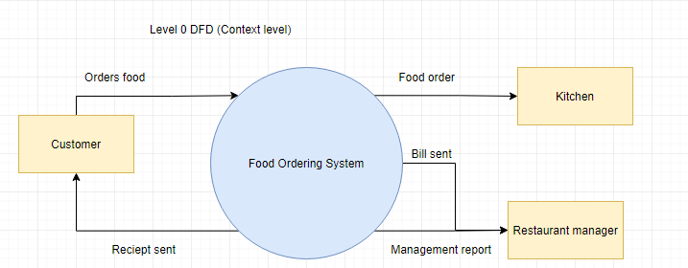
Level 0 DFD
Input information:
- The food order is input as the customer’s order for food.
Output information:
- A receipt of the order is sent to the customer.
- The order is received by the system, then sent to the kitchen for further processing.
- The restaurant management receives the report of the bill, as well as a management report.

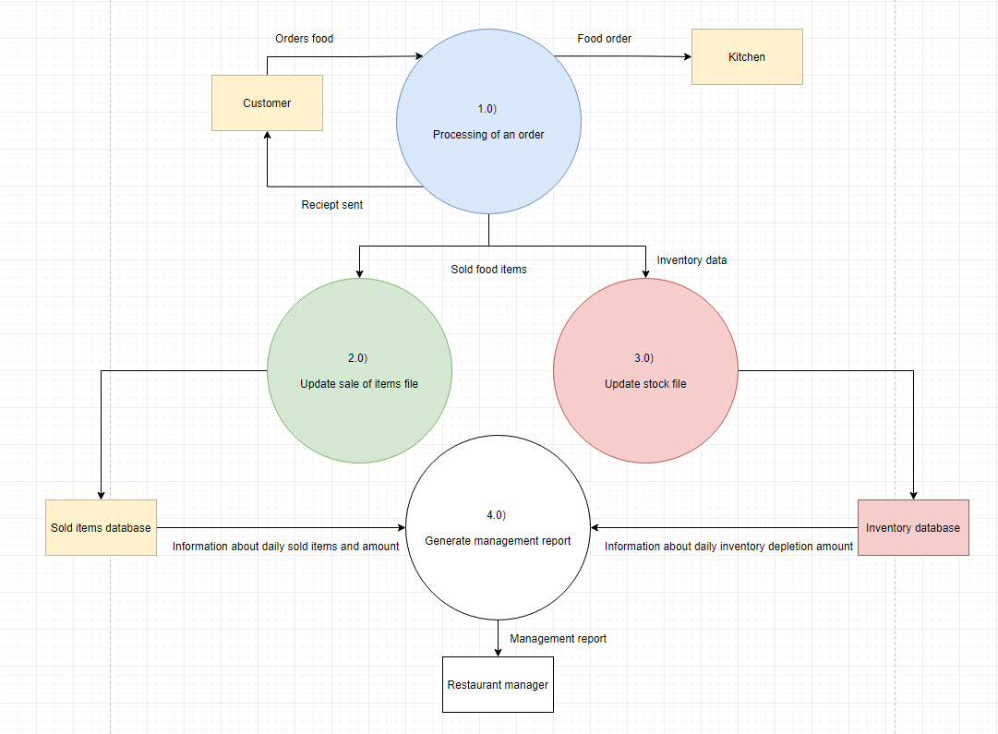
Level 1 DFD
The order is processed by process 1.0.
The food as well as the activities involved to complete the customer & system transaction are processed by process 2.0, 3.0, and 4.0.

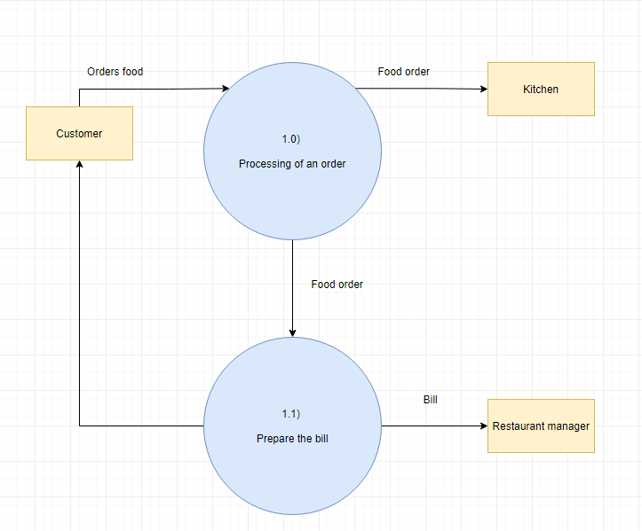
Level 2 DFD
More detailed information on how the “processing of an order” is shown

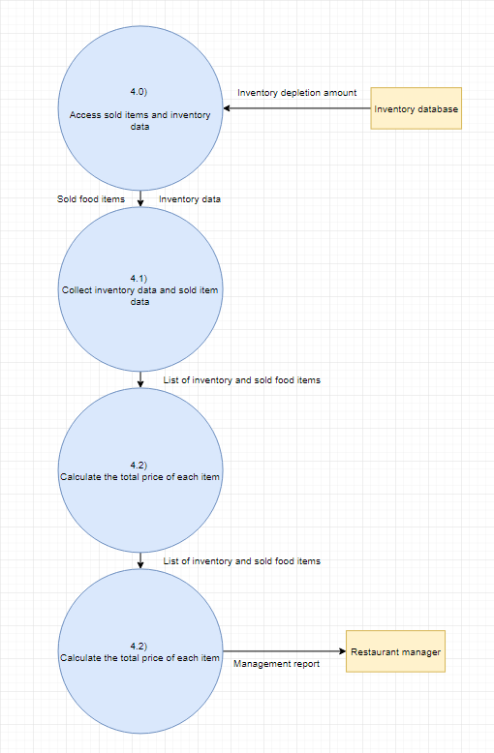
Level 3 DFD
More detailed information on management being able to generate a report to view is shown at this level of the data flow diagram. A report should be generated but the inventory data and data of sold food items, as well as the total should be calculated before generating the report

Justification of choice of technology and framework.
The software development tool that will be utilized for developing this project is Eclipse. Eclipse is an “integrated development environment” for Java as well as other languages. This IDE is utilized simply for the purpose that it is free, and open source allowing it to be utilized on any computer it can be downloaded on. Eclipse itself also includes a modular architecture meaning that the developer can “utilize modules to make work easier.” (Memon, 2019)[1]
Eclipse Advantages
- A free, open-source integrated development environment that supports Java Programming.
- Has large support for plugins, also supports large projects very well.
- Eclipse also has much “better java server support including JBoss, WildFly and Tomcat” (Lazar, 2018)[3] which would be very useful if this socket program was taken from local hosting to dedicated hosting in the future if required.
Eclipse Disadvantages
- However, Eclipse has a “tendency to run slower than NetBeans and other IDEs due to insufficient memory allocation.”
NetBeans Advantages
- A free, open-source integrated development environment that supports Java Programming.
- Beginner friendly, has a simpler user-interface and you do not require plugins.
- NetBeans is more stable; it also requires less system resources than Eclipse as well as having better memory allocation for programming.
NetBeans Disadvantages
- Less support for plugins or scalability for large-scale project as Eclipse.
To conclude, Eclipse is being utilized for myself as a developer as it will allow for more efficient program and resource usage, it also has a plethora of plugins and libraries to its disposal as well as having better socket programming support compared to NetBeans, it very useful for it to be able to run on college systems. Eclipse is also being utilized as it is the tool initially started using to create the system, allowing more familiarity instead of having to learn a new integrated development environment.

The language that was utilized to develop the application system was Java. Every enterprise utilizes Java in one way or another, as per Oracle “more than 3 billion devices run applications designed on the development platform” (Moore, 2015)[6] Java is utilized to design the following applications:
- Desktop GUI Applications
- Embedded Systems
- Web applications, including eCommerce applications.
- Web servers and application servers
- Mobile applications including Android applications.
- Enterprise Applications
- Scientific Applications
Java has a multitude of advantages and disadvantages that swayed me to utilize this development platform over other development languages such as:
- Java is simple – The syntax of Java is straightforward, easy to write, learn, maintain, and understand as well as being less complex than languages like C or C++. I also have much more experience in writing Java having used it a variety of times for other projects in the past therefore it was a much more feasible language for me to use for development rather than having to learn C++ or C# while attempting to develop under a strict timespan.
- Java is also considered a “standard in enterprise computing” Java “supports a plethora of libraries – building blocks of any enterprise system – that help developers create any function that a company may need” (Altexsoft, 2018)[2]
- Platform independency – “write once, run anywhere” is a popular programming catchphrase which describes Java’s cross-platform capabilities meaning that a Java program that is designed on MacOS will run exactly the same on Windows. This inclusivity is not necessarily needed for this project as it will be run on Windows systems for its specific purpose, however it is still a good advantage to have if it were scaled up in the future.
However, Java has disadvantages when being compared to other languages such as Visual Basic or C++ such as:
- The performance of Java is considerably slower during runtime “which allows it to run on every operating system but it also makes it perform slower than languages such as C or C++” (Javatpoint, 2011)[4] However this performance decrease is negligible considering the small size of the program therefore not something to consider changing programming language for.
- The default look of the GUI applications “written in Java utilizing the Swing toolbox is very not quite the same as local applications” (GeeksforGeeks, 2020)[5] While this is true considering Java is very bland looking and takes a multitude of more effort to make a professional looking program, this program is being utilized for efficiency based purposes therefore the design does not necessarily have to be the main focus.

The utilization of using a dedicated library for outputting and storing data was considered during the design process. However, using an external library for outputting data in JSON format can be considered out of scope for the program and a case of over-fitting given the small amount of data being output to each file. If the quantity of data written to a single file were to be increased, or if data was to be written to a cumulative file in the future, then the approach used would be reconsidered. A database management system was also considered however deemed unnecessary as the information does not need to be stored. Consequently, it is being sent through the client to the server dynamically where the information is cleared once the order has been retrieved successfully by the kitchen.
The utilization of a Java socket was needed versus a web socket, as a web socket typically runs from a browser connecting to an application server over a protocol similar to HTTP that runs through TCP/IP. However, they are primarily for web applications that require a permanent connection to the server. Moreover, this application does not require a permanent connection and could be completed through a java oriented local socket as it is more powerful and generic to implement. Consequently, this does mean that if this system were transferred to an enterprise tier application it should utilize a web socket to allow for a connection handshake from the user device (mobile phone, tablet, etc) and a message frame that will respond from the application to mutually accept the connection and then use the frame to pass back and forth information (receipt, payment, order information, etc.)

A thick client was also utilized which is basically a networked computer system with most of the resources installed locally, in this case eclipse, the server and software all installed on my local machine rather than being distributed over a network. This works efficiently in the current state of the application, however if it were to be transferred into an enterprise system then I would recommend a web/cloud application as one that runs on a remote server and interacts with its users through a browser-based user interface. This would mean that there is less hardware demand from the client, as well as being able to run multiple iterations of the software simultaneously if it were outsourced as external software for restaurants to purchase. It would also allow for neat advantages such as mobile device access, as well as the ease of deployment and upgrade potential as it is much easier to upgrade a web service than have users download, then individually install upgrades on a thick client system.

A messaging queue system could also be implemented into the system in the future which is a form of asynchronous service-to-service communication. Messages, or in this case orders would be stored on the queue of the server until they are processed and deleted. Each message is processed only once, by a single consumer to rid the server of overloading issues if there is a large spike in workload. However, this may not be needed as the system works smoothly in its current state, allowing multiple orders to be made simultaneously however this could be a customer-driven feature to only accept orders when they are ready or when the previous orders have been finished to maintain a smooth workload on the kitchen staff.

There is no current need for any security implementations as the system does not possess any features that store user information, or login information as the user simply enters their name and identification number at the end of the order process which is sent to the kitchen to simply identify who placed an order. However, if were to be transformed into an enterprise system with a web-socket, it could utilize a login system so that users could place a previous order or view previous order information therefore would need to utilize security features.

Prototype Designs
Sketch of the splash screen to initialize the system.
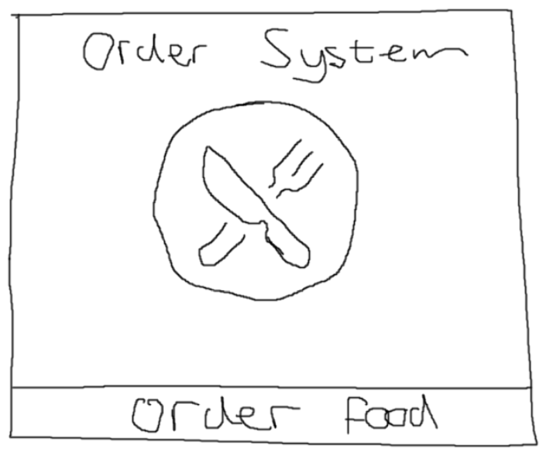
Improvements that could be made:
- Adding color
- Adding a dedicated logo in the middle of the splash screen
- Highlighting on the buttons
- Better outlining around the system

Sketch of the menu system
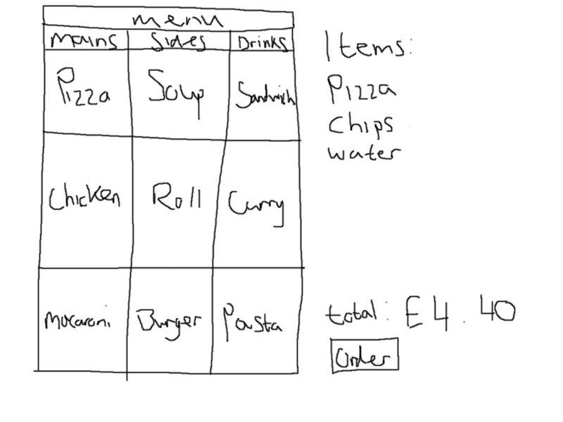
Improvements that could be made:
- Adding color.
- Adding logo and brand to the top left corner of the system.
- Adding quantity to the receipt on the side.
- Adding total to each individual item to provide individual price breakdown.
- Adding pictures to showcase the item.
- Adding a combo box for user accessibility to increase or decrease amount of items.

Sketch of the order screen after menu system
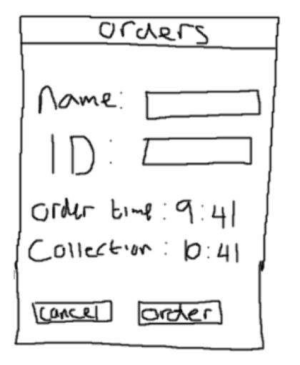
Improvements that could be made:
- Adding color
- Adding logo to top left of the system
- Adding a selectable collection time so that it is not always mandatorily an hour.

Revised splash screen design
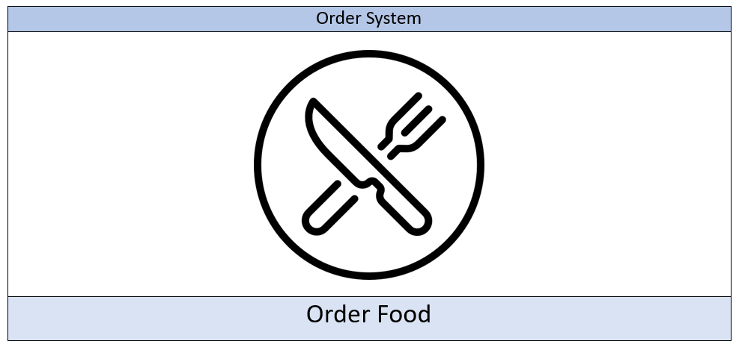

Revised main’s menu screen
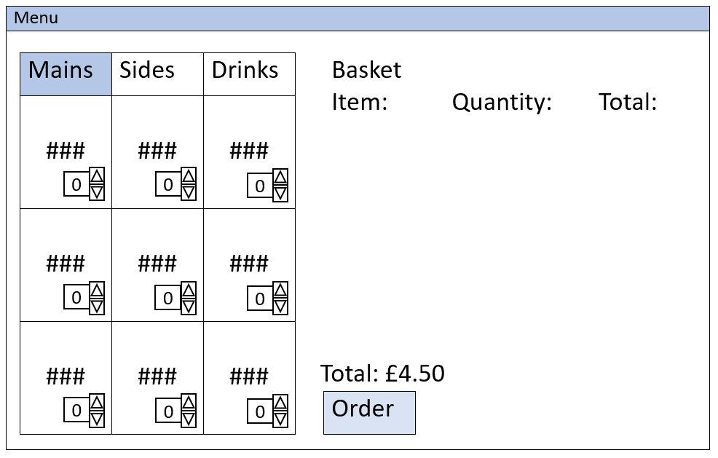

Revised side’s menu screen
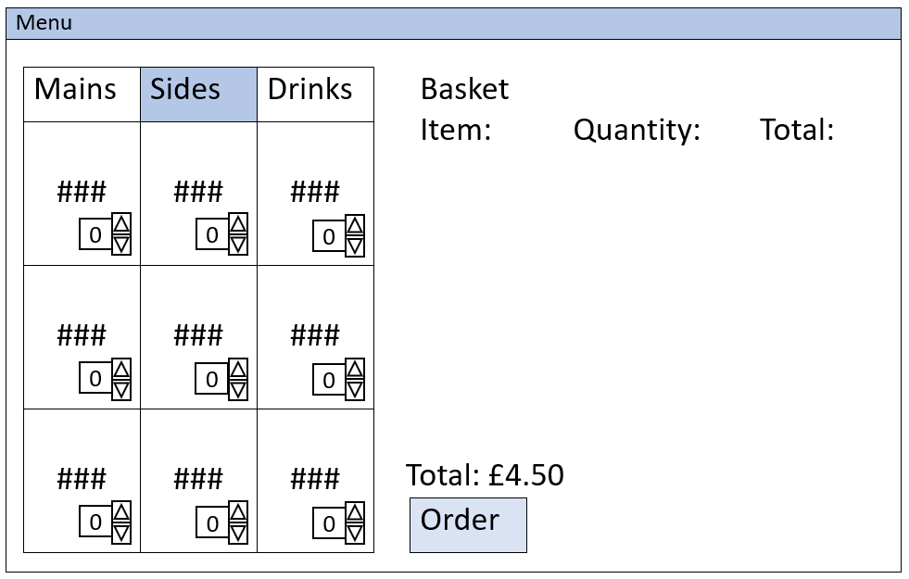

Revised drink’s menu screen
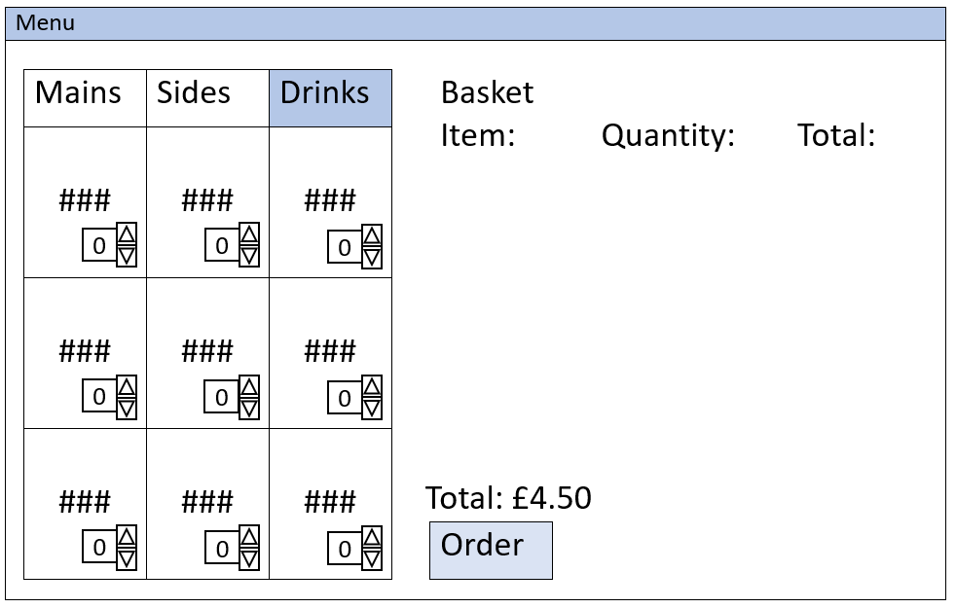

Final working design of the system
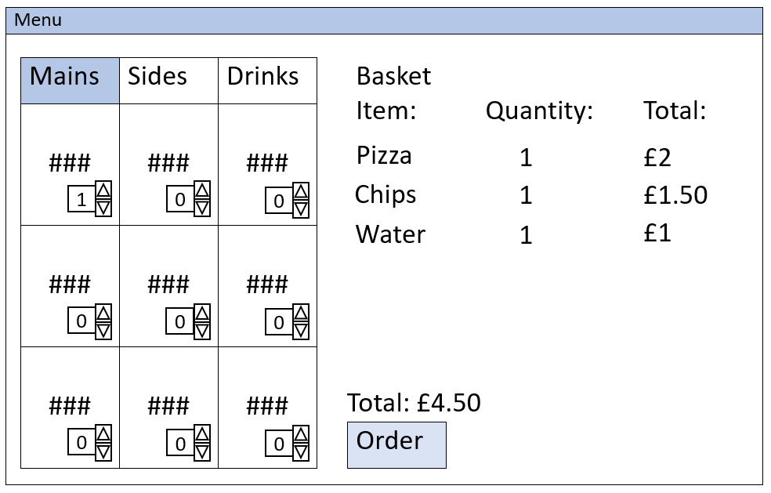

Revised order screen design
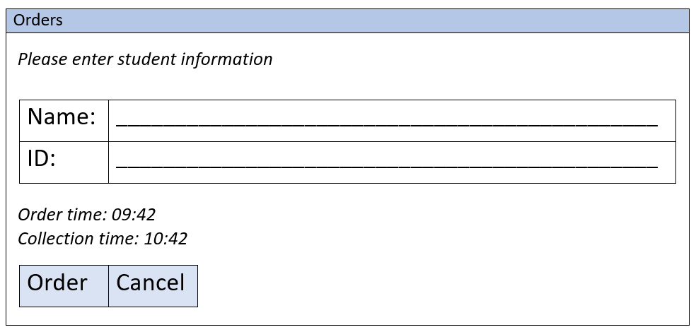

System splash screen system design in Java using Eclipse.
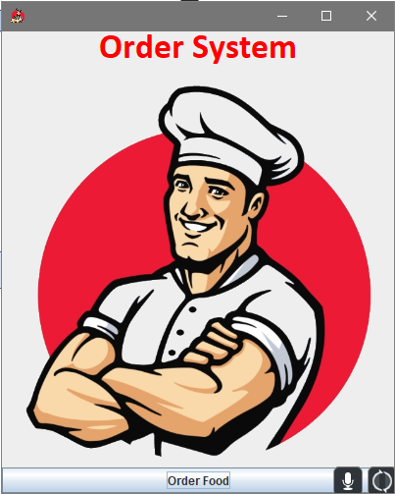

System main menu screen design in Java using Eclipse.
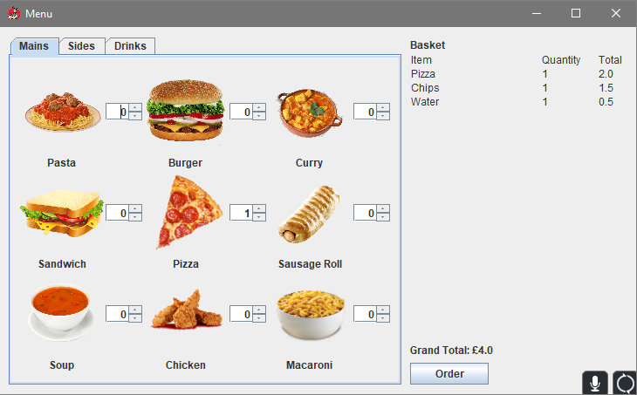

System sides menu screen design in Java using Eclipse.
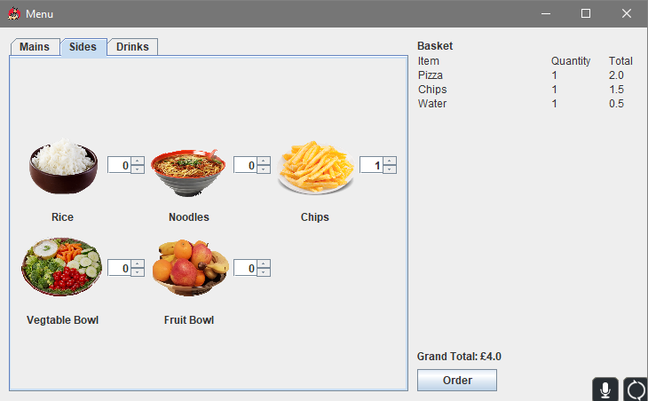

System drinks menu screen design in Java using Eclipse.
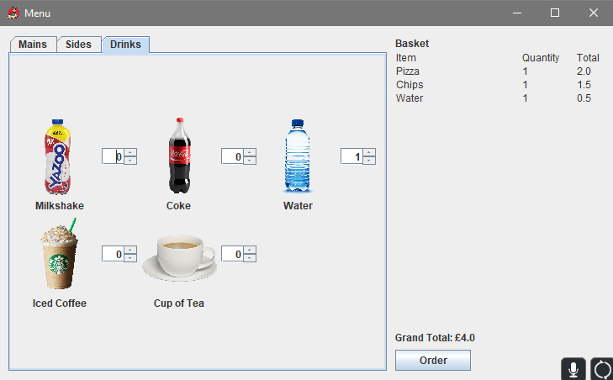

System order screen design in Java using Eclipse.
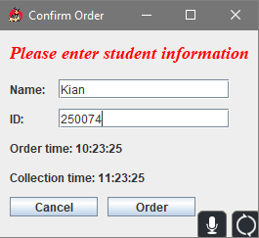

Example of transformation of information from order information into .json
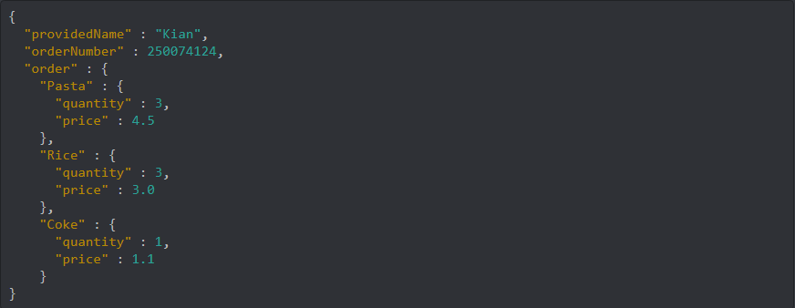

Screenshot of how the order is sent through a json format from the client order system to the server, however in this screenshot the server is not running so it refuses to send the order.
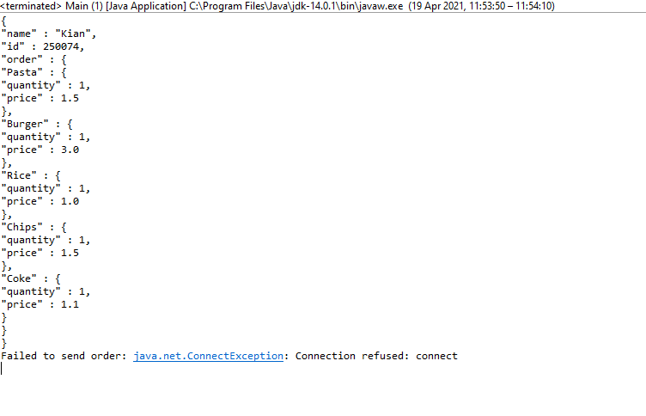

Screenshot of how the order is sent through a json format from the client system to the server, in this screenshot the server is started on the local machine before sending the order on port 8080. It then states that it has received the client order in the screenshot before showing the order details.
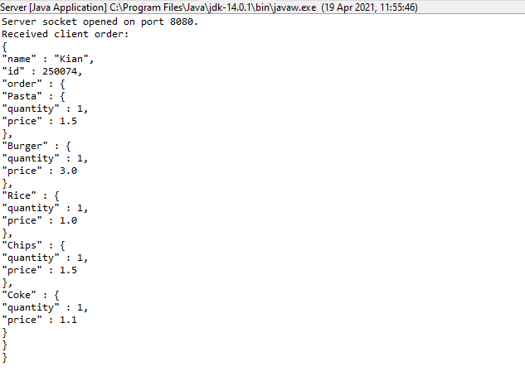

A screenshot to show that the system is able to handle two orders being placed simultaneously. This was done via the usage of running the system on my local machine and sending in an order while having another tester send in their order on a different machine at the same time which went through without error.
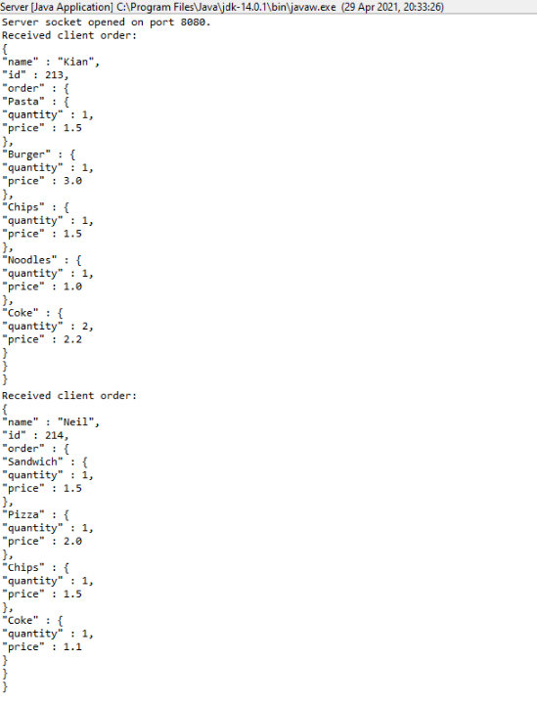

References
- Memon, Z. (2015). A brief comparison of Java IDE’s: NetBeans Vs Eclipse – Linux Hint. [online] Linuxhint.com. Available at: https://linuxhint.com/netbeans_vs_eclipse/ [Accessed 18 Apr. 2021].
- AltexSoft. (2018). The Good and the Bad of Java Programming. [online] Available at: https://www.altexsoft.com/blog/engineering/pros-and-cons-of-java-programming/ [Accessed 18 Apr. 2021].
- Lazar, A. (2018). The battle of the IDEs - JAXenter. [online] JAXenter. Available at: https://jaxenter.com/battle-ides-150122.html [Accessed 18 Apr. 2021].
- www.javatpoint.com. (2011). Advantages and disadvantages of Java - Javatpoint. [online] Available at: https://www.javatpoint.com/advantages-and-disadvantages-of-java [Accessed 18 Apr. 2021].
- GeeksforGeeks. (2020). Advantages and Disadvantages of Java - GeeksforGeeks. [online] Available at: https://www.geeksforgeeks.org/advantages-and-disadvantages-of-java/ [Accessed 18 Apr. 2021].
- Moore, W. (2015). Benefits of Java over Other Programming Languages - Invensis Technologies. [online] Invensis Technologies. Available at: https://www.invensis.net/blog/benefits-of-java-over-other-programming-languages/ [Accessed 18 Apr. 2021].

Appendix

Pseudo-code
// builds the order using name and ID
void socketOrder (name, id, array<string> order) {
stringBuilder json = new stringBuilder (name, id)
for (string item : order ) {
string[] data = item.split(“,”);
json.append(“quantity).append(data[qty])
json.append(“price”).append(data[price])
}

// sends the order to the server as a concatenated JSON string
try {
Socket socket = new Socket (“localhost”, 8080);
printWriter writer = new printWriter = getoutputstream
writer.print ( json.toString() );
socket.close();
catch (IOException e) {
“failed to print order, try again” + e.toString()
}
// open server socket
serversocket serverSocket = new serverSocket(8080);
“server socket opened on port 8080”;

// closes the server socket on program termination
runtime,getruntime().addShutDownHook(new Thread(() -> {
try {
serversocket.close();
} catch (IOException e) {
throw new RuntimeException(e);
}
}));

// server accepting the client information
while (true) {
Socket socket = serverSocket.accept();
InputStreamReader input = new InputStreamReader(socket.getInputStream(), StandardCharsets.UTF_8);
BufferedReader buffer = new BufferedReader(input);
StringBuilder content = new StringBuilder();
for (String line; (line = buffer.readLine()) != null;) {
if (content.length() > 0) content.append("\n");
content.append(line);
}

System.out.println("Received client order:\n" + content.toString()); //Usually this content would be saved/used.

//Return confirmation.
PrintWriter writer = new PrintWriter(socket.getOutputStream());
writer.println("Data received.");
writer.flush();

// array of sides (sides would be replaced with mains/drinks for the other two menus)
sideImages = new JLabel[SIDES];
sideNames = new String[SIDES];
sideQuantitySpinners = new JSpinner[SIDES];
sidePrices = new Double[SIDES];
sideImagePaths = new String[SIDES];

sideImagePaths[0] = new String("image/Rice.png");
sideImagePaths[1] = new String("image/Noodles.png");
sideImagePaths[2] = new String("image/Chips.png");
sideImagePaths[3] = new String("image/Veg.png");
sideImagePaths[4] = new String("image/fruit.png");

sideNames[0] = "Rice";
sideNames[1] = "Noodles";
sideNames[2] = "Chips";
sideNames[3] = "Vegtable Bowl";
sideNames[4] = "Fruit Bowl";

sidePrices[0] = 1.00;
sidePrices[1] = 1.00;
sidePrices[2] = 1.50;
sidePrices[3] = 1.10;
sidePrices[4] = 0.75;

User Feedback Testing
Feedback Type
[✓] Comments
[✓] Questions
Describe Feedback:
- System works how it should.
- Easy to order food items.
- Menu system is simple.
Potential corrections/additional features for the future:
Add more user control options so that the user can go back once on the order page to cancel their order for example or change their items.
How easy is it to use?
[✓] Very Easy [] Easy [] Hard [] Very Hard [] Unusable
Do you think the software developed is suitable for the purpose?
[✓] Yes [] No
Name
Alex Thomas
Email
N/A
Conducted via
Discord voice call with it being shown via screensharing software running off my local machine.

User Feedback Testing
Feedback Type
[✓] Comments
[✓] Questions
Describe Feedback:
- System works flawlessly.
- Data validation works so that dud entries cannot be made.
- System is very consistent; all images and coloring remain the same throughout.
Potential corrections/additional features for the future:
Add the ability for the user to choose their own timescale for collection, i.e., 30 minutes, 1 hour, 1 hour 30 minutes instead of the static hour.
How easy is it to use?
[✓] Very Easy [] Easy [] Hard [] Very Hard [] Unusable
Do you think the software developed is suitable for the purpose?
[✓] Yes [] No
Name
Rhodri Dugay
Email
N/A
Conducted via
Discord voice call with it being shown via screensharing software running off my local machine.

User Feedback Testing
Feedback Type
[✓] Comments
[✓] Questions
Describe Feedback:
- Software works and is very easy to use for a non-technologically advanced user
Potential corrections/additional features for the future:
Could add a desserts menu as a fourth option to the three mains (main, sides, drinks)
Fix the currency issue that is displayed in the total, so that it shows to the first decimal point (£1.10) instead of (1.1)
How easy is it to use?
[✓] Very Easy [] Easy [] Hard [] Very Hard [] Unusable
Do you think the software developed is suitable for the purpose?
[✓] Yes [] No
Name
Abigail Dignan
Email
N/A
Conducted via
Discord voice call with it being shown via screensharing software running off my local machine.

