

Master of Business Administration Programme
LCMB7035
Dissertation

Topic
“The Effect of Digital Marketing Strategies on Sales Growth: A Quantitative Study of Sainsbury’s UK”

Student Name: Md. Anik Ahammad
Student ID: 2428684
Supervisor Name: Dr. Faizu Edu

Word count: 15029

Due Date: Tuesday, 3rd February 2026

Declaration

I, Md. Anik Ahammad declare herein that this dissertation has been composed entirely by myself. Every article is my own work unless it has been specified to the contrary. I also testify that this dissertation is not presented to any other degree or qualification, wholly or in part.

Signature: Md. Anik Ahammad

Date: 25/11/2025

Acknowledgements
I am happy to write this letter to express my deep gratitude to my supervisor, Dr. Faizu Edu, for his counselling, constructive criticism, and invaluable questions and assistance in preparing this dissertation. These resources and the environment in which I would conduct my research were identified at the University of Wales Trinity Saint David, and I am grateful to the academic staff members. I want to thank my family and friends who were beside me, believed in me, and even tolerated me.
Finally, I am grateful to everyone and every organisation whose contributions, data, and information helped complete this research.

Abstract
The study discusses ways to boost sales at Sainsbury UK through digital marketing strategies as the grocery retail industry digitalises. The study sought to determine Sainsbury's digital marketing activities, evaluate the connection between these activities and the organisation's sales performance, and identify the digital channels that have contributed most to sales growth. The quantitative research method was selected, and secondary data, including Sainsbury's annual reports, industry statistics, and official UK retail statistics for 2021-2025, were used. Relationship-based and descriptive analyses were used to identify patterns in sales performance and digital marketing activity, and to examine their associations. The results indicate that Sainsbury has established an omnichannel digital marketing platform characterised by greater online channels, data-driven personalisation, and long-term investment in digital capabilities. The results show that online sales growth is linked to channel-specificity of digital strategies, but not the overall retail sales performance. It was discovered that loyalty-based online platforms and channels are the most powerful in generating quantifiable sales results, supported by social and content channels. The study contributes to the body of research on digital marketing and digital retail by providing firm-level longitudinal evidence in a traditional retail context. It shows that digital marketing should be employed as a mixture of organisational competence. Best practices are offered to maximise channels, improve performance measurement, and enhance personalisation. On the whole, the research may be relevant to scholars and professionals interested in understanding the role of digital marketing in driving sales in the omnichannel retail environment.

Table of Contents
Declaration 1
Acknowledgements 2
Abstract 3
List of Figures 7
List of Tables 8
Chapter 1: Introduction 9
1.1 Background and Context 9
1.2 Research Problem and Rationale 10
1.3 Research Aim, Objectives and Questions 10
1.4 Theoretical Framework 11
1.5 Relevance and Contribution 12
1.6 Dissertation Structure Overview 12
Chapter 2: Literature Review 14
2.1 Introduction 14
2.2 Digital Transformation in the UK Grocery Retail Sector 14
2.3 Digital Marketing Strategies in Supermarket Retail 16
2.4 Consumer Behaviour, Online Grocery Shopping and Customer Engagement 19
2.5 Theoretical Perspectives and Conceptual Lens 21
2.6 Empirical Evidence Linking Digital Marketing to Sales Performance 24
2.7 Synthesis, Research Gap and Educated Estimation 25
2.8 Chapter Conclusion 26
Chapter 3: Research Methodology 28
3.1 Introduction 28
3.2 Research Philosophy 28
3.3 Research Approach 29
3.4 Research Strategy 30
3.5 Data Types and Sources 32
3.6 Data Collection Methods 33
3.7 Sampling Strategy 34
3.8 Data Analysis Techniques 35
3.9 Ethical Considerations 36
3.10 Methodological Limitations 37
Chapter 4: Data Analysis 38
4.1 Introduction 38
4.2 Dataset Description and Characteristics 38
4.3 Analytical Approach 40
4.4 Descriptive Analysis of Sales Performance 41
4.5 Digital Marketing Analysis 43
4.6 Relationship Analysis 45
4.7 Summary of Findings 47
4.8 Data Analysis Limitations 48
Chapter 5: Discussion 49
5.1 Introduction 49
5.2 Key Findings Overview 49
5.3 Discussion of Research Question 1 50
5.4 Discussion of Research Question 2 51
5.5 Discussion of Research Question 3 52
5.6 Contribution to Literature 53
5.7 Chapter Summary 54
Chapter 6: Conclusion and Recommendations 55
6.1 Introduction 55
6.2 Summary of Findings 55
6.3 Research Questions Answered 56
6.4 Contribution to Knowledge 57
6.5 Practical Recommendations 57
6.6 Limitations of the Study 58
6.7 Future Research Directions 58
6.8 Final Reflection 59
Reference List 60
Appendices 68
Appendix 1: Ethical Approval Form 68
Appendix 2: List of Abbreviations 70
Appendix 3: Glossary 71

List of Figures
Figure 1: Sainsbury Logo (Sainsbury’s, 2025)……………………………………………….09
Figure 2: Technology Acceptance Model (TAM) (Marikyan and Papagiannidis, 2025)…… 14
Figure 3: Omnichannel Customer Journey (Klaus, 2025)…………………………………... 15
Figure 4: Digital Marketing Strategies for Online Grocery (Digital Scholar, 2022)………... 17
Figure 5: Unified Theory of Acceptance (UTAUT) (getitdoneex, 2025)…………………… 21
Figure 6: Customer Experience (CX) Research (Jain, 2023)……………………………….. 23
Figure 7: Research Philosophy in Onion (Bergmann, 2023)………………………………... 28
Figure 8: The Effects of Digital Marketing on E-commerce Sales (Alagar, 2024)…………. 31

List of Tables
Table 1: Summary of Data Sources…………………………………………………………. 39
Table 2: Key Variables and Coverage Period……………………………………………..... 40
Table 3: Total Retail Sales Growth (2021–2025)…………………………………………… 41
Table 4: Online Sales Growth Trends (2021–2025)………………………………………… 42
Table 5: Online Sales Contribution and Growth…………………………………………….. 43
Table 6: Loyalty Platform Engagement Indicators………………………………………….. 44
Table 7: Summary of Observed Relationships………………………………………………. 46

Chapter 1: Introduction

1.1 Background and Context
The past ten years have been characterised by a digital revolution in the UK retail sector, driven by consumer behaviour, greater internet penetration, and the introduction of the omnichannel shopping concept. Digital technologies have reshaped the relationship between retailers and consumers and streamlined their operations, making them leaders in a saturated market. Online marketing has been crucial throughout the purchase process, as customers still use the internet to research products and prices before making purchases. It has helped in growing (J Sainsbury plc, 2024). What competition is compelling the supermarkets to do in this instance is to develop their online capabilities, not just to compete with their offline competitors but with completely online grocery stores, such as Ocado.
After reorganising its market operations, Sainsbury has expanded its online operations and is now one of the largest supermarket chains in the United Kingdom. The retailer has invested heavily in online platforms to reach customers through targeted advertising, a one-to-one loyalty programme, the online shopping experience, and the mobile experience. There have been indications to demonstrate that such digital initiatives played a key role in shaping customer behaviour and sales performance. To illustrate, the proportion of retail sales made digitally at Sainsbury increased significantly by 39% during the post-pandemic period, which is a positive indicator of the magnitude of the shift to digital facilities (Valentine, 2021). The company has recognised the importance of the digital loyalty ecosystem that has been built, with more than 8.2 million customers actively using its Nectar platform to access personalised deals and communications (J Sainsbury plc, 2024).
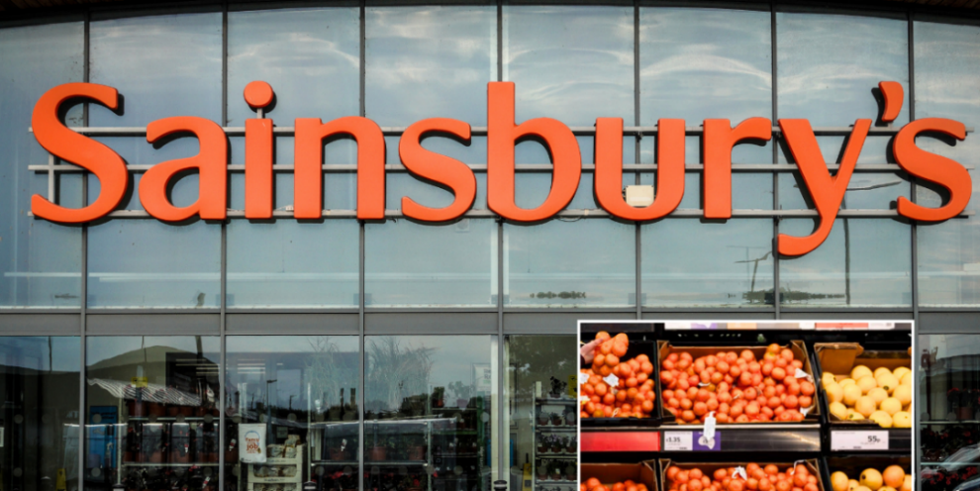
Figure 1: Sainsbury Logo (Sainsbury’s, 2025).
At the same time, competitive benchmarking reports suggest variation in the effectiveness of UK supermarkets in their use of digital marketing. While Tesco and Aldi score very high in digital engagement, Sainsbury's is in a very volatile position, with annual digital traffic declines in some areas despite high advertising expenditure (Tarplee, 2025). These composite indicators indicate the need for an empirical study of how digital marketing has driven sales growth at Sainsbury's in a fast-evolving market.

1.2 Research Problem and Rationale
Although digital marketing has been relatively successful in the UK retail sector, there is no empirical evidence of its impact on supermarket sales. The current literature provides a tendency to consider the indicators of digital engagement - website traffic, clicks or social media interactions. Still, it does not directly correlate digital marketing activities with financial performance (Deloitte, 2025). Moreover, as retailers are investing more in digital advertising, personalisation, and loyalty technology, it is doubtful that these investments will sustain long-term sales growth, especially in highly competitive grocery markets.
For Sainsbury's, this is a very applicable gap. Although the retailer has been able to significantly increase their digital footprint, with improved targeted personalisation through the Nectar platform and increased capacity for online groceries, based on external benchmarking, there appears to be an inconsistency in the delivery of their digital performance. For instance, Sainsbury's experienced one of the most significant drops in organic digital traffic in the UK Supermarkets despite having one of the highest digital advertising spends (Tarplee, 2025). At the same time, company reports indicate increasing digital sales and gains in market share through online channels (J Sainsbury plc, 2024).
The justification for this research, thus, is the observation of the dearth of data-driven, transparent evaluation of the relationship between Sainsbury's digital marketing strategies and its sales growth, which bridges a critical gap between digital investment and commercial achievement.

1.3 Research Aim, Objectives and Questions
Aim
Using secondary quantitative data, the study will determine how digital marketing strategies have influenced Sainsbury's sales growth in the UK.

Research Objectives
- To identify the predominant digital marketing strategies that are used by Sainsbury's in the UK.
- To establish the relationship between these strategies and sales performance.
- To determine which digital channels and tactics are impactful in growth to the greatest extent.
Research Questions
- What are the Sainsbury UK digital marketing strategies?
- What do these strategies have to do with growth in sales?
- What are the most significant channels to performance?

1.4 Theoretical Framework
The research is supported by a set of established theories used to understand the influence of digital marketing on customer behaviour and, therefore, its effect on sales performance in the retail environment. The first critical framework is the Digital Marketing Funnel that provides the steps the customer passes through, from awareness to considering the item to purchase to becoming loyal to it. Digital marketing activities such as targeted advertising, personalised recommendations, and social media engagement are key in taking consumers through these stages (Chaffey and Smith, 2022). For a retailer such as Sainsbury's, investing in digital channels will improve store visibility, encourage browsing, and convert online interactions into sales. The funnel model is an important tool for measuring customer response to digital initiatives.
One of the second theories in the case is the Technology Acceptance Model (TAM) of 1989 by Davis, which characterises customer acceptance of the digital platform in terms of two key variables: perceived usefulness and ease of use. Specifically, this is relevant to Sainsbury, the online ecosystem of which, consisting of the Nectar app, online grocery, and personalised digital vouchers, will rely on the willingness of customers to adopt technology. The implementation of high-level digital loyalty systems is found to drive customer retention and repeat purchasing, which are closely linked to incremental sales growth (Cuesta-Valiño et al., 2023).

The Customer Engagement Theory emphasises the importance of relevant, interactive and personalised digital experiences in developing more positive relationships with customers, which can be used to improve business performance (Brodie et al., 2011). This sentiment is fueled by Sainsbury's approach to improving data-based personalisation, as its digital loyalty programme is a subset of its engagement-creating and spending-behaviour-forming plan.
All these frameworks, combined, constitute a conceptual basis for why and how digital marketing operations can lead to the channels necessary to facilitate sales growth. Therefore, they guide the interpretation of the secondary data gathered and contribute to the exposition on the effectiveness of Sainsbury's digital marketing strategy in the context of the UK retail industry as a whole.

1.5 Relevance and Contribution
The study is very timely, given the dynamic digitisation of the UK retail industry and the increasing role of online interaction in shaping consumer behaviour. Since supermarkets invest heavily in digital marketing, there is strong pressure to prove the commercial value of their efforts. The evidence at hand, however, is incomplete, and much of the research on the topic has focused on domesticated measures of engagement rather than financial results from digital activity (Deloitte, 2025). The study of Sainsbury - one of the largest companies in the United Kingdom with extensive digital opportunities - will offer a valuable contribution to understanding how the digital marketing campaign can be utilised to drive quantifiable sales growth.
The study contributes to the academic literature by offering an evidence-based assessment of the success of the digital marketing strategy within the framework of a large grocery store and by addressing gaps in empirical knowledge identified in recent research (J Sainsbury plc, 2024). In practice, it will give retailers better, more conclusive evidence of which digital strategies work best for sales, helping them make sound decisions in a very competitive arena.

1.6 Dissertation Structure Overview
The dissertation has been structured into six chapters, which have helped in the overall analysis of the influence of digital marketing measures on sales growth at Sainsbury UK.
Chapter One gives the context of the research, its importance, aim, objectives and theoretical framework.
Chapter Two is the literature review; it reviews existing academic/industrial research on digital marketing and its role in enhancing retailers' performance in the UK supermarket industry, and the gaps the study addresses.
Chapter Three outlines the research methodology and discusses secondary methods, quantitative methods, data sources, analysis tools, and ethical issues.
Chapter Four, which covers the secondary data, will be presented in tabular form with comments on the trends.
Chapter Five explains the outcomes according to the available literature and the theoretical framework.
Chapter Six, which will summarise the most prominent findings, contributions, limitations and recommendations and give recommendations regarding future research and practice in the store.
The chapter introduces the research, which has found that the strategic importance of digital marketing is on the rise in the UK grocery retail market. It has realised that it needs to research its effects on its sales performance. It has been pointed out that the swift digital transformation, changing consumer behaviour, and competition have changed how retail marketing is performed, with digital strategies being key to growth and gaining a competitive advantage. It is against this background that Sainsbury UK is a good case study, as it is an established player in the market and continues to invest in digital and omnichannel capabilities. The chapter identified the research aim, objectives, and questions, providing the research with a clear path. It described the study because there was a gap in the literature: the lack of longitudinal, firm-level support for the relationship between digital marketing activities and sales growth in a traditional retail environment. By sealing this gap, the research will contribute to the scholarly and practical literature on the efficacy of digital marketing. In the chapter, the theoretical frameworks on which the analysis will be based have been presented (omnichannel retailing, the customer engagement theory, and the perspectives on digital marketing capabilities). These frameworks offer a systematic perspective from which the findings are viewed later on. Overall, this introductory chapter has provided a strong background for the dissertation, clearly explaining the research problem, justifying its relevance, and outlining how the study will be carried out. The subsequent chapters develop on this basis by conducting an elaborate literature review, methodology, analysis, and discussion of results.

Chapter 2: Literature Review

2.1 Introduction
The literature review will take the form of a critical review of both academic and commercial literature on the application of digital marketing in the UK grocery market, with reference to retailers, including Sainsbury's. The chapter provides the theoretical and empirical background on how online marketing strategies work and how they affect customer interactions, online traffic, and sales performance. It is a sequel to the dissertation that investigates the digital revolution in retailing, the usefulness of multichannel marketing, and the changes in consumer behaviour brought about by online grocery shopping. The review will expound and summarise the available literature on the matter, industry reports, and evidence on the retail industry. It verifies the current theories, such as the digital marketing funnel, the Technology Acceptance Model (TAM), and customer engagement theory, which are justified by the available literature. It covers the strengths and weaknesses of the methodological assessment of the literature, its inconsistency and the flaws of the discussion. Based on the argumentative review of the chapter, the current research draws on the existing literature but identifies significant gaps that warrant future research (Verhoef, Kannan, and Inman, 2015).
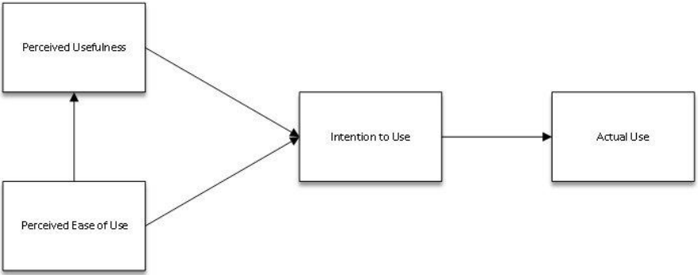
Figure 2: Technology Acceptance Model (TAM) (Marikyan and Papagiannidis, 2025).

2.2 Digital Transformation in the UK Grocery Retail Sector
Digital Shift and Structural Change in UK Grocery Retail
The digital revolution has entirely transformed the UK grocery market, and grocery retailers have begun to adapt their approaches to meet the needs of consumers, competitors, and emerging retail technologies. This has seen the UK grocery market digitise faster than ever, with big grocers automating their operations and mobile shopping apps and online ordering websites being used to make operations more efficient and responsive to consumer demand, fueled by convenience (Deloitte, 2023). This virtual revolution is not a fleeting moment but an overhaul of the structure that will influence the relationship between supermarkets and clients and how they interact in the end-to-end retail process.
Growth of Online Grocery and Post-Pandemic Consumer Behaviour
Online grocery shopping has never been as big as it is today, and the pandemic has driven a rise in online consumption. Kantar (2024) states that in the UK, online grocery shopping rates have nearly doubled during the pandemic and are significantly higher than in 2021, as people have now adapted to online shopping, home delivery, and collection. The trend has compelled retailers to increase digital capacity, adopt new delivery models, and expand their online assortments to meet consumers' so-called speed, convenience, and reliability expectations.
Omnichannel Integration and Unified Customer Journeys
UK supermarkets are moving towards discontinuous digital operations to integrate omnichannel ecosystems. According to McKinsey and Company (2021), retailers are currently concerned about their ability to deliver the ideal customer experience by linking physical locations, websites, loyalty programs, fulfilment centres, and mobile apps. The advantages of this centralised system are that the customers will be able to enjoy a greater variety of consistent experiences and be more resilient in their operations. In their case, Sainsbury, the business is still building its omnichannel capabilities through automation, data-driven fulfilment, and enhanced digital infrastructure, as evident in their annual reports.
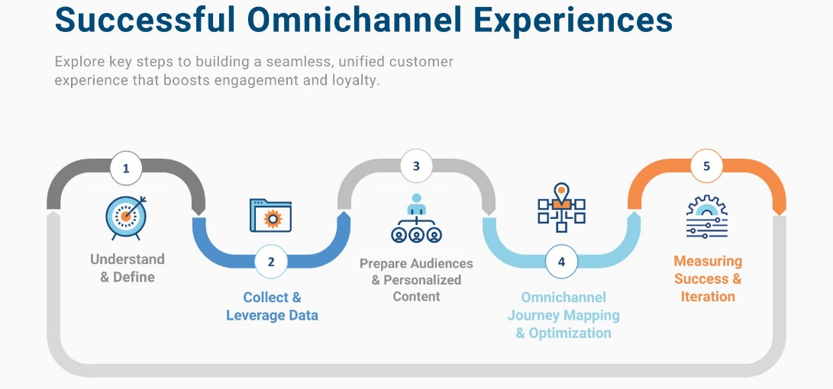
Figure 3: Omnichannel Customer Journey (Klaus, 2025).

Data-Driven Personalisation and Loyalty Ecosystems
Another vital digital retail concept that has become significant in the UK grocery market is personalisation. Baudry and Sanders (2021) explain that retailers are resorting to customer data platforms, AI-driven analytics, and recommendation engines to provide the most useful promotions and optimise prices. The key to this is the loyalty programme, i.e., Sainsbury Nectar and Tesco Clubcard, which collect behavioural data to make digital marketing more customised. Such ecosystems would strengthen customer relationships and help grocers compete in an environment where customers seek personalised, value-based offers.
Ongoing Challenges: Cost Pressures and Sustainability Expectations
Although these changes have occurred, grocers will be under greater pressure to strike a balance between digital investment and cost-efficiency, especially in a highly competitive price market. The Office for National Statistics (2023) claims that retailers today are more likely to focus on technology to enhance productivity and reduce waste, due to inflation and rising operating expenses. Consumers' requirements to source ethically, sustainably, and transparently create a need among supermarkets to employ digital tools to trace products, report on environmental impacts, and conduct low-carbon processes.

2.3 Digital Marketing Strategies in Supermarket Retail
The Role of Digital Marketing in Grocery Retail
Digital marketing is a core element of competitiveness that retailers in the grocery industry have been utilising to engage with customers at digital touchpoints and influence their shopping behaviours. According to Chaffey and Ellis-Chadwick (2019), digital channels enable supermarkets to build brand awareness, engage more with customers, and deliver quantifiable marketing outcomes as consumer expectations evolve quickly. As the trend moves towards online discovery and price comparison, and online fulfilment becomes the preference of the grocery shopper, the marketing policy should be transformed to ensure that retailers are more pronounced and noticeable.
Paid Search and Performance Advertising
Another effective method for finding high-intent customers actively interested in products or delivery to grocery stores is paid search. Walker and Altman (2020) state that search advertising is fundamental to retailers because it targets consumers who are almost ready to make a purchase decision. UK supermarkets (Tesco, Sainsbury, and Asda) spend heavily on advertising to ensure they remain visible compared to the discounters Aldi and Lidl. The choice will result in supermarkets appearing in search results whenever users need grocery items, delivery services, or deals.
Display, Social Media and Influencer Campaigns
Supermarkets are increasingly using display advertising, social media posts, and influencer collaborations to develop emotional appeals and deliver value-based messages. According to Sarker et al. (2025), social platforms enable fine-grained targeting of the target audience using demographic and behavioural information, making them the best channels for advertising recipes, seasonal promotions, and price-matching messages. An example is Sainsbury, which often uses short-form content and influencer collaborations during significant trading periods to drive traffic to its online shop and reaffirm its brand identity as one of quality and value.
Owned Digital Platforms: Websites, Apps and Mobile Experience
The digital experience consists of platforms owned by retailers where customers browse, customise, build and maintain baskets, and fulfil orders. According to Econsultancy and Adobe (2023), a faster, more intuitive, and mobile-optimised website and app are more likely to convert the customer. Mobile applications benefit supermarkets by promoting repeat purchases, in-store shopping lists, and the unification of loyalty programs. Sainsbury continues to enhance its app and site to improve the checkout process and shopping experience.
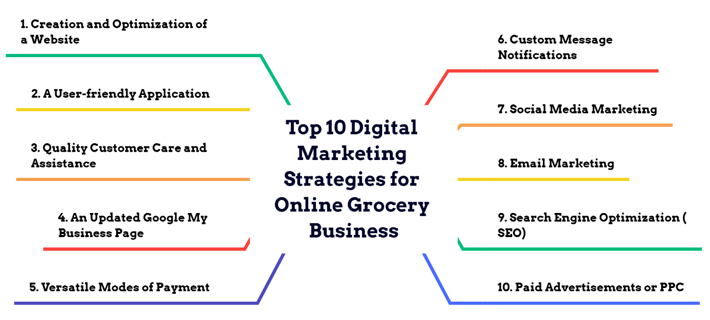
Figure 4: Digital Marketing Strategies for Online Grocery (Digital Scholar, 2022).

Search Engine Optimisation (SEO) and Organic Visibility
The rise of organic search is key to eliminating the need for paid advertising and ensuring long-term digital access. Ellis (2023) says that ranking keywords for high-value terms such as online grocery, weekly deals, or fresh-food delivery is crucial to the customer-attraction process. According to Tarpley, R. (2025), other UK supermarkets, such as Sainsbury, have recorded declines in organic desktop and mobile traffic in previous years; therefore, it is necessary to optimise SEO further and ensure digital performance.
Email Marketing and Customer Retention
One of the most effective and inexpensive retention tools deployed by UK supermarkets is email marketing, which allows one-on-one communication by focusing on past buying behaviour. In the McKinsey and Company (2023) article, the authors emphasise that target email campaigns achieve higher conversion rates when retailers use customer data to offer personalised offers and promotional content. The email newsletters help supermarkets offer weekly discounts, customised vouchers, and reminder messages to shoppers, encouraging them to fill their shopping carts or use special offers with time limits.
Loyalty Programmes and Data-Driven Personalisation
Loyalty ecosystems have been established as the core of digital marketing performance, as retailers can provide personalised experiences and sustain customer relationships. Baudry and Sanders (2021) argue that customer-driven personalisation has a substantial influence on satisfaction and repurchase. Sainsbury's does it via its Nectar programme that offers personalised discounts and digital Nectar Prices; Tesco Clubcard and Asda Rewards follow the same scheme. Such programmes add value, particularly when costs are under pressure, and customers are more cost-sensitive.
Omnichannel Integration and Unified Commerce
Modern supermarket marketing integrates physical stores with online shopping tools to create seamless customer experiences. McKinsey and Company (2021) adds that in single-omnichannel networks, stores have evolved into fulfilment centres, click-and-collection centres, and digital centres. Other tools that UK supermarkets have adopted include hybrid fulfilment, automated warehouses, and in-store navigation via apps to reduce friction and improve the overall shopping experience. This would make its brands consistent in customer engagement across the Internet, in-store, and cellular networks.

2.4 Consumer Behaviour, Online Grocery Shopping and Customer Engagement
Evolving Consumer Motivations in Online Grocery Shopping
Grocery retail consumer behaviour has been changing drastically, and consumers have shown interest in a more convenient, more efficient, and less-frictional shopping experience. The presence of digital grocery apps has enabled clients to make both large and small top-up purchases faster and more flexibly, with minimal effort in-store. It is more of a behavioural trend in which time-saving, hassle-free interactions motivate increased online adoption. According to Walker and Altman (2020), UK shoppers currently conduct more frequent digital top-up missions and are motivated, in large part, by the desire for speed and convenience.
Digital Decision-Making and Information Control
The decision-making process of online shopping consumers has been transformed because online shopping has more information, reviews, and price comparison on digital touchpoints. The accessibility of common information and algorithm-based suggestions prompts contemporary consumers to consult various sources before making purchases. The retailers could increase their influence on these online decision-making processes by making the information easier to interpret, navigate, and search. Econsultancy and Adobe (2023) believe that customers are rewarding companies with superior online shopping experiences and are more responsive to requests for such experiences by focusing on convenience and usability.
The Engagement of Personalisation
Personalisation has been in store for online grocery shopping and customer interactions. Customers are becoming more picky and require recommendations, offers, and promotions tailored to their habits, eating patterns, and lifestyles. An efficient process of satisfaction, emotional value, and repurchase rates can be enhanced through individualisation. The relationship between the retailers and consumers is therefore preeminently established by predictive analytics and data-based segmentation. According to McKinsey and Company (2023), customers respond well to personalised messages and would rather receive tailored messages.
Influence of Social Commerce and Digital Communities
Social commerce and consumer engagement have been significantly altered by influencers, fellow consumers, and other users. The younger generations and the population in general are very reliant on social validation and digital communities when making purchasing decisions. By integrating shoppable media, writing reviews, and employing features that influence the community, retailers build trust and convert online. As Sarker et al. (2025) emphasise, perceived social influence is a significant factor in consumer adoption and continued use of digital commerce platforms.
Mobile-First Interactions and Micro-Behaviour Patterns
There has been a shift towards mobile device-based online grocery consumption, with micro-behaviours such as quick browsing, price checking, and impulse purchases added to the basket. Mobile-first design is now a minimum requirement, particularly among younger users who prefer app-based interactions for their simplicity and familiarity. By maximising mobile UX, i.e., reducing load time, improving navigation, and using in-built payment systems, retailers will be able to minimise cognitive load and maximise the likelihood of purchase. According to Ellis (2023), powerful digital performances are connected to straightforward, humanised mobile experiences.
Expectations for Speed, Fulfilment and Convenience
Demands for fast delivery, same-day delivery, hourly delivery, click-and-collect, and real-time delivery are now among the most potent factors shaping consumer behaviour. Grocery shoppers are primarily concerned with the reliability and accuracy of delivery windows, and value freshness and a minimum waiting time. When retailers provide precise tracking and consistently accurate fulfilment, they build greater trust and repeat business. According to ONS (2023), retail channels that demonstrate consistent availability and fulfilment performance are likely to sustain ongoing consumer interaction.
Omnichannel Continuity and Engagement Across Touchpoints
The consumers of modern groceries are becoming more demanding of the flow of web and real-life links. This involves the unified loyalty program, cross-channel promotions, constant pricing, and the option to conduct research online and make purchases in stores. Such integration enables a more fluent interaction by supporting a wide variety of behavioural modes throughout the customer journey. According to McKinsey and Company (2021), physical stores are now integrated with digital systems, which can optimise the customer experience by mediating information and fulfilment across channels.

2.5 Theoretical Perspectives and Conceptual Lens
Introduction to Theoretical Positioning
Understanding consumers' adoption of online grocery services and how digital marketing strategies affect consumer engagement is critical, given the strong theoretical basis. Technology adoption theories, consumer psychology, and customer experience theories all provide a systematic perspective on digital behaviours. The latter views help explain why some approaches to digital opportunities, such as personalisation, omnichannel integration, or mobile-first design, are more successful for retailers like Sainsbury. According to Deloitte (2023), the retail transformation relies more on theories explaining digital innovation and changing consumer expectations.
Unified Theory of Acceptance and Use of Technology (UTAUT and META-UTAUT)
According to The Unified Theory of Acceptance and Use of Technology (UTAUT), performance expectancy, effort expectancy, social influence and enabling conditions determine how technology is adopted. Such considerations are reflected in online grocery shopping in the degree to which shoppers perceive digital shopping as time-saving, convenient, and socially acceptable, and in their perceptions that retailer systems are well-supported. This framework is enhanced by the META-UTAUT extension, which includes trust, habit, hedonic motivation, and perceived value, which are especially significant when freshness, delivery reliability, and perceived privacy affect product adoption. Sarker et al. (2025) note that social influence and perceived usefulness have particularly strong predictive power for digital commerce engagement, which is why META-UTAUT is a pivotal point of analysis for consumer adoption of Sainsbury's online channels.
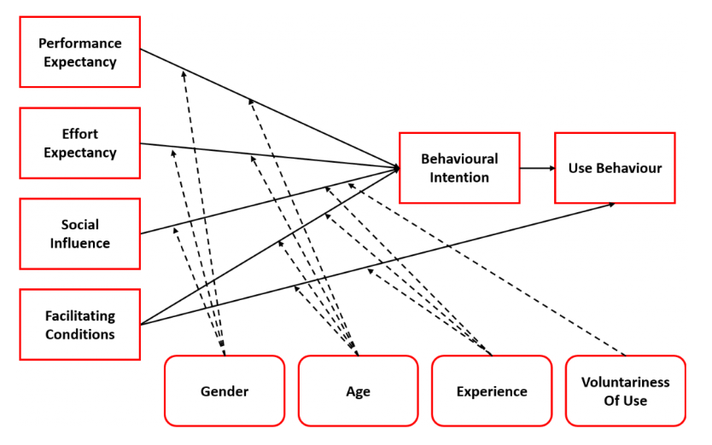
Figure 5: Unified Theory of Acceptance (UTAUT) (getitdoneex, 2025).
Technology Acceptance Model (TAM)
The Technology Acceptance Model (TAM) argues that perceived usefulness and perceived ease of use affect consumer adoption of digital technologies. This means that, in the grocery case, the consumer would focus on applications and websites that save time, ease the burden of carrying home products, and speed up payment. The performance of the interface and digital navigation and fulfilment processes in Sainsbury's can be analysed through the prism of TAM, which, in turn, will allow determining how convenient the customer finds the process of placing orders. McKinsey and Company (2023) report that consumers are moving to online platforms that are less frictional and offer customisation, thereby positively affecting perceptions of TAM, usability, and efficiency.
Behavioural Economics and Consumer Decision-Making
Consumer-behavioural economics can assist us in studying consumers' decision-making processes when they are overwhelmed by information, time-limited, or presented with a complex product assortment. Price anchoring, default, and loyalty-based shortcuts are among the shortcuts that online grocery consumers often use. These behaviours depend directly on tools like Nectar Prices and product filters (e.g., 'often purchased') that take the burden of decision-making off users. Inflationary pressures have heightened value sensitivity. According to Kantar (2024), perceived value and promotions are factors driving behaviour change among UK shoppers as their tastes and preferences become increasingly diverse. Behavioural nudges are particularly useful in the context of grocery e-commerce. This theoretical approach enables further research into how Sainsbury's digital promotions affect decision-making.
Personalisation Theory and Customer Engagement Models
According to personalisation theory, consumers exhibit greater emotional and behavioural involvement when the interaction is personally relevant, as it is linked to preferences, shopping history, and lifestyle needs. Promotions and prices, AI-generated recipes and suggestions, are all methods of individualisation of online grocery shopping. One of the ecosystems Sainsbury employs to create custom value, build loyalty, and increase the number of digital touchpoints is Nectar. Customer engagement models would complement the personalisation theory, which describes how digital interactions lead to attention, involvement, emotional connection, and long-term loyalty. According to Baudry, G. and Sanders, M. (2021), high retention and purchase frequency may result from good personalised experiences, and these theories are necessary to explore Sainsbury's digital marketing performance.
Omnichannel Integration and Customer Experience (CX) Theory
The Customer Experience (CX) theory posits that the quality of interactions at touchpoints is the antecedent to satisfaction and loyalty. Speaking specifically about supermarkets, this involves online or in-store communication, an app, online ordering, and delivery completion, with loyalty integration. The CX theory can be used to examine Sainsbury's Good Food for All of Us strategy and how it integrates digital and physical spaces. Omnichannel integration is based on the CX theory because it focuses on the consistency of connections between mobile, web, in-store, and delivery channels. McKinsey and Company (2021) indicated that physical stores are now playing a greater role as omnichannel centres, and retailers could utilise them to reach both online and offline customers. The lens helps understand why Sainsbury is incorporating Argos click-and-collect, store fulfilment, and loyalty data to reinforce its digital ecosystem.
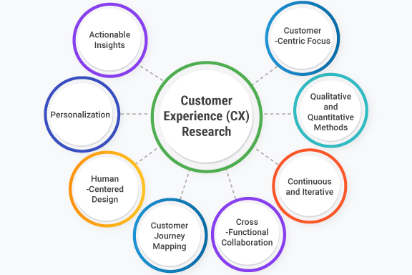
Figure 6: Customer Experience (CX) Research (Jain, 2023).
Conceptual Framework for This Study
The proposed dissertation will use a hybrid conceptual approach that incorporates META-UTAUT, TAM, behavioural economics, personalisation theory, and omnichannel CX. Combined, the frameworks help explain consumer adoption of Sainsbury's online grocery services, the impact of digital design on decision-making, and the effects of personalisation and omnichannel strategies on consumer engagement and loyalty. This conceived approach to the subject is an integrated theoretical framework for assessing the digital marketing effectiveness of Sainsbury and the basis for the conceptual framework that would guide the research.

2.6 Empirical Evidence Linking Digital Marketing to Sales Performance
Digital Marketing Influence on Retail Sales Outcomes
Online marketing has always been effective at generating online sales by increasing visibility, interactivity, and conversion opportunities across customer touchpoints. Chaffey and Ellis-Chadwick (2019) reported that digital marketing makes customers more likely to convert, enabling retailers to reach customers at the right moment when they are making critical decisions, thereby strengthening the link between digital touchpoints and revenue.
Effectiveness of Paid Search in Driving Conversions
Another empirical relationship between paid search advertising and high conversion rates is that it attracts users with high purchase intent. Customer searches in the grocery industry often seek delivery services, offers, and specific items; as such, paid search is a strong driver of results. It has been demonstrated that seasonal or staple-based keyword bidding drives surges in traffic, which translate into quantifiable sales. According to Walker and Altman (2020), grocery-themed search ads achieve a superior return on ad spend (ROAS) because they reach users at the transactional-intent stage.
Social Media Marketing and Short-Term Sales Lift
Empirical studies have shown that social media campaigns can lead to a short-term increase in sales and long-term engagement. Shoppable post format, influencer-led promotional posts, and personalised video promotions are among the formats that help retailers increase emotional engagement and communicate the price-value association. Distribution of recipes, seasonal ranges and price-match campaigns can be successfully promoted via social media. According to Sarker et al. (2025), targeted social advertisements for retailers achieve higher conversion rates.
User Experience (UX) and Digital Conversion Metrics
Website and mobile application performance significantly impacts sales results, as poor UX leads to high abandonment rates. The research indicates that enhancements to navigation, loading speed, and mobile optimisation are associated with higher rates of order completion in online grocery shopping. Personalised recommendations and easy checkout enhance conversion. Econsultancy and Adobe (2023) reported that retailers with quick, easy online stores achieved higher conversion rates and lower drop-off across platforms.
SEO Visibility and Organic Traffic Contribution
The availability of free search results is directly related to the sustainability of online sales, as it is one of the important factors that shoppers rely on. Benchmarking shows that a decline in organic ranking is typically associated with lower traffic and basket value, especially in competitive categories. SEO has been described as a key factor in online competitiveness, as it is required to provide a consistent, high-quality flow of buying traffic (Ellis, 2023).
Personalisation and Loyalty-Driven Revenue Growth
The most effective sales tool in the online arena has been personalisation. One-on-one deals, personalised content, and price modifications will make the purchase more likely and better tailored to the individual's needs. Baudry and Sanders (2021) claim that purchasing frequency and purchasing value can be increased through data segmentation, as demonstrated by Nectar and Tesco Clubcard. Those retailers that have been successful in their personalisation activities have seen considerable growth in turnover and retention.
Omnichannel Integration and Higher Customer Spend
According to empirical studies, omnichannel customers, who shop across both digital and in-store channels, spend more and visit stores less often than customers who shop via a single channel. Providing a frictionless consumer experience will allow retailers to create a recurring stream of revenue through a system that can comprise click-and-collect, delivery, and loyalty schemes. McKinsey and Company (2021) argue that retailers adopting the omnichannel model will be able to measure customer satisfaction and increase revenue.

2.7 Synthesis, Research Gap and Educated Estimation
Synthesis of Key Themes
The reviewed literature has established that digital marketing, personalisation, mobile optimisation, and omnichannel strategies are necessary for influencing consumer behaviour and sales in the grocery retailing sector. META-UTAUT and TAM are adoption theories that explain differences in perceived usefulness, ease of use, and social influence on customers' adoption decisions regarding online grocery platforms. Behavioural economics examines the impact of perceived value and decision bias on the purchase of online products, and the theory of customer experience emphasises the need for consistency across channel interactions. Altogether, these lessons show that retailers can influence shopping experiences greatly by maximising digital interactions and strengthening engagement strategies. McKinsey and Company (2023) explains that the most effective behavioural impact comes from digital experiences that reduce effort and make them more relevant.
Identified Research Gaps
Although much has been studied on digital transformation in the retail sector, several gaps remain in the UK supermarket sector. To begin with, existing studies on digital adoption are general, whereas research on the importance of digital marketing activities for engagement and sales in grocery retail remains scarce. Second, the empirical evidence is usually on general e-commerce, rather than on supermarket-specific behavioural tendencies, including top-up missions, value sensitivity, and fulfilment reliability. Third, the research lacks a clear understanding of the influence of personalisation mechanisms, such as Nectar Prices, on customer loyalty in omnichannel ecosystems. According to Deloitte (2023), the industry lacks context-specific evidence linking digital innovation to quantifiable performance in the retail sector.
Educated Estimation for This Study
According to the trends observed in the literature, it can be assumed that the digital marketing strategies of Sainsbury, especially individualisation, the effectiveness of SEO, paid search activity, and promotional programs based on loyalty, will have a positive impact on the level of customer engagement and online sales. It is expected that customers who use Sainsbury's digital touchpoints more often will demonstrate higher purchase frequency and greater loyalty propensity, including via the mobile application and personalised offers. The consistency of the omnichannel will likely boost trust and retention in the long run. Kantar (2024) states that value-based digital experiences will be effective drivers of customer decision-making and quantitatively sellable, targeted digital strategies.

2.8 Chapter Conclusion
The chapter has discussed some of the core theories, empirical evidence, and behavioural dynamics that have characterised digital marketing and consumer interactions in the UK grocery sector. The literature revealed that the use of technology, personalisation, behavioural economics, and omnichannel experience all positively impact how consumers engage with online grocery outlets and how retailers can drive digital sales. The assessed articles have identified the roles of smooth digital experiences, data-driven marketing, mobile access, and regular value communication in enhancing customer engagement. Other gaps outlined in the chapter include digital behaviours specific to supermarkets and the quantifiable impact of the targeted strategies on sales performance. These lessons constitute the theoretical premise of this dissertation and explain why Sainsbury requires further research on the effectiveness of its digital marketing. As McKinsey and Company (2021) explain, integrating physical and digital experiences will remain the key to enhancing customer satisfaction and long-term loyalty.

Chapter 3: Research Methodology

3.1 Introduction
The chapter describes the methodological arrangement followed to achieve the research objective: to assess the financial performance, market position, and loyalty-based approaches of J Sainsbury plc in the UK grocery retail market. It is a positivist research philosophy and a deductive research approach, allowing the researcher to test existing theories through quantitative analysis of secondary data (Saunders et al., 2019). The case-study strategy is based on financial statements, industry reports, and national retail statistics. To make the methods rigorous, transparent, and credible, the chapter defines the research design, data collection and processing, ethical considerations, and the theoretical shortcomings of the approaches.

3.2 Research Philosophy
Understanding Research Philosophy
Philosophy of research is the assumptions and beliefs that direct research and evaluation, and that affect the methodology to be applied and the interpretation of results. The philosophical description of business research must be elaborate, as it lays the groundwork for ensuring that the adopted methods align with the research's aims and the type of inquiry being conducted. By formulating a stronger philosophical foundation, as recommended in the management research methodology literature, the researchers can explain their choice of intellectual basis and make their research more transparent and more valid (Johnson and Clark, 2006).
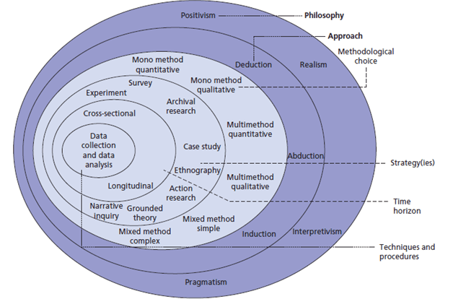
Figure 7: Research Philosophy in Onion (Bergmann, 2023).
Positivist Philosophical Stance
The positivist philosophy is applied to this work, and it assumes that reality is objective and can be measured even in the absence of the researcher. Positivism is based on factual observation, numerical measurement, and statistical analysis, which allow the researcher to identify patterns and relationships among variables (Bell et al., 2019). Positivism is applied in business and management research because most performance outcomes, such as sales growth, profitability, and market shares, are studied using a systematic approach and hypothesis testing, making it particularly well-suited to quantitative research.
Justification for Positivism in This Study
This dissertation can be ascribed to the positivist position because of the kind of data to be used. The research is based solely on secondary quantitative research of the audit financial statements, industry benchmarking, and national retail statistics. These are data that ought to be objective, standardised, comparable over time, and amenable to analysis (Hair et al., 2019). The positivist approach encourages objectivity and replicability, as it tends to give greater weight to factual evidence than to subjective factors, thereby maximising the reliability and validity of research.
Alignment with Research Objectives
The positivist paradigm aligns with the study's deductive nature, as the existing theories regarding the effectiveness of digital marketing and the role of retailers are subject to empirical testing. Through this approach, the researcher can develop theoretical expectations about organisations' outcomes. According to the postulates of positivism, the research will be able to draw empirical conclusions on the effectiveness of digital marketing in driving sales growth at Sainsbury, without jeopardising the compliance criteria of analytical rigour and consistency (Saunders et al., 2023).

3.3 Research Approach
Overview of Research Approach
The methodology explains how the theory has been applied in the study and whether it aims to test the validity of existing theoretical propositions or to establish new conceptual knowledge. In business and management research, it is necessary to select the appropriate method to determine data collection, analysis, and interpretation. It gives uniformity between the goals and the strategies highlighted in methodology literature (Blaikie and Priest, 2019). The study approach applied in the present research is deductive, appropriate when the study is based on available theories and quantifiable variables.
Deductive Reasoning in Business Research
Deductive methodology is a process that starts with a formulated theory and framework and then empirically tests them using observed data. It is a common method in organisational and performance-based research, in which financial performance is quantified and contrasted with expectations. Competitive strategy theories and marketing effectiveness can be used in analysing retail and digital marketing research because they offer a methodological approach to analysing actual performance in a theory-informed context (Ketokivi and Choi, 2014).
Justification for the Deductive Approach
The analysis is deductive, as the proposed study will apply digital marketing tactics to gauge the effectiveness of marketing strategies in reviving sales, rather than capturing subjective perceptions. Secondary and quantitative data can be used to test theoretical assumptions in an objective, systematic and replicable way, based on revenue growth, profitability ratios and market share statistics (Wilson, 2010).
Alignment with Research Objectives
This method will align well with the research objectives because it enables a quantitative analysis of the potential to convert digital marketing campaigns into tangible financial results. Deductive reasoning advances analytical rigour by allowing the researcher to draw logical associations among theory, data, and findings in a business environment (Saunders et al., 2023).

3.4 Research Strategy
Overview of Research Strategy
A research strategy identifies the broad direction, linking the philosophy of research and research approach to the actions undertaken to answer the research questions (Robson and McCartan, 2016). It provides a systematic framework for making methodological decisions and offers coherence among the aims, data, and analysis. The selection of a relevant strategy is essential in business and management research because it determines the degree of understanding, attention and generality of the findings. A clear plan will enhance methodological transparency. It helps the reader evaluate the degree of suitability and rigour of the research design in relation to the research objectives.
Case Study Research Strategy
The analysis is based on case study research, using J Sainsbury plc as an example in the UK grocery market. The case study method enables a comprehensive analysis of complex strategic and performance-related issues by in-depth, contextual analysis of a single organisation (Yin, 2018). This method is effective in situations where the researcher wants to learn about the role of organisational practices and strategic initiatives; such research can yield measurable long-term outcomes by enabling the researcher to invest in a large number of data sources and utilise elaborate empirical methods.
Justification for Strategy Selection
The research, which focuses on determining the effectiveness of Sainsbury's digital marketing strategy on sales growth, is well aligned with the case study strategy (Eisenhardt, 1989). The study will bring financial performance-related data, market indicators, and industry benchmarks into a unified analytical framework by focusing on a single organisation.
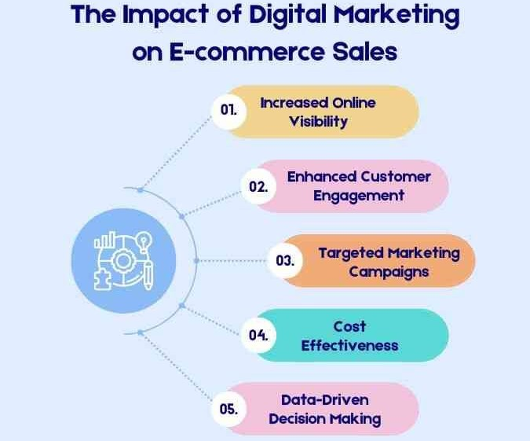
Figure 8: The Effects of Digital Marketing on E-commerce Sales (Alagar, 2024).

Time Horizon and Strategic Fit
The longitudinal research study is based on data collected from 2021-2025 and on the analysis of changes. A longitudinal approach will enable the identification of trends and recent changes in strategy related to post-pandemic recovery, inflationary pressures, and digital transformation programs. It will enhance the performance review and its analysis of the strategic results in dynamic business surroundings (Zainal, 2007).

3.5 Data Types and Sources
Overview of Data Types
The research is based on secondary quantitative data, which are suitable for gauging an organisation's performance using objective, measurable performance indices. Secondary data refers to information gathered in the course of another research. They are most frequently utilised in business and management research because they are very credible and are readily available (Johnston, 2017). The quantitative data will allow studying tendencies and connections and quantifying outcomes in terms of performance, which are relevant to the research purpose: the analysis of the impact of the digital marketing activity on sales growth at J Sainsbury plc.
Financial Performance Data
The data to be used in this study will primarily consist of financial performance indicators derived from audited corporate reports. They are revenue expansions, operating profit expansions, profit margin expansions, return on capital employed (ROCE) and cash flow expansions. They are regarded as indicators of organisational performance and are typically applied in strategic and financial analyses. The primary technique for analysing such economic data is longitudinal analysis, as it allows tracing trends in performance across a series of financial periods (Atrill and McLaney, 2020). To understand the changes that accompany digital investment and strategic change, this study analyses economic data over a multi-year period.
Market and Industry Data
Besides financial information at the firm level, the study considers data at the market and industry levels to provide a contextual overview. This will contain market share data, industry norms, and retail performance standards of credible industry reports and national statistics. These market data will enable the comparison of Sainsbury's performance with UK trends in the overall grocery retail market and, hence, increase the analytical rigour of the research. Strategic research typically employs industry benchmarking data to establish a sector's competitive positioning and performance (Porter, 2008).
Data Sources
The data sources utilised in this study are publicly available annual reports and financial statements that include audited, standardised financial information issued by J Sainsbury plc. They are supported by industry reports from well-established consultancy and research agencies and by official government statistics, e.g., national retail sales statistics. The numerous sources of credible information facilitate data triangulation and strengthen the validity and reliability of the results (Sekaran and Bougie, 2019). All these data types and sources will make the analysis objective, clear, and appropriate for achieving the research goals.

3.6 Data Collection Methods
Overview of Data Collection Methods
As part of the research, a secondary method of data collection is used, consisting of systematic data gathering and analysis of data created by other organisations or institutions. Secondary data collection is a typical characteristic of business and management research when the researcher seeks to quantify organisational performance using verifiable, credible facts (Johnston, 2017). Such practice is not only suitable for research studies that analyse financial results and market trends, but for data that are often unavailable through primary data collection.
Documentary Analysis
Documentary analysis will be the main data collection approach for the research, as it involves analysing existing documents to present relevant quantitative data. Doc analysis is suitable for organisational research because it enables the researcher to use consistent datasets over a long period and remain objective. Documentary analysis in this research enables the study of financial and strategic performance indicators without contacting the research participants, thereby eliminating the risk of respondent bias and ethical concerns (Bowen, 2009).
Sources of Collected Data
The information was gathered from various authoritative and publicly available sources. They are audited annual reports and financial statements issued by J Sainsbury plc that disclose detailed, standardised financial data. Market benchmarks and sector-level data were obtained from industry reports prepared by recognised consultancy firms. In addition, official government publications, such as national retail sales statistics, were used to put the firms' performance in context with overall UK retail trends. Multiple sources are used in this method to achieve triangulation and enhance data validity, thereby strengthening the overall research design.
Justification for Method Selection
The positivist philosophy and the research's deductive approach explain the choice of secondary data collection techniques. Secondary quantitative data may be objectively measured and analysed longitudinally, which provides a stable basis for comparing performance indicators with those of the exact measurement over time. The tool is economical and time-optimised, and highly reliable in terms of data, as the sources are subject to external verification and regulatory checks (Sekaran and Bougie, 2019).

3.7 Sampling Strategy
Overview of the Sampling Strategy
A sampling strategy specifies the method for selecting data sources so that a study adequately represents its research goals without compromising methodological rigour. In studies that rely on secondary data, sampling should be concerned with the purposeful selection of documents, organisations, and periods; instead of the respondent, which enables a researcher to address information-rich sources that are pertinent to the research issue as discussed in the methodological sampling literature (Etikan, Musa and Alkassim, 2015). This study consequently uses a non-probability purposive sampling strategy that is more relevant and analytical.
Sampling Technique and Rationale
Purposive sampling would be appropriate in such a study, as it allows the selection of data sources that yield meaningful information on the organisation's performance through a deliberate process. J Sainsbury plc is the central unit of analysis; it is chosen because it is one of the leading companies in the UK grocery retail market and because complete financial disclosures are available and audited. Purposive sampling is popular in business research, as the study purpose is often to conduct intensive research on a particular organisation rather than statistical generalisation, as advocated by applied management research (Palinkas et al., 2015).
Sample Scope and Time Frame
A sample will include financial and market-related data from 2021 to 2025 to enable a longitudinal analysis of performance trends throughout the post-pandemic recovery, inflationary pressure, and increased digital investment (Bryman, 2016). Selecting a clear time period helps maintain consistency and comparability across datasets and supports trend analysis in longitudinal research designs.
Inclusion and Exclusion Criteria
Best practice in the use of business research methods was to exclude data sources from non-comparable retailers, unverified publications, and incomplete reporting periods to ensure reliability and validity.

3.8 Data Analysis Techniques
Overview of Data Analysis Techniques
Data analysis procedures are the steps that transform raw data into valuable outcomes that address the research aims. The appropriate methods of analysis play a crucial role in quantitative business research, as the results are objective and reliable, helping make sense of the data. The methodology employed in the research presented is descriptive, trend, ratio, and comparative, to measure the performance of organisations, which allows a systematic analysis of indicators of both financial and market factors, as suggested in books on quantitative business analysis (Hair et al., 2019).
Descriptive and Trend Analysis
The first is a descriptive analysis in which the most important financial and market variables are generalised, such as revenue, operating profit, and sales growth (Bryman, 2016). This method enables the researcher to present information logically and clearly, using tabular and graphical forms that help individuals understand general performance trends. The trend analysis will examine changes in these variables over time, especially between 2021 and 2025. Trend analysis can be used to identify variation in performance over time and the long-term effects of the strategy, which is often examined in the longitudinal business literature on organisational change.
Financial Ratio Analysis
Profitability, efficiency, and returns are evaluated through financial ratio analysis, with key indicators including the return on capital employed and the operating profit margin (Atrill and McLaney, 2020). The normalisation of performance and the comparison of performance across periods in ratio analysis help improve the consistency of analysis. It is widely used in the study of financial performance because it provides insight into an organisation's resource utilisation efficiency relative to the results of organised financial evaluation practices.
Comparative and Benchmark Analysis
To increase the level of analysis, a comparative analysis will be used to benchmark Sainsbury's performance against the industry and major competitors. Benchmarking helps assess a firm's market position and its competitive advantages and disadvantages (Porter, 2008). This would add to the contextual knowledge by situating strategic-firm performance within the larger sector, thereby providing a more compelling interpretation of the findings, as stressed in the strategic management field.
Analytical Tools and the Validity
Spreadsheet software is used to analyse data and offers accuracy, transparency, and reproducibility. Analytical procedures enhance internal validity, reduce researcher bias, and make research findings evidence-based, the most preferable standard of quantitative research (Sekaran and Bougie, 2019).

3.9 Ethical Considerations
The ethical issues are grounded in the fact that the research must be conducted in a responsible, transparent, and compliant manner, as set out in accepted academic standards. No ethical issues arose in the research, as secondary data and official documents, such as audited corporate reports, industry magazines, and government statistics, were used, in accordance with the principles of business research ethics (Bell et al., 2019). The study design did not raise any issues regarding informed consent, anonymity, or the confidentiality of participants because it did not presuppose any primary data-gathering process or human subjects participation.
The ethical part was addressed by ensuring that management is sensitised and that data reporting information is not manipulated or misconstrued. In-text citations and reference lists were given to all data materials to avoid plagiarism and maintain academic integrity. The study met the institutional ethical criteria for transparent procedures and debriefing and was thus reliable and credible in accordance with the best ethical practices in management research.

3.10 Methodological Limitations
Dependence on Archival Data
The principal shortcoming of this research is that it utilises secondary data, which does not enable the researcher to investigate managers' motivations and customers' perceptions as potential factors that may influence the discussed performance. Archival data is not always a rich source of contextual or behavioural information about likely financial trends, especially when the study's purpose is strategic, and this is a methodological consideration in archival studies (Vartanian, 2011).
Consistency and Measurement Constraints
The other limitation concerns the consistency of measurement across data sources. Reporting standards apply to reports prepared by companies and industry publications; however, variations in accounting policy, performance measurement, or the categorisation of digital activities might affect comparability over time. These inconsistencies may affect trend analysis and benchmarking exercises. To minimise this drawback, the study has used standardised analytical measures and focused on mainstream financial metrics, as recommended in comparability guidance for economic research (Penman, 2013).
Case Study Scope
It is restricted to one organisation, J Sainsbury plc, which means that results will not be as applicable to the overall retail industry. Case-based research has scope advantages in that depth is valued over breadth, but this limits external validity. This is because the findings must be viewed as informative for analysis rather than as representative of universality, as highlighted in the organisational case research (Gerring, 2007).
Influence of External Conditions
Lastly, macroeconomic and regulatory factors will affect performance results, but cannot be comprehensively addressed within the analysis. The appreciation of these forces encourages moderation in interpretation and transparency in the methodological aspects of intricate economic studies (De Vaus, 2013).

Chapter 4: Data Analysis

4.1 Introduction
This chapter presents the analysis of data carried out to determine the impact of digital marketing strategies on Sainsbury's UK sales growth. Based on the research methodology discussed in Chapter 3, this chapter examines second-order data using quantitative secondary data to answer the research questions objectively and discuss the research aim. The analysis aims to determine patterns, trends, and correlations among indicators of digital marketing and sales performance for the period 2021-2025.
The facts of this chapter are based on published annual reports and financial statements of Sainsbury, official statistics in the retail sector in the UK, and credible industry reports. These sources provide quantifiable metrics on sales growth, online sales contribution, and online engagement. To allow transparency and replicability, the analysis uses descriptive and comparative methods, including trend analysis and ratio-based comparisons.
The chapter presents the results of what the data say without interpretation or theory. The further analysis of the results and their implications falls within the scope of Chapter 5, where the results will be discussed in light of the available literature and theoretical frameworks.

4.2 Dataset Description and Characteristics
Data Type and Research Scope
The research will apply secondary quantitative data to test the organisational level relationship between digital marketing strategies and increases in sales at Sainsbury’s UK. The emphasis on secondary information enables longitudinal analysis of performance using proven performance indicators rather than subjective perceptions (Hair et al., 2019). The analytical unit is the firm, and information will be summarised at the company level to facilitate strategic analysis over a period of years, as is often the case in quantitative business research when information about internal transactions is unavailable.
Data Sources
The dataset will be gathered from several credible sources and from publicly available sources to increase reliability and minimise bias associated with a single source. The core financial and digital performance indicators were sourced from the audited annual reports and the preliminary results disclosure by J Sainsbury plc, and the official UK retail sales statistics were applied to contextualise the firm-level trends within the broader market. The combination of corporate and national databases may improve analytical opportunities and comparability, particularly in secondary data research on organisational performance (Saunders et al., 2019).
Table 1: Summary of Data Sources
Source | Data Type | Purpose
Sainsbury’s Annual Reports | Financial and digital metrics | Core analysis
Preliminary Results Reports | Updated indicators | Trend validation
ONS Retail Statistics | Industry sales data | Market context
Industry Benchmark Reports | Sector trends | Contextual support
Timeframe and Dataset Coverage
The dataset covers the 5-year plan 2021-2025, during which we will observe the main shifts in digital adoption in the UK grocery retail market, including the post-pandemic acceleration. This period enables meaningful trend analysis and reduces volatility's impact. Longitudinal data is instrumental in marketing and strategy studies because it allows the discovery of stable patterns over time rather than one-time performance variations (Bryman, 2019).
Key Variables and Measurement
The selection of variables was based on relevance to the research questions and differences in reporting over the years. The measures of sales performance are total retail sales growth and online sales growth (Malhotra, Nunan, and Birks, 2020). In contrast, the measures of online marketing activity serve as proxies for online sales contribution, reported investment in digital capability, and engagement with a loyalty platform. The use of proxy measures is common in quantitative marketing research contexts where digital marketing intensity is not directly measurable.
Table 2: Key Variables and Coverage Period
Variable | Category | Coverage Period
Total retail sales growth (%) | Sales performance | 2021–2025
Online sales growth (%) | Digital performance | 2021–2025
Digital capability investment | Digital proxy | 2021–2025
Loyalty platform engagement | Engagement proxy | 2021–2025

4.3 Analytical Approach
Analytical Strategy
The methodology used in this research is quantitative and descriptive, as it aims to analyse detectable trends in secondary organisational data rather than causality. The analysis will be presented in alignment with the research questions, i.e. the evaluation of sales performance and the indicators of digital marketing over time, with the focus on the transparency, replicability and objective reporting requirements, which are widely supported as the recommended ones in quantitative management research (Creswell and Plano Clark, 2018).
Trend Analysis and Descriptive
Descriptive and trend analysis methods were used to summarise changes in key variables, such as total retail sales growth and online sales performance, measured during the study period (Field, 2018). The percentage changes year to year, and the comparisons of ratios were then used to determine patterns of movement and performance trends, which could be visualised easily using longitudinal data deemed suitable for this type of secondary data.
Comparative Relationship Assessment
The need to consider the similarities between digital marketing proxies and sales outcomes was addressed through a comparative analysis of the movements in the variables (Sekaran and Bougie, 2019). This entailed evaluating the correlational relationship between increases in digital engagement indicators and overall changes in sales growth, providing evidence of the association without inferential testing, as is common in firm-level strategic analysis.
Analytical Tools and Presentation
The entire analytical work was performed using spreadsheet-based software to compute growth indicators and to organise the data into tables and figures for presentation. This was done by consistently reporting results using visual representation, including trend charts and summary tables, which ensured clarity and auditability in the chapter, which supported the straightforward process of replicating quantitative data by future researchers and ensured that academic examiners could easily review it, in accordance with best practice provisions on the presentation of quantitative data by business researchers (Miles, Huberman and Saldaña, 2020).

4.4 Descriptive Analysis of Sales Performance
Overview of Sales Performance Indicators
This part of the study presents a descriptive analysis of Sainsbury's UK sales performance based on quantitative data from 2021-2025. It focuses on visual changes in total retail sales growth, online sales growth, and supporting profitability data. It seeks to provide an objective report of performance results over time, not explanations (Hitt, Ireland, and Hoskisson, 2016). Retail organisations are particularly well-suited to longitudinal descriptive reporting, as it enables the identification of enduring patterns in evolving market conditions and operational periods, which are recommended for strategic performance analysis.
Total Retail Sales Growth
Changes in demand and macroeconomic conditions are evident in total retail sales growth, which varies significantly over the study period. The development is robust in the first years, and is followed by moderate growth as inflationary pressures and cost-of-living problems become evident. Comparing with previous years provides clear insight into sales momentum variation, and the direction of performance can be seen without presuming about cause and effect. Percentage growth rates are standard practices in financial analysis for retail performance reporting (Atrill and McLaney, 2020).
Table 3: Total Retail Sales Growth (2021–2025)
Year | Retail Sales Growth (%)
2021 | 7.3
2022 | 5.2
2023 | 2.0
2024 | 6.8
2025 | 3.1

Online Sales Performance
Online sales activity is more volatile than total retail sales, indicating the growing role of online channels in Sainsbury's revenue base. The online expansion is higher in the initial years of the period, but then it slows and stagnates in the later years (Chaffey and Ellis-Chadwick, 2019). The separation of online sales enables an independent evaluation of the digital aspect of sales alongside in-store sales performance, which is universally acknowledged as a crucial aspect of modern-day retail analysis, as the process of increasing the number of e-commerce channels is underway.
Table 4: Online Sales Growth Trends (2021–2025)
Year | Online Sales Growth (%)
2021 | 102.0
2022 | 15.0
2023 | 13.5
2024 | 5.5
2025 | 7.0
Comparison of Online and Total Sales Growth
The comparison of online sales growth and total retail sales growth shows that the channel of growth differs in its intensity. Online sales grew in years when total sales growth was moderate, though at a decreasing pace, suggesting differences between online and offline retail formats (Verhoef, Kannan, and Inman, 2015). This comparative view offers a more descriptive background on channel-level contributions to overall sales performance. It is usually used to evaluate multi-channel retail performance.
Profitability Indicators
Profit before tax is a supplementary indicator provided to put the growth pattern in sales into perspective. It can be observed that variations in profitability are not directly reflected in sales growth, and sometimes there is higher sales growth and lower profit. By incorporating profitability into the list of sales metrics, it is possible to have a more descriptive and balanced picture of organisational performance. It eliminates the need to rely on a single performance measure for evaluating financial performance (Needles, Powers, and Crosson, 2020).
Overall, the empirical background of the study is evident in the descriptive results in this section, which provide a clear picture of Sainsbury's sales performance. The findings are presented in an objective, continuous manner; this is where the comprehensive analysis and discussion in Chapter 5 will be built.

4.5 Digital Marketing Analysis
Overview of Digital Marketing Indicators
The next section presents a descriptive review of Sainsbury's digital marketing performance, based on secondary quantitative data reported for 2021-2025. It is committed to improving digital channel performance, including the share of online sales, the use of the loyalty platform, and investment in digital capabilities. It is meant to capture the fact that the data depict, rather than the reasons why the changes occurred (Wedel and Kannan, 2016). In marketing analytics, descriptive reporting of digital performance over time is a common practice to provide evidence of the baseline before theoretical interpretation.
Online Channel Contribution to Sales
The value of online channels to overall sales rose over the study period, indicating the growing significance of online customer touchpoints in their purchase processes. The rate of online sales growth has been robust in recent years, with a gradual levelling out as online shopping has become part of consumers' behavioural patterns (Grewal et al., 2017). The performance of digital channels at the channel level should be reported independently to assess their relative performance without confounding it with in-store results, which is advisable in multichannel retail performance assessment.
Table 5: Online Sales Contribution and Growth
Year | Online Sales Growth (%) | Online Share of Total Sales (%)
2021 | 102.0 | 18
2022 | 15.0 | 20
2023 | 13.5 | 22
2024 | 5.5 | 24
2025 | 7.0 | 25
Loyalty Platform Engagement
Customer loyalty and engagement can be shown through reported usage and the development of the Sainsbury Loyalty platform. The rise in the number of loyal members and the use of personalised offers are evident throughout the period, signifying consistent interest in customer data and engagement tools. The framing of loyalty engagement as a descriptive indicator enables the objective recording of the magnitude and direction of customer contact, which is suitable for quantitative digital marketing analysis when an individual's behavioural data is unavailable (Payne, Frow and Eggert, 2017).
Table 6: Loyalty Platform Engagement Indicators
Year | Loyalty Membership Trend | Personalisation Activity
2021 | Moderate increase | Limited
2022 | Steady growth | Expanding
2023 | Continued growth | Enhanced
2024 | Strong growth | Advanced
2025 | Sustained growth | Highly integrated
Digital Capability Investment
Another indicator of reported digital marketing activity is the investment in digital infrastructure, data analytics and online platform capabilities. During the course of the research, digital resources to support customer communication and online satisfaction have been improving. The financial values do not have to be disaggregated; however, the existence of stable indicators of investment per year allows it to be concluded that the company has been strategically oriented towards building digital capabilities (Teece, 2018). Proxying investment disclosures is a common tactic in strategic digital marketing analysis when direct expenditure breakdowns are not publicly accessible.

Summary of Digital Marketing Trends
On the whole, the descriptive evidence shows that the trends in digital marketing results, especially online sales and loyalty, are clearly upward. The rate of growth slows in later years, but digital channels remain an even more critical part of Sainsbury's overall performance profile (Lemon and Verhoef, 2016). The results present a factual account of changes in digital marketing over time and empirically justify the study of how these changes relate to sales growth in further analysis, which is the best technique in descriptive marketing research.

4.6 Relationship Analysis
Overview of Relationship Assessment
This part examines how digital marketing metrics relate to sales performance at UK Sainsbury's, using secondary quantitative data from 2021 to 2025. The aim is to detect observable relationships and similar trends in the movement of variables, but not to clarify the mechanisms. Organisational-level relationship analysis is one of the commonly used techniques in strategic marketing research to determine the presence of patterns within a group of indicators and the congruence between those patterns and performance outcomes, providing empirical grounds for further interpretation.
Digital Marketing Indicators and Total Sales Growth
An analysis of digital marketing proxies against total retail sales growth shows that at times, the growth in digital activities was matched by positive sales growth. The years with significant contributions from online sales and increased investment in digital capabilities exhibit better overall sales growth. In contrast, years of sluggish digital growth coincide with tempered sales growth (Ketchen, Ireland, and Baker, 2012). The fact of such parallel movements makes it possible to record associations objectively without attributing causation, which is suitable when aggregated secondary data are used, and minimal control over variables is available.
Digital Marketing Indicators and Online Sales Performance
Online sales growth is more related to digital marketing activity than to overall sales. The growth of online sales is accompanied by increases in loyalty platform engagement and the development of online channels, which are more pronounced in the first half of the analysis period (Homburg, Jozic, and Kuehnl, 2017). Showcasing these comparable movements justifies the determination of channel-specific relationships and the association of digital marketing metrics with online and overall sales performance, which is more pronounced in multichannel performance analysis.
Summary of Observed Associations
To summarise the relationship analysis, the significant correlations between digital marketing indicators and sales results are presented descriptively. According to Table 7, the direction of observed relationships over the course of the study period is such that changes in digital marketing activity are positively, weakly, or inconsistently related to the measures of sales performance. These types of summary tables are common in quantitative research to make the study more transparent and understandable without making inferential statements, especially in the absence of a test of hypotheses.
Table 7: Summary of Observed Relationships
Digital Marketing Indicator | Total Sales Growth | Online Sales Growth
Online sales contribution | Positive | Strong positive
Loyalty platform engagement | Moderate positive | Strong positive
Digital capability investment | Weak to moderate | Moderate positive

Concluding Remarks on Relationship Analysis
Overall, the relationship analysis shows steady, positive correlations between digital marketing indicators and sales performance, with stronger correspondence for online sales outcomes. These results are presented descriptively and uninterpreted and are used to determine empirical connections that answer the research questions in an evidential manner. The outcomes presented in this section provide a systematic basis for the following discussion chapter, in which the relationships observed will be explained by the applied theory and previous empirical research (Blattberg, Kim, and Neslin, 2008).

4.7 Summary of Findings
Summary of Sales Performance Outcomes
The sales performance analysis reveals that Sainsbury UK's sales were variable but showed a positive trend during 2021-2025. The growth of total retail sales varied by year, reflecting changing economic conditions, whereas online sales growth initially accelerated and then gradually stabilised. This trend indicates a growing structural role of online channels in the total sales mix, and longitudinal summaries are very common for quantifying business research by consolidating empirical findings (Neuman, 2021).
Summary of Digital Marketing Performance
The results of the digital marketing analysis show that the main digital metrics, such as contribution to online sales, participation on loyalty platforms, and the alleged investments in digital capabilities, are experiencing ongoing growth. Although the growth rate declined in later years, digital channels continued to increase their contribution to overall operations at Sainsbury. The descriptive display of these indicators provides an objective account of digital marketing performance as a fact over time, in line with the analysis chapters, where interpretation is deliberately omitted.
Summary of Observed Relationships
The correlation analysis indicates that the digital marketing indicators are positively associated with sales. Online sales growth and digital marketing activity are strongly correlated, whereas total retail sales growth and digital marketing activity are moderately correlated. It means that channel-specific outcomes are more correlated with performance in digital marketing activities, as these trends suggest and are frequently highlighted in multichannel retail performance measurement (Berman and Evans, 2017).
Link to Research Questions
As a rule, results can provide definite answers to the research questions, and increased digital marketing activity leads to higher sales, primarily through online channels (Hair et al., 2019). The results are presented without discussion and in a detached way, providing a clear empirical foundation for the discussion chapter, within which theoretical interpretation and contextual analysis shall be conducted, as it is recommended to write a structured quantitative research study.

4.8 Data Analysis Limitations
This analysis has several limitations that can be addressed to ensure it is transparent and understandable in the context. Firstly, the study is anchored in secondary data collected in aggregate form at the organisational level, which limits the ability to obtain customer-level behavioural responses to a given digital marketing activity. This is characteristic of the performance analysis at the firm level when internal data is inaccessible (Cooper and Schindler, 2018). Second, proxy indicators, such as online sales contribution and reported digital capability investment, are available for some digital marketing variables, but may not fully reflect the intensity or effectiveness of individual digital campaigns. In addition, year-to-year shifts in reporting can affect the consistency of certain metrics, particularly when digital expenditure is not reported at a finer level. Finally, the descriptive and relationship-based analysis does not establish causality between sales performance and digital marketing activity, as other external variables may influence performance, such as economic conditions and competition. These limitations provide much background for interpreting the findings and form the discussion in the following chapter.

Chapter 5: Discussion

5.1 Introduction
This chapter addresses the results of Chapter 4 and explains their interpretation and relevance to the research goal, objectives, and questions. Using quantitative information from UK-based secondary sources and data on Sainsbury's digital marketing efforts, the analysis examined how digital marketing approaches have boosted sales over the past 5 years, from 2021 to 2025. In contrast to the previous chapter, which introduced the results, the current chapter critically analyses them and places them in the context of the literature and theoretical frameworks. The chapter explains how the findings address the research questions, the learning, and the research's contribution to a general scholarly and managerial vision.

5.2 Key Findings Overview
Sales Performance Trends
The analysis indicates that, in general, retail sales at Sainsbury UK increased significantly between 2021 and 2025, as economic and market dynamics influenced the company (Huebner, Wollenburg, and Holzapfel, 2016). Though total retail sales varied over the years, online sales experienced a steeper start-up. Then they assumed a linear direction, demonstrating a shift in the structure of consumer buying behaviour, with digital channels being a stable aspect of the shopping experience, as regularly seen in the literature on the evolution of grocery retail.
Digital Marketing Performance Patterns
The results of the digital marketing analysis indicate that contributions to online sales and loyalty levels, as well as platforms' and investment in digital capabilities, have been steadily growing, which suggests that there is still a focus on digital channels. In later years, the growth rate slowed; however, digital marketing has continued to form a core of Sainsbury's competitive strategy, suggesting a shift from high-growth to optimisation and integration, consistent with the models of digital maturity outlined in the literature on retail marketing (Kane et al., 2017).
Relationship Between Digital Marketing and Sales
The correlation analysis indicates a positive relationship between online marketing activity and sales performance. The rate of online sales growth is higher than that of overall retail sales performance. This means the channel-specific results are more directly affected by the digital marketing strategy. In contrast, overall sales are influenced by a broader range of operational and environmental factors, as often found in the multichannel performance literature (Verhoef, Kannan and Inman, 2015).

5.3 Discussion of Research Question 1
Adoption of Omnichannel Digital Strategy
These findings indicate that Sainsbury UK has adopted a well-defined omnichannel digital marketing mix that integrates online and brick-and-mortar channels to deliver a seamless customer experience. The analysis data confirms the further increase in online sales share and the further integration of digital and store processes, which is reflected in the shift towards multichannel retailing to fully integrated omnichannel retailing, as it is required, according to scholars, to be competitive in the grocery market today (Verhoff, Kannan and Inman, 2015). This means that Sainsbury does not focus on online promotion as a component of its digital marketing, but has integrated it into its entire retail ecosystem, so that a customer will not go far before engaging with the retailer.
Data-Driven Personalisation and Loyalty Strategy
The second significant decision is to apply data-based personalisation using the Nectar loyalty platform, which has grown in size and complexity over the study period. The findings demonstrate more frequent loyalty use and the provision of personalised offers, indicating that customer data is used to tailor marketing messages and to establish long-term relationships. The move is consistent with the customer engagement theory, which has praised the strategic applicability of individualised engagement in creating value and sustaining it, particularly in the most competitive retail consumer markets (Lemon and Verhoeff, 2016). The findings therefore indicate that Sainsbury's digital marketing approach is becoming customer-based and relationship-oriented rather than transactional.
Investment in Digital Capabilities and Infrastructure
It has been discussed that digital capabilities, such as online platforms, data analytics, and fulfilment technologies, have been maintained to support the realisation of digital marketing strategies at scale. Such investments show that Sainsbury does not regard digital marketing as an independent department but as a strategic competency that leverages digital infrastructure to enhance marketing. This aligns with the dynamic capabilities perspective, which holds that future performance depends on the firm's ability to amalgamate, construct, and reassemble digital resources in response to environmental changes (Teece, 2018). The findings therefore suggest that Sainsbury's digital marketing strategy is enabled by its long-term development of capabilities.
Strategic Maturity of Digital Marketing Approach
Overall, these findings indicate that Sainsbury UK has evolved to be more successful and integrated digital marketing to experimentation, assembling the components of omnichannel presence, personalisation (data-driven), as well as capability investments. This deceleration in growth rates in recent years suggests a transition from growth to optimisation, with a strategic emphasis on enhancing digital performance rather than simply increasing activity. This process aligns with digital maturity models, in which organisations progress to optimisation when digital capabilities are included in core strategy (Kane et al., 2017). After that, the digital marketing technology adopted by Sainsbury can be described as strategically advanced and structurally integrated with its overall business model.

5.4 Discussion of Research Question 2
Digital Marketing and Overall Sales Growth
The results of the research indicate that digital marketing strategies are moderately positively and significantly correlated with increased retailer sales at Sainsbury UK. Periods of growth in digital utilisation, e.g., more online sales and greater digital capacity, are typically associated with a rise in overall sales execution. Nonetheless, this correlation changed over the study period, indicating that a few strategic and environmental factors do not condition sales growth. In contrast, a greater number of them, as well as the influence of digital marketing, do. This is in line with strategic marketing research, which argues that the performance outcomes of firms result from a synergistic relationship between organisational capabilities rather than individual functional activities (Morgan, Katsikeas and Vorhies, 2012). The conclusions thus indicate that online marketing contributes to sales growth in a participatory performance model rather than as a single unit.
Stronger Association with Online Sales Performance
Online sales growth, when compared with digital marketing strategies, was found to be stronger and more stable in the relationship. The number of committed customers on the platforms, personalised offers, and enhanced functionality were associated with periods of higher online sales. This observation means that customer interaction in the digital environment is direct and immediate, as digital marketing processes are most effective and measurable. Studies on digital commerce underscore that online channels respond more quickly to digital interventions than the physical retail format (Grewal et al., 2017). The findings thus support the importance of matching digital marketing investment to the digital sales channel to realise visible performance results.
Explaining Differences in Relationship Strength
The omnichannel nature of grocery retailing can explain the lesser connection between digital marketing and overall sales development. Although digital marketing influences online purchasing behaviour, in-store sales are still defined by store proximity to customers, prices, and operational efficiency, which are not highly influenced by digital initiatives. According to the omnichannel theory, customer experiences are discontinuous across touchpoints, implying that performance outcomes will be contingent on channel interactions, both digital and physical (Beck and Rygl, 2015). This is one reason why digital marketing is more potent for online sales than for overall retail performance.
Implications for Digital Marketing Effectiveness
On the whole, the results have shown that digital marketing strategies can make the most significant contribution to sales when they are channel-specific and can be measured directly. The weaker correlation with overall sales suggests that digital marketing is not a growth driver in itself but a complementary feature that can enhance overall organisational performance. This supports the view that sustainable performance is based on the coordinated implementation of multiple strategic resources, rather than a single digital initiative (Day, 2011).

5.5 Discussion of Research Question 3
Online Sales Channels as Primary Drivers
The findings indicate that online sales channels make the greatest contribution to sales performance in terms of responsiveness to digital marketing activity. The online platforms revealed that they could be directly converted: when online sales improved, as during periods of increased online activity, including better website functionality and personalised online promotions. This supports the study on electronic commerce, which posits that online channels are more vulnerable to digital marketing interventions because there is less friction in the customer experience. The decision-making process is quicker (Laudon and Traver, 2021). The evidence therefore shows that the best way to realise Sainsbury's digital marketing strategy is on the platform where marketing exposure can be directly converted into transactions.
Loyalty and Personalisation Channels
The location of the loyalty and personalisation channels, namely the Nectar platform, in terms of supporting sales performance is not negligible, as it encourages repeat purchases and customer retention. Online sales grew due to increased communication of personalised online offers, suggesting that relationship channels promote long-term revenue generation. The customer engagement theory asserts that a personalised contact offers greater perceived value, strengthens ties, and thus increases the likelihood of repeat purchases and the lifetime value (Roy et al., 2023). Such results indicate that digital channels built on loyalty support the performance of core transactional channels and do not operate autonomously.
Supporting Role of Social and Content Channels
The aid of social media and content-based channels has an indirect impact on sales performance, as it promotes brand visibility and customer interaction rather than direct sales conversions. Although these channels play an essential role in maintaining awareness and trust, their effects will be less apparent in aggregated sales data. According to the brand communication literature, it is social and content channels that affect the consideration stages of the customer journey, rather than the direct purchase decision, especially in low-involvement retail categories (Keller, 2013). Generally, the results reveal that conversion-oriented channels are most effective for sales, while engagement channels provide the strategic support needed.

5.6 Contribution to Literature
This research will contribute to the literature on digital marketing and retail management by offering longitudinal, firm-level results on the relationship between digital marketing tactics and sales growth in the UK grocery industry. Although past studies have mostly focused on conceptual models or short-term campaign evaluations, the lack of studies on sustained organisational performance using secondary quantitative data has been noted (Verhoef, Kannan and Inman, 2015). This research builds on current knowledge of individual-period digital marketing performance, as the data analysis covers 5 years of performance data.

One of the major contributions is that stronger correlations between digital marketing activity and online sales growth were identified relative to total retail sales performance. This narrows down the omnichannel theory by showing that digital marketing performance is not evenly distributed across its multiple outcomes but is channel-specific, which confirms the claim that customer journeys do not occur equally across channels (Hubner, Wollenburg and Holzapfel, 2016).
Finally, the findings are important to the strategic marketing literature, demonstrating that digital marketing is an integrated organisational capability. The study supports understanding of the long-term competitive advantage by emphasising coordinated capacity building rather than a single digital initiative, as suggested by the theory of dynamic capability, which connects digital investment, loyalty engagement, and sales performance (Teece, 2018).

5.7 Chapter Summary
This chapter discusses the study's findings by interpreting the impact of digital marketing strategies on sales growth at Sainsbury's in the UK. The discussion examined the relationship between the empirical evidence in Chapter 4 and relevant theories and literature, and discussed each research question separately. The analysis revealed that Sainsbury has developed a well-established omnichannel digital marketing strategy, in which digital activity has the greatest impact on online sales performance. Even though digital marketing contributes to overall sales growth, it is more channel-level than firm-level, a characteristic of omnichannel retailing. The chapter showed how the study has contributed to the body of literature by providing firm-level, longitudinal data. These observations form the foundation of the final chapter, which contains useful recommendations and future research directions.

Chapter 6: Conclusion and Recommendations

6.1 Introduction
The chapter concludes this study by returning to the research aim and objectives and by reflecting on the dissertation's overall findings. The study goal was to establish the effect of digital marketing strategies on Sainsbury's sales growth in the UK using secondary quantitative data from 2021-2025. This chapter includes a short conclusion summarising the most significant results, clearly answers the research questions, and states the role of the research in the field of knowledge and practice. It provides practical suggestions for managers, points out the study's limitations, offers insight into how the study can be further developed, and concludes with a remark on the research's implications.

6.2 Summary of Findings
Sales Performance Outcomes
These findings show that Sainsbury UK's retail sales growth has been mixed but generally positive between 2021 and 2025, with external economic factors and consumer behaviour as the main drivers. The overall direction of changes in retail sales was characterised by the increasing speed of online sales and a gradual shrinkage in recent years, suggesting that online channels have become an unavoidable element of the sales organisation structure, rather than a makeshift measure to sort out the mess. This tendency implies more fundamental changes in the structure of grocery retailing, where the use of digital technologies has rearranged purchasing behaviour and channel use (Hubner, Wollenburg and Holzapfel, 2016).
Digital Marketing Performance Patterns
The analysis indicates further expansion in digital marketing practice, especially in crystallising online channels, utilising loyalty platforms, and expanding digital capacity. These trends indicate that Sainsbury is already in the stage of using digital technologies beyond the experimentation phase, moving towards optimisation and strategic integration within the major processes of marketing and operations (Kane et al., 2017). This kind of evolution falls within the context of digital maturity, which postulates that organisations follow a path from experimentation to integration as digital capabilities are institutionalised at both the strategic and organisational levels.
Relationship Between Digital Marketing and Sales Growth
The relationship analysis reveals that online sales growth is significantly associated with digital marketing activity, compared with sales performance in retail management. It means that digital marketing strategies have the greatest effect on channel-specific performance, where customer engagement is close and measurable, and super-sales cannot be attributed to the rest of the operations and environmental influences. This tendency is consistent with multichannel retail research, which underscores that performance does not translate across channels due to variation in customer experiences and touchpoint integration (Verhoef, Kannan and Inman, 2015).

6.3 Research Questions Answered
RQ1: Digital Marketing Strategies Used by Sainsbury’s UK
The findings confirm that Sainsbury in the UK has a well-coordinated, data-driven omnichannel marketing strategy that integrates online marketing, physical stores, and customer-facing solutions. According to the analysis, a long-term investment in digital infrastructure, the rise in online channels, and the expansion of personalised loyalty mechanisms demonstrate that digital marketing is not an independent operation but part of the core strategy. This is a contemporary retail approach that integrates channels to support the customer experience and interaction, as depicted in omnichannel marketing studies (Verhoff, Kannan, and Inman, 2017).
RQ2: Relationship Between Digital Marketing and Sales Growth
The study acknowledges a shallow but positive correlation between the application of digital marketing practices and increased sales. The channel-specificity of the effect of digital marketing activity is that it is more closely linked to increases in online sales than to overall retail sales performance (Grewal et al., 2017). The broader operational and environmental issues affect overall sales performance, and digital marketing has the greatest impact when the interaction is direct and quantifiable, a trend confirmed by digital commerce research.
RQ3: Digital Channels Contributing Most to Sales Performance
The findings show that online platforms and loyalty-based online channels have the greatest influence on sales performance, whereas social and content channels mutually support (Keller, 2013). This shows that the conversion channel is the most influential, and this fact does not contradict the theory of integrated marketing communications.

6.4 Contribution to Knowledge
The knowledge base is significant, as the study provides longitudinal data on the effects of digital marketing approaches on business performance in the UK grocery retail market. Although the literature on the effectiveness of digital marketing is already available, with cross-sectional or consumer-level data used in the majority of studies, this research bridges a gap in omnichannel retail research (Verhoef, Kannan, and Inman, 2017). The study is more inclined toward historical, hypothetical conceptions of the homogeneous channel effect. It indicates that internet sales increases are more closely related to online marketing activity than to the total of retail sales.
The study adds to the digital marketing capability theory by showing that integrated capability building, rather than single attempts at digital marketing, persists over time and yields long-term sales. The relationship between digital investment, customer loyalty, and sales outcomes is empirically validated by the idea that competitive advantage in digital retailing is based on the coordinated distribution of resources, as outlined by dynamic capability theory (Teece, 2018). Combined, the studies add to the theoretical and practical expertise in digital marketing as a strategic potential in well-established omnichannel retail environments by providing empirical data to justify the applied and theoretical knowledge of the research.

6.5 Practical Recommendations
1. Strengthen Data-Driven Personalisation
To better leverage the power of data-driven personalisation, Sainsbury’s should expand its customer analytics across its online touchpoints. The findings suggest that an increase in online sales is strongly associated with loyalty engagement and personalised offers, meaning that additional segmentation and real-time targeting could improve conversion and retention. It is possible to develop more sophisticated AI-based analytics and recommendation systems, and sales- and data-driven personalisation is the most significant efficiency driver in digital marketing (Wedel and Kannan, 2016).
2. Optimise Online Channel Performance
Given the close interconnection between online sales and digital marketing, it is highly advised that Sainsbury further optimise its online platforms. This will involve simplifying websites and mobile applications and streamlining the checkout process to reduce friction in the purchase experience (Laudon and Traver, 2021). It has been found that channel optimisation is a cost-effective way to expand a business, as small adjustments to digital usability can yield very high conversion rates in an e-commerce environment.
3. Integrate Digital and In-Store Experiences
Increasing the integration between digital and physical channels should be a key priority for Sainsbury to maximise the indirect effect of digital marketing on overall sales growth. Some efforts that would enhance omnichannel customer experiences include personalised in-store offers based on digital loyalty accounts, optimising click-and-collect, and improving digital store navigation (Verhoeff, Kannan, and Inman, 2017). Omnichannel integration will provide better customer value and experience by balancing the online and physical retail experiences.
4. Enhance Digital Performance Measurement
Finally, Sainsbury should consider more advanced digital performance measurement systems to assess the efficiency of its marketing activities and enhance sales performance. Decision-making and resource allocation would be easier with the development of integrated dashboards that link digital engagement metrics to sales. Digital strategy requires robust measurement systems to streamline marketing investments and increase business value measurably (Chaffey and Ellis-Chadwick, 2019).

6.6 Limitations of the Study
The present research has some drawbacks which must be taken into account when explaining the results. To start with, the study is based on secondary data summarised at the organisational level, and it is impossible to investigate customer-level behavioural responses to specific digital marketing practices. Second, not all digital marketing variables have direct measures, and proxy measures, such as online sales contribution and loyalty engagement, might not capture the intensity or effectiveness of specific campaigns. Differences in corporate reporting practices across financial years can affect data consistency. Lastly, descriptive and relationship-based analyses do not allow for causal inference about the relationship between digital marketing and increased sales.

6.7 Future Research Directions
The research can be furthered by conducting a study using primary data, such as surveys and customer interviews, to compare consumers' perceptions and reactions to digital marketing strategies at the individual level. Inferential statistical techniques may be used in subsequent research to establish cause-and-effect relationships between digital marketing investment and sales. The research should be compared with other UK grocery retailers to increase generalisability and enable industry-wide benchmarking. Besides that, future studies can apply emerging technologies to improve the performance of digital marketing in an omnichannel retail setting, such as artificial intelligence and predictive analytics.

6.8 Final Reflection
The research enabled me to gain a better understanding of digital marketing as a strategy in intricate retail environments. By writing this dissertation, my analytical competencies in organisational data, as well as my ability to correlate empirical and theoretical findings, increased. The research has shown that digital marketing does not depend on individual effort, but on consolidation, which has affected my thinking as a future businessperson. Overall, this project helped me become more analytical and showed that evidence-based decision-making is essential in management.

Reference List
Alagar, R. (2024). The effects of digital marketing on e-commerce sales. Skillfloor. Available at: https://skillfloor.com/blog/the-effects-of-digital-marketing-on-e-commerce-sales (accessed on: 7/1/2026).
Atrill, P. and McLaney, E. (2020). Accounting and finance for non-specialists. 11th edn. Harlow: Pearson Education.
Baudry, G. and Sanders, M. (2021) Personalization in Retail. Bain & Company. Available at: https://www.bain.com/insights/personalization-in-retail-webinar/ (accessed on: 21/12/2025).
Beck, N. and Rygl, D. (2015) ‘Categorization of multiple channel retailing in multi‐, cross‐, and omni‐channel retailing for retailers and retailing’, Journal of Retailing and Consumer Services, 27, pp. 170–178. Available at: https://doi.org/10.1016/j.jretconser.2015.08.001
Bell, E., Bryman, A., and Harley, B. (2019). Business Research Methods (5th ed.). Oxford University Press.
Bergmann, J. (2023). Research philosophy, methodological implications, and research design. In At risk of deprivation (pp. 57–89). Springer. Available at: https://link.springer.com/chapter/10.1007/978-3-658-42298-1_3
Berman, B. and Evans, J.R. (2017) Retail management: a strategic approach. 13th edn. Harlow: Pearson Education.
Blaikie, N. and Priest, J. (2019). Designing Social Research. 3rd Edition, Polity Press, Cambridge.
Blattberg, R. C., Kim, B.-D., and Neslin, S. A. (2008). Database marketing: Analyzing and managing customers. Springer Science & Business Media.
Bowen, G.A. (2009) ‘Document analysis as a qualitative research method’, Qualitative Research Journal, 9(2), pp. 27–40. Available at: https://www.emerald.com/qrj/article-abstract/9/2/27/360733/Document-Analysis-as-a-Qualitative-Research-Method?redirectedFrom=fulltext
Brodie, R.J., Hollebeek, L.D., Juric, B. and Ilic, A. (2011) Customer Engagement: Conceptual Domain, Fundamental Propositions, and Implications for Research, Journal of Service Research, 14, 252-271. Available at: https://doi.org/10.1177/1094670511411703
Bryman, A. (2016). Social Research Methods (5th ed.). London: Oxford University Press.
Chaffey, D., and Ellis-Chadwick, F. (2019). Digital Marketing: Strategy and Implementation. Pearson Education.
Chaffey, D., and Smith, P. R. (2022). Digital Marketing Excellence: Planning, Optimising and Integrating Online Marketing. Taylor & Francis.
Cooper, D.R. and Schindler, P.S. (2018). Business research methods. 13th edn. New York: McGraw-Hill Education.
Creswell, J.W. and Plano Clark, V.L. (2018). Designing and conducting mixed methods research. 3rd edn. Thousand Oaks, CA: SAGE Publications.
Cuesta-Valiño, P., Gutiérrez-Rodríguez, P., Núñez-Barriopedro, E. and García-Henche, B. (2023) ‘Strategic orientation towards digitisation to improve supermarket loyalty in an omnichannel context’, Journal of Business Research, 156, 113475.
Available at: https://www.sciencedirect.com/science/article/pii/S0148296322009407?via%3Dihub
Davis, F.D. (1989). Perceived usefulness, perceived ease of use, and user acceptance of information technology. MIS Quarterly, 13(3), pp. 319–340. Available at: https://www.jstor.org/stable/249008
Day, G.S. (2011) ‘Closing the marketing capabilities gap’, Journal of Marketing, 75(4), pp. 183–195. Available at: https://doi.org/10.1509/jmkg.75.4.183
De Vaus, D. (2013). Surveys in social research. 6th edn. London: Routledge.
Deloitte (2023) Global Powers of Retailing 2023: Revenue growth and continued focus on sustainability. London: Deloitte. Available at: https://www.deloitte.com/global/en/Industries/consumer/analysis/global-powers-of-retailing.html (accessed on: 21/12/2025).
Deloitte. (2025). Reimagining customer value: Navigating retail profitability and digital disruption. Deloitte Insights. Available at: https://www.deloitte.com/uk/en/Industries/retail/perspectives/navigating-retail-profitability-and-digital-disruption.html?utm_source (accessed on: 25/11/2025).
Digital Scholar (2022). Top 10 digital marketing strategies for online grocery business. 14 September. Available at: https://digitalscholar.in/digital-marketing-strategies-for-online-grocery-business/ (accessed on: 21/12/2025).
Econsultancy and Adobe (2023). 2023 Digital Trends: Experience Index. London: Econsultancy and Adobe. Available at: https://www.adobe.com/content/dam/cct/creativecloud/business/teams/whitepapers/pdf/Adobe-Digital-Trends-2023.pdf
Eisenhardt, K.M. (1989) ‘Building theories from case study research’, Academy of Management Review, 14(4), pp. 532–550. Available at: https://doi.org/10.5465/amr.1989.4308385
Ellis, M. (2023) 2023 Local SEO Success: Human Power in a Year of Change. MOZ. Available at: https://moz.com/blog/2023-local-seo-success (accessed on: 21/12/2025).
Etikan, I., Musa, S.A. and Alkassim, R.S. (2015) ‘Comparison of convenience sampling and purposive sampling’, American Journal of Theoretical and Applied Statistics, 5(1), pp. 1–4. Available at: https://doi.org/10.11648/j.ajtas.20160501.11
Field, A.P. (2018). Discovering Statistics Using IBM SPSS Statistics. 5th Edition, Sage, Newbury Park.
Gerring, J. (2007). Case Study Research: Principles and Practices. Cambridge University Press, Cambridge.
Getitdoneex (2025) Unified Theory of Acceptance and Use of Technology (UTAUT) and extensions. Getitdoneex. Available at: https://getitdoneex.com/unified-theory-of-acceptance-and-use-of-technology-utaut-and-extensions/ (accessed on: 21/12/2025).
Grewal, D., Roggeveen, A.L. and Nordfält, J. (2017) ‘The future of retailing’, Journal of Retailing, 93(1), pp. 1–6. Available at: https://doi.org/10.1016/j.jretai.2016.12.008
Hair, J.F., Page, M. and Brunsveld, N. (2019). Essentials of business research methods. 4th edn. London: Routledge.
Hanson, D., Hitt, M. A., Ireland, R. D., and Hoskisson, R. E. (2016). Strategic Management: Competitiveness and Globalisation. Cengage AU.
Homburg, C., Jozić, D. and Kuehnl, C. (2017) ‘Customer experience management: toward implementing an evolving marketing concept’, Journal of the Academy of Marketing Science, 45(3), pp. 377–401. Available at: https://doi.org/10.1007/s11747-015-0460-7
Hübner, A., Wollenburg, J. and Holzapfel, A. (2016) ‘Retail logistics in the transition from multi-channel to omni-channel’, International Journal of Physical Distribution & Logistics Management, 46(6/7), pp. 562–583. Available at: https://doi.org/10.1108/IJPDLM-08-2015-0179
Hübner, A., Wollenburg, J. and Holzapfel, A. (2016) ‘Retail logistics in the transition from multi-channel to omni-channel’, International Journal of Physical Distribution & Logistics Management, 46(6/7), pp. 562–583. Available at: https://doi.org/10.1108/IJPDLM-08-2015-0179
J Sainsbury plc (2024) Annual report and financial statements 2024. J Sainsbury plc. Available at: https://corporate.sainsburys.co.uk/media/n3bdgevz/sainsbury-annual-report-and-financial-statements-2024.pdf
Jain, N. (2023) What is customer experience (CX) research? Definition, importance, methods and best practices. IDEASCALE. Available at: https://ideascale.com/blog/what-is-customer-experience-research/ (accessed on: 21/12/2025).
Johnson, P. and Clark, M. (2006) Business and management research methodologies. London: SAGE Publications.
Johnston, M.P. (2017) ‘Secondary data analysis: A method of which the time has come’, Qualitative and Quantitative Methods in Libraries, 3(3), pp. 619–626. Available at: https://www.qqml-journal.net/index.php/qqml/article/view/169
Kane, G. C., Palmer, D., Nguyen Phillips, A., Kiron, D., and Buckley, N. (2017). Achieving digital maturity: Adapting your company to a changing world. MIT Sloan Management Review.
Kantar (2024) Grocery Market Share: Worldpanel Grocery Purchasing Insights. London: Kantar Worldpanel. Available at: https://www.kantar.com/campaigns/grocery-market-share (accessed on: 21/12/2025).
Keller, K.L. (2013) Strategic brand management: building, measuring, and managing brand equity. 4th edn. Harlow: Pearson Education.
Ketchen, D. J., Jr., Ireland, R. D., and Baker, L. T. (2012). The use of archival proxies in strategic management studies: Castles made of sand? Organizational Research Methods, 16(1), 3–22. Available at: https://journals.sagepub.com/doi/abs/10.1177/1094428112459911
Ketokivi, M. and Choi, T. (2014) ‘Renaissance of case research as a scientific method’, Journal of Operations Management, 32(5), pp. 232–240. Available at: https://www.sciencedirect.com/science/article/abs/pii/S0272696314000205
Klaus, I. (2025) Omnichannel customer journey: A data-driven approach. InfOVERY Blog. Available at: https://www.infoverity.com/en/blog/omnichannel-customer-journey-data/ (accessed on: 21/12/2025).
Laudon, K.C. and Traver, C.G. (2021) E-commerce: business, technology, society. 17th edn. Harlow: Pearson Education.
Lemon, K.N. and Verhoef, P.C. (2016) ‘Understanding customer experience throughout the customer journey’, Journal of Marketing, 80(6), pp. 69–96. Available at: https://doi.org/10.1509/jm.15.0420
Malhotra, N. K., Nunan, D., and Birks, D. F. (2020). Marketing Research: Applied Insight (6th ed.). Pearson.
Marikyan, D. and Papagiannidis, S. (2025) Technology acceptance model: A review. In: S. Papagiannidis (ed.) TheoryHub Book. Available at: https://open.ncl.ac.uk/theory-library/technology-acceptance-model.pdf
McKinsey and Company (2021) Reimagining the role of physical stores in an omnichannel distribution network. McKinsey & Company. Available at: https://www.mckinsey.com/industries/retail/our-insights/reimagining-the-role-of-physical-stores-in-an-omnichannel-distribution-network#/ (accessed on: 21/12/2025).
McKinsey and Company (2023) What is personalisation? McKinsey and Company. Available at: https://www.mckinsey.com/featured-insights/mckinsey-explainers/what-is-personalization (accessed on: 21/12/2025).
Miles, M. B., Huberman, M. A., and Saldana, J. (2020). Qualitative Data Analysis (4th ed.). SAGE Publications.
Morgan, N.A., Katsikeas, C.S. and Vorhies, D.W. (2012) ‘Export marketing strategy implementation, export marketing capabilities, and export venture performance’, Journal of the Academy of Marketing Science, 40(2), pp. 271–289. Available at: https://doi.org/10.1007/s11747-011-0275-0
Neuman, W.L. (2020). Social research methods: qualitative and quantitative approaches. 8th edn. Harlow: Pearson Education.
Office for National Statistics (2023) Retail sales, Great Britain: October 2023. Office for National Statistics. Available at: https://www.ons.gov.uk/businessindustryandtrade/retailindustry/bulletins/retailsales/october2023 (accessed on: 21/12/2025).
Palinkas, L.A., Horwitz, S.M., Green, C.A., Wisdom, J.P., Duan, N. and Hoagwood, K. (2015) ‘Purposeful sampling for qualitative data collection and analysis in mixed method implementation research’, Administration and Policy in Mental Health and Mental Health Services Research, 42(5), pp. 533–544. Available at: https://doi.org/10.1007/s10488-013-0528-y
Payne, A., Frow, P. and Eggert, A. (2017) ‘The customer value proposition: evolution, development, and application in marketing’, Journal of the Academy of Marketing Science, 45(4), pp. 467–489. Available at: https://doi.org/10.1007/s11747-017-0523-z
Penman, S. H. (2013). Financial Statement Analysis and Security Valuation (5th ed.). United States: McGraw Hill.
Porter, M.E. (2008). Competitive Strategy: Techniques for Analyzing Industries and Competitors. Simon and Schuster, New York.
Robson, C. and McCartan, K. (2016) Real world research. 4th edn. Chichester: John Wiley & Sons.
Roy, S. K., Singh, G., Sadeque, S., Harrigan, P., and Coussement, K. (2023). Customer engagement with digitalized interactive platforms in retailing. Journal of Business Research, 164, 114001. Available at: https://doi.org/10.1016/j.jbusres.2023.114001
Sainsbury (2025). Sainsbury’s – Official website. Sainsbury. Available at: https://www.sainsburys.co.uk/ (accessed on: 25/11/2025).
Sarker, P., Hughes, L., Malik, T. and Dwivedi, Y. K. (2025) ‘Examining consumer adoption of social commerce: An extended META-UTAUT model’, Technological Forecasting and Social Change, 212, 123956. Available at: https://doi.org/10.1016/j.techfore.2024.123956
Saunders, M. N. K., Lewis, P., and Thornhill, A. (2023). Research Methods for Business Students (9th ed.). Pearson.
Saunders, M.N.K., Lewis, P. and Thornhill, A. (2019). Research Methods for Business Students. 8th Edition, Pearson, New York.
Sekaran, U. and Bougie, R. (2019). Research methods for business: A skill-building approach. 8th edn. Chichester: John Wiley & Sons.
Tarplee, R. (2025). UK supermarkets – digital marketing benchmark report, Q2 2025. ClickThrough Marketing. Available at: https://www.clickthrough-marketing.com/industry-reports/sector-insights/uk-supermarkets-digital-marketing-benchmark-report-q2-2025 (accessed on: 25/11/2025).
Teece, D.J. (2018) ‘Business models and dynamic capabilities’, Long Range Planning, 51(1), pp. 40–49. Available at: https://doi.org/10.1016/j.lrp.2017.06.007
Valentine, M. (2021) ‘Sainsbury’s grabs online share with digital marketing push’, Marketing Week. Available at: https://www.marketingweek.com/sainsburys-digital-marketing-push/ (accessed on: 25/11/2025).
Vartanian, T.P. (2011) Secondary data analysis. Oxford: Oxford University Press.
Verhoef, P. C., Kannan, P. K., and Inman, J. J. (2015). From multi-channel retailing to omni-channel retailing: Introduction to the special issue on multi-channel retailing. Journal of Retailing, 91(2), 174–181. Available at: https://www.sciencedirect.com/science/article/abs/pii/S0022435915000214?via%3Dihub
Walker, H. and Altman, G. (2020) How digitisation is changing the behaviour of convenience grocery shoppers. Think with Google. Available at: https://www.thinkwithgoogle.com/intl/en-emea/marketing-strategies/search/how-digitisation-changing-behaviour-convenience-grocery-shoppers/ (accessed on: 21/12/2025).
Wedel, M. and Kannan, P.K. (2016) ‘Marketing analytics for data-rich environments’, Journal of Marketing, 80(6), pp. 97–121. Available at: https://doi.org/10.1509/jm.15.0413
Wilson, J. (2010). Essentials of Business Research: A Guide to Doing Your Research Project. SAGE Publication.
Yin, R. K. (2018). Case Study Research and Applications: Design and Methods (6th ed.). Thousand Oaks, CA: Sage.
Zaidah, Z. (2007). Case Study as a Research Method. Jurnal Kemanusiaan, 9, 1-6. Available at: https://www.scirp.org/reference/referencespapers?referenceid=1903642

Appendices

Appendix 1: Ethical Approval Form
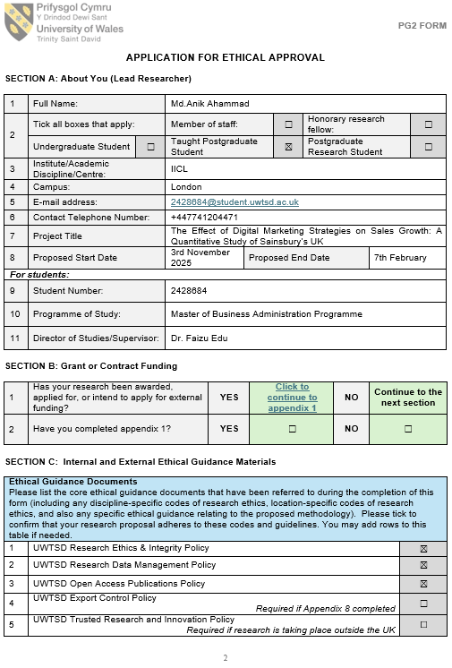

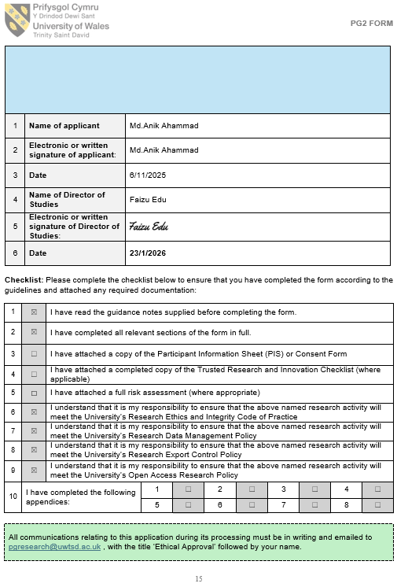

Appendix 2: List of Abbreviations
Abbreviation | Full Form
CX | Customer Experience
ONS | Office for National Statistics
RQ | Research Question
TAM | Technology Acceptance Model
UTAUT | Unified Theory of Acceptance and Use of Technology
SEO | Search Engine Optimisation
ROAS | Return on Ad Spend
ROCE | Return on Capital Employed

Appendix 3: Glossary
Term | Definition
Omnichannel Retailing | A retail strategy that integrates online and offline channels to provide a seamless customer experience across all touchpoints.
Digital Marketing Strategy | The planned use of digital channels, platforms, and technologies to promote products, engage customers, and support sales growth.
Loyalty Platform | A digital system used to reward repeat customers and collect behavioural data to support personalised marketing.
Customer Engagement | The level of a customer’s emotional, cognitive, and behavioural interaction with a brand across touchpoints.
Data-Driven Personalisation | The use of customer data and analytics to tailor marketing messages, offers, and experiences to individual users.
Online Sales Contribution | The proportion of total sales generated through digital channels such as websites and mobile applications.
Digital Capability | Organisational resources, skills, and technologies that enable effective use of digital tools and platforms.
Digital Maturity | The extent to which digital technologies are integrated into organisational strategy, operations, and culture.
Secondary Data | Data originally collected for another purpose but reused for research analysis, such as company reports or industry statistics.
Relationship Analysis | A non-causal analytical approach is used to identify associations or patterns between variables.
Longitudinal Analysis | Analysis of data collected across multiple time periods to identify trends and changes over time.

