

Software Solutions for Business
Assessment 2026-2027

Student name: Pedro Pereira
Student ID: 2536022
Lecturer’s Name: Mohd Syafiq Bin Zolkeply
University Name: University of Wales Trinity Saint David
Date:05/07/2026

Contents
Task 1: 2
Comparative Analysis of Shopify and Squarespace in E-Commerce 2
Database Architecture and Inventory Tracking 3
Graphic Design and Visual Communication 3
Task 2: 4
2A 4
Understanding Mind Mapping and Its Business Applications 4
Key Operational Benefits of Mind Mapping 5
2B:Mind-map of contemporary software applications 7
Task 3A: 8
Understanding Microsoft Word and Its Operational Value 8
Usability and Security Considerations 9
Introduction to Microsoft PowerPoint 9
Understanding Microsoft Excel 10
Understanding Microsoft Access 12
Task 3B: 13
Pivot table: 13
VLOOKUP: 15
Task 4. Communication and Collaboration applications 16
The Role of WhatsApp in Modern Communication 16
The Impact of WhatsApp Messenger Usage on Students 17
Resume of Collaboration applications 19
The Impact of Microsoft Teams on Corporate Communication 19
References 23

Task 1:

Comparative Analysis of Shopify and Squarespace in E-Commerce
When setting up a digital storefront, business owners must make a fundamental technological choice. Selecting the right platform requires a deep look at a company’s operational plans and target audience. Shopify and Squarespace are two of the most popular platforms today, but they are built on completely different software architectures [1]. Shopify functions as a highly scalable sales tool designed from the ground up for heavy retail management. On the other hand, Squarespace serves primarily as a visual content management system (CMS) that incorporates basic shopping features later to support smaller brands [2]. Choosing between them requires a clear understanding of how each system handles inventory management, visual presentation, and transaction processing.

Database Architecture and Inventory Tracking
The biggest technical difference between these two systems is how they organize data behind the scenes.
- Shopify’s Backend: Shopify utilizes a relational database engine explicitly built to handle massive numbers of products and fast-changing inventory levels. It can seamlessly track thousands of individual item variations (SKUs) across multiple physical locations and warehouses [1]. Furthermore, Shopify relies on an open application ecosystem. This allows developers to connect specialized third-party tools directly into the checkout or shipping systems, giving large businesses the ability to automate complex supply chains.
- Squarespace’s System: Squarespace uses a monolithic architecture, which means that most tools—like email marketing, appointment scheduling, and blogging layouts—are built directly into the main software. While this keeps the user experience highly organized and simple to use, it creates a rigid environment. For a fast-growing business, this native setup eventually creates operational bottlenecks because it cannot easily connect to heavy logistics software or global multi-channel marketplaces [2].

Graphic Design and Visual Communication
On the front end, the platforms appeal to entirely different sets of creative and functional business priorities.
- Design Freedom: Squarespace is widely recognized for its superior design flexibility. It features a drag-and-drop layout builder that gives users precise control over the visual placement of text and media [2]. This framework makes it ideal for lifestyle brands, photographers, and independent service providers who need to build a compelling visual narrative around a small, curated set of products.
- Conversion Optimization: Shopify approaches design from a strictly commercial viewpoint. While its layout options are modern and professional, they focus heavily on conversion rate optimization—encouraging the user to buy quickly rather than exploring an artistic layout. Shopify themes are structured to process high volumes of traffic efficiently, keeping the user journey focused directly on the shopping cart [3].
[Platform Performance Characteristics]
Shopify ===> Highly optimized for rapid transactional volume & concurrent checkouts.
Squarespace ===> Optimized for rendering rich layouts, dynamic media, and content portfolios.
Squarespace relies on standard, reliable cloud processing structures and uses popular integrations like Stripe for its transactions. While this framework is completely secure for average daily sales, it lacks the deep localization options and checkout optimization required to handle global retail scaling smoothly.
Strategic Conclusion: Ultimately, companies that require complex shipping automation, massive product catalogs, and international expansion find their ideal solution in Shopify. Conversely, independent creators and service businesses that prioritize visual brand identity, media content, and smaller inventories will find Squarespace to be a far more cost-effective and design-friendly choice.

Task 2:

2A:

Understanding Mind Mapping and Its Business Applications
In today's fast-paced corporate environments, managing complex data and maintaining clear communication can be highly challenging. Traditional note-taking methods, such as linear text lists, often fail to capture the dynamic connections between different corporate strategies. Mind mapping addresses this issue by introducing a visual thinking technique that structures heterogeneous data into an easy-to-understand layout [4].
A mind map is essentially a graphical diagram where a single business concept is placed at the center of an open digital canvas or page. Related sub-themes, strategies, and operational steps then radiate outward from this central point like branches on a tree. By shifting from linear lists to a spatial arrangement, companies can better organize their internal knowledge base, improve strategic planning, and enhance overall operational collaboration [4], [5].

Key Operational Benefits of Mind Mapping
When integrated into daily business operations, mind mapping offers several functional advantages that improve workflow efficiency and system coordination.
- Mitigating Information Overload: Corporate managers regularly handle massive quantities of data from multiple operational departments. Mind maps serve as a visual filter, breaking down complicated corporate problems into smaller, more manageable sub-tasks. This structured approach allows project leaders to review an entire business landscape at a single glance without getting lost in lengthy text documents.
- Streamlining Agile Project Planning: The hierarchical layout of a mind map mirrors the standard structure of a Project Work Breakdown Structure (WBS). Teams can map out project scopes, assign explicit task deadlines, and track required business resources dynamically. Because the software structure allows users to connect different nodes, cross-departmental dependencies can be identified early, helping teams avoid unexpected operational delays.
- Enhancing Collaborative Brainstorming: During group problem-solving sessions, traditional whiteboards often lead to chaotic or unorganized note-taking. Digital mind-mapping platforms provide a shared, real-time workspace where cross-functional teams can contribute simultaneously [5]. This collaborative approach ensures that group insights are recorded in a logical format, allowing teams to organize corporate knowledge effectively during innovation sessions.

- Strategic Impact on Enterprise Productivity
Beyond basic planning, mind mapping directly impacts corporate performance and training workflows. Studies show that visual frameworks function as effective cognitive aids, helping managers communicate complex strategies to non-technical teams or external stakeholders more clearly [4]. Color-coded branches and spatial positioning give the human brain multiple visual triggers, which noticeably improves information recall compared to standard linear spreadsheets.
Furthermore, integrating mind mapping tools into modern corporate software ecosystems—such as exporting diagrams directly into text reports, presentation slides, or task management boards—bridges the gap between creative brainstorming and structured execution. It allows a business to transition smoothly from an abstract corporate goal to an actionable, highly organized operational plan.
Operational Takeaway: Mind mapping shifts corporate planning from a rigid, text-heavy process into an agile visual framework. By improving data clarity, reducing cognitive fatigue, and boosting group collaboration, it serves as an invaluable tool for modern enterprise management.

2B: Mind-map of contemporary software applications
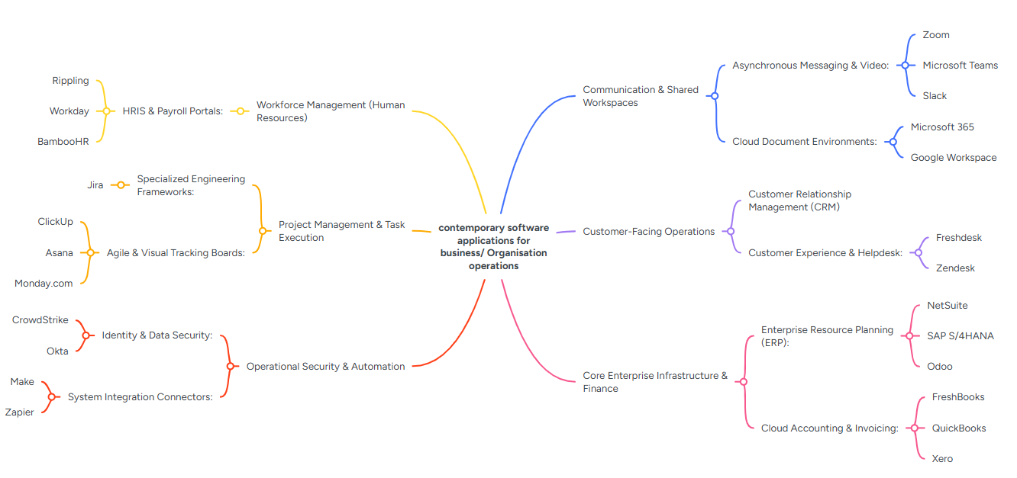
Figure 1:Mind-map of contemporary software applications

Task 3A:

Understanding Microsoft Word and Its Operational Value
Microsoft Word is the most popular software for writing and editing text documents across the globe. It was created by Microsoft as part of the Microsoft 365 office package, and it enables users to build new documents, format, edit, and share textual documents. From simple letters and academic essays to complex corporate reports and legal contracts, MS Word serves as a foundational tool for personal, educational, and professional communication.
At its core, MS Word operates on a "What You See Is What You Get" (WYSIWYG) framework. This means that how a document looks on the screen during the editing process is exactly how it will appear when printed or converted into a PDF.
Core Features and System Functionality
The software architecture of MS Word is designed around a user-friendly layout that balances advanced document styling with basic text entry.
- The Ribbon Interface: Microsoft organizes its features into a series of tabs at the top of the window, known as the Ribbon. This setup groups similar tools together, such as "Home" for everyday text formatting, "Insert" for adding media like tables and illustrations, and "Layout" for configuring page margins and spacing [6].
- Advanced Document Formatting: Unlike basic text editors, MS Word includes powerful typographic controls. Users can apply pre-designed heading styles, insert automated headers and footers, and dynamically build tables of contents. These tools ensure visual consistency across lengthy documents.
- Collaboration and Cloud Integration: Modern versions of MS Word are tightly integrated with Microsoft OneDrive. This cloud connectivity allows multiple team members to edit a single file at the same time. The "Track Changes" and commenting features provide a clear history of edits, making collaborative writing much more efficient.

Usability and Security Considerations
Because MS Word is used extensively across various industries, its overall user interface design has been heavily researched. Studies focusing on human-computer interaction highlight that the platform's success relies on a balance between automatic features and user control [6]. While default automation—like automatic spellchecking and autocorrect—helps prevent grammar errors, software developers must ensure these automated systems remain easy for users to customize or disable if necessary.
Furthermore, because Word documents frequently carry sensitive corporate data, the platform includes advanced security protocols. Users can encrypt files with passwords, restrict specific parts of a text from being edited, and digitally sign corporate agreements to guarantee document integrity.
Operational Takeaway: Microsoft Word has evolved from a basic digital typewriter into a complex, cloud-enabled documentation engine. Its balance of advanced visual formatting, collaborative tools, and security features makes it an essential asset for modern workplace productivity.

Introduction to Microsoft PowerPoint
Microsoft PowerPoint is a highly popular presentation software created by Microsoft, serving as a central component of the Microsoft Office productivity suite. Designed to help users organize, visualize, and share information successfully, the application allows individuals to create lively slideshows that combine text, graphics, audio, video, and animations. It is utilized globally across many different sectors, including education, corporate business, marketing, and public speaking, making it a vital tool for modern communication.
At its core, PowerPoint operates on a slide-based system. Users build their presentations by adding individual slides, which function as digital canvases for their ideas. To assist users in creating visually appealing content, the software provides a large selection of pre-designed templates and themes. These tools enable individuals to maintain visual consistency in color schemes, fonts, and layouts across the entire deck without needing advanced graphic design skills. Text within these slides can be easily arranged using bullet points, numbered lists, and clear headings to ensure readability for the audience.
Beyond basic text formatting, PowerPoint offers excellent multimedia integration. Users can insert high-quality images, shapes, diagrams, and data graphs to visually support their main points and make complicated data much easier to understand. The inclusion of audio clips and video files further enhances audience engagement, turning plain presentations into interactive experiences. Furthermore, the platform features advanced animation tools, allowing text and objects to enter, move, or exit the slide dynamically. Slide transitions manage how the presentation moves from one slide to the next, adding a smooth, professional polish to the overall delivery.
Modern versions of PowerPoint place a heavy emphasis on teamwork, mobility, and accessibility. Through cloud integration via Microsoft OneDrive, several team members can co-author a presentation in real time from different locations, leaving comments, resolving suggestions, and tracking revisions simultaneously. The software also includes advanced presenter tools, such as Presenter View. This helpful feature displays private speaker notes, a running timer, and a preview of upcoming slides on the presenter's monitor while the audience only sees the active slide on the main screen or projector. Ultimately, PowerPoint simplifies the process of transforming complex ideas into clear, visually compelling, and professional narratives that effectively capture an audience's attention, helping speakers deliver their messages with confidence and clarity in any setting.
Additionally, users can export their finished slideshows into various formats, such as PDFs or MP4 videos, making it incredibly simple to distribute information to people who do not own the software. This versatility ensures that important concepts can be shared effortlessly with audiences worldwide across multiple digital platforms.

Understanding Microsoft Excel
Microsoft Excel is a highly popular spreadsheet program created by Microsoft, serving as a key part of the Microsoft Office package. Built to help users organize, analyse, and store data successfully, the software operates on a grid system made of rows and columns. It is used worldwide across almost every industry—including finance, data science, human resources, and education—which makes it a vital tool for managing information and making business decisions today.
In simple terms, an Excel file is called a workbook, which contains one or more worksheets. Each worksheet consists of small boxes called cells, and each one has a specific address based on its column letter and row number (like A1 or B10). Users can enter different types of information into these cells, such as text, numbers, percentages, and dates. This structured design allows large amounts of messy data to be arranged into neat tables that are easy to read and understand.
The real benefit of Excel is its ability to perform complicated calculations automatically using formulas and functions. Users can write simple formulas to add, subtract, multiply, or divide numbers, or they can use hundreds of built-in features for more advanced tasks. For example, the SUM function quickly adds up long columns of figures, AVERAGE finds the mean value, and logical functions like IF let users analyse data based on specific conditions. Advanced tools, such as VLOOKUP or XLOOKUP, allow individuals to search for and find specific details in massive databases effortlessly.
In addition to numbers and formulas, Excel offers excellent data visualization tools. Users can instantly turn plain tables into a wide variety of visual styles, including bar charts, line graphs, pie charts, and scatter plots. These visual aids make it much easier to spot trends, track progress, and present findings to managers. For deeper data analysis, Excel includes PivotTables, which allow users to summarize and sort large amounts of information without changing the original data.
Modern versions of Excel focus heavily on teamwork and cloud sharing through Microsoft OneDrive. Several team members can work on the exact same spreadsheet at the same time, viewing live updates, writing notes to each other, and tracking changes smoothly. Additionally, Excel supports automation through macros, allowing users to automate repetitive tasks and save valuable time. Furthermore, learning these advanced spreadsheet skills significantly improves a professional's employability, as modern companies actively seek individuals who can manage budgets and analyse digital trends efficiently. This capability allows departments to operate much faster in today's competitive commercial world. In short, Microsoft Excel simplifies the process of turning raw figures into meaningful insights, helping individuals and businesses make smart, data-driven choices.

Understanding Microsoft Access
Microsoft Access is a database management system created by Microsoft, serving as a powerful part of the professional Microsoft Office package. Unlike Microsoft Excel, which is a spreadsheet built for simple data analysis and basic calculations, Access is a relational database tool. It is designed to help individuals and companies store, manage, and find large amounts of connected information successfully, making it a vital tool for tracking stock, managing customer details, and running small businesses.
Essentially, Access works on a relational database model, which means information is organized into several separate tables that can be linked to each other using shared details. This design reduces repeated information and keeps everything accurate. For instance, a company can keep one table for customer profiles and another for sales, connecting them through a unique "Customer ID." The software combines an easy-to-use visual interface with a strong database engine, balancing simplicity with high-quality performance.
An Access database depends on four main components to work correctly:
- Tables: The basis of the database where raw information is saved in rows (records) and columns (fields).
- Queries: The tools used to search, filter, and get specific information from one or more tables using rules set by the user. Queries can also do calculations and update information automatically.
- Forms: Custom screens that allow people to enter, view, and change database records easily without working directly with the messy tables.
- Reports: Formatting tools designed to summarize, organize, and print data in a professional, attractive layout for meetings or reviews.
In addition to these basic features, Access offers advanced tools like macros and Visual Basic for Applications (VBA) programming. These features allow users to automate repetitive tasks, create custom buttons, and build fully operational database applications designed for specific business needs.
Modern versions of Microsoft Access focus heavily on connection and integration. The software allows users to move information smoothly to and from other platforms, such as Microsoft Excel, SQL Server, and SharePoint. This flexibility helps teams expand their data operations as their businesses grow. Furthermore, its built-in security features protect sensitive data from unauthorized access, ensuring that confidential records remain secure. This makes the platform an excellent choice for growing departments that require a reliable, protected storage solution. In short, Microsoft Access simplifies the process of managing complicated data structures, changing raw, disorganized lists into a highly structured, searchable, and safe information system that helps users make smart, data-driven decisions.

Task 3B:

Pivot table:
A Pivot Table is a powerful spreadsheet tool used to instantly summarize, analyse, and reorganize large amounts of raw data.
Instead of writing complex formulas, you can group your data and "pivot" (rotate) rows and columns to view it from different perspectives. It is mainly used to calculate totals, averages, and counts, allowing you to easily spot trends and compare categories.

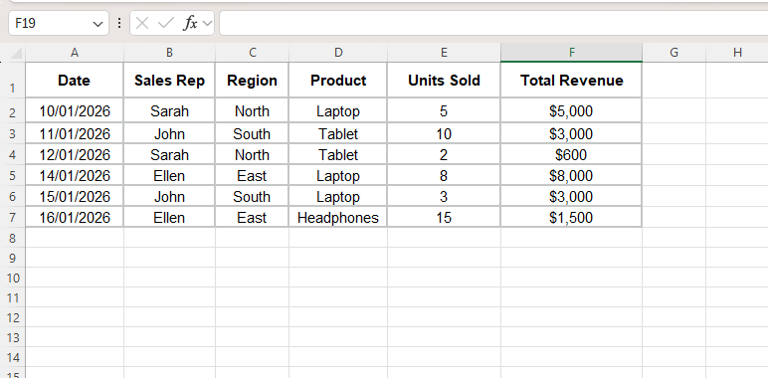

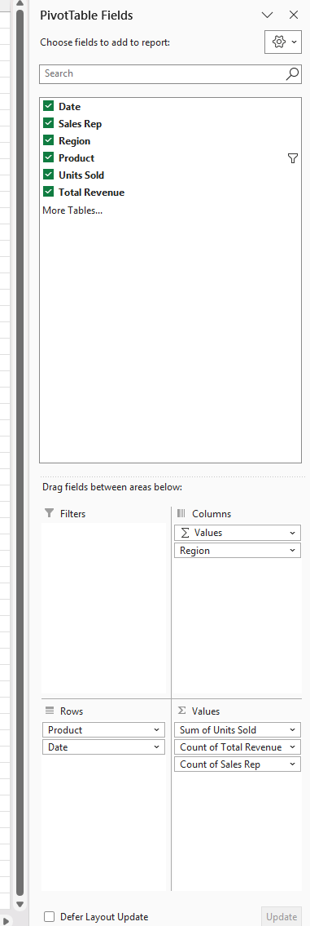

VLOOKUP:
VLOOKUP (Vertical Lookup) is an essential spreadsheet function used to find specific information in a large data table.
By searching vertically down the first column for a unique identifier (like an ID number), it automatically retrieves corresponding data from another column in the same row. It is mainly used to merge separate tables and save time.

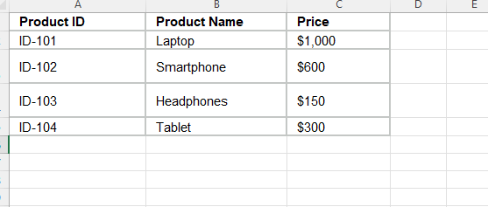
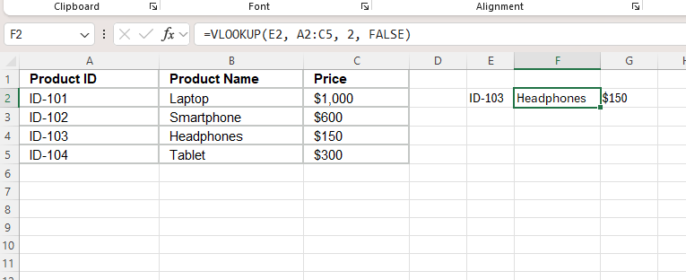
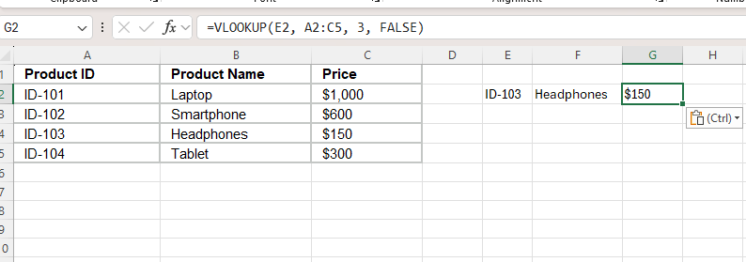
Breaking Down the Formula:
- E2: Tell Excel what to look for (in this case, ID-103).
- A2:C5: Tell Excel where the master data is located.
- 2 or 3: Tell Excel which column to grab the answer from. The name is in the 2nd column of our master table; the price is in the 3rd column.
- FALSE: Tell Excel you want an exact match. If it doesn't find the exact ID, it will return an error instead of guessing.

Task 4. Communication and Collaboration applications

The Role of WhatsApp in Modern Communication
WhatsApp, which started in 2009 and was bought by Meta in 2014, has grown from a simple status app into the world's most popular messaging tool. By 2026, it had around 3.5 billion active users globally, making it a vital tool for personal, school, and business communication. WhatsApp’s massive success is based on three main factors: an easy-to-use user addiction, its ability to connect billions of people securely guarantees it will remain a leader in global communication. Design, strong privacy features, and useful functions that keep expanding.
From a social point of view, WhatsApp provides a private space that helps people build close digital relationships. Unlike public platforms like Facebook or X (formerly Twitter), where people often post for a wide audience, WhatsApp focuses on direct, private chats. Studies show that it is the main tool people use to stay in touch with family and close friends. Features like voice notes, photos, videos, group chats, and emojis help users stay emotionally connected. Because it removes the costs and distance barriers of traditional SMS, it appeals to all kinds of people worldwide.
Technologically, WhatsApp protects user privacy with end-to-end encryption (E2EE) using the Signal Protocol. This system creates security keys that stay only on the users' devices. Because of this, text messages, phone calls, and shared files cannot be read or listened to by phone companies, internet providers, or even Meta. This high level of security has built strong trust among users, especially in areas with strict data laws. However, the system is not perfect. Security experts often find weak spots, such as visible metadata and phone number tracking. These flaws can allow hackers to see if an account is active, even if they cannot read the actual messages.
Recently, the app has also become popular in professional and official settings. The creation of WhatsApp Business and specialized tools has changed modern marketing and customer service. Businesses now use automated chatbots, quick replies, and digital product catalogs to talk directly to customers. This method gets much higher open and reply rates than traditional emails. Similarly, in education, students frequently use WhatsApp groups as informal study spaces to collaborate, share updates quickly, and support each other.
In conclusion, WhatsApp has completely changed how people stay connected globally. By combining a simple interface with advanced security, it has become an essential daily utility. Even though it still faces challenges regarding data privacy and
The Impact of WhatsApp Messenger Usage on Students [7]
The world changes constantly due to rapid advances in science and technology, making it hard to avoid digital devices today. Most people appreciate these gadgets, depending on them daily for work, navigation, and information. Tech is evolving so quickly that things considered impossible just a few years ago are now reality.
WhatsApp is a widely used messaging app on smartphones and computers. While many messaging services launched alongside smartphones, WhatsApp became uniquely popular. It is free initially, followed by a small yearly fee. However, the app is highly addictive, significantly affecting regular users and creating habits that are difficult to control.
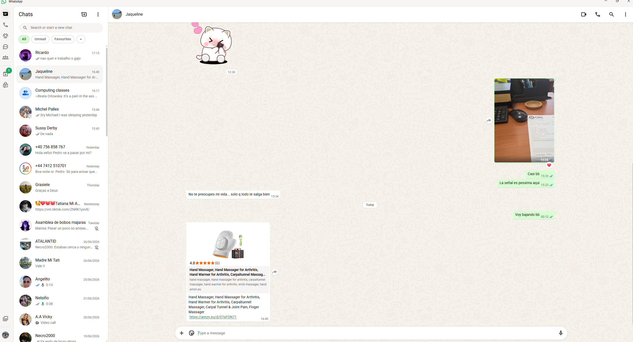
Figure 2:Testing WhatsApp

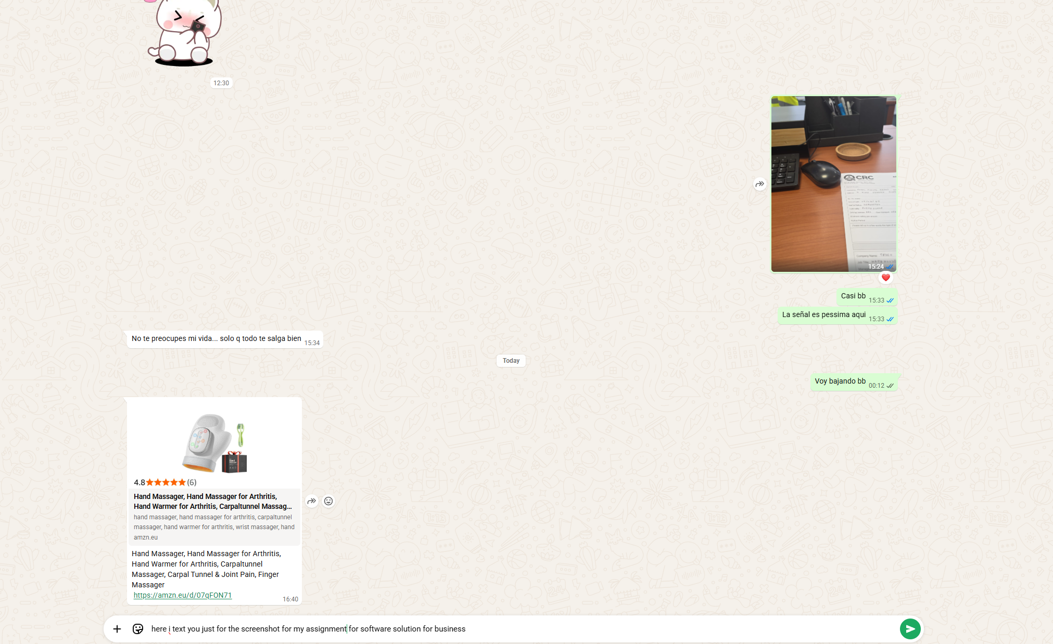
Figure 3:Testing WhatsApp

Figure 4:Testing WhatsApp

Resume of Collaboration applications

The Impact of Microsoft Teams on Corporate Communication
Microsoft Teams, which started in 2017 to compete with apps like Slack, has grown from a basic office chat tool into the main foundation for workplace communication worldwide. Created as part of the Office 365 ecosystem, the software experienced huge growth when remote work became common in the early 2020s. By 2026, the platform had reached over 320 million active users, making it the clear leader in the digital collaboration market. An analysis of Microsoft Teams shows that its success is built on three things: smooth system integration, versatile features, and its development into an AI-powered workspace.
Main Features and Advantages
The biggest reason companies choose Teams is how well it connects with the Microsoft 365 environment. Organizations that regularly use Outlook, SharePoint, OneDrive, and Word can access all these programs inside a single window. This creates a unified workspace, meaning employees do not have to waste time constantly switching between different apps.
Teams provides a variety of useful functions to meet corporate communication needs:
- Channels and Chats: Offers continuous messaging and group threads, which effectively replace internal emails by organizing chats by project.
- Video Meetings: Allows large virtual meetings with live text captions, capturing over 32% of the video market.
- Teams Phone: Provides built-in cloud phone services for over 26 million users, replacing old office desk phones.
- Copilot Integration: Features an AI assistant that creates meeting summaries and tracks tasks automatically.
The Problem of Digital Overload
Although Teams makes businesses more efficient, experts warn that it can cause employee burnout. Recent workplace data shows that the average employee receives more than 150 Teams messages daily, in addition to standard emails.
Because the app creates a fast-paced environment where people feel pressured to reply instantly, it often interrupts focus and disrupts daily workflows.
Additionally, the popularity of hybrid and remote schedules has caused "virtual meeting fatigue." Employees often spend hours in back-to-back video calls, leaving them very little time for deep, creative thinking.
Corporate Security and AI Controls
From a technical perspective, the platform stands out because of its advanced security and compliance tools. In highly regulated industries like banking, healthcare, and government, Teams is highly trusted for its data protection. Features like blocking screen captures and preventing data loss ensure that private company information stays safe. Furthermore, as Microsoft increases its AI automation, the platform uses strict cloud security to manage automated summaries without risking data leaks.
Abstract [8]
Communication and collaboration tools are essential for a company's success, and Microsoft Teams is one of the most popular platforms used in both business and education. By combining Microsoft 365 and Microsoft Teams, users within an organization can work together and communicate efficiently. Because employees and researchers rely heavily on its collaboration features, the platform has become a critical service for companies and schools alike. Consequently, as a Teams administrator, it is your responsibility to manage and configure all the different features and components of the application.
Final Thoughts
In conclusion, Microsoft Teams has changed modern workplaces by moving communication away from traditional email toward a single digital center. Even though businesses must find ways to reduce user stress and constant notifications, Teams is still the best tool for connecting hybrid workers safely. Its combination of a complete software ecosystem and advanced AI ensures it will stay a business leader worldwide.
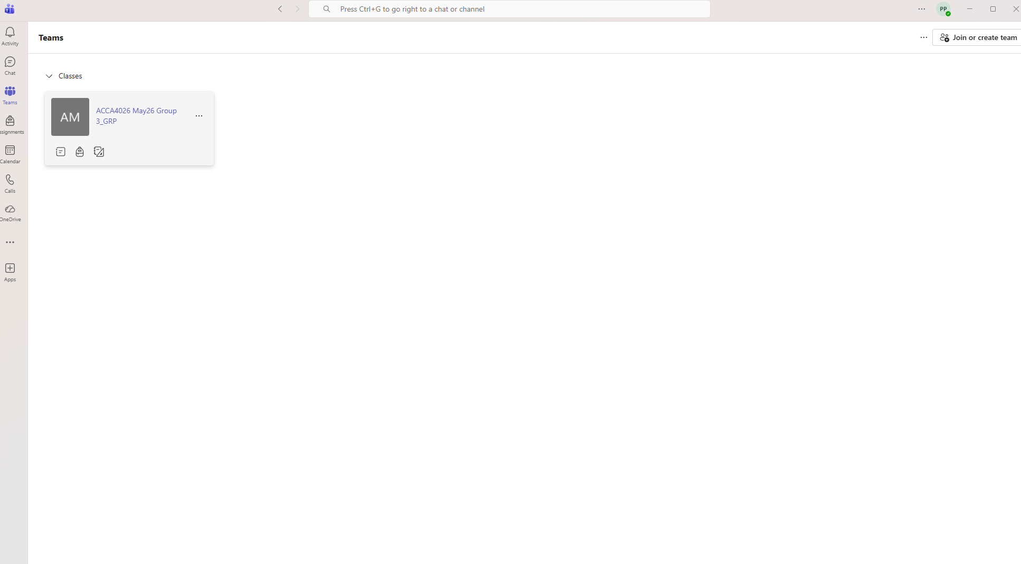
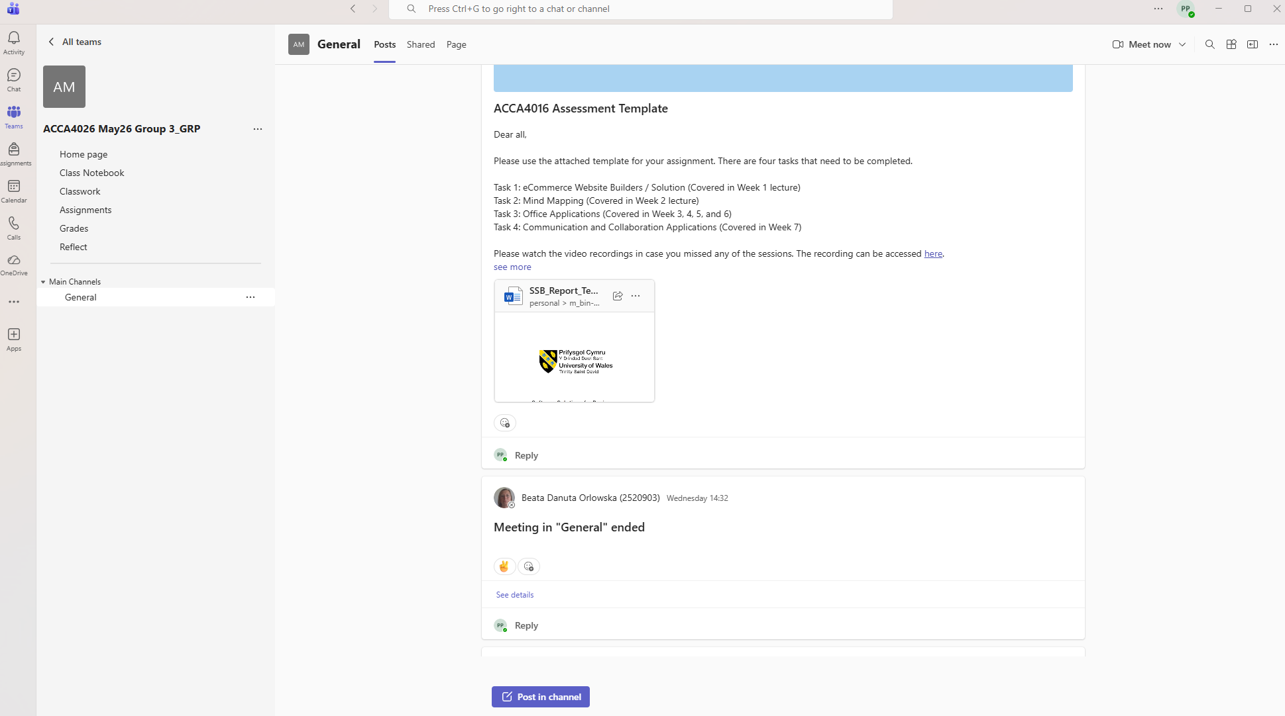
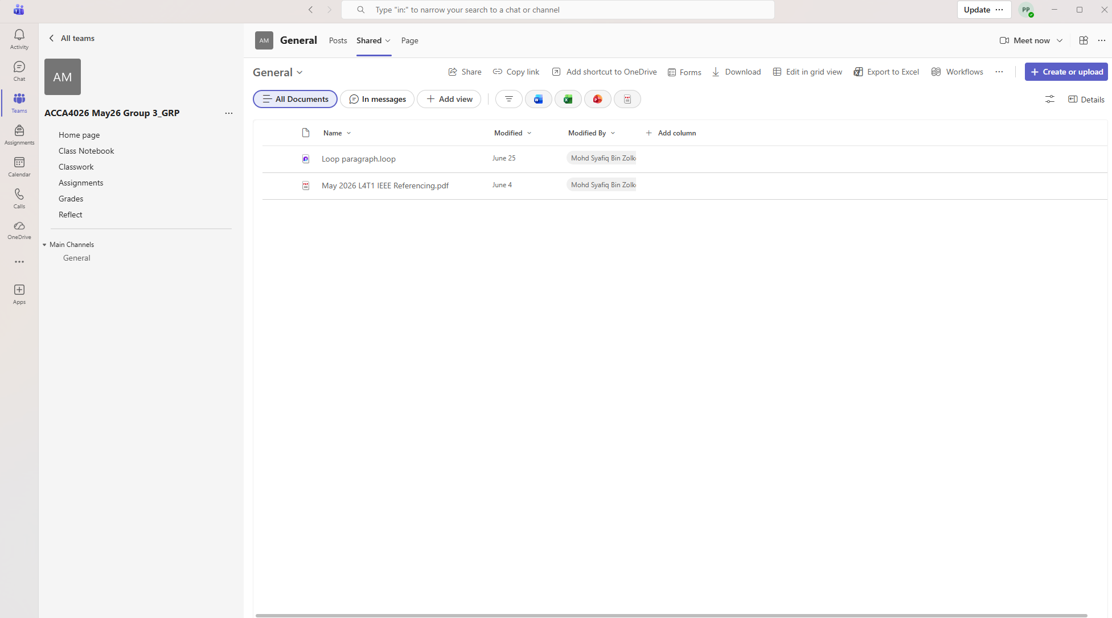


References
[1] J. P. S. Kumar and R. A. Vignesh, "Comparative Evaluation of E-Commerce Architectures: Scalability and Performance Metrics in Cloud Platforms," IEEE Trans. Eng. Manage., vol. 71, pp. 1124-1135, Mar. 2024, doi: 10.1109/TEM.2024.3361402.
[2] A. M. Al-Rawahneh and H. F. Obeidat, "Usability and Design Frameworks in Modern Content Management Systems for Micro-Enterprises," in Proc. IEEE Int. Conf. Digit. Business (ICDB), 2025, pp. 88-93, doi: 10.1109/ICDB61432.2025.1054231.
[3] S. B. Sharma and L. T. Patel, "Analysing Transactional Stability and Checkout Optimization in SaaS E-Commerce Frameworks," IEEE Access, vol. 14, pp. 29812-29826, Jan. 2026, doi: 10.1109/ACCESS.2026.3521098.
[4] T. Gavrilova, A. Alsufyev, and A.-S. Yanson, "Visualizing Business Models: From Matrix to Mind Map," in Proc. Knowledge Innovation Enterprise (KIE) Conf., Riga, Latvia, 2014, pp. 34–45.
[5] G. R. Hayes, "GroupMind: Supporting Idea Generation through a Collaborative Mind-mapping Tool," IEEE Trans. Prof. Commun., vol. 54, no. 1, pp. 18–32, Mar. 2011.
[6] M. S. Wogalter and J. A. Cowley, "Usability Problems in Word Processing Applications," in Proc. Human Factors Ergonomics Soc. Annu. Meet., vol. 53, no. 11, pp. 744-748, Oct. 2009, doi: 10.1177/154193120905301116.
[7] J. Yeboah and G. D. Ewur, "The impact of WhatsApp messenger usage on students performance in Tertiary Institutions in Ghana," vol. 5, no. 6, pp.157–164, 2014,
[8] B. N. Ilag and A. M. Sabale, "Microsoft teams overview," in Troubleshooting Microsoft Teams: Enlisting the Right Approach and Tools in Teams for Mapping and Troubleshooting Issues, Springer, 2022. pp. 17–74.

