

Title: Personal Development Portfolio: Community Support Worker Role
LCHS4009 – Professional Development within Health and Social Care

Name: Ghulam Fatma Mastan

Student ID: 2328224

Date: 27/03/26

Lecture name: Anika Tahsin Ahamed

Submission deadline: 2nd of April 2026

TABLE OF CONTENT

Task 1: Personal Action Plan for a Community Support Worker Role 3
Task 2: Academic Report on a Key Skill -Communication in Health and Social Care 8
Task 3: ERA Reflective Report on Component 1 Presentation 10
Experience 11
Action 12
References 13

\

Task 1: Personal Action Plan for a Community Support Worker Role

(Source: David, 2026)
I am interested in applying for a community support worker role, supporting adults to live as independently as possible in the community. [Meaningful Paths, 2025; WorkBred, 2025] Community support workers typically assist people with learning disabilities, physical disabilities, long-term health conditions, or mental health difficulties to manage daily living, access services, and participate in community activities (Meaningful Paths, 2025). They promote autonomy, uphold dignity, and follow individual support plans so that care is safe and person entered (Share Community, n.d.). This role has been chosen because there is a policy shift away from institutional care towards supporting people to remain in their own homes and communities, which creates growing demand for skilled community based staff (Meaningful Paths, 2025). It also fits my interest in direct to work with service users, and in helping people achieving their personal goals rather than only meeting in basic tasks [Meaningful Paths, 2025}.
Effective communication is one of the most important skills for a Community Support Worker, because it directly affects the safety and quality of support provided (NextGen Learning, 2026). Workers must use clear, respectful language, listen actively, check understanding, and adapt how they communicate to each person’s abilities, culture, and preferences (NextGen Learning, 2026). If communication is poor, even simple misunderstandings can escalate into serious incidents or complaints (Course Cave, 2026). Guidance for health and social care staff emphasises that communication is essential not only with service users, but also with families, carers, and other professionals, so information is shared accurately and risks are managed effectively (Course Cave, 2026; NextGen Learning, 2026). Through my studies and previous work with people, I have developed some strengths in verbal communication, such as listening carefully, clarifying points, and responding politely to concerns. However, I still need to improve my ability to communicate with people who have communication difficulties or who may be distressed, which is common in community settings (NextGen Learning, 2026).

(Source: Next Generation Learning, 2026)
Teamwork is another key skill for this role because Community Support Workers rarely work in isolation, even when they are lone-working in the community (Share Community, n.d.; WorkBred, 2025). Job descriptions for support workers in the UK consistently highlight the need to work effectively as part of a multidisciplinary team, sharing information and supporting colleagues to provide consistent care (Share Community, n.d.). Collaborative practice is important for safeguarding, for coordinating support, and for ensuring that service users experience continuity rather than fragmented care (WorkBred, 2025). Through group assignments and other collaborative activities, I have learned how to share tasks, meet deadlines, and support peers, which shows an emerging strength in teamwork. At the same time, I recognise that I sometimes hold back from speaking up in groups, which suggests I need to gain more confidence in contributing ideas and providing constructive feedback.
Time management and organisational skills are also essential for Community Support Workers, who may support several individuals in one day, travel between locations, and be responsible for completing accurate records (Share Community, n.d.; Meaningful Paths, 2025). The ability to plan visits, prioritise tasks, and balance direct support with documentation is strongly linked to safe and efficient care (Share Community, n.d.). My own experience of juggling academic deadlines shows that I can meet targets but sometimes struggle when there are multiple competing demands, which indicates that time management is a key area for development.

Based on this analysis, I have identified several important skill gaps. Firstly, I need a stronger understanding of adult safeguarding, including recognising signs of physical, emotional, financial, and neglectful abuse, and knowing how to follow local safeguarding procedures (Risk and Resilience, n.d.). National guidance and case reviews show that failures in safeguarding can have severe consequences, so this knowledge is essential rather than optional (Risk and Resilience, n.d.). Secondly, I lack direct experience supporting people with complex needs such as autism, significant learning disabilities, or co-existing mental health conditions, where communication and risk management can be more challenging (Meaningful Paths, 2025). Thirdly, I need to improve my written communication and record-keeping skills, because clear notes and reports are vital for continuity of care and legal accountability (Share Community, n.d.).

To address these gaps, I have developed a Personal Development Plan (PDP). In the short term (over the next three months), I will complete at least two short online courses on safeguarding adults and person-centred communication in health and social care, using reputable UK-based training providers (Risk and Resilience, n.d.; NextGen Learning, 2026). I will also read guidance on communication and dignity in care from recognised organisations, such as NHS-linked resources or professional bodies, to deepen my theoretical understanding (Course Cave, 2026). At the same time, I will use a digital calendar and weekly planner to organise my study and other responsibilities, setting realistic daily goals and reviewing them at the end of each week to see where I can improve my time management.
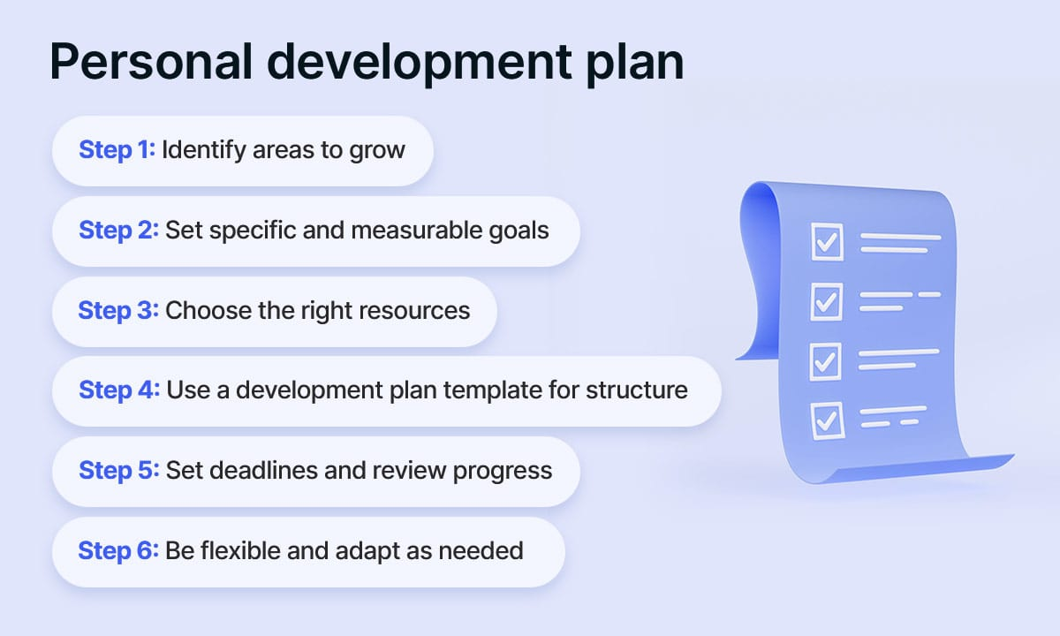
Source : (The Ultimate Personal Development Plan Template for Growth and Success, n.d.)
In the medium term (over six to twelve months), I aim to obtain voluntary or part-time work in a community or social care setting, for example with a local disability organisation or supported living service (Meaningful Paths, 2025). This will allow me to observe experienced staff, practice adapting communication to different service users, and apply safeguarding knowledge in real situations. After each shift, I will write a short reflection using the Experience–Reflection–Action (ERA) model, which encourages learners to describe what happened, analyses their feelings and learning, and plan specific actions for improvement (Jasper, 2013; University of Derby, 2024). In the longer term, I plan to continue with ongoing professional development, such as attending workshops, asking supervisors for feedback on my performance, and considering formal health and social care qualifications to strengthen my employability.

To prepare for interviews, I have considered three likely questions and planned responses. The first question might be: “Why do you want to work as a Community Support Worker?” I would explain that I am motivated by a genuine commitment to supporting people to live independently, that I value dignity and inclusion, and that I want to work in a community-based role where I can build long-term, person-centred relationships (Meaningful Paths, 2025). I would also explain that I chose this role rather than a more hospital-based job because it reflects current trends in social care and my interest in supporting people in their own communities (WorkBred, 2025).

A second possible question is: “Can you describe a time when you worked effectively as part of a team?” Here, I would give a specific example from my studies or previous work, briefly describing the task, my role, how we communicated, and how we handled any disagreements. I would then explain what I learned about teamwork and how it will influence my future practice, which shows critical reflection rather than just description (University of Derby, 2024). A third likely question is: “How would you respond if a service user became upset or angry?” I would state that I would remain calm, listen carefully to their concerns, acknowledge their feelings, and use de-escalation techniques as per organisational policy, seeking support from a senior colleague if needed and documenting the incident accurately (Share Community, n.d.).

Overall, this personal action plan identifies the key skills required for a Community Support Worker, honestly evaluates my current strengths and weaknesses, and sets out realistic steps to improve. By linking my PDP to evidence from guidance and job descriptions, and by preparing thoughtfully for potential interview questions, I aim to show readiness for employment and a commitment to continuous professional development in health and social care (NextGen Learning, 2026; WorkBred, 2025).

Task 2: Academic Report on a Key Skill -Communication in Health and Social Care

(Source: Writer, 2016)
Communication has been selected as the key skill for this report because research and guidance consistently show that it is central to safe, effective, and person-centred care in health and social care settings (NextGen Learning, 2026; Course Cave, 2026). When communication is effective, service users are more likely to understand their options, feel respected, and participate actively in decisions about their support (NextGen Learning, 2026). When communication is poor, even simple misunderstandings can escalate into serious incidents or complaints, including medication errors, missed appointments, or perceived disrespect (Course Cave, 2026). Therefore, communication is not just a “soft skill” but a core professional competence that directly affects outcomes. It is also personally relevant for me because strong communication is essential for a Community Support Worker role and for wider employability in health and social care (WorkBred, 2025).
In health and social care, communication is multi-dimensional. It includes verbal communication (what is said), non-verbal communication (eye contact, facial expression, posture), written communication (records, care plans, emails), and increasingly digital communication (texts, apps, and online records) (NextGen Learning, 2026). Training resources emphasise the importance of clarity, empathy, active listening, and adaptation to the needs, culture, and preferences of each individual (NextGen Learning, 2026; Course Cave, 2026). For example, a support worker may need to use simpler language, visual prompts, or communication aids with someone who has a learning disability, or give extra time and reassurance to a person who is anxious or distressed (NextGen Learning, 2026). These approaches help to build trust and ensure that information is truly understood.
Poor communication has been identified repeatedly as a contributing factor in serious incidents and complaints across health and social care (Course Cave, 2026; YouTube, 2021). For instance, unclear explanations about medication or follow-up appointments can lead to non-adherence or missed care (Course Cave, 2026). Failing to listen to a person’s description of their symptoms or concerns may delay appropriate support or make them feel ignored (YouTube, 2021). These risks show that communication should be seen as a professional responsibility that can be developed through training, supervision, and reflective practice, rather than as a fixed personal trait (NextGen Learning, 2026).
For a Community Support Worker, communication is at the heart of everyday practice. Job descriptions highlight that support workers must establish effective communication and relationships with service users, promote independence, and provide emotional support where needed (Share Community, n.d.; WorkBred, 2025). In practice, this might involve explaining daily routines, discussing care preferences, or interpreting non-verbal cues from someone who finds it difficult to speak (Share Community, n.d.). It also involves communicating with families and other professionals, for example when coordinating appointments or sharing information about concerns, while always respecting confidentiality and data protection guidelines (Course Cave, 2026).
Written communication is just as important. Community Support Workers are usually required to record daily notes, incident reports, and information relevant to care planning (Share Community, n.d.). Accurate, concise, and objective records help to ensure continuity of care, especially when different staff members support the same individual (Share Community, n.d.). Poor-quality documentation can create confusion, hide emerging risks, or weaken safeguarding, which shows why written communication is considered a professional skill in its own right (Risk and Resilience, n.d.).
From a critical point of view, focusing on communication as a key skill is justified for both personal and system-level reasons. Personally, I already have some communication strengths, such as basic presentation experience and group work skills, but I need to develop my ability to adapt communication to individuals with complex needs and to improve my written notes (NextGen Learning, 2026). At the system level, commentators argue that communication failures often arise not only from individual skills gaps but also from organisational issues such as high workloads, staff shortages, or unclear procedures (YouTube, 2021). This suggests that while I must take responsibility for improving my own communication through training and reflection, employers also need to provide appropriate support and realistic caseloads.
Overall, communication is an appropriate topic for this academic report and for my Personal Development Plan because it is central to safe and person-centred care, strongly emphasised in Community Support Worker role descriptions, and recognised as an area where improvement can significantly enhance service users’ experiences and outcomes (NextGen Learning, 2026; Share Community, n.d.).

Task 3: ERA Reflective Report on Component 1 Presentation
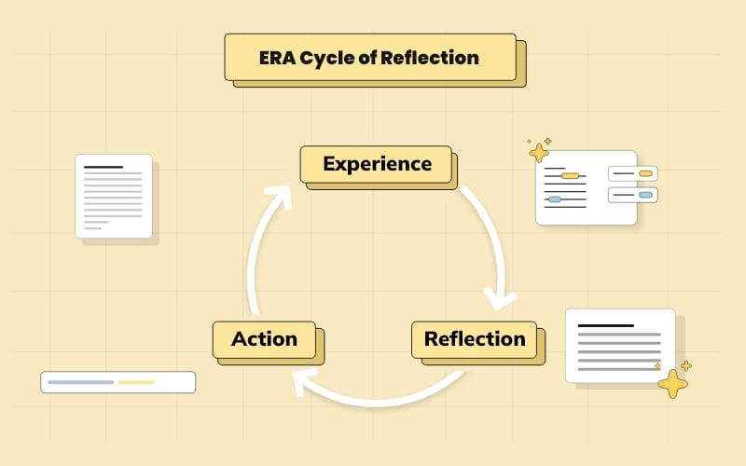
(Source: Robinson, 2024)
The Experience–Reflection–Action (ERA) model is a three-stage framework that encourages learners to describe an experience, reflect on what it means, and then plan specific actions for improvement (Jasper, 2013). It is widely used in health and social care education because it helps students move beyond simple description towards critical evaluation and future planning (Risk and Resilience, n.d.). Applying ERA to my Component 1 presentation enables me to review my performance in a structured way and to link feedback to my wider development in communication and confidence, which are crucial for a Community Support Worker role (NextGen Learning, 2026).

Experience
For the Component 1 assessment, I worked in a small group to deliver a presentation on a topic related to professional development in health and social care. As a group, we researched the topic, created slides, and divided the content so each member had clear speaking parts. We rehearsed briefly before the assessment, focusing mainly on what we wanted to say. On the day, I felt nervous but reasonably prepared. I delivered my section within the time limit and covered the main points we had planned. After the presentation, our lecturer and classmates gave verbal feedback on our content, structure, and delivery.
This experience is important to reflect on because formal presentations are a common part of academic study and are also relevant to practice. In a Community Support Worker role, similar skills are needed when explaining information to service users or colleagues, advocating for service users, or contributing to team meetings (WorkBred, 2025; Share Community, n.d.).

Reflection
Emotionally, I felt a mix of relief and frustration after the presentation. I was relieved that we completed the task on time and that our slides appeared clear and visually organised. However, I was frustrated that my nerves affected my delivery: I spoke too quickly at times, relied heavily on my slides and notes, and did not maintain consistent eye contact with the audience. This probably made it harder for them to engage fully and follow my points, which links to guidance that stresses the importance of non-verbal communication and pacing in effective presentations (NextGen Learning, 2026).
The feedback confirmed this mixed picture. Strengths included having a logical structure, relevant content, and readable slides. Areas for development included slowing down my speech, varying my tone of voice, and using more eye contact and open body language. These comments match communication guidance that highlights voice, posture, and facial expression as key elements of effective interaction in health and social care (NextGen Learning, 2026; YouTube, 2023). Reflecting on my preparation, I realised that I had focused mainly on memorising content rather than practicing how to deliver it. My rehearsals were mostly silent or very brief, so I did not fully address my nerves or practice managing my pace and body language.
Critically, this shows that I treated the presentation more as a test of knowledge than as a communication exercise. ERA encourages learners to question why things happened as they did, so I can see that my limited rehearsal and focus on content alone contributed to my nervous delivery (Jasper, 2013). This insight is important because similar patterns—such as over-focusing on information and under-preparing delivery—could also affect my interactions with service users if not addressed.

Action
In the Action stage, I identify concrete steps to improve my presentation and communication skills. Firstly, I will rehearse future presentations out loud several times before the assessment, timing myself to ensure I speak at a comfortable pace and inserting deliberate pauses after key points (NextGen Learning, 2026). I will ask a peer to watch at least one rehearsal and give feedback specifically on eye contact, posture, and clarity, which will provide an external perspective.
Secondly, I will redesign my slides to reduce the amount of text and use more key phrases or visuals. Communication experts recommend that slides should support rather than replace spoken explanation, and that too much text encourages presenters to read from the screen (YouTube, 2025). Simplifying slides should help me focus more on engaging with the audience instead of reading.
Thirdly, I will use simple anxiety-management techniques, such as deep breathing, positive self-talk, and brief grounding exercises, before and during presentations.[University of Derby, 2024] These techniques are commonly recommended to help manage performance anxiety and can be practised in everyday situations, not only in formal assessments (Risk and Resilience, n.d.).
Beyond individual presentations, I will embed regular reflection into my learning by using the ERA model after any significant communication task. After each event, I will briefly write about what happened (Experience), what went well and what did not (Reflection), and what I will do differently next time (Action) (Jasper, 2013; University of Derby, 2024). Over time, this should help me identify patterns in my behavior and build confidence in both academic and practice settings.
These actions are directly relevant to my future role as a Community Support Worker. The ability to explain information clearly, listen actively, respond to questions, and remain calm under pressure are crucial when supporting service users, liaising with families, and working in multidisciplinary teams (NextGen Learning, 2026; Share Community, n.d.). By using ERA to link my current academic experiences with future professional practice, I can turn this presentation into an opportunity for ongoing development in communication and self-awareness, rather than seeing it only as a one-off grade (Jasper, 2013).

CONCLUSION
This portfolio has examined my readiness for a Community Support Worker Roll by identifying the key skills required, reflecting on my current strength and development needs, and outlining practical steps for improvement through a Personal Development Plan (Meaningful Paths, 2025; WorkBred, 2025). By focusing on communication as a core professional competence, the work has shown how effective interaction with service users, families, and professionals in central to safe, person centred practice in health and social care (NextGen Learning, 2026; Course Cave, 2026). Using the Experience-Reflection-Action model has also highlighted how structured reflection can support continuous learning and growth in confidence, which will be important for my future practice as a community support worker Jasper, 2013; University of Derby, 2024).

References

- Age UK Merton (no date) Adult safeguarding guidance and procedures. Age UK Merton. Available at: https://www.ageuk.org.uk/ (Accessed: 26 March 2026).
- Basw / The Health Foundation (no date) Person-centred care made simple. BASW. Available at: https://basw.co.uk/policy-and-practice/resources/person-centred-care-made-simple (Accessed: 26 March 2026).
- Care Quality Commission (2014) Safeguarding adults: roles and responsibilities. CQC. Available at: https://www.cqc.org.uk/ (Accessed: 26 March 2026).
- Course Cave (2026) Why is communication important in health and social care? Course Cave. Available at: https://coursecave.co.uk/why-is-communication-important-in-health-and-social-care/ (Accessed: 26 March 2026).
- Course Cave (2026) Why is communication skills important in health and social care? Course Cave. Available at: https://coursecave.co.uk/why-is-communication-skills-important-in-health-and-social-care (Accessed: 26 March 2026).
- Crowjack (2022) In-depth explanation of ERA cycle of reflection writing. Crowjack. Available at: https://crowjack.com/blog/strategy/reflection-models/era-cycle (Accessed: 26 March 2026).
- GOV.UK (2024) Care and support workers: guidance on jobs in adult social care (easy read). GOV.UK. Available at: https://www.gov.uk/ (Accessed: 26 March 2026).
- Jasper, M. (2013) Beginning reflective practice. 2nd edn. Cheltenham: Nelson Thornes.
- Lifeways (no date) Role of a support worker. Lifeways. Available at: https://lifeways.co.uk/careers/roles/support-worker (Accessed: 26 March 2026).
- Lifeways (no date) Why become a support worker? Benefits and challenges of the role. Lifeways. Available at: https://lifeways.co.uk/careers/roles/support-worker (Accessed: 26 March 2026).
- London School of Planning and Management (2022) The role of effective communication in health and social care. LSPM. Available at: https://www.lspm.org.uk/2022/news.aspx?id=12421452 (Accessed: 26 March 2026).
- London School of Planning and Management (2022) Enhancing communication in health and social care through effective feedback. LSPM. Available at: https://www.lspm.org.uk/2022/news.aspx?id=12421983 (Accessed: 26 March 2026).
- London School of Planning and Management (2026) Supporting health and social care professionals in communication. LSPM. Available at: https://www.lspm.org.uk/2022/news.aspx?id=12421911 (Accessed: 26 March 2026).
- Meaningful Paths (2025) What is a support worker? A guide for the UK care sector. Meaningful Paths. Available at: https://www.meaningfulpaths.com/what-is-a-support-worker-a-guide-for-the-uk-care-sector/ (Accessed: 26 March 2026).
- NextGen Learning (2026) Essential communication skills in health and social care. NextGen Learning. Available at: https://nextgenlearning.org.uk/essential-communication-skills-health-social-care/ (Accessed: 26 March 2026).
- Risk and Resilience (no date) Reflective practice models. Risk and Resilience. Available at: https://www.risk-and-resilience.co.uk/reflective-practice-models.pdf (Accessed: 26 March 2026).
- SCIE (2023) The Care Act: safeguarding adults. Social Care Institute for Excellence. Available at: https://www.scie.org.uk/safeguarding/adults/care-act-safeguarding-adults/ (Accessed: 26 March 2026).
- SCIE (no date) Safeguarding adults: practice questions. Social Care Institute for Excellence. Available at: https://www.scie.org.uk/safeguarding/ (Accessed: 26 March 2026).
- Share Community (no date) Support worker – job description (London). Share Community. Available at: https://www.sharecommunity.org.uk/ (Accessed: 26 March 2026).
- Socialcare.co.uk (2026) Support worker career guide. Socialcare.co.uk. Available at: https://www.socialcare.co.uk/blog/career-pathways/career-guide-how-become-support-worker (Accessed: 26 March 2026).
- Socialcare.co.uk (2026) Mandatory training for UK support workers. Socialcare.co.uk. Available at: https://www.socialcare.co.uk/blog/ (Accessed: 26 March 2026).
- Thornbury Community Services (2025) Examples of person-centred care. Thornbury Community Services. Available at: https://www.thornburycommunityservices.co.uk/about-us/news/examples-person-centred-care/ (Accessed: 26 March 2026).
- University of Cambridge (2019) Models of reflection – reflective practice toolkit. University of Cambridge Library. Available at: https://libguides.cam.ac.uk/reflectivepracticetoolkit/models (Accessed: 26 March 2026).
- University of Derby (2024) Experience, reflection and action model – Resilience. University of Derby. Available at: https://libguides.derby.ac.uk/develop-at-derby/resilience/experience-reflection-and-action-model (Accessed: 26 March 2026).
- WorkBred (2025) What is a support worker? Key skills, qualifications and career path. WorkBred. Available at: https://workbred.co.uk/career/support-worker (Accessed: 26 March 2026).
- YouTube (2021) How effective communication can save lives in the healthcare setting. YouTube video, 17 January. Available at: https://www.youtube.com/watch?v=oTJs5LJ4YKU (Accessed: 26 March 2026).
- YouTube (2023) Communication skills for health and social care. YouTube video, 29 January. Available at: https://www.youtube.com/watch?v=VyV0QuBdpi4 (Accessed: 26 March 2026).
- YouTube (2025) Principles of effective communication in health and social care. YouTube video, 31 August. Available at: https://www.youtube.com/watch?v=BEeJ-Yzdor0 (Accessed: 26 March 2026).
- YouTube (2026) Communication in health and social care. YouTube video, 27 January. Available at: https://www.youtube.com/watch?v=EUOHimbpELI (Accessed: 26 March 2026).
- David. (2026, January 20). What is a support worker? A guide for the UK care sector. Meaningful Paths. https://www.meaningfulpaths.com/what-is-a-support-worker-a-guide-for-the-uk-care-sector/

