title: HOW IS FAITH, RELIGION AND SPIRITUALITY REPRESENTED IN SMALL COMMUNITIES

Student Number: P141314

Course: BA Photojournalism And documentary Photography

Word count: 5036

Tutor: Sian Addicott

This essay will discuss the changing face of religion in Wales and how faith, religion and spirituality has changed during the course of the last thousand years. Different areas of faith will be analysed; including ancient religious beliefs prior to Christianity and the use of iconography. The invasion of Wales by force by the Romans in 43AD, which affected both culture and religion this is extended in to the proliferation of cathedrals and abbeys. This essay will also review the increase of non conformist religions particularly related to industrial parts of Wales from the the 18th through to the 20th century. This is of particular interest due to the themes and subject matter which is conveyed through my photography. The passion that is seen through my own experiences and through my family are in extreme contrast to the deep decline of attendance seen in many community places of worship.

I will firstly speak about my own experiences with religion and how growing up in a small Welsh speaking community made me feel about religion. I spent my childhood attending my local Welsh speaking chapel that my family had gone to, and in a way this gave me a very narrow minded view on the world. I feel like my own experiences along with research will give me a good insight in to the subject. Gathering information through books, art, photography and my own experiences I will look at how faith in particular has decline in Britain and how other religions have taken it’s place. This subject has greatly inspired my own work and I feel like a project about this subject is very much needed in a time where religion is on the decline and chapels keep closing down. This essay will be conducted through multiple methods including both primary and secondary research. Secondary sources will include important information that I have used and gathered through extended research. During this essay I will explore how faith, religion and spirituality is also represented in small communities. I will conduct this essay by discussing different times throughout history and explaining the natural timeline of religion and faith in Wales, this will start with the ancient history of faith in wales starting in 597AD and will go all the way through to present day. During the third year of university I also extended my written research in to my photographic practise. Through looking at my Welsh roots I decided to look at wether the attendance of churches and religion in Wales changed or effected my upbringing. I felt like this was the best project idea to continue for my work as I wanted to try and do a project that interests me. Subconsciously during my time at university i’ve based a lot of my work on the welsh language and it’s decline. The project that I did on the decline of welsh speaking chapels was one that interested me greatly and through my natural interest for the project theme I feel like I produced some good and interesting images.

During this last year I have also been exploring the representation of faith, religion and spirituality in small communities. Through my own work I have explored the decline in attendance to welsh chapels in Wales, I feel like this has helped in my own understanding of the subject. As a young boy I myself attended a welsh chapel in a small Swansea community and have therefore seen first hand the decline in the attendance in Welsh chapels. Even throughout my lifetime I’ve seen my own chapel’s decline, when I was much younger the sunday school in my chapel had approximately 20 members ranging from 5-20, now in 2018 the Sunday school has no members. I was planning throughout the year to explore not only the facts of this subject matter but also how it has been explored through the medium of photography.

Starting at the very beginning the earliest burial site in Wales found on Gower coast. Christianity was founded in Wales during height of roman empire and by 597AD christianity was the main religion in Wales. The Welsh of the sixteenth and seventeenth centuries were proverbially proud of their history. They saw themselves as the descendents of the Ancient Britons who had dominion over these islands long before the arrival of the Romans. This Welsh heritage itself had a long lineage by the time the Tudors came to the throne, appearing in one form in the Armes Prydain (The Prophecy of Britain) in the early tenth century. It was most successfully synthesised by one of their own, Geoffrey of Monmouth, whose Historia Regum Britanniae (c.1136) encapsulated both the majesty of the Welsh people’s distant past, but also foretold their restitution to former glories by the mab darogan (‘son of prophecy’) who would deliver them from Saxon bondage and restore their authority over Britain. (Jones,1990)

During this last year I also wrote a statement regarding my photographic work, I feel like it perfectly sums up my feelings toward religion in Wales in the present day,

‘I am always struck with the feeling, impact and emotion that an image can stir within the viewer. Through examining themes regarding Wales and my local environment I try to explore subject matters that mean something to me personally but also the changing face and landscape of places and things I deem important. Through looking at the landscapes around me in a nostalgic way my photography is very much documentary based whilst still keeping an open mind. Through the medium of photography, film and occasionally multimedia my aim through my photography is to explore subject matters that are intriguing yet very much documentary based. My works are often classified as romanticised or sentimental because of my desire for the local in the unfolding globalised world, yet on the other hand I reflect on the closely related subjects of archive and memory. Through future exhibitions and projects I aim to explore further the changing face of Wales and the future of the Welsh language, I will also be working with sound in the future to create an installation piece conveying the decline in Christianity in Wales.’

Celtic Iconography is a very interesting part of our history, it gives us a unique understanding of the past and gives us a good insight in to the old traditions of Wales, this is explained in the quote below,

“And although the vernacular traditions of the British Isles, those splendid literatures of early Ireland and Wales, reflecting as they do so much of an essential heroic and barbaric world, are constantly referred to for purpose of comparison, they are by no means exhaustively explored here as the repository of Celtic mythology and ritual.”

Jones, D (2015)

The details of chapels can also be such a wonderful and grand thing, there’s always something new to uncover. When it comes to understanding the way our country used ti be and how important religion was we must look at images, painting and iconography.

“Now, after five years of restoration work, the church is revealing its treasures: startlingly bold images of the seven deadly sins, a royal family, a ghoulish death figure - and what has been described as one of the largest and most spectacular tableaux of St George and the Dragon ever seen in a British church.”

Jacob, L (2009)

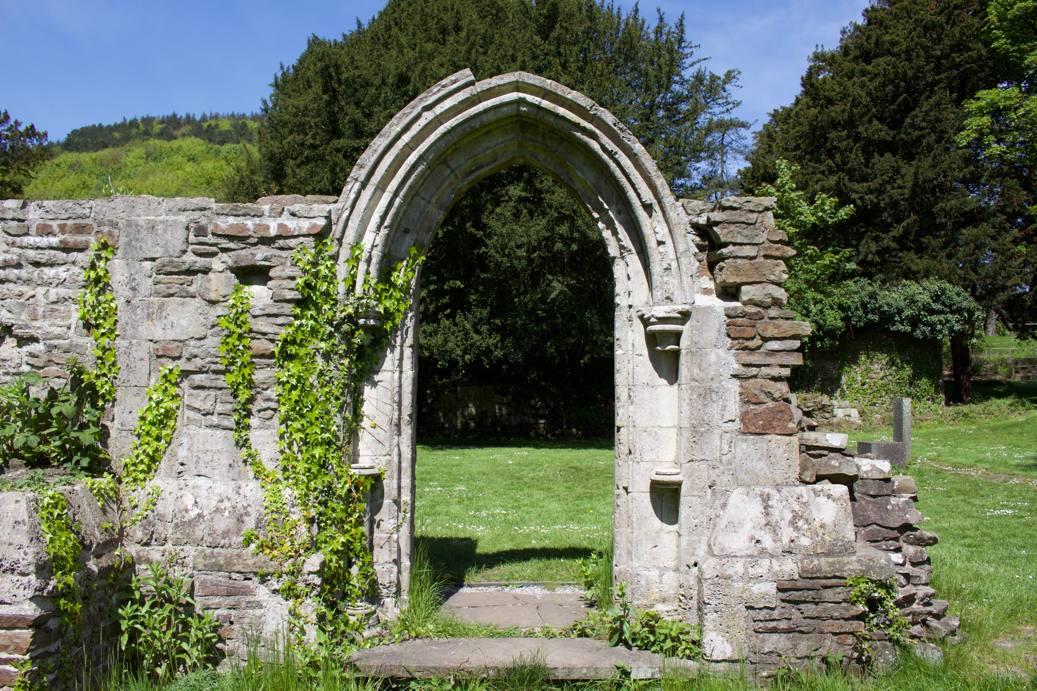
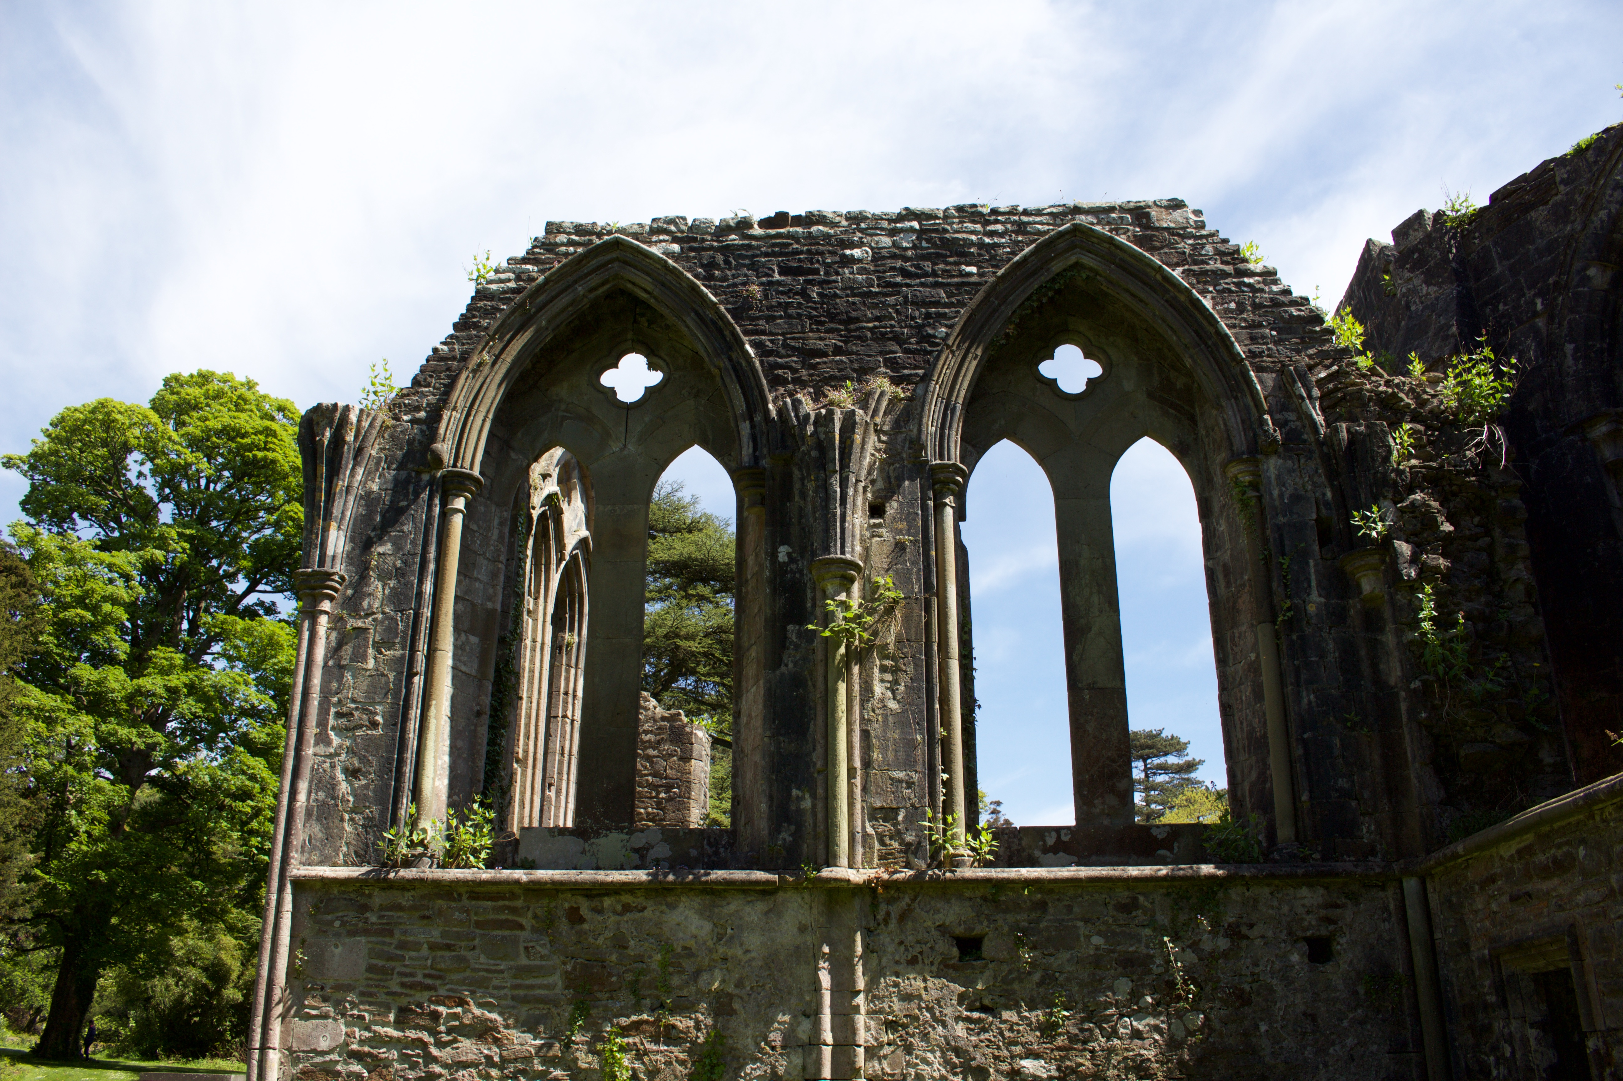
Anderson-Watkins, B (2018)

The next chapter in Welsh history is nonconformism, each Nonconformist congregation that gathered as a church was completely unique of any other congregation, and recognised no central law to define on rule on how it conducted itself, all decisions were made by the individual congregations. They were said not to be ‘not a sect, not even a society, but an attitude, a manner, a way, whatever you choose’, and the final word that they did choose was chapel. Each chapel carefully guarded its independence from all others, and quite what this tenacious independence meant when congregations began to build chapels will be seen in due course. At times of harshest persecution they returned to gatherings at night in inconspicuous dingles in the hills, woods, caves and remote barns. There is no contemporary documentary account by those nonconformist of quite what it was like to attend an illegal gathering in the days of persecution. The nonconformists became increasingly confident and their chapels began to have a central role in every Welsh community. In the coming nineteenth century this would be massively amplified and reflected in the kind of building they would begin to erect and build within communities. These chapels grew from domestic meetings in the ordinary houses, and the growth of the chapel from those humble beginnings into capacious temples. There was no central authority to direct their work or legislate their design, for the Nonconformists had no church commissioners to instruct them in the designing of their buildings. (Jones, 1990)

“When one examines the remarkable proclivity of the Welsh to religious revivalism, and at least somewhere in Wales experienced a spiritual awakening every year between the mid-18th century and 1905, the extent to which Welsh nonconformists had a generous worldview, that could at times be global in scope, becomes readily apparent.”

Jones, D (2015)

There are no surviving chapels from the 1600s other than Maesyronnen and even examples from the 1700s and 1800s are quite rare. Some chapels from the 1900s survived long enough to be captured by the camera, they show us how small and humble these meeting places were, while emphasising how reluctant the nonconformists were to abandon the traditions of their old chapels.

The methodist chapels were not independent churches, but overflow preaching houses of the Established church. The methodists did not call their buildings chapels, in case they would be seen as ‘small churches for worship’, and very rarely called them meeting houses as that word associated them with the separatist Nonconformists. The revivals were an intrinsic part of the development of chapels from the early 1800s, and news of outbreaks spread quickly, sometimes resulting in smaller copycat revivals in other parts of Wales. The pattern of Welsh revivalism began to emerge in the 1780s, and led to the most powerful and influential national revival in 1859. The effect of the revivals was to change the social structure by creating, in the chapel, a highly charged magnet, a force so powerful and overwhelming that it irresistibly drew in thousand of people to fill those chapels to overflowing, creating the need for more buildings. This revival affected an enormous number of people, mostly Nonconformists, but new converts also flocked to the Anglican Church. Over 100,000 persons were converted during this revival. It’s not difficult to imagine the effects of such national mass obsession with revival on the chapels. (Jones, 1990)

As I grew up I decide that religion and attening a Welsh chapel might not be for me, this was until I was deciding on what I could photograph for my final year project. As I was now looking at religion from an outside perspective I felt like I could give a more interesting look at religion.
I have done a lot of research based on welsh communities and small welsh chapels. I draw a lot of inspiration from these communties and feel like they inspire my work greatly, the importance of these chapels.

One photographer that I’m really interested in is Abbas. A magnum photographer basing his work mainly on religion his work greatly inspired my own. In the following article with ‘Vice’ they explains his work.

“Abbas loves to tell people that he was born a photographer. It's easier than having to explain that it was growing up as an Iranian immigrant during the Algerian war that actually got him into it. Throughout that conflict, he felt that he witnessed history in the making and it was that revelation that made him want to become a journalist.”

Le Baron, J (2015)

In an explosive burst of building, the nonconformist denominations in Wales erected over five thousand chapels in the nineteenth century. Their enthusiasm was so great and so contagious that they were opening new chapels at a rate of more than one a week. Distinguished buildings have been abandoned and demolished whilst some have been converted for purposes such as ballrooms, cinemas, houses etc. Some of these conversions have been successful in retaining the essential architectural character of the chapel, but most conversions have paid little respect to such qualities or the distinctive presence the chapel has brought to its environment. The excellent efforts of the volunteer group CAPEL founded in 1986 and the work of the Royal Commissions on Historic monuments in Wales CADW have allowed old chapel buildings to remain as part of our culture and our history. (Jones, 1990)

“THE future of chapels in Wales is simply a question of keeping the doors open until the last members die, an academic has claimed. The bleak analysis – heralding the end of one of the most significant social movements in Welsh history – is that of Dr Paul Chambers, whose study of nonconformist religion in Wales is due to appear shortly in the University of Wales series Contemporary Wales. Dr Chambers, of the University of Glamorgan, said: “From the high point of the 1904 revival and the 1914 Welsh Church Act, where as many as three-quarters of the Welsh population were regular church or chapel-goers, Wales is now experiencing the most rapid and deepest rate of religious decline in the UK. Nonconformity, the traditional focus for Welsh religious and national identity, has been most affected, both numerically and in terms of its influence on Welsh society and culture. Today, it is a shadow of its former self and its future is growing ever more uncertain, For the rest, it is merely a matter of keeping the doors open until the last members die.”

Shipton, M (2008)

By the beginning of the 20th century Wales had began its change from a predominantly christian country to embracing other cultures and religions, along with this came a change in the attendance to local churches and the importance of churches declined.

A campaign has been launched to save the historic frontage of one of the country’s most iconic chapels. Building work on Peniel Chapel in Tremadog, near Porthmadog, Gwynedd with its eye-catching and unusual columns, was finished in 1849 and influenced the design of other chapels built during the period. The village of Tremadog was the project of London entrepreneur William Madocks, who bought the marsh land in 1798 after envisioning it as a settlement on the trade route between London and Ireland. The Calvinistic Methodist chapel was built on sand and its “temple” front loosely based on Inigo Jones’ St Paul’s in Covent Garden, London. Forced to close in 2015 because of its dwindling congregation, Peniel was bought by Welsh Government charity Addoldai Cymru - the Welsh Religious Buildings Trust - set up to protect historically or architecturally-important chapels. It is now set to be given a new lease of life thanks to grants of £136,000 from the Department for Culture, Media and Sport to fix its roof. However, a further £15,000 is needed to repair its “pediment”, or triangular frontage which, with its pillars are currently impounded because of their “perilous” condition. Tanya Jenkins, of Addoldai Cymru, said: “People can’t see the roof but they can see the pediment. Our aim is that work on renovating the roof will start on February 25 and that it will be completed at the same time as the pediment.”

Bowen, L (2000)

By the end of world war 1 organised christianity was in decline. Chapel building in Wales ground to almost a complete halt in the decade leading up to the first world war, and after the war had stopped and what was left of the soldiers had come home, they had no desire to build new chapels.
The great revival of 1905 had put new life in to the Nonconformists and with new renowned energy they began to build new chapels in response to excited congregations. Revivals had always spurred chapel building, but the role of the chapel especially in the revival period went far beyond being a place of worship and became an integral part of the community. The great national revivals were knows for their encouragement of the building of bigger chapels. Slumbering though they may have been, even before 1905 the nonconformists had built more chapels in Wales than the whole of the rest of Britain. The scale of the chapel building in Wales can be measure by one example, in 1905 the county of Merioneth had two hundred and seventy three chapels and thirty four churches, which could in total seat 75,800 people. (Jones,1990)
“Plenty were built during the 18th century and reflect a time when the people of Llanelli - as would have been the case across Wales - observed the Sabbath and flocked through their doors to worship. It was a different world with our churches and chapels - paid for out of the wage packets of the steel, tin, dockers and mine workers’ wages, alongside donations from the landed gentry - the very pillars of society.”

Thomas, G (2017)

Not all chapel buildings can be saved, or indeed should be saved, but the best of them ought to be before the ravages of deferred maintenance, vandalism, the ministrations of the chapel breaking salvage companies, weather and sheer neglect render them unstable. Little has been done in any coordinated way to record the chapel, even if we recognise the inevitability of massive loss of architectural heritage, and only since about 1990 has there been a concerted effort to sensitive the nation to the immediacy of this potential loss. A sensitised and interested public who are convinced that the chapel buildings may still have a role to play in their community is a vital need, if not as religious buildings, then playing an alternative role. The conversion of Glenala chapel in Llanelli to a community performance space is a simple example. It welcomes now not congregations but audiences to the restored building that retains its strong identity in the street scape. Intelligent conversion of this kind can do wonders to preserve worthy buildings. (Jones, 1990)

The future for religion in Wales is looking very mixed, on one hand many people still feel like christianity is the core religion of Wales but as explained in the article below this isn’t so much the case,

“Are we losing our religion? The answer for the UK seems to be "Yes", while the answer for the developing world is a resounding “No". That was the conclusion of a recent analysis by the Pew Research Center in the US. It suggests that in the UK, if current trends continue, the proportion of the population identifying themselves as Christians will fall from 64% in 2010 to 45% by 2050, while the proportion of Muslims will rise from 5% to 11%. The proportion of the population claiming no religion in the UK - the "unaffiliated" - will also rise significantly, from 28% to 39%. Pew's research also suggests there are likely to be more Muslims than Christians in the world by 2070, with Islam's share of global population equalling that of Christianity at just above 30% each by 2050. Equally eye-catching is its conclusion that by 2050, under half of the population will be Christian not just in the UK, but also France, the Netherlands, Bosnia-Herzegovina, Australia and New Zealand, while Muslims will make up about 10% of Europe's population, up from 6% now, thanks to higher birth rates.

Wyatt, C (2015)

Looking at also education and the future of religion in our local schools I found the information below from an article conducted by the independent very interesting and appropriate to my essay, it reads as follows,

Wales is poised to scrap Religious Education lessons in its schools, it has been revealed. Instead, the Welsh Government’s Minister for Education and Skills Huw Lewis, argued it should be renamed to focus on the teaching of “religion, philosophy and ethics”. Mr Lewis told Senedd, the Welsh Parliament, that he wanted to see a transformation of the current religious education curriculum to help combat extremism. “My contention would be that we rename the RE curriculum and transform it into the religion, philosophy and ethics element of the curriculum - where there is an explicit commitment to allowing children to ponder ideas around ethics and citizenship and what it means ti be a citizen of a free country,” he added. It follows a Government commissioned review of the curriculum in Welsh schools by Professor Graham Donaldson, a former chief inspector of schools in the principality, who urged that pupils in Welsh schools should be “ethical, informed citizens of the world”. It also comes after a major report on the English education system - compiled jointly by former Education Secretary Charles Clarke and religious education experts Professor Linda Woodhead from Lancaster University - urged a radical overhaul of religious education in English schools. The Welsh move has been welcomed by Accord, the campaigning group which aims to end religious discrimination in schools. Rabbi Dr Jonathan Romain, its chairman, said: “This is a welcome development. Challenging young minds to explore ethical options is an important educational role. The report recommended that religious instruction should be banned from schools and become the preserve of Sunday schools, madrassas and the home - and that legislation compelling schools to hold a daily act of “predominantly Christian” worship should be scrapped. Instead, the duo argue that the emphasis should shift away from merely religious education with pupils being taught religious and moral education as well. The move in Wales emerges from a desire to combat extremism and radicalisation in schools with Mr Lewis arguing that they must “rise to the challenge of community cohesion” through reforming religious education. The Welsh move has been welcomed by Accord, the campaigning group which aims to end religious discrimination in schools. Rabbi Dr Jonathan Romain, its chairman, said: “This is a welcome development. Challenging young minds to explore ethical options is an important educational role. “The Minister should not stop there, though, but ensure that all state schools pursue a broad RE syllabus and that faith schools in particular should ensure their pupils are informed about a broad range of religions and beliefs in society at large, not just their own one.”

Garner, R (2015)

Within my research for this particular essay I thought that it would be interesting to conduct a short questionnaire, I asked 4 simple questions to 15 people between 14 - 75. Below are the results of that essay:

1. Do you feel that religion is important to Welsh people?

2. Have you ever attended a church service?

3. Do you think that chapels are for the older generation?

4. In your opinion will all welsh chapels be taken down within the next 10 years?

Through my research I also conducted a small questionnaire to be answered by a chapel minister. My grandad is a minster in a local chapel and has been in the job for around 40 years, with the questions below I feel like his knowledge gave me a good insight in to the opinion of someone who has seen the change.

- In which year did you start being a minister and why?

I became a minister in 1966 because I felt like god called upon me to carry out his work.

2. Why do you think that less young people are going to chapel now than ever before?

I think that there are less people going to chapels because it is no longer fashionable. Less adults are also going less because other hobbies such as sports are more important to them.

3. Have you seen a change in the number of people attending chapel during your time working as a minsiter?

Yes, i’ve seen a significant decline in the last few years especially, but in the communities that i’ve served i’ve tried my best to bring those numbers up through setting up clubs and activities for the next generation.

4. In your opinion will all welsh chapels be taken down within the next 10 years?

I think some but not all will be taken down because some will protest as they still like to attend their local churche

597 AD.
Christianity arrived in Britain along with the Romans.
1135.
After death of Henry I in England, Wales entered a period of disorder.
1649.
John Miles, founder of first baptist congregation in Ilston, Gower.
1700’s.
Methodist Revival led in Wales by Howel Harris and Daniel Howard.
1904.
Evan Roberts begins a revival in Loughor, Swansea.
2000’s.
Half a million welsh people admit that they have no religion whatsoever.
‘Other religions’ came up at 7,000 members in 2001 census.

1689.
Toleration act allows religious freedom in Wales.

1884.
Reform Act passed meant that men now had the vote.
The Nonconformists were now in a brilliant position to start using their political muscle.

1063. Gruffudd Ap Llewelyn dies.

1485.
Battle of Bosworth effectively marks tend of the dynastic conflict in England. Following this victory, Pembrokeshire born Henry Tudor became King Henry VII.

When asking the question ‘How is faith, religion and spirituality represented in small communities’ I wasn’t quite sure what I would find, I had a general overview of the subject but this essay gave me new information I had not previously found. To conclude the essay I feel like religion has been on the decline in a big way over the last decade. Some of the older generation still see religion and attending religious services as a major part of their routine but I fear that as the older generation passes on the tradition of attending church will not carry on. My essay has hit upon many points and themes throughout e.g the beginnings of christianity, non conformism, the welsh revival and the future of christianity. The positive things that came from this essay in my opinion was the knowledge and information that I had gathered from my research. In particular I found my questionnaire to be very informative when asking the next generation how they feel about religion, this was an insight that I found worked extremely well in my essay. Throughout the year and in particular the last few months I have taken a lot of inspiration from my research to inspire my photographic practise, but on the other hand I have also used my photographic practice and the places that I have been and the people that I have spoken to to inspire my academic writing. I feel like the two have worked hand in hand to allow me to explore a really interesting subject matter and to engage with the subject well. I feel like religion has been on the decline in a big way over the last decade or so, some of the older generation still see religion and attending religious services as a major part of their routine but I fear that as the older generation passes on the tradition of attending church will not carry on and members will fade as young people don't attend. During the past year I have taken all of the research i’ve found and tried to convey this information plus my own views and feelings through my own work. I hope that my exhibition peace plus my portfolio and my written work conveys a strong and clear message with regards to my chosen subject choice.n a time where religion really is on the decline I felt that it was important for me to talk about something that is not only close to my heart but a subject that really does need to be spoken about. Through organisations like ‘CADW’ and the tremendous efforts taken by communities to preserve and repair chapels and churches I hope that we don’t see a complete wipe out of churches in the next 10 years. Next in my own photographic practise I hope to carry on using my photography to create some sort of awareness for this cause and I feel through using archive footage, film and talking to local communities I can play at least a small role in keeping these integral parts of the community alive.

References

Jones, D (2015) Welsh History Month: Wales, religious revival and the world. Available from: https://www.walesonline.co.uk/lifestyle/nostalgia/welsh-history-month-wales-religious-10248368 (Accessed: June 2018)

Jacob, L (2009) Welsh Church uncovers stunning wall paintings. Available from: https://www.bbc.co.uk/news/av/magazine-25214557/welsh-church-uncovers-stunning-medieval-wall-paintings (Accessed: July 2018)

Thomas, G (2017) Church and chapel congregations are slowly deserting their places of worship in this Welsh town. Available at: https://www.walesonline.co.uk/news/wales-news/church-chapel-congregations-slowly-deserting-13722397 (Accessed: July 2018)

Garner, R (2015) Wales Poised to Scrap Religious Education lessons in schools. Available at: https://www.independent.co.uk/news/education/education-news/wales-poised-to-scrap-teaching-of-religious-education-in-schools-10435880.html (Accessed: July 2018)

Le Baron, J (2015) The Name of God. Available at: https://www.vice.com/en_uk/article/4wbvnj/interview-photographer-abbas-magnum-876 (Accessed: January 2018)

Wyatt, C (2015) Is the UK still a Christian Country?. Available at: https://www.bbc.co.uk/news/uk-32722155 (Accessed: July 2018)

Shipton, M (2008) Future Bleak for Welsh Chapels. Available at: https://www.walesonline.co.uk/news/wales-news/future-bleak-welsh-chapels-says-2159868 (Accessed: February 2018)

Benjamin Anderson-Watkins, 2018. Margam Abbey. [JPEG]

Ross, A. 2005. Pagan Celtic Britain: Studies in Iconography and Tradition. 1st ed. Chicago: Chicago Review Press.

Jones, A. 1990. Welsh Chapels. 1st ed. Stroud: Alan Sutton Publishing

Bowen, L (2000) The Battle of Britain: History and Reformation in Early Modern Wales. Available at: https://orca.cf.ac.uk/65753/7/Bowen%20Battle%20of%20Britain%20DRAFT%2021.pdf. (Accessed July 2018)

Jones, D. 2005. The Chapels of Wales. 1st ed. Cilfowyr: Marian Delyth.

