
Applied Leadership and Management in the Workplace
Module Assignment Submission
Student Name: | Whitney Davies
Student Number: | 2329046
Module No: | BMSK4011
Module Title: | Continuous Professional Development
Statement of Confirmation of Authenticity
By the act of making this submission, the student declares that this is the work of the student named above. The work has not, in whole or in part, been knowingly presented elsewhere for assessment, or where assessment has been built on a previous assessment, this has been identified. Where materials have been used from other sources it has been properly acknowledged. If this statement is untrue, the student acknowledges that an assessment offence has been committed.
Attention is drawn to the plagiarism and unfair practice policies of both the University and of ILM.

Table of Contents
Introduction 3
Section 1: Know how to identify development needs 4
Identify learning styles for self and another 4
Use a simple technique for identifying development needs for self & another 4
Whitney 5
Person 2 - Colleague 5
Gap Analysis - Person 1 (Whitney) 6
Gap Analysis - Person 2 (Colleague) 7
Identify potential barriers to learning for self and another. 7
Section 2: Know how to develop self & others to achieve organisational objectives 2
Person 1 - Whitney 2
Personal Objectives 3
Person 2 - Colleague 3
Personal Objectives 3
Method used to monitor the development of self & another. 3
Career planning process 4
Reflective model what have we learnt about everything 5
Kolb (Kolb 1984) – Experience, Reflection, Theorising, Planning. 6
References 7
Appendix A – Curriculum Vitae 8
Appendix B – Continuous Professional Development Plan 11

Introduction
This report will focus on Continuous Professional Development (CPD). This report will look at key tools and strategies to support CPD, including learning styles to make learning more effective for everyone, addressing barriers both external and internal. It covers how important it is setting achievable goals with SMART techniques, using SWOT and Gap Analysis to identify areas for improvement, putting these into a Personal Development Plan and using reflective models to learn from past experiences.

Section 1: Know how to identify development needs
This section of the report will be focusing on learning styles, according to (Education Endowment Foundation, 2021) is that everyone has their own way of learning. The theory is that people learn better if they’re taught in a way that matches their style. For example, someone with a "listening" style might get more out of storytelling and discussions than doing written exercises.
There are many different learning styles, however, based on the presentation by (Wilfrid Laurier University, 2008) there are 4 predominant learning styles:
- Visual
- Auditory
- Read/Write
- Kinaesthetic

Identify learning styles for self and another
I have researched and identified 3 learning styles for myself, and I’ve also tried to recognise these for a colleague. Using the (VARK, 2024) questionnaire for myself, I found that I am Multimodal (VK), my scores are Visual 13, Aural 1, Read/Write 0, Kinaesthetic 15.
Whitney | Colleague
Learning Styles
Visual – learning by watching demonstrations and videos | Interpersonal – learns better in groups
Kinaesthetic – learning by doing and practice | Reading and Writing – learn by reading the instructions, writing down and following the process
Intrapersonal – learns better alone
From years of work experience, college education and university I have learned that I am a visual, kinaesthetic and sometimes a solitary learner. The way that I found works for me is, I can watch an example of something being done and then I like to attempt the task myself, whilst I do prefer to try and learn alone, I am happy to work as a team as well. I know teamwork can be a great factor in completing tasks and solving problems.
My colleague is quite the opposite, he learns better in a team, and he prefers to learn from reading and writing. Following written instructions are the best method for him, once he has read the instructions, he will then write down the process of the task and this will help him complete the task his way.

Use a simple technique for identifying development needs for self & another
To identify the development needs of myself and my colleagues, I have used a SWOT analysis below.
The SWOT analysis has been historically credited to Albert Humphry, however, according to (Teoli, An and Sanvictores, 2023) the fact it’s been credited to Albert Humphry remains debatable as there is no universally accepted creator.
The SWOT analysis is a great tool for self-management, it makes everyone really look at themselves to identify their strengths and weaknesses and the threats and opportunities that relate to them.

Whitney
SWOT
STRENGTHS  - Communication  - I.T Skills  - Organisational Skills | WEAKNESSES  - Presentation Skills  - People pleaser  - No leadership skills
OPPORTUNITIES  - Take on presentations at work to build my confidence with presenting  - Feel more comfortable saying no and setting boundaries at work.  - Take a leadership course | THREATS  - Others have better presentation skills, and this can be a crucial part for work  - Someone could use the fact I try to people please against me or cause trouble at work.

Person 2 - Colleague
SWOT
STRENGTHS  - Good presentation skills  - Excellent problem-solving skills  - Good Mathematical skills | WEAKNESSES  - Poor time management  - Literature skills
OPPORTUNITIES  - Take a course to help improve the literature skills  - Online course for time management, practice different methods to find what works | THREATS  - Poor time management can cause issues for work as it can cause delays and upset client  - Poor literature skills can also cause upset clients as if the deliverables aren’t proofread then the work won’t be a high standard, and this can be unacceptable

Gap Analysis - Person 1 (Whitney)
Another tool for identifying your development needs is a Gap Analysis. Gap Analysis gives a better look into an individual’s strengths and weaknesses, allowing them to create targets on how to bridge that gap.
Current Position | Goal | Gap analysis
Poor presentation skills -  - Struggles with confidence when speaking in front of an audience  - Presentation delivery lacks clarity and engagement | Good presentation skills -  - Confidently delivering presentations with a clear and engaging communication style  - Strong audience engagement and handling of questions effectively | - Attend public speaking workshops or online courses  - Schedule regular practice sessions, including mock presentations with feedback  - Study techniques for structuring content and keeping an audience engaged  - Seek constructive feedback from peers
People pleaser –  - Struggles to say no to requests, often taking on too much  - Prioritises other people’s needs at my own expense of personal well-being or goals  - Seeks validation or approval from others, leading to stress  - Difficulty asserting personal boundaries | - Confidently set boundaries and says no when necessary  - Makes decisions based on values and goals rather than external approval  - Feels comfortable expressing personal opinions and standing firm in choices | - Attend workshops or read books on assertiveness and setting boundaries  - Use reflective tools to identify patterns of people-pleasing and its impact on well-being  - Start small by saying no to less important requests and gradually build confidence  - Regularly review personal goals and use them as a guide when making decisions.
Strengthen Leadership Abilities –  - Limited experience in leading diverse teams or handling conflicts  - Struggles with delegation, often taking on too many tasks personally | Gain leadership skills  - Strong ability to lead, inspire, and build trust with team members  - Effective delegation skills to empower others and focus on strategic priorities  - Proactively manages conflicts and fosters a collaborative team environment | - Attend leadership development programs or workshops  - Improve communication by seeking feedback on leadership style and conducting regular one-on-one meetings with team members  - Use reflective models to evaluate leadership decisions and improve over time

Gap Analysis - Person 2 (Colleague)
Current Position | Goal | Gap analysis
Poor time management –  - Completes tasks at the last minute  - Struggles to prioritise tasks effectively, leading to procrastination or wasted time  - Overcommits to activities, resulting in feeling overwhelmed or stressed | - Consistently meets deadlines with well organised and prioritised tasks.  - Effectively allocate time to high-priority activities and minimise procrastination  - Proactively uses time management tools and strategies to maximise productivity | - Use calendars to allocate specific time slots for tasks, ensuring focused and uninterrupted work periods  - Practice saying no or delegating tasks to avoid overcommitting  - End each day with a few minutes to review and assess progress and plan for the next day
Literature skills  - Struggles with writing clear, structured reports and essays | - Write effective, powerful, clear and accurate reports and essays | - Practice writing essays using a structured approach, such as the PEEL method (Point, Evidence, Explanation, Link), and seek feedback from peers or mentors

Identify potential barriers to learning for self and another.
Barriers to learning are different for everyone, a few examples of these are bullet pointed below.

- External
  - Family
  - Logistics
  - Other source dependants
  - Money
  - Work
  - Private life
- Internal
  - Skill levels
  - Levels of knowledge
  - Perceived abilities
  - Behavioural
  - Attitudinal

My barrier | Solution |  | Colleague barrier | Solution
Work | Find courses that are outside work hours, or a job with flexi hours |  | Family | Using his GO MAD network to help with childcare when it’s available
Money | Apply for jobs with higher salary. Save more. Use Student Finance Wales |  | Literature Skills | Finding the right course to help with the literature skills
Behaviour – being shy | Online courses in difficult conversations, how to deal with criticism etc. |  | Work | Find courses that are outside work hours, or a job with flexi hours
Some barriers can be overcome with support from an individual’s Go MAD network. My network is my parents, my grandparents and my partner. I am very fortunate to know that I can lean on them for support regardless of the issue.
My colleague will have a different network, but he shared with me that he also has his parents, his wife and siblings.

Section 2: Know how to develop self & others to achieve organisational objectives
A Personal Development Plan (PDP) is a great tool to use to monitor progress. Using a SMART technique, CFI Team (2022) offer a bit more detail of what SMART stands for, these are bulleted below.
- Specific: Clear, and straightforward, not vague
- Measurable: The specific criteria you will use to measure if you have achieved your goal
- Achievable: Attainable and possible to achieve
- Realistic: Within reach, realistic, and relevant to your life purpose
- Timely: With a clearly defined timeline, including a starting date and a target date.
The benefit of using a PDP is that it is easy to use and easy to follow. According to Richards (2023), A Personal Development Plan (PDP) created specifically for you and your career can be a powerful tool in your professional growth and help you achieve long-term success. By setting clear career goals, focusing on improving your skills, and actively seeking feedback from colleagues, you can create a plan that guides your development. This plan not only helps you stay on track but also ensures you’re continuously progressing in your career, allowing you to reach your full potential and achieve the professional milestones you’ve set for yourself. While this is accurate, Martinelli (2023), offers a fresh perspective that isn’t purely focused on the professional side. A PDP offers more than just professional benefits, it can also greatly support your mental well-being and increase your overall satisfaction. By giving you a clear sense of direction and purpose, a PDP helps you feel more focused and motivated. As you work towards achieving your goals and fulfilling your potential, you can experience a real sense of accomplishment. These positive feelings can have a meaningful impact on your mental health, boosting your confidence and helping you maintain a healthier, more balanced mindset.

Person 1 - Whitney
What is my end goal? | What do I have to do to achieve it? | What support and resources will I need? | How will I measure success? | Target Date for Review
Be comfortable to give presentations | Give presentations, more frequently, reflect and gain feedback | My network, work for information to present | Give 30 presentations throughout the year | 25/11/2025
Become a leader/mentor in work | Continue to learn and gain experience and share this | My workload and knowledge and my colleagues at work | Be given the position to train the 1 or 2 newcomers | 03/07/2025
Graduate from University | Pass my modules | Money, family, tutor, the relevant books, laptop or computer. | Attending the graduation ceremony and graduating | 01/03/2025

Personal Objectives
Short Term Goals (next 12 months)
Further Your Education: Enrol in and complete a university course and graduate
Medium Term Goals (2-3 years)
Expand Professional Network: Actively participate in industry events, conferences, and networking groups to build relationships with key people in my field and expand career opportunities.
Long Term Goals (3-5 years)
Achieve Career Advancement: Aim for a promotion or new role that aligns with my long-term career aspirations, whether through gaining new skills, leadership experience, or increasing responsibility.

Person 2 - Colleague

Personal Objectives
Short Term Goals (next 12 months)
Read More Books: Set a goal to read a certain number of books, focusing on personal development, industry knowledge, or fiction
Medium Term Goals (2-3 years)
Enhance Leadership Skills: Take on more leadership roles in projects or volunteer opportunities to develop skills such as decision-making, team management, and conflict resolution.
Long Term Goals (3-5 years)
Travel and Explore New Cultures: Plan and embark on international trips to experience different cultures and gain new perspectives.

Method used to monitor the development of self & another.
There are many methods you can use to monitor your development and another for example, The Johari Window (Luft and Ingham, 1955), it’s a 2x2 matrix where you assess yourself honestly and gain feedback from others to fill in the below. Communication Theory (2014) explain each section:
- Arena – is the section known by the person as well as by others. Gaining feedback from others can increase the arena and decrease the blind spot. The size of the Arena can also be increased downwards and reducing the ‘Façade.’
- Blindspot – Information about yourself that others are aware of, but you are unaware of it. Others may interpret you differently than expected. As mentioned in point 1, the blind spot can be reduced by seeking feedback from others.
- Façade – Information that is known to you but will be kept from others. This can be any personal information that you are reluctant to disclose. This includes feelings, past experiences, fears, and secrets.
- Unknown area – The information which are unaware to yourselves as well as others. This includes information, feelings, capabilities, talents etc. Open communication is also an effective way to reduce the Unknown area.

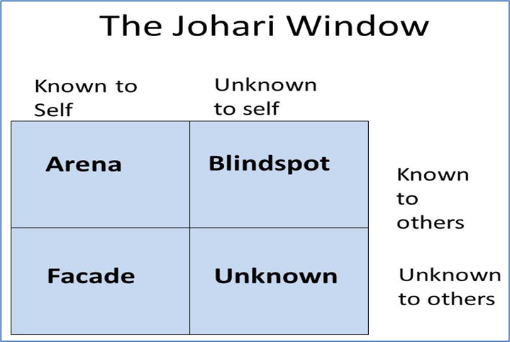
After learning about the above matrix, I tried it on myself. I’ve given an example below. Although as I’ve been open and honest about my Façade section, this could go into my Arena section.
Known to Self | Unknown to Self
- I am shy  - I talk too fast  - I struggle with eye contact | - I ramble and fidget when nervous |  | Known to Others
- I have Endometriosis, as this is personal, I usually keep it to myself.  - I have bad social anxiety, but I try to hide this and try to not let it influence my life. | Currently Unknown |  | Unknown to Others

Career planning process
I think that the most effective career planning process to me would be using a Grid Analysis. Using the factors and the weight they have for more would be the best way for me to determine which job option would be the best fit for me. Following the guide created by differentlyWired (2019),
Factors | Travel | Remote | Salary | Progression | Total
Weight | 4 | 1 | 2 | 3
Administrative Assistant for Local Council | 2  (2x4 =8) | 0  (1x0=0) | 3  (2x3=6) | 2  (2x3=6) | 20
Current position | 3  (3x4=12) | 3  (3x1=3) | 1  (1x2=2) | 2  (2x3=6) | 23
Administrative Assistant for UNISON | 2  (2x4=8) | 3  (3x1=3) | 0  (0x2=0) | 1  (1x3=3) | 14
Using the above Grid Analysis to look at career options, I can see that my currently position is currently the best option for me, but job number 1 is a close 2nd.

Reflective model what have we learnt about everything
A good way to keep track of your learning and experience to reflect is by keeping a Learning Log or a CPD Record. Using the information from (The CPD Standards Office, 2023), I created my CPD record (Appendix B).
Reid (1993) noted that reflection is an active, rather than passive, process. Reflection is a process of examining an experience of practice in order to describe, analyse, evaluate.
I think the reflective model that works best for me is Kolb’s Learning Cycle. As the image shows below it focuses on the Concrete/Experience, Reflective/Observation, Theorising and development concepts/ideas and then Testing the new concepts.
For example, reflecting on my first job interview.
Concrete | Had a job interview some things went well, some didn’t.
Reflect | I was nervous, but I shook their hands, I was actively listening and responding to their questions, but I didn’t ask questions
Concept Idea | I should do some more research on the companies I have interviews for and then create some questions about the information I gather.
Testing the new concepts | For my next interview, I tried to come across less shy and I had questions prepared in advance. I was successful, started the job earlier this year.

Kolb (Kolb 1984) – Experience, Reflection, Theorising, Planning.
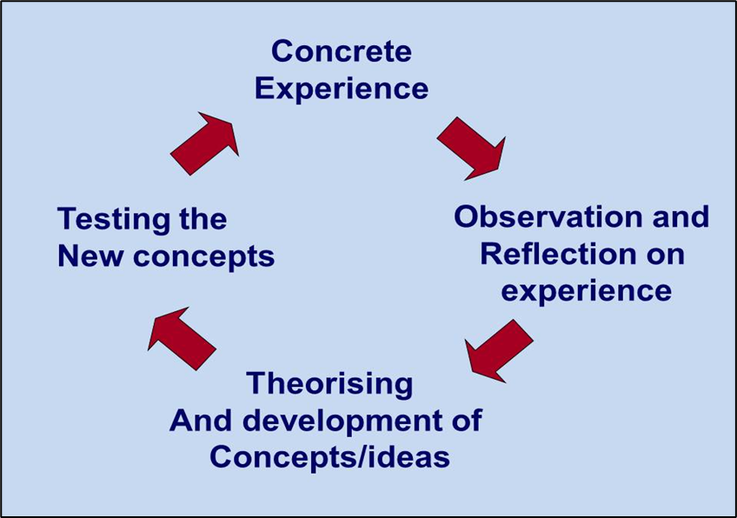

References
CFI Team (2022). SMART Goals. [online] Corporate Finance Institute. Available at: https://corporatefinanceinstitute.com/resources/management/smart-goal/ [Accessed 24 Nov. 2024].
The CPD Standards Office. (2023). Institute of Leadership and Management (ILM) | The CPD Standards Office. [online] Available at: https://www.cpdstandards.com/sectors/institute-of-leadership-and-management-ilm/ [Accessed 24 Nov. 2024].
differentlyWired (2019). Tools for Decision Making. [online] Differently Wired. Available at: https://differentlywired.co.uk/tools-for-decision-making [Accessed 24 Nov. 2024].
Education Endowment Foundation (2021). Learning Styles. [online] EEF. Available at: https://educationendowmentfoundation.org.uk/education-evidence/teaching-learning-toolkit/learning-styles [Accessed 18 Nov. 2024].
Kolb (Kolb 1984) – Experience, Reflection, Theorising, Planning.
Martinelli, K. (2023). A Personal Development Plan (PDP) Guide &... [online] The Hub | High Speed Training. Available at: https://www.highspeedtraining.co.uk/hub/personal-development-plan-template/ [Accessed 24 Nov. 2024].
Reid, B. (1993) ‘But we’re doing it already’ Exploring a response the concept of reflective practice in order to improve its facilitation.’ Nurse Education Today 13: 305-309.
Richards, L. (2023). What Is a Personal Development Plan? [online] www.intelligentpeople.co.uk. Available at: https://www.intelligentpeople.co.uk/candidate-advice/personal-development-plan/ [Accessed 24 Nov. 2024].
Teoli, D., An, J. and Sanvictores, T. (2023). SWOT analysis. [online] National Library of Medicine. Available at: https://www.ncbi.nlm.nih.gov/books/NBK537302/ [Accessed 19 Nov. 2024].
VARK (2024). VARK Questionnaire. [online] VARK - A Guide to Learning Preferences. Available at: https://vark-learn.com/the-vark-questionnaire/ [Accessed 23 Nov. 2024].
Wilfrid Laurier University (2008). Understanding Your Learning Style. [online] Wilfrid Laurier University. Available at: https://web.wlu.ca/learning_resources/pdfs/Learning_Styles.pdf [Accessed 10 Nov. 2024].

Appendix A – Curriculum Vitae

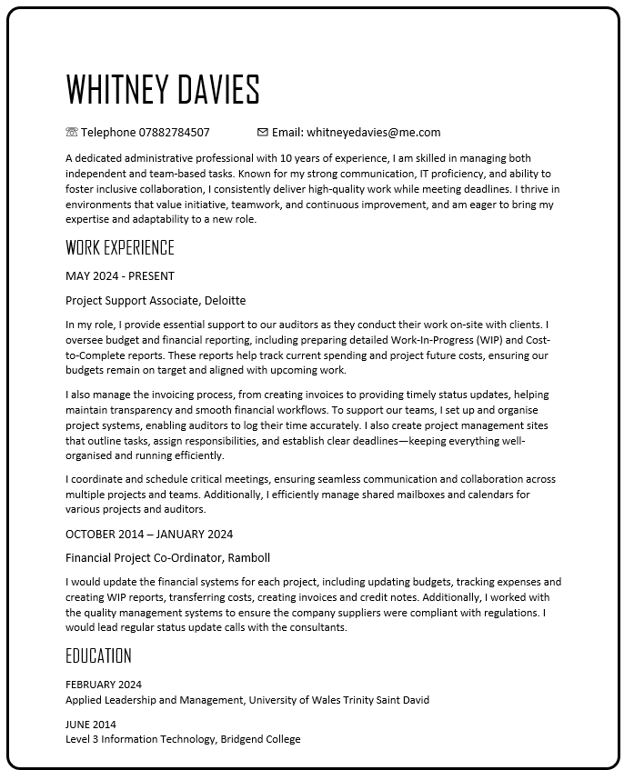
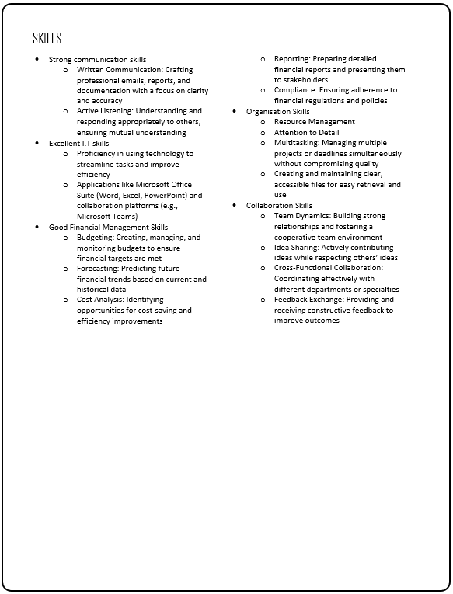

Appendix B – Continuous Professional Development Plan

