Robert Constantin Dan | 2507758
Computer Architecture and Operating Systems | ACCA4022
Md Shantanu Islam
Operating Systems Assignment
University of Wales Trinity Saint David
27th March 2026

Contents
Introduction 3
Key functions of general Operating Systems 3
Task Management: 3
Application/Program Management: 4
File/Directory Management: 5
Device Management: 6
Security Management: 7
Use of Windows OS CLI commands 8
Example 1: 8
Example 2: 9
Example 3: 10
Example 4: 10
Example 5: 11
Example 6: 12
Example 7: 12
Example 8: 13
Example 9: 13
Example 10: 14
Use of Linux OS CLI commands 15
Example 1: 15
Example 2: 15
Example 3: 16
Example 4: 17
Example 5: 17
Example 6: 18
Example 7: 19
Example 8: 19
Example 9: 20
Example 10: 21
Use of Windows OS scripts 21
Example 1: 21
Example 2: 22
Use of Linux OS scripts 24
Example 1: 24
Example 2: 26
Conclusion 28
Appendices 28
References 30

Introduction
This report explores the key functions of modern operating systems and demonstrates how these concepts are applied in practice using both Windows and Linux platforms. It first explains core responsibilities such as task, application, file, device, and security management in Windows, supported by screenshots and real system examples. The report then uses a range of Windows and Linux command-line interface (CLI) commands and simple scripts to show how users and administrators can manage files, processes, and system configuration efficiently from the terminal. Overall, the coursework links theoretical operating system concepts with practical command usage to develop my understanding and technical skills.

Key functions of general Operating Systems
The Windows operating system, created by Microsoft, is one of the most important platforms in personal computing. Launched in 1985, it introduced a graphical interface that lets users interact with computers using icons, menus, and visual elements instead of typing commands, making computers easier and more accessible for everyday users.[1]

Task Management:
The Windows Task Manager helps users check how their computer is running. It shows the overall system performance and the performance of each program that is open. It also displays the users currently logged in and the services running on the computer. An administrator can control and manage these.[2][3]
On the figure 1 bellow it shows the Windows Task Manager open on the Processes tab. It displays the programs and background processes currently running on the computer.
At the top, you can see overall system usage: CPU: 10% Memory: 42% Disk: 1% Network: 0%.
Under Apps (3), three main programs are open: Google Chrome (with multiple tabs or processes running), Microsoft Word, Task Manager.
Below that, there are many Background processes (73) running, such as system services, antivirus services, and driver-related programs.

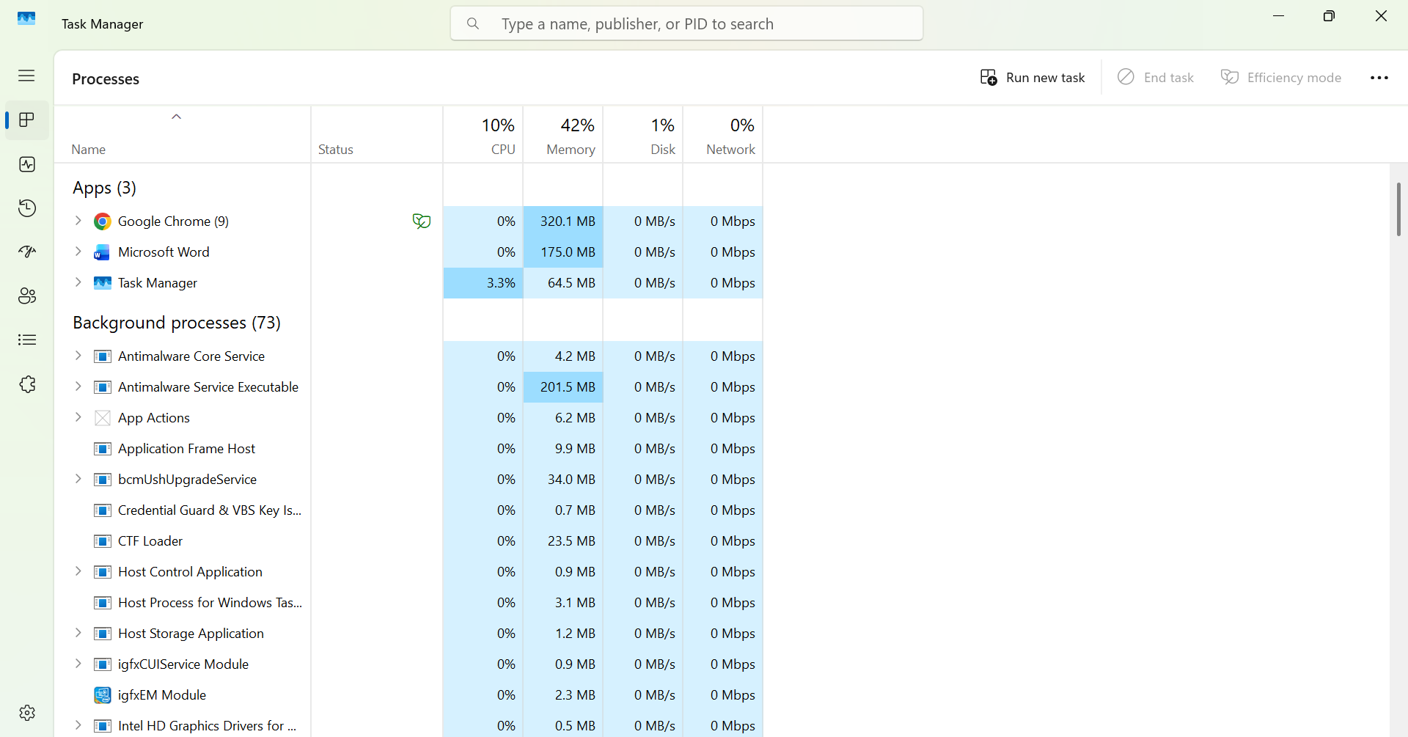
Figure 1: Windows Task Manager

Application/Program Management:
In Windows, application management is how the system controls programs from installation to removal. It manages their use of memory and processor power so multiple applications can run smoothly at the same time without affecting each other.[4]
On the figure 2 bellow it shows the Settings window open to Apps > Installed apps. This page displays a list of applications currently installed on the computer.
At the top, there is a search bar to find specific apps. The screen shows that 48 apps are installed on my pc.

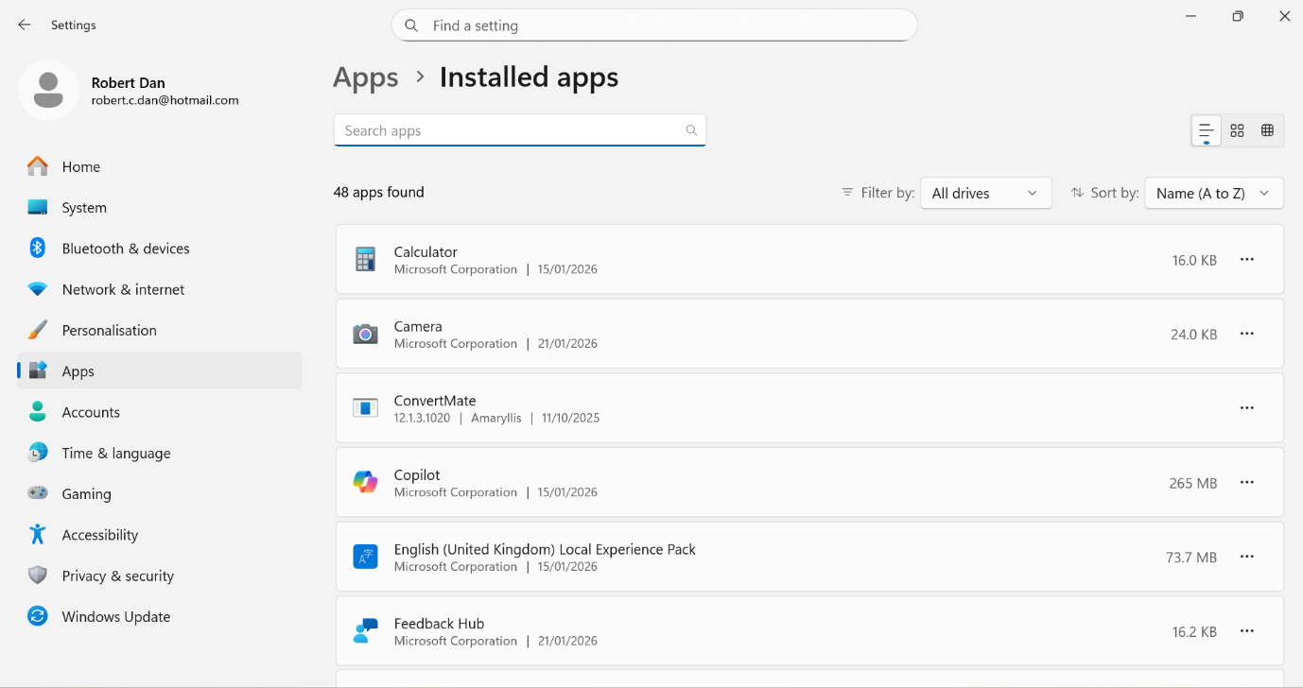
Figure 2: Application Management

File/Directory Management:
File and directory management in Windows is how the system stores and organizes data on storage devices. It uses a hierarchical structure where files are kept inside folders and subfolders, forming a tree-like layout that makes information easy to find and manage.
Windows manages file names, locations, dates, and access permissions to protect data and keep it secure. It allows users to create, open, edit, move, rename, and delete files while tracking changes and efficiently using storage space.
The file system is an essential part of the operating system because it organizes storage and ensures data remains available and consistent, even after the computer is restarted.[5]
Figure 3 shows File Explorer open to This PC in Windows. Under Devices and drives, there is one local drive (C:), with 404 GB free out of 475 GB, meaning most of the storage is still available.
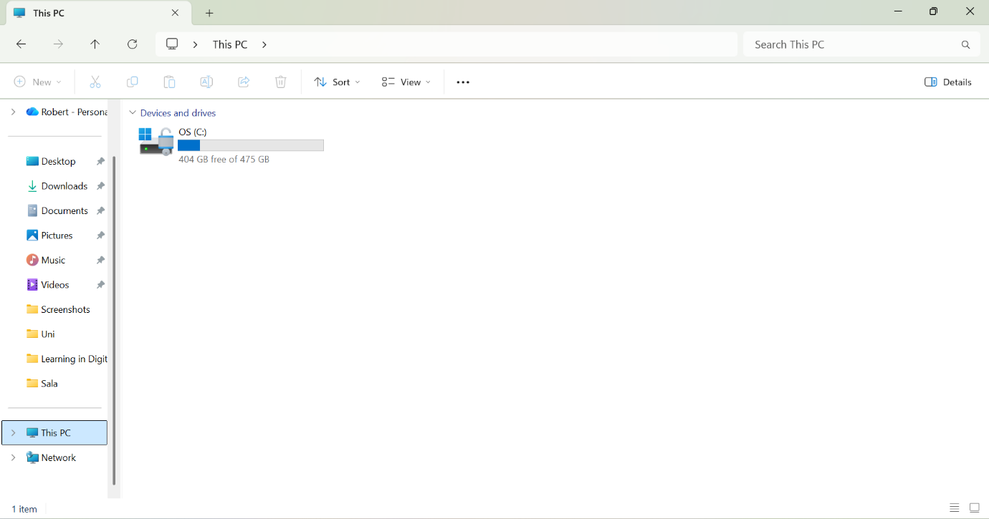
Figure 3: Directory File

Device Management:
Device management in Windows is how the operating system controls hardware connected to a computer. It uses device drivers, which are special programs that help the system communicate with devices like keyboards, printers, storage drives, and network adapters. This allows applications to use hardware without needing to understand technical details, improving compatibility and stability.
Windows also includes Device Manager, a tool that shows all installed hardware and allows users to install, update, disable, or remove drivers. Managing input and output devices is a key function of any operating system because it ensures smooth communication between software and hardware and handles device errors efficiently.[6]

The figure 4 shows the Device Manager window with a list of hardware categories on the left, such as Audio inputs and outputs, Cameras, Disk drives, Keyboards, and Processors. In the centre, the Integrated Webcam Properties dialog is open under the Cameras category.

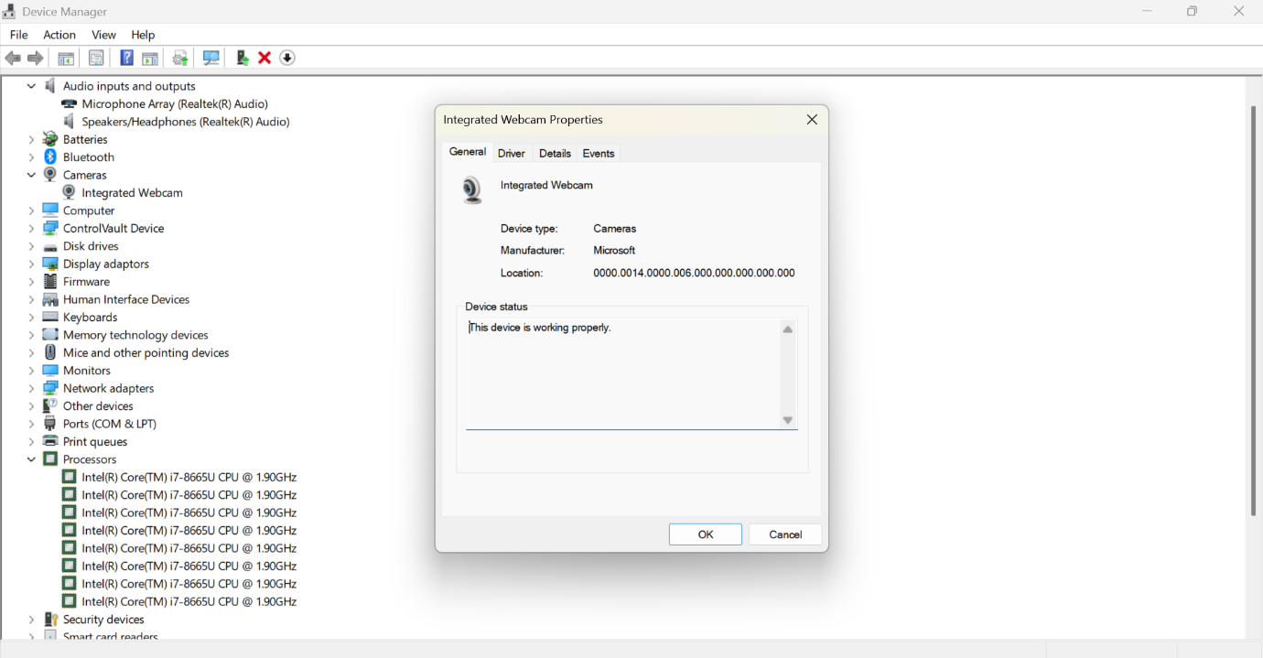
Figure 4: Windows Device Manager – Integrated Webcam Properties

Security Management:
Windows security management is how the system protects files and resources from unauthorized use. It does this with access controls, user authentication, and security policies. Traditional discretionary access control (DAC) can be weak if an attacker gains higher permissions. Using mandatory access control (MAC), where permissions are centrally set and strictly enforced, can better block unauthorized access even if DAC is bypassed.[7]
The figure 5 shows the Windows Security “Security at a glance” dashboard. It lists key protection areas such as Virus & threat protection, Account protection, Firewall & network protection, App & browser control, Device security, Device performance & health, and Family options, each indicating that no action is currently needed except for a quick virus scan.
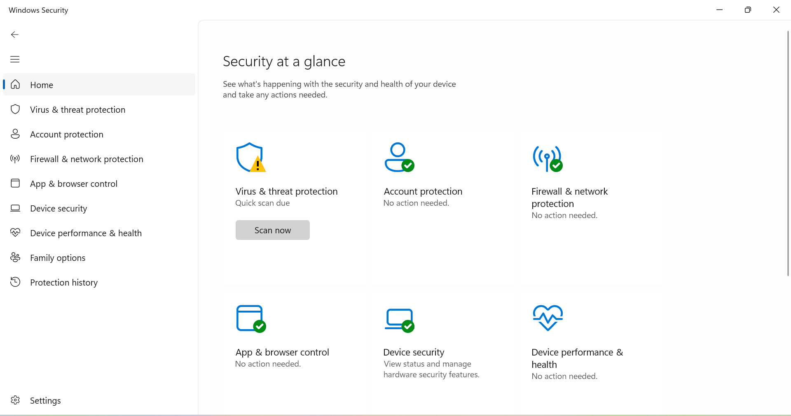
Figure 5: Windows Security – Security at a Glance Dashboard

Use of Windows OS CLI commands
The Windows command-line interface (CLI), mainly through Command Prompt and PowerShell, let users manage files, configure networks, automate tasks, and administer systems using text commands instead of graphical menus.[8]

Example 1:
The command shown in example 1 is “dir” (directory), this is a Command Prompt command that lists the contents of the current directory (folders and files), along with dates, times, and sizes. The output shows the name and the numbers of folders I have on the drive and how much free space remains.

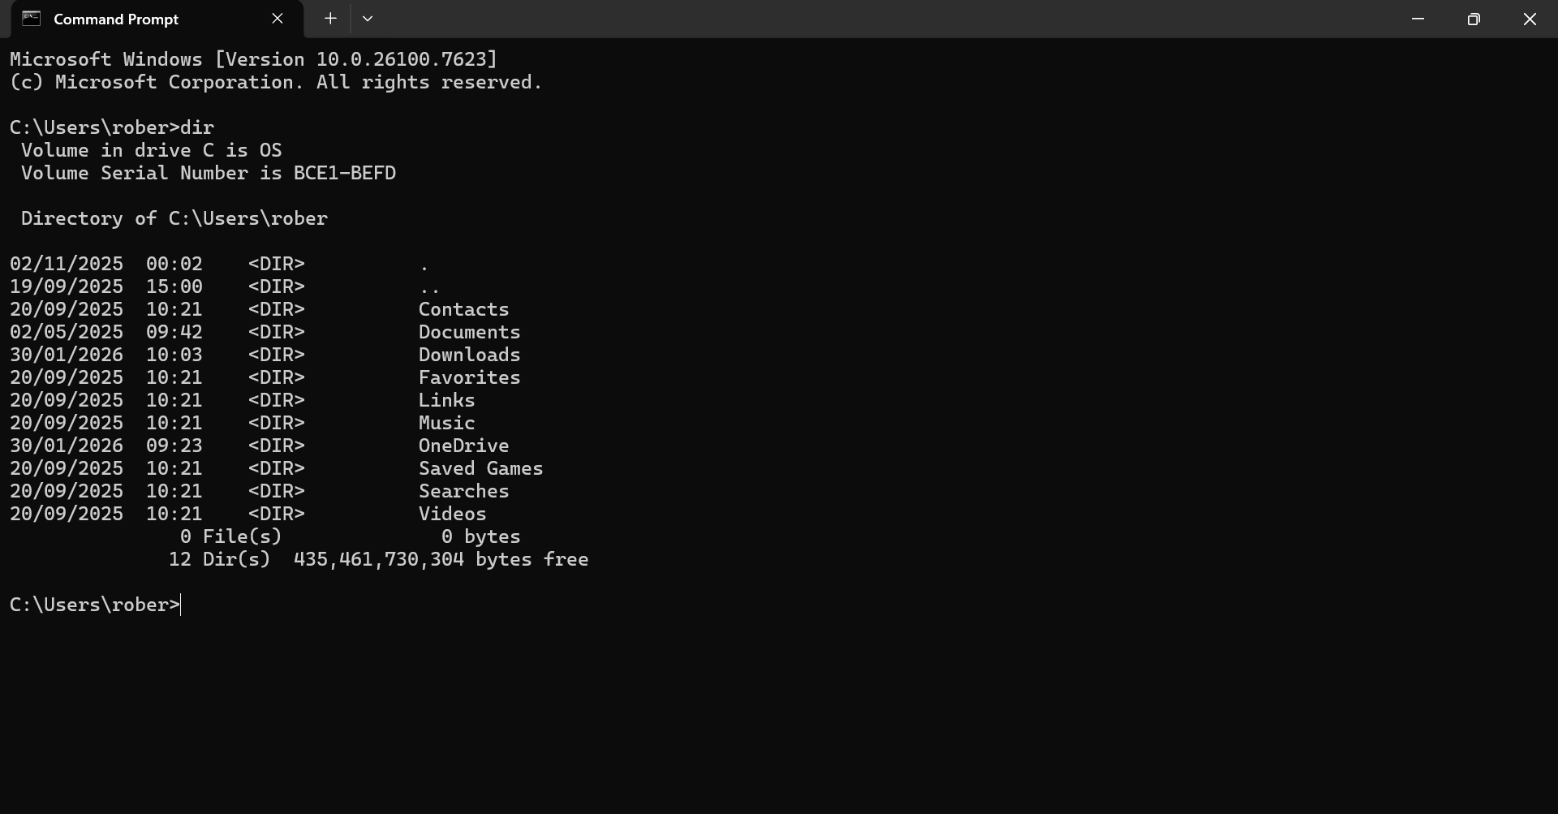
Figure 6: Windows Command Prompt – dir Command in User Folder

Example 2:
The command “cd” (change directory) allows user to move between directories. By typing cd followed by a directory name, users can move into that specific folder. To move back one level in the directory hierarchy, using “cd ..” , this command returns to the previous parent directory, making navigation efficient.
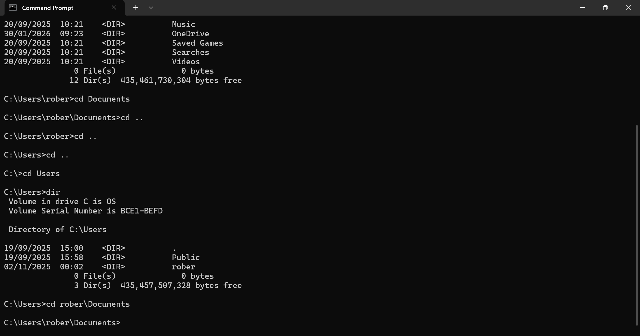
Figure 7: Windows Command Prompt – CD and back command

Example 3:
The “mkdir” (make directory) command is used to create a new folder within the file system. In this example, I created a folder named “new folder” and then used the “dir” command to confirm it.
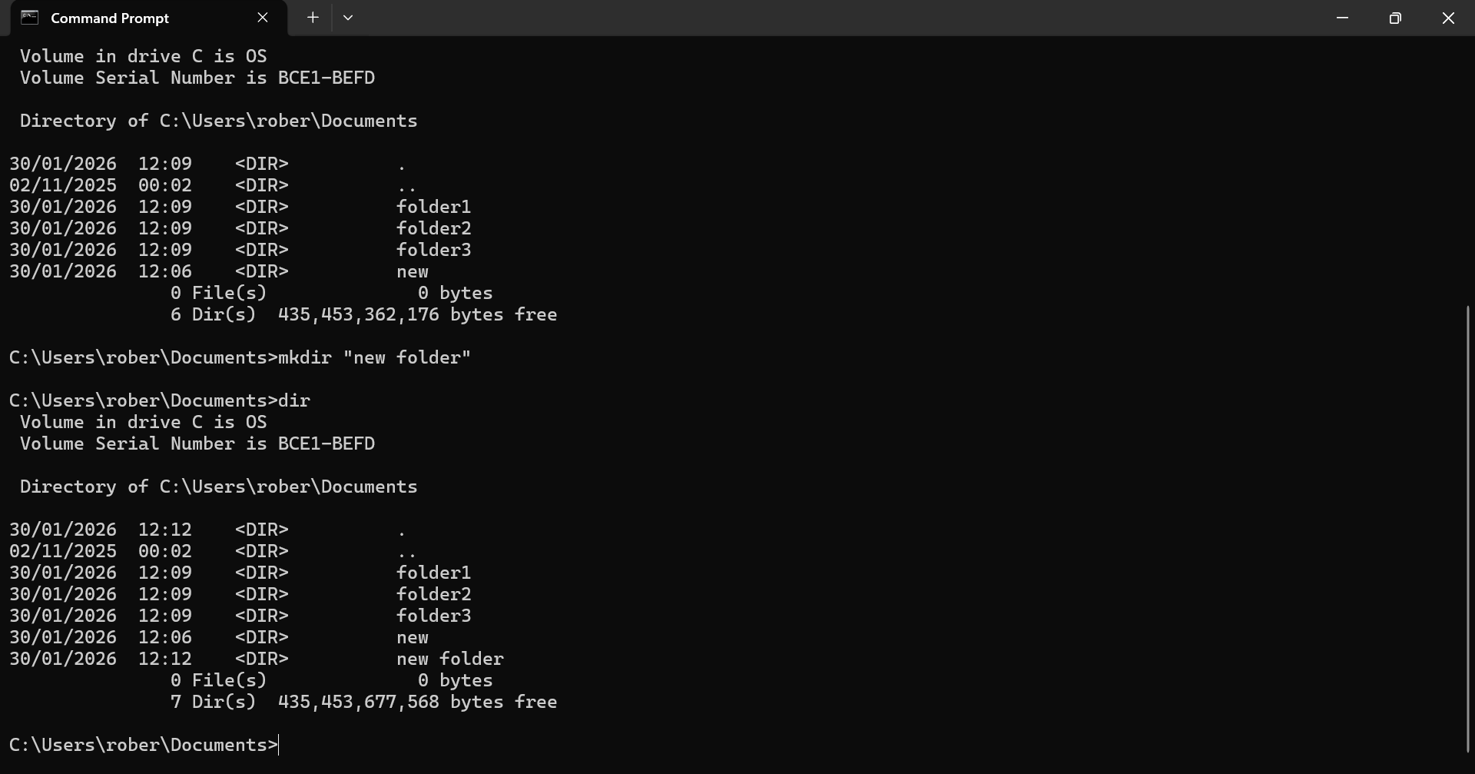
Figure 8: Windows Command Prompt – mkdir command

Example 4:
The “rmdir” (remove directory) command is used to delete folders from the file system. By typing “rmdir” followed by a folder name, the specified directory is removed. In this example, I deleted three different folders and then used the “dir” command to display the updated directory contents.
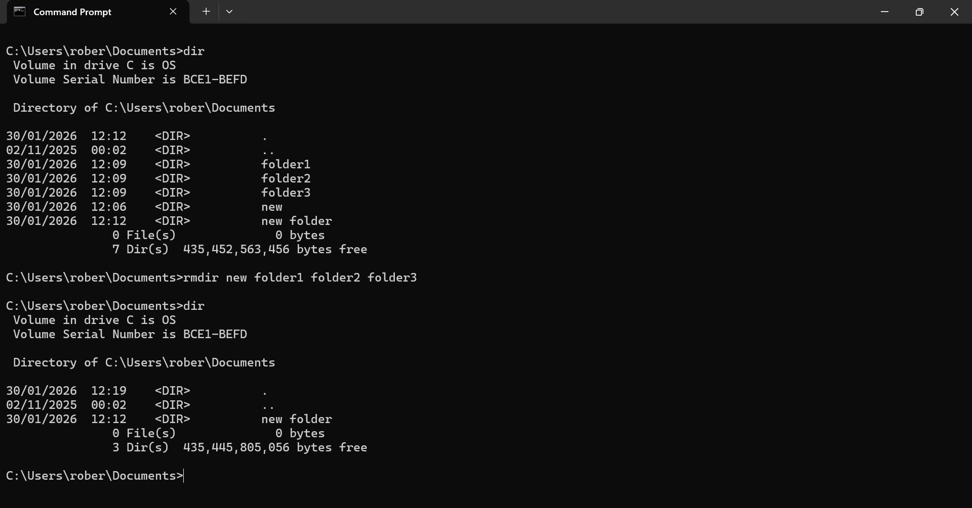
Figure 9: Windows Command Prompt – rmdir command

Example 5:
The “echo” command is used to display messages on the screen or to control whether commands themselves are displayed as they are executed within a batch file.
In this example, I used echo to write text into a file and saved it with a .txt extension, effectively creating a simple text note. For instance, typing echo This is text test > new.txt generates a file named new.txt containing the text.

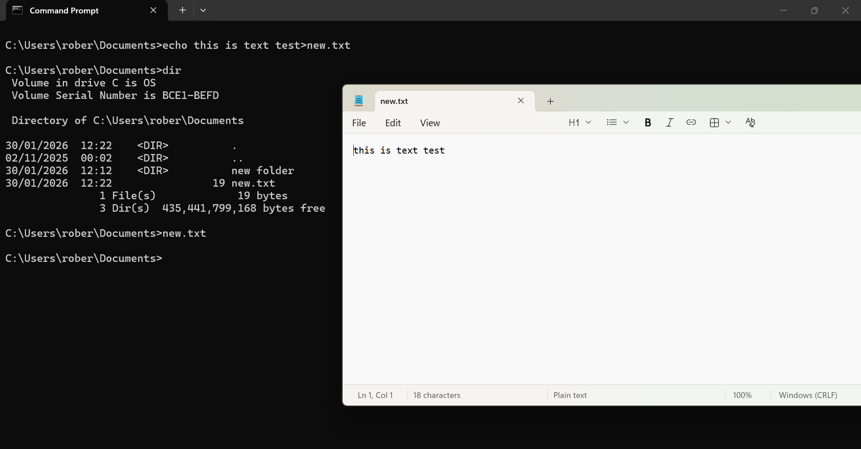
Figure 10: Windows Command Prompt – echo command

Example 6:
The “tasklist” command “shows all of the different local computer processes currently running.
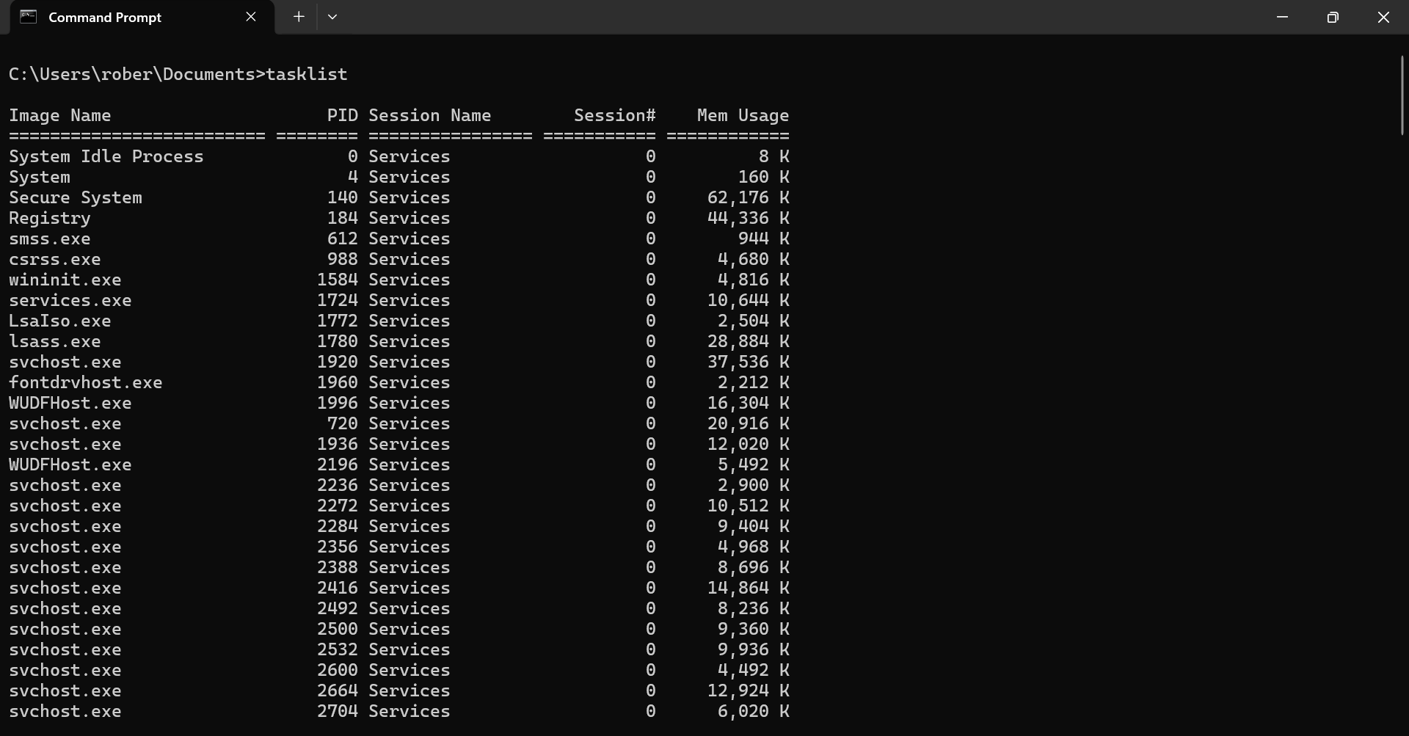
Figure 11: Windows Command Prompt – tasklist command

Example 7:
The “systeminfo” command provides detailed information about the computer and its operating system. It displays key system details such as the OS version, system manufacturer, processor type, memory configuration, network information, and more. This command is especially useful for quickly assessing system specifications, troubleshooting, or verifying hardware and software configurations directly from the Command Prompt.
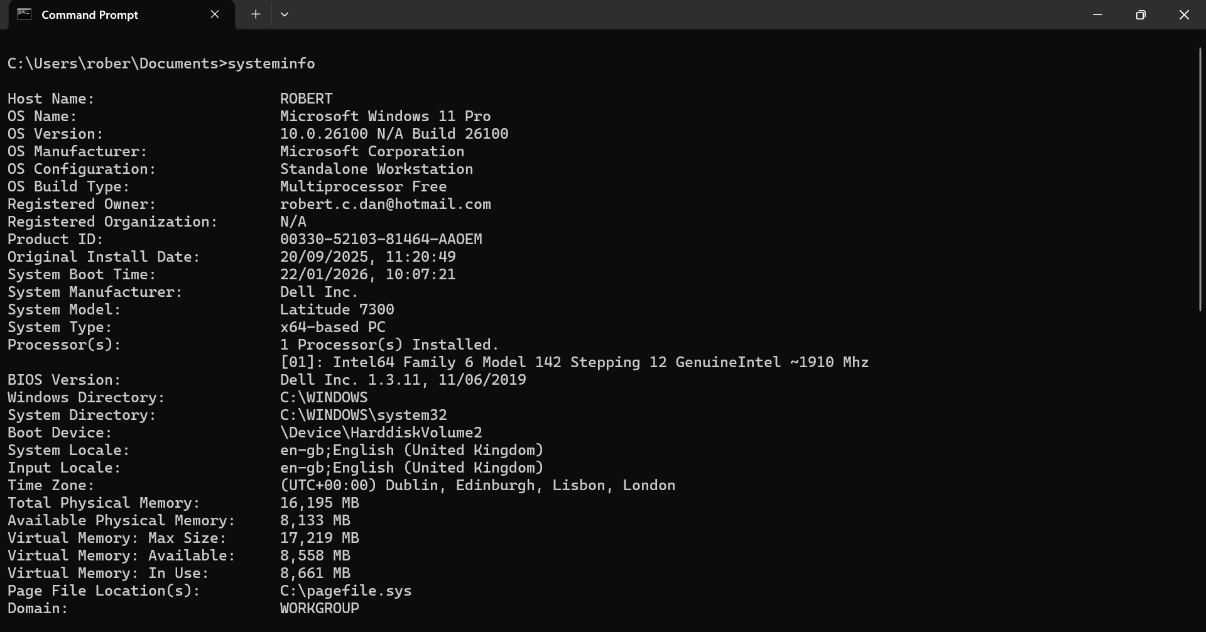
Figure 12: Windows Command Prompt – systeminfo command

Example 8:
The “ipconfig” command displays detailed information about the device's network interfaces, including the IP address, subnet mask, physical address, and default gateway.
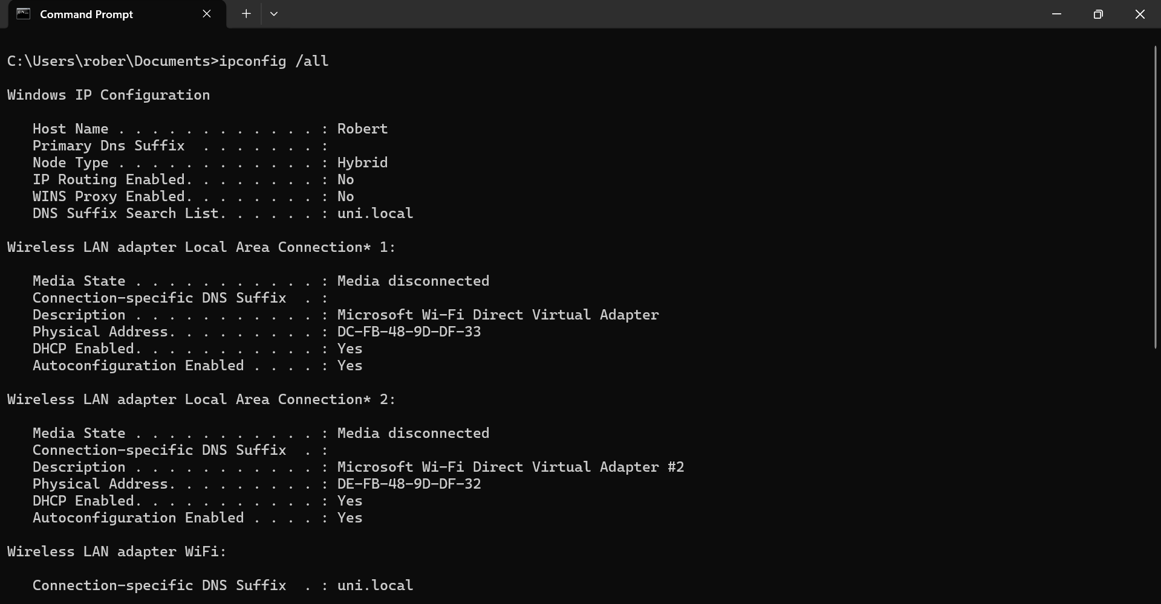
Figure 13: Windows Command Prompt – ipconfig command

Example 9:
The “ping” command is used to test network connectivity between your computer and a specific website or IP address. For example, using ping www.google.com can confirm if the site is reachable and provide details on delays, making it a simple but essential tool for troubleshooting network issues.
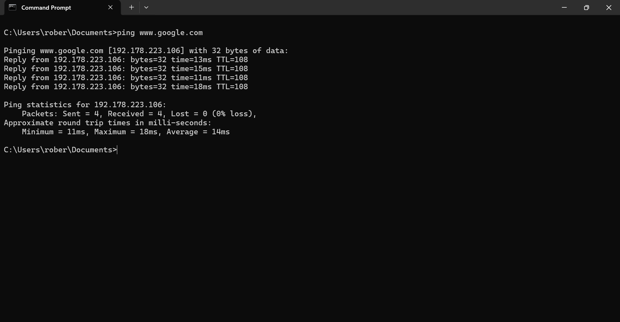
Figure 14: Windows Command Prompt – ping command

Example 10:
“Tracert” (Trace Route) is a command used to trace the route that data packets take to reach a specific destination across an IP network. It’s limited to 30 hops.
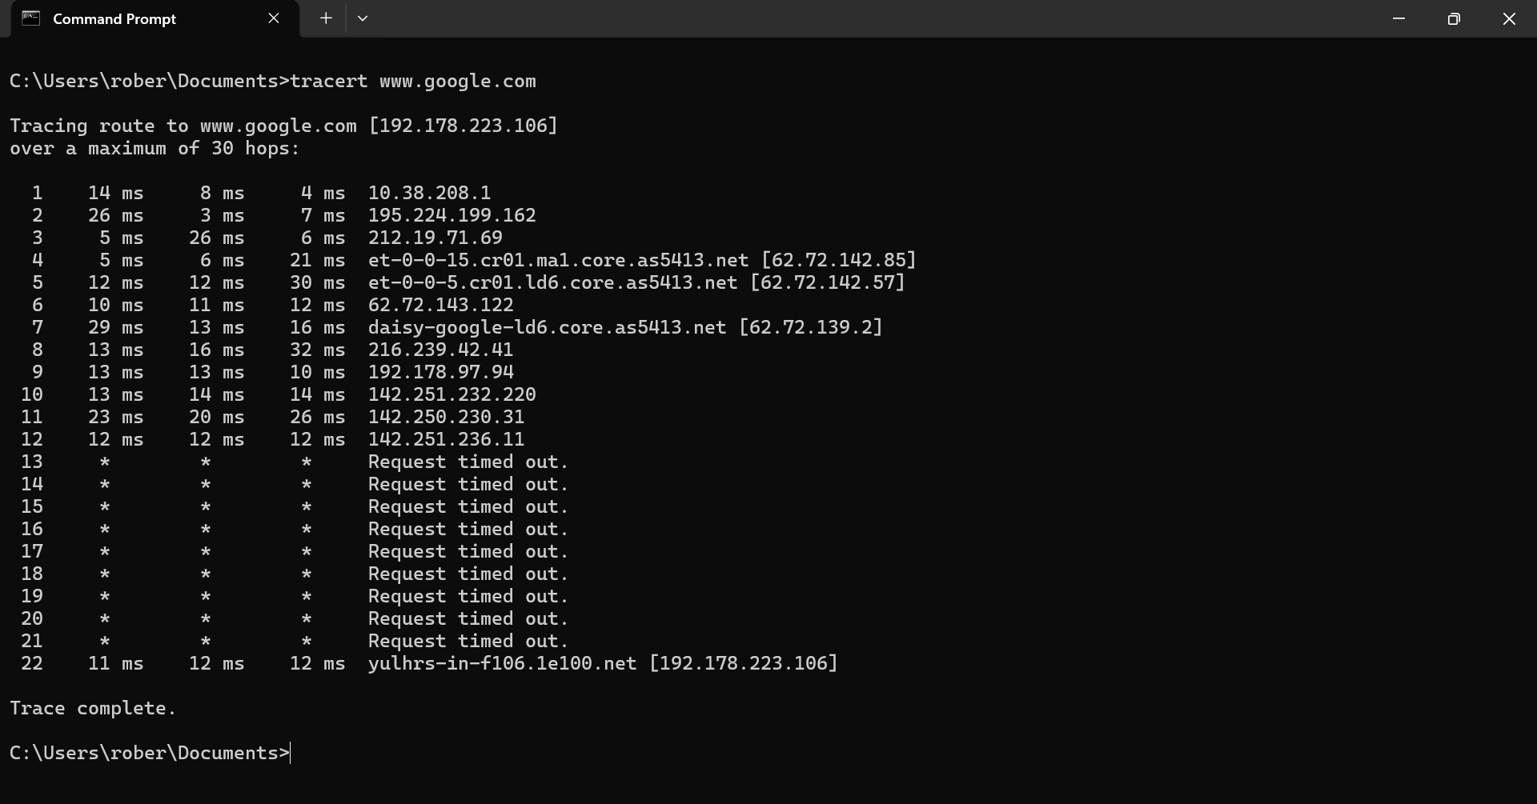
Figure 15: Windows Command Prompt – tracert command

Use of Linux OS CLI commands
The Linux command-line interface (CLI) let users control the system by typing commands and is more efficiently than graphical tools.
The shell, such as Bash, interprets typed commands to perform tasks like navigating directories, managing files, executing programs, and writing scripts that automate repetitive operations.[9]

Example 1:
Root is the name of the superuser account in Linux. It has unrestricted access to the entire system, including all files, users, processes, and system settings.
A sysadmin (system administrator) is a person or role responsible for managing and maintaining Linux systems.
The “su” (substitute user or switch user) command in Linux is used to change the current user account to another user in a terminal.

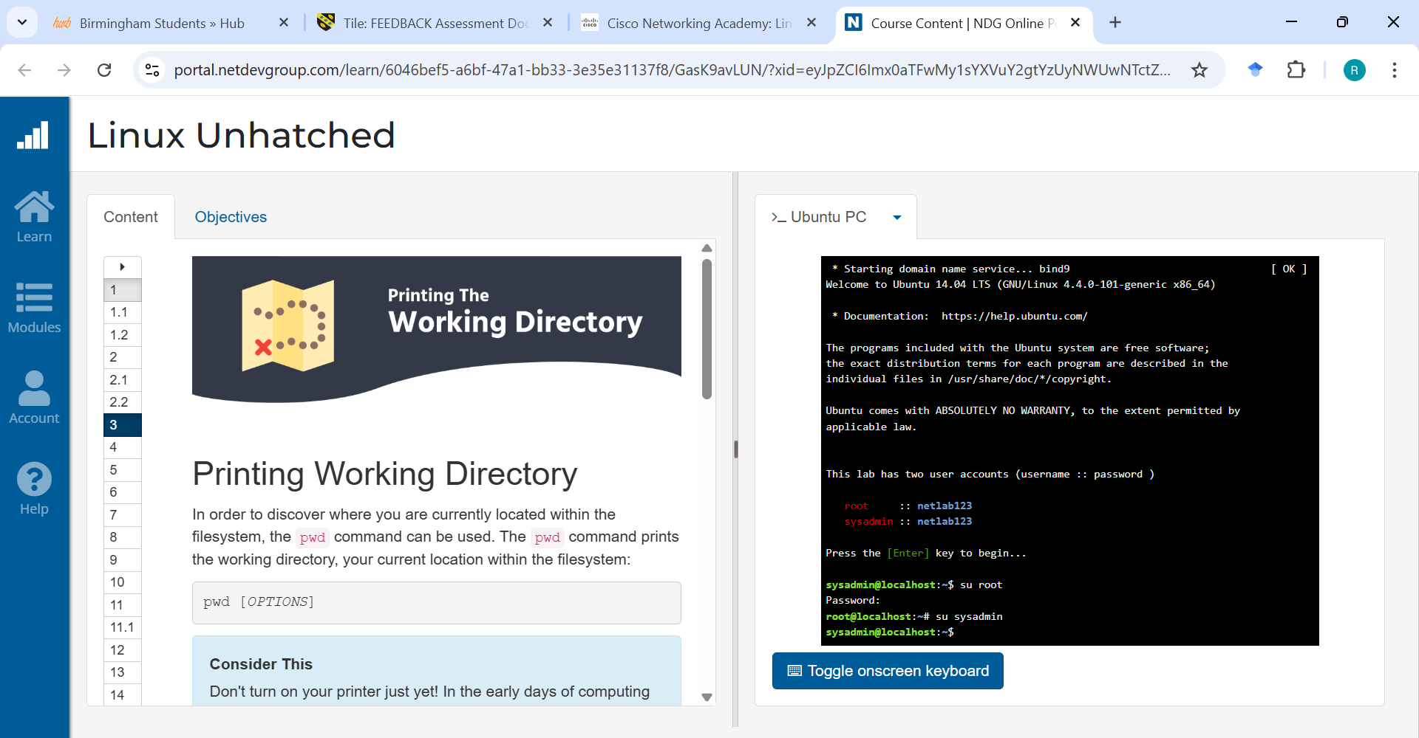
Figure 16: Linux “su” command in a Terminal

Example 2:
The “pwd” command in Linux stands for “print working directory.” It is used to display the full path of the current directory I am working in.
This output means I am currently inside directory /home.
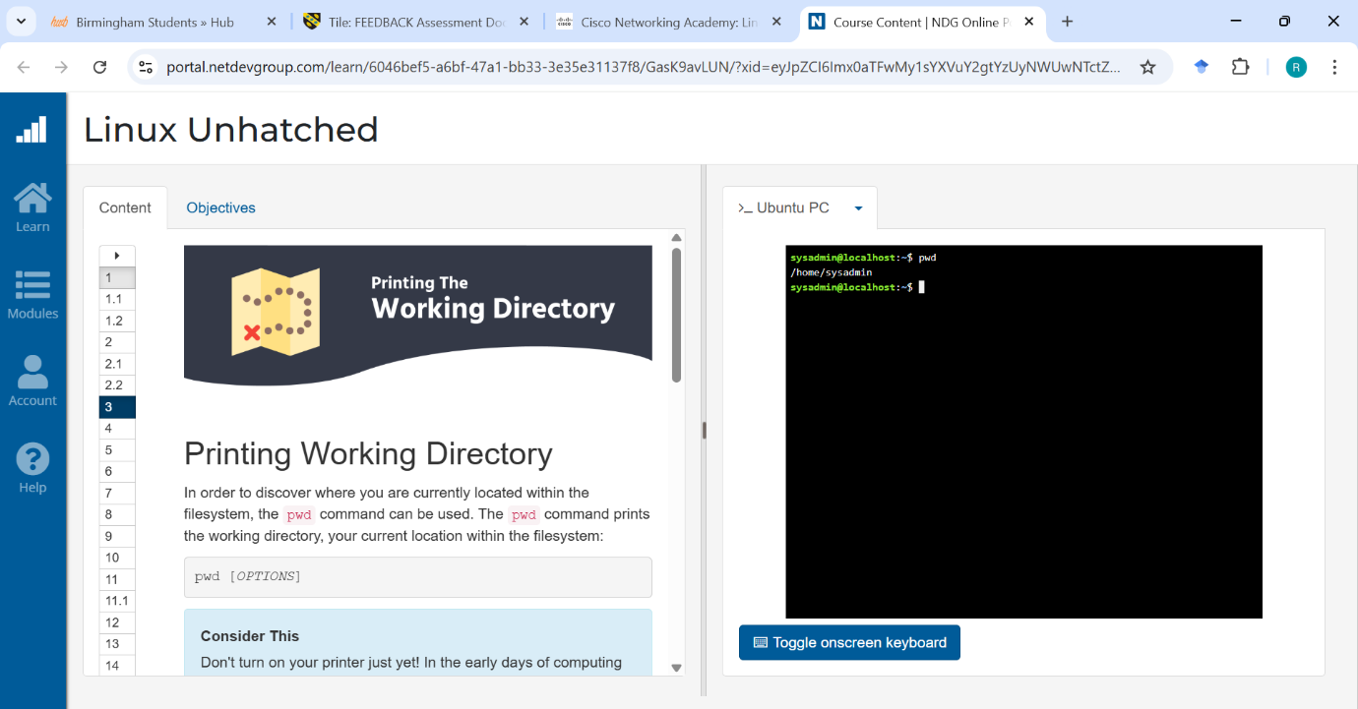
Figure 17: Linux “pwd” command in a Terminal

Example 3:
The “ls” command lists the contents of a directory.
The “-a” option stands for “all”, which means it displays all files, including hidden files.
The output will show regular files, folders and hidden files.
The “-l” option stands for “listing format”, when combined with -a, the command shows all files (including hidden ones) and detailed information about each file.

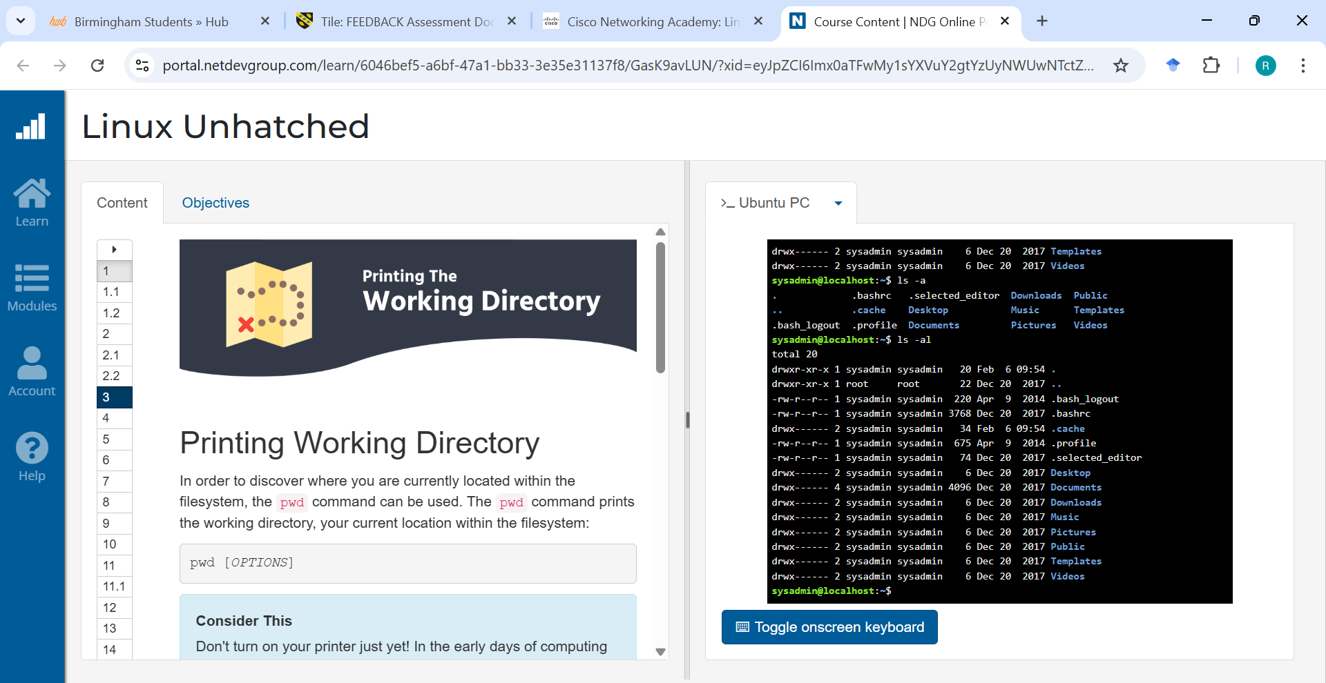
Figure 18: Linux “ls -a” and “ls -al” commands in a Terminal

Example 4:
The “cd” command in Linux stands for “change directory.” It is used to navigate between directories in the file system through the terminal.
I used the “cd” command to navigate into the Desktop directory. By typing cd Desktop, I changed my current working directory to the Desktop folder.
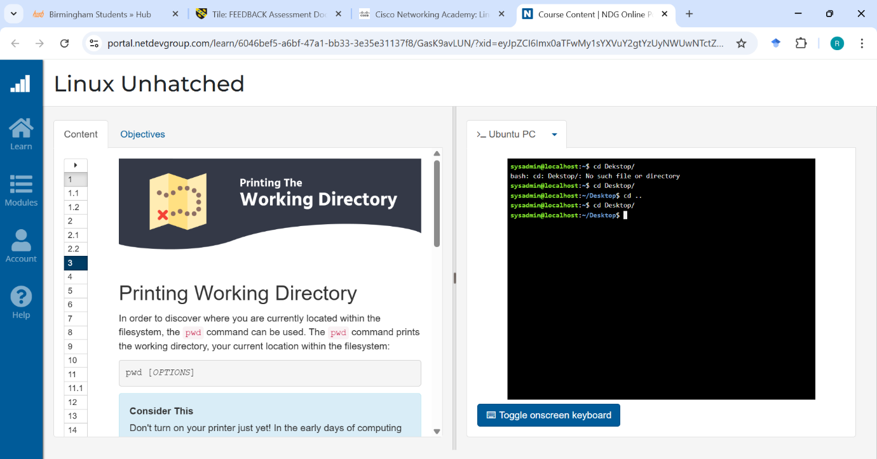
Figure 19: Linux “cd” command in a Terminal

Example 5:
The “mkdir” command in Linux stands for “make directory”. It is used to create new folders within the file system.
If the command is successful, “mkdir” does not display any output. You can verify its creation by using the “ls” command to list directory contents.

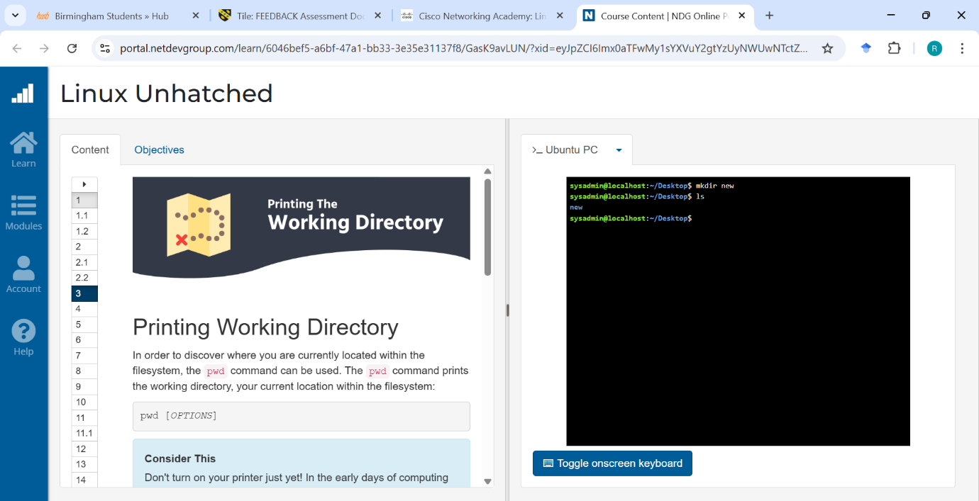
Figure 20: Linux “mkdir” command in a Terminal

Example 6:
The “rmdir” command in Linux stands for “remove directory”. It is used to delete directories from the file system. The “rmdir” command only works if the directory is empty. If the folder contains files or subdirectories, the command will not remove it.

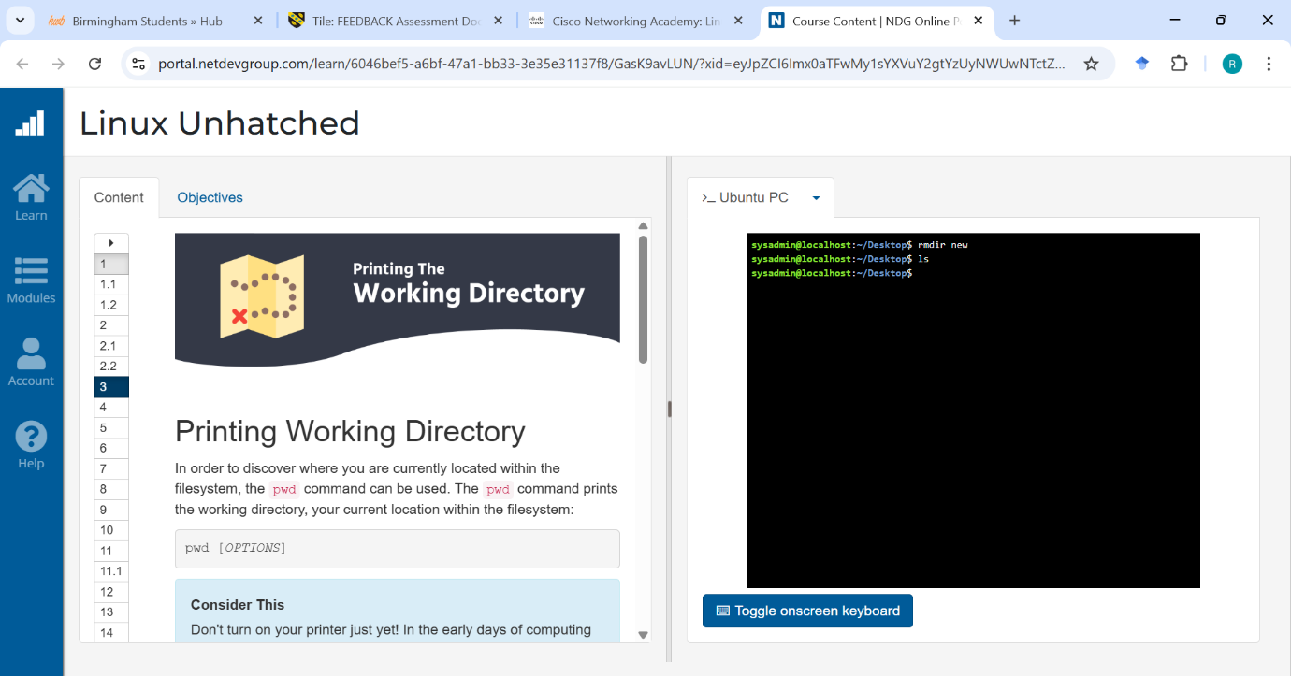
Figure 21: Linux “rmdir” command in a Terminal

Example 7:
The “touch” command in Linux is used to create new empty files. As an input, I created a new empty file named new.txt in the current working directory.
If the command is successful, “touch” produces no output. I can verify that the file was created or updated by using the “ls” command. This output shows the newly created file new.txt.

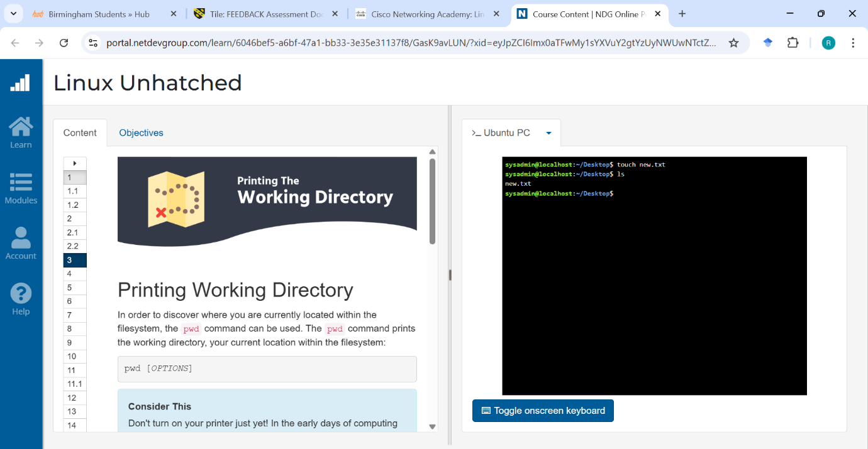
Figure 22: Linux “touch” command in a Terminal

Example 8:
The “echo” command is used to display text or messages on the terminal. It can also be used to write text into files using redirection (>).
I used the “echo” command to print the text "This is the test" and redirected the output to a file using > new.txt.
The “cat” command is used to view the contents of files.

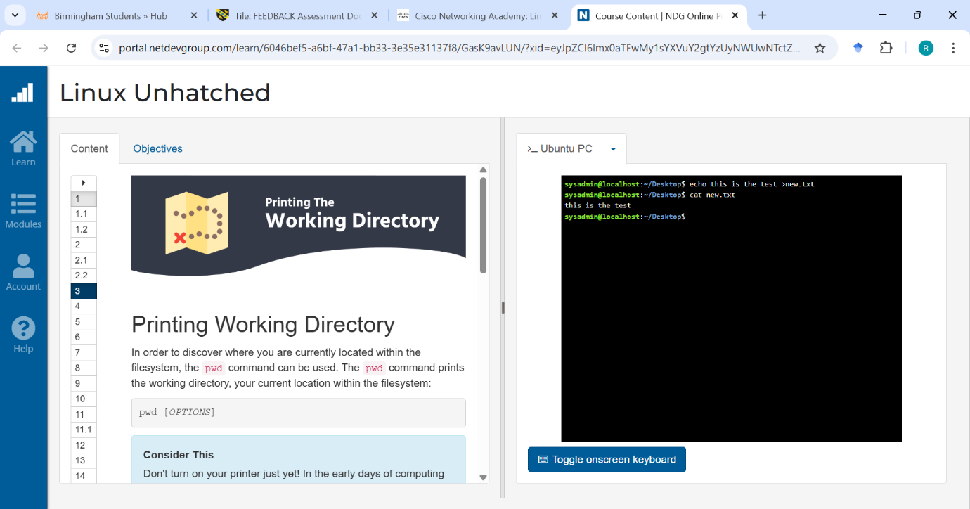
Figure 23: Linux “echo” and “cat” commands in a Terminal

Example 9:
The “ifconfig” command in Linux shows and controls network connections. It displays details like IP and MAC addresses, and it can turn interfaces on or off and change their IP settings.

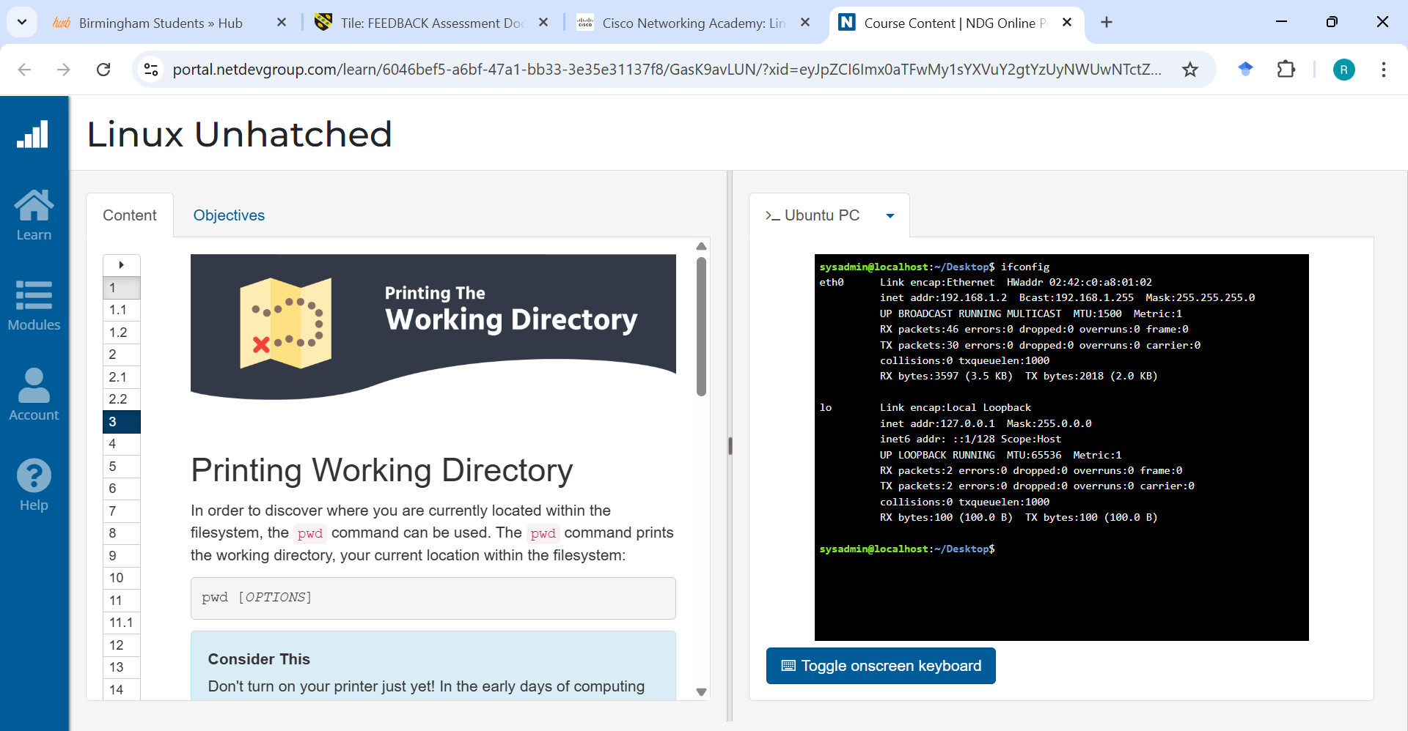
Figure 24: Linux “ifconfig” command in a Terminal

Example 10:
The “whoami” command is used to display the username of the current user logged into the terminal session. It is helpful for confirming which account is currently active.
The “date” command is used to display the current system date and time.
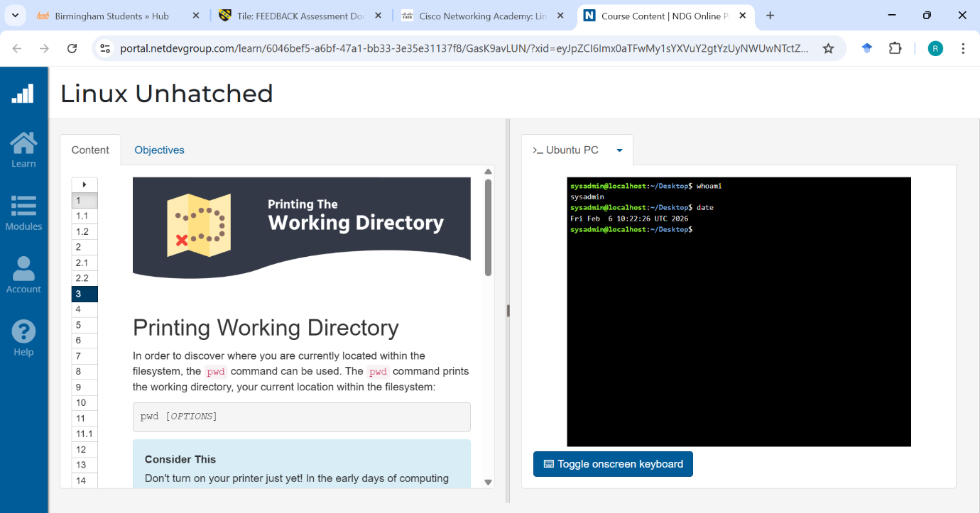
Figure 25: Linux “whoami” and “date” commands in a Terminal

Use of Windows OS scripts
Batch scripting is the process of writing a series of commands in a plain text file that the Windows command interpreter such as Command Prompt executes in sequence.
These scripts are widely used to automate repetitive tasks such as file backups, log cleanup, software deployment, and basic system configuration.[10]

Example 1:
”echo off” command hides the commands themselves from being displayed in the Command Prompt. Only the results are shown, making the output cleaner.
set /p allows the user to input a value.
set /a performs arithmetic calculations.
echo displays the result on the screen.
%result% prints the calculated value.
“Pause” keeps the Command Prompt window open until the user presses a key.
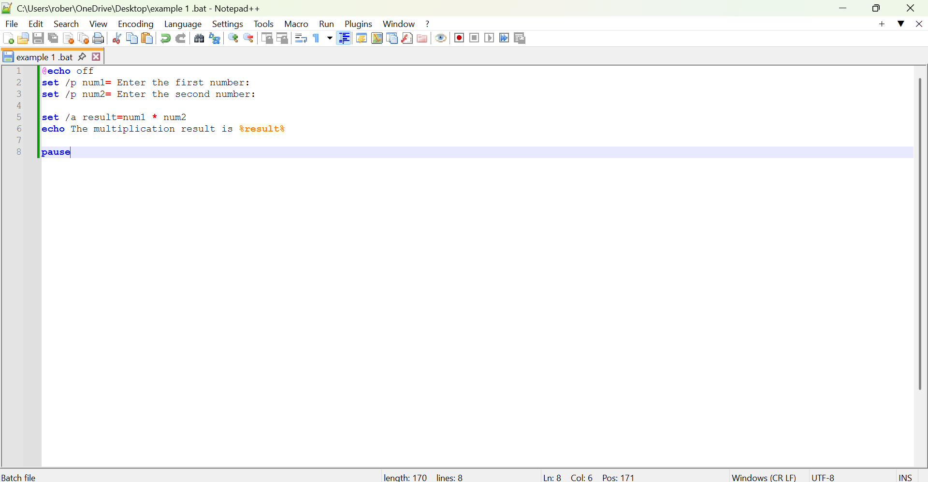
Figure 26: Multiplication in Notepad++
To display the output of my script, I saved the file as a batch file. When the file is opened, it runs automatically in the Command Prompt. The script first prompts the user to enter a number, and after the first value is entered, it asks for a second number. Once both inputs are provided, the script immediately performs the calculation and displays the result on the screen.
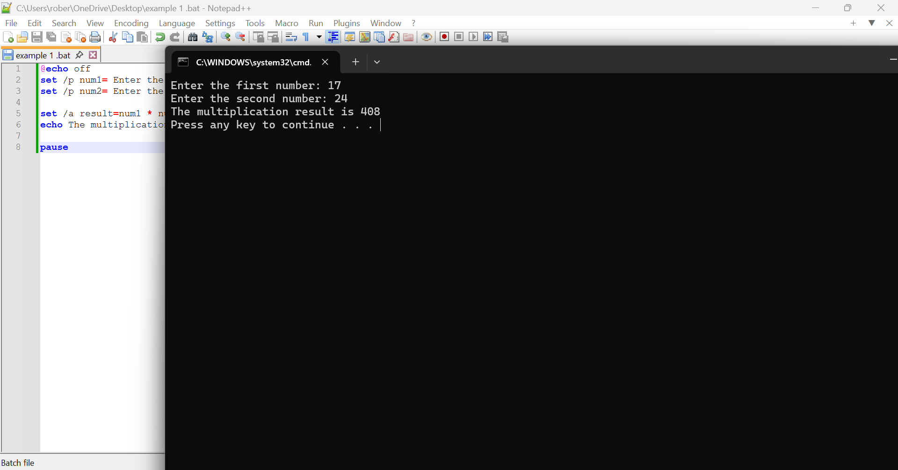
Figure 27: Output of the script in Command Prompt

Example 2:
set /p allows the user to type a value into the Command Prompt.
The value entered by the user is stored in the variable money.
if compares the value of money.
geq means greater than or equal to.
The script checks if the amount entered is 20 or more.

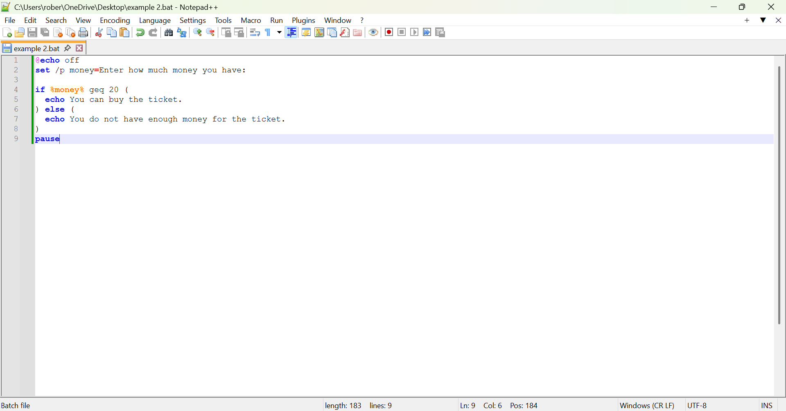
Figure 28: “if statement” in batch file

For the output, the script produces two possible scenarios based on the amount of money entered. If the user enters an amount less than the required value, the script displays a message indicating that there is not enough money to buy the ticket. If the user enters an amount greater than or equal to the required value, the script displays a message confirming that the ticket can be purchased. Both scenarios were demonstrated to show how the script handles different inputs and produces different outcomes.
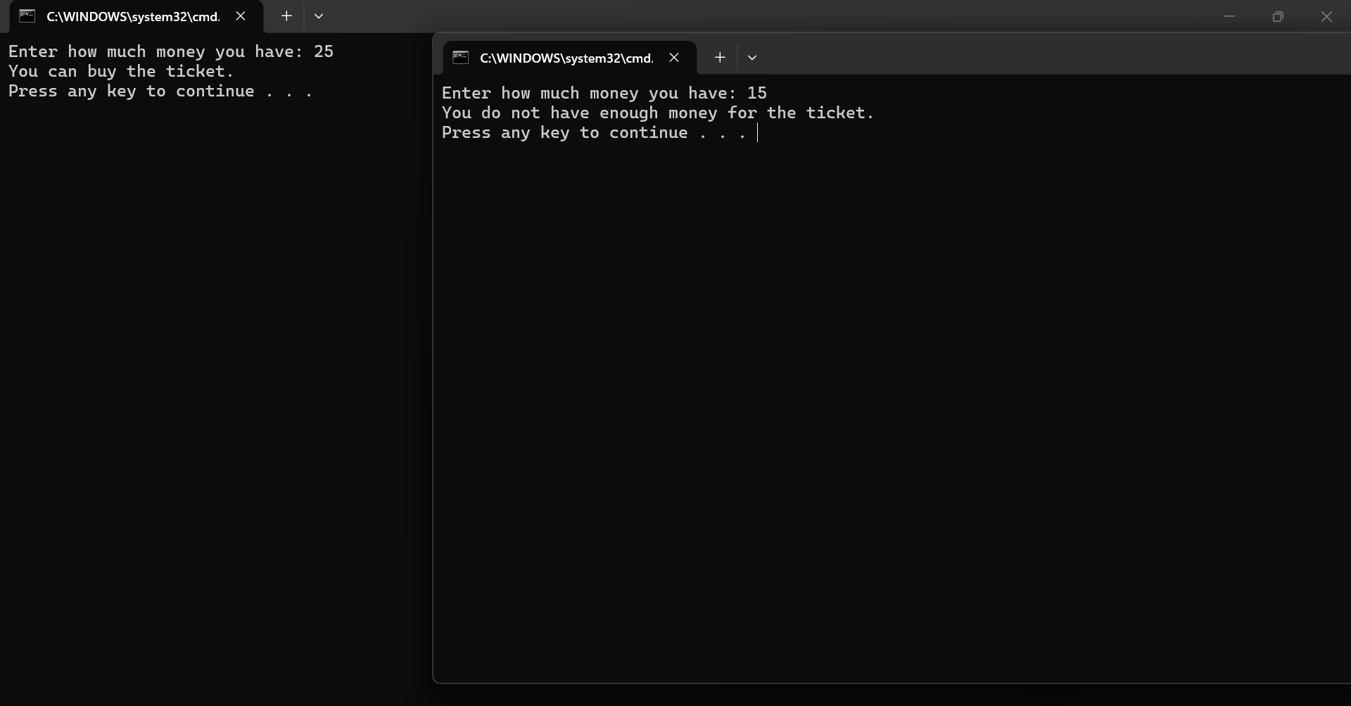
Figure 29: Output of script in Command Prompt

Use of Linux OS scripts
Bash scripting means writing small programs for the Bash shell, the main command line on most Linux systems. A Bash script is a text file with commands that run automatically, letting you use things like variables, loops, and if-statements to automate tasks.[11]

Example 1:
I began by creating the script using “nano” and saving it as a “.sh file” so I could write and execute my Bash script. The script directs the user to enter two values: the “number of hours worked during the week” and the “hourly pay rate”. This is done using the read command, which allows the user to input information through the terminal. The value entered for hours worked is stored in the variable “hours”, while the hourly pay rate is stored in the variable “rate”. The script then performs a calculation using $(( )), which is used in Bash for arithmetic operations. It multiplies the “hours” by the “rate”, and the result is stored in the variable “pay”. Finally, the script displays the calculated result using the echo command.
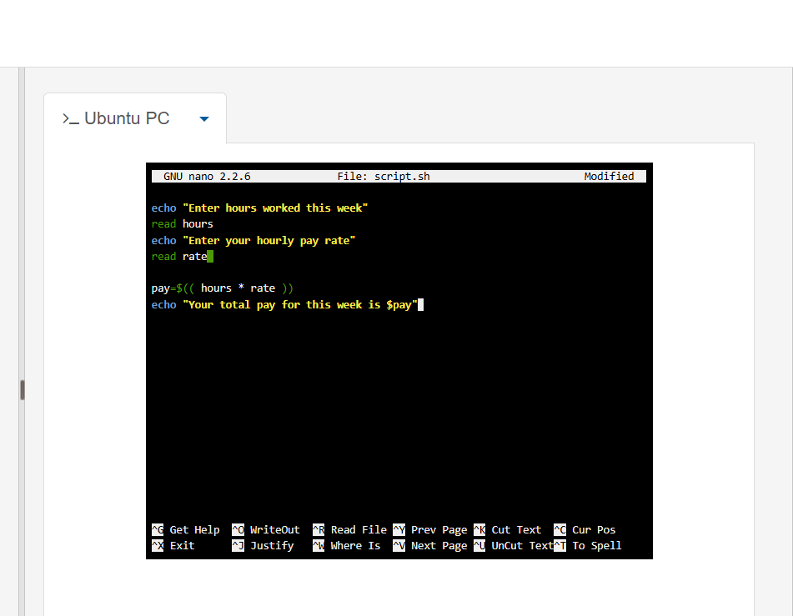
Figure 30: Bash Script in Nano Adding Two User-Entered Numbers

After writing the script, I used the “chmod +x” command to make the .sh file executable. This allowed the script to run as a program. I then executed the script using the ./ command followed by the file name. When the script runs, it prompts the user to enter the “number of hours worked” and the “hourly pay rate”, and it automatically calculates and displays the “total weekly pay” based on the values entered.
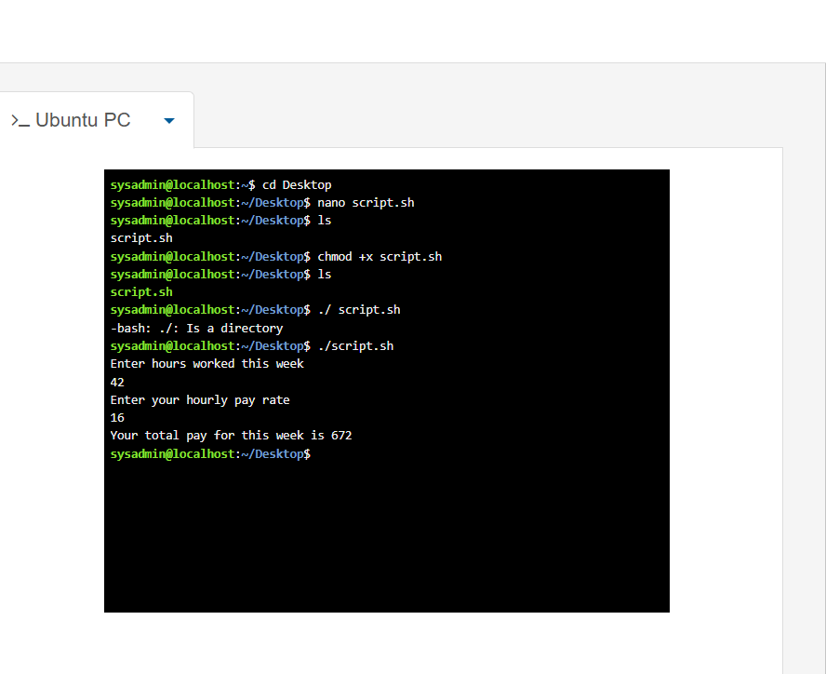
Figure 31: Output of Bash Script Calculating Two Numbers

Example 2:
I began by creating the script using “nano” and saving it as a “.sh file” so I could write and execute my Bash script. The script asks the user to enter a number for which a multiplication table will be generated. This is done using the read command, which allows the user to input information through the terminal. The value entered by the user is stored in the variable “num”.
The script then uses a “for loop” to repeat a calculation multiple time. The loop starts at 1 and continues until 10, allowing the script to calculate the multiplication table for the entered number. Inside the loop, the script performs a calculation using $(( )). It multiplies the value stored in “num” by the loop variable i, and the result is stored in the variable “result”. The script then displays each multiplication step using the echo command.

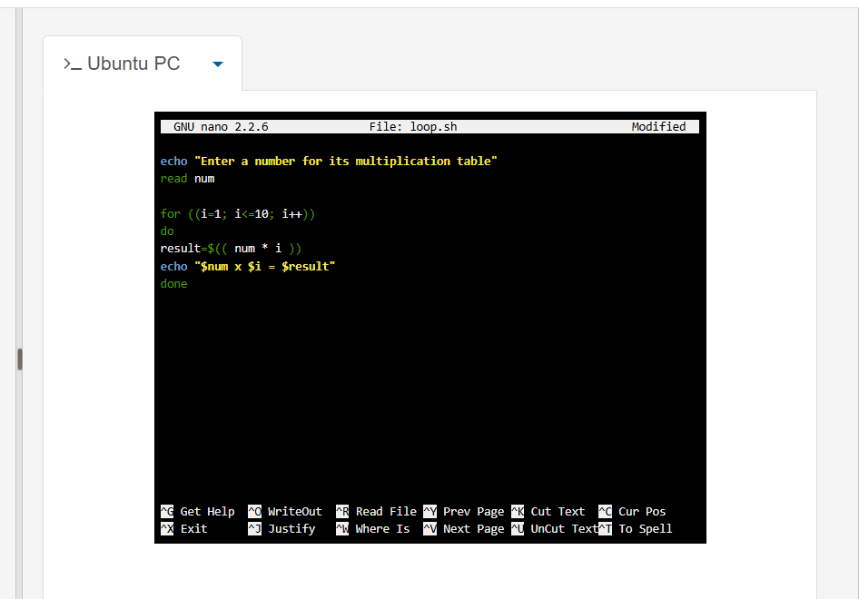
Figure 32: Multiplication Table Bash Script Execution

After writing the script, I used the “chmod +x” command to make the .sh file executable, allowing it to run as a program. I then executed the script using the ./ command followed by the file name. When the script runs, it asks the user to enter a number, and it automatically generates and displays the multiplication table from 1 to 10 for that number in the terminal.
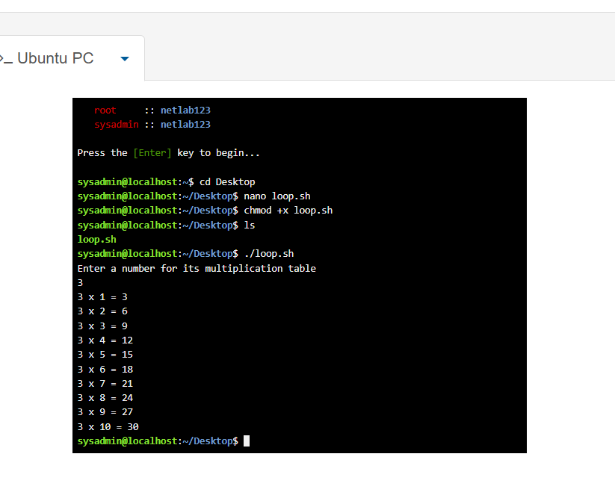
Figure 33: Multiplication Table Script Output in Bash Terminal

Conclusion

In conclusion, this coursework helped me understand how operating systems manage hardware and software while keeping the system secure and easy to use. By looking at Windows tools like Task Manager, Device Manager, file management, and security features, I learned how the main OS functions work together to keep a system stable and protected. The practical exercises with Windows and Linux command-line commands and scripts showed me how useful text-based tools are for navigating, automating tasks, monitoring the system, and fixing problems. Overall, this mix of theory and practice improved my confidence in using both Windows and Linux for basic system management and problem-solving.

Appendices
Online Course name: Linux Unhatched
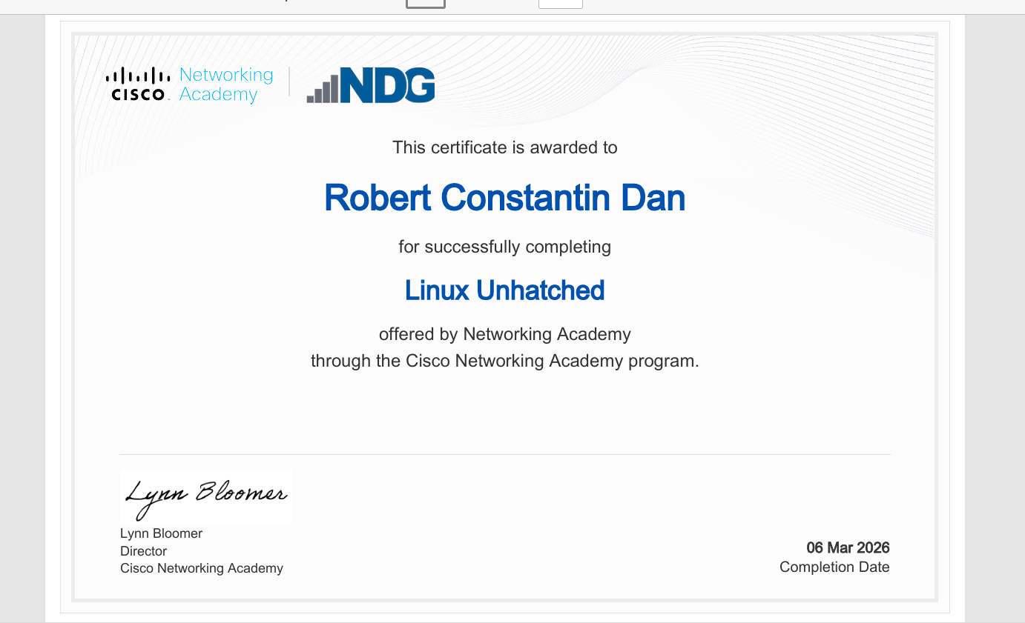
Figure 34: Linux Unhatched Certificate

References

[1] V. Rawat, "A brief study on Operating Systems along with their history, types, working, challenges and advancements." vol. 15869774, 2025,
[2] Microsoft. "Task Manager." learn.microsoft.com. Accessed: March 02 2026. [Online]. Available: https://learn.microsoft.com/en-us/shows/inside/task-manager
[3] A. I. Martyshkin, "TASK MANAGER FOR GENERAL-PURPOSE OPERATING SYSTEMS," no. 5, pp.1–15, 2020,
[4] D. Spinellis, "A critique of the Windows application programming interface," vol. 20, no. 1, pp.1–8, 1998,
[5] F. Hafeez, "Role of File System in Operating System," vol. 2016, pp.117–127, 2016,
[6] A. Silberschatz, P. B. Galvin and G. Gagne,Operating system concepts, John Wiley & Sons, 2019.
[7] C. Cho, Y. Seong and Y. Won, "Mandatory access control method for windows embedded OS security," vol. 10, no. 20, pp.2478, 2021,
[8] M. Schröder and J. Cito, "An empirical investigation of command-line customization," vol. 27, no. 2, pp.30, 2022,
[9] E. William Jr, The Linux command line: a complete introduction, No Starch Press, 2012.
[10] J. McLarney, The Book of Batch Scripting: From Fundamentals to Advanced Automation, No Starch Press, 2024.
[11] S. R. Madamanchi, "Modern approaches to Unix automation: Shell scripting, configuration management, and security," vol. 13, no. 6, pp.3190–3201, 2025,

