Taylor Davies (2214080)

A report showing key properties of rubber materials and also calculating the stress strain curve of a rubber band.
Rubber Properties
Materials and introduction to processing

Contents
Introduction 2
Experimental Method 2
Materials/Equipment 2
Creep Experiment 5
Results 6
Analysis of results 7
Analysis of experimental inaccuracy and cost/quality trade-off 15
Discussion 15
Conclusion 15
Acknowledgements 15
References 16

Introduction
In this report I will demonstrate an experiment which outlines the properties of rubber and calculate the stress strain curve of a rubber band. There are several types of properties which will be discussed such as stress, strain, young modulus, ultimate tensile stress, creep in materials and material property variation.
Before jumping to the experiment, I will first discuss what is an elastomer is and the properties they obtain. The term "elastomer," which comes from the phrase "elastic polymer," refers to any rubbery substance made of long chainlike molecules, or polymers, which can regain its original shape after being greatly stretched [1]. The lengthy molecules that make up an elastomeric substance are typically coiled erratically. However, when force is applied, the molecules straighten in the direction in which they are pulled. The molecules spontaneously return to their regular compact, random structure after being released [1].

Experimental Method
In this experiment I will be evaluating the how much weight an elastic band can take before snapping.
My independent variable I will be using to add the weight to the rubber band is compost, the only reason I am using this is because it is what I had at hand. To control my independent variable, I will be adding a set amount of weight to the bucket at each time. My dependant variable is the point it takes for the rubber band to snap. To control my dependant variable, I will ensure all three rubber bands are the size and will be stored in the same place at the same temperature therefore the property of the rubber remains the same.
My hypothesis is that the rubber band will stretch under strain of the weight applied and snap once it cannot take the strain anymore. I will complete this experiment three times which will then prove that my results are valid.

Materials/Equipment
The materials/Equipment required for this experiment are listed below:
- Vernier callipers
- Small Ruler
- Bucket
- Compost (independent variable)
- Tub
- Weighing Scale
- Rubber bands
- S hooks
- Pen
- Paper (Results Table)

Method:
- Firstly, I obtain three rubber bands which have been stored in a container in my cupboard for 24 hours. I have measured the circumference of the three rubber bands before storage to ensure they are the same size. Using a Vernier Callipers, I then measure the rubber band once more and record in my results table.

- Using the scales record the weight of the bucket empty and record it in the results table.
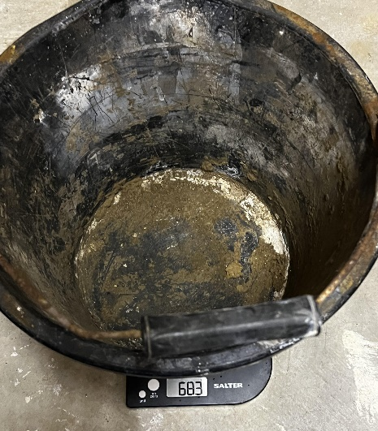

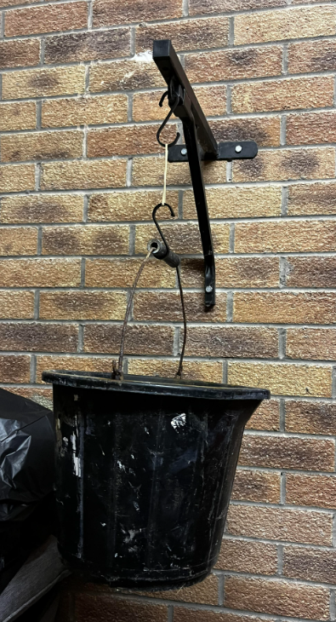
- Using the S hooks, hook the first hook to the boxing bag frame and the other end of the hook to the elastic bank, using another S hook, hook one end to the other side of the elastic band and the other end to the bucket. Record the length of the rubber band in results table
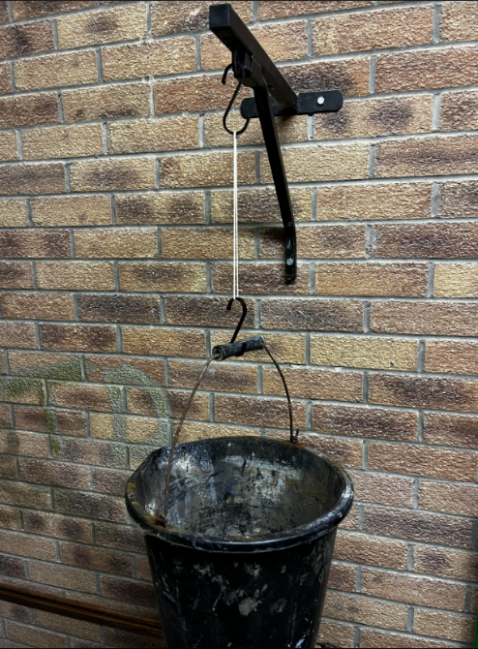
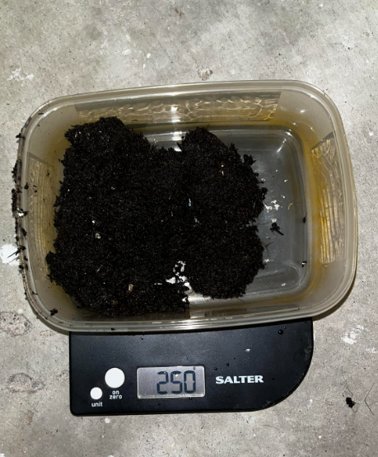
- Using the scales, measure out 250g of compost into a tub, then place the 250g into the bucket. Record the length of the rubber band again and record in the results table.

- Repeat step 4 until the rubber band breaks due to too much strain
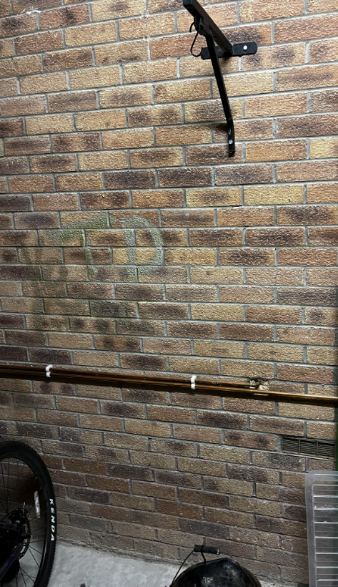
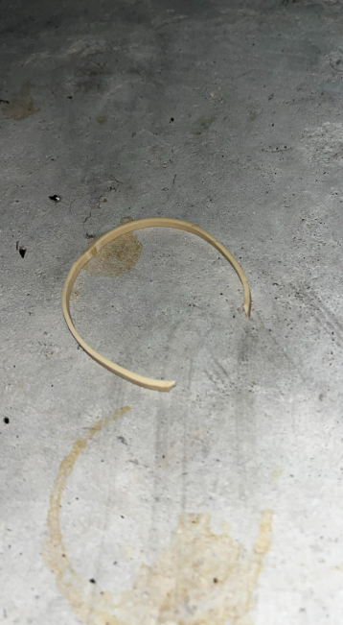

Creep Experiment
While completing my experiment on a fourth rubber band I decided to test creep using my current set up demonstrated in the previous experiment above. I used the steps below to carry out my creep experiment:
- Measure the length of rubber band using vernier
- Fill up the bucket with 1000g total weight including the bucket
- Hook the new elastic band to the s hook already in place
- Attach the bucket using an s hook to another end of elastic band
- Leave the bucket hang for 5 minutes
- After 5 minutes take off the load and measure length of rubber band

Results
The results were recorded on paper originally while carrying out the experiment and then transferred to an excel sheet which as displayed below:
Results Table
Compost (gf) | Force (gf) | Length (mm)
0 | 0 | 60
0 | 683 | 88
250 | 933 | 117
250 | 1183 | 132
250 | 1433 | 141
250 | 1683 | 163
250 | 1933 | 175
250 | 2183 | 194
250 | 2433 | 209
250 | 2683 | 223
250 | 2933 | 234
250 | 3183 | 241
250 | 3433 | 253
250 | 3683 | 260
250 | 3933 | 265
250 | 4183 | 273
250 | 4433 | 278
250 | 4683 | 282
250 | 4933 | 285
250 | 5183 | SNAP

From this table of results, I also produced a graph showing the proportional relationship between the increase in length when under tension, please see the graph below:

The table below are the results from the creep experiment:
Creep Experiment
Compost gf | Force gf | Length at rest
0 | 0 | 64
317 | 1000 | 71

Analysis of results
From the results above we can see that my hypothesis discussed is proven correctly, however from the results we can calculate and infer several different things.
Firstly, we will calculate the engineering strain and the true strain. Engineering strain is the amount of deformation a material can withstand relative to its initial length in the direction of applied forces, in comparison true strain is the natural log of the difference between the immediate gauge length and the initial gauge length is true strain [3]. I will demonstrate my workings for the initial calculation and then present the following results using excel, this will ensure accuracy of the results as it reduces the risk of human error.
Engineering Strain, the formula for engineering strain is $ε= \frac{∆L}{L0}$
ɛ = Engineering strain
ΔL = Change In length
L0 = original length
From this we can work out the engineering strain for the initial time the rubber band was under strain. Using Table. as a reference results:
$$ε= \frac{(88-60)}{60}$$
$$ε= 0.467$$
The formula for true strain is $εt=Σ \frac{∆L}{L}$
ɛt = True Strain
Σ = The Sum of
ΔL = Change in length
L = Length
From this we can work out the True Strain for the time the rubber band was under strain. Using Table. as a reference for results:
$$εt=\int_{L0}^{Lf}{\frac{1}{L}dL}$$
$$εt={}_{L0}^{Lf}{[lnL]}$$
$$εt=lnLf-LinL0$$
$$εt=Ln\frac{Lf}{L0}$$
$$εt=Ln\frac{88}{60}$$
$$εt=0.383$$

After completing the first initial calculations manually, I then decided to use excel as it will save time massively and it will verify my results as it reduces the risk of human error. Please see the results in the table Below:
Results Table
Compost (gf) | Force (gf) | Length (mm) | Engineering Strain | True Strain
0 | 0 | 60 | X | X
0 | 683 | 88 | 0.466666667 | 0.3829923
250 | 933 | 117 | 0.95 | 0.6678294
250 | 1183 | 132 | 1.2 | 0.7884574
250 | 1433 | 141 | 1.35 | 0.8544153
250 | 1683 | 163 | 1.716666667 | 0.9994056
250 | 1933 | 175 | 1.916666667 | 1.0704414
250 | 2183 | 194 | 2.233333333 | 1.1735136
250 | 2433 | 209 | 2.483333333 | 1.2479897
250 | 2683 | 223 | 2.716666667 | 1.3128272
250 | 2933 | 234 | 2.9 | 1.3609766
250 | 3183 | 241 | 3.016666667 | 1.3904524
250 | 3433 | 253 | 3.216666667 | 1.4390449
250 | 3683 | 260 | 3.333333333 | 1.4663371
250 | 3933 | 265 | 3.416666667 | 1.4853853
250 | 4183 | 273 | 3.55 | 1.5151272
250 | 4433 | 278 | 3.633333333 | 1.5332766
250 | 4683 | 282 | 3.7 | 1.5475625
250 | 4933 | 285 | 3.75 | 1.5581446
250 | 5183 | X | X | X

After completing the engineering strain and true strain, I will next calculate the Engineering Stress and True Stress. But before completing this I need to calculate the cross-sectional area of the rubber band.
Using a vernier I measured two sections of the vernier, these came out to 3cm and 1.5cm
To calculate the area, I then multiplied these numbers together:
$$A=3 ×1.5$$
$$A=4.5{cm}^{2}$$
And as the rubber band has two sides, I multiplied the area by 2
$$CA=A ×No Sides$$
$$CA=4.5 x 2$$
$$CA=9$$
Once completing the initial cross-sectional area, I once again used Excel to complete the rest of the results, please see the table of results below:

Results Table
Compost (gf) | Force (gf) | Length (mm) | Engineering Strain | True Strain | Cross-Sectional Area
0 | 0 | 60 | 0 | 0 | 9
0 | 683 | 88 | 0.466666667 | 0.3829923 | 6.136363636
250 | 933 | 117 | 0.95 | 0.6678294 | 4.615384615
250 | 1183 | 132 | 1.2 | 0.7884574 | 4.090909091
250 | 1433 | 141 | 1.35 | 0.8544153 | 3.829787234
250 | 1683 | 163 | 1.716666667 | 0.9994056 | 3.312883436
250 | 1933 | 175 | 1.916666667 | 1.0704414 | 3.085714286
250 | 2183 | 194 | 2.233333333 | 1.1735136 | 2.783505155
250 | 2433 | 209 | 2.483333333 | 1.2479897 | 2.583732057
250 | 2683 | 223 | 2.716666667 | 1.3128272 | 2.421524664
250 | 2933 | 234 | 2.9 | 1.3609766 | 2.307692308
250 | 3183 | 241 | 3.016666667 | 1.3904524 | 2.2406639
250 | 3433 | 253 | 3.216666667 | 1.4390449 | 2.134387352
250 | 3683 | 260 | 3.333333333 | 1.4663371 | 2.076923077
250 | 3933 | 265 | 3.416666667 | 1.4853853 | 2.037735849
250 | 4183 | 273 | 3.55 | 1.5151272 | 1.978021978
250 | 4433 | 278 | 3.633333333 | 1.5332766 | 1.942446043
250 | 4683 | 282 | 3.7 | 1.5475625 | 1.914893617
250 | 4933 | 285 | 3.75 | 1.5581446 | 1.894736842
250 | 5183 | X | X | X | X

After completing the cross-sectional area, I next need to work out the force. The formula is
$$F=mg$$
$$Force=mass x acceleration due to gravity$$
Initial Force applied to rubber band:
$$F=mg$$
$$683 x 9.81=6700.23$$
This then needs to be divided by one thousand as we are currently in grams.
$$F=\frac{6700.23}{1000}$$
$$F=6.7N$$
Once completing the initial Force (N), I once again used Excel to complete the rest of the results, please see the table of results below:

Results Table
Compost (gf) | Force (gf) | Length (mm) | Engineering Strain | True Strain | Cross-Sectional Area | Force (N)
0 | 0 | 60 | 0 | 0 | 9 | X
0 | 683 | 88 | 0.466666667 | 0.3829923 | 6.136363636 | 6.70023
250 | 933 | 117 | 0.95 | 0.6678294 | 4.615384615 | 9.15273
250 | 1183 | 132 | 1.2 | 0.7884574 | 4.090909091 | 11.60523
250 | 1433 | 141 | 1.35 | 0.8544153 | 3.829787234 | 14.05773
250 | 1683 | 163 | 1.716666667 | 0.9994056 | 3.312883436 | 16.51023
250 | 1933 | 175 | 1.916666667 | 1.0704414 | 3.085714286 | 18.96273
250 | 2183 | 194 | 2.233333333 | 1.1735136 | 2.783505155 | 21.41523
250 | 2433 | 209 | 2.483333333 | 1.2479897 | 2.583732057 | 23.86773
250 | 2683 | 223 | 2.716666667 | 1.3128272 | 2.421524664 | 26.32023
250 | 2933 | 234 | 2.9 | 1.3609766 | 2.307692308 | 28.77273
250 | 3183 | 241 | 3.016666667 | 1.3904524 | 2.2406639 | 31.22523
250 | 3433 | 253 | 3.216666667 | 1.4390449 | 2.134387352 | 33.67773
250 | 3683 | 260 | 3.333333333 | 1.4663371 | 2.076923077 | 36.13023
250 | 3933 | 265 | 3.416666667 | 1.4853853 | 2.037735849 | 38.58273
250 | 4183 | 273 | 3.55 | 1.5151272 | 1.978021978 | 41.03523
250 | 4433 | 278 | 3.633333333 | 1.5332766 | 1.942446043 | 43.48773
250 | 4683 | 282 | 3.7 | 1.5475625 | 1.914893617 | 45.94023
250 | 4933 | 285 | 3.75 | 1.5581446 | 1.894736842 | 48.39273
250 | 5183 | X | X | X | X | X

Finally, we have all the values required to calculate the Engineering Stress and True Stress.
To calculate Engineering Stress the formula is:
$$Engineering Stress= \frac{Force (N)}{Nominal Cross Sectional Area}$$
Initial Engineering Stress Calculated:
$$Engineering Stress= \frac{6.70}{9}$$
$$Engineering Stress= 0.744 N/{mm}^{2}$$
To calculate True Stress the formula is:
$$True Stress= \frac{Force (N)}{Actual Cross Sectional Area}$$
Initial True Stress Calculated:
$$Engineering Stress= \frac{6.70}{6.14}$$
$$Engineering Stress= 1.09 N/{mm}^{2}$$

Once calculating the initial Engineering Stress and True Stress I used an Excel sheet to calculate the rest, this will help save time and reduce the risk of human error.
Results Table
Compost (gf) | Force (gf) | Length (mm) | Engineering Strain | True Strain | Cross-Sectional Area | Force (N) | Engineering Stress | True Stress
0 | 0 | 60 | 0 | 0 | 9 | X | 0 | X
0 | 683 | 88 | 0.466666667 | 0.3829923 | 6.136363636 | 6.70023 | 0.74447 | 1.09188933
250 | 933 | 117 | 0.95 | 0.6678294 | 4.615384615 | 9.15273 | 1.01697 | 1.9830915
250 | 1183 | 132 | 1.2 | 0.7884574 | 4.090909091 | 11.60523 | 1.28947 | 2.836834
250 | 1433 | 141 | 1.35 | 0.8544153 | 3.829787234 | 14.05773 | 1.56197 | 3.6706295
250 | 1683 | 163 | 1.716666667 | 0.9994056 | 3.312883436 | 16.51023 | 1.83447 | 4.9836435
250 | 1933 | 175 | 1.916666667 | 1.0704414 | 3.085714286 | 18.96273 | 2.10697 | 6.14532917
250 | 2183 | 194 | 2.233333333 | 1.1735136 | 2.783505155 | 21.41523 | 2.37947 | 7.69361967
250 | 2433 | 209 | 2.483333333 | 1.2479897 | 2.583732057 | 23.86773 | 2.65197 | 9.2376955
250 | 2683 | 223 | 2.716666667 | 1.3128272 | 2.421524664 | 26.32023 | 2.92447 | 10.8692802
250 | 2933 | 234 | 2.9 | 1.3609766 | 2.307692308 | 28.77273 | 3.19697 | 12.468183
250 | 3183 | 241 | 3.016666667 | 1.3904524 | 2.2406639 | 31.22523 | 3.46947 | 13.9357045
250 | 3433 | 253 | 3.216666667 | 1.4390449 | 2.134387352 | 33.67773 | 3.74197 | 15.7786402
250 | 3683 | 260 | 3.333333333 | 1.4663371 | 2.076923077 | 36.13023 | 4.01447 | 17.3960367
250 | 3933 | 265 | 3.416666667 | 1.4853853 | 2.037735849 | 38.58273 | 4.28697 | 18.9341175
250 | 4183 | 273 | 3.55 | 1.5151272 | 1.978021978 | 41.03523 | 4.55947 | 20.7455885
250 | 4433 | 278 | 3.633333333 | 1.5332766 | 1.942446043 | 43.48773 | 4.83197 | 22.3881277
250 | 4683 | 282 | 3.7 | 1.5475625 | 1.914893617 | 45.94023 | 5.10447 | 23.991009
250 | 4933 | 285 | 3.75 | 1.5581446 | 1.894736842 | 48.39273 | 5.37697 | 25.5406075
250 | 5183 | X | X | X | X | X | X | X

From the results above I conducted two graphs, one graph representing an Engineering Stress Strain Curve and another representing True Stress Strain Curve.

A graph for the Engineering Stress Strain Curve:

A Graph for True Stress Strain Curve:

After analysing both graphs, personally I expected more of a curve on the engineering stress strain graph than what we calculated. In comparison of the values, I can see that the true stress is a lot higher than the engineering stress.
Based on the True Stress Strain curve I can calculate the Youngs modulus at the initial stretch point.
To work out the Youngs modulus we can use the gradient of the initial stress point. I have used a red line to show the gradient of the line at the initial stretch point on the graph.
$$E= \frac{Stress }{Strain}$$
$$E= \frac{2.86}{0.78}$$
$$E= 3.67{×10}^{6}$$

I then calculated the Ultimate Tensile Strength using the same graph
The Ultimate tensile strength is the maximum force the material can take before breaking, from the graph we can see following the green line that brings across and shows that the Ultimate Tensile Strength is: 5.37697${mm}^{2}$
As previously mentioned also we can see that the curve is very curved towards the top end, this proves that rubber hardness as you stress it.
Based on the True Stress Strain curve I can calculate the Youngs modulus at the initial stretch point.
To work out the Youngs modulus we can use the gradient of the initial stress point. I have used a red line to show the initial stretch point on the graph.
$$E= \frac{1.35 }{1.56}$$
$$E=0.8654 ×{10}^{6}$$

I then calculated the Ultimate Tensile Strength using the same graph
The Ultimate tensile strength is the maximum force the material can take before breaking, from the graph we can see following the green line that brings across and shows that the Ultimate Tensile Strength is: 25.${mm}^{2}$
As previously mentioned also we can see that the curve is very curved towards the top end, this proves that rubber hardness as you stress it.
Creep Experiment Results:
The results show from the creep experiment that the rubber band will permanently deform after being put under stress for a period, at first our rubber band started at a length of 64mm and then after being put under strain this increased to a length of 71mm. This can cause various issues as it may decrease the yield strength and UTS.

Analysis of experimental inaccuracy and cost/quality trade-off
My experiment went well considering the budget I had to spend, however there were areas that could be improved depending on I had a larger budget. First, I would change the environment of where the experiment took place, due to having a place to hang the band from in my garage I completed the experiment there, the reason I would change this is because of the cold temperature, this may have affected my elastic band properties. I would also change what I used to hang the bands from the boxing bag wall mount to the band and the band to the bucket; I used metal S hooks which are quite slim and could cause a point of higher stress on the band. To improve this, I would use something rubber or a softer material with a wider surface area which will minimise the point of stress. If I was too improve my creep experiment I would complete the same tests using various different forces with rubber bands the same size throughout all the experiment, this would help me understand the creep properties of the rubber band more. I would also like to test the bands under different conditions also in the future, for example one which has been heated and one which has also been chilled, I feel this would also demonstrate the effect of temperature on the properties of the bands.

Discussion
The results reflected the theory well, from the graphs we can see that the band hardens as you stress it. We can also infer that the results back up our hypothesis that the rubber band will stretch under strain of the weight applied and snap once it cannot take the strain anymore. I also completed this experiment 3 times, the results are shown in the excel sheet, the results were very similar in comparison as the rubber bands were from the same batch.

Conclusion
In this experiment I conducted an experiment to find the stress strain curve for rubber. After completing the experiment, we can infer that the results back up our hypothesis that the rubber band will stretch under strain of the weight applied and snap once it cannot take the strain anymore. This allowed us to explore the properties such as the Youngs modulus, ultimate tensile strength, and elasticity. Overall, I am happy with how the experiment went and the results I received were extremely useful. Once again if I had more of a budget, I feel like I could improve the accuracy of the experiment which will leads to a better study on the properties of elastomers.

Acknowledgements
Throughout this experiment I worked solo, I completed the experiment at home in my garage. Also, all completed calculations and graphs for the tables shown throughout the document were completed in Excel which will be submitted with the report. I also used my tool kit which included all the tools shown in the equipment except the weighing scales which I borrowed from my mother’s kitchen.

References
[1] “Elastomer | chemical compound | Britannica,” Encyclopædia Britannica. 2020. [Online]. Available: https://www.britannica.com/science/elastomer

[2] “Engineering Stress-Strain vs. True Stress-Strain,” AHSS Guidelines, Mar. 24, 2021. https://ahssinsights.org/forming/formability/engineering-stress-strain-true-stress-strain/
[3]
Y. Capar, “Engineering Stress/Strain vs True Stress/Strain – Yasin ÇAPAR.” https://yasincapar.com/engineering-stress-strain-vs-true-stress-strain/#:~:text=Engineering%20strain%20is%20the%20amount%20that%20a%20material (accessed Nov. 11, 2022).

