

Cardiovascular Disease: An Information
Booklet on Prevention, Management and
Healthcare Strategies in the United
Kingdom
Module Title: Community Care and
Management of Longer-term Conditions
Module Code: LCHS7003
Student Name: Disha Nasit
Student ID: 2528386

Lecturer’s Name: Dr Aishat Bakre
Submission Date: 27
of February 2026
th
Table of Contents

1. Introduction...............................................................................3
1.1 Definition of Cardiovascular Disease....................................3 1.2 Global Prevalence and Burden..............................................3 1.3 UK Prevalence and Burden....................................................4

2. Risk Factors of Cardiovascular Disease.................................4
2.1 Biological Risk Factors...........................................................4 2.2 Lifestyle Risk Factors.............................................................5 2.3 Psychological Risk Factors....................................................5

3. Impact of Cardiovascular Disease on Patients and Families..........................................................................................6
3.1 Physical Impact.......................................................................6 3.2 Psychological Impact..............................................................6 3.3 Social Impact...........................................................................7 3.4 Economic Impact....................................................................7

4. NHS Treatment and Management............................................8
4.1 Medical Treatment...................................................................8 4.2 Lifestyle Management.............................................................8 4.3 Rehabilitation and Long-Term Care.......................................8

5. Healthcare Models and Policy..................................................9
5.1 UK Healthcare Model – NHS Long Term Plan.......................9 5.2 International Healthcare Model – WHO Prevention

Framework.....................................................................................9
5.3 UK Healthcare Policy and Political Agenda........................10 5.4 NICE Clinical Guideline Policy.............................................10
6. Recommendations for Improving Care.................................11 7. Conclusion...............................................................................11 Reference List..............................................................................12

1. Introduction

1.1 Definition of Cardiovascular Disease
Cardiovascular disease (CVD) is a collection of disorders which include the heart and blood vessel disorder such as coronary heart disease and stroke, heart failure and peripheral vascular disease. The causes might be that the blood vessels are constricted or blocked and significantly decreased circulation to the vital organs and the threat of developing severe problems, including heart attacks as well as strokes (National Health Service, 2026). The interplay of biological, behavioural and environmental factors may cause CVD and develops with age. It is as well associated with other ongoing diseases, including hypertension and diabetes that further worsen the severity and complications of diseases (National Institute for Health and Care Excellence, 2023). Cardiovascular disease is considered a chronic condition that has to be monitored, treated and lifestyle controlled at all times to reduce the complications and improve patient outcomes. In addition, there are many individuals with cardiovascular disease with other underlying health conditions an aspect that highlights the complexity of the care and the need to offer a coordinated health care support (British Heart Foundation, 2026).

1.2 Global Prevalence and Burden
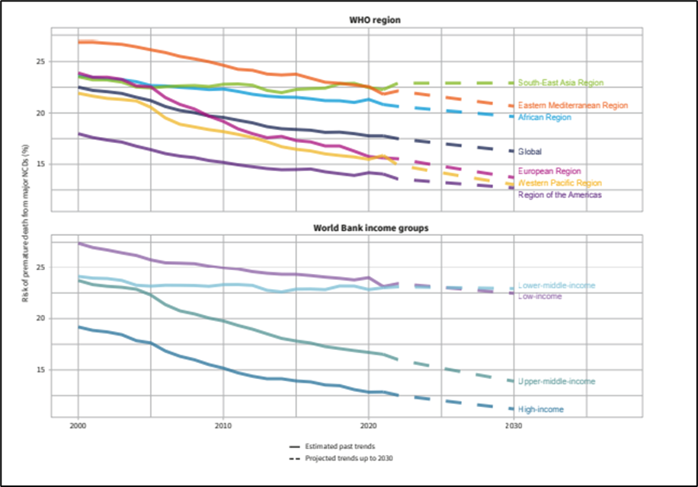
Figure 1: Global Burden of Cardiovascular Disease
and Mortality Trends
(
Source: World Health Organisation,
2025)
The
cardiovascular
disease
is
currently
one
of
the
leading
contributors
of
morbidity
and
mortality
in
the
world
and
has
become
a
big
burden
on
the
healthcare
systems
and
populations.

The
prevalence
of
heart
failure
alone
is
approximately
56.1

million
people
all
over
the
world,
so
cardiovascular
diseases
are
widespread and should be regarded
as the problem impacting health of
individuals as also mentioned in the
image
below
(
Johnson
and
Roth,
2025).

Moreover, the prevalence of premature deaths is also caused by thenon-communicable diseases, such as the cardiovascular disease, despite the shift in the lifestyle and the higher risks of getting non-communicable diseases with the exposure to behavioural risk factors like physical inactivity and unhealthy diet (World Health Organization, 2024). In addition to the loss of life expectancy, these conditions would result in disability and worsening of the quality of life, which further load the long-term services and support in terms of health care.
3

1.3 UK Prevalence and Burden
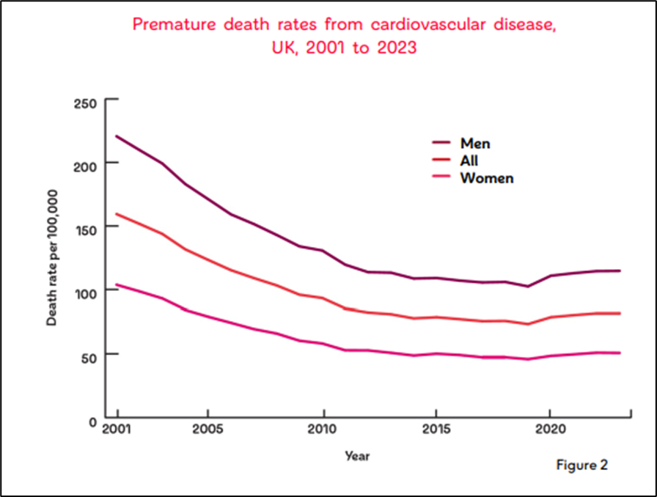
The cardiovascular disease is a major problem in the United Kingdom as approximately 8 million cases of the disorder were diagnosed in 2006, as well as the death rate of the condition was approximately 170,000 per year (British Heart Foundation, 2026; Figure 2). It is estimated to cause around 26 per cent of the entire mortality insinuating that it makes an enormous contribution to the health care burden and mortality rates in the country. It is also cardiovascular disease that promotes health inequalities as the individuals in the deprived communities experience more prevalence, earlier, and worse health outcomes compared to those in more of these rich communities (British Heart Foundation, 2025). All these emphasize on the importance of good
Figure 2: Premature Cardiovascular Disease prevention, early diagnosis and general management techniques in the healthcare system Mortality Trends in the UK of the UK (NHS England, 2024). As represented in
(Source: British Heart Foundation, 2026) the image below there are increasing rate of the
premature cardiovascular mortality.
2. Risk Factors of Cardiovascular Disease

2.1 Biological Risk Factors
The biological determinants are centred, as they increase the level of pressure of blood vessels slowly destroying arteries walls, leading to a heart attack, stroke, and heart failure (De la Maza-Bustindui et al., 2025; Figure 3). Uncontrolled high blood pressure can result in heart attack, stroke, and heart failure to a significant degree.
Effective management and a proper hypertension diagnosis, therefore, requires cardiovascular prevention (National Institute for Health and Care Excellence,2023). Diabetes is no exception with hypertension as it is also a major cause. The blood glucose may eventually damage the blood vessels and thus it is likely to be atherosclerotic and other related issues (Aleksandrowicz et al., 2025).
The other non-modifiable risk factor is age since the risk of cardiovascular disease is more in old age due to the natural changes in the vascular system. Susceptibility is also genetic in nature and mainly in such individuals who have a family history of premature cardiovascular events. These biological issues tend to correlate which adds to the overall risk and underlines the importance of the early risk assessment and clinical follow-up.
4
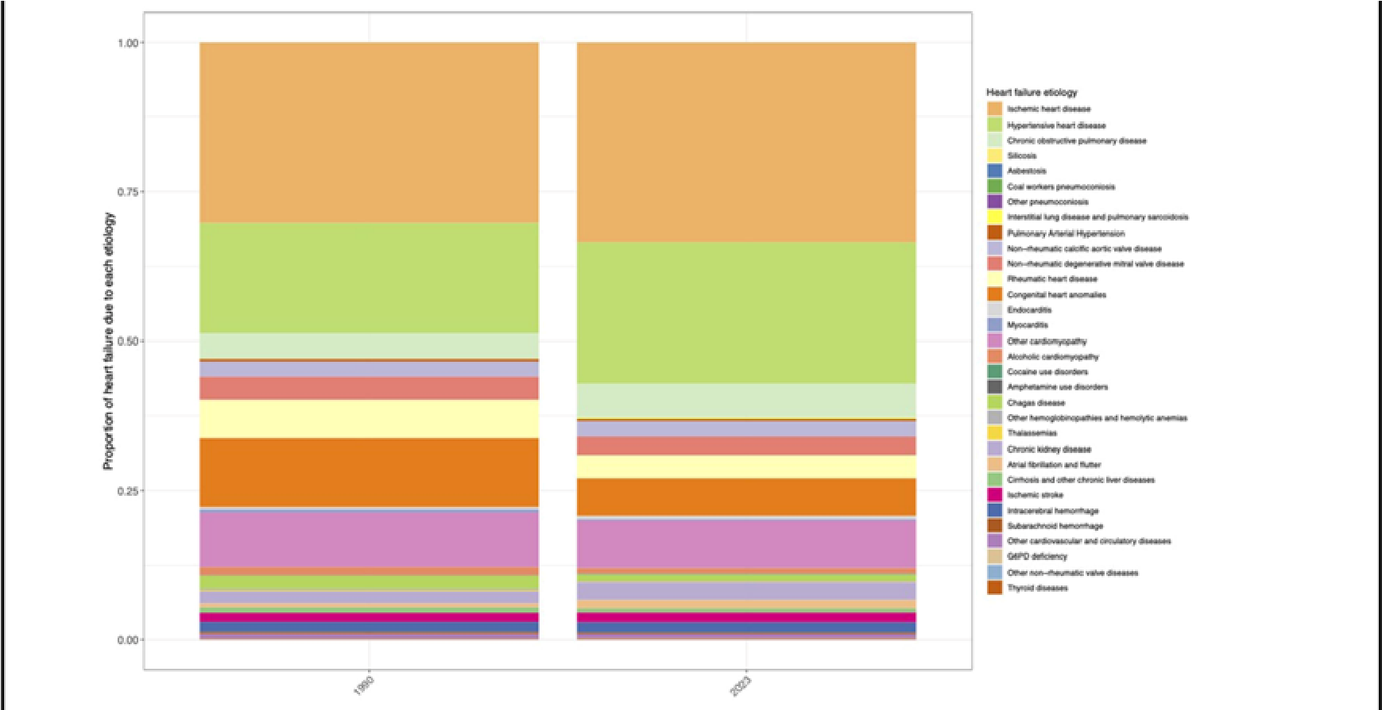
Figure 3: Proportion of Heart Failure
(Source: Johnson and Roth, 2025)

2.2 Lifestyle Risk Factors
Lifestyle behaviours are those behaviours that have a deep influence on the cardiovascular health. Smoking has been cited as one of the most prevalent causes of cardiovascular disease, which result in damages on arteries, reduction on oxygen supply, and clotting (World Health Organization, 2025). Similarly, hypertension, type 2 diabetes and dyslipidaemia, which are risk factors of cardiovascular issues are strongly correlated with obesity and excess body weight (Chakraborty et al., 2023). Exercise further goes hand in hand with this menace in aggravating metabolic fitness and heart conditioning. The diet is also significant. It is claimed that high saturated fat, salt, and processed food diets have led to the increase in cholesterol levels and hypertension, whereas the balanced diet including fruits, vegetables, and whole grains is beneficial in the prevention of the cardiovascular system (Vignesh et al., 2025).

2.3 Psychological Risk Factors
The mental well-being is also being regarded as a major cause of cardiovascular disease (McLeish et al., 2022). The biological mechanisms of stress response have been switched to the on position by the chronic stress, leading to an increase in the heart rate, rise in blood pressure, and inflammation, which will ultimately harm blood vessels. It is also directly physiological and indirectly through behaviours such as poor compliance with medications, unhealthy food consumption, and physical inactivity, which put depression and anxiety at risky predisposition to cardiovascular (Contrada, 2025).
Post-traumatic stress disorder and other stress related disorders have also been found to increase prevalence of the coronary heart disease. The associations between psychological variables and cardiovascular disease are complex and multicomponent, and the interplay of the emotional control, neuroendocrine responses, and behavioural inclinations. The outcomes of these findings give a background that cardiovascular disease is not merely a physical condition but rather a compounded group of broader psychological and social settings that must also be considered by means of prevention and control interventions.
5
3. Impact of Cardiovascular Disease on Patients and Families

3.1 Physical Impact
Cardiovascular disease may cause severe and chronic physical effects on patients (Sulashvili and Nimangre, 2025). Heart attack, stroke, and heart failure are some of the conditions that may cause low mobility and fatigue and physical weakness. A lot of people find it hard to carry out their daily functions like moving around, walking, or taking of stairs and even the routine chores. The elderly are especially susceptible due to ageing and underlying health issues that aggravate the level of cardiovascular complications and reduce the rate of recovery (Townsend et al., 2025).
ermanent neurological injuries may be the result of stroke, such as stroke-induced paralysis and speech disorders and difficulties with coordination; these greatly decrease the independence (Ma et al., 2025). Correspondingly, heart failure may result in difficulty in breathing, fluid retention and frequent hospitalization. The physical restrictions normally need long term treatment, rehabilitation and constant medical check-ups. Cardiovascular disease being a chronic illness, the patients often remain with persistent physical challenges that also influence their health and quality of life.

3.2 Psychological Impact
There is also a great psychological effect of cardiovascular disease. Most patients feel anxious, scared and emotional after getting a diagnosis or after undergoing significant events like heart attack or stroke. Depression is widespread and may have an adverse impact on recovery and the adherence of treatment (Contrada, 2025). The patients may not know what to expect as per their health in future and they may be fearful of further complications, which could be a cause of emotional stress.
Another outcome and a risk factor of chronic stress is cardiovascular disease (Woodward et al., 2025). It helps cause an elevation in blood pressure and detrimental physiological alterations, and even the diagnosis may cause emotional burden and disruption of lifestyle. Psychological distress can decrease the desire to adhere to treatment regimes, continue with healthy behaviours, or even receive follow-up care (Dirga, Muhktar and Permata, 2025). These aspects indicate the necessity of dealing with mental health as well as physical treatment.
6
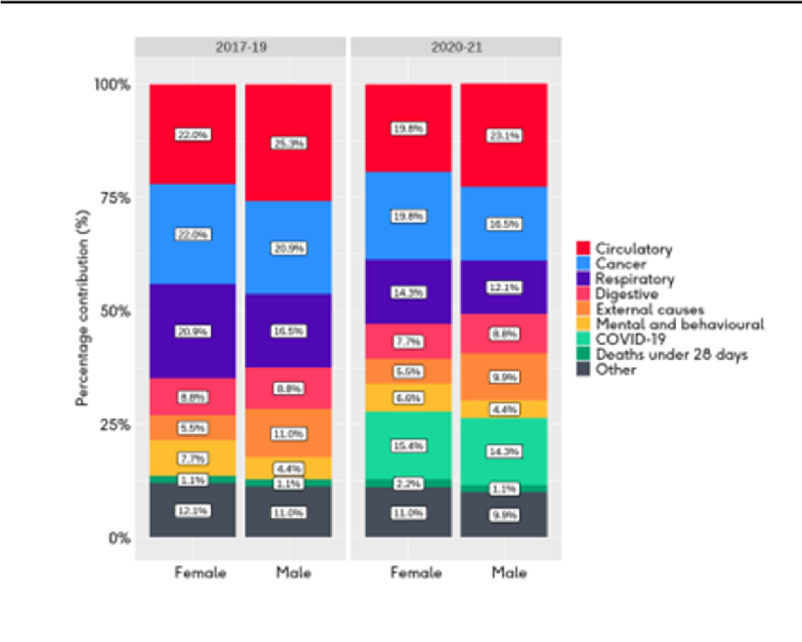
3.3
Social Impact

Social
and
economic
factors
are
the
significant predictors of cardiovascular
disease.
The
image
below
represent
that the health outcomes and the rates
of cardiovascular disease are worse in
individuals living in poor areas than in
communities
with
more
advantages
(
British
Heart
Foundation,
2025).
These
inequalities
are
caused
by
limited
access
to
healthcare,
preventive
services
and
health
education.
Figure 4: Contribution of Cardiovascular
Disease to Health Inequalities in England

Source: British Heart Foundation,
(
2025)
The
cardiovascular
disease
patients
can
also
feel
isolated
in
the
society
because
of
their
physical
incapacity
and changes in lifestyles. Care giving
is a role that family members assume,
and
this
may
cause
emotional
and
financial stress. These social
impacts
show that cardiovascular disease does
not only affect a patient; it also affects
his family and the community at large.
3.4
Economic Impact

The
cardiovascular
disease
is
a
significant
economic strain to the UK healthcare and the
population. In the United Kingdom, the overall
cost
of
cardiovascular
disease
in
2021-2022
was estimated to be £29.021 billion of which
healthcare costs and productivity losses were
included (Shih et al., 2025).
Direct costs are incurred during hospital care,
medication
and
long-term
treatment
whereas
indirect costs are incurred through low rates of
employment, retirement and informal care. The
overall
result
is
that
the
need
of
people
to
receive healthcare and the costs are likely to
surgeon
as
more
people
live
longer
with
cardiovascular
disease.
This
emphasises
the
need to prevent and manage the disease well
to
minimize
the
economic
cost
in
the
long
term.
7
4. NHS Treatment and Management

4.1 Medical Treatment


The prevention and treatment of cardiovascular disease in the NHS is aimed at decreasing the progression of the disease, its complications as well as enhancing the outcome of the patients. The medication is a highly essential component of therapy, particularly lipid-lowering medication such as statins, which is typically utilized to lower the concentration of cholesterol in addition to the risk of heart attack and stroke occurrence (National Institute for Health and Care Excellence, 2023). The antihypertensive medications are also applied to control the elevated blood pressure that is one of the major contributors of cardiovascular complications (National Institute for Health and Care Excellence, 2023).
In addition, they can prescribe antiplatelet drugs to reduce the probability of the formation of blood clots, particularly to the patients who have already had a heart attack or a stroke in the past (Jabbar et al., 2025). The treatments assist in enhancing blood flow and lower the risk of additional heart attacks. Clinical follow-ups should be normal to measure the effectiveness of treatment and to change medication where needed. The strategy facilitates the management of diseases in the long-term and prevents mortality and hospitalization.

4.2 Lifestyle Management
Lifestyle modification is one of the key aspects of management of cardiovascular diseases. The patients are educated on how to do more healthy behaviours, which include physical exercises, healthy diet, and smoking. The alterations work in the direction of the reduction of cardiovascular risk factors such as obesity, high blood pressure, and cholesterol (World Health Organization, 2025).
The healthcare workers become mentors and help the patients to change their lifestyle in a sustainable way. The preventive steps are also of particular importance to prevent the occurrence of diseases and improve the overall condition. Lifestyle management is an addition to medical treatment and is essential to improvement of long-term results.

4.3 Rehabilitation and Long-Term Care
Cardiac rehabilitation is a vital aspect of long-term care and recovery
(Damluji et al., 2025). It is supervised exercise, education, and psychological support to help the patients to come to normal and enhance their quality of life.
Long-term care also includes followup appointments, symptoms monitoring and assessment of risks as well as empower the patients to have healthy lives (British Heart Foundation, 2025).
It gives an opportunity to expose the complications at the initial stage and allows to manage the disease. The patient is under the constant care of the NHS; hence, the patient regulates cardiovascular disease and improved health outcomes.
8

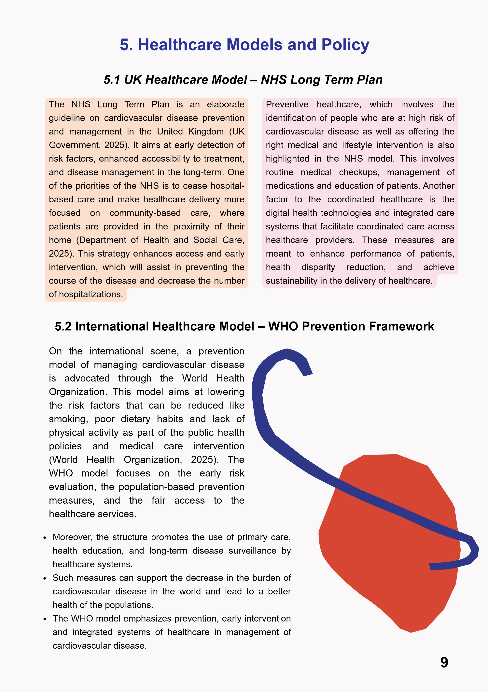


UK Healthcare Policy and Political Agenda
5.3
Cardiovascular disease is one of the major public health
priorities
in
the
UK
healthcare
policy,
and
national
strategies are aimed at preventing it, early diagnosis, as
well as effective management. The NHS Long Term Plan
is
expected
to
lower
the
mortality
rate
caused
by
cardiovascular diseases through early detection and the
increased use of community care (Department of Health
and Social Care, 2026).

The
necessity
of
decreasing
health
inequalities is also considered by the national
policy,
as
it
is
more
evident
among
the
deprived population where the cardiovascular
disease
prevalence
rates
and
premature
mortality rates are higher (Anand et al., 2025).

The
purpose
of
investing
in
integrated
care
systems
is
to
enhance
interaction
among
primary
care,
hospitals,
and
community
services to provide equal as well as uniform
care.
A
cardiovascular
disease
is
also
one
of
the
most
important
causes
of
premature
death
parliamentary
evidence,
which
necessitates
further
government
intervention
(
House
of
Commons Library, 2025).

Nevertheless,
the
shortage
of
workforce
and
growing demand on services pose a challenge
to
the
effective
policy
execution
as
well
as
access
to
timely
care
British
(
Medical
Association, 2024).
NICE Clinical Guideline Policy
5.4

The
NHS
is
influenced
by
evidenced
based
recommendations
that
give
clinical
decision-
making in the NHS.
National
Institute
for
Health
and
Care
Excellence
(2023)

or
NICE
guidelines
are
a
well-organized
prescription
regarding
cardiovascular
risk
assessment,
lipid
modification,
and
blood
pressure
management
(
National
Institute
for
Health
and
Care
Excellence, 2023).

These principles make sure that the decision on
treatment
is
guided
by
the
available
evidence
that is best, and favourable, safe, effective and
standardised care is promoted in all healthcare
settings.
10
6. Recommendations for Improving Care
Improving prevention   | It is important to reinforce prevention measures in order to mitigate the burden of cardiovascular disease. Healthy lifestyle programs such as cessation of smoking, healthy eating, and exercise should be promoted through the use of public health programs. Disease progression may be prevented by identifying the risk people at risk early with the help of regular health checks, and this will lead to better long-term outcomes (World Health Organization, 2025). A higher awareness and access to preventive services is of high significance especially in reducing risks on the population level.
  Improving NHS  treatment services | Improved availability of timely diagnosis and treatment can be  used to enhance patient outcomes and complications. The risk of  cardiovascular issues can be minimized with the help of regular  use of evidence-based interventions, including statins and blood  pressure management (National Institute for Health and Care  Excellence, 2023). Effective disease management can be further  enhanced by strengthening the primary care services and the  clinical monitoring.
Improving patientcentred care and Reducing inequality   | Patient-centred care needs to be individualized, based on needs, tastes, and long-term assistance. The access to rehabilitation, education, and psychological support can be improved, which will improve recovery and quality of life. Moreover, special actions are required to prevent healthcare inequality, especially in underprivileged areas, where cardiovascular disease rates are greater (British Heart Foundation, 2025). The Self-management strategies like the structured education and the remote monitoring are also essential to take care of. For the person having advanced issues cardiovascular disease, end-of-life care discussions and planning is also necessary while having necessary planning.

7. Conclusion
Cardiovascular disease continues to pose a significant health issue affecting the people of the UK and the international community as it is a leading cause of mortality, disability, and healthcare cost. Prevention, evidence-based treatment, and patient support in the long run have to be combined to achieve proper management. NHS policies and clinical guidelines are very fundamental in enhancing the quality of care as well as minimizing risk. Enhancing prevention and seeking equal opportunities of access to healthcare services are essential in enhancing patient outcomes and minimizing the overall effect of cardiovascular disease.

11

Reference List
Aleksandrowicz, M., Konop, M., Rybka, M., Mazurek, Ł., Stradczuk-Mazurek, M., Kciuk, M., Bądzyńska, B., Dobrowolski, L. and Kuczeriszka, M., (2025). Dysfunction of microcirculation in atherosclerosis: implications of nitric oxide, oxidative stress, and inflammation. International Journal of Molecular Sciences, 26(13), p.6467. Available at: https://www.mdpi.com/14220067/26/13/6467 (Accessed on 20 February 2026)
Anand, S.S., Kandasamy, S., Marchand, M., Kavousi, M., Gulati, M., Deanfield, J. and Quyyumi, A.A., (2025). Reducing inequalities in cardiovascular disease: focus on marginalized populations considering ethnicity and race. The Lancet Regional
Health–Europe, 56. https://www.thelancet.com/pdfs/journals/lanepe/PIIS2666-7762(25)00163-2.pdf
British Heart Foundation (2025). Socioeconomic inequalities in heart and circulatory diseases in England: an analysis. Available at: https://www.bhf.org.uk/-/media/files/what-we-do/our-research/heart-statistics/health-inequalities/socioeconomic-inequalities-inheart-and-circulatory-diseases-in-england.pdf?
rev=d29adfff59124633a1127873016a367a&hash=FFE5E71E11B6A6939AB006FA41BB185F (Accessed on 20 February 2026).
British Heart Foundation (2026). UK Cardiovascular Disease Factsheet. Available at: https://www.bhf.org.uk/-/media/files/forprofessionals/research/heart-statistics/bhf-cvd-statistics-uk-factsheet-jan26.pdf?rev=26534e1487094dbd806277891baef112 (Accessed on 20 February 2026).
British Medical Association (2024). Analysis of the NHS Long Term Plan. Available at: https://www.bma.org.uk/advice-andsupport/nhs-delivery-and-workforce/the-future/analysis-of-the-nhs-long-term-plan (Accessed on 20 February 2026).
Chakraborty, S., Verma, A., Garg, R., Singh, J. and Verma, H., (2023). Cardiometabolic risk factors associated with type 2 diabetes mellitus: a mechanistic insight. Clinical Medicine Insights: Endocrinology and Diabetes, 16, p.11795514231220780. https://journals.sagepub.com/doi/pdf/10.1177/11795514231220780
Contrada, R.J., (2025). Stress and cardiovascular disease: the role of affective traits and mental disorders. Annual Review of Clinical Psychology, 21(1), pp.139-168. https://www.annualreviews.org/content/journals/10.1146/annurev-clinpsy-081423-023833? crawler=true&mimetype=application/pdf
Damluji, A.A., Tomczak, C.R., Hiser, S., O’Neill, D.E., Goyal, P., Pack, Q.R., Foulkes, S.J., Brown, T.M., Haykowsky, M.J., Needham, D.M. and Forman, D.E., (2025). Benefits of cardiac rehabilitation: mechanisms to restore function and clinical impact. Circulation research, 137(2), pp.255-272. https://www.ahajournals.org/doi/pdf/10.1161/CIRCRESAHA.125.325705
De la Maza-Bustindui, N.S., León-Álvarez, M., Ponce-Acosta, C., Zarco-Morales, K.P., Fermín-Martínez, C.A., Antonio-Villa, N.E. and Bello-Chavolla, O.Y., (2025). Impact of cardiometabolic risk factors and its management on the reversion and progression of arterial stiffness. npj Cardiovascular Health, 2(1), p.36. https://www.nature.com/articles/s44325-025-00074-6.pdf
Department of Health and Social Care (2026). Cardiovascular disease. Available at: https://fingertips.phe.org.uk/profile/cardiovascular (Accessed on 20 February 2026).
Dirga, A., Muhktar, N. and Permata, I., (2025). Health Psychology Approaches to Improving Treatment Adherence Among Patients with Chronic Illnesses. Magenta Journal De Healthymedi, 2(1), pp.33-34. https://gensain.com/index.php/mjdh/article/download/267/216
House of Commons Library (2025). Prevention of cardiovascular disease. Available at: https://commonslibrary.parliament.uk/research-briefings/cdp-2025-0034/ (Accessed on 20 February 2026).
Jabbar, K., Advani, R.S., Kirmani, S.A.H., Ahmad, H. and Ali, S., (2025). Advances in Antithrombotic Therapy: A Review of New Antiplatelet and Anticoagulant Medications in Cardiovascular Disease. Indus Journal of Bioscience Research, 3(4), pp.69-78.
https://www.ijbr.com.pk/IJBR/article/download/1071/991
Johnson, C. and Roth, G.A., (2025). Global aetiologies of heart failure: results from the Global Burden of Disease Study 2023. European Heart Journal, 46(Supplement_1), pp.ehaf784-1065. Available at: https://doi.org/10.1093/eurheartj/ehaf784.1065 (Accessed on 20 February 2026).
Ma, Y.N., Karako, K., Song, P., Hu, X. and Xia, Y., (2025). Integrative neurorehabilitation using brain-computer interface: From motor function to mental health after stroke. Bioscience trends, 19(3), pp.243-251. https://www.jstage.jst.go.jp/article/bst/19/3/19_2025.01109/_pdf
McLeish, A.C., Smith, T., Riggs, D.W., Hart, J.L., Walker, K.L., Keith, R.J., Anderson, L., Sithu, I., Pinilla‐Baquero, J., Srivastava, S. and Bhatnagar, A., (2022). Community‐based evaluation of the associations between well‐being and cardiovascular disease risk. Journal of the American Heart Association, 11(22), p.e027095. https://www.ahajournals.org/doi/pdf/10.1161/JAHA.122.027095 National Health Service (2026). Cardiovascular disease. Available at: https://www.nhs.uk/conditions/cardiovascular-disease/ (Accessed on 20 February 2026).
National Institute for Health and Care Excellence (2023). Cardiovascular disease: risk assessment and reduction, including lipid modification. Available at: https://www.nice.org.uk/guidance/ng238/resources/cardiovascular-disease-risk-assessment-andreduction-including-lipid-modification-pdf-66143902851781 (Accessed on 20 February 2026).
National Institute for Health and Care Excellence (2023). Hypertension in adults: diagnosis and management. Available at:
https://www.nice.org.uk/guidance/ng136/resources/hypertension-in-adults-diagnosis-and-management-pdf-66141722710213 (Accessed on 20 February 2026).
NHS England (2024) Cardiovascular disease prevention and management. Available at: https://www.england.nhs.uk/ourwork/clinical-policy/cvd/ (Accessed: 20 February 2026).
Shih, K., Herz, N., Sheikh, A., O'neill, C., Carter, P. and Anderson, M., (2025). Economic burden of cardiovascular disease in the
United Kingdom. European Heart Journal-Quality of Care and Clinical Outcomes, 11(5), pp.678-690. https://academic.oup.com/ehjqcco/article-pdf/11/5/678/62115255/qcaf011.pdf
Sulashvili, N. and Nimangre, R.R., (2025). Manifestation of some aspects of cardiovascular diseases, implications, pharmacotherapeutic strategies, effects, impacts and potential hazards in general. Junior Researchers, 3(1), pp.1-27. https://journals.4science.ge/index.php/jr/article/download/3393/3403
Sun, P., Wan, Z. and Liu, Y., (2026). Towards Comprehensive Chronic Disease Control: Prevention, Early Detection, and Integrated Management. Medicine Bulletin. https://onlinelibrary.wiley.com/doi/pdf/10.1002/mdb2.70020
Townsend, N., Timmis, A., Erglis, A., Miličić, D., Perrone-Filardi, P., Weidinger, F., Guzik, T. and Gale, C.P., (2025). Challenges in the prevention, treatment and management of cardiovascular disease among older adults. The Lancet Regional Health–Europe,
56. https://www.thelancet.com/pdfs/journals/lanepe/PIIS2666-7762(25)00164-4.pdf
UK Government (2025). FIT FOR THE FUTURE: 10 Year Health Plan for England. Available at:
https://assets.publishing.service.gov.uk/media/6888a0b1a11f859994409147/fit-for-the-future-10-year-health-plan-for-england.pdf (Accessed on 20 February 2026).
Vignesh, A., Amal, T.C., Shanmugam, A., Vasanth, K. and Selvakumar, S., (2025). Effects of dietary approaches to prevent hypertension and enhance cardiovascular health. Discover Food, 5(1), p.9. https://link.springer.com/content/pdf/10.1007/s44187-
025-00278-w.pdf
Woodward, W., Johnson, C.L., Krasner, S., O’Driscoll, J., McCourt, A., Dockerill, C., Balkhausen, K., Chandrasekaran, B., Firoozan, S., Kardos, A. and Sabharwal, N., (2025). Long-term outcomes after stress echocardiography in real-world practice: a 5year follow-up of the UK EVAREST study. European Heart Journal-Cardiovascular Imaging, 26(2), pp.187-196. https://academic.oup.com/ehjcimaging/article-pdf/26/2/187/60968394/jeae291.pdf
World Health Organization (2024). cardiovascular diseases. Available at: https://www.who.int/europe/news-room/factsheets/item/cardiovascular-diseases (Accessed on 20 February 2026).
World Health Organization (2025). Cardiovascular diseases (CVDs). Available at: https://www.who.int/news-room/factsheets/detail/cardiovascular-diseases-(cvds) (Accessed on 20 February 2026).
World Health Organization (2025). World health statistics 2025. Available at: https://iris.who.int/server/api/core/bitstreams/c992fbdc-11ef-43db-a478-7e7a195403ae/content (Accessed on 20 February 2026).
12

