DECLARATION

This work has not previously been accepted in substance for any degree and is not being concurrently submitted in candidature for any degree

Signed Jessica Rachel Lewis

Date 5th April 2019

STATEMENT 1
This dissertation is being submitted in partial fulfilment of the requirements for the degree of BA.

Signed Jessica Rachel Lewis

Date 5th April 2019

STATEMENT 2
This dissertation is the result of my own independent work/investigation, except where otherwise stated.

Other sources are acknowledged by footnotes giving explicit references. A bibliography is appended.

Signed Jessica Rachel Lewis

Date 5th April 2019

STATEMENT 3
I hereby give consent for my dissertation, if accepted, to be available for photocopying and for interlibrary loan, and for the title and summary to be made available to outside organisations.

Signed Jessica Rachel Lewis

Date 5th April 2019

STATEMENT 4

I hereby give consent for my dissertation, if accepted, to be available on the university’s IT system to those who have consent to use the system.

Signed Jessica Rachel Lewis

Date 5th April 2019

Is there a Mental Health Crisis with children and young adults aged 11-20 in the UK?

Jessica Rachel Lewis
P151709
5th April 2019

Dissertation submitted as part of the requirements for the award BSc (Hons) Health and Social Care.

Abstract
Is there a mental health crisis for children and young adults aged 11-21 in the UK? Research has shown that childhood is a period of increased risk of emotional, social, physical and psychological development. This could have a significant impact on a child’s mental health. Government and charitable reports suggest there is an increased demand on Child and Mental Health Services with patients waiting sometimes up to sixty days to access treatment. This study aims to establish if a mental health crisis is happening in young people in the UK.

Literature reviews were critiqued using a critical appraisal tool, CASP. This tool ensures that only the most salient, up-to-date literature is used.

The literature highlighted three prominent themes: bullying, social media and sleep deprivation. Depression and anxiety re-occurred significantly in each theme.

The results strongly suggest in the majority of studies that there is an increasing number of children and young adults suffering from mental health issues.

In view of these findings, it is recommended that Government funding be substantially increased to provide more mental health professionals, reduce waiting times, and that school staff are provided and trained to recognise signs of mental health issues, offer information, support and early intervention.

Acknowledgments

I would like to thank my supervisor Ben Duxbury for the support and guidance throughout the year. I would also like to thank my mother, Aly Flint, Fran and David Eddon for filling me with confidence and belief. Thank you.

Content Page
Declaration | 1
Tittle Page | 2
Abstract | 3
Acknowledgment | 4
Content page | 5
Chapter One | 6
1.1 Introduction | 7-10
1.2 Justification | 11
1.3 Aim and Objectives | 12
Chapter two | 13
2.1 Methods and Methodology | 13-16
2.2 Ethical Consideration | 17-18
2.3 Creation of themes | 19
Chapter three | 20
3.1 Theme one | 20-25
3.2 Theme two | 26-30
3.3 Theme Three | 31- 34
Chapter four | 35
4.1 Discussion | 35-42
4.2 Conclusion | 43
4.3 Recommendations | 44
Gantt Chart | 45
References | 46-61
Bibliography | 62
Appendix A: CASP | 63-72
Appendix B: Search Strategy  Appendix C: Creation of Themes | 73-80  81-83
Appendix D: Cronbach Alpha | 84

Chapter one
Introduction
This dissertation aims to explore the mental health crisis that society faces with children and young adults in the United Kingdom (UK). Gladerisi et.al (2015, p.231) defines mental health as “a state of wellbeing in which the individual realises his or her own abilities to cope with the normal stresses of life, can work productively and fruitfully and can make a contribution to his or her community.” However, according to Stubbs (2018), mental health is more than the absence of mental illness and is related to the social and emotional wellbeing of an individual and communities. Stubbs (2018) explains that culture can play a big part in mental health, as it refers to the enjoyment of life, the ability to be able to cope with emotions, such as stress, sadness, the lack of fulfilled potential and a connection to other individuals.

The Mental Health Services (2015) state that poor mental health has become one of the leading causes of disease burden worldwide, with the UK becoming one of the main countries to experience a mental health condition. Wongkoblap et al. (2017) explain that over twenty-five percent of the population are suffering from a mental health condition.

Whilst, Sadler et al (2018) note that government statistics indicate the number of children and young adults suffering from a mental health disorder in the UK in 2017 is one in eight children.

The NSPCC (2019) state that a child is an individual that has not yet reached their eighteenth birthday; once the child turns eighteen, they are then legally classed as young adult.

Lelliott et al. (2017) explain that childhood is an essential element of the child’s life due to emotional, social, physical and psychological development and that this development can have a significant impact on a child’s mental health. Similarly, Kenny et al. (2016) declare that twenty percent of young adults are also suffering from mental health disorders. As a consequence of this, Sadler et al. (2018) explain that emotional disorders have become the most prevalent in young adults.

According to Burton et al. (2014) children are not too young to experience a mental health condition, those who have experienced maltreatment can exhibit cognitive symptoms such as post-traumatic stress disorder (PTSD).

According to The Children’s Society (2008), ten percent of children and young adults aged between five and sixteen years have a clinically diagnosable mental health condition, and seventy percent of children and young adults who have experienced mental health have not had appropriate interventions at an early age. Moreover, the Department of Health (2011) explains that most individuals that experienced a mental health issue will have their first symptom emerge before fourteen, although three quarters may be diagnosed by their middle twenties (Burton, et al 2014). The NHS (2018) note, in 2017, one in eight, five to nineteen-year-olds in England were diagnosed with a mental health disorder. These disorders were significantly higher in females with anxiety disorders and depression (NHS, 2018).

The Welsh Government (2017) state Child and Adolescents Mental Health Services (CAMHS) is a professional service that children and young adults who may be experiencing a mental health condition can access. The Mental Health Services (2016) state that CAMHS referrals to accessing treatment in Wales between April 2010 and July 2010 have doubled, with one thousand, 138 children and young adults attempting to access the service. In other words, this suggests that it is difficult to secure an appointment with CAMHS immediately. According to the National Assembly for Wales (2018), the Children, Young people and Education Committee (predecessor committee) have recently confirmed that in 2014 there was a large number of children and young adults using specialist CAMHS. However, they were referred wrongly. The National Assembly for Wales (2018) committee argues that not enough has been done to help prevent mental health from 2014 to 2018.

Similarly, a report by Barrance (2018) states that the target for patient waiting time for CAMHS was estimated at twenty-eight days. But this target was not met. In August 2017 only 39.4 % were seen by a CAMHS specialist within the four weeks waiting period.

Public Health England (2016) emphasize there has been a recent drive to make substantial improvements to mental health services across the UK, due to the increase in mental health conditions and disorders in children and young adults due to increasing demand. Jennings et al. (2018) report that appointments to CAMHS has risen by 26% over the last five years. This suggests that CAMHS mental health services are struggling with the increasing demand with appointments and treatment. Jennings et al. (2018) explain that CAMHS main priority are behavioural, emotional and mental health difficulties (The Welsh Government, 2017). Jennings et al. (2018) highlight that the average waiting time to be seen by a CAMHS specialist has been reported to be thirty-four days. However, it can take up to sixty days to commence treatment.

Moreover, the longest waiting time was reported at one hundred and eighty-eight days in 2017/18 (Jennings et al, 2018). The lengthening waiting times emphasises that there is an increasing demand for intervention in child and young adult’s mental health conditions in the UK.
Young Minds (2019) argue that over five hundred children needed tier three CAMHS in 2017/18 and have waited over a year to begin treatment. However, only 14% of children are able to start treatment within four weeks of being assessed. This suggests if waiting times continue to increase for children and young adults the UK there could be a risk of significant damage to these young children and adolescents.

Justification of Study
It is important to explore the mental health crisis as a report by Earle (2016) state that a survey by Royal College of Psychiatrists found there was a significant difficulty with the shortage of beds available for young adolescents despite twenty-five percent of young people reporting they self-harm. Further, this left patients over one hundred miles away from home or without a bed. Fahy et al. (2017) state that with the UK leaving the European Union (EU), this could have profound consequences for the National Health Services (NHS) as the EU is an important source of capital investment. Fahy et al. (2017) explain that if this affects the UK economy, this may have a significant effect on the funding towards the NHS and mental health services. Ultimately, this implies there will be a decrease in funding and an increase in demand for health services.
Mughal et al. (2016) stress the importance of healthy wellbeing. They state that mental health can have a significant effect on the physical, educational and social development of children with enduring consequences in adulthood. The Office of National Statistics (2018) state that in 2017 the UK experienced up to 5,821 of suicide. Similarly, Appleby et al. (2017) explain a report by National Confidential Inquiry into Suicide and Homicide (NCISH) revealed 137 suicides occurred between the year 2003 and 2013 in people under 20. Further, 60 suicides were people below the age of 18 in England.

Aim and Objectives
The aim of this dissertation is to review the current literature regarding mental health, by providing evidence to determine if there is a mental health crisis for children and young adults in the UK. This project will set out to meet the following four objectives listed below:

- To explore literature on the affect mental health has on children and young adults.
- To examine the mental health crisis while providing relevant research
- To evaluate the themes affecting children and young adults whilst using academic resources.
- To discuss the literature and provide recommendations for the future

The first chapter of this project has provided important background knowledge in regard to mental health. By exploring government and mental health charity reports relevant to child and young adult’s mental health in the UK. Equally important, a justification to ensure important issues has been discussed in order to understand why research needs to be carried out. Finally, the first chapter provides the aim of the project and four objectives that will potentially answer the research question. The next chapter of this project will cover methodology, methods and ethical consideration and its importance.

Chapter two
Methodology and Methods
Regarding the importance to literature, Daniel et al. (2011, p.15) stress the importance of research. They believe research is a search for knowledge and define research as ‘a scientific and systematic search for pertinent information on a specific topic.’ Daniel et al. (2011) explain that the purpose of research is to investigate and discover the possible answers to a question by exploring the truth. This can be done by conducting a literature review. Aveyard (2014) states that a literature review is a comprehensive study that relates to a particular subject. She notes that when an individual undertakes a literature review, a research question must be identified, and the possible answers explored. Aveyard (2014) notes that this can be done by searching and analysing the current literature available to the chosen question. Machi et al. (2009, p.4) define a literature review as ‘a document that presents an argued case for credible evidence founded by previous research.’ Onwuegbuzie et al. (2016) state that a literature review represents a methodology because it includes a broad approach to scientific research. That includes a research question, research purposes, objectives and uses methods and procedures.

Machi et al. (2009) clarify that each section of the literature review must be compatible, for instance, searching for the correct literature, developing the argument and critiquing the literature. Moreover, this will support optimal results. Aveyard (2014) state that the importance of a literature review is to seek and summarize the current literature on a specific topic. Therefore, this suggests that this is vital as it increases the current literature available for health and social care professions. Moule (2015) notes that evidence-based practice is essential when conducting a literature review as it requires current evidence needed for the review. Moule (2015) explains that the most effective intervention is to identify the issue and turn it into a question. By doing so, a thorough critique, analysis, and evaluation can be accomplished. Ultimately, this will help when conducting the literature review, as it highlights the critical factors to consider when writing the review.

Jesson et al. (2011) explain that a systematic review can be described as working systematically in a methodical way. To clarify, the researcher will take a systematic approach and work in order. Walliman et al. (2009) state that a systematic review refers to the concise summary of the essential available data that will sharply address a defined clinical question. Clarke (2012) declares a systematic review is a reliable source of evidence as its primary focus is to collect and critically analyse secondary information. The purpose of the systematic approach is that it will collect the most necessary information for the question. Booth (2016) state that conducting a systematic review will also ensure the researcher is not biased and shows a comprehensive knowledge of the chosen question. For instance, when an individual is biased towards their beliefs of the question, this could influence the overall result. Therefore, this is important to take into consideration when researching and writing the review to ensure evidence-based practice is applied throughout to conclude with an honest answer.

Public Health Resource Unit (2006) note that an advantage of writing a systematic review is that it can show a clear understanding of how findings can be applied to everyday practice can be applied. By conducting a systematic literature review, this will bring depth to an issue that is affecting society. However, a disadvantage of a systematic review is the time consumption, as it requires producing the work, evidencing the themes and concluding an answer. Secondly, the question may lack evidence of the chosen topic for example, if the issue is relatively new and not much research has been applied. Despite this, a systematic review summarizes research evidence from a range of different resources. This will help evidence-based practice and help with concluding an overall answer.

As regards methods, a research strategy will be carried out throughout the findings section of the dissertation. This includes the aim of the study, a section providing databases used and a section available to help the reader understand where research was discovered. The research strategy aims to demonstrate the importance of key terms, search number results and if the resources used were relevant to the study. Hill et al. (2012) note the importance of being able to utilize consistent terminology as the convergent measures allow the researcher to build a foundation of better understanding. A search strategy will also ensure that the sources used are relevant and build a better understanding of what research is being conducted and how it was conducted. For instance, a research strategy and correct terminology throughout the literature review will show consistency, accuracy, and relevance to the topic, while the sources used will ensure organisation throughout the assignment. A disadvantage to a search strategy would be the time that needs to go into the strategy ensuring no information is forgotten. (re: Appendix. B).

A critical appraisal critiquing tool is to be utilised throughout the literature review. The tool chosen is CASP. CASP (2018) explains that this tool enables individuals to assess the relevance of a journal article systematically. Public Health Resource Unit (2006) state CASP is a tool created to develop efficient, evidence-based approach research for health care professions. This appraisal program has over twenty-five years of expertise. It includes a checklist of 10 questions to help the researcher read the research (Public Health Resource Unit, 2006). CASP will also help organise the most important journals when conducting research (CASP, 2018). Singh (2013) states that using this critical appraisal tool should improve the quality of the research provided by screening out any poor-quality research. CASP (2018) states research for a systematic review would be strengthened if it entails quantitive studies, qualitative studies, cohort studies, randomised controlled trials and case studies. A disadvantage of using CASP throughout this project is how time-consuming the tool is when critiquing the relevance of the study. This suggests that by using CASP throughout this project, the tool will help eliminate any poor-quality journals, by going through the ten questions asked. Therefore, providing a systematic way of assessing the validity of the results. This will be beneficial for the project and prevent any possible errors. (re: Appendix A for CASP Checklist.)

Initially, the search method used to collect literature involved manual search using databases such as Google Scholar, UWTSD Library, Google books, Sage Publications, National Centre for Biotechnology Information (NCBI), British Medical Journals (BMJ). Other resources involved are Governmental Reports, Google and books. Terminology was searched through key terms such as ‘Mental Health’, ‘Children’s Mental Health’ ‘[Mental Health+Children+UK] ‘Young adults’ ‘Mental Health Crisis’ ‘Teenage Mental Health’ ‘Adolescent Mental Health’. By using key terms while searching for literature, it was possible to utilise the most specific journals, books, articles to use when collecting literature. (re: Appendix B for).

Ethical Consideration
Castellano (2004, p.99) defines ethics as ‘a rule of conduct that reinforces and expresses important social and cultural values to society.’ She also explains that the rules for ethical research should be formal and easy to understand. Castellano (2004) notes that the ethical code will place emphasis on informed consent and reduce risk incurred by participants.

Ethical consideration will not be essential for this project as it is a systematic literature review which does not include empirical research. A systematic literature review will search for primary and secondary information which has already been conducted. However, the literature discovered will stay within ethical boundaries.

According to The British Psychological Society (2009), informed consent is a crucial primary principle for research ethics. When research ethics is carried out participants will be informed about the nature of the research. Researches will follow procedures of ensuring they have provided significant information including the methods, purpose, and future of the research including all risks.

Powell et al. (2012) state that the ethical issues of consent have generated debates regarding research involving children and four core ethical principles. These being; written and verbal consent that the participants have been informed and understand the research being conducted and that the consent must be renegotiable and voluntary (Powell et al, 2012).

Sanjari et al. (2014) note the relationship between the researcher and participants are crucially important. This is because researchers face potential issues such as respect of privacy of the participant and avoiding misrepresentation. In addition, ethical consent should be taking significantly when carrying out confidentiality (Sanjari et al, 2014). Although this project does not involve ethical consideration, it is essential to understand why ethics are used and applied in research.

Creation of Themes
Thematic analysis is important when evidencing the themes for the review. Polit et al. (2009) explain that thematic analysis will show the consistent and inconsistent patterns found. They explain this can help with identifying the themes. Graham et al. (2017) state a theme should contain a thorough analysis including an overall account of the data. That is, what are the patterns of evidence, how persuasive is the argument, how strong are the effects and the consistency of the evidence (Polit et al, 2009). This indicates that by conducting a thematic analysist throughout the research, this will give the understanding to help pick the strongest recurring themes. Pope et al. (2007) state that the strength of thematic analysis is that it provides a means of organisation, that helps summarise the findings from a large body of research. However, this can be associated with a lack of transparency. To clarify, this can make it more difficult for the reader to be aware of what stage themes were identified.

While conducting the literature review into reasons for the current increase in mental health amongst children and young adults, various themes were discovered in the academic literature. Given its limitations; however, three themes were prominent, bullying, social media and sleep deprivation. Each theme has been evidenced by highlighting the key terms in the search strategy. (re: Appendix. C).

The Guardian (2018) stresses the key demographic appears to be with children and young adolescents, and they stress that large financial investment needs to be implied to prevent a lifetime of damage for children and young adults.

The next part of this dissertation consists of the results section; and begins by considering the link between poor mental health and bullying.

Chapter Three
Bullying
(Vaillancourt, et al. 2017, p. 368) defines bullying as ‘an aggressive behaviour that is intentional, directed at people who hold less power than the aggressor. Bullying can take on many forms, verbal, physical and social’. An article by Busby (2017) states that children who experience bullying are more likely to suffer from a mental health condition. Further, Patalay et al. (2016) state that given the amount of time a child and young adolescent spend in school, the structure to ensure planned provision and intervention with mental health is not considered a priority. Yet schools are a key setting for mental health conditions (Patalay, 2016). For this reason, Elgar et al. (2014) and Landstedt et al. (2014) both highlight that children and young adults who are a victim of bullying can suffer serve health concerns. In particular, depression, anxiety, self-harm or suicidal ideations.

Bullying can manifest itself in different forms (Landstedt, et al. 2014). There is a key distinction between face to face bullying known as ‘traditional’ and online cyberbullying (Landstedt, et al 2014). It has been noted by Elgar et al. (2014) that around one in five young adults will experience this form of abuse in the UK whether it be online or traditional. Landstedt et al. (2014) argue cyberbullying can make an individual feel harassed continuously as it can reach the victim anywhere. Electronic bullying known as online bullying can also stay anonymous, meaning there is a risk of increased cruelty towards the individual, for instance, body shaming and name calling (Landstedt, et al 2014). Macaulay et al. (2018) emphasise how distressing bullying can be for a victim. Suffering can range from psychological distress to suicide. It appears that bullying is an important component in mental health and psychological distress on individuals (Macaulay, et al 2018).

A study by Fahy et al. (2016) sets out to uncover the association between mental health in children, young adolescents and cyberbullying. Participants (n=2480) were involved. Teenagers aged 12-13 years were invited across 25 schools with 55.2% of boys and 44.8 % of girls in the UK. Ethical consideration was approved by Queen Mary University of London Ethics Committee. The study aimed to measure the consequences of cyberbullying and the mental health of the children to understand if bullying is a contributing factor towards a mental health crisis. Fahy et al. (2016) conducted a qualitative short mood and feelings questionnaire (SMFQ), the scale has a total of thirteen questions and is used to measure the depressive symptoms of young adults. The scale consists of the following three options: ‘Not true’ ‘Sometimes true’ and ‘true’. The scores range from 0-26, zero meaning fewest symptoms and twenty-six for most symptoms. Rhew et al. (2010) explain that the SMFQ scale is a good alternative to identify young adolescents at risk of mental health conditions. Similarly, Hoare et al. (2016) also highlight how research supports using the SMFQ in measuring the symptoms of depression in young adolescents to be effective.

A second measure used to evaluate mental health condition that Fahy et al. (2016) used in the study was, a mini social phobia inventory (MINI SPIN). This is a scale designed to measure social anxiety. The scores range from 0-12 with greater than six indicating there are significant symptoms with social anxiety.

The last scale used in Fahy et al. (2016) study was to measure mental health and wellbeing, Warwick- Edinburgh Mental-Being Scale (WEMWBS). This scale ranges from 14-70 with fourteen being the lowest score and seventy being the highest, Clarke et al. (2011) state measuring children and young adult’s mental health is a priority, and the WEMWBS is a validated tool purposely to measure the wellbeing of participants.

Fahy et al. (2016) results indicate that 42% of participants had reported being involved with cyberbullying over 12 months, with 8.2% admitting being cyber bullies. Regarding the mental health and wellbeing of the participants, 24.8% of the participants had reported depressive symptoms while 28.8% of participants reported social anxiety with females more likely to report depressive symptoms than males. This indicates that over half of the participants have screened positive for a mental health condition as a result of being bullied.

In summary, Fahy et al. (2016) state that victims of cyberbullying were twice as likely to report substantial depressive symptoms. Comparably, participants of cyber- victims reported social anxiety symptoms compared to those uninvolved. Ultimately, cyberbully victims reported below average mental well-being than those not affected by bullying. Therefore, this study suggests there is a high prevalence in depressive symptoms, social anxiety, and below average wellbeing. Consequently, it could be argued that cyberbullying may lead to mental health conditions in young adults.

In contrast, Goswami (2012) sets out to investigate bullying and mental health while contrasting positive and negative relationships children had with their family, friends and bullying. Gowsami (2012) conducted a study in England involving (n=4673) children and young adolescents in primary and comprehensive school. The participants were aged 10 and 15. The study consisted of two samplings the first for primary school children, and the second for comprehensive students. Initially the study consisted of (n=6744) young people; however, Gowswami (2012) excluded year six primary children due to cognitive testing because he deemed it inappropriate regarding questions on relationships. Female participants outnumbered males with 53/47 with 83% of the participants identifying themselves as white British. The other minority of participants identified as Bangladeshi, Indian, black African and Pakistani. The measure used to conduct the study is a qualitative life satisfaction scale which required participants to answer, ‘strongly agree’ or ‘strongly disagree.’ Schnettler et al. (2017) state this is a scale to assess the life satisfaction of young adults, adolescents and children in five life domains regarding their life, Proctor et al. (2008) explain this scale is designed for eight to eighteen-year-olds. However, Jiang et al (2017) state that this scale is more suitable for adults, not children, although they state this is a reliable scale supported by numerous studies.

Regarding bullying, Goswami (2012) states a Huebner’s friendship scale for the Multidimensional Students’ Life Satisfaction Scale (MSLSS) was used to evaluate the positive or negative impact with participants and friendship. Reckart et al. (2018) explain that no studies have addressed the consistency of this scale. Although Huebner et al. (2012) state this scale has internal consistency, Goswami (2012) explains that participants had a positive and negative perception of friendship and bullying. This was measured using Cronbach Alpha. Tavakol et al. (2011) state this is how medical educators create validity in questionnaires. The main aim of Cronbach Alpha is to enhance the accuracy of the assessment, tests, and evaluation. Al-Osail et al. (2015) explain that this measure is used to achieve internal consistency. Despite this, they explain this measure has disadvantages affected by dimensionality.

Goswami (2012) identifies results with a mean average. Manikandan (2011) explains 'mean' is a commonly used measure of central tendency. He explains that in research data is collected and needs to be summarised, mean is used to conclude an overall average by adding the values in the data. (re: Appendix D).

As a result, this study has demonstrated that young adults averaged 14.8 which suggests participants were overall happy with their life. However, the small minority of participants had an adverse effect of life satisfaction towards bullying on their overall wellbeing. Also, an article by Cesaroni et al. (2012) argue that there is little research on bullying, and they believe there is the potential to cause real harm to individuals mental health.

Despite the result from Goswami (2012) study, research by Rothon et al. (2011) supports Fahy et al. (2016) by conducting a prospective study on the effects bullying has on mental health and educational achievement. Originally, Rothon et al. (2011) study consisted of (n=2790). Participants aged 11-14 years over twenty-eight schools in London over two years. However, three schools declined the invitation due to school absence during 2001-2003. This resulted in (n=2093) individuals left to participate in the study. Rothon et al. (2011) measured bullying with a qualitative self-report. The questions used to measure if the participant had been a subject to bullying was as follows: ‘have you been bullied'? ‘have you been bullied this term’? As a result, participants would respond with how many days in a week they had been the subject to bullying.

Regarding measuring depression Rothon et al. (2011) similarly used the SMFQ. This suggests that both Rothon et al. (2011) and Fahy et al. (2016) argue this scale is reliable. The study consisted of a team of researchers entering classrooms between 40-50 minutes assuring to all participants this would be confidential. Researchers ensured participants understood the task required by assisting participants and guaranteeing students did not confide in each other for answers. Rothon et al. (2011) held community groups for health and social professionals and parents to advise on ethics aspects or the research. As a result (n=2734) participants had complete data concerning bullying, (n=1876) participants had data on depressive symptoms and (n=2145) participants had data on achievement during school. However, only 46.6% of students had reached academic achievement during this study due to half the students who had been a victim of bullying last term. Participants were less likely to reach the academic achievement. This suggests that bullying could have a significant effect on students’ academic ability. This leads on to the effect bullying has on a children’s’ and young adolescents’ mental health. 27.3% of students showed positive to depressive symptoms with older children showing the most symptoms. However, children and young adults of ethnic backgrounds showed a concern. Pakistani children showing the highest depressive symptom followed by Indian, Bangladeshi children, and black ethnicity.

Compared with the Goswami (2012) study which indicated that bullying was relevantly low in schools, however, 85% identified as white British. While 45% of participants in Rothon et al. (2011) identified as white British. This suggests that ethnic minority may contribute to bullying.

Rothon et al. (2011) have provided strong evidence of mental health conditions in young adults in the UK. Similarly, Fahy et al. (2016) highlight that being cyberbullied or being bullied for a more extended period can contribute to poor mental health and mental health disorders. In particular, anxiety. Overall both studies stress ethic minority have a link to bullying and mental health. It is not to say that white British are less likely to be a victim of bullying; however, it could be argued as an important finding to emerge from a theme.

To summarise, the weight of evidence in these studies does indicate that bullying can be linked to mental health conditions in children and young adults.

Social Media
Social media can be defined as “the platform to create profiles, make explicit and traverse relationships” (Boyd et al, 2008, P. 210). Treem et al. (2016) note the term social media seems to have emerged in the late 2000s. Wongkoblap et al. (2017) state that social media has become an increasingly popular trend over recent years with children and young adults sharing personal online content. Social media has recently been highlighted as a significant role in children and young adults’ life (O’ Keefe et al. 2011), which could be said to be due to the amount of time children and young adults spent online (Baker et al. 2008).

Social media includes platforms such as Facebook, Twitter, You Tube, Instagram, and Snapchat. This is where an individual can make an online personal profile and contact other individuals online (McCrean et al. 2013). Ahadzadeh et al. (2016) state that Instagram, in particular, is one of the leading platforms that individuals can use to share photos. Social media platforms are where individuals can connect with other users by adding or accepting friend requests or joining other networks (Hammond et al. 2018). Boyd (2014) notes that figures would suggest that almost 97% of young adults use social media. Similarly, O’ Reilly et al. (2018) and Franchina et al. (2018) highlight that the average young person will spend up to ten hours a day using their social media accounts. This suggests that young adults are becoming more addicted to using social media due to the substantial number of hours spent online. Arguably, this could indicate that more people are spending time online and less time out socialising with friends.

Baker (2008) emphasises that by spending a constant amount of time using social media, this is causing a concerning decline in face to face contact, with children and young adults. This suggests that due to the amount of time children and young adults are spending online this could have an increase in social isolation due to online engagement. Gale (2018) explains that the term ‘social isolation’ refers to having little, to no involvement in social activities and the feeling of dissatisfaction with a social relationship and can make an individual feel lonely. According to Dalbudak et al. (2013) and Carter et al. (2017 the exposure of social media has had an increasing impact on child and young adult mental health problems, such as obsessive-compulsive disorders (OCD) depression, sleep disorders, depression, and anxiety. Carter et al. (2017) explain social media and the internet can be highly associated with individuals feeling dissatisfied with their own body, in other words, individuals can be left feeling overweight and experience low self-esteem.

Findings from a Millennium Cohort study conducted by Kelly et al. (2018) set out to investigate the association between social media and depressive symptoms in young adults. A questionnaire was given to participants to describe their mood over two weeks.
Participants (n=10,904) included both females (n= 5496) and males (n=5408) aged fourteen. Kelly et al. (2018) concluded that girls had a higher score in depressive symptoms than boys. The study hypothesised those greater hours online contributed to lower self-esteem, depression symptoms and body weight dissatisfaction. These scores arguably suggest the more time an individual spent on social media the symptoms of depression increase. Compared with 1-3 hours of daily use to 3-5 hours there is a 26% increase with girls and a 21% increase in boys. If participants spent over 5 hours online girls depression scores increased further, with girls reaching 50% and boys reaching 35%. These scores are of concern and would suggest spending long hours on social media can contribute to depression symptoms and body weight dissatisfaction.

Woods et al. (2016) also examined the connection between emotional investment and social media. They indicate that participants, who spent more time on social media, experience feelings of anxiety, depression, low self-esteem, and disturbed sleep. Woods et al. (2016) results did not present a clear distinction between genders. An online quantitative questionnaire survey was used to collect data on anxiety and depression in young adolescents involving social media. Adolescents answered seven questions on two subscales, items scored 0-3, and the participants would then get a score between 0-21. A score of 8 and above would be classed as ‘anxiety and depression.’

The participants also received guidance and support from teachers who first native language was not English. Woods et al. (2016) explain the participants with language barriers were encouraged to speak to teachers about their overall wellbeing throughout the study. Woods et al. (2016) note that participants were both female and male students and the study was relatively small (n=467). This study in comparison with the original cohort study is quite controlled. Kelly et al. (2018) cohort studied involved over 10,904 adolescents. However, Woods et al. (2016) state the results indicate that over 35% of participants had disturbed sleep and 47% of the participants were classed as anxious while the other 21% of participants met the criteria for depression according to the HADS results.

Overall, due to participants having a disturbed sleep, this may result in individuals reporting low self-esteem. This suggests that participants who used social media for an extended period or at night were at risk of disturbed sleep and symptoms of anxiety and depression.

O’ Reilly et al. (2018) took a different approach when collecting data, they conducted six focus groups over three months of a qualitative design to explore the impact of social media, mental health, and wellbeing. This study involved two UK schools in Leicester and London. The participants involved (n= 56). Age between 11- 18 years. The study aimed to talk openly with students to get an understanding of their knowledge of mental health and their thoughts on the effects of social media. This suggests that by talking to participants in focus groups, researchers could get an insight into what the students thought by potentially getting honest answers.

Willis et al. (2009) support this by explaining focus groups are a cost-effective way to gather evidence on a particular subject as researchers can note down the diversity of views. O’ Nyumba et al. (2018) note this is a good technique to uncover the participants' perception and values. However, when asked to define mental health some participants did not quite understand the meaning of mental health or what having a bad mental health meant. This suggests the lack of knowledge children and young adults have on their wellbeing. Also, if the participants did not have a clear understanding of the core subject area. It could be possible that during the focus group sessions participants may not have answered correctly.

O’ Reilly et al. (2018) note participants aged 15 and 16 argue social media is addictive and participants explain how some individuals cannot live without their phone due to the constant need to check social media. As a result of this, children and young adults complained of a disturbed sleep at night and less time spent with family.

Furthermore, a numerous amount of studies by Franchina et al. (2018), Nasirundeen et al. (2017) and Booker et al. (2018) indicate that children and young adults who spend a long period on social media may have implications for mental health and wellbeing.

Despite this, it is not to say all social media will have a negative effect on children and young adult’s mental health. Weinstein (2018) highlights that there is a positive experience to social media. For instance, young adolescents can create the opportunity for self-expression which enables self-reflection. She explains that social media could be used to gain knowledge or make friendships stronger.

However, above all Woods et al. (2016) Kelly et al. (2018) and O’ Reilly et al. (2018) have all highlighted the amount of time an individual spends on social media is dangerous to the wellbeing and mental health of the child and young adolescent. This could be argued that spending long hours on social media could contribute to the rise in depression, anxiety, low self-esteem and disturbed sleep of the children and young adolescents. This links to the next theme, Sleep deprivation or known as insomnia or disturbed sleep which suggest links with mental health.

Sleep Deprivation
Medic et al. (2017) state that sleep will play a significant role in brain function. Issues with sleep are prevalent in an individual’s quantity or quality of sleep. Numerous factors will contribute to sleep deprivation, for instance, lifestyle, diet, sleep disorders, environmental factors and medical factors (Medic et al, 2017). Walker (2017) note a lack of sleep can result with serious health consequences. A disturbed sleep, lack of sleep or sleeping less than 6 hours can contribute to ill health, for example, obesity and major psychiatric disorders such as anxiety, depression, and suicidality (Walker, et al 2017). Alvaro et al. (2013) also highlight sleep disturbances can result in insomnia disorders and hypersomnia, anxiety and depression and neuropsychological impairment. The National Alliance of Mental Illness (NAMAI) (2019) emphasize that having a poor sleep will worsen mental health conditions and having a good night sleep is necessary for prevention or recovery.

This suggests that having a poor sleep or a lack of sleep could result in a risk of mental health conditions. However, there seems to be relatively little literature published on this topic.

A study carried out by Orchard et al. (2017) set out to see what contributes to depressive and anxiety disorders in young adolescents. Maj (2011) states that depression is a common mental health condition that individuals suffer. Doy et al. (2005) highlight that depression can link to a range of mental health conditions and problems such as Insomnia, disturbed sleep, and hypersomnia. Orchard et al. (2017) recruited participants aged 12 – 18 years old in the UK and conducted the study at the University of Reading. The study invited (n=103) children and adolescents however, three declined the invitation of participation. (n=100) Participants took part. The participants that were recruited were triaged from primary and secondary services and are known to the services with primary, moderate and severe depression, anxiety and obsessive-compulsive disorder (OCD). Berkshire Local Ethics Committee approved ethical consideration. The children aged 12-15 required consent from parents, while young adolescents aged 16-18 had to confirm the consent from themselves.

Orchard et al. (207) measured symptoms with a qualitative Mood and Feeling Questionnaire (MFQ). This is where participants would rank how they felt on a scale from 0-3. Davies et al. (2006) note the MFQ is a good psychometric property. The Revised Child Anxiety and Depression Scale (RCADS) was also used to utilise anxiety and depression in the participants. Esbjorn et al. (2012) state this tool was created purely to assess clinical syndromes of anxiety and depression. RACADS scores six subscales, OCD, Generalised Anxiety (GA) Separation Anxiety (SA) Panic Disorder (PD) Major Depressive Disorder (MDD) Generalised Anxiety Disorder (GAD).

The results indicate that (n=42) participants met the criteria for depression, (n=43) met the criteria for MDD, (n=2) for schizoaffective depressive disorder and only (n=23) out of the remaining (n=34) met the criteria for anxiety disorder. However, 71% of the participants who met the criteria for depressive disorder highlight they have disturbed sleep and negative perception. This suggests that just under three-quarters of the participants who met the criteria for depression had issues with sleep deprivation. Therefore, it could be argued that sleep deprivation may contribute to young adolescent depressive symptoms in the UK. Moreover, this shows that over three-quarters of the participants are suffering from a mental health condition.

The second study examines mental health disorders and sleep deprivation. Freeman et al. (2017) conducted a randomised control trial (RCTs) across 26 UK universities for students who have insomnia. Bondemark et al. (2015) explain that randomised trials minimize bias during the assessment, Spieth et al. (2016) state RCTs will provide assistance in critically evaluating clinical research.
Freeman et al. (2017) set out to discover whether insomnia, sleep disorders contributed to students decline in mental ill health, and if having an improved sleep would benefit the student’s mental health.

The measures taken for this study differ from Orchard et al. (2017) as participants are only selected university students who have screened positive for a sleep disorder. This shows that participants will be 18 and over with a main focus on young adults. A wide range of academic ability and geographical locations were considered during this study. This indicates that any form of bias is removed from the study as participants were selected from around the UK with an already known sleep disorder. However, out of the (n=8448) participants selected only (n=3755) accepted the invitation. The chosen method for Freeman et al (2017) study is digital Cognitive Behaviour Therapy (CBT).

Fen et al. (2013) state CBT is a therapy based on the cognitive model of mental illness and explores the process of thoughts, behaviour, and emotion. Williams et al. (2013) explain, for a patient who suffers from a sleeping disorder, CBT focuses on identifying the beliefs the individual has towards sleep and replaces that belief with a more adaptive attitude towards sleep. In contrast, Gratzer et al. (2016) state there is a lack of patient monitoring and a lack of human relationship. However, Kyle et al. (2014) support CBT as an effective treatment for sleep disorders.

Freeman et al. (2017) study perused from March 2015 to February 2016 the 69% of participants logged in once a week (n=1302), 50% of participants logged on twice a week (n=953), 36% of participants logged on (n=672), 26% (n=497) four times a week, 21% of participants (n=390) and 18% of participants (n=331) logged online for six sessions a week. Freeman et al. (2017) result indicate that after ten weeks the meditation analysis had a 30% reduction in paranoia in participants due to having a better sleep. Additionally, there was a reduction in hallucinations over three weeks due to participants having a better sleep.
Freeman et al. (2017) found a positive correlation between improved sleep and the reduction in anxiety symptoms, psychological wellbeing, and participants who had nightmares.

Other studies have considered the link between mental health conditions and sleep. An RCT by Scott et al. (2017) state that mental health and sleep go hand in hand together; however, they explain sleep is traditionally conceptualised as secondary consequences of mental health conditions. Moreover, Chorney et al. (2008) state a study examined (n=128) children and young adults with anxiety disorder the results found 88% of the participants had a sleep disorder or disturbed sleep, for instance, sleep deprivation, insomnia or nightmares.

In summary this suggests that sleep deprivation and insomnia may be a contributing factor in mental health conditions. Both studies provide evidence towards the effect sleep deprivation has on a young person’s mental health. It could be argued that sleep deprivation affects young adult’s mental health.

The next chapter will discuss the results of the review and critically examination the previous eight journals relating to child and young adult mental health. The strengths, limitations, gaps in the literature and methodical weaknesses will be reviewed. Recommendations for the future will be provided and a concluded answer on if there is a child and young adult mental health crisis in the UK.

Chapter four
Discussion
This project has set out to investigate if there is a mental health crisis with children and young adults in the UK. Three prominent themes became apparent in the search strategy. The themes that were investigated were bullying, social media and sleep deprivation. Each study was conducted in the UK with a focus on schools, colleges and universities. However, there was a restriction with accessing studies based in the UK, as many studies required payment to obtain the information.

The ages of participants ranged from 11- 20 which saw coverage of both young children and young adults. In order to add weight and reliability to the findings, a considerable amount of qualitative studies were selected. However, a limitation to the research would be the restriction in quantitive research available to access. On the other hand, Rahman (2017) states qualitative research has a flexible structure as the design can be reconstructed to a greater extent. As with, Anderson (2010) who explains that qualitative research collects analysis and interprets data and is used largely with health care professions with the aim to understand the experiences the participant has been through (McCusker, et al. 2015). This suggests that qualitative research is relevant in this dissertation as majority of studies include patient experiences.

The first study looked at bullying and online bullying. Three studies were evaluated Fahy et al (2016), Goswami (2012) and Rothon et al. (2011). It must be noted that no articles were discovered after 2017 in the UK.

One may argue that this suggests there is a gap in research for bullying. In addition, the majority of recent articles found on child and young adolescent bullying were conducted in America. This suggests that there is a lack of awareness in the UK in comparison to other countries. In light of this, this project focuses on the UK. It can be said that Fahy et al. (2016) study consisted of a large number of participants over a large amount of schools in east London. However, a limitation to the study is that the age group was very controlled. Despite this, the focus of the study was to evaluate if cyber bullying was a contributing factor of mental health in children. A second limitation to Fahy et al. (2016) study was the percentage of males to females involved in the study. It’s not to be said this would make the study biased. However, a methodological weakness to this study would be race, as white British and white other were the largest ethnic group involved.

A strength to Fahy et al. (2016) study is that no schools dropped out during the twelve months which suggests school deemed the study as appropriate. This study consisted of different measures to assess the mental health and well-being of the children. WEMWBS SMFQ and the MINI SPIN were the methods used when collecting data for study. With that being said, Tennant et al. (2007) state that the WEMWEBS ensured good content, validity and showed high correlations with other mental health condition.

Similarly, Rhew et al. (2010) explain that the SMFQ scale is a good alternative to identify young adolescents at risk of mental health conditions. Likewise, Hoare et al. (2016) also highlight how research supports using the SMFQ in measuring the symptoms of depression in young adolescents to be effective. Moreover, Rhew et al. (2010) state this tool has been rated highly as a valuable tool. This suggests that the SMFQ is a highly reliable and accurate tool to measure depressive symptoms in children and young adults who have being bullied.

The last measure used in the study was the MINI SPIN. Wait et al. (2009) state this tool has the ability to identify participants with social anxiety compared to participants without a mental health condition. They explain the MINI SPIN has demonstrated excellent sensitivity and is a reliable tool. Johnson et al (2006) also highlight the MINI SPIN tool as a valid measure for social anxiety in young adults. Overall, this scale has been highlighted as an excellent tool to measure mental health conditions. In light of this, the WEMWEBS and SMFQ have also been credited as a reliable measure, this suggest that the methods Fahy et al. (2016) used to conduct their study are a strong indicator towards mental health conditions in bullied participants.

Fahy et al. (2016) note that the analysis plan implies a small amount of data went missing. Despite this, the missing data was excluded along with the participants which suggest the results of the study are accurate. This shows that the data used to access the mental health in the participants is accurate.

Another limitation to Fahy et al. (2016) study is the lack of emphasis on traditional bullying. On the contrary, Fahy et al. (2016) did consider the mental health of the small minority of individuals who admitted being the cyber bully. This study has shown that nearly half the participants involved have experienced cyber bullying and a quarter have experienced depression and anxiety. Therefore, this could be argued that cyber bullying contributes to child mental health in the UK.

In contrast to Fahy et al. (2016) findings, Goswami (2012) conducted study on the positive and negative relationships between children and young adolescents in regard to their friendships and if they had been bullied. Goswami (2012) aim was to study if negative relationships affected the participants mental health. A strength of Goswami (2012) study is the large number of participants involved. However, it isn’t clear which primary and secondary school in England were selected.

A second limitation of Goswami (2012) study is the excluded data from primary schools originally involved as he deemed it inappropriate. Despite this, a strength to Goswami (2012) study in comparison to Fahy et al. (2016) was the ability to check for positive relationships as well as negative. This suggests that Goswami (2012) is interested in the overall wellbeing of the participants. In regard to methods used, a weakness would be the fact that over three quarters of participants identified themselves as ‘white British’ which indicates that a limited amount of ethnic’s groups was involved. Therefore, it could be argued that this study could be biased.

In contrast to this, Fahy et al. (2016) implemented diversity into her study by having ethnic groups participate. This was able to compare participants with mental health conditions between ethnic groups and white British.

The last study was conducted by Rothon et al. (2011) whose aim was to understand if bullying affected academic ability and mental health in young adolescents. Rothon et al. (2011) considered a large volume of participants across a range of the different school. However geographically, the study was limited due to only involving students across east London. Above all, a strength to Rothon et al. (2011), Fahy et al. (2016), Goswami (2012) studies consisted of a large number of participants. However, both studies had limitations by not having equal diversity. Yet, Rothon et al. (2011) ensured they implemented diversity in the finding as over half the participants were of an ethnic minority, while the other half of participants identified as white British. It is important to consider ethnicity as it refers to the identity of the participants involved. Both Rothon et al. (2011) and Fahy et al. (2016) used the same method of measures when considering the appropriate scale to use. This suggests both studies believed the SMFQ is an appropriate scale to test mental health in children and young adolescents. Rothon et al. (2011) suggest that children who identify as male and who are of ethnic minority tended to be at a higher risk of mental health conditions as a result of bullying at school.

The UK guidelines state The Education and Inspection Act 2006, school policy on behaviour should be implemented and understood by pupils, parents and staff and measures should be in place to encourage good behaviour regarding bullying at school. (Department of Health, 2017). Given the number of children and young adults reporting bullying it would suggest that this guideline has not be implemented properly at some schools in the UK.

To sum up, bullying may be a contributing factor to the mental health crisis. However, there is a gap in research which made it challenging to obtain evidence in the UK. Despite this, there is a connection between diversity, bullying and mental health which ultimately needs more research.

The second theme discussed in the review was ‘social media.’ Social media is a relatively new form of technology that emerged in the late 2000s (Treem et al, 2017). It could be said that not a wide range of research has been conducted suggesting a gap in literature as many studies believe more research needs to be done. Numerous amounts of studies believe social media is connected to mental health issues in children and young adults. However, it cannot be said that social media could not be positive aspect of children’s and young adults’ life. However, A Millennium Cohort study by Kelly et al. (2018) indicates it negatively affects the overall mental health of individuals who feel it is essential to be online.

A strength to Kelly et al. (2018) study is the volume of participants and shows a clear focussed issue in the representative group chosen. However, a limitation to the study is that the assumption that the participants were honest about screen time. A methodological weakness to Kelly et al. (2018) study is the fact that they failed to state the ethnic minority of participants. Despite this, Kelly et al. (2018) study involved similar sized female and male participants. This would indicate non-biased results.

Woods et al. (2016) study also suggest participants spend too long online using social media. However, the number of adolescents who experienced language barriers has not been stated in the study. This suggests that this cannot be generalised as the group studied was small, and an inclusion and exclusion criteria were not listed. A method used in Woods et al study was the HADS tool; this tool is considered to be highly reliable in measuring mental health conditions such as anxiety and depression which is used in clinical practice and research (Kjaergaard et al, 2014). However, Stern (2014) acknowledges that the HADS tool was devised 30 years ago, implying that it is out of date.

Regarding the survey, Woods et al. (2016) stress the language barrier some participants may have faced. This suggests that another methodological limitation of the study is that participants may not have understood the questions. This implies, they may not have answered appropriately. However, the participants were encouraged to speak to their teacher about their overall wellbeing. With that being said, this suggests if Woods et al. (2016) study had taken in to account the language barriers of the students, the method used could have been more reliable.

An important factor emerging from this study is the percentage of children who had a disturbed sleep. O’ Reilly et al (2018) also highlighted disturbed sleep; however, the study conducted by O’ Reilly et al (2018) had a very controlled yet limited number of participants. The study consisted of focus groups over three months. It is suggesting that the strength of this study is the technique used. However, it could be argued that some participants may not want to talk about their mental health. In comparison to Woods et al (2016) and Kelly et al (2018) who’s studies required participants to answer online questions regarding how they felt. Additionally, it could be said that this form of involvement could be more beneficial than speaking openly in front of other participants about their thoughts and feelings.

On the other hand, O’ Nymba et al (2019) suggests this is a useful technique that allows the researcher to note down a different diversity of views.

In contrast, a limitation to this study could be the lack of participants involved and the gender identity not included in the study. If there were more participants included in the study, there could have potentially been a better understanding of mental health and more clear results could have been noted. Above all, the studies indicate that social media is a contributing factor towards children and young adult mental health. However, more research needs to be conducted to ensure a direct link is made.

The last theme to discuss is ‘sleep deprivation.’ This theme emerged from the findings of social media. However, there is minimal literature, with studies mainly in Australia, New Zealand and America and focusing on adult mental health. However, two studies argue that mental health is associated with sleep disturbances. The first study by Orchard et al (2017) and the second study by David et al (2017). A strength to these studies is the fact they are both relatively new studies. The first limitation to Orchard et al (2017) study is the limited number of participants involved. However, the participants who were known to have a disorder, for instance, anxiety and depression, were referred by public mental health services. As the individuals are already known to services it could suggests that the participants were more comfortable about discussing how they felt.

Regarding methods, a re-occurring measure utilised throughout the three themes was the mood and feelings questionnaire which suggest high validity. A methodological weakness to the study is the limited information on ethnic minority. Orchard et al (2017) includes the ratio of females. However, over three-quarters of the participants identify as white British which suggests Orchard et al (2017) had not considered diversity when selecting participants.

In comparison to David et al (2017) who conducted a randomised controlled trial which would remove all bias from the study. David et al (2017) targeted an individual who is known to have a sleep disorder, in particular, individuals with insomnia and disturbed sleep. Their study was utilised across a wide range of university’s in the UK with a large volume of participants. Despite this, participants’ ages are not discussed.

Orchard et al (2017) studies were online assessments; this could be seen as a strength as participants could complete assessments in privacy. However, a limitation to the study is that some participants only logged online once a week compared to others that logged in over five days a week. This indicates there could be a gap in the results as many participants were not as consistent as others. On the whole, both studies have emphasised the effect having a lack of sleep has on a child and young adult and therefore can be argued that disturbed sleep could be linked with poor mental health.

Conclusion
This research dissertation has set out to investigate if there is a mental health crisis in the UK. The four objectives set have highlighted that there is a clear demand on child and young adult’s mental health services in the UK, with CAMHS struggling to provide appointments and accommodation for patients. The three themes that emerged from academic literature suggests links to mental health issues. Studies for bullying, social media and sleep deprivation have all argued that there is a direct link with mental health conditions and disorders. However, research indicates that there is a gap in literature. Despite this, each theme has provided strong evidence of the rise in mental health conditions with children and young adults. An important finding to emerge from bullying is the depressive symptoms in children and young adults of different ethnic backgrounds. Social media has highlighted that individuals who spend long periods of time online are more likely to suffer from a mental health conditions such as, anxiety and depression. Sleep deprivation has also highlighted the effect having a disturbed sleep has on an individual’s mental health and suggests links to depression, anxiety and psychotic experiences. It is not to be said that these themes are a direct indication of the child and young adult mental health crisis however, the three themes have provided evidence to be key contributors to the increase in mental health issues. To answer the question, in light of the three themes chosen, the majority of the studies examined have found evidence of mental health issues in children and young adults. The increasing number of referrals and longer waits for appointment and subsequent treatment for mental health conditions would suggest that there is a mental health crisis in children and young adults ages 11- 20 in the UK.

Recommendations
A recommendation to prevent bullying in school and online is to ensure policy is implemented properly with children, staff and parents. Also, to ensure staff are checking up on children who show concerning behaviour. In addition, this could reduce mental health conditions. Further, classes could be introduced to inform children and young adults about the danger to mental health from being online and to equip them with the means to protect themselves.

Secondly, to ensure children and young adults are happy and achieving at school is to provide schools with specialist mental health training and appropriate skills to access situations in regard to mental health issues. The Royal College of Nursing (2017) State that a recommendation for the future should require all school nurses need to have an enhanced knowledge for early intervention of mental health conditions in children.

An important recommendation to consider in regard to social media would be to provide time restrictions, this way children and young adults will not be able to spend an increasingly amount of time online. This will hopefully stop individuals being awake late at night. Therefore, this could result in children and young adults getting improved sleep.

Another recommendation for the future is to ensure that there is more robust research into child and young adult mental health in the UK as the most relevant studies seem to be in different countries such as, Australia, New Zealand and America.

The final recommendation would be to prioritise the increasing waiting times for mental health treatment indicates insufficient appropriately trained mental health professionals and accessible services this requires more funding from the government

Gantt Chart
Below is a Gantt chart used to ensure organisation was used throughout this dissertation. Durfee (2008) state a Gantt chart is a project planning tool that is commonly used to represent timing of tasks requires.

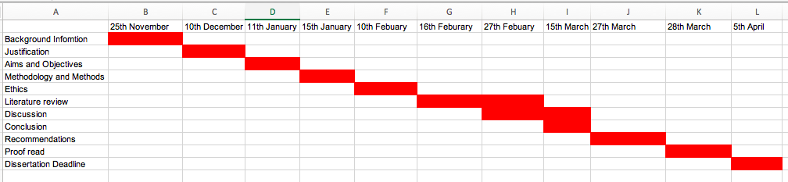

References

Ahadzadeh, A., Pahlevan, S and Ong, F. (2016) ‘Self- schema and self- discrepancy mediate the influence of Instagram usage on body image satisfaction among youth’, Computers In Human Behaviour, 68, PP. 8-16.

Anderson, C. (2010) ‘Presenting and Evaluating Qualitative Research’, American Journal of Pharmaceutical Education, 74(8), pp. 141.

Al-Osail, A., Al-Sheikh, M., Osail, E., Al-Ghamdi, M., Hawas, A., Bahussain, A. and Dajani, A. (2015) ‘Is Cronbach’s alpha sufficient for assessing the reliability of the OSCE for an internal medicine course’, Bio Med Central, 8, pp. 582.

Alvaro, P., Robers, M, R and Harris, K, J. (2013) ‘A Systematic Review Assessing Bidirectionality between Sleep Disturbances: Anxiety and Depression’, Journal of Sleep Disorders Research, 36(7), pp. 1059-1068.

Appleby, L. Shaw, J. Turnbull, P. and Tham, S. (2017) Suicide by Children and Young People. National Confidential Inquiry into Suicide and Homicide by People with Mental Illness (NCISH). Manchester: University of Manchester.

Aveyard, H. (2014) Doing a literature Review in Health and Social Care (3rd edition) England, Open University Press. Pp. 113.

Baker. J, and More, S. (2008) ‘Blogging as a special tool: A psychosocial examination of the effects of blogging’, Cyberpsychology & Behaviour. 11, pp. 747-749.

Barrance, R.(2017) The human rights of children in Wales: An evidence Review. Wales: Comisiynydd Plant cymru.

Bondemark, L. and Ruf, S. (2015) ‘Randomized controlled trial: the gold standard or an unobtainable fallacy’, European Journal of Orthodontics, 37(5), pp. 457-461

Booker, C., Kelly, Y. and Sacker, A. (2018) ‘Gender differences in the association between age trends of social media interaction and well-being among 10-15-year olds in the UK, Journal of Occupational Medicine and Toxicology, 18 (321) pp. 1-12.

Booth, A. (2016) ‘Search for qualitative research for inclusion in systematic reviews: a structured methodological review: Medical Research, 5(74) pp. 1-23.

Boyd, B. (2014). It’s complicated: The social lives of networked teens. New Haven, CT: Yale University Press.

Boyd, D., and, Ellison, N. (2008). Social Network Sites: Definition, History, and Scholarship. Journal of Computer-Mediated Communication, 13, 210-230.

Burton, M. Pavord, E., and Williams, B. (2014) An introduction to Child and Mental Health 1st Ed. California: Sage Publications.

Busby, E. (2017) One school Pupil in every class room is bullied every single day, survey suggests. Available at : https://www.independent.co.uk/news/education/education-news/anti-bullying-week-school-pupil-bullying-classroom-parents-children-wellbeing-mental-health-aba-a8624646.html (Accessed: 13 March 2019).

CAMHS Commissioners. (2012) Referral guidelines for children and young adolescent mental health services. Available at: http://www.westerntrust.hscni.net/pdf/THRESHOLD_CRITERIA_FOR_SPECIALIST_CAMHS.pdf (Accessed 14th February 2019).

Carter, A., Forrest, J, L. and Kaida, A. (2017) ‘Association Between internet Use and Body Dissatisfaction Among Young Females: Cross – sectional Analysis of the Canadian Community Health Survey, Journal of Medical Internet Research, 19 (2) pp. 2-11.

CASP. (2018). CASP Checklists - CASP - Critical Appraisal Skills Programme. [online] Available at: https://casp-uk.net/casp-tools-checklists/ [Accessed 4 Nov. 2018].
Castellano. M. (2004) ‘Ethics of Aboriginal Research’, Journal of Aboriginal Health, 1(1). PP. 98-114.

Cesaroni, c. Downing, S. Alvi, S., (2012)’ Bullying Enters the 21st century? Turning a critical eye to cyber bullying- Bullying research, Youth Justice, 12(3) pp. 199-211
Children’s Society (2008) The good Childhood inquiry: health research evidence. London: Children’s society.

Chorney, D., Detweiler, M., Morris, T. and Kuhn, B. (2008) ‘The interplay of Sleep Disturbance, Anxiety, and Depression in Children’, Journal of Paediatric psychology, 33(4), pp. 339-348.

Clarke, A., Friede, T., Putz, R., Ashdown, J., Blake, A., Adi, Y., Parkinson, J., Flynn, P., Platt, S. and Brown, S. (2011) ‘Warwick- Edinburgh Mental Wellbeing scale (WEMWBS): Validated for teenage school students in England and Scotland. A mixed Methods Assessment”, Journal of Health, Population and Nutrition, 11(487), pp. 1-9.

Clarke, J. (2011) What is a systematic review? Evidence-based Nursing, 14 (3), pp. 64

Dalbudack, E., Evren, C., Aldemir, S., Cosku, N., Ugurlu, H., and Yildrim, F, G. (2013) ‘Relationship of internet addiction severity with depression, anxiety, and alexithymia, temperament and character in university students. Cyberpsychology, Behaviour, and Social Networking, 16 (4), pp. 272-278.

Daniel, S. and Aroma, S. (2011) Research Methodology 1st Ed. Delhi: Gyan Publishing House.

Department of Health. (2011) No Health without Mental Health: A cross Government Mental Health outcomes strategy for people of all Ages. Available at: http://www.dh.gov.uk/enpublicationsandstatisitics/Publications/PublicationsandpolicyAndguidence/DH_123766 [Accessed 5th February 2019].

Department of Health. (2017) Advice for the headteachers, staff and governing bodies. London: Department of Health.

Doy, R., Burroughs, D. and Scott, J. (2005) ‘Mental Health- Consent, The Law and Depression- Management in Emergency Settings’ British Medical Journal, 22, pp. 279-285.

Durfee, W. (2008) ‘Project Planning and Gantt Charts’ Available at: http://www.me.umn.edu/courses/me2011/handouts/proj_planning.pdf (Accessed 1st April).

Earle, J. (2016) Children and Young Peoples Mental Health, London: British Medical Association.

Elgar, F., Napoletano, A., Saul, G., Dirks, M., Craig, W., Holt, M. and Koenig, B. (2014) ‘Cyberbullying Victimization and Mental Health in Adolescents’, American Medical Assosiation, 168(11), pp. 1015-1022.

Esbjorn, B., Somhovd, J, M., Turnstedt, C. and Reinholdt-Dunne, M. (2012) ‘Assessing the Revised Child Anxiety and Depression Scale National Sample of Danish Youth Aged 8-16 years. Plos One A Peer- Reviewed, Open Access, Journal, 7(5), pp. 37338- 37339.

Fahy, A., Stansfeld, S., Smuk, M., Smith, N., Cummins, S. and Clark, C. (2016) ‘Longitudinal Associations Between Cyberbullying Involvement and Adolescents Mental Health’, Journal of Adolescent Health, 59, pp. 502-509.

Fahy, N., Herver, T., Greer, S., Jarman, H., Struckler, D., Galsworthy, M. and Mcke, M. (2017) ‘How will Brexit affect health and health services in the UK? Evaluating three possible scenarios’, Journal of Health Policy, 390, pp. 2010-2018.

Fenn, K. and Byrne, M. (2013) ‘The key principles of cognitive behaviour therapy’, Education and inspiration for general practice, 6(9), 579-585.

Franchina, V. and Coco, L, G. (2018) ‘The use of Social Media use on body concerns’, International Journal of Psychoanalysis and Education, 10(1), pp. 1-12.

Freeman, D., Sheaves B., Goodwin, G., Yu, L., Nickless, A., Harrison, P., Emsley, R., Luik, R., Foster, R., Wadekar, V., Hinds, C., Gumley, A., Jones, R., Lightman, S., Jones, S., Bentall, R., Kinderman, P., Rowse, G., Brugha, T., Balgrove, M., Gregory, A., Fleming, L., Walklet, E., Glazebook, C., Davies, B., Hollis, C., Haddock, G., John, B., Coulson, M., Fowler, D., Pugh, K., Moseley, P., Brown, G., Hughes, C., Obonsawin, M., Coker, S., Watkins, E., Schwannauer, M., MacMahon, K., Siriwardena, N. and Espie, C. (2017) ‘ The effects of improving sleep on mental health (OASIS) a randomised controlled trail with meditation analysis, The Lancet Psychiatry, 4(10), pp. 749-758.

Gale, R, C. Westbury, L. and Cyrus, C. (2018) ‘Social isolation and Loneliness as risk factor for the progression or frailty: the English Longitudinal study of Ageing’. International Journal of The British Geriatrics Society’. 47 (3), pp. 392-393.
Gladerisi, S. Heinz, A. Kastrup, M. Beezhold, J. and Satorius, N. (2015)’ Toward a new definition of mental health’, Official Journal of The World Psychiatric Association. 14(2). Pp. 231-233.

Goswami, H. (2012) ‘Social Relationships and children’s Subjective Well-being’, An International and Interdisciplinary Journal for Quality-of-Life Measurement, 107(3), pp. 575-588.

Gratzer, D. and Khan- Khalid, F. (2016) ‘Internet- delivered cognitive behavioural therapy in the treatment of psychiatric illness’, Canadian Medical Association Journal, 188(4), pp. 263-272.

Graham, R, W. and Whitaker, A. (2017) Succeeding in Literature Reviews and research Project Plans for Nursing Students 3rd Ed. London: Learning Maters.

Gunnel, D. Kidger, J. and Elvidge, H. (2018) Adolescent mental health crisis. British Medical Journal. 361:2608 pp. 1-2.

Hammond, P, S., Cooper, N., and Jordan, P (2018) ‘Social Media, Capital and Adolescents Living in State Care: A Multi-perspective and Multi – Method qualitative Study’, The British Journal of Social Work, 48(7), pp. 2058-2076.

Hill, D, A. Kern, A, D. and White, M. (2012) Building understanding in strategy research: The Importance of employing consistent terminology and convergent. Strategic Organization, 10(2) pp. 187-200.

Hoare, E., Millar, L., Tyszkiewicz, M., Skouteris, H., Nicholas, M., Malakellis, M. Swinbum, B. and Allender, S. (2016) ‘Depression symptomatology, weight status and obesogenic risk amoung Australian adolescents: a prospective Cohort Study, British Medical Journal, pp. 1-10.

Huebner, E, S., Zullig, K, J. and Saha, R. (2012) ‘Factor structure and reliability of an abbreviated version of the Multidimensional Students’ Life Scale, Child Indicators research, 5, pp. 651-657.

Jennings, W. and Hutchinson. (2018) Research Area: Vulnerable Learners and social Mobility. England: Education Policy Institute.

Jesson, K, J. Mathson, L. and Lacey, M, F. (2011) Doing Your Literature review: Traditional and Systematic Techniques 1.st Ed. London: Sage Publications.

Jiang, X. and Huebner, S, E. (2017) ‘Students’ Life satisfaction Scale: Analysis of Factorial Invariance Across Gender’, A Journal of Diverse Perspectives on Diverse Psychological Issues, 1, pp. 25-32.

Johnson, H., Nolan, M, H. and Anderson, E. (2006) ‘The Social Phobia Inventory: Validity and reliability in an adolescent community sample’, Psychological Assessment, 18(3), pp. 269-77.

Kenny, R., Dooley, B., and Fitzgerald, A. (2016) ‘Developing mental health mobile apps: Exploring adolescents’ perspective’. Health Informatics Journal, 22(2), pp. 265-275.

Kelly, Y., Zilanawala, A., Booker, C and Sacker, A. (2018) ‘Social Media use and Adolescents Mental Health: Findings from the UK Millennium Cohort Study, Eclinical Medicine, 6, PP. 59-68.

Kjaergaard, M., Arfwedson-Wang, C, E., Waterloo, K and Jorde, R. (2014) ‘ A study of the psychometric properties of the Beck depression Inventory- II, the Montgomery and Asberg Depression Rating scale, and the Hospital Anxiety and Depression Scale in a sample from a healthy population, Journal of Psychology, 55(1), pp. 83-89.

Kyle, S. and Espie, C. (2014) ‘The HUNT continues and gathers pace: shedding light on the relationship between insomnia and ill health’ Journal of Sleep Research, 23(2), pp. 121-123.

Landstedt, E. and Persson, S. (2014) ‘Bullying, cyberbullying, and mental health in young people’, Scandinavian Journal of Public Health, 42, pp. 393-399.
Lelliott, P. and Gallagher, U. (2017) Review of children and young people’s mental health, Newcastle: Care Quality Commission.

Machi, A, L. and Brenda, T, M. (2009) The Literature review 1st Ed. New Delhi: Corwin Press.
Maj. M. (2011) ‘When does depression become a mental disorder’, The British Journal of Psychiatry, 199, pp. 85-86

Manikandan, S. (2011) ‘Measures of Central tendency: The mean’, Journal of Pharmacology & Pharmacotherapeutics, 2(2), pp. 140-142

McCrean, T. Lyons, A. Griffin, C. Goodwin, I., Moewaka, H., and Hutton, F. (2013) ‘Youth Drinking Cultures, social networking and alcohol Marking: implications for public health’, Critical Public Health, 23(1), pp. 110-120.

McCusker, K. and Gunaydin, S. (2015) ‘Research using qualitative, quantitative or mixed methods and choice based on the research, Perfusion, 30(7), pp. 537-542.

Medic, G., Willw, M. and Hemels, M. (2017) ‘Short- and long-term health consequences of sleep disruption’, Nature of Science of Sleep, 9, PP. 151-161.

Mental Health foundation (2015) Fundamental Facts About Mental Health. London: Mental Health Foundation.

Mental health foundations (2016) Fundamental facts about mental health 2016. London. Mental Health Foundation.

Moule, P. (2015) Making sense of Research in Nursing, Health and Social Care 5th Ed. Croyden: Sage Publications.
Mughal, F. England, E. (2016) ‘The Mental Health of Young People: The view from primary care’, British of General Practice, PP. 502-503.

Nasirudeen, A., Adeline, L., Josephine, K., Seng, L. and Wenjie, L. (2017) ‘Impact of Social Media unage on daytime sleepiness: A study in sample of tertiary students in Singapore’, Sage Publications, 3, pp. 1-9.
National Assembly of Wales. (2018) Mind over Matter, A report on the step change needed in emotional and mental health support for children and young people in Wales. Cardiff Bay: Children and Young People Committee.
NCPCC. (2019) A child’s Legal Rights. Available at: https://www.nspcc.org.uk/preventing-abuse/child-protection-system/legal-definition-child-rights-law/legal-definitions/ (Accessed 14th February 2019).

NHS. (2018) Mental Health of children and young people in England, 2017 key findings. Surrey: National Health Services.

NIAMI. (2019) Sleep Disorders, The connection between Sleep and Mental Health. Available at: https://www.nami.org/Learn-More/Mental-Health-Conditions/Related-Conditions/Sleep-Disorders (Accessed 16th March 2019).

O’ Nyumba, T., Wilson, K., Derricl, C. and Mukherjee, N. (2018) ‘ Thenuse of focus group discussion methodology: Insights from two decades of application in conservation’, British Ecological Society, 9, pp.21-22.

O’Keefe, G. and Clarke, p, K. (2011) ‘Clinical Report- The impact of social media on children, adolescents, and families. Paediatrics, 127 (4), pp. 800-804.

O’Reilly, M., Dogra, N., Whiteman, N., Hughes, J., Eruyar, S. and Reilly, P. (2018) ‘Is social Media bad for mental health and wellbeing? Exploring the perspectives of adolescents’, Clinical Child Psychology and psychiatry, 23(4), pp. 601-613.

Office of National Statistics (2018) Suicides in the UK:2017 registrations. Office of national statistics. United Kingdom: stationary office.

Onwuegbuzie, j, A. and Frels, R. (2016) Seven steps to a Comprehensive Literature Review: A Multimodal and Cultural Approach 1st Ed. London: Sage Publications.

Orchard, F., Pass, L., Marshall, T. and Reynolds, S. (2017) ‘Clinical Characteristics of adolescents referred for treatment of depressive disorders’, Child and Adolescents Mental Health, 2, pp. 61-68.

Patalay, P., Giese, L., Stankovic, M., Curtin, C., Moltercht, B. and Gondek, D. (2016) ‘Mental Health provision in schools: priority, facilitators and barriers in 10 European countries’, Child and Adolescent Mental Health, 21(3), pp. 139-147.

Polit, D. and Tatano, B. (2009) Essentials of Nursing Research 7th Ed. Philadelphia, United States: Lippincott Williams & Wilkins
Pope, C. Nicolas, M. and Jennie, P. (2007) Synthesising Qualitive and Quantitative Health Evidence: A Guide to Methods 1.st Ed. London: Open University Press.

Powell, M. Fitzgerald, R. Taylor, J. and Graham, A. (2012) International Literature Review: Ethical Issues in Undertaking Research with Children and Young People. (Literature review for the child watch international Research Network). Lismore: Southern cross University of Otago.

Proctor, C., Linley, A. and Maltby, J. (2008) ‘Youth life satisfaction measures: a review’ The Journal of Positive Psychology, 4,2, pp. 128-144.

Public Health England. (2016) The Mental Health of Children and Young Adults in England. London: Public Health Wales.

Public Health Resource Unit (2006). The Critical Skills Appraisal Programme: making sense of evidence. England: Public Health Resource Unit.

Raham, S. (2017) The Advantages and Disadvantages of Qualitative approaches and Methods in Language “Testing and Assessment” Research: A literature review, Journal of Education and Learning, 6(1), pp. 101-106.

Reckart, H., Huebner, S. and Hills, K. (2018) ‘Reliability of life satisfaction Measure in Middle school students’, Journal of Psychoeducational Assessment, 36(7), pp. 684-693.

Rhew, C, I., Simpson, K., Tracy, M., Lymp, J., McCauley, E., Tsuang, D. and Storp, A. (2010) ‘Criterion Validity of Short Mood and Feelings Questionnaire and one- and two-item depression screens in young adolescents’, Child and Adolescent Psychiatry and Mental Health, 4(8), pp. 1-11.

Ridley, D. (2012), A step-by-step guide for students. (3rd edition) Sheffield university, uk: Sage publications. Pp-1-50.

Rothon, C., Head, J., Klineberg, E and Stansfeld, S. (2011) ‘Can social support protect bulled adolescents from adverse outcomes? A prospective study on the effects of bullying on the educational achievement and mental health of adolescents at secondary schools in east London, Journal of Adolescence, 34, pp. 579-588.

Rothon, C., Head, J., Klineberg, E. and Stansfeld, S. (2011) ‘Can social support protect bullied adolescents from adverse outcomes? A prospective study on the effects of bullying on the educational achievement and mental health of adolescents,’ Journal of Adolescence, 34(3), pp, 579-588.

Royal College of Nurses (2017) Child and Adolescent Mental Health, London: Royal College of Nurces.

Sadler, K. Vizard, T. Marcheselli, F., Pearce, N., Mandalia, D., Davies, J., Brodie, E., Forbes, N., Goodman, A., Goodman, R. and McManus S. (2018) Mental Health of Children and Young People in England, 2017. England: NHS DIGITAL.

Sanjarni. M. Bahramnezhad, F. Khoshnava, F. Shoghi, M. Cherghi, M. (2014) Ethical Challenges of Researchers in qualitative studies: The necessity to develop a specific guideline. Journal of Medical Ethics and history of medicine. 7(14). Pp.106 -107.

Schnettler, B., Orellana, L., Sepulveda, J., Miranda, H., Grunert, K., Lobos, G. and Hueche, C. (2017) ‘Psychometric properties of the Multidimensional Students’ Life Satisfaction Scale in a sample of Chilean university students’, Suma Psicologica, 24(2), pp. 97-106

Scot, A., Webb, T. and Rowse, G. (2017) ‘Does improving sleep lead to better mental health? A protocol for meta analytic review of randomised controlled trials. British Medical Journal Open, 7(9), pp. 1-8.

Singh, J. (2013) Critical Appraisal Skills Programme. Journal of Pharmacology and pharmacotherapeutics. 4 (1) pp. 76-77.

Spieth, P., Kubasch, A., Penzlin, A., Illigens, B., Barlinn, K. and Siepmann, T. (2016) ‘Randomized controlled trials- a matter of design’ Neuropsychiatric Disease and treatment, 12, pp. 1341-1349.

Stern, A, F. (2014) ‘Hospital Anxiety Depression Scale’, Occupational Medicine, 64(5), pp. 393-394.

Stubbs, B. and Rosenbaum, S. (2018) Exercise- based interventions for mental illness: physical activity as part of clinical treatment. (1st edition) London, academic press. Pp 3.

Tavakol, M. and Dennick, R. (2011) ‘Making sense of Cronbach’s alpha’, International Journal of Medical Education, 2, pp. 53-55.

Tennant, R., Hiller, L., Fishwick, R., Platt, S., Joseph, S., Weich, S., Parkinson, J., Secker, J. and Brown-Stewart, S. (2007) ‘ The Warwick-Edinbrugh Mental Well-being Scale (WEMWBS): Development and UK validation’, Health and Quality of Life Outcomes, 5,(63) pp.1-13.

The British Psychological Society. (2009) Code of Ethic and Conduct. Leicester: The British Psychological Society.

The Guardian. (2018) Calls for Action over UK’s ‘intolerable’ child mental health crisis. Available at: https://www.theguardian.com/society/2018/aug/31/calls-for-action-over-uks-intolerable-child-mental-health-crisis (Accessed 17th march 2019).

The Welsh Government. (2017) Facilities for child and adolescent mental health services (Camhs). Wales: NHS Wales.

Townsend, P. (1979) Poverty in the United Kingdom: a survey of household resources and standard living 1.Ed. Middlesex, UK: Penguin BooksLtsd.

Treem, W, J. Daily, L, S. Pierce, S, C. and Biffi, D. (2016) ‘What we are talking about when we talk about social media: A framework for Study’. Sociology Compass, 10(9), pp. 768-784.

Vaillancourt, T., Faris, R. and Mishna, F. (2017) ‘Cyberbullying in Children and Youth: Implications for Health and Clinical Practice’, The Canadian Journal of Psychiatry, 62(6), pp. 368-373.

Wait, E., Abbot, J, M. and Rapee, M, R. (2009) ‘Psychometric Properties of the Mini-Social Phobia Inventory’, Clinical Psychology, 11(5), pp. 231-236.

Walker, M. (2017) ‘Unlocking the Power of Sleep and Dreams 1.ED. New York: Simon and Schuster.

Walliman, N. and Appleton, J. (2009) Your Undergraduate Dissertation in Social Care 1.st Ed. London: Sage Publications.

Weinstein, E. (2018) ‘The social media see-saw: Positive and negative influences on adolescents’ affective well-being’, New Media and Society, 20(10), pp.3597-3623.

William, J., Roth, A., Vatthauer, K. and McCrae, C. (2013) ‘Cognitive Behavioural Treatment of insomnia, CHEST, 143 (2), pp. 554-565.
Willis, K., Green, J., Daly, J., Williamson, L. and Bandyopadhyay, M. (2009) ‘Perils and possibilities: achieving best evidence from focus groups in public health research’ Public Health, 33 (2) pp. 131-136.
Wongkoblap, A., Vadillo, A, M., and Curcin, V. (2017) ‘Researching Mental Health Disorders in the Era of Social Media: A Systematic Review’, Journal of Medical Research, 19(6), pp. 228.

Woods, C, H. and Scott, H. (2016) ‘Sleepy teens: Social media use in adolescence is associated with poor sleep quality, anxiety, depression and low self-esteem’, Journal of adolescence, 51, pp. 41-49.

Young Minds (2019) New figures on CAMHS Waiting Times. Available at: https://youngminds.org.uk/blog/new-figures-on-camhs-waiting-times/ [Accessed 4th February 2019].

Bibliography

Horwitz, S. Demeter, C. Hayden, M. Isser, A. Frazier, T. Fristad, M. Arnold, E. Youngstorm, E. Birmaher, B. Axelson, D. and Finding, R. (2013). Parents’ perception of Benefits of children’s Mental Health Treatment and Continued Use of Services. NCBI Medical Journal, 63 (8), pp. 793-801.

Welsh Government (2015) Welsh Health survey 2015: Health status, Illness, and other conditions. Caerdydd: Statistical Bullentin Bweletin Ystadeogol.

Viner, R. (2018) NHS must prioritise health of children and young people. London: Royal college of paediatrics and child health. British Medical Journal, 8 (361), Pp 1-2.

Katikireddi, S. Niedzwiedz, C. Popham, F. (2012) ‘Trends in Population mental health before and after the 2008 recession: a repeat cross-sectional analysis of the 1991-2010 Health Surveys of England, British Medical Journal, 2(5), pp.

Appendix A
CASP Checklist.

 | Q1 | Q2 | Q3 | Q4 | Q5 | Q6 | Q7 | Q8 | Q9 | Q10
Journal 1  Qualitative | yes | Yes | Yes | Yes | Can’t Tell | No | Yes | Can’t Tell | Yes | Yes
Journal 2  Qualitative | Yes | Yes | Can’t Tell | No | Yes | No | Yes | Can’t Tell | Yes | Yes
Journal 3  Qualitative | Yes | Yes | Yes | Yes | Yes | Yes | Yes | Can’t Tell | Yes | Yes
Journal 4  Qualitative | Yes | Yes | Yes | Yes | Can’t Tell | Can’t Tell | Yes | Yes | Yes | Yes
Journal 5  Quantitive | Yes | Yes | Yes | Can’t Tell | Yes | Yes | Yes | Can’t Tell | Yes | Yes
Journal 6 Qualitative | No | Yes | Yes | Yes | Yes | Can’t Tell | yes | Yes | Yes | Yes
Journal 7  Qualitative | Yes | Yes | Yes | Yes | Yes | Yes | Can’t Tell | Yes | Yes | Yes
Journal 8  Qualitative | Can’t Tell | Yes | Yes | Yes | Yes | Can’t Tell | Yes | Can’t Tell | Yes | Yes

CASP Sheet.
See below print screens of the CASP sheet followed.

Critique box for CASP

Bullying.

Author/Date /Published | Aims of Article | Type of Study/ Methodology | Key Findings | Strengths / Weaknesses
A.Fahy  S. Stansfeld  M. Smuk  N. Smith  S. Cummins  C. Clark  2016  Journal of  Adolescent. | To examine the association between cyber bullying and adolescent mental health | Qualitative study.  SMFQ used to measure depressive symptoms. | 20% of participants have been cyber bullied.  Bullying leads to depressive symptoms, social anxiety symptoms and below average mental health. | No schools dropped out.  Research found that a small amount of cyber bullies suffers with mental health conditions.  Ethical consideration granted  Measures for, depression, mental health and wellbeing and social anxiety.  Weaknesses:  Only located in East London.  More male than female participants.

Author, Date/ Publication | Aim or Article | Types of Methodology | Key Findings | Strengths / Weaknesses
H. Goswami | Positive and Negative relationships with children, bullying and friendships | Qualitative study. | Being bullied decreases the child’s mental health and wellbeing. | Strengths:  Focuses on the positive factors of a child’s wellbeing.  Large Study and variety of age ranges in children.  Ethical Approval granted with special consideration towards risk or harm to young people.  Weaknesses:  Large volume of participants.  Didn’t include a wide range of ethnic minority.

Author/ Date/ Publication | Aim of Article | Types of study/ Methods | Key Findings | Strengths/ Weaknesses
C. Rothon  J. Head  E. Klineberg  S. Stansfeld  Journal of Adolescence  2011  London | Investigate the consequences of bullying and academic achievement. | Three qualitative measures used to access mental health, bullying and educational achievement  Social Support provided. | Ethnic minority children and young adults at risk of depressive symptoms  27% of the participants had mental health symptoms due to bullying. | Strengths:  Large number of participants.  Equal ethnic minority shows diversity in the study.  Thirty schools out of the forty-two were randomly selected to participate. Which reduces bias.  Excluding participants who were at risk of depressive symptoms to get a clear result of bullied children.  49.5 % of children were the younger group which shows equal age range was considered.  Weakness:  Study only conducted in East London.  Doesn’t state clearly the percent of girls involved.

Social Media.

Author/Date/ published | Aims of Article | Type of study / Methods | Key Findings | Strengths /Weaknesses
Y. Kelly,  A.Zilanawala, C. Booker, A. Sacker.  2018.  London, U.K.  The LANCET  Elsevier. | The aim of the article Is to find a connection between, social media and depressive symptoms in young children. | Cohort Study  U.K Population based data  Depressive symptoms- participants filled in questionnaires for depressive symptoms on mood and feelings over the last two weeks.  Participants asked about the hours they spent on Social Media. | The connection between social media and depressive symptoms was larger for girls than boys.  Using social media for a frequent amount of time brought on low self-esteem, Poor sleep, body dissatisfaction. This can then result in depressive symptoms.  Emerging theme:  Sleep deprivation. | Strengths:  Large cohort study this show clearly focused issue in the representative group chosen.  Secondly, 98% of the population chosen.  The original study is also a large Cohort study.  Weaknesses:  The group is intentionally over sampled in the original study. The focus is on children and young adults in disadvantaged areas. This could be bias. However, this is stated in the article.

Author /Date /Published | Aim of Article | Methodology | Key findings | Strengths/ Weaknesses
H. Woods  H. Scott  2016.  Glasgow. U.K.  School of Psychology.  Elsevier Ltd.  Fear of missing out and sleep: cognitive behaviour factors in adolescents’ night time social media use. | The aim of the article is to connect social media with, anxiety, depression, low self-esteem in children and young adolescents in Scotland. | Quantitive tick box questionnaire.  Language support from teachers for pupils who spoke English as a second language. | Participants who were emotionally invested in social media had higher levels of anxiety and depression.  Participants had poor sleep quality.  Emotional investment and social media are to key factors that should be investigated more. | Strengths:  Ethical consideration was granted.  Limitations have been acknowledged.  Anxiety and depression linked to emotional investment in social media  Hospital anxiety and depression scale (HADS) has a high reliability.  Weaknesses:  Gender and the age of participants were not recorded in the analysis.  Some Participants had poor literacy skills due to English not being their native language. This could have potentially affected the results of questionnaire from language barrier.  Number of pupils who had language barrier is not noted.  Small study of 467 adolescents.

Author/Date/ Publication | Aims of Journal | Methodology | Key findings | Strengths/ Weaknesses
M. O’Reilly, N. Dogra, N. Whiteman, J. Hughes, S. Eruyar and P. Reilly  2018.  Greenwood institute of Child Health.  U.K.  Is social media bad for mental health and wellbeing, exploring the other perspectives of adolescents. | To connect social media to the mental health and wellbeing of children and young adolescents. | Qualitative design.  Macrosocial constructionist perspective.  3 months consisting of 6 focus groups across two schools in London and Leicester.  Sampling adequacy was ensured.  Ethical consideration granted. | Consistent negative views on social media.  Social media was dangerous towards mental health.  Many participants didn’t have a clear understanding of mental health.  Large number of significant usage levels | Strengths:  A wide range of ages 11-18  Participants were asked about the positive as well as negatives of social media meaning.  Students expressed their opinions.  Weaknesses:  Participants may not speak truthy in front of friends and class mates.

Sleep Deprivation.

Author/ Date/ Publication | Aim of Journal | Methodology | Key Findings | Strengths/ Weaknesses
F. Orchard  L. Pass  T. Marshall  S. Reynolds  2017.  Association of Child and Adolescent Mental health.  Oxford London  School of Psychology and Clinical Language Science.  Clinical Characteristics of adolescents referred for treatment of depressive disorders. | To understand the key symptoms that contribute towards adolescents for depressive disorders. | The study contained Child and young adolescents ages 12-17.  Study notes participant that declined invite for study.  Clear understanding of what type of quantitive questionnaire were being conducted.  Participants referred from primary and secondary care services.  Study | Participants who met the criteria for depressive symptoms, had key symptoms of sleep deprivation, negative perceptions and cognitive ability. | Key symptoms stated in the abstract.  Study clearly shows how sleep disturbances are high within an individual suffering from a depressive symptom/ disorder compared to participants without a diagnosis.  Weaknesses:  Very small study.  Doesn’t state clear aims and objectives in the abstract.  Participants who needed consent from a caregiver / parent may not have been honesty when answering the questions.  Limitation the study notes there is missing data on self-report measures

Author/Date  Publication | Aim of Journal | Methodology | Key Findings | Strengths/ Weaknesses
D. Freeman  B. Sheaves  G. Goodwin  L. Yu  A. Nickless  P. Harrison  R. Emsley  A. Luik  R. Foster  V. Wadekar  C. Hinds  A. Gumley  R. Jones  S. Lightman  S. Jones  R. Bentall  P. Kinderman  G. Rowse  T. Brugha  M. Blagrove  A. Gregory  L. Fleming  E. walklet  C. Glazebook  B. Davies  C. Hollis  G. Haddock  B. John  M. Coulson  D. Fowler  K. Pugh  P. Moseley  G. Brown  C. Hughes  M. Obonsawin  S. Coker  E. Watkins  M. Schwannauer  K. MacMahon  N. Siriwardena  C. Espie  2017.  Lancet Psychiatry | To determine if treating insomnia leads to the reduction in mental health conditions such as, hallucinations and paranoia. | Randomized Controlled Trail.  Qualitative  Online CBT with meditation analysis. | Participant all had sleep disorders found that the worse their sleep was the more severe the mental health condition | Strengths:  Large volume of participants.  Participants were known for sleeping disorders.  Weaknesses:  Missing data and sampling  Participants dropped out.  Only some participants used the CBT therapy consistently compared to other participants who only logged on one a week for a hour this could affect the overall results.

Appendix B

Search Strategy

Situated below is the search strategy. This is where key terms were entered to help with the creation of themes.

This search helped initially, by keeping track of what information was being searched, it also helped with understanding what key terms were deemed as not useful and which one showed the most literature. On databases such as SAGE publications, when looking at an article useful for a theme the data base would give an option of articles similar to the one that is being viewed.

My research question / aim / objective: | Why Is there a mental health crisis for children and young adults ages 11-21 in the UK?  Aim:  To Determine if there is a mental health crisis for children and young people in the UK.  Objectives:  - To explore literature the affect mental health has on children and young adults.  - To examine the mental health crisis while providing relevant research  - To evaluate the themes affecting children and young adults whilst using academic resources.  - To discuss the literature and provide recommendations for the future  .
Places to search for information: | Google scholar, free journal databases, UWTSD library, BMJ, Key terms including: Mental Health, Children and Young Adults Mental Health, Adolescent Mental Health, Teenagers and Children Mental Health’ ‘Adolescent and Wellbeing’
Date |  | Database Name | Search Terms | No of Results | Comments
29/10/18 |  | UWTSD Library | Mental Health | 1,947,514 | This was not useful, due to the amount of results that were shown. The Search term was too broad meaning that to many results had been show.
29/10/18 |  | UWTSD Library | Mental Health and Children | 594,497 | Useful articles based on child mental health were shown in this search term. Relevant literature was found and utilised in the dissertation
29/10/18 |  | UWTSD Library | Mental health+ children | 1,886,214 | Not useful, search term was to broad resulting in not finding any relevant articles to use.
31/10/18 |  | UWTSD Library | [Children]+[Mental health]+ [Young Adults] | 485,824 | Useful, Relevant articles found to use in the research proposal. More accurate results were shown by ensuring the brackets are around the search terms. This stopped a large amount of unnecessary information being used. Article on social media had appeared.
3/11/18 |  | UWTSD Library | [Mental health] +[children and UK] | 331,649 | Useful, the number of results is a lot smaller. This made the results more efficient.
3/11/18 |  | British Medical Journal  (BMJ) | Children’s Mental health | 47,762 | Not Useful, Requires log in details. Free BMJ journals that UWTSD university is not subscribed to after 2009. No up to date access. However free BMJ is available on certain journals.
3/11/19 |  | Google Scholar | Child Mental Health 2018 | 1,840,000 | Not useful due to information coming up worldwide.
3/11/18 |  | Google Scholar | Child Mental Health 2018 | 86,100 | Useful, relevant information appearing due to stating where the information should be and what date.
12/01/19 |  | Google | Mental Health of Children and Young People, 2017 |  | This report is very useful as it provides statistics of different mental disorders in England, this can be used in the dissertation.
12/01/19 |  | Google | Statistics for Child Mental Health 2018 |  | Useful reports can be found under this search term. Results can be used in the dissertation.
15.01.19 |  | Google scholar | Social Media Depression study UK 2018 | 17, 100 | A useful Journal on how social media is affecting children and young adults. Self-esteem, anxiety, depression, lack of sleep. This journal can be contributed towards the theme.
11.2.19 |  | UWTSD Library | Child Mental Health UK | 9, 365 | This search was useful. Journal for peer assessed study. This can be used in the themes.
12.3.19 |  | Sage Publications | ‘Mental health and young adults’ | 91 | This search showed all relevant journals that could be a potential theme. However, this search wasn’t UK based as many journals that appeared had excellent information.
12.3.19 |  | Elsevier | ‘Mental Health’ and ‘Adolescence’ | 2,302 | This search was useful, the key terms found the  Journal of Adolescence.  This search for a journal on bullying used for a theme. the journal applies to bullying in the UK and the effect it has on the mental health and wellbeing of the adolescent.
12.3.19 |  | Google | ‘Child and Teenager Mental Health’ | 246,000,000 | It is clear that this search term in google is not relevant as many websites, books, journals had shown up. If there was more time to go through all these journals. I may have found relevant information to go in the dissertation.
14. 3. 19 |  | Google Scholar | Adolescent mental health studies in the UK. | 1,220,000 | This search was interesting as it at showed articles on subjects that could have been a potential theme such as, drug abuse, social support and many more. However, the focus was on different themes that showed more literature

Appendix. C

Theme one- Bullying.

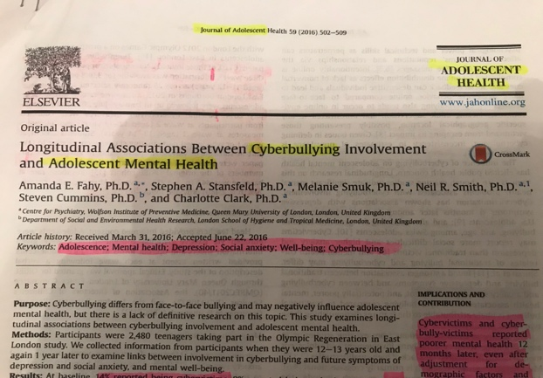

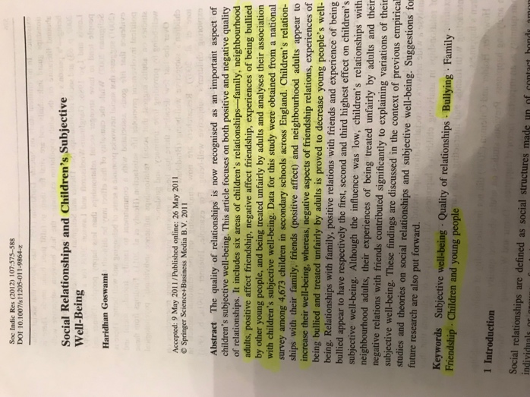

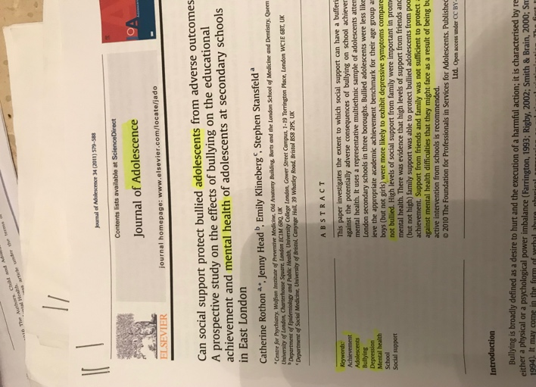

Theme two – Social Media

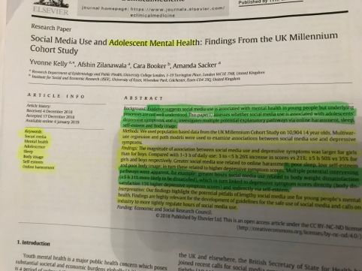
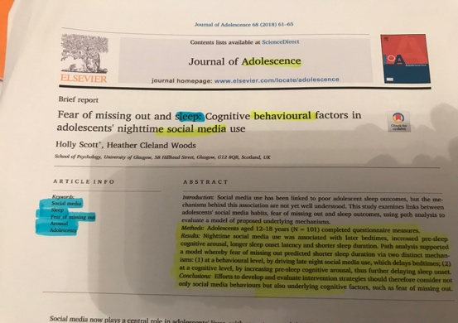

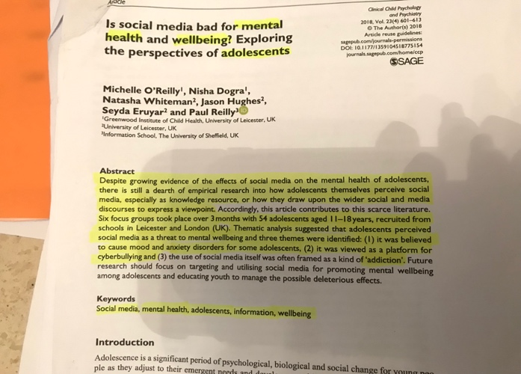

Theme three – Sleep Deprivation

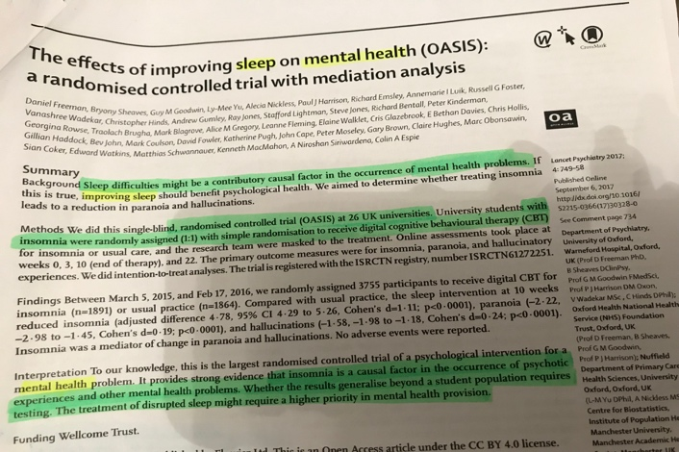
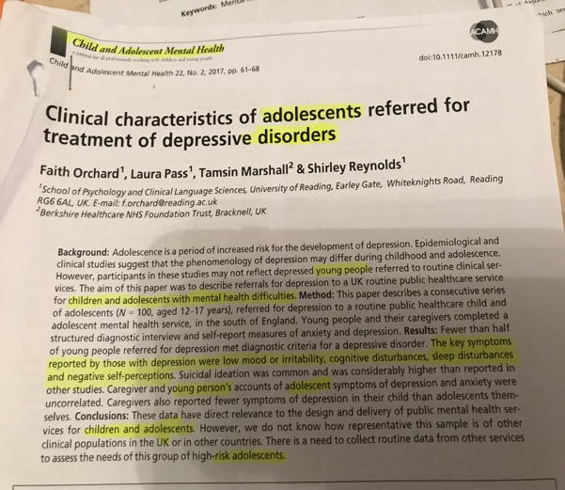

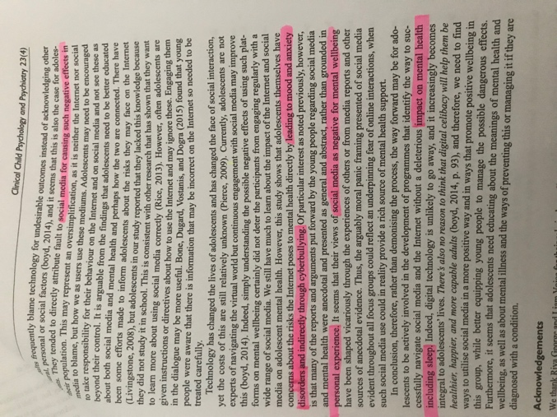
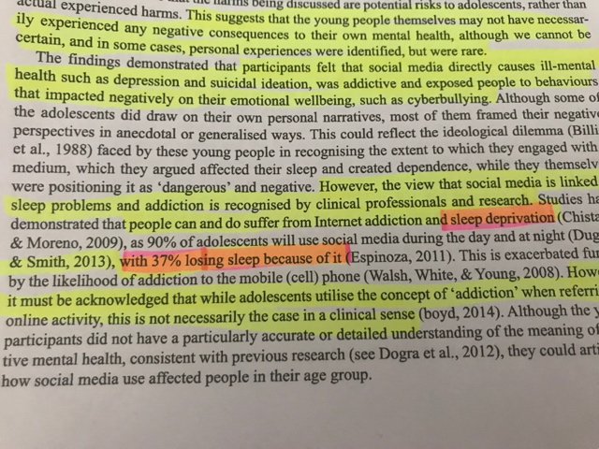

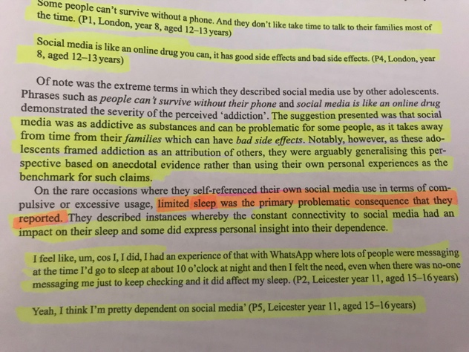

Appendix. D

Cronbach Alpha scale, how Goswami measured the Mean.

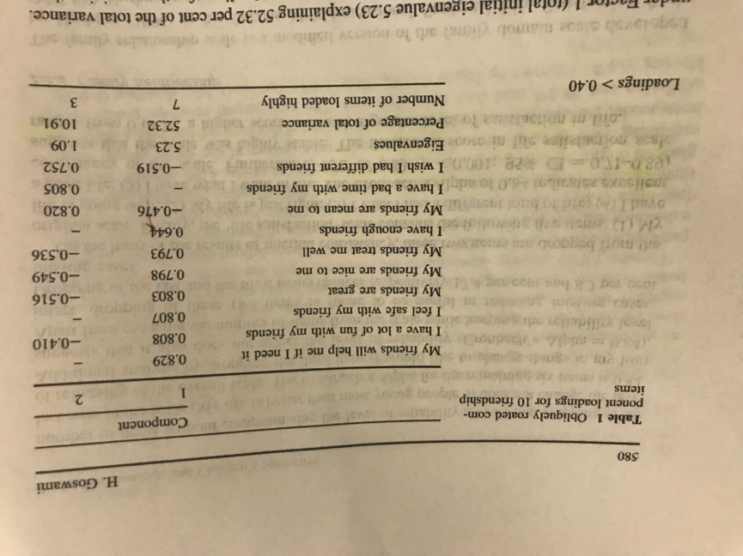

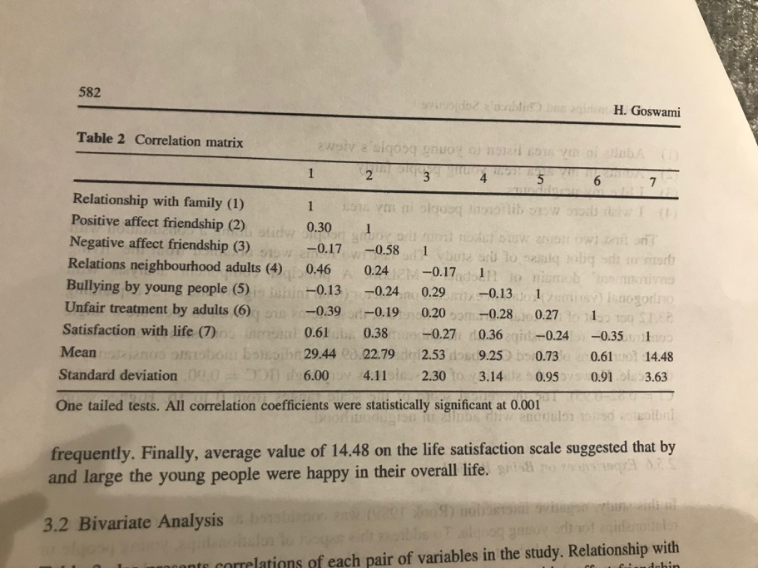

CAMHS Commissioners (2012) state tier 3 CAMHS is a diagnostic assessment for systemic, pharmacology and psychological therapy. Tier 3 CAMHS deals with children and young people who are experiencing moderate emotional and mental health difficulties which effect daily functioning. (CAMHS Commissioners, 2012).

