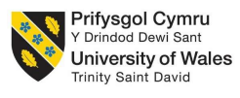

Impact of integrated marketing communication (IMC) on consumer buying behaviour: a case study of Zara

Student name: Kush Jani
Student ID: 2504341
Module: Dissertation LCMB 7035
Supervisor name: Ebaid Banissi

Table of Contents
1.0 Introduction 1
1.1 Background 1
1.2 Research problem 1
1.3 Research Aim 2
1.4 Research Objectives 2
1.5 Research questions 2
Main Question 2
Sub Questions 2
1.6 Research propositions 2
1.7 Significance of the study 3
1.8 Scope 3
1.9 Dissertation structure 3
2.0 Literature review 4
2.1 IMC strategies used by the fast-fashion industry associated with marketing communication 4
2.2 Impact of IMC on the buying behaviour of customers 4
2.3 Communication credibility 4
2.4 Theoretical concepts 5
2.5 Literature gaps 5
2.6 Conceptual model 6
3.0 Methodology 6
3.1 Research philosophy 6
3.2 Research approach 7
3.3 Research strategy 7
3.4 Data collection technique 7
3.5 Sampling strategy 8
3.6 Data analysis method 9
3.7 Research quality 10
3.8 Ethical consideration 10
4.0 Expected findings 10
5.0 Expected contribution 10
6.0 Proposed conceptual framework 11
7.0 Timeframe 12
8.0 References 13

1.0 Introduction

1.1 Background
Integrated marketing communication (IMC) is associated with a tactical approach, which is effective in unifying all the marketing tools (social media, direct marketing, public relations, advertising and others) to convey a consistent brand message to customers (Rehman et al., 2022). IMC is effective in improving customer awareness and trust by conveying clear business goals to customers. Therefore, customer interest in buying products is gradually enhanced (Najah and Jenita, 2025). The role of IMC is essential for the business growth of the fast fashion sector. Zara is the leading fast-fashion brands, which promotes net-zero related advertisements, minimum budget shopping, digital storytelling and many more IMC strategies, which influence the buying behaviour of customers (Kutlu et al., 2025). However, Ahmed et al. (2025) explained that promoting deceptive information through IMC can play a negative role in altering the buying behaviours of customers. So, this research to be implemented to understand the influence of IMC on the buying decisions of consumers in the light of Zara.

1.2 Research problem
A study by Butler (2022), published in the Guardian, depicted that greenwashing issues are prominent in the fast-fashion industry, which conveys misleading claims. Zara, Asos, H&M and other leading fashion brands have been accused of this kind of false claim. Zervoudi et al. (2025) argued about the deceptive marketing communication of Zara. So, it could be said from these instances that misleading claims can reduce customer interest in buying fashion items. However, the study did not clearly explore how consumer purchasing intention is affected by greenwashing. On the other hand, the article by Jordan (2023) revealed that Zara was criticised for a campaign named “The Jacket.” The picture used in this campaign was similar to Gaza during the Israel-Gaza war. So, it negatively impacted customer perceptions, which prevented customer engagement at that time. But the report did not clarify how IMC disputes led to this incident. By considering the gaps mentioned in this section, this research is to be conducted to explore the IMC strategies used by Zara and their influence on buying behaviour of customers. Moreover, the challenges faced by Zara associated with IMC strategies associated with greenwashing, deceptive information and others will also be discussed in this study by providing potential solutions.

1.3 Research Aim
To explore how Integrated Marketing Communication (IMC) influences consumer buying behaviour in the UK fast-fashion industry through a qualitative case study of Zara.

1.4 Research Objectives
- To examine the Integrated Marketing Communication strategies employed by Zara.
- To explore how consumers, interpret Zara's Integrated Marketing Communication.
- To investigate the influence of Integrated Marketing Communication on consumer buying behaviour.
- To explore how communication credibility and perceived authenticity influence purchasing decisions.
- To develop recommendations for improving Integrated Marketing Communication within the fast-fashion industry.

1.5 Research questions

Main Question
- How does Integrated Marketing Communication influence consumer buying behaviour in Zara.

Sub Questions
- What IMC strategies are employed by Zara?
- How are Zara's marketing communications interpreted by consumers?
- Which aspects of IMC appear to influence buying behaviour?
- How do communication credibility and authenticity shape purchase decisions?
- What improvements could strengthen Zara's IMC strategy?

1.6 Research propositions
Proposition 1
Integrated Marketing Communication influences consumer perceptions of the Zara brand.
Proposition 2
Consumers respond more positively to consistent and credible marketing communications.
Proposition 3
Perceived inconsistencies between corporate behaviour and marketing communications reduce consumer trust.
Proposition 4
Digital communication channels play a central role in influencing consumer buying behaviour.
Proposition 5
Transparent and authentic IMC strengthens consumer engagement and purchasing intentions.

1.7 Significance of the study
This study will be beneficial for the managers of Zara to understand the loopholes in IMC which negatively affect consumer buying intentions and adopt relevant strategies to mitigate the loopholes. However, the study will also be effective for the fast-fashion industry to identify specific digital communication strategies affecting consumer behaviour. The study will also provide information regarding how sustainability in Zara and the fast-fashion industry can be promoted through IMC. In addition, future researchers can also use the results of this study in their studies to strengthen their research with sufficient information related to IMC and buying behaviour of customers.

1.8 Scope
The study will be effective for exploring the role of IMC influencing business growth of the UK fast-fashion market. On the other hand, the study will also be beneficial for eradicating the challenges faced by the fast-fashion industry including Zara associated with IMC and purchasing decisions of consumers.

1.9 Dissertation structure
There will be five chapter in the dissertation such as introduction (setting the scene), literature review (analysis of the previous literature), methodology (choosing specific methods), findings (presentation of secondary findings with thematic analysis), discussion (discussion on the findings) and conclusion and recommendations (summarising the key findings and providing suggestions).

2.0 Literature review

2.1 IMC strategies used by the fast-fashion industry associated with marketing communication
According to the findings by Sefa et al. (2026), data-driven digital advertising is used in the fast-fashion industry to collect real-time customer data and understand their buying intentions. However, Castillo-Abdul et al. (2021) explained that the role of user-generated content and influencer marketing is beneficial in improving customer interest in buying fast-fashion products. However, neither of the studies was focused on Zara. Moreover, as opined in the study by Kolotouchkina et al. (2025), environmental awareness campaigns are beneficial in engaging customers in the fast-fashion sector by conveying messages regarding ethical sourcing and net-zero goals. Therefore, this type of campaign might be effective for Zara to improve its customer buying behaviour through IMC. Furthermore, the study by Zahran (2025) explained that the use of social media marketing is beneficial for improving customer engagement within a shorter time in the fast-fashion industry. It is effective for shaping the purchase intentions of customers within the fast-fashion industry by offering personalised products based on their social media activities.

2.2 Impact of IMC on the buying behaviour of customers
As per the viewpoints by Rehman et al. (2022), a unified brand message over all channels is effective in influencing brand recall and trust among customers. So, the customers of Zara could not have any confusion regarding its brands after watching its specific brand message. On the other side, the study by Najah and Jenita (2025) explored that the use of digital marketing through personalised email or text messages is one of the vital strategies of IMC to build customer trust and shape their purchasing intentions. As a result, brand equity might be improved. Consequently, the customers of Zara could feel valued, and more customers would be willing to buy products from Zara. However, both studies by Rehman et al. (2022) and Najah and Jenita (2025) did not clearly state what type of IMC strategy would be appropriate for the fast-fashion sector, including Zara, to influence the buying intentions of customers.

2.3 Communication credibility
As per the study by Sudirjo et al. (2024), the limited digital presence of Zara is a major drawback for influencing customers to engage. Besides this, the study by Niu (2022) explained that the lack of direct two-way communication restricts Zara from resolving customer feedback quickly. Therefore, the company may face issues with poor consumer trust associated with poor communication. The adoption of AI-driven customer feedback resolution systems and more celebrity endorsements might be beneficial for Zara to enhance its digital presence and upgrade customer buying intentions. Apart from this, the study by Adamkiewicz et al. (2022) revealed that greenwashing issues are common in the fast-fashion sector, which negatively affects consumer trust by portraying false claims about sustainability and environmental impacts. This might be detrimental for the growth and development of Zara through IMC causing degraded corporate reputation.

2.4 Theoretical concepts
The inclusion of the theory of planned behaviour would be effective for understanding how IMC of Zara influences consumer buying behaviour. This theory suggests that human behaviour depends on rational decision-making based on some actions (Hagger and Hamilton, 2024). In the context of the study, it could be inferred that strong IMC strategies might improve customer loyalty in terms of upgrading customer interest. Apart from this, the application of AIDA model could also be effective for shaping the buying behaviours of customers through IMC in the fast fashion industry. The four components of this model are attention, interest, desire and action (Sarfraz et al., 2025). The application of social media campaigns and influence marketing in the fast-fashion industry would be beneficial for making customer aware of the brands. Providing engaging information associated with ethical sourcing, sustainability and others would be effective for building trust with customers and influencing their buying interest. However, using personalised digital advertisements would be beneficial for the fast-fashion industry to strengthen emotional connection with customers, which would affect their desire to buy products. Lastly, providing easy guidance to customer for buying online fashion products would be the ultimate action.

2.5 Literature gaps
The researches by Sefa et al. (2026) and Castillo-Abdul et al. (2021) explained the impact of IMC on customer buying behaviour, focusing on the fast-fashion industry. But these studies failed to reveal the IMC strategies used in Zara and their impact on consumer purchasing behaviour. These gaps motivated to conduct this study in terms of adopting a secondary qualitative research design.

2.6 Conceptual model

Figure 1.1: Conceptual model
(Source: Created by the author)

3.0 Methodology

3.1 Research philosophy
The application of interpretivism philosophical stance to be effective for conducting the research to gain subjective explanation the reality related with the influence of IMC on consumer buying behaviour under a case study of Zara. This philosophy will be effective in elaborating the collected secondary facts with contextual insights, which can lead to answering the research questions and generating high validity results (William, 2024). On the contrary, limited data generalisability and chance of bias are the key limitations of this philosophy.

3.2 Research approach
An inductive approach will be appropriate to use in this study to flexibly conduct the research. New theories related to IMC and its impact on consumer behaviour in Zara will be developed by using this approach by observing the data patterns (Proudfoot, 2023). The inclusion of logical insights will be beneficial for fulfilling the aim and research questions of the study, along with the objectives. However, this approach is time-consuming, so a proper time management plan will be needed.

3.3 Research strategy
A qualitative case study analysis research strategy, along with an exploratory research design associated with qualitative secondary research, will be beneficial for performing the study flexibly. This design will be effective for exploring the facts collected from the secondary sources in a detailed and contextual manner. However, this design will be cost-effective and less time-consuming, which to be worthwhile for researcher for the completion of study within the given deadline by the university (Olawale et al., 2023). In addition, the high subjectivity of this design can create biased outcomes, which may negatively affect the results of the study.

3.4 Data collection technique
A secondary qualitative technique for data collection to be used in this research. This technique will be worthwhile for collecting a huge amount of information within a limited time, and the overall process will be less complex in comparison to the primary data collection, as there will be no human participants (Cheong et al., 2023). The collected data in this process will be from freely accessible online media reports (Forbes, The BBC, The Guardian, KPMG, McKinsey and industry reports), digital sources (Zara website, Instagram, YouTube, LinkedIn), corporate sources (Zara annual reports, sustainability reports, investor reports) and peer-reviewed academic journals. The sources will be collected based on some inclusion and exclusion criteria explained in Table 3.1.
Criteria | Inclusion criteria | Exclusion criteria
Published year | 2021 to 2026 | Before year 2021
Language | English | Data not published in English language
Accessibility | Freely available | Paid or restricted accessibility
Article type | Relevant, reliable, peer-reviewed, industry reports, official company reports | Blogs, opinion pieces, unverified websites, duplicated reports, irrelevant industries
Keywords | “Integrated marketing communication,” “IMC,” “consumer buying behaviour,” “Zara,” “fast-fashion” | Irrelevant keywords according to the research context
Table 4.1: Inclusion and exclusion criteria
(Source: Developed by the author)

3.5 Sampling strategy
Purposive sampling strategy will be specific to collect secondary sources linked to the studytopic (Obilor, 2023). By using this non-random sampling technique, 20–30 high-quality documents explaining the influence of IMC on buyer purchasing behaviour, in the context of the fast fashion industry, including Zara, will be collected.
Data Link:
https://www.bbc.com/news/articles/c62j2dxe9zyo
https://www.inditex.com/itxcomweb/es/en/sustainability
https://www.bbc.com/news/business-67690447
https://www.zara.com/uk/
https://www.mdpi.com/2071-1050/17/5/2222
https://www.bbc.com/news/articles/cp941z3nnnxo
https://www.inditex.com/itxcomweb/api/media/1da2c9d1-dbca-49fb-9563-982a8a27fae6/INDITEXFullYear2025.pdf?t=1773216267196
https://www.statista.com/statistics/1498676/zara-transparency-index/?srsltid=AfmBOoooY10I-GNXjH-otDjV6IOZGFB2UVrt9oNF7FAYzM58gUEoODE3
https://www.forbes.com/sites/pamdanziger/2018/04/23/zaras-difference-pull-people-in-not-push-product-out/
https://www.instagram.com/zara/?hl=en
https://www.facebook.com/Zara/

3.6 Data analysis method
The six-stage thematic method of data analysis postulated by Braun and Clarke (2023) to be employed to this research to analyse the gathered secondary data. The six stages of this technique are Stage 1: Familiarisation, Stage 2: Open Coding, Stage 3: Axial Coding, Stage 4: Theme Development, Stage 5: Theme Review and Stage 6: Interpretation. Data familiarisation involves reading the collected sources repeatedly. A manual coding to be applied to produce initial codes and this will keep the researcher deeply engaged with the collected secondary facts. The codes to be employed in formation of sub-themes, and after that, themes to be prepared based on the sub-themes and considering the research objectives. Thereafter, a thorough thematic analysis and discussion on the findings will be performed by conflicting the literature review with the collected secondary data (Ayre and McCaffery, 2022). Judgmental bias will be an issue while using this data analysis method.
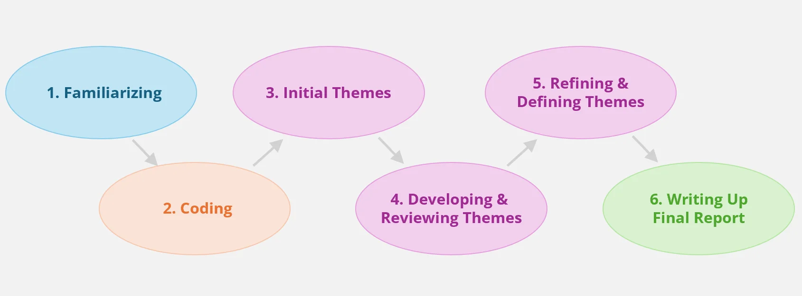
Figure 4.1: Six-stage thematic data analysis
(Source: Influenced by Braun and Clarke, 2023)

3.7 Research quality
The credibility of the findings will be measured by source-wise comparing the data with similar or dissimilar findings. The inclusion of high-quality secondary sources and reports will enhance the dependability of the study. Providing contextual insights will increase the transferability of the study. The elimination of researcher bias by incorporating logical insights will be beneficial for improving confirmability of the study.

3.8 Ethical consideration
The regulations and guidelines of plagiarism, copyright and collusion will be strictly maintained throughout the research to avoid the issue of academic misconduct (Holden et al., 2021). Specific in-text referencing will be provided during the collection of facts from literature and secondary sources. All the confidential data will be saved on the university computer within a zipped and password-protected folder, which will be only accessible to the researcher and the supervisor.

4.0 Expected findings
The current study will provide knowledge for the leaders and managers of the fast-fashion industry, including Zara, to find out the customer-specific IMC tactics, which will improve consumer purchasing intention, consumer trust, brand authenticity, digital engagement and others. However, the study will also be beneficial for the mentioned sector and Zara to identify the loopholes in IMC, which negatively impact the buying intentions of customers associated with greenwashing. Furthermore, the realistic recommendations associated with the adoption of technology, recruiting skilled employees, modifying leadership styles and others will also be worthwhile for Zara to improve the loopholes in its IMC and upgrade brand loyalty and buying intentions of customers.

5.0 Expected contribution
From the overall study, it can be inferred that IMC is necessary for the fast-fashion marketers and Zara can engage customers by delivering a unified brand message across all the channels through influencer marketing, social media advertisements and others through qualitative understanding of IMC. Consequently, transparency among customers will be increased, and more customers will show interest in opting for Zara over other fast-fashion brands. Future researchers can also use the results of this study in their studies to strengthen their research with sufficient information related to IMC and buying behaviour of customers.

6.0 Proposed conceptual framework
Integrated Marketing Communication
--------------------------------------------
• Advertising
• Social Media
• Influencer Marketing
• CSR Communication
• Public Relations
• Sustainability Messages
│
▼
Consumer Interpretation
--------------------------------------------
• Message Consistency
• Credibility
• Authenticity
• Trust
│
▼
Consumer Buying Behaviour
--------------------------------------------
• Purchase Intention
• Purchase Decision
• Repeat Purchase
• Recommendation

7.0 Timeframe
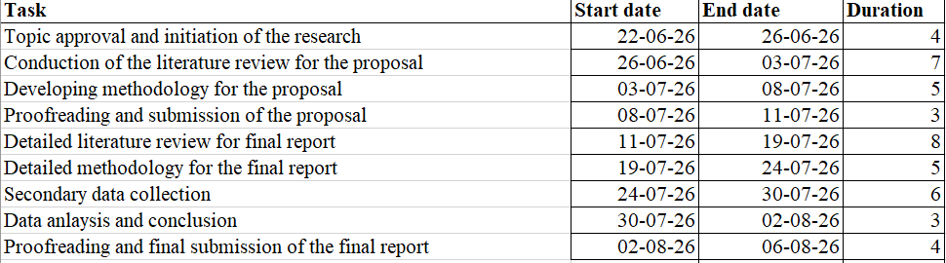
Figure 7.1: Project timeline
(Source: Created by the author)

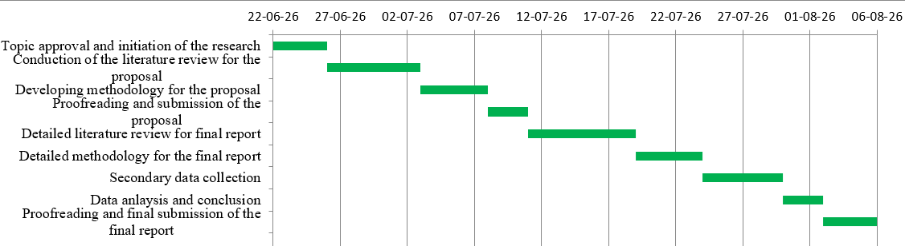
Figure 7.2: Gantt chart
(Source: Made by the author)

8.0 References
Adamkiewicz, J., Kochańska, E., Adamkiewicz, I. and Łukasik, R.M. (2022) Greenwashing and sustainable fashion industry. Current opinion in green and sustainable chemistry, 38, p.100710. https://doi.org/10.1016/j.cogsc.2022.100710
Ahmed, A., Singh, S., Sinha, S. and Nargis, S. (2025) Broken promises: The impact of misleading marketing on consumer trust and brand loyalty. European Economic Letters (EEL), 15(2), pp.2996-3005. http://eelet.org.uk/
Ayre, J. and McCaffery, K.J. (2022) Research Note: Thematic analysis in qualitative research. Journal of Physiotherapy, 68(1), pp.76-79. https://doi.org/10.1016/j.jphys.2021.11.002
Braun, V. and Clarke, V. (2023) Toward good practice in thematic analysis: Avoiding common problems and be (com) ing a knowing researcher. International journal of transgender health, 24(1), pp.1-6. https://doi.org/10.1080/26895269.2022.2129597
Butler, S. (2022) Dirty greenwashing: watchdog targets fashion brands over misleading claims. The Guardian, Jan 14. [Online] Available at: https://www.theguardian.com/business/2022/jan/14/dirty-greenwashing-watchdog-targets-fashion-brands-over-misleading-claims [Accessed on 23 June 2026]
Castillo-Abdul, B., Bonilla-del-Río, M. and Núñez-Barriopedro, E. (2021) Influence and relationship between branded content and the social media consumer interactions of the luxury fashion brand Manolo Blahnik. Publications, 9(1), p.10. https://doi.org/10.3390/publications9010010
Cheong, H.I., Lyons, A., Houghton, R. and Majumdar, A. (2023) Secondary qualitative research methodology using online data within the context of social sciences. International Journal of Qualitative Methods, 22, p.16094069231180160. https://doi.org/10.1177/16094069231180160
Hagger, M.S. and Hamilton, K. (2024) Longitudinal tests of the theory of planned behaviour: A meta-analysis. European Review of Social Psychology, 35(1), pp.198-254. https://doi.org/10.1080/10463283.2023.2225897
Holden, O.L., Norris, M.E. and Kuhlmeier, V.A. (2021) Academic integrity in online assessment: A research review. In Frontiers in education (Vol. 6, p. 639814). Frontiers Media SA. https://doi.org/10.3389/feduc.2021.639814
Jordan, D. (2023) Zara says it regrets Gaza images misunderstanding. The BBC, Dec 12. [Online] Available at: https://www.bbc.com/news/business-67690447 [Accessed on 23 June 2026]
Kolotouchkina, O., Díaz-Bustamante Ventisca, M., Carcelén-García, S. and Díaz-Soloaga, P. (2025) Environmental activism and sustainable communication of B-Corp fashion brands on Instagram: best practices, emerging opportunities, and remaining challenges. Humanities and Social Sciences Communications, 12(1), pp.1-16. https://doi.org/10.1057/s41599-025-05941-2
Kutlu, E. (2025) Online Branding and Digital Communication Strategies. Online Retail Marketing Strategy: Foundations and Consumer Experience, p.63. https://doi.org/10.58830/ozgur.pub943.c3948
Najah, K.A. and Jenita, A.M.A. (2025) An Empirical Study on the Impact of Integrated Marketing Communication Strategies on Consumer Buying Behaviour. JOURNAL OF TECHNICAL EDUCATION, p.90. https://www.ijteonline.in/assets/uploads/issue_pdf/1766494686.pdf#page=100
Niu, H. (2022) Marketing Communication Strategy for International Fashion Retail Brands after COVID-19. Journal of Economics, Business and Management, Vol. 10, No. 4. p. 1-6. https://doi.org/10.18178/joebm.2022.10.4.703
Obilor, E.I. (2023) Convenience and purposive sampling techniques: Are they the same. International Journal of Innovative Social & Science Education Research, 11(1), pp.1-7. https://www.researchgate.net/profile/Esezi-Obilor/publication/398681103_Convenience_and_Purposive_Sampling_Techniques_Are_they_the_Same/links/693fe9e8a1fd01798907e406/Convenience-and-Purposive-Sampling-Techniques-Are-they-the-Same.pdf
Olawale, S.R., Chinagozi, O.G. and Joe, O.N. (2023) Exploratory research design in management science: A review of literature on conduct and application. International Journal of Research and Innovation in Social Science, 7(4), pp.1384-1395. https://doi.org/10.47772/IJRISS.2023.7515
Proudfoot, K. (2023) Inductive/deductive hybrid thematic analysis in mixed methods research. Journal of mixed methods research, 17(3), pp.308-326. https://doi.org/10.1177/15586898221126816
Rehman, S.U., Gulzar, R. and Aslam, W. (2022) Developing the integrated marketing communication (imc) through social media (sm): the modern marketing communication approach. Sage Open, 12(2), p.21582440221099936. https://doi.org/10.1177/21582440221099936
Sarfraz, M., Al Kurdi, B. and Rafiq, M. (2025) How digital marketing shapes consumer decision-making employing (AIDA) model with respect to consumer knowledge and consumer experience. International Journal of Management and Marketing Intelligence, 2(1), pp.39-48. https://doi.org/10.64251/ijmmi.66
Sefa, A.A.O., Rezaei, M. and Valilai, O.F. (2026) An analytics-driven method for building ethical customer digital twins using neuromarketing and social media data. Decision Analytics Journal, 18, p.100689. https://doi.org/10.1016/j.dajour.2026.100689
Sudirjo, F., Sari, E.N., Apramilda, R. and Hendra (2024) The role of customer trust toward digital sales and website visitor satisfaction on customer loyalty of Zara Indonesia. Jurnal Informasi dan Teknologi, 6(1), pp.291-296. https://jidt.org/jidt
Taherdoost, H. (2021) Data collection methods and tools for research; a step-by-step guide to choose data collection technique for academic and business research projects. International journal of academic research in management (IJARM), 10(1), pp.10-38. https://hal.science/Hal-03741847/
William, F.K.A. (2024) Interpretivism or constructivism: Navigating research paradigms in social science research. International Journal of Research Publications, 143(1), pp.134-138. https://ijrp.org/paper-detail/6086
Zahran, A.M. (2025) The impact of marketing strategies on the success of the fast fashion industry: A systematic review. JUMDER: Jurnal Bisnis Digital dan Ekonomi Kreatif, 1(3), pp.1-15. https://doi.org/10.1234/jumder.v1i3.25
Zervoudi, E.K., Moschos, N. and Christopoulos, A.G. (2025) From the corporate social responsibility (CSR) and the environmental, social and governance (ESG) criteria to the greenwashing phenomenon: A comprehensive literature review about the causes, consequences and solutions of the phenomenon with specific case studies. Sustainability, 17(5), p.2222. https://doi.org/10.3390/su17052222

