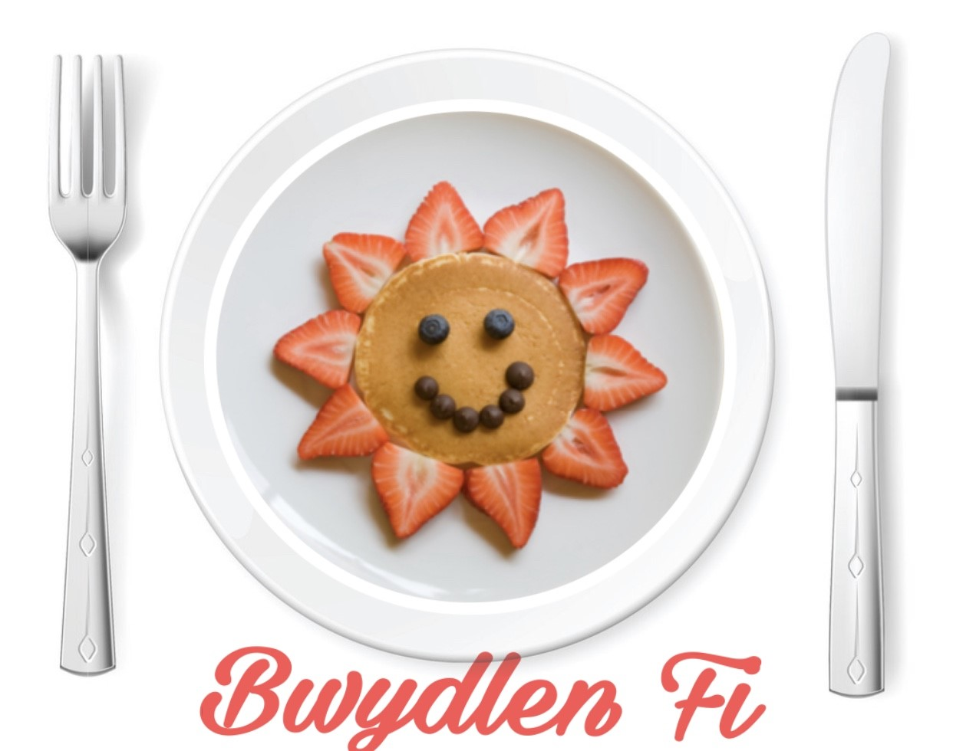
Contents Page
Images of logo and app (images to refer to).…………………………………. Page 3
Introduction of Concept ………………………………………………………… Page 4
Statistics ……………………………………………………………………………. Page 5
Innovation ……………………………………………………………………… Page 5 – 6
Benefits ………………………………………………………………………..……. Page 6
Business Aims ………….……………………………………………….....……… Page 7
Barriers/Challenges …………………………………………………….……. Page 7 – 8
Profitability comes with a cost …………………………...……….…………….. Page 8
Concept ……….……………………………………………………………….. Page 8 – 9
Critical Analyse ………………………………………………...………………… Page 9
Link to Theory …………………………………………………………………… Page 10
Obesity Statistics in Childhood ………………………………………...……… Page 11
Conclusion ……………………………………………………………….……….. Page 11
Reference List ……………………………………………………………….. Page 12 – 14

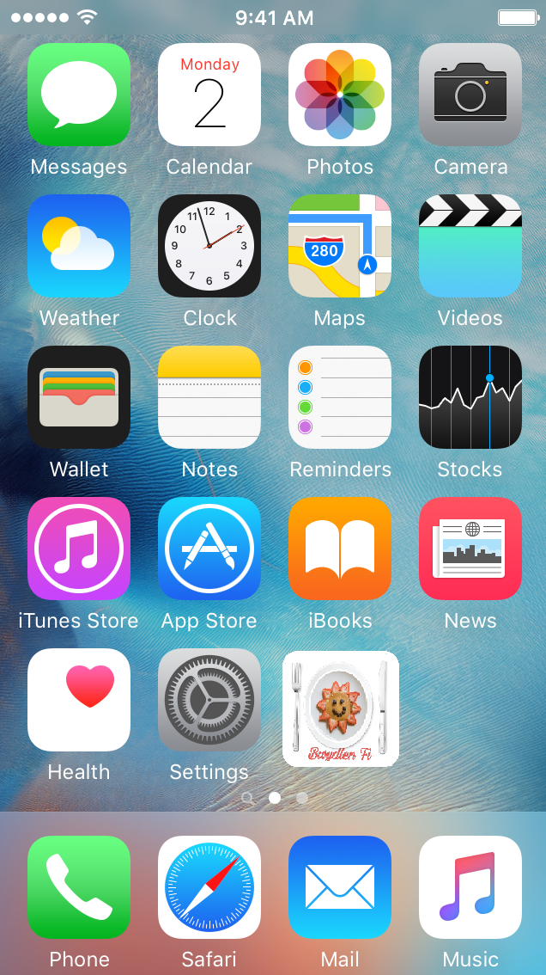
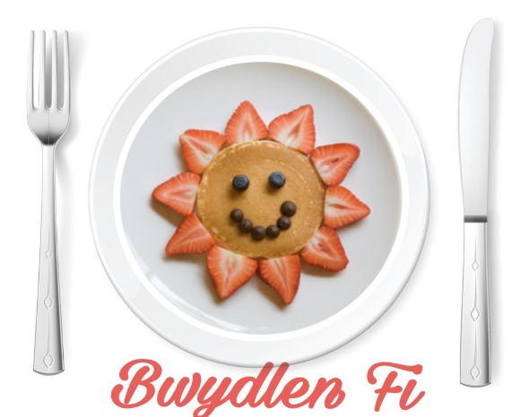
Images to refer to

Logo
(Source: Combined Image (RFCA, (2015)
and 8tracks, 2014) with personal
logo 19/04/19)
Example of App
(Source: Evans, L. (2019)
‘Personal Image’. [Digital photograph].

Introduction of idea
The concept for this business is to create an application (app) via an online device such as an Apple iPhone or iPad, as well as Android devices. The app content would also be accessible online via a website. The audience are parents, children and practitioners as this app has the potential to improve relationships professionally, academically and lovingly. The concept for the app, is to provide children with more choices when it comes to school dinners. Parents/carers can also pay securely for school dinners via the app. The children will once a week, sit with parents at home and discuss their food choices for the following week in school. The app will have options for children with allergies such as peanut free food, dairy free food and gluten free food. It will also encourage the children to eat healthier as well as providing them with choices. This links to Maslow’s Hierarchy of Needs (1943) because providing children with food is a psychological, basic need that needs to be met for them to fulfil self-actualisation. Therefore, this can relate to the United Nations International Children’s Emergency Fund (UNICEF) (2010) statement known as the United Nations Convention on the Rights of the Child (UNCRC) (1989). Article 12 of the UNCRC (1989) states children have a right to express their views and feelings in matters which affect them. It can also be linked to Article 24 that states children ‘have a right to the best possible health’. Children who are deemed ‘picky eaters will benefit from this concept because they could eat a meal they have picked because they were provided with a choice and the idea is that it will encourage children to eat more food. This is because the parent helps the children make a choice of food and encourage them to choose meals they may have eaten at home. For example, if one of the options were lasagne and salad, a child may say ‘I do not like that’ and the parent could respond with ‘I have made you that at home and you like it. Remember you ate it all? It is my favourite!’. This could make the child remember the time they have eaten that meal before, and encourage the child to make a choice because they know their parent/carer has prepared that meal at home. This could have a positive effect on the child because they may feel a sense of pride of eating a meal that is approved by their parent, and because the meals provided are tasty, they may be unaware of just how healthy the meal is.

Statistics
The concept links to government funded campaigns such as Change4Life (no date) whose goal is to encourage children to move more as well as eat better. Change4Life claims that nine out of 10 children in the United Kingdom could be more at risk of heart disease and type 2 diabetes because of the ‘dangerous amounts of fat in their bodies’. StatsWales (2018) show that between 2007-2008, 12,593 children in Wales were eligible for free school meals, and in 2017-2018, this had increased to 14,107 children. That means that within the last ten years, 1,514 more children have required free meals due to the deprivation and poverty they may live in at home. However, it does not seem like a huge increase when divided between ten years but it is important to consider that poverty is still increasing in Wales. It is also worrying because a Free School Meal (FSM) may be the only nutritional meal that the child has all day, therefore, children should receive a meal that they like, have chosen and want to eat. BBC News (2018) reported that in Wales, ‘more children than ever in Wales could go hungry over the six-week school break’ and how foodbanks should ‘be prepared’. In term time, children do have access to breakfast clubs as well as FSM if they meet the requirements to receive them for free. Therefore, part of this business would also include free classes for parents to attend within the school setting where I would teach them how to eat well without spending a lot because it can cost parents up to £40 extra a week to feed one child outside of school term-times (Forsey, 2017) and I want to help change that.
Innovation
The concept spoken about is innovative because there is nothing like it anywhere in the world – it is unique. It is innovative because there is a main focus within the Early Years to give children choice, yet when it comes to their dinner, they are expected to eat what they are given. It is my aim to change that. It links with the Early Years because it takes into consideration the health and well-being of children. Public Health Wales (2012) discuss that a child’s health and well-being should not be underestimated and be protected at all costs. This is done in Wales by providing children with education, free school meals (if eligible), free health services as well as explaining their rights to them.
It also links with the Early Years as it emphasises the importance of providing a choice to children of all ages, this is the main purpose of this app.
Benefits
The benefits of this business concept are that it is accessible to all. It is a concept that can be government approved and spread nationwide, given the opportunity. It relates to the UNCRC Articles 12 and 24; giving children choices and being healthy. This concept has the potential to reduce the amount of money the school spends on food for the setting because the kitchen staff will get a weekly account of what needs to be purchased to meet the needs of the children. It then has the potential to reduce food waste which leads us on to being more sustainable individuals as well within the setting as the carbon footprint will be reduced by wasting less food on our part. The premises would be more organised as well just by providing children with meals they actually want to eat. It also banishes the shame some children may have knowing they receive free school meals. Learning Gov Wales (2013) state that children entitled to FSM believe that there is a stigma attached to them because it means ‘they are poor’ to their friends. We would reduce this stigma with a technology that is available in a majority of schools in Wales with the cashless dining service used to access their school dinner fund with their thumb print. If schools who are interested in this app for their school but do not have the machines, I would approach the Local Education Authority for funds for machine. The concept could be supported by the Donaldson Report (2015) where evidence shows children in Wales believe that when it comes to digital technology within their educational setting, it was out of date. With this app, children could feel happier about the opportunity they are provided with in making choices for themselves with new technology. The financial feasibility for parents is a benefit because they know that if they want to pay for school meals instead of packed lunch, that their child is eating a meal they know their child likes. A major benefit of this plan is that children are given three different choices every day so will not get bored of eating the same thing daily and weekly, which is the system Welsh schools follow now.

Business Aims
An aim for this business is to create a partnership with Ella’s Kitchen which provides organic food for children. They place a focus on making food fun and appealing to the children’s eye. In 2006, Paul Linley set up Ella’s Kitchen to ‘improve children’s lives through developing healthy relationships with food’ (Ella’s Kitchen, 2018). The U. K’s number 1 baby food brand is expanding their food products for older children and therefore, this concept could benefit Ella’s Kitchen as a business as they would be fulfilling their aim to provide older children with the same benefits as they provide baby’s with from organic, tasty food. The aim is to partner with Ella’s Kitchen team to provide healthy meals for children of all ages. Create new school menu’s together. Local Education Authorities and then the Government would be approached to help fund this concept and spread it nationwide.
Barriers/Challenges
However, there are some barriers and challenges that need to be taken into consideration. First of all, the reliability of technology. Are we a generation becoming too reliant on it when it is not always reliable. Marsh (2014) believes that children are experts in this digital age. However, Hallet (2016) believes that encouraging children to use digital technology continuously, can affect their childhood as it can be conflicting for the child to grow up in a tech obsessed world. This app could be supported by the Digital Competence Framework (2016) as it encourages practitioners to become more ‘tech savvy’ by knowing what they are teaching to children and parents. However, teaching practitioners how to use the app may come at a cost to the manager of the setting. Another barrier could be the accessibility to the app. If parents living in poverty cannot afford meals for their children, can they afford the device needed to use this app. To overcome this barrier, access would be granted to them through a designated digital device which they can use once a week in the premises. However, this app. would be available to download for free on all Apple and Android devices including mobile phones. If parents wish to use the premises, a staff member would monitor them just so the setting followed the General Data Protection Regulation (GDPR) (2018) guidance ensuring that no child’s identity may be compromised. The device would have no photos or private documents as it would only be designated to use for this purpose.
Another challenge would be the start up costs, to benefit me I would get an expert’s help to create the app and website just because it needs to look professional so there is that cost to consider, as well as legal fees for solicitors as the concept needs to be patent so it is protected.
Profitability comes with a cost
The biggest negative, would be that dinners would have to go by £1 a week term time. Children entitled to FSM would only pay this if they wanted to use the app, children who have dinners by choice would by an additional £1 on top of their meal fees. This would have to be done to cover the cost of starting the business up as well as approaching food suppliers, businesses, Local Authorities and the Government. One pound a week does not sound like a lot to make a profit but according to my calculations, if a school has 500 students, and $\frac{2}{3}$ (on average 330 pupils) paid £1 a week during term time, that equates to £13,200 a year for one school. Carmarthenshire alone has 213 schools made up of 101 primary schools, 12 secondary schools and 2 Additional Learning Needs schools. £1 extra a week over term time equates to a profit of £716,000 a year just in Carmarthenshire. Obviously, deductions would need to be made such as paying for legal fees, the start up of the app and website as well as maintenance such as app updates. British Educational Suppliers Association (BESA, 2017) stated that Wales has 476,000 students (rounded up). On a larger scale if $\frac{2}{3}$ of Welsh children paid £1 a week during term time, it would equate to a profit of over £2.5 million which is enough money to cover all start-up costs and legal fees. Some of this money would be given back through the summer holiday meal classes.
Concept
I came up with this concept because of two reasons. Number one, as an almost qualified Early Years practitioner, my experience on placements and theory of what I have learnt in university has broadened my expertise. It upsets me being a student and seeing qualified staff try and force children to eat food they do not like. Telling a child ‘mmm of course you like it’ is not going to make them eat it.
Secondly, as a child, I was lucky enough to have a father who by profession was a chef, he always encouraged me to eat his homemade food and because of it, my appetite and appreciation for food was healthy.
Critical Analysis
Craft et al. (2013) discuss how practitioners should be encouraging children to become independent and innovative learners within the Early Years. Therefore, practitioners could be innovative thinkers as well. The business concept, links well to the Early Years for many reasons. First of all, it takes into consideration the expectations that the setting and parents can have for another. Hallet (2016) explores how parents and practitioners have certain expectations of each other. Brooker (2002) further supports this statement by stating that parents that aim to be successful in their child’s eye, support the practitioner. This is underpinned by Tickell (2011) who states a parent’s role is to show an interest in their child’s education. However, this can only be achieved if practitioners have effective parental engagement included in their practice and encourage parents to get involved through courses and workshops. To make the concept successful, parents/carers would need to be taught how to use the application and website. Therefore, parents and practitioners could work in partnership to discuss the details of the concept to ensure it would benefit all stakeholders. The stakeholders in this instance are children, parents and practitioners described by Ball (1994) as ‘a triangle of care’. However, a barrier to this partnership regarding the concept is that it could pressure parents into attending courses they simply have no time to attend due to other commitments. A benefit to this business, could be a possible partnership in the future with a brand known as ‘Ella’s Kitchen’.
The unique concept links to health and well-being because it takes into consideration the health benefits of the food that will be provided to the children. There is nothing of its sort available to children in the Early Years at the moment. Children in Wales (2017) state that practitioners have a duty to children to ensure that they are supported in regards to concerns they have about their health. The UNCRC (1989) statement supports this through Article 6 which states children ‘have a right to life and to grow up to be healthy’. The Rights of Children and Young Persons (Wales) Measure (2011) was the first country in the UK to enforce these laws therefore benefiting Welsh children to be happy and healthy individuals.
Link to Theory
A child’s health and well-being start with factors measured in Bronfenbrenner’s ecological systems theory (1979). The theory looks at how children interact with their environment as well as how the people within the environment around them influence their choices. Whilst parents are a part of the microsystem, practitioners are a part of the mesosystem which is the second biggest influence to the child. However, it can be argued that whilst practitioners can influence a child’s choices when it comes to healthy eating and encouraging the children to eat what is in front of them, the main role model a child looks up to, is their parent/carer. Therefore, the business concept may help prove that children would enjoy using this app because it is something, they can do that will make their parents influence their healthy choices. It may also encourage children to eat their food because they were given a choice, rather than one meal fits all. However, Underdown (2007) could argue that while this business concept meets a child’s health needs through the nutritional value in the food, it does not give the children as much freedom of choice as first thought, because the children’s responses in their food choices may influence them to make choices to please their parent because parents are the biggest influence and role model a child has. However, Bowlby (1969) could argue that the child’s role model may not be their parent, because they may not have a strong attachment to them and therefore could easily be influenced by others such as peers, practitioners or whoever the child has a bond with and therefore effecting the child’s health and well-being. It could also be argued that regardless of who influences the child’s choices, all choices of food for the children are healthy regardless of who picks what. A challenge of the concept is that it may not be global success, and rather just a nationwide success because free school meals are ‘a unique phenomenon worldwide’ (Tikkanen, 2011). Tin Finland and Sweden, children are given free school meals because it is considered to be a part of the child’s welfare. Whereas in Wales, children are only entitled to a free meal if they meet the threshold where the income is low in the family. However, Maslow’s hierarchy of needs (1943) could argue that children will not have the motivation to become self-actualised because their basic needs such as food have not been provided.
Tikkanen (2011) could support this because she states that by giving children a choice in what they eat, children will leave less waste because they have participated in planning their own individual menu.
Obesity Statistics in Childhood
Eating a good, healthy meal ensures the child has enough energy to carry out any work tasks and therefore not only will their health and well-being improve, but also their education. A positive of the business concept is that by introducing healthier choices to children and food they actually want to eat, with a regular exercise programme in place such as weekly physical education, this could also help tackle obesity in children in Wales. In 2011-2012 it was reported that 28% of children were obese compared to just 11.3% in 2014 (Public Health Wales, 2014) so whilst obesity amongst children is decreasing, parents and practitioners need to do more to control it and ensure children are encouraged to make healthy choices. However, another challenge for the concept, is that it discusses how it aims to have summer holiday cooking classes, yet in North Wales this concept has already been introduced. The Guardian (2017) reports that:
The children are here for a free school meal… they are being fed during the summer holidays as part of a scheme that has been boosted by £500,00 from the Welsh Government.
(Marsh: The Guardian) (2017)
It was reported that foodbanks ran out of stock in the summer holidays in 2017 and 3 million children in the UK risk going hungry during the holidays. However, this could be just the proof the concept needs in able to have help to fund these cooking classes and a benefit is that it would not cost not parents or children because the £1 extra they pay on top of their FSM or usual payment would cover the cost. However, a challenge could be having permission from the setting’s manager or head teacher to hold the classes in the premises. They may not allow it due to health and safety reasons and adult: ratios.
Conclusion
To conclude, the business concept is truly unique and there is nothing of its sort in existence at the moment. There are risks and challenges to all new business adventures however, theory can often provide a clearer assessment of the risks. Theory looks at all points of view including the positives, challenges and barriers. Children’s health and well-being is a right, not a choice and therefore practitioners and parents must work in partnership to foresee these rights are met so the child is happy, healthy and provided with choice.
References
8 Tracks (2014) ‘Sunshine Pancakes’ https://8tracks.com/daylight-again/sunshine-pancakes [Accessed: 19th April 2019].
Ball, C. (1994) Start right report. London: Royal Society of Arts.
British Educational Suppliers Association (2017) ‘Key UK education statistics’ https://www.besa.org.uk/key-uk-education-statistics/ [Accessed: 19th April 2019].
Bronfenbrenner, U. (1979) The ecology of human development. Cambridge, MA: Harvard University Press.
Brooker, L. (2002) Starting school: young children learning cultures. Buckingham: Open University Press.
Change4Life (No Date) ‘About Change4Life’ https://www.nhs.uk/change4life/about-change4life [Accessed: 19th April 2019].
Children in Wales (2017) ‘Children’s rights, health and well-being’ file:///C:/Users/liahe/Downloads/Health-Childrens-rights%20(1).pdf [Accessed: 19th April 2019].
Craft, A., Cremin, T., Burnard, P., Dragovic, T., and Chappell, K. (2013) Possibility thinking: culminative studies of an evidence-based concept driving creativity? International Journal of Primary, Elementary and Early Years Education. Volume 41, Issue 5.
Donaldson, G. (2015) ‘Successful Futures: Independent Review of Curriculum and Assessment Arrangements in Wales’.
Ella’s Kitchen (2018) ‘The Good Stuff We Do’ https://www.ellaskitchen.co.uk/static/images/sustainability/Ella-s-Kitchen-GSWD-FY18.pdf [Accessed: 19th April 2019].
Evans, L. (2019) Personal Image. [Digital photograph].
Forsey, A. (2017) ‘Hungry holidays: a report on hunger amongst children during school holidays. http://www.frankfield.co.uk/upload/docs/Hungry%20Holidays.pdf [Accessed: 19th April 2019].
Hallet, E. (2016) Early Years Practice. London: SAGE Publications.
Hallet, E. (2016) Early Years Practice: For Educators & Teachers.
Hume, C. (2018) ‘Foodbanks in Wales brace for hungry children over summer’ https://www.bbc.co.uk/news/uk-wales-44874405 [Accessed: 19th April 2019].
Marsh, J. (2014) ‘Childhood in digital age’, in T. Maynard and S. Powell (eds) Early childhood studies (3rd edn). London: Sage.
Marsh, S. (2017) ‘Wales takes bite out of children’s holiday hunger’, The Guardian, 30 Aug: pp.1.
Maslow, A. (1943) A Theory of Human Motivation. Psychological Review, 50(4), pp.370-396.
NHS (2014) ‘Child obesity rates higher in Wales than in England’ http://www.wales.nhs.uk/sitesplus/888/news/33512 [Accessed: 19th April 2019].
Public Health Network Cymru (2013) ‘Children and Young People’ https://www.publichealthnetwork.cymru/en/people/life-stages/children-and-young-people/ [Accessed: 19th April 2019].
Royalty Free Clip Art (RFCA) (2015) ‘7083 Food and Beverages’ https://chainimage.com/image/7083-food-and-beverages-download-royalty-free-vector-clip-art-eps [Accessed: 19th April 2019].
StatsWales (2018) ‘Pupils eligible for free school meals by local authority, region and year’ https://statswales.gov.wales/Catalogue/Education-and-Skills/Schools-and-Teachers/Schools-Census/Pupil-Level-Annual-School-Census/Provision-of-Meals-and-Milk/pupilseligibleforfreeschoolmeals-by-localauthorityregion-year [Accessed: 19th April 2019].
The Rights of Children and Young Persons (Wales) Measure (2011) http://www.legislation.gov.uk/mwa/2011/2/contents [Accessed: 19th April 2019].
The United Nations Convention on the Rights of the Child (1989) https://www.unicef.org.uk/rights-respecting-schools/wp-content/uploads/sites/4/2017/01/UNCRC-in-full.pdf [Available: 19th April 2019].
Tickell, C. (2011) The early years: foundations for life, health and learning. London: DfE.
Tikkanen, I. (2011) Nutritionally balanced school meal model for a comprehensive school. British Food Journal, Volume 113, Issue. 2, pp. 222-233.
Underdown, A. (2007) Young Children’s Health and Well-being. New York: Open University Press.
UNICEF (2010) ‘A Summary of the UN Convention on the Rights of the Child’ https://www.unicef.org.uk/wp-content/uploads/2010/05/UNCRC_summary-1.pdf [Accessed: 19th April 2019].
Welsh Assembly Government (2013) ‘Free School meals case studies report’ https://learning.gov.wales/docs/learningwales/publications/140811-free-school-meals-case-studies-report-en.pdf [Accessed: 19th April 2019].
Welsh Assembly Government (2018) ‘Digital Competence Framework guidance’ https://learning.gov.wales/docs/learningwales/publications/180620-dcf-guidance-2018-en.pdf [Accessed: 19th April 2019].

