

Programme: MSc Data and Artificial Intelligence

Module: Advanced Statistical Programming

Module Code: ACCA7022

Assignment Title: Data Analysis

Statistical Analysis of the Port Talbot Hourly Air Quality Dataset Using R

Student name: Chetanbharthi atit
Student id: 2522450
Lecturer: Dr Aliyu sambo

Table of Contents
TASK 1 2
Introduction to Dataset 2
Data Import, Cleaning, and Summary 2
Exploratory Visualization 4
Correlation Analysis 7
Hypothesis Test — Two Conditions 9
Seasonal Group Comparison 12
TASK 2 17
Reflective Summary 17
References 19

TASK 1

Introduction to Dataset
The analysis would be based on the air quality dataset, belonging from port talbot. This dataset has been containing hourly air pollution and weather condition observation, from past 9 years, starting from the year 2015, till 2024. Since this dataset has been containing data from past 9 years, this is considered best suited for examining major changes in pollutant concentration, which is crucial for exploring how weather conditions were heavily interlinked with the quality of air [6].

Data Import, Cleaning, and Summary
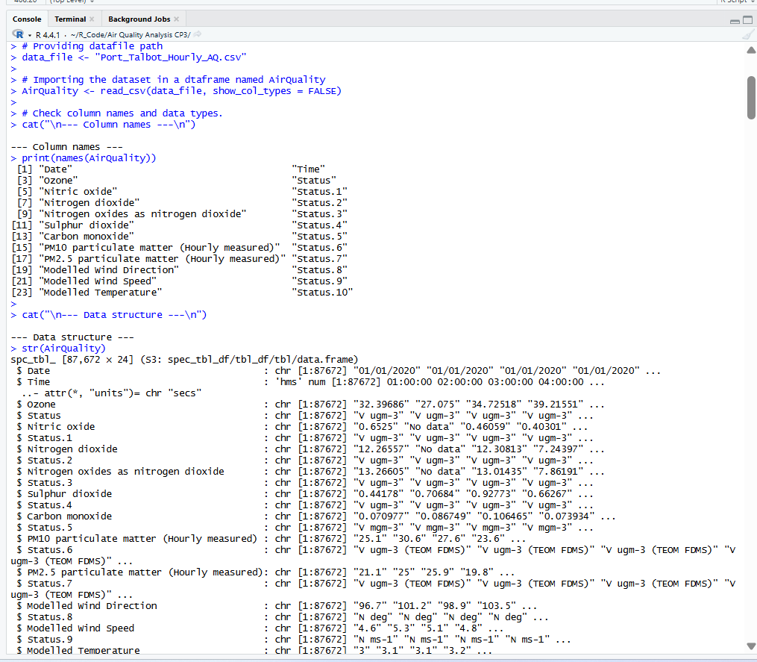
Before beginning with the analysis, all of the critical data were reviewed for making sure that the uploaded dataset file is being read properly [5]. The column names, dataset size, as well as variable structures were checked for confirming that every observation was available here for analysis.
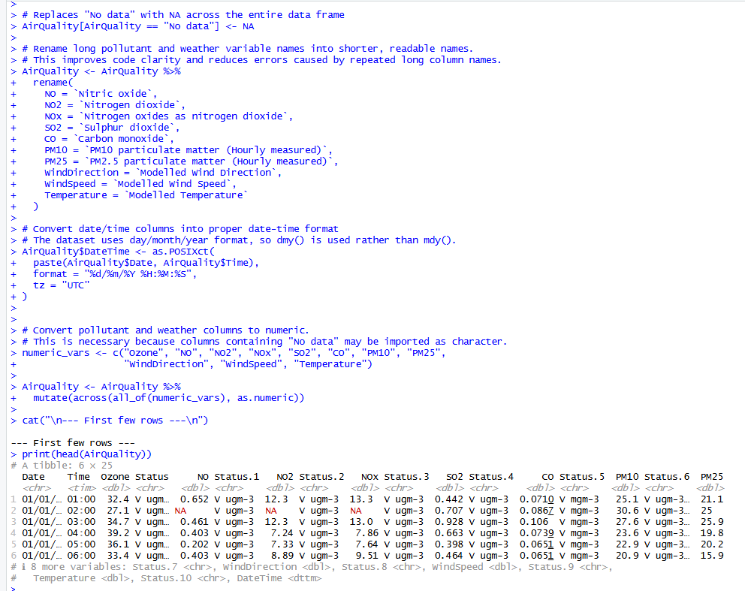
After completely verifying the dataset, the data preparation stage is initiated. All of the entries with “No Data” labels were replaced completely with the missing values. Along with that, any of the longer variable names were also shortened to support code readability [7]. Two separate columns of date and time fields were combined as a DateTime variable.
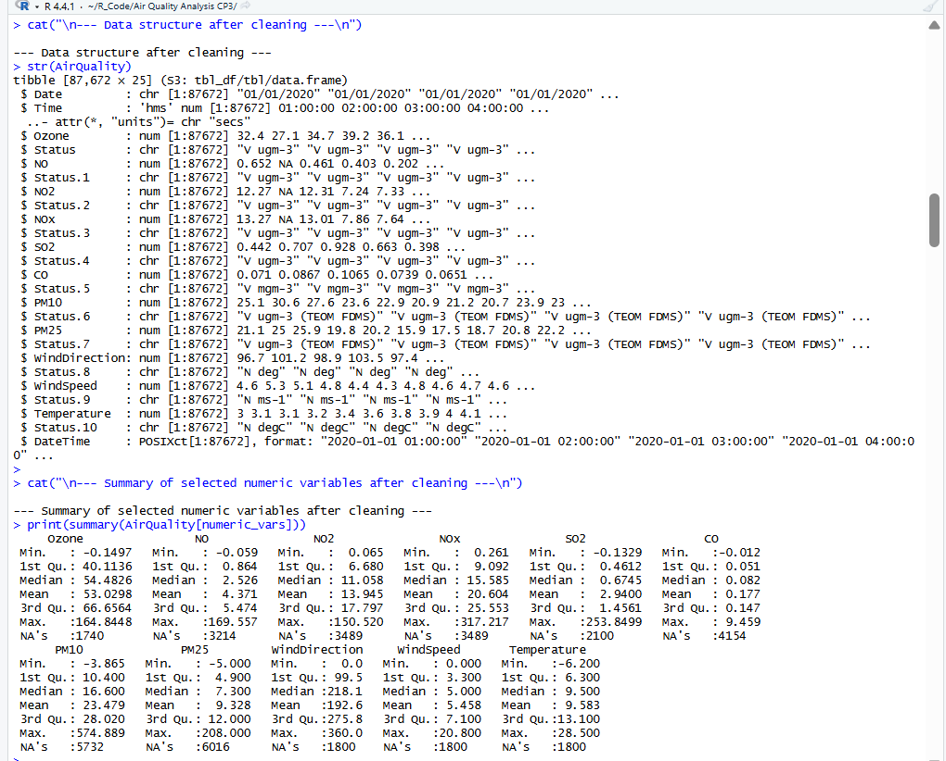
Afterwards, a final inspection of the cleaned dataset was performed, which confirmed that the selected variables were successfully converted into suitable data, while verifying that the cleaning process had been completed successfully.

Exploratory Visualization
A significant time-series graph plot was created for PM10 and NO₂, since the dataset has been containing hourly observations, which were being collected across 10-years of period. Each of the monthly average values were being used here for making sure that any of the long-term trends can easily be observed [8]. These respective graphs seem crucial for identifying major changes across each of the pollutants over a time period, as each shows repetitive peaks and low recordings across different years.
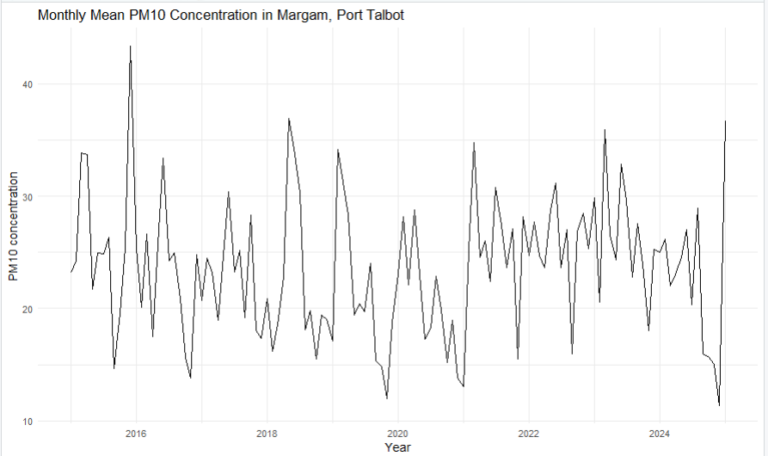
The PM10 graph shows how pollutant levels have been changing at regular intervals throughout the years, with significant ups and downs, as can be observed clearly.
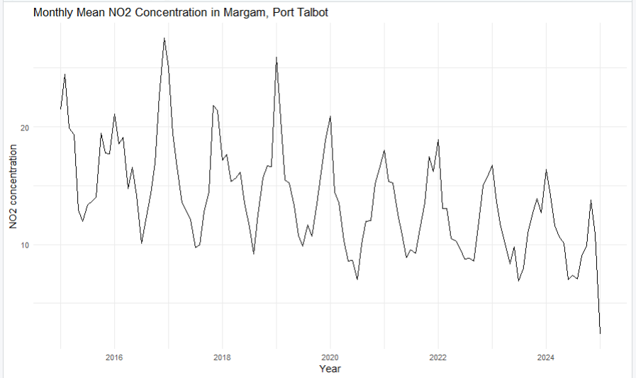
Consequently, the graph for NO₂ shows constant variation with complete declining rate towards the later years of the dataset [3]. These kinds of observations were responsible for suggesting how a pollutant conversation was never stable and can easily get influenced by the frequently changing environmental conditions.
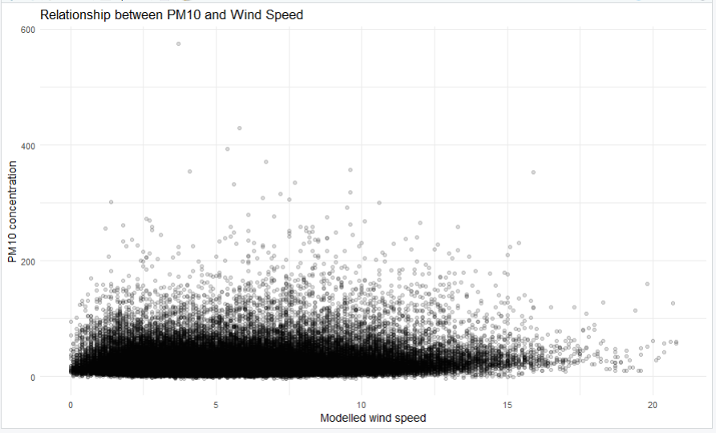
Furthermore, scatterplots were created for analyzing the basic relationships among the air pollutants and weather conditions. The graphs here were comparing PM10 with the wind speed, which explains that with higher wind speed, the concentration of PM10 would be lowered simultaneously.
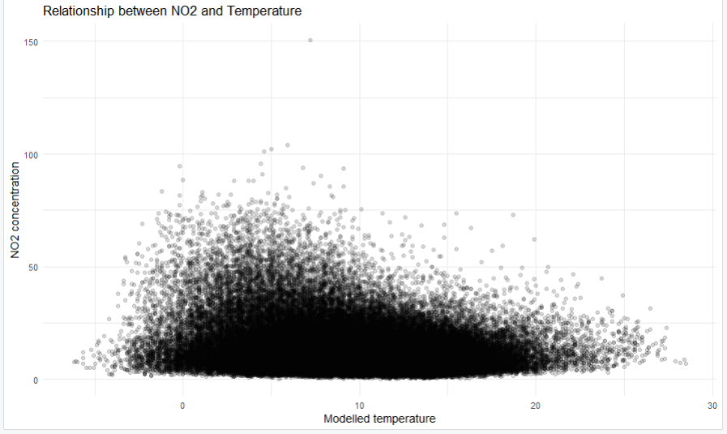
Consequently, another scatterplot graph was created for NO₂ and temperature, which would be focused on analysing how the concentration of NO₂ can be impacted by changing atmospheric temperature. These visual graphs have been providing an initial understanding of the basic relationship among different pollutants and other weather conditions.

Correlation Analysis
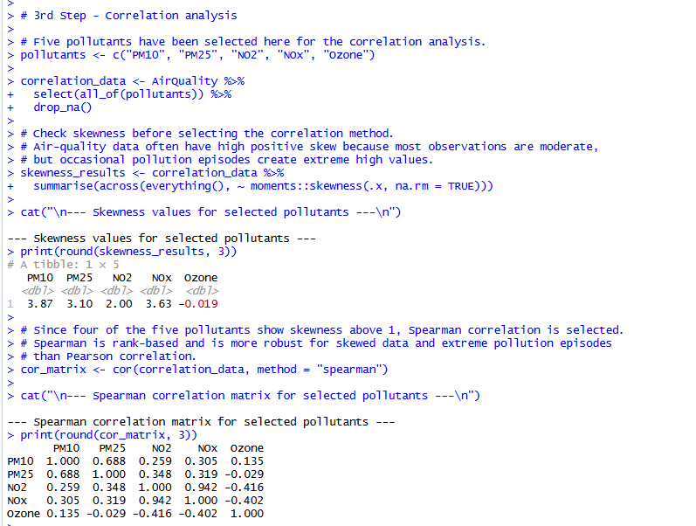
A detailed correlation analysis has been performed to examine the basic relationship among the selected pollutants, which mostly include PM10, PM2.5, NO₂, NOX, as well as Ozone. Before properly calculating their correlations, the basic distribution among the pollutants was determined [4]. As these data shows immensely skewed values, Spearman correlation method has been utilized for providing much more reliable assessment of the entire relationship among these selected pollutants. As per the correlations, it was observed that the NO₂ and NOX have higher correlations among them, whereas PM10 and PM2.5 have stronger positive association among each other.
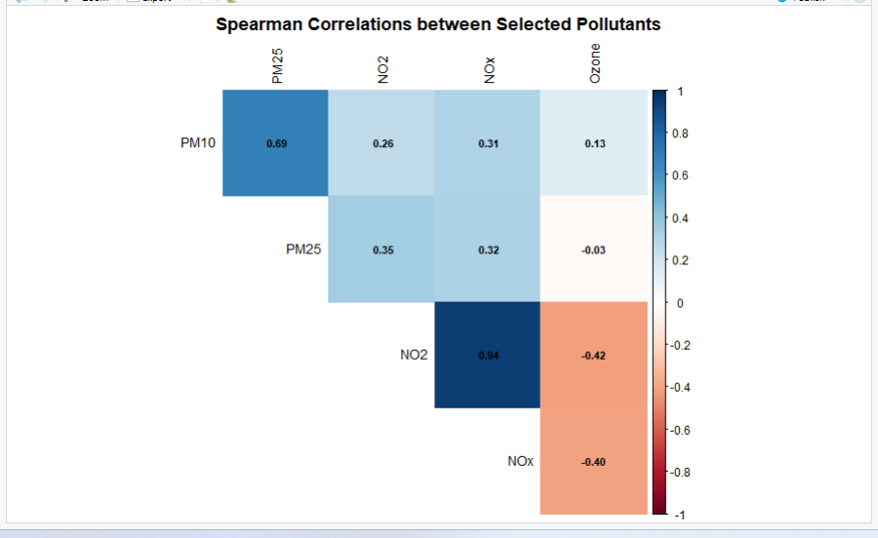
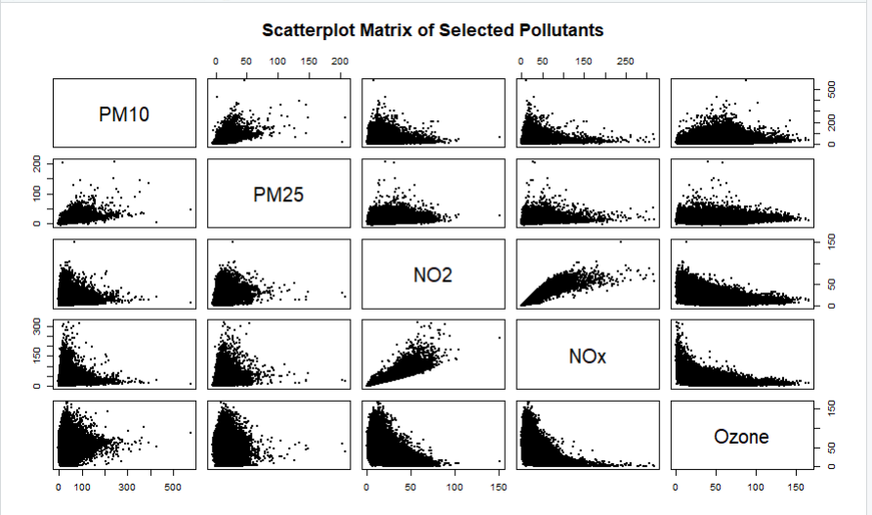
The correlation heatmap and scatterplot graph have been used here to present the complete relationship among these selected pollutants using a complete visual format. The heatmap has been revealing the basic strength and direction for each of the correlations, which responsibly helps in making this comparison much easier. During analysis, a positive relationship was revealed among NO₂ and NOX, while that of PM10 and PM2.5 [2]. Furthermore, Ozone tends to show a negative relationship with both the NO₂ and NOX, which indicates that with higher level of Ozone were directly linked with the lower concentration of these identified pollutants.

Hypothesis Test — Two Conditions
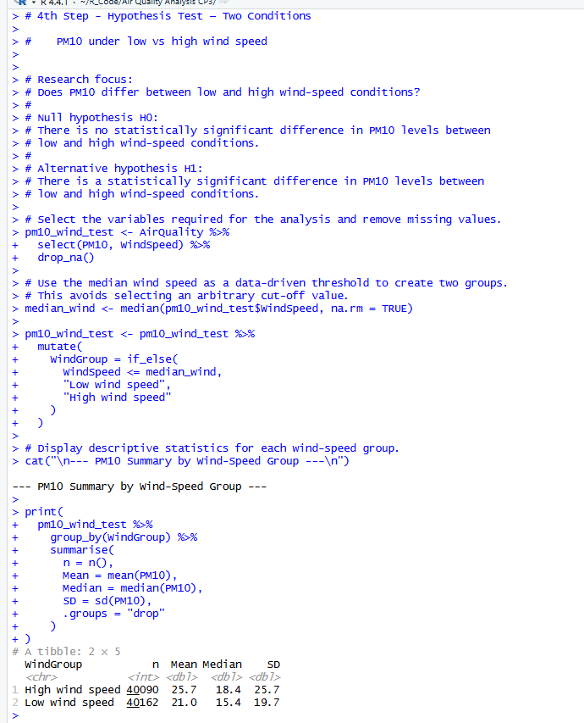
For investigating the wind speed, and how it affects particulate matter levels, PM10 concentration levels have been compared under extreme low and high wind speed conditions. These two different wind speed groups have been created using a median wind speed, which would be crucial for providing an objective threshold, apart from just randomly selecting a cut-off value.
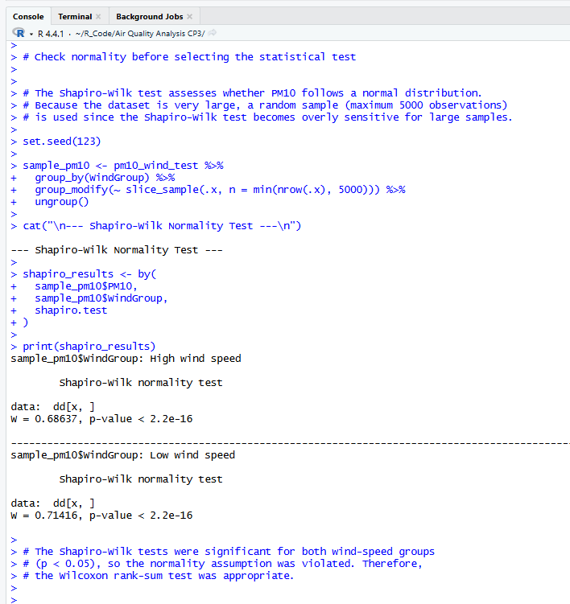
The null hypothesis performed here has been stating how no statistical differences would be created using the PM10 concentration among the two wind speed groups, while a completely alternative hypothesis has been proposed for specifying that a significant difference still exists here. Hence, before successfully selecting the statistical test, the normality of PM10 has been distributed among every group using Shapiro-Wilk test method [1]. The final result obtained here highlighted how both the groups have a p-value lowered than 0.05, hence indicating that the PM10 data were not properly distributed. Since normality assumptions were not being satisfied here, Wilcoxon rank-sum test has been conducted for comparing both the independent groups.
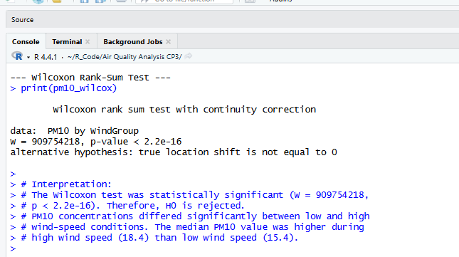
Considering the Wilcoxon Rank-Sum test, the statistic value of W = 909754218, p<2.2x10⁻¹⁶ is obtained, which indicates that the PM10 concentration is completely different across both the wind speed groups. Though the p-value obtained is less than 0.05, the null hypothesis is completely rejected, as well as an alternative hypothesis value is accepted [5]. The descriptive statistics have been indicating that the median PM10 concentration is much more higher during strong wind speed, than during poor wind speed conditions.
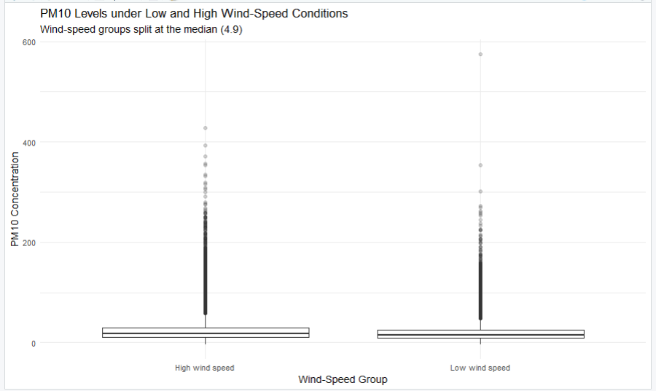
The boxplot further has been illustrating these differences, while clearly showing a slightly higher central value for high wind speed, despite the several extreme conditions followed across each observation [1]. While some other environmental factors could responsibly be influencing pollutant level, the statistical result has been showing that wind conditions play major role for creating variations among the airborne particulate matters.

Seasonal Group Comparison
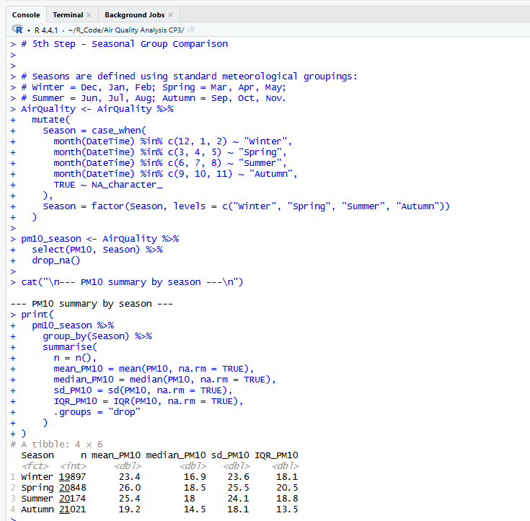
The seasonal comparison has been made, which helps to find details on whether PM10 levels have changed at different seasons such as Winter, Spring, Summer, and Autumn. The seasonal variables are being created by using the general meteorological classification [13]. This step was highly important because it helps in the process of having a properly organized layout for the hourly PM10 records into four killer seasonal groups before it is taken for statistical analysis. |
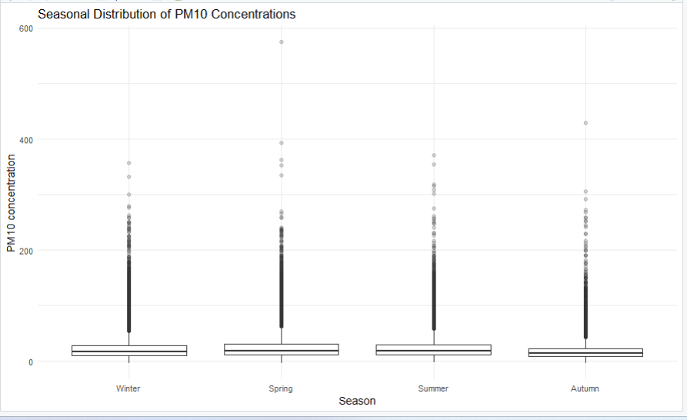
First, a boxplot has been created that helps to make a comparison regarding how PM10 concentrations were spread across four seasons. The graph is highly appropriate and necessary because it helps to provide a clear representation of the median, the variation in values, and the extreme observations which are being found for each season [9]. Within the boxplot, it has been clearly highlighted that PM10 concentrations were unevenly distributed, and it included different types of unusually high values. This is mostly during Spring and Summer. The seasonal summary further highlights that Spring has been able to record the highest median PM10 Level of 18.5, which is followed by Summer with 18.0, then it is the Winter with 16.9, and at the end it is the Autumn with 14.5.
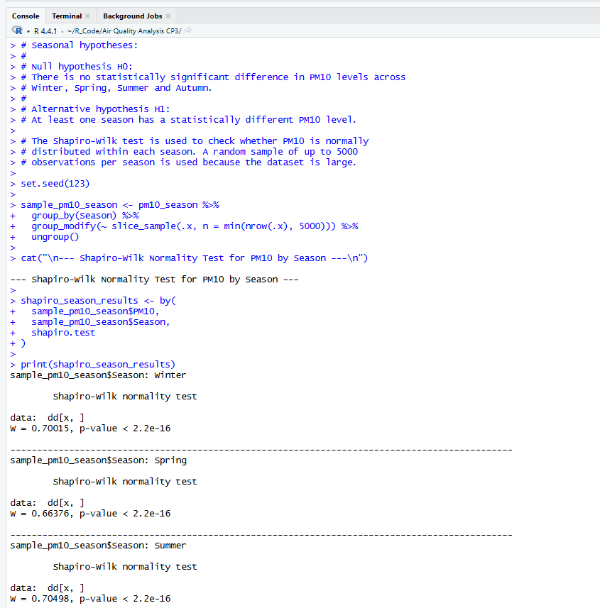
Before making a decision for which starting health test should be applied, the PM10 data for each of the season was checked for normality, where for this the Shapiro-Wilk test has been used [11]. The outcome has provided p-values which is smaller than 0.05 which is across all four seasons. This helps in the process of showing that the PM10 values are not kind of distributed in a normal manner [14]. Due to this reason, instead of one-way ANOVA, the Kruskal-Wallis test has been selected. This makes it more viable selection for making comparison between four separate groups.
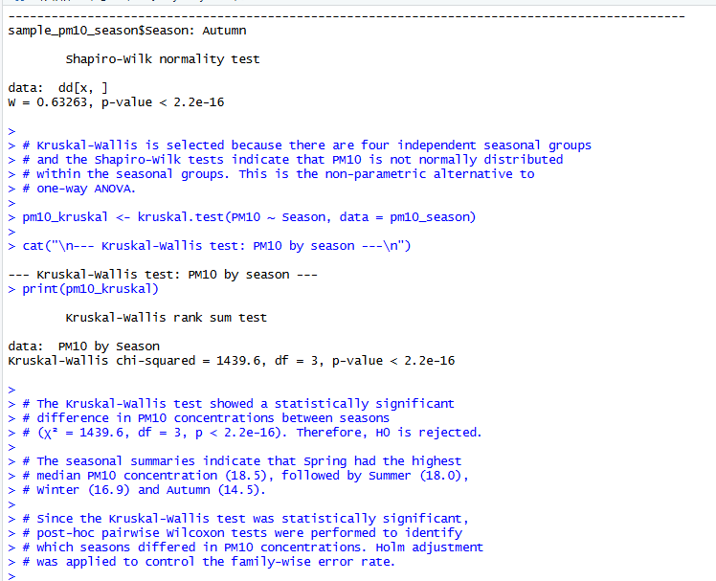
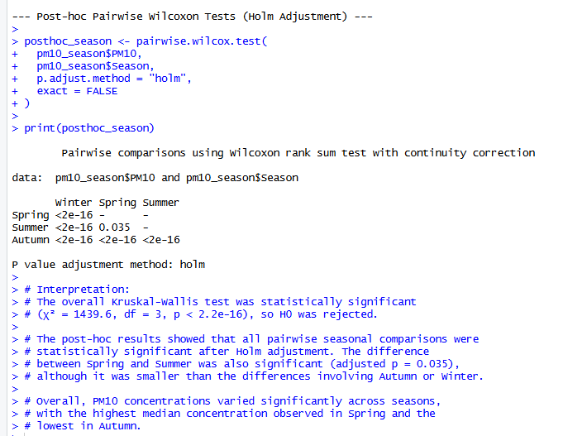
The null hypothesis highlights that PM10 concentration does not gets differ in a significant manner between the four seasons. Where the alternative hypothesis highlights that the PM10 level was very different within at least any one of the seasons [10]. Where the results which have come out from the Kruskal-Wallis test highlighted that with χ² = 1439.6, df = 3, and p < 2.2e-16, which is kind of statistically significant. Where based on these findings, the null hypothesis was not accepted.
The results completely confirm that PM10 concentrations are impacted in a significant manner across the different seasons [12]. Further analysis, which has been made by using post-hoc Wilcoxon tests with the Holm adjustment, showed that statistically significant differences are present between different types of seasonal pairs, which even includes the comparison between Spring and Summer.

TASK 2

Reflective Summary
Approach to Analysis
Within the analysis, I have started by analysing the structure and quality of the Port Talbot hourly air quality data set before making use of any type of statistical techniques. In this process, I have first analysed the variable names, data types, dataset size, and summary details in order to ensure that the data has been imported in a correct manner. Where within the next step, I have to change all “No data” entries into missing values and then convert the pollutant and weather variables into numeric values [5]. After that, I also have to join the data and time columns in order to create a single dateTime variable, which has helped me within the later analysis.
Visualisation Reflection
I have made use of time series graphs in order to highlight the monthly PM10 and NO2 patterns because highlighting the hourly readings which have been collected over the period of 10 years would have resulted in making the complete graph highly difficult to analyse and find insights from it. Monthly averages have helped to make the long-term changes easier to view while still being capable of highlighting the details which have been noted for seasonal differences. Regarding this part, I have made selection of scatterplots because they were highly helpful for me in the process of analyzing the main relationship which is existing between PM10 and wind speed, and as well as which is between NO2 and temperature. These graphs have provided me an earlier understanding regarding the possible relationships before I was able to start the complete statistical analysis.
Statistical Choices
The section on Spearman correlation is included because Multiple polytene variables had improper distributions, which makes it more suitable than Pearson correlation. Where the correlation matrix and heatmap have helped me to make a detailed observations of both positive and negative relationships without implying that one variable has been the reason for the other. Where before conducting out hypothesis analysis, I have used the Shapiro-Wilk test, which has highlighted that PM10 was not being distributed in a normal manner. Due to this, I have to apply the Wilcoxon rank-sum test, which helps me to make a comparison of the low and high wind-speed groups. After that, I have used the Kruskal-Wallis test for the seasonal analysis since it involves four separate seasonal groups, and the normality assumption was not being met.
Challenges and Solutions
One of the difficulties that I have faced was within the process of dealing with the missing values. The challenges were for me to deal with unevenly distributed pollutant data and the large number of hourly observations. I have been able to manage these problems by cleaning the dataset in a proper manner, by making use of non-parametric statistical tests, and by converting the hourly data into monthly averages. Another challenge that I have faced was in the process of dealing with the incorrect distribution of pollutant concentrations, which demands for non-parametric statistical methods instead of making use of any usual parametric test. These steps are highly important and have contributed to making the results easier to understand and have also helped me to improve the reliability of the analysis.
Learning and Future Improvements
The analysis has helped me to understand how important is to make careful preparations for data and select the correct statistical method. Where within the future, I would use regression analysis and time series models. I am also looking to make a comparison between different periods that will help me to analyse whether long-term air quality patterns have an impact or changed overtime, and I will also look to include additional pollutants that will help me to provide a detailed environmental assessment. These improvements could allow me to provide detailed evidence regarding pollutant behaviour and will also provide support for informed environmental decision-making.

References
[1] C. Acosta Ramírez and J. E. Higham, “Application of proper orthogonal decomposition to elucidate spatial and temporal correlations in air pollution across the city of Liverpool, UK,” Urban Science, vol. 9, no. 5, p. 166, 2025.
[2] Y. Boddu, A. Manimaran, B. Arunkumar, M. Sucharitha, and J. S. Babu, “Advanced air quality forecasting using an enhanced temporal attention-driven graph convolutional long short-term memory model with seasonal-trend decomposition,” IEEE Access, vol. 12, pp. 189233–189252, 2024.
[3] R. Das, A. I. Middya, and S. Roy, “High granular and short term time series forecasting of PM2.5 air pollutant—A comparative review,” Artificial Intelligence Review, vol. 55, no. 2, pp. 1253–1287, 2022.
[4] A. Dayalu, C. Calkins, J. Hegarty, and M. Alvarado, “PM2.5 anomaly detection for exceptional event demonstrations: A Texas case study,” Journal of the Air & Waste Management Association, vol. 74, no. 11, pp. 771–782, 2024.
[5] D. C. Friel and D. R. Jeske, “Wilcoxon rank-sum tests to detect one-sided mixture alternatives in group sequential clinical trials,” Statistical Methods in Medical Research, vol. 32, no. 9, pp. 1711–1727, 2023.
[6] S. Owusu-Mfum, M. D. Hudson, P. E. Osborne, T. J. Roberts, L. M. Zapata-Restrepo, and I. D. Williams, “Atmospheric pollution in port cities,” Atmosphere, vol. 14, no. 7, p. 1135, 2023.
[7] E. Pagano and E. Barbierato, “A time series approach to smart city transformation: The problem of air pollution in Brescia,” AI, vol. 5, no. 1, pp. 17–37, 2023.
[8] C. Wang, B. Wang, N. Jia, W. Zhao, N. Xu, and B. Wang, “An analytical study on the correlations between natural gas pipeline network scheduling decisions and external environmental factors,” Energies, vol. 18, no. 13, p. 3274, 2025.
[9] L. Drudi, M. Giardino, M. Tedone, A. Tiano, D. Janner, F. Pognant, F. Matera, M. Sacco, L. Bardi, and R. Bellopede, "An analysis of the PM10 chemical composition and its spatial and seasonal variation in Piedmont (Italy) using Raman spectroscopy," Science of the Total Environment, vol. 951, p. 175427, 2024.
[10] M. M. M. Hoque, M. M. Khan, M. E. Sarker, M. N. Hossain, M. S. Islam, M. M. H. Khan, M. Shil, and M. N. I. Sarker, "Assessment of seasonal variations of air quality and AQI status: Evidence from Chittagong, Bangladesh," Indonesian Journal of Environmental Management and Sustainability, vol. 6, no. 3, pp. 88–97, 2022.
[11] G. A. Wani and V. Nagaraj, "Effect of sustainable infrastructure and service delivery on sustainable tourism: Application of Kruskal–Wallis test (non-parametric)," International Journal of Sustainable Transportation Technology, vol. 5, no. 2, pp. 38–50, 2022.
[12] A. Sumeer, F. Ullah, S. Khan, R. Khan, and W. Khan, "Comparative analysis of parametric and non-parametric tests for analyzing academic performance differences," Policy Research Journal, vol. 3, no. 8, pp. 55–62, 2025.
[13] N. Ojha, M. Soni, M. Kumar, S. S. Gunthe, Y. Chen, and T. U. Ansari, "Mechanisms and pathways for coordinated control of fine particulate matter and ozone," Current Pollution Reports, vol. 8, no. 4, pp. 594–604, 2022.
[14] R. Pimentel and C. Notarnicola, "Asymmetry in snow-water nexus in mountain areas mainly governed by meteorological seasonal changes," Scientific Reports, vol. 15, 2025.

