Enhancing Sustainability at Travelodge: Implementing Energy Efficiency Practices
Report
Student Name: Iulia Ferent
Student ID: 2225255
Module Title: Sustainability for Hospitality Industry
Module Code: BMIH5006
Lecturer’s Name: Lisa Knight

AI acknowledgment:
I acknowledge the use of Grammarly (https://www.grammarly.com/) on 04 November 2024 to check spelling errors in my work. Grammarly did not require me to key in any prompt but only provided the document for spelling and grammar checks, and I chose what I wanted to change and what I wanted to dismiss from change among the issues it highlighted. I confirm that I have not used any AI tools in the research and creation of this assignment. I confirm that I have not presented any AI-generated materials as my work. I confirm I have copies of my drafts, notes, and other resources I used, which I may be asked to provide in evidence.

Executive Summary
This report examine at Travelodge's sustainability initiatives programs management, emphasizing the business's enthusiasm to environmentally responsible performance. The operation of energy-efficient source for the improvements all the way through its properties, such as the installation of LED illumination, intelligent heating systems, and improved wadding, is a remarkable endeavor that stands away. The main purpose of these modifications is to minimize the environmental impact of hotel operations and decrease energy expenditure. The important conclusions show that these pains significantly save energy operating cost and increase visitor comfort or experience, which increases overall operational effectiveness service management. The report also explanation certain difficulties, such as the early funding needed for these changes and the obligation for employee training to properly supervise and maintain the new systems. The compensation of implementing green practices are evident regardless of these challenges, providing a route to increased brand acknowledgment and cost investments. Travelodge must keep improving its environmentally friendly operations to both satisfy growing customer demand or requirements for ecological lodging and make a good impact on environmental stewardship. Travelodge can make significant strides toward a greener future while invigorating its competitive advantage in the hospitality sector by putting sustainability initially.

Table of Contents
1. Introduction……………………………………………………………………………………………………………………………………5
2. Enhancing Sustainability at Traveloge : Implementing Energy Efficiency Practices…………………….5
3. Conclusion………………………………………………………………………………………………………………………………..11
4. Reference……………………………………………………………………………………………………………………………………..12

Introduction
In the hospitality sector greener practices relay to programs aimed at reducing the environmental impact and advancing sustainability practices management. These methods that includes conserving resources management such as wounding back on electrical energy and water management use, as well as lowering pollution levels by managing waste management level well and sourcing responsibly practices (Wan et al., 2019). Hotels may decrease their carbon footprint, improve operational effectiveness services, and illustrate in visitors by putting these green tactics management performance into practice. A popular sensibly priced hotel brand management in the UK, Travelodge is famous for providing reasonably priced lodging to a assorted range of visitors engagement. Travelodge, which has many sites across the nation, is devoted to operating sustainably programs (Floričić, 2022). The business management has confirmed its commitment to reduction its environmental that effect by launching a several number of ecological activities, such as recycling schemes and water-saving projects managements. Travelodge does have a great opportunity to improve its sustainability initiatives programs, especially by implementing energy-saving measures like installing smart thermostats and switching to LED illumination (Filimonau and Magklaropoulou, 2020). Travelodge hopes to get better its market position trends, meet consumer demands or requirements for sustainable hospitality, and aggressively contribute to ecological conservation by intent on these greener practices management.

Enhancing Sustainability at Travelodge: Implementing Energy Efficiency Practices
The main goal of Travelodge's projected green practice initiative is to set up smart thermostats and LED lighting all through its properties as part of a complete energy saving program. In comparison to conformist incandescent lights, LED lighting not only uses a great deal less energy but also lasts longer, requiring less maintenance management (Hernández-Callejo et al., 2019). By modifying temperatures in response to tenancy patterns, smart thermostats maximize heating and cooling systems and assurance that energy is saved in empty lodging. By utilizing this technology, Travelodge can become compliant with current sustainability principles and drastically reduce its energy consumption and operating expenses level (Jones and Comfort, 2021). Similar energy-saving techniques have been productively implemented by a number of hotel companies, proving their realism and efficacy. Premier hotel has implemented LED lighting in all of its properties, ensuing in significant energy savings that help the corporation meet its sustainability targets (Sinha and Fukey, 2020).
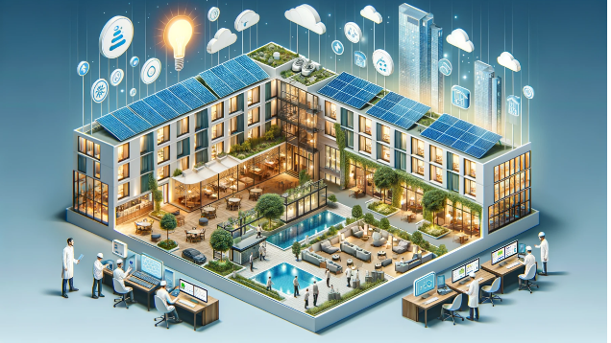
Figure 1: Sustainable Hospitality: Implementing Energy Efficiency Practices in Hotels and Resorts
Source: (Linkedin, 2024)
The chain management claims to have a lower carbon impact and cheaper energy expenses as a result of replacing traditional illumination. Marriott has initiated a comprehensive energy efficiency initiative, which includes the operation of energy management systems and smart thermostats (Klada and Georgopoulos, 2024). This approach has maintained ideal opportunity temperatures, which has improved guest experience or comfort in addition to springy significant cost savings. Marriott's goal to cut energy and water uses to demonstrate the company's dedication to sustainability program management and the long-standing advantages of implementing such ecological measures. Travelodge can professionally improve its own sustainability programs and establish itself as a pioneer in ecological hospitality while satisfying the increasing demands of environmentally conscious tourists by taking a prompt from these successful implementations plans (Park and Kang, 2022).
There are several advantages, including prepared, financial, and environmental ones, to Travelodge's deployment of a complete energy conservation program that includes LED lighting and smart thermostats. These actions have a major positive environmental impact by drastically reducing energy use, which also lowers the hotel's carbon trail (Yu et al., 2024). Making the switch to LED lighting can save power use by up to 75%, while smart thermostats maximize heating and cooling while consuming energy only when needed. Since it lowers greenhouse gas emissions and encourages a more sustainable future. This energy consumption reduction is essential in the wrestle against climate change (Nematchoua et al., 2021). By using such procedures, Travelodge not only improves its environmental stewardship but also identifies with the objectives of global sustainability, attracting more and more environmentally concerned tourists. Energy-efficient technology helps hotels save a important amount of money when it comes to operating efficiency. Travelodge can improve resource management service by allocate the money it saves on energy to other operational requirements. LED lighting is also more cost-effective to maintain because it lasts longer than traditional lighting because these bulbs need to be changed less frequently (Mahmoud, 2021). Because they make sure that heating and cooling systems run as efficiently as possible and avoid wasting energy, smart thermostats improve operational efficiency. The workforce is able to concentrate on guest services and operational efficiency in its place of energy management, leading to an improvement in reserve portion.
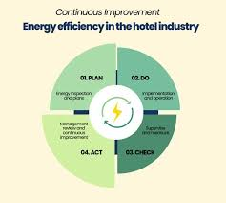
Figure 2: Key Objectives of PDCA for Energy Management System
Source: (Karvounidi et al 2024)
The program offers Travelodge a of note prospect in terms of economics as it draws environmentally concerned travelers who place a high value on sustainability programs (Brody, 2022). Travelodge can improve the perception of its brand and maybe boost occupancy rates and guest loyalty by promoting its energy-efficiency programs (Filimonau and Magklaropoulou, 2020). In an extremely competitive market, the experiences that guests have that are connected to sustainability can result in positive ratings and increased levels of satisfaction or loyalty. Furthermore, as a growing number of tourists actively seek for lodging with ecological credentials, sustainability certificates might give an advantage. Travelodge's adoption of energy-efficient procedures not only supports environmental objectives but also improves operational efficiency and generates revenue Langgat, 2019). Travelodge affirms its leadership position in the hospitality sector and meets the increasing need for ecological travel solutions while maintaining lasting profitability.
To make sure the successful implementation of energy saving programs at Travelodge, a number of difficulties must be carefully considered. The cost implications related to the initial expenses required for renovations or innovations are one of the main problems. Although energy-saving technologies like smart thermostats and LED lighting that can result in large enduring savings by lowering energy bills, the initial expenditures might be excessive, especially for low-priced hotel chains (Bakshi and Singh, 2024). To gather support from stakeholders, Travelodge will required to perform extensive cost-benefit effect of evaluations that weigh the initiatives' immediate costs against their probable savings. Engagement and training management programs of the employees are other significant problems. The employees need to be properly trained or motivate in new technology and measures for energy efficiency techniques to be efficient (Alhamami et al., 2020). This kind of training program is vital for creating a sustainable culture within the corporation and inspiring employees. The technology is might not function to their complete capacity if employees are short of the necessary buy-in and training programs (Fountaine et al., 2019). There are significant difficulties related to visitor perception and contribution as well. Promoting Travelodge's environmental initiatives and obtaining visitor support and engagement or satisfaction require effective communication skills (Haynes and Egan, 2020). The Travelodge should address this by putting in place comprehensible messaging that emphasizes in what way the visitors may participate in ecological activities like recycling and energy conservation through a selection of channels or networks which includes digital platforms, and staff interactions or contribution (Foris et al., 2020). Through the addressing these issues, Travelodge will be able to develop a thorough background for incorporating energy-saving measures, which will eventually improve the hotel's overall visitor experience or satisfaction rating as well as its green effect.
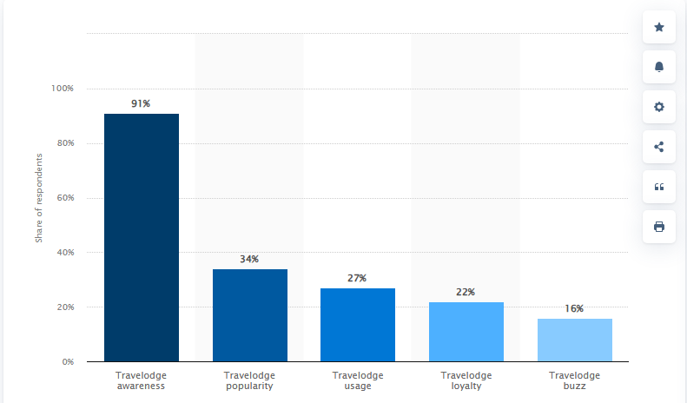
Figure 3: Travelodge brand awareness, usage, popularity, loyalty, and buzz among hotel customers in the UK in 2022
Source: (Statista, 2022)
The Travelodge hotel has implemented multiple initiatives planned to mitigate its environmental impact, demonstrating imposing progress in its sustainability efforts. In the private of the remarkable initiatives is the recycling program, which encourages waste separation and the appropriate disposal of recyclables among employees and companies (Altassan, 2023). The Travelodge has put energy-saving actions in place, like encouraging staff members to practice energy conservation and installing energy-efficient lighting in communal spaces (Foskett et al., 2021). These programs show the hotel chain's dedication to sustainability and its understanding of by what means critical it is to cut back on waste and energy use. Still, Travelodge may improve its sustainability policies in several areas in spite of these encouraging developments and growth development. One of the major needs that still exists is waste management. (Dixit and Srivastava, 2024). Incorporating composting systems contributes to community sustainability initiatives programs by decreasing landfill trash and producing practical organic material for use in close by agriculture.
The sourcing of regional goods is an additional area that needs work. Travelodge now sources its food and amenities from a wider supplier chain, which might not give priority to locally or sustainably produced goods. By making the commitment to source locally, Travelodge will be able to assist local businesses, lessen its transportation-related carbon footprint, and provide visitors with a more genuine experience (Gunter and Wöber, 2021). Enhancing the brand's sustainability narrative and drawing in eco-aware tourists can be accomplished by collaborating with regional vendors for food, toiletries, and other hotel services. Additionally, there is another chance to increase visitor involvement in sustainability initiatives. Although the present measures are praiseworthy, Travelodge might do more to encourage visitors to engage in environmentally friendly habits by giving them additional details about sustainability projects and ways they can help while there (George, 2021). This might entail promoting conservation techniques through in-room signs as well as offering discounts or other prizes to visitors who take part in sustainability initiatives. Even while Travelodge has laid the groundwork for sustainable practices by recycling and implementing energy-saving techniques, trash management, local sourcing, and guest interaction still have a lot of room for growth. Travelodge can improve its sustainability initiatives by filling these loopholes, which will eventually help the environment and the company's reputation.
The recommended preparation calls for installing smart thermostats in common places and guest rooms, as well as a complete repair of the lighting systems to include LED fixtures, to improve Travelodge's energy efficiency management service. Smart thermostats improve heating and cooling system that based on concurrent occupancy data, while LED lighting can save up to 75% on energy use when compare to standard bulbs (Lou, 2021). Both the power costs and the carbon track will be greatly decreased by this dual strategy level. The strategy for accomplishment comprises multiple vital steps. Previous to any modifications, a beginning evaluation of the HVAC and lighting systems will be 3approved out to identify specific areas that need for improvement. To achieve financial plan approval over the next two months, a comprehensive plan with cost estimates and predicted savings will be fashioned. The installation of smart thermostats and LED lights can start. The marketing department will be in accuse of informing guests experience about these improvements and emphasizing Travelodge's dedication to sustainability, while the amenities management team will handle technical completing (Langgat, 2019). But during accomplishment, possible difficulties can appear. When it comes to energy-efficient modifications level, the initial cash expend might be quite difficult to administer services. That may need to look for outside funding or incentive. Employee understanding of in what way to use and preserve the new technologies is also a requirement for staff training or management. One way to lessen this difficulty is to offer systematic training sessions both before and after installation. The guest involvement is vital to educate visitors about the latest energy-saving practices and attract them to join sustainability projects, competent communication techniques must be used. Travelodge can successfully execute these energy efficiency improvements and increase its operational efficiency and sustainability initiatives by taking practical measures to solve these difficulties.

Conclusion
In the conclusion, it is imperative that Travelodge incorporates energy efficiency initiatives, such smart thermostats and LED illumination. To improve its environmental consequence and sustainability standards programs. The one of the main compensation of this integration are prominent savings on energy and operating fixed cost, along with increased guest satisfaction or experience from more contented accommodations and environmentally friendly practices management. They face difficulties like as original investment operating cost, staff training management, and effective guest experience participation must be addressed to ensure successful implementation rate. Travelodge should give summit priority to a widespread energy efficiency improvement to make stronger its sustainability initiatives management programs. The savings should be justified through careful cost-benefit evaluations. It is also advised that the cabin create effective communication plans to involve visitors in these endeavors and conduct a comprehensive training or management plan for staff members to promote a sustainable culture programs. They are looking into joint venture with regional food and facility providers that could improve the brand's sustainability narrative initiatives.

References
Alhamami, A., Petri, I., Rezgui, Y. and Kubicki, S., 2020. Promoting energy efficiency in the built environment through adapted bim training and education. Energies, 13(9), p.2308.
Altassan, A., 2023. Sustainable integration of solar energy, behavior change, and recycling practices in educational institutions: a holistic framework for environmental conservation and quality education. Sustainability, 15(20), p.15157.
Bakshi, N. and Singh, A.K., 2024. The Role of Artificial Intelligence in Optimizing Energy Efficiency in Eco-Friendly Hotels. In Hotel and Travel Management in the AI Era (pp. 585-602). IGI Global.
Brody, S., 2022. Improvement of Roadway Design for Sustainable Communities (Master's thesis, Rutgers The State University of New Jersey, School of Graduate Studies).
Dixit, Y.C. and Srivastava, M.S., 2024. Sustainable Waste Management For Green Environment. Academic Guru Publishing House.
Filimonau, V. and Magklaropoulou, A., 2020. Exploring the viability of a new ‘pay-as-you-use’energy management model in budget hotels. International Journal of Hospitality Management, 89, p.102538.
Filimonau, V. and Magklaropoulou, A., 2020. Exploring the viability of a new ‘pay-as-you-use’energy management model in budget hotels. International Journal of Hospitality Management, 89, p.102538.
Floričić, T., 2020. Sustainable solutions in the hospitality industry and competitiveness context of “green hotels”. Civil Engineering Journal, 6(6), pp.1104-1113.
Foris, D., Crihalmean, N. and Foris, T., 2020. Exploring the environmental practices in hospitality through booking websites and online tourist reviews. Sustainability, 12(24), p.10282.
Foskett, D., Paskins, P., Pennington, A. and Rippington, N., 2021. The theory of hospitality and catering. Hodder education.
Fountaine, T., McCarthy, B. and Saleh, T., 2019. Building the AI-powered organization. Harvard Business Review, 97(4), pp.62-73.
George, R., 2021. The Tourism and Hospitality Marketing Environment. In Marketing Tourism and Hospitality: Concepts and Cases (pp. 183-219). Cham: Springer International Publishing.
Gunter, U. and Wöber, K., 2021. Estimating transportation-related CO2 emissions of European city tourism. Journal of Sustainable Tourism, 30(1), pp.145-168.
Haynes, N. and Egan, D., 2020. The perceptions of frontline employees towards hotel overbooking practices: exploring ethical challenges. Journal of Revenue and Pricing Management, 19, pp.119-128.
Hernández-Callejo, L., Gallardo-Saavedra, S. and Alonso-Gómez, V., 2019. A review of photovoltaic systems: Design, operation and maintenance. Solar Energy, 188, pp.426-440.
Jones, P. and Comfort, D., 2021. Modern slavery statements and leading UK hotel companies. Athens Journal of Tourism, 8(3), pp.147-162.
Karvounidi, M., Alexandropoulou, A. and Fousteris, A. (2024). Towards Sustainable Hospitality: Enhancing Energy Efficiency in Hotels. [online] doi:https://doi.org/10.56472/25835238/IRJEMS-V3I6P145.
Klada, N. and Georgopoulos, N., 2024, January. Internet of Things (IoT) a Trending Technology: Transforms the Hospitality Industry. Case Study: W Costa Navarino (Messinia, Greece). In International Conference on Business Analytics in Practice (pp. 1-10). Cham: Springer Nature Switzerland.
Langgat, J.A., 2019. Sustainability adoption in hotel restaurants: Evidence from Malaysia. University of Exeter (United Kingdom).
Langgat, J.A., 2019. Sustainability adoption in hotel restaurants: Evidence from Malaysia. University of Exeter (United Kingdom).
Linkedin.com. (2024). LinkedIn. [online] Available at: https://www.linkedin.com/pulse/sustainable-hospitality-implementing-energy-practices-malvin-delgado-ady6e/ [Accessed 15 Nov. 2024].
Lou, Y., 2021. A Smart WIFI Thermostat Data-Based Neural Network Model for Controlling Thermal Comfort in Residences Through Estimates of Mean Radiant Temperature. University of Dayton.
Mahmoud, M.M., 2021. Economic applications for LED lights in industrial sectors. Light-emitting diodes and photodetectors: advances and future directions, 21.
Nematchoua, M.K., Sadeghi, M. and Reiter, S., 2021. Strategies and scenarios to reduce energy consumption and CO2 emission in the urban, rural and sustainable neighbourhoods. Sustainable Cities and Society, 72, p.103053.
Park, J.E. and Kang, E., 2022. The Mediating Role of Eco-Friendly Artwork for Urban Hotels to Attract Environmental Educated Consumers. Sustainability, 14(7), p.3784.
Sinha, M. and Fukey, L.N., 2020. Circular Economy: Assessing a Progress of Resources Efficient Practices in Hotel Industry. In Circular Economy for the Management of Operations (pp. 89-117). CRC Press.
Statista. (2022). Travelodge brand profile UK 2022 | Statista. [online] Available at: https://www.statista.com/forecasts/1335657/travelodge-hotels-brand-profile-in-the-uk [Accessed 15 Nov. 2024].
Wan, C., Shen, G.Q. and Choi, S., 2019. Waste management strategies for sustainable development. In Encyclopedia of sustainability in higher education (pp. 2020-2028). Cham: Springer International Publishing.
Yu, F.W., Ho, W.T. and Wong, C.F.J., 2024. Novel load allocation analysis for energy management and carbon emissions reduction of chiller system in hotel buildings. Journal of Building Engineering, 96, p.110405.
‌

‌

