AI and Big Data Summit for Hotel Industry

Student Name: Robert Lavric
Student Number: 2121182
Lecturer Name: Kathryn Flynn
Date: 03.05.2024

Overview
Artificial intelligence (AI) and Big Data present vast opportunities to revolutionise how business and research are conducted (Jagatheesaperumal et al., 2021). AI and Big data can potentially streamline operations in the hotel industry. As a result, this presentation focuses on a technology and innovation event. The theme of the event will be the integration of AI and Big Data into the systems utilized in the hotel industry. The event will be open to researchers and leaders/managers working in the hotel industry. The presentation presents findings of a situational analysis and research on the feasibility of the event. Focus is given to market, operational, and financial factors crucial to the success of the event.
Market Factors
Target Market
The target market for the upcoming AI and Big data event is leaders and researchers in the hospitality industry. The event is meant to educate leaders and managers in the hospitality industry on some practical ways of implementing AI and Big data in hotel operations. Also, the event targets researchers in the hospitality field in order to expand their knowledge of how AI and Big Data are currently used in hospitality. Moreover, the event will also target scholars at undergraduate and postgraduate levels pursuing technology or hospitality-related courses.
Demand for this Type of Event
A study by Sexena and Lamest (2018) indicates a growing need for knowledge dissemination on the use of AI and Big data in hotels. Some players and researchers in this market have already utilised AI and Big data to streamline operations, but this knowledge is not yet commonplace. Besides, there is a notable gap in research and academia concerning the use of AI and Big Data in hospitality. Subsequently, researchers and academicians might be interested in attending the event so that they can close the existing knowledge gap. The event might also interest undergraduate and postgraduate students pursuing courses related to technology and innovation.
Competition that could impact the Event
Although the event has focused on a narrow market segment, competition still exists. Several technology and innovation events in the UK and other parts of the world may interest our target market. These events include the Re-Work Generative AI Summit London, AI & Big Data Expo Global, Ai4 2024, EmTech Digital USA, and World Summit AI-Montreal, among others.
Operational Factors
Venue Availability
The targeted venue for the event is the Donald English Theatre at the Central Hall Westminster. There is confirmation of the availability of the venue. This venue has a 150-capacity auditorium. No extra decorations will be required for the venue, and they will be sufficient for the expected guests.
Skills Required
For the event to be successful, staff with previous experience in event management will be needed. Also, the staff needs to have effective communication skills and time management skills. More importantly, we will need AI and Big Data experts to perform presentations during the meeting. Furthermore, hotel staff who are already using AI will be present at the event.
Resources Required
In terms of decoration and lighting, no extra resources will be needed because the venue has good lighting and decoration. Nevertheless, other tools and equipment related to technology will be needed. These resources include but are not limited to hardware and software devices for presentation, access to AI Technologies (e.g., Chat GPT), and advanced information systems from hotels relying on AI and Big Data.
Financial Factors s
Costs and Predicted Revenues
Income
Cash from Ticket Sales | £18,000
Cash from Food and Beverage Sales | £1,000
Capital/loan received | £3,330
Other payments | £550
Total (£) | £22,880
Expenses
Fees for the Venue | £2,500
Insurance | £500
Marketing and Advertisement | £1,268
Wages for the Staff | £2,000
Snacks, Beverage and other | £350
Loan repayment and interests | £3,500
Total (£) | £8,118
Funding Sources
The event will be self-funded from ticket sales. Nevertheless, additional funding will come from owners’ capital. Also, a small bank loan will be taken to prevent any unforeseen expenses.
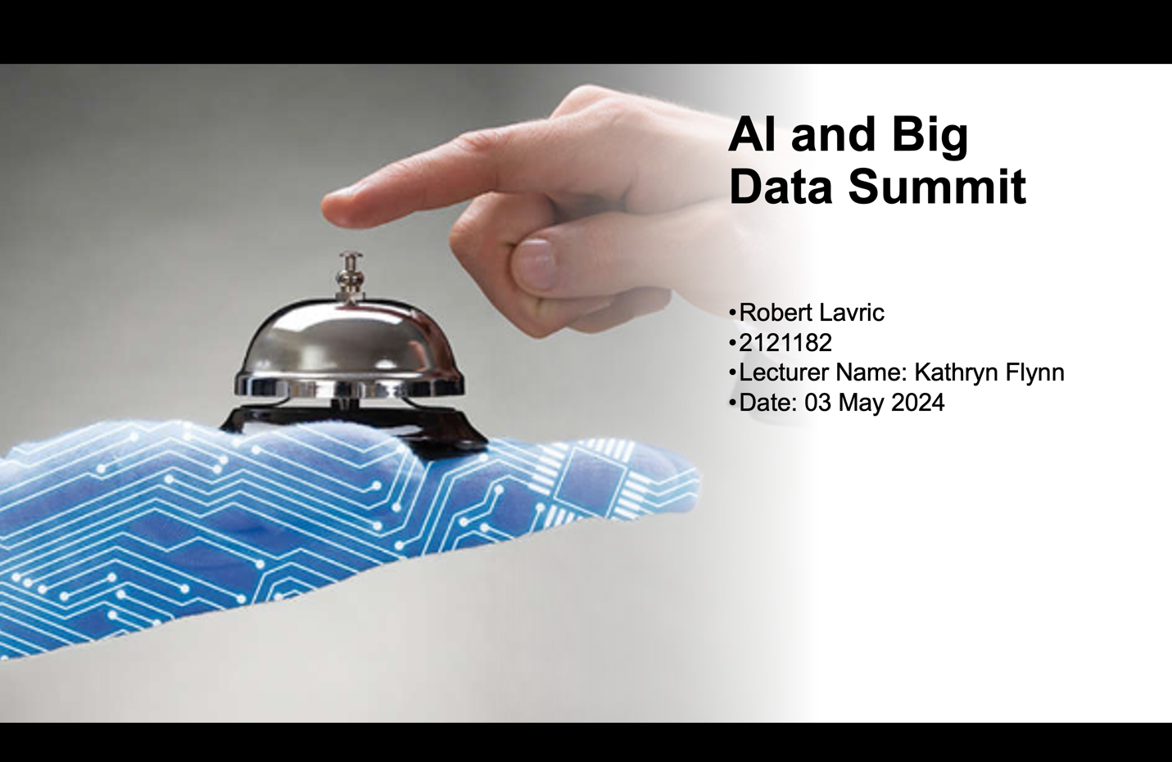

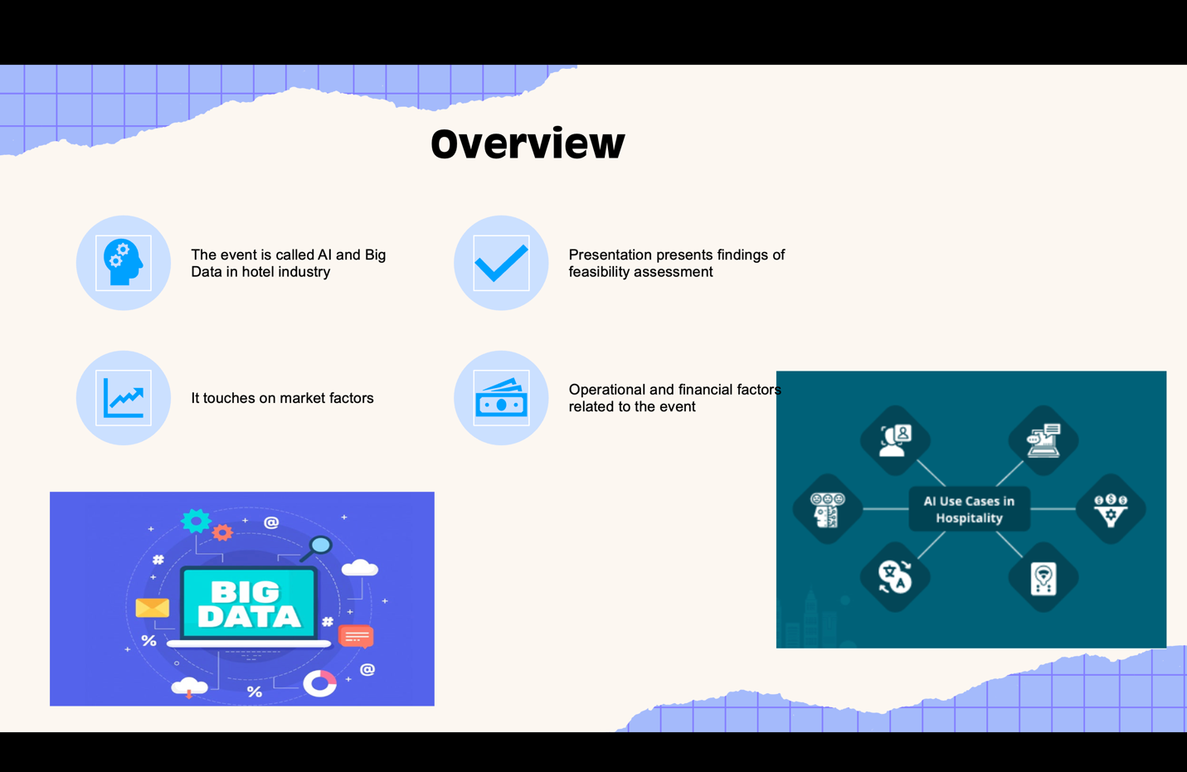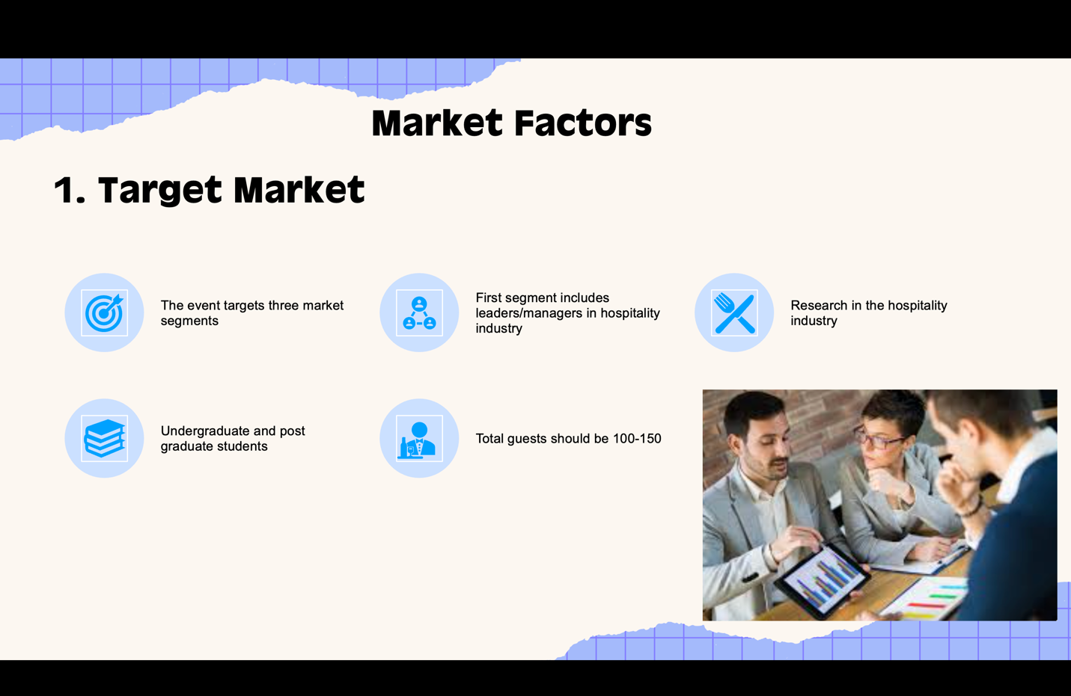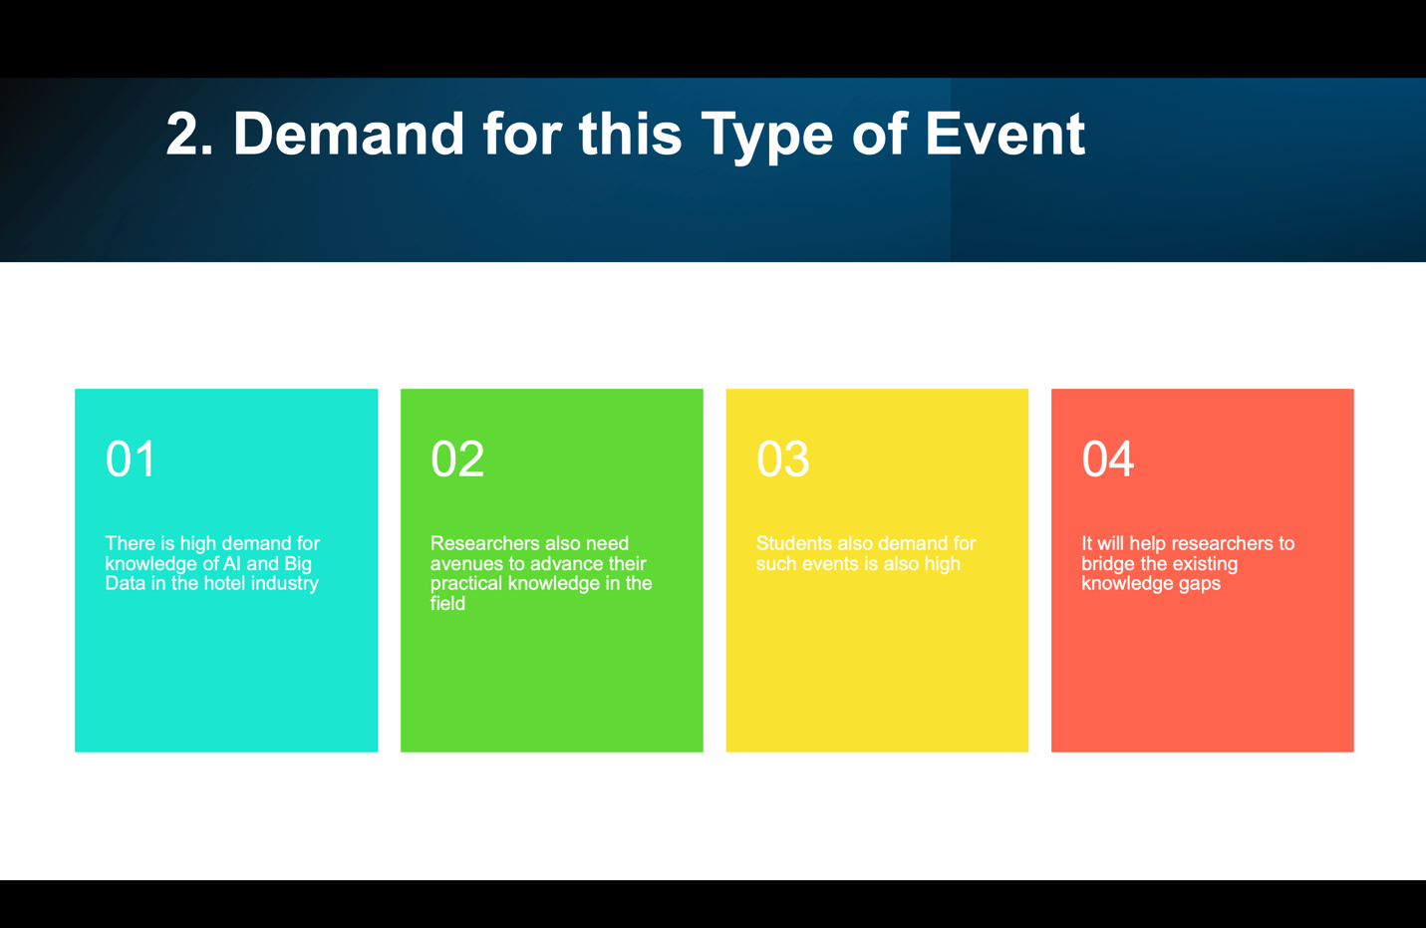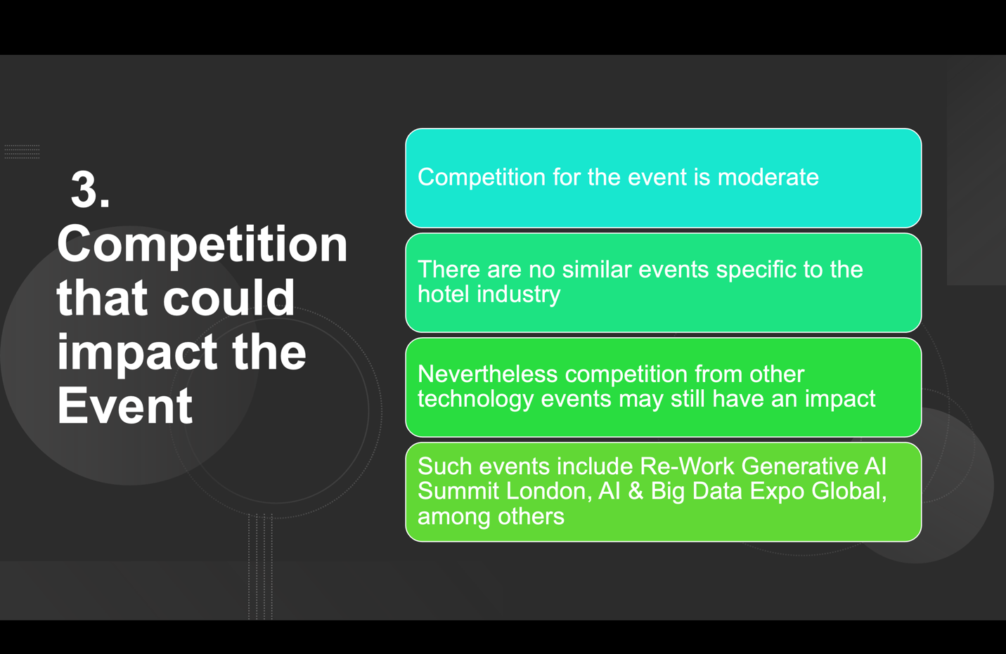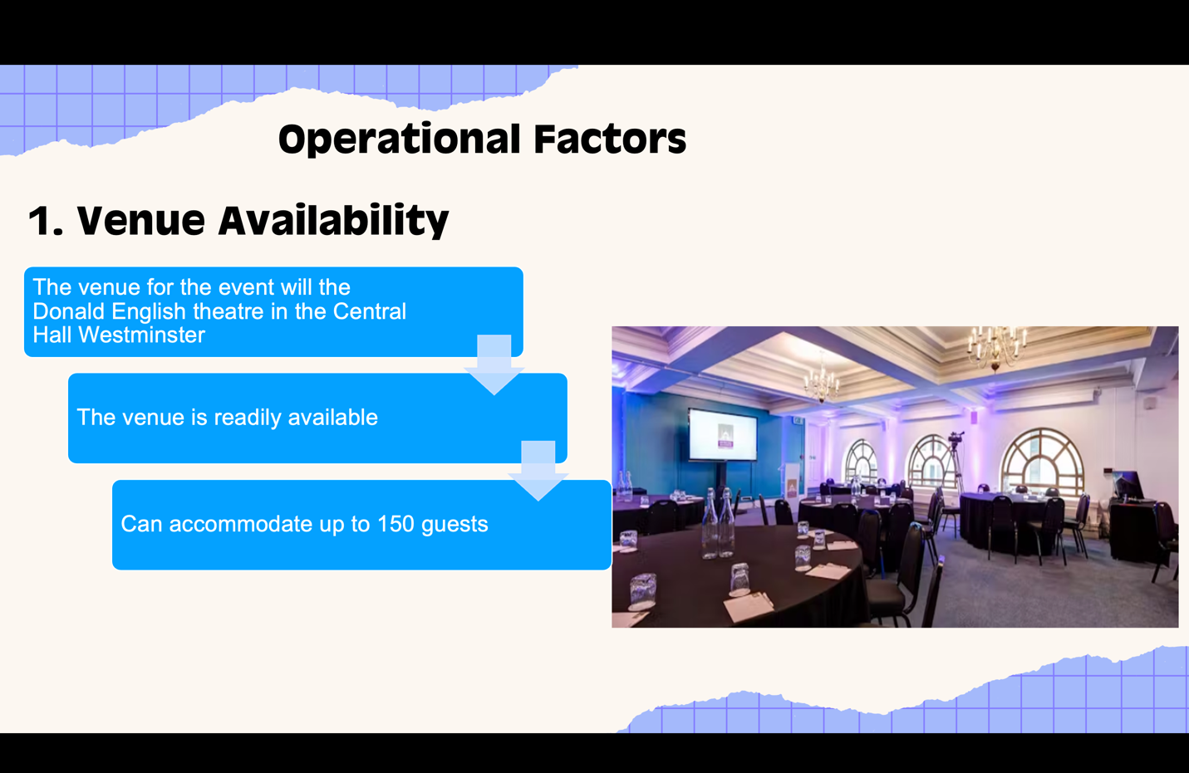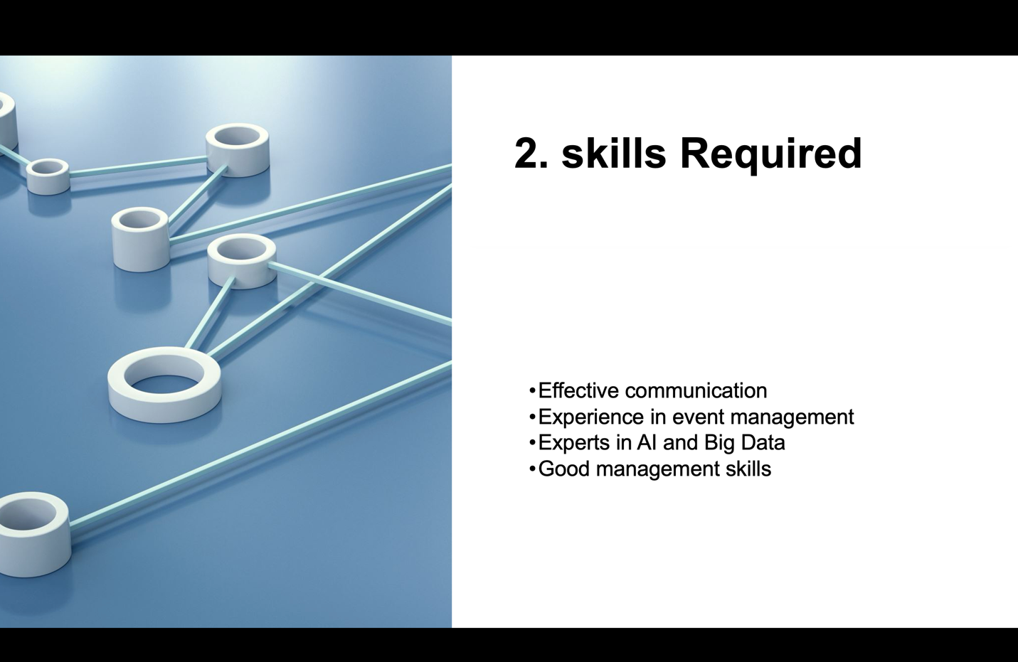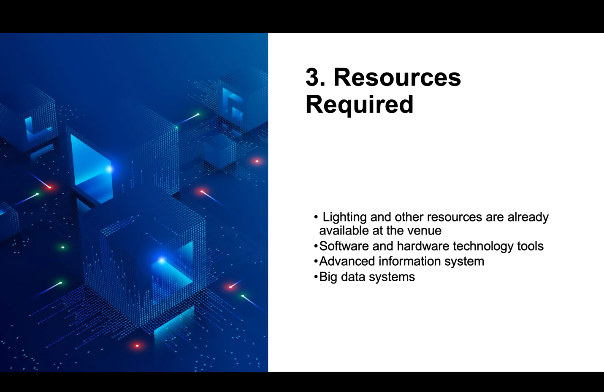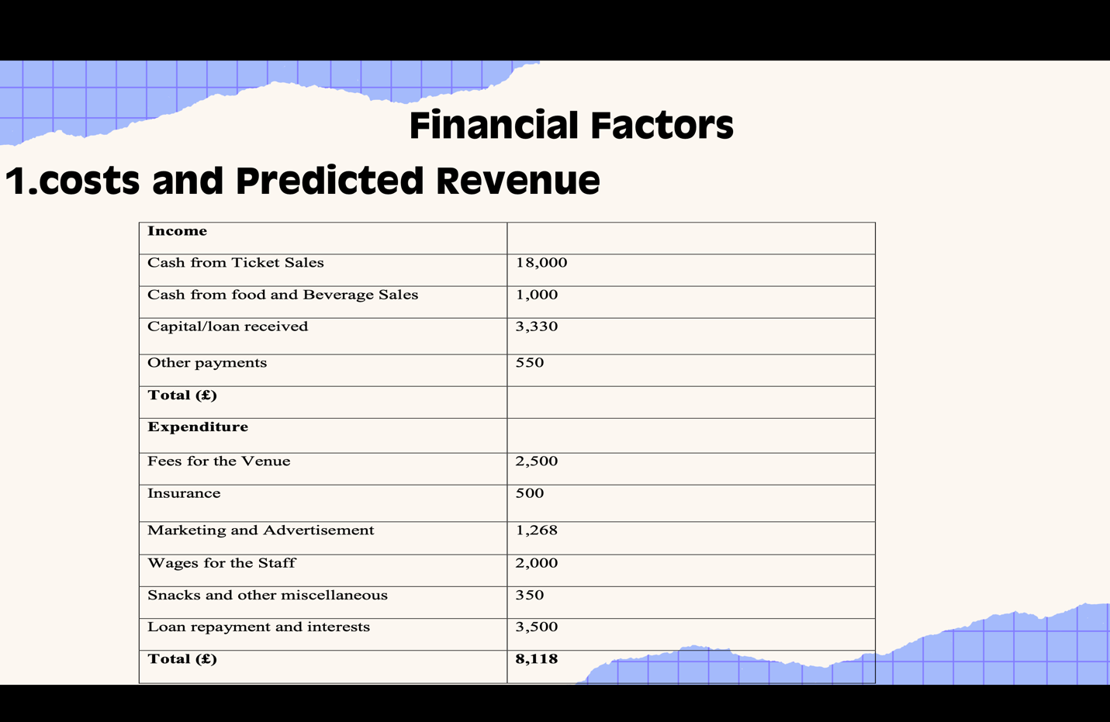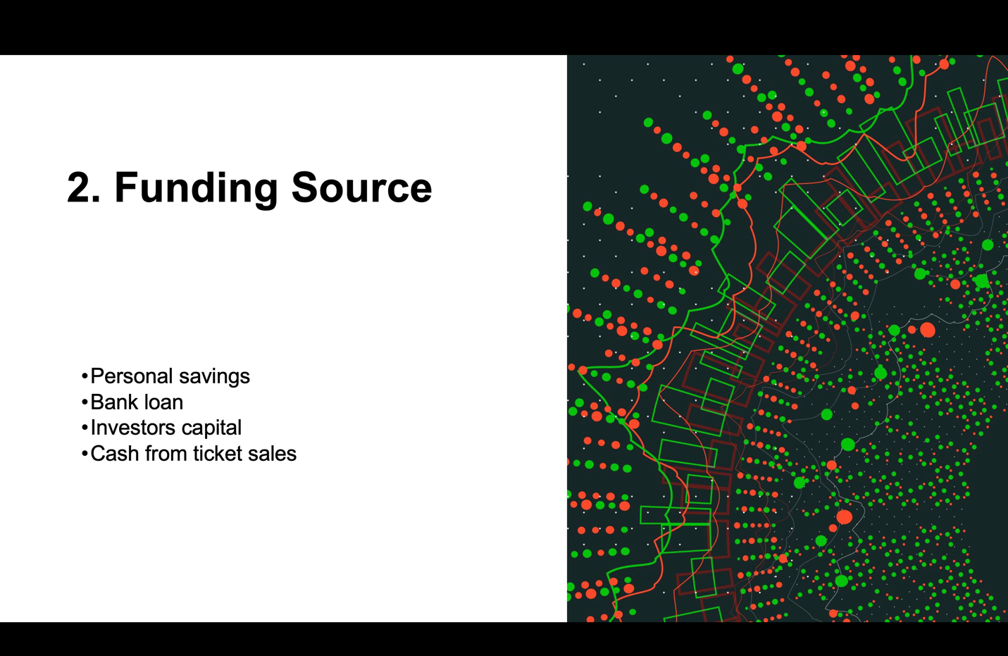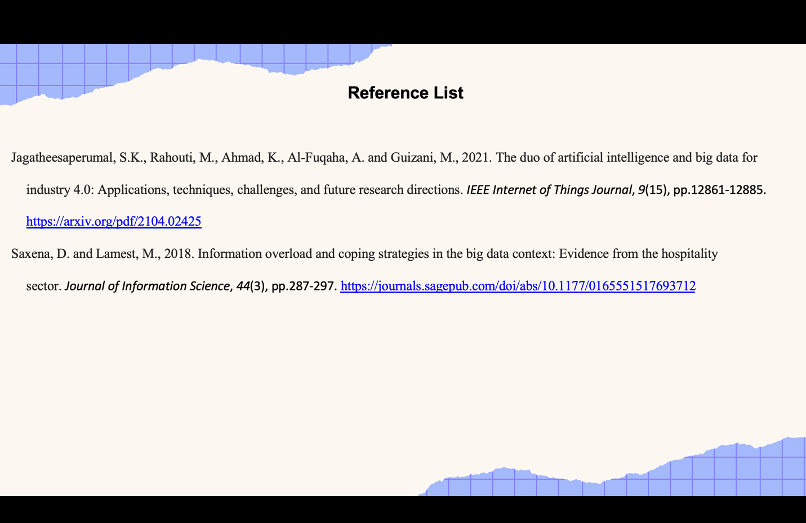
Reference List
Jagatheesaperumal, S.K., Rahouti, M., Ahmad, K., Al-Fuqaha, A. and Guizani, M., 2021. The duo of artificial intelligence and big data for industry 4.0: Applications, techniques, challenges, and future research directions. IEEE Internet of Things Journal, 9(15), pp.12861-12885. https://arxiv.org/pdf/2104.02425
Saxena, D. and Lamest, M., 2018. Information overload and coping strategies in the big data context: Evidence from the hospitality sector. Journal of Information Science, 44(3), pp.287-297. https://journals.sagepub.com/doi/abs/10.1177/0165551517693712

