University of Wales Trinity Saint David


Wales Institute of Science and Art

Engineering Skills Technical Report

Engineering Skills (ACHA4022A)

Dafydd Pughe
2401243
Date (12/2025)

Word Count : 2021
Contents
1. Introduction: 1
2. Health & Safety with Risk Assessments: 2
2.1: Personal Protective Equipment at Work Regulations 1992 2
3. Security Risk Matrix 4
3.1. Potential Risks 4
3.1.1 Electric/Hybrid Car Batteries Malfunctioning 4
3.1.2. Remote Exploitation of Connected Vehicle Systems 4
3.1.3. Supply Chain & Software Manipulation Attacks 4
3.1.4. Physical Proximity Attacks 5
3.2. Risk Matrix 5
4. Engineers Role in Society 6
4.1. Code of Conduct 6
4.2. Engineering Council 6
4.3. Porsche Code of Conduct 6
4.3 Engineers Responsibilities 7
5. Problem Solving 8
5.1. FMEA (Failure Mode and Effects Analysis) 8
6. Team Structure 9
6.1. My Personal Experience 9
6.2. Other team structures 10
7. Conclusion 11
8. References 12
List of Figures 14
Tables: 14

Introduction:
In this report, the aim is to discuss the various ways health and safety is applied within a work environment. It will cover the PPE required for engineers to remain safe in the workplace, as well as the relevant health and safety laws and an examination of risk assessments. This report will also analyse the importance of team structure and explore different types of team structures, explaining how they support the development of skills that can help progress careers.

Health & Safety with Risk Assessments:
Health and safety is a priority in all workplaces today. It is a crucial set of laws that everyone must follow to reduce the risks associated with dangerous activities. Students in the UWTSD Motorsport Engineering degree need to be particularly aware of these responsibilities in order to stay safe in the work environment. Tasks such as machinery workshop sessions and assisting in the workshop involve several potential hazards. By following the rules and wearing the correct PPE (Personal Protective Equipment), students can significantly reduce the risks that may arise.
One task that students participate in is using a lathe machine. There is a range of safety equipment provided for this, such as an operating guard that prevents the machine from being turned on accidentally. The lathe also includes a foot-operated emergency stop brake that can shut the machine off instantly in the event of an accident. Various PPE that students are required to wear includes safety glasses, steel-toe boots and a long-sleeved top. The lathe produces a lot of debris when cutting which could lead to injuries such as burn marks on the skin, this could be prevented by wearing a long sleeved top to cover any unprotected skin.

2.1: Personal Protective Equipment at Work Regulations 1992
Appropriate PPE helps ensure students remain safe while operating any machinery in the workshop. These regulations are crucial to follow in order to maintain safety in workshop environments.
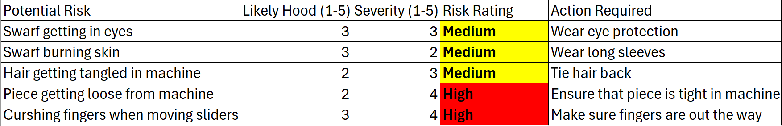
The regulations were first introduced in 1992 and amended in 2022. (HSE, 2022). They were created to reduce the risk of injuries among workers who were not wearing the correct protective equipment. Both employers and employees are assessed to ensure they are following the correct safety procedures. This helps guarantee that the workplace has the correct PPE in place to comply with the rules. Many workplaces require employees to complete training sessions to make sure that they understand which equipment is necessary to stay safe in the workplace. To ensure that the correct PPE is provided, the workplace must look at the hazards and create a risk matrix to discover the risks and how to prevent them from causing any harm.
Figure 1- Risk Assessment

Security Risk Matrix
Modernised vehicles are becoming more popular today due to the United Kingdom planning on reducing the use of combustion engines by the year 2030. Their goal is to make the air less polluted by using electric vehicles which produce less emissions and therefore are better for the environment. The plan is to stop the sale of new petrol and diesel vehicles in 2030 and to be 100% zero emissions by 2035. (Department for Transport and The Rt Hon Heidi Alexander MP, 2025). Due to the UK planning this ban, the number of hybrid and electric vehicles are increasing, this also means an increase in the potential security and safety risks.

Potential Risks

3.1.1 Electric/Hybrid Car Batteries Malfunctioning
Since the talks of getting electric batteries to replace combustion engines, the amount of fully electric cars and hybrid cars that are on the road is increasing daily. One risk of a car using a battery as an engine is the possibility of it malfunctioning. This isn’t a very common fault due to the progress of battery manufacturing over the recent years, however, it is one that can happen. One possible malfunction is caused by the HV battery depleting which forces the car to shut down and therefore it cannot be operated. (Shang Ming. Zhang, 2024)

3.1.2. Remote Exploitation of Connected Vehicle Systems
Technology is one of vital aspects in modern day cars with the introduction of Bluetooth, dashboard screens, central locking, etc. It is also one of the most common ways to hack into a vehicle to unlock and steal it. Car aerials are an “unlicensed spectrum, connecting unmanned aerial vehicles with cellular networks” , (Xu, et al., 2024), to have the conditions to communicate with other networks.

3.1.3. Supply Chain & Software Manipulation Attacks
A modern vehicle consists of hundreds of ECUs (Electronic Control Unit) that are a critical part of operating the vehicle due to its sensors and software packages. By having so many control units it is a popular way to hack a car. Cyberattacks are a serious threat to vehicles by exploiting the vehicles connected controlled to attempt to steal data and take control of its functions. Transportation is one of the most targeted with cyberattacks with each incident costing $3.58million in 2020. (Hang Zhou, 2025)

3.1.4. Physical Proximity Attacks
Physical Proximity Attacks happen when the attacker is near the car to exploit a weakness in the electronics of the car. One way the attacker can hack the system is by unlocking the car from a few meters away, some use the signal of the key and can hack it to unlock the car for them. Due to the increase of technological components in modern cars, this risk will increase. (Hyera Jeong, 2018)

3.2. Risk Matrix
 | Impact | 1 | 2 | 3 | 4 | 5
Likelihood
1 |  |  |  | Physical Proximity Attacks
2 |  |  |  | Remote Exploitation of Connected Vehicle Systems |  | Electric/Hybrid Car Batteries Malfunctioning
3 |  |  |  |  |  | Supply Chain & Software Manipulation Attacks
4
5
Table 1- Risk Matrix
One proposal that can stop the risk of Supply Chain & Software Manipulation Attacks is by keep updating the software of the vehicles to back up the system patches. The owner of the vehicle can also be aware with physical access point of the vehicle by removing an dongles, that could be a tracker, to prevent the amount of ways the system can be attacked.

Engineers Role in Society

4.1. Code of Conduct
An engineer’s code of conduct is essential because it reflects professional responsibility toward others. It emphasizes fairness, respect, confidentiality, and other important principles. Most companies establish a code of conduct for their employees to ensure they act respectfully and professionally. (Jansy, 2015)

4.2. Engineering Council
The engineering council have supplied a code of conduct to their employees to follow 4 main principles which are “Honesty, Respect, Leadership and communication, Accuracy and rigour” (Engineering Council, 2025). These are strict principles that are essential to follow in a workplace, as it shows professionalism and trustworthiness towards others.

4.3. Porsche Code of Conduct
Porsche Code of Conduct stand with respect towards everyone and shows strong values such as trust, respect and fairness. There are 9 key principles that the workers of Porsche has to follow, these consist of “compliance, responsibility, compliance organisation and programs, preventive and reaction measures, whistleblower system and human rights” (Porsche, 2025). These are critical rules to follow in a workplace, such as Porsche, to represent the brand name in a professional and respectful way. These set of rules are made so every worker is equal and is open to everyone. Porsche also take risk analysis into account on specific business models and environments to make sure that the workplace is a safe environment for everyone.
They also offer external and internal reporting channels to prevent violations relating to the brand. Porsche also represents that human rights is a fundamental corporate responsibility and is respected in their own company and also their business partners.

4.3 Engineers Responsibilities
The WRC (World Rally Championship) has been developing their regulations to reduce the amount of fossil fuels that are used throughout a season. They introduced a hybrid system to their vehicles that were used on road sections between stages and service parks. This system used a battery as a form of power in non competitive sections and a combustion engine in stages. The WRC also use a 100% fossil free fuel in the vehicles making them better for the environment. This would transition the sport into becoming a sustainable motorsport in the future by becoming cleaner for the environment. (WRC, 2025)

Problem Solving
Problem solving is an important skill to have when engineering a product goes wrong. It’s requires quick thinking of different ways that the problem can be fixed and the process of making that idea work. Many engineers have to go through this process and it’s a skill that needs in any environment of the workplace. It’s a skill that requires observation and inspection of the problem and a detailed analysis on what exactly has gone wrong and what is the best way to fix the problem.

5.1. FMEA (Failure Mode and Effects Analysis)
FMEA (Failure Mode and Effects Analysis) is structured way for engineers to analyse the project that is being made and to think what could go wrong in the process of creating the product. This structures helps the engineers discover what could go wrong and how that problem can be avoided. This also helps identify the risk that could occur during the system which they find out by doing a risk score to see how bad the effect would be if the operation went wrong, this would also help identify the worst risks that could happen in the process which will lead to the engineers identify when the risk is going to happen and prevent that risk from happen and stop it from becoming harmful to others.
(Jing, 2024)
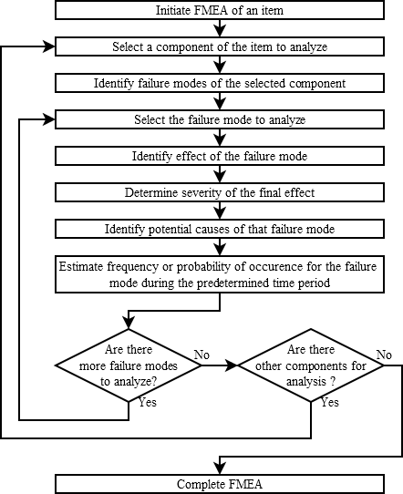
Figure 2 - A flow diagram showing solving techniques using FMEA
https://www.researchgate.net/figure/FMEA-analysis-flow-chart-based-on-3_fig1_290751391

Team Structure
A team structure that I have used before was a self managed team, this consists of a team that doesn’t have a team leader. This was a positive way of working in a team due to everyone contributing equally without being push around by an individual. By not having a team leader, it led to key communication skills through the team, understanding everyone’s opinions and respect towards the other team member.
By not having a team leader it did lead to some problems, by everyone going their own paths sometimes in the tasks and people making their own decisions without discussing to everyone else for their opinions. Some team members could’ve fell behind by not having the motivation from a team leader and not hitting their goal in the project.
Positive of working in a team | Negatives of working in a team
Strengthens ideas | Scheduling problems
Faster problem solving | Different work skills (Speed, Communication)
New learning opportunities | Distractions can be accrued
Improves many different skills (Social, mentally) | Dependence risk
Having support on difficult tasks | Coordination
Table 2- Showing Positives and Negatives of Team Working

My Personal Experience
My group consisted of three other students. We worked well together, which contributed to achieving a high mark in the assignment. Teamwork also made it easier to break down the required tasks, and it was helpful to have support whenever I needed assistance with different parts of the coursework.
Working in a team was easier for me because I could share my ideas and receive feedback, helping me understand what I did well and what I could improve on for future. It also helped that my group members were easy to talk to, which made me more confident when contributing ideas and offering suggestions that could help them.
The group also helped me improve skills I was lacking and boosted my confidence in my work. Overall, I was happy working in a team environment. It was a positive space that allowed me to share my ideas and skills. In the end, I was pleased with our final result, which was a mark of 66%.

Other team structures
There are many different team structures to work under, each with its own characteristics that help develop a variety of skills. Examples include functional teams, cross-functional teams, and self-managed teams.
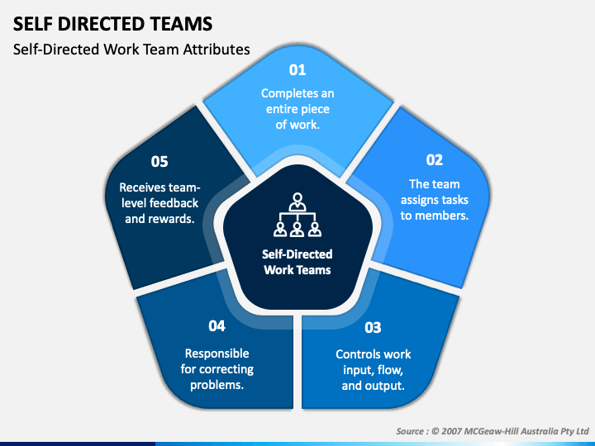
These team structures operate in different ways. In a self-managed team, work is distributed equally among members, and responsibilities are shared rather than assigned to a single leader. This type of structure encourages members to collaborate effectively, communicate their ideas and solutions, and take collective ownership of the project. Roles are often rotated rather than fixed, allowing everyone to gain experience in different areas throughout the project. (AIHR, n.d.)

Figure 3- Structure of Self Directed Teams - https://ar.inspiredpencil.com/pictures-2023/self-managed-work-teams

Conclusion
To conclude, all of the aims have been covered by discussing various health and safety risks and how to assess and prevent them. The process of analysing a risk using a risk matrix was also explained, including how to determine the severity of a risk and identify ways to reduce or eliminate them. PPE was covered, along with the importance of wearing appropriate equipment in the workplace.
Codes of conduct in different areas and companies were discussed, highlighting the importance of having clear rules to maintain respect and equality in a work environment. FMEA was evaluated and how it helps engineers during a problem and how they can prevent that problem from happening. Team structure was addressed by reflecting on past experiences of working in a team. Different team structures were explored, along with the skills that can be developed and strengthened through teamwork.
Overall, all aims have been discussed throughout the report highlighting key information to keep safety a priority in the workplace, also keeping the work environment one that follow all code of conduct to keep the workplace professional and respectful.

References
AIHR, n.d. Self Managed Teams. [Online]
Available at: https://www.aihr.com/hr-glossary/self-managed-teams/
[Accessed 11 11 2025].
Bedfordshire Fire And Rescue Service, 2023. Bedfordshire Fire And Rescue Service. [Online]
Available at: https://www.bedsfire.gov.uk/safety/electric-vehicles
[Accessed 11 11 2025].
Department for Transport and The Rt Hon Heidi Alexander MP, 2025. Gov.uk. [Online]
Available at: https://www.gov.uk/government/speeches/phasing-out-the-sale-of-new-petrol-and-diesel-cars-from-2030-and-support-for-zero-emission-vehicle-zev-transition
[Accessed 11 11 2025].
Department for Transport, 2023. Recovery operators: working with electric vehicles. [Online]
Available at: https://www.gov.uk/government/publications/recovery-operators-working-with-electric-vehicles/recovery-operators-working-with-electric-vehicles
[Accessed 11 11 2025].
Engineering Council, 2025. Engineering Council. [Online]
Available at: https://www.engc.org.uk/resources-and-guidance/guidance-for-the-profession/ethical-principles
[Accessed 11 November 2025].
Hang Zhou, C. M. X. C. K. M. X. L. B. R., 2025. ScienceDirect. [Online]
Available at: https://www.sciencedirect.com/science/article/abs/pii/S0968090X25002207
[Accessed 25 11 2025].
HSE, 2022. HSE. [Online]
Available at: https://www.hse.gov.uk/ppe/ppe-regulations-2022.htm
[Accessed 11 November 2025].
Hyera Jeong, J. S., 2018. ietresearch-onlinelibrary-wiley. [Online]
Available at: https://ietresearch-onlinelibrary-wiley-com.ezproxy.uwtsd.ac.uk/doi/epdf/10.1049%2Fel.2017.4360
[Accessed 25 11 2025].
Jansy, B., 2015. JSTOR. [Online]
Available at: https://www-jstor-org.ezproxy.uwtsd.ac.uk/stable/24744490?seq=1
[Accessed 25 11 2025].
Jing, G. G., 2024. ASQ. [Online]
Available at: https://asq.org/quality-resources/fmea
[Accessed 11 11 2025].
Porsche, 2025. Porsche. [Online]
Available at: https://www.porsche.com/international/legal/compliance/
[Accessed 11 11 2025].
Shang Ming. Zhang, Z. Y. C., 2024. ProQuest. [Online]
Available at: https://www.proquest.com/docview/3111672758/fulltextPDF?accountid=130472&pq-origsite=primo&sourcetype=Scholarly%20Journals
[Accessed 25 11 2025].
WRC, 2025. WRC. [Online]
Available at: https://www.wrc.com/en/misc/beyond-rally
[Accessed 1 12 2025].
Xu, Q. et al., 2024. ProQuest. [Online]
Available at: https://www.proquest.com/docview/3120633989/fulltextPDF?pq-origsite=primo&accountid=130472&searchKeywords=Remote%20Exploitation%20of%20Connected%20Vehicle%20Systems%20issues&sourcetype=Scholarly%20Journals
[Accessed 25 11 2025].

List of Figures
Figure 1- Risk Assessment 3
Figure 2 - A flow diagram showing solving techniques using FMEA https://www.researchgate.net/figure/FMEA-analysis-flow-chart-based-on-3_fig1_290751391 8
Figure 3- Structure of Self Directed Teams - https://ar.inspiredpencil.com/pictures-2023/self-managed-work-teams 10

Tables:
Table 1- Risk Matrix 5
Table 2- Showing Positives and Negatives of Team Working 9

