

China policy support on Digital Transformation in Small Medium-sized manufacturing Opportunities and Challenges From perspective of Change management

DBA CANDIDATE:
Yu Ding
2023-01-28
Content
1 Introduction 3
2 Literature Review 3
2.1 Definition of Change Management in DT 3
2.2 Organization impact of Digital Transformation 5
2.4.1 Leadership Roles in DT 6
2.4.2 Factors of Employee in DT 8
3 Management Theory in Digital Transformation 10
3.1 Kuhn Paradigm Cycle theory 10
3.2 Lewin’ change management Theory 10
3.3 Institutional theory 11
3.4 Organizational Behavior Theory 11
3.4.1 Transactional and Transformational Leadership Theory 12
3.4.2 McGregor's Theory X and Theory Y 12
3.5 Dynamic Capabilities Theory 13
3.6 The Resource-Based View (RBV) 14
4 Case Stuy： DT of SMEs in ShanXi of China 15
4.1 Policy support 15
4.2 DT Case in ShanXi 16
4.2.1 Digital Economy in ShanXi 16
4.2.2 Support from Government 16
4.2.3 Pilot Demonstration 18
4.2.4 School-Enterprise Co-operation 18
4.2.5 Financial Support 19
5 Discussion of innovative solutions 19
5.1 Strategy of Digital Transformation 20
5.2 Awareness of Digital Transformation 20
5.3 Improve the Institution （Institutional Theory） 21
5.4 Establishing a Digital Department（RBV&DC Theory） 21
5.5 The leadership 21
5.6 Behavior of Employee 22
6 Conclusion 23
7 Reference 24

1 Introduction
In Industry 4.0, the development of technologies has a great impact on companies. It is a great trend for SMEs to embrace digital transformation, which impacts competitiveness and sustainability. Although many benefits of DT for SMEs. The SMEs still face more changeling in DT, such as a lack of technologies and financial support. In the past three years, a series of policies to support the digital transformation of SMEs, including policy, technology, and financial support, have been issued by the Chinese government(EU SME Centre, 2023; Qiao Do, 2023; Xinhua, 2022; Yu Zhu, 2022). This report analyzed the current situation of the digital transformation of SMEs in China. According to the previous literature, this report explored the challenges, risks, and opportunities of DT in SMEs from the opinions of change management and theories and emphasized the importance of leadership and employees. It aims to give implementation advice, which can guide the SMEs to complete Digital transformation.
Moreover, according to China's policy requirement of supporting the digital transformation of SMEs in 2023, Taiyuan, as the first selected pilot city for the digital transformation of SMEs, this project starts from the case of digital transformation of SMEs in Taiyuan, and combines the current relevant policies and measures to find the prime obstacles and challenges of the current digital transformation of SMEs, and to help SMEs to complete their digital transformation from the peripatetic organizational level.
In summary, this study examines the change influencing factors, and the main resistances to organizational change from the management change theory, with a special focus on the digital transformation of SMEs. The influence of leadership and employee factors on digital transformation in SMEs is presented in terms of organizational behaviors and resource management.

2 Literature Review

2.1 Definition of Change Management in DT
In the constantly changing competitive business environment, change management has become a key factor in organizational adaptability, sustainability, and success (Hayes, 2014, p. 4). Joseph Galli,(2018)emphasizes that Change management is a method of guiding and handling changes within an organization by using methods to help businesses achieve their commercial objectives, which involve in three key factors(including organization culture and individual) (Fig.1 )(Lauer, 2021).
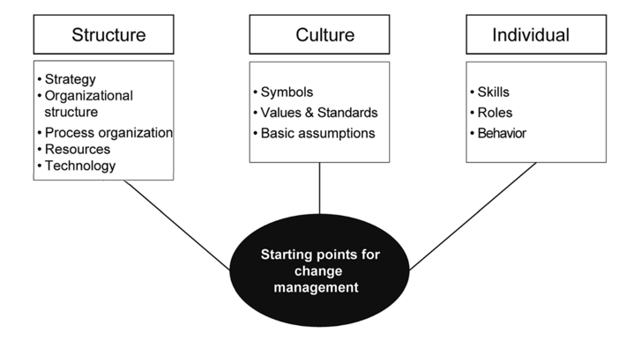
Fig.1：Starting points for change management (Lauer, 2021)
It refers to the transition from one situation (“where the organization is now”) to a more perfect one (“where the organization wants to be”) smoothly(Senior et al., 2020). Change management is a continuous cyclical process that relies on a series of closely interlinked elements (objectives, planning, resources, momentum, etc.) to achieve successful change(Bekmukhambetova, 2021). Successful change management is not only a crucial investment but also significantly impacts the sustainability of the organization and the ability to adjust to a dynamic market environment (Moran & Brightman, 2000). Joseph Galli also (2018)outlined four key stages of change management: identifying the reasons and areas, determining feasibility, effective communication, and monitoring the updating process（Fig.2）,while Oakland & Tanner (2007) point out the change framework encompasses two interrelated cycles: change preparation and change implementation（Fig.3 Change Framework）.
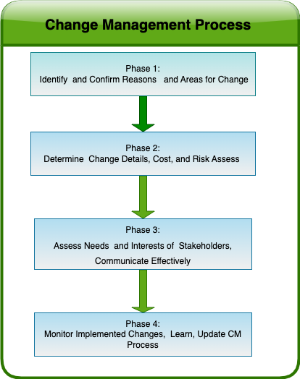  Fig.2： Change Management Process  (Joseph Galli, 2018) | 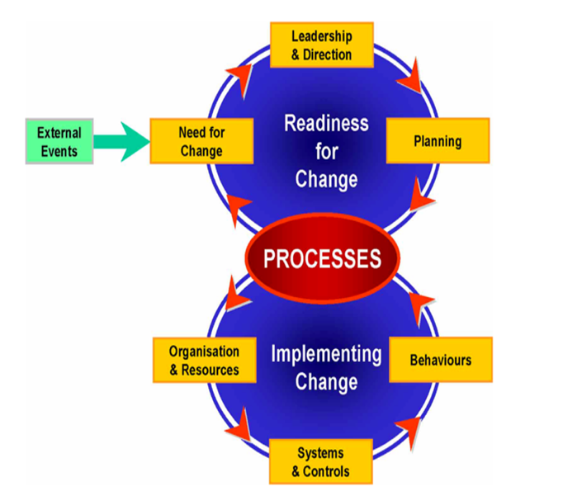  Fig.3：Change Framework  (Oakland & Tanner, 2007)
Bekmukhambetova (2021) compared five different theories. Lewin's Change Theory describes a three-steps process of organizational change, including unfreezing (“preparing for change”), changing (“implementing change”), and refreezing (“stabilizing the change”). The E-O Theory distinguishes the change between economic value (Theory E) , focusing on cost reduction, and organizational capability (Theory O), focusing on valuing processes and people, such as enhancing teamwork. The ADKAR model emphasizes the process and steps of managing change, including “Awareness”, “Desire”, “Knowledge”, “Ability”, and “Reinforcement”. Based on a goal-oriented, this model focuses on achieving specific change outcomes. Kotter's model views change as a linear process rather than a cyclical one, emphasizing early correct steps like establishing alliances and setting visions, rather than later steps like empowerment and integration. Giesen et al., (2013)explained that the impact of the change comes from a combination of external and internal factors. External changes are driven by market environments, political factors, and technological advancements, while internal changes stem from the organization's developmental processes（Fig3）. The main success factor of a change is dependent on how well the driving forces and obstacles are balanced throughout the transformation process according to the change formula (Cady, S.H. et al., 2014).

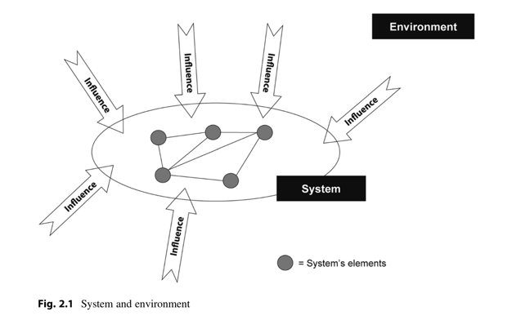
Fig.4： system and environment(Lauer, 2021)

2.2 Organization impact of Digital Transformation
Digital transformation is defined as a profound change encompassing business and organisational activities, processes, capabilities and models (Lugonja, 2020). External environmental changes have driven digital transformation, presenting SMEs with unprecedented challenges and opportunities. Industry 4.0 has become one of the drivers of digital transformation (DT) for small and medium-sized enterprises (SMEs) (Bellantuono et al., 2021). These technological developments have changed the way products and services are delivered. At the same time, it affects the functioning of markets and the competitiveness of enterprises. Over the past few decades, Technologies have had a significant impact on many areas of business such as information and communication technologies (ICT), artificial intelligence (AI), and the Internet of Things (IoT). As a global development trend, digital transformation impacts various industries and domains (Lugonja, 2020). Meanwhile, COVID-19 speeds up the pace of digital transformation among small and medium-sized enterprises (Ali et al., 2021). By comparing change management models and DT models, Pulido & Taherdoost (2023) highlighted the key role of change management in successfully implementing organizational digital transformation, which can help organizations in addressing challenges and resistance encountered during the change process. It also highlights the need for a more flexible and robust model to cope with changes. In contrast, Abraham (2019) classified the importance of multifaceted factors in the process of digital transformation and change management. These factors include structure, culture, technology, and leadership, among others. They influence how successfully an organisation adapts to change. Schallmo et al. (2017) point out that digital transformation is a process involving managing change. It uses digital technology to transform the way organization’s operate. It not only affects organizational structures and business models but also involves the optimization of processes, reshaping relationships within stakeholders, as well as the innovation of products and services. Mazzone (2014)suggests that digital transformation is a critical process involving a life-and-death decision for businesses. Therefore, it is a vital necessity for survival and growth for SMEs to embrace digital transformation, as well as a key opportunities brought by new technologies and maintaining competitiveness.

2.4.1 Leadership Roles in DT
Digital transformation refers to the utilization of technologies to thoroughly reshape an organization's strategic revolution including talent management approaches, daily operational methods, and organizational structure (Morakanyane et al., 2017). Correani et al. (Correani et al., 2020) indicated that the roles of leaders and employees within an organization play a key role in the process of digital transformation. Many literatures illustrate the importance of leaders in the digital transformation of organizations.
During change, the traditional role of a leader is not only to deal with the routine but more importantly to be able to make the right decisions and to be able to take risks (Oakland & Tanner, 2007). The most important thing in leadership is creating and communicating a clear vision that motivates people to follow. This requires not only communication skills, but also meeting the needs, values, and emotions of followers to inspire their enthusiasm. By creating a supportive and inclusive environment, effective leaders can drive change from one state to a new one smoothly(Gilley et al., 2009; Kotter, John P, 2008). Hayes (2014) indicated that leadership is widely recognized to be a key driving factor in the process of change, but there is considerable debate about what constitutes effective leadership. Sirkin, H.L et al.explained that leaders should inspire employees' innovation and enthusiasm, which can encourage employees to be more motivated and passionate about participating in the growth and transformation of the company (Sirkin, H.L et al., 2005)
Research shows leadership style has a deep impact on digital transformation. Compared with transactional leadership, Burns (2010) suggested that transformational leaders who play a catalyst in an organization actively drive the organization towards new goals and directions rather than merely maintaining the current status (transactional leadership). Similarly, AlNuaimi et al. (2022) argue that transformational leaders can improve self-cognitive capabilities by enhancing organizational learning and supporting appropriate knowledge management practices. This will make them more capable of dealing with digital transformation, improving organizational agility.
Kane et al. (2015) suggest that digital transformation was derived by encouraging leadership. Since they can provide employees with the skills and retraining to adapt to constantly changing job roles, which can encourage their confidence to achieve digital transformation. Cameron & Green (2019) argue that courage and self-awareness of leadership are equally important in leading change. Courage empowers leaders to confront uncertainty and risk, while self-awareness helps to understand their strengths and limitations. This allows them to make decisions aligned with their values and abilities. Compared with task-oriented leadership, Weber et al (2022) believe that the people-oriented leadership approach not only enhances employees' trust and improves innovation performance but also reduces resistance to change. According to Malodia et al. (2023), younger entrepreneurs with higher digital self-efficacy are more likely to drive digital transformation. Chen & Hao (2022) state that board members' characteristics and backgrounds affect digital transformation strategies. For example, female board members with high levels of education show a more open and transformational leadership style, which makes them more accepting of advanced tech and more supportive of digital transformation strategies. However, the complexity of board members with different opinions can affect digital transformation. Alma Çallı et al. (2022) show that specific styles of leadership（e.g. “generative leadership” and “digital ability”） have a positive impact on enhancing an organization's digital maturity. They can promote the organization's digital maturity including technology, strategy, and culture.
Research has shown that leadership cognition has a positive impact on digital transformation.Ramadan et al.(2023) indicated that a digitally skilled leader is better equipped to drive change and to help employees be well-prepared for the challenges of an uncertain work environment, which can improve organizational agility. Jia et al.(2024) argue that various factors (e.g. entrepreneurial cognition, resources, external marketing and governmental policy) drive the digital transformation of Chinese SMEs. Chatterjee et al.(2022) shows that active support from leadership can facilitate the implementation of AI technology, and can help employees break the barriers of change when using new technology. The findings of Leso et al. (2023) suggest that active supports from senior management(including resource allocation,policy reform, innovation promotion,risk-taking support) are beneficial for SMEs to successfully achieve digital transformation. Benitez et al. (2022) shown that "digital leadership" can effectively transform platforms and processes into digital forms to support leaders in spearheading digital transformation and increasing the level of organizational innovation. It not only includes advanced information technology (IT) but the optimization of workflows and increased efficiency. Winasis et al. (2021) indicated that the atmosphere created by transformational leaders has a positive impact on the of engagement employees. For example, they can facilitate digital transformation by inspiring and motivating the engagement of employees.

2.4.2 Factors of Employee in DT
The individual roles of employees, as key members of the group, also have an important influence on the digital transformation of SMEs. Joseph Galli (2018)points out that the motivation for change is people, not models. During digital transformation, organizational culture and employee attitudes are vital for achieving a successful transformation, as it mitigates the negative attitudes relating to organizational change. Keenan et al. (2012) believe that the process of digital transformation is considered to be much more than simply implementing technology. There are many reasons for failure including employee resistance, ambiguous definitions and objectives, management inadequacy, and poor communication. Byrnes (2017) indicated that employees may resist transformation for fear of losing their jobs or lack of abilities and resources to adapt to change. For example, Goldman Sachs' digital transformation programme in the US resulted in 99.7 % of equity traders being replaced by automated trading programmes. Bughin et al.(2019) suggest that the importance of providing digital support to employees at all levels (not just to senior management) is essential. Providing the necessary digital tools and resources for employees can significantly increase their productivity and innovation to facilitate. The abilities, behaviors, and attitudes of employees are critical in driving organizational digital transformation.Blanka et al.(2022) believe that employees' abilities, including digital competence and entrepreneurship, are key factors in facilitating organizations digital transformationAlieva & Powell(2023) researched the impact between behaviours of employees and the application of digital technologies. The study shows that personal factors of employees, such as innovation, job satisfaction and career engagement, positively influence their behaviors in digital transformation. At the same time, creativity, intenational effort, turnover propensity and initiative can negatively affect employee behaviours. Thi Thu Thuy et al. (2023) suggest that traits such as employee attitudes and leadership self-efficacy can have an impact on digital transformation readiness and job performance, which can be facilitated by employees' awareness and positive attitudes towards DT. Encouraging employee engagement and confidence, not only improves employee readiness and performance but also reduces the risk of digital transformation.
Employee engagement and satisfaction substantially influence digital transformation. The research points out that increasing employee engagement at all stages of digital transformation can significantly impact business performance (Matsunaga, 2024, p. 13). Frankiewicz & Chamorro-Premuzic (2020) indicated that employee engagement plays an importance in digital transformation. The priority for a company is to invest in skilled employees compared to technology. Thileepan & Raveendran, (2022). show that there are many aspects involved when organisations implement digital transformation (e.g., customer service, operational efficiency, and business models). Employees may be more engaged in digital transformation if they are interested in innovative business models and recognize improved work processes. Abhari et al.(2021) explained that an employee-orientated approach (prioritizing the needs and experiences of employees) is fundamental to the success of digital transformation. When employees feel that their experiences and needs are valued, they prefer to actively participate in digital transformation and take a more proactive role in it. Ullrich et al.(2023) point out that adopting the recommendations of employees is crucial for digital transformation. It's not just about engaging employees in the change process, but also providing them with enough confidence to understand the changes and contribute ideas. Managers must integrate and utilize employee suggestions to effectively facilitate digital transformation “Digital leadership” involves the process of adopting advanced technologies and digital tools to implement organizational change and empower employees. Raed et al.2023) that implementing digital leadership increases employee job satisfaction. Consequently, job satisfaction of employees contributes to a company's digital transformation. Purba (2021) show that many approaches such as adapting leadership styles and providing effective e-learning opportunities can create a supportive work environment where employee engagement and job satisfaction can be increased to facilitate digital transformation. The study indicates that to boost staff engagement and job fulfilment, companies need to focus on adapting their leadership style, providing effective e-learning opportunities, and creating a supportive work environment. Employees expect leaders to adopt new styles that align with the digital age, as this directly impacts their engagement and sense of commitment to the company. Inappropriate leadership styles may lead to a lack of belonging among employees. Additionally, effectively utilizing e-learning can increase employee engagement and motivation.

3 Management Theory in Digital Transformation

3.1 Kuhn Paradigm Cycle theory
The industry 4.0 paradigm promotes technological development, which can improve business performance. The digital transformation paradigm is also driving organizational change management within companies. Affected by both external and internal determinants, change becomes inevitable. Finding new strategies for change management has become a serious challenge for organizations.(Kuhn & Hacking, 2012).
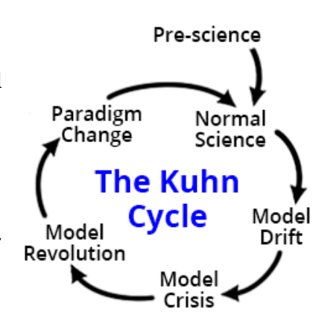
Fig.5: The Kuhn paradigm Cycle(Kuhn & Hacking, 2012; The Kuhn Cycle, n.d.)

3.2 Lewin’ change management Theory
Kurt Lewin's theory states that change management involves a process of three key steps (Fig2)("unfreezing", "changing" and "refreezing"). The factor of individual is critical in organizational change. The "unfreezing" stage refers to strengthening the forces driving change and reducing resistance to change. The "change" phase requires the active participation of the members of the organisation. The "refreezing" phase aims to establish and consolidate a new balance(Lewin, K. & Cartwright, D., 1953).Digital transformation can be considered as change management. Lewin's change management model highlights that for businesses to embrace new changes effectively, they must find a fitting balance between different forces (environmental, demands, resistance)(Lauer, 2021, p. 63)
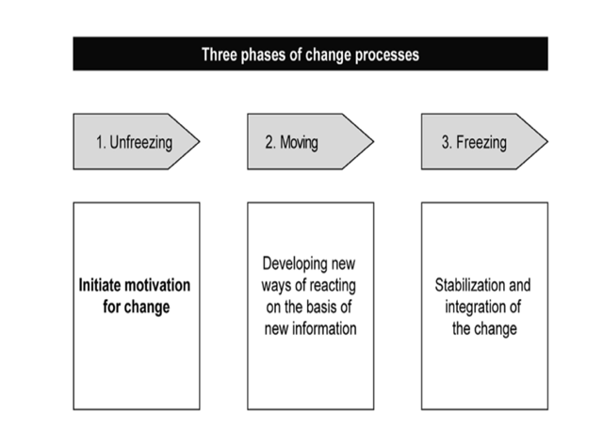  Fig.6: Three phases of change processes  (Lauer, 2021) | 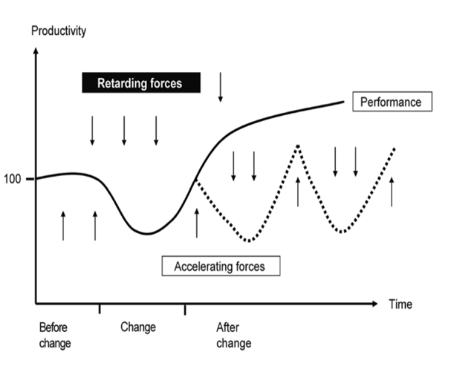  Fig. 7: Process of excessive change  (Lauer, 2021)

3.3 Institutional theory
Institutions play a crucial role in shaping individual behaviors, collective dynamics, and the overall social structure. It emphasizes the strong influence of environmental factors on organizational behaviors. Institutions can profoundly influence all aspects of society(Greenwood, 2008). Digital transformation disrupts existing organisational and industry norms, leading to the emergence of new institutions. Institutional theory can guide us in responding effectively to digital change and developing relevant policies (Hinings et al., 2018; Meyer, J.W & Rowan, B., 1977).

3.4 Organizational Behavior Theory
Organisational behaviour theory emphasises the behaviours of individuals and teams within organisations and how these behaviours affect the overall effectiveness and efficiency of the organisation (includes elements of psychology, sociology, political science, anthropology and economics)(Altman et al., 1985).
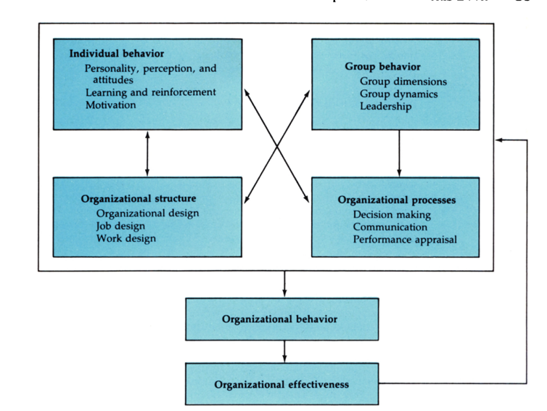
Fig.8:Organizational behavior framework(Altman et al., 1985)

3.4.1 Transactional and Transformational Leadership Theory
Burns (2010) indicated that there are two types of leadership styles (“transactional leadership” and “transformational leadership”). Transactional leaders focus primarily on managing routine matters effectively, highlighting organisation and coordination to ensure that tasks are completed correctly. Transformational leaders aim to improve the status quo and drive change, emphasizing inspiring and motivating the team to initiate and drive change.
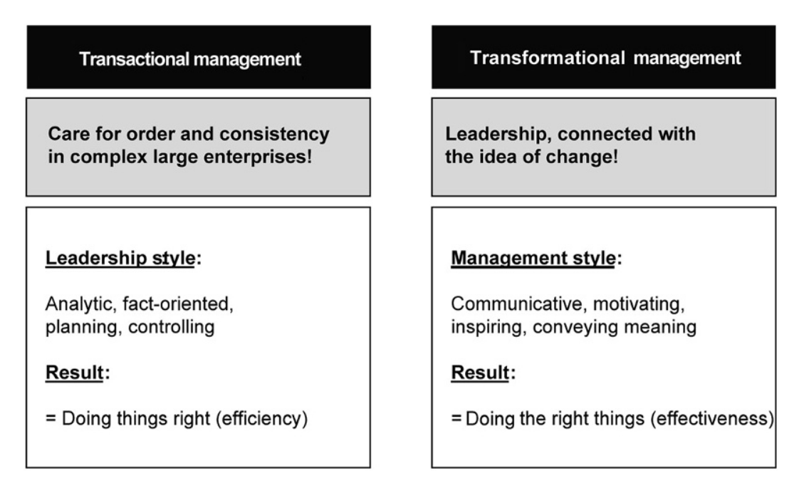
Fig.9 Transactional and transformational Leadership(Lauer, 2021)
Leadership behaviours directly influence organisational change because they can play the role of change agent (including identifying change, developing plans, and implementing change)(Gilley et al., 2009).
Research has shown that transformational leadership promotes digital transformation (AlNuaimi et al., 2022). They tend to inspire positive attitudes in employees, encouraging them to be more engaged and passionate about their work. The positive work atmosphere created by transformational leadership encourages employees to try out new digital tools and methods and makes them more actively involved in the digital transformation. (Winasis et al. For example, employees’ capabilities and traits can also affect the digital transformation. Lanka et al. (2022) indicated that a higher level of digital ability employees prefer to adapt digital tools, which effectively drives the process of digital transformation. On the contrary, they will resist digital transformation for fear of losing their jobs because of their inadequacy.

3.4.2 McGregor's Theory X and Theory Y
Theory X suggests that employees fundamentally do not like their jobs and need strict supervision and motivation, whereas theory Y suggests that employees are self-motivated and love their work as long as their needs are met. Theory Y tends to increase employee satisfaction (McGregor, D, 1960).
When employees feel their jobs are unattractive (e.g., lack of challenge and innovation, monotony, and repetition), they may become less proactive, and unwilling to put in the extra effort to get things done. Conversely, if employees find their work valuable and meaningful, they more probably show high levels of engagement and motivation, which can boost digital transformation success (Kopelman et al., 2008). By increasing employee engagement, satisfaction and fulfilment, employees become more loyal to the organization and are willing to make extra efforts for its success(Thileepan & Raveendran, 2022).
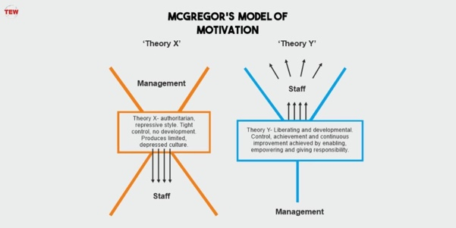
Fig.10: McGregor’s Theory of Motivation(The Enterprise World, 2020)

3.5 Dynamic Capabilities Theory
Dynamic capabilities are key factors for companies to maintain competitiveness. By increasing organizational flexibility, agility, and innovation. Dynamic capabilities theory helps organizations better respond to the ever-changing business environment, adapting to challenges and opportunities (Teece et al., 1997).Dynamic capabilities is the key abilities of an organization to adapt to the market environment. Enterprises need to continually invest in these capabilities (including staff training, technological upgrades and optimising work processes) to maintain competitiveness and ensure that they can respond quickly to market changes(Teece, 2007). These capabilities enable organisations to evaluate whether their existing products are in line with market demand and future development plans. This requires managers to not only make assumptions about the market and technology but also to adapt the company's assets and strategies to new market demands(Hall & Rosenberg, 2010, p. 692).
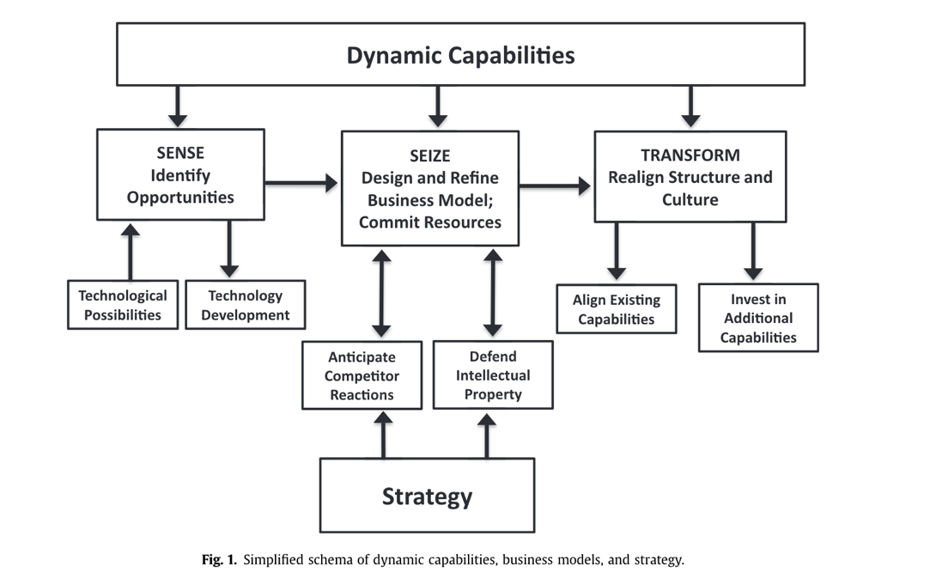
Fig.11 Simplified schema of dynamic capabilities business models (Teece, 2018)
Many researchers have explored the digital transformation of SMEs from dynamic capabilities. Vasi et al.(2024)point out that dynamic capabilities integrated with innovation management can help firms improve their resilience and enable SMEs to better survive during the pandemic. According to research by Khurana et al. (2022), “Digital transformation through the development of resilience as a second-order dynamic capability” Matarazzo et al.(2021)indicated that the ability of sense and learn is a key dynamic capability for enabling digital transformation in SMEs. Similarly, Khurana et al.( 2022) investigate the first-order and second-phase dynamic capabilities of SMEs in providing transformational processes that embrace digital technologies.

3.6 The Resource-Based View (RBV)
Internal resources and capabilities of a company contribute to the efficiency and effectiveness of the organisation. By identifying and exploiting these unique resources(e.g. assets, capabilities, organizational processes, company attributes, information, and knowledge), firms can establish a significant competitiveness(Wernerfelt, 1984). These irreplaceable and scarce resources are key factors for enterprises to gain and maintain competitiveness. (Grant, 1991). By a resource-based view (RBV), researchers investigated digital transformation to understand how organizations can leverage their internal resources to achieve successful transformation in a fast-evolving environment (Chatterjee et al., 2022; Elia et al., 2021).

4 Case Stuy: DT of SMEs in ShanXi of China
The Digital Transformation Index for Chinese Enterprises reveals that companies in China are simultaneously facing multiple challenges in the form of a "squeeze". Companies in China should start a comprehensive reshaping of their corporate strategy if they want to enhance their resilience to risks and achieve sustained growth. It shows that only 2% of Chinese companies have activated a comprehensive reshaping of their strategy(“2023 Accenture Digital Transformation Survey of Chinese Enterprises”)(Xiao Long He, 2023).

4.1 Policy support
The development and transformation of technologies be considered as the main driver for the Industry 4.0 paradigm(Cannavacciuolo et al., 2023). This change also accelerated the process of DT as a new paradigm.
From the national level, China's Ministry of Industry and Information Technology (MIIT) has introduced a policy to support local SMEs in developing digital transformation. The goal is to enhance the capacity of digital public service platforms and provide digital solutions for SMEs. It will establish replicable typical models covering 100 industries and support around 300 service platforms. Over 4,000-6,000 demonstration enterprises will be cultivated to accelerate the steps of digital transformation of SMEs(Yu Zhu, 2022).
In June 2023, the Chinese government introduced a policy to assist the digital transformation of SMEs. The Ministry of Finance (MoF) and the Ministry of Industry and Information Technology (MIIT) announced a plan to conduct pilot projects in three phases from 2023 to 2025 to test and promote SME digitalization strategies. These pilot projects aim to provide a platform for SMEs to explore effective pathways for digital transformation. It provides a reference for nationwide digital transformation. This marks significant progress for the Chinese government in promoting SME digitization(EU SME Centre, 2023; Yu Zhu, 2022)
Pilot cities will focus on small businesses in the manufacturing sector (e.g. automotive, transport equipment, pharmaceuticals, chemicals, electronics, etc.) The central government will provide incentives (RMB 100 million to 150 million) to these pilot cities. The pilot project will last for two years. The objective of the programme is to support innovation and accelerate digital technology(Hua Wen Ma, 2023).
In October 2023, there are 30 pilot cities established for the digital transformation of SMEs, including Suzhou, Xiamen, Changchun, ShanXi and others. More than 159,000 SMEs participated in the assessment process. The results show that more than 60 per cent of the participating companies have achieved visualization and lean management in their key production processes. This progress has been made in traditional industries such as light manufacturing, petrochemicals, steel and food production(Wen Hua Ma, 2023).
Local governments in China's provinces and cities have actively introduced policies to support the digital transformation of small and medium-sized enterprises (SMEs) (e.g. Shanxi, Sichuan, Chongqing, Suzhou, etc.). These policies aim to encourage SMEs to develop digital technologies and strategies, improving competitiveness. By providing financial support and training, they help SMEs to adapt to the business environment in the digital era, and ultimately promote business growth(Bing Li, 2023; Shan Yu, 2021; ShanYu, 2021; Tao Wang, 2023).

4.2 DT Case in ShanXi

4.2.1 Digital Economy in ShanXi
In recent years, Shanxi Province has developed the digital economy through the construction of a big data industrial park to achieve digital transformation from traditional coal resources to the development of high-tech industries.(Xinhua, 2023). Taiyuan, the capital of Shanxi Province, has long been a traditional manufacturing base in China, with competitive industries such as steel, machinery, food and semiconductors(shanxi.chinadaily, 2023a). To achieve sustainable development of advanced manufacturing and become an important part of the country's advanced manufacturing industry, Taiyuan develops nine key industrial chains, including metal materials, carbon-based materials, biomaterials, mining and construction machinery, transport and aviation equipment, semiconductors, intelligent terminals, and new energy.(shanxi.chinadaily, 2023b). This strategy not only supports the digital transformation of SMEs, but also promotes the high-quality development of the regional economy. Meanwhile, Meanwhile, Taiyuan is actively developing its digital economy by strengthening digital infrastructure and promoting the digital transformation of traditional industries. By 2021, the value of industries of Taiyuan's digital economy reached RMB 42 billion (about USD 6.05 billion), accounting for nearly half of the total, and ranking 33rd among China's top 100 cities for digital economy development(subsites.chinadaily, 2023).
In 2023, Taiyuan was selected by the Ministry of Industry and Information Technology (MIIT) and the Ministry of Finance (MOF) as one of the pilot cities for digital transformation of SMEs(Cheng Shen, 2023). The digital transformation of Chinese SMEs has not yet been widely implemented due to technological and financial constraints. However, COVID-19 has created a significant opportunity for digital transformation. The Ministry of Industry and Information Technology (MIIT) has launched “The SME Digitisation Programme” to support this transformation. This project promotes the development of digital transformation. It also helped small and medium-sized enterprises to improve communication with financial institutions and reduce financing challenges (Ping An, n.d.).

4.2.2 Support from Government
The Shanxi provincial government has adopted a series of diversified measures (covering hardware, software, finance, technology and digital platforms) to support the digital transformation of SMEs. It is strengthening the integration of industry and digitalization to create conditions for the competitiveness and sustainable development of SMEs.Taiyuan has made great efforts to develop 5G in its infrastructure construction. It has now successfully installed 15,751 5G base stations which has attained complete 5G network coverage. This important initiative not only promotes the integration of information technology and manufacturing, but also strengthens the application of industrial Internet. This has laid a strong foundation for Taiyuan's industrial upgrading and digital transformation(govt.chinadaily, 2023; sx.news.cn, 2023; Xinhua, 2023).
Four industrial parks in Taiyuan (Shanxi Data Traffic Ecological Park, Taiyuan TIPark, Zhongke Tongchang Digital Economy Industrial Park and Xiaodian Investment Industrial Park) were recognized as Digital Economy Demonstration Parks by the Shanxi Development and Reform Commission. These industrial parks have successfully attracted more than 400 enterprises with a total revenue of more than RMB 10 billion, which promoted the construction of a digital industry centre in Taiyuan from a wide range of perspectives(e.g. technology, finance and services)(subsites.chinadaily., 2023).
In cooperation with Peking University, Taiyuan City has established the official Peking University Science Park Taiyuan Science and Technology Innovation Centre. The Centre has effectively strengthened the transformation from scientific to technological application by introducing academicians, experts and resources from scientific and technological service institutions. This not only promotes the interfusion of the digital economy and the real economy but also develops enhancement of the regional industrial structure(sx.chinanews, 2024).
Shanxi Province has introduced the "Comprehensive Plan for Promoting the Development of Digital Economy in Shanxi Province (2022-2025)". It established “the Centre for the Promotion of Digital Transformation of SMEs” including universities, technology companies, research institutes, logistics and energy companies, and investment companies, which can help the SMEs deal with the issue of digital transformation(Tao Wang, 2023).In Shanxi, more than 200 companies are undergoing digital transformation, with small and medium-sized enterprises being a vital part of the national economy and a major force in the digital economy. This is crucial for Shanxi's economic development and a key step in upgrading traditional industries(Qiao Do, 2023).
The construction of national pilot sites in Taiyuan has driven the development of intelligent manufacturing by accelerating the fusion of information technology and manufacturing. It has cultivated 110 national two-chemical fusion management system certified enterprises, 24 state-level pilot demonstrations of industrial internet and big data industry, 8 state-level pilot demonstrations of intelligent manufacturing, 38 provincial-level pilot demonstrations and benchmarks of intelligent manufacturing, and accelerated integration of digital economy and manufacturing(govt.chinadaily, 2023).

4.2.3 Pilot Demonstration
The Industrial Internet secondary identification and resolution nodes of 10 enterprises, including Taiyuan Brewery and Taiyuan Boiler, have been put into operation to create application scenarios such as product coding, quality traceability, supply chain management, etc., to shape a new model and new benchmark for digital transformation. In addition, typical application scenarios, such as the 5G remote excavator of Tai Heavy Group and the 5G smart factory of Zhonglai, have also been implemented, providing strong support and impetus for the high-quality development of the industry(Bing Li, 2023). Taiyuan is committed to, creating specialized, refined, differentiated and innovative industries, and constructing special industrial towns, such as Qingxu Vinegar Town, Motor Town and Carbon Fibre Town, to promote the development of intelligent manufacturing and special industries(shanxi.chinadaily, 2023a; subsites.chinadaily, 2023).

4.2.4 School-Enterprise Co-operation
Co-operated with universities and research institutes, technology companies, it promote the fusion of digital economy and real economy. By setting up professional committees, the Shanxi Federation of Enterprises has taken multifaceted measures to promote the digital transformation and high-quality development of small and medium-sized enterprises (SMEs). They have set up professional service committees covering a wide range of areas such as finance, digital technology, policy, and human resources. Activities such as visits to advanced manufacturing industries and digital service providers were organized to provide enterprises with in-depth digital transformation experiences and practical opportunities(Xinhua, 2024).
The Shanxi provincial government has established the first provincial digital transformation facilitation centers, which include universities, technology companies, investment firms and research institutes, with the aim of accelerating the digital transformation of SMEs(Tao Wang, 2023). Through the implementation Plan for the Action of Upgrading and Transformation of Small and Medium-sized Enterprises in Shanxi Province for Digital Empowerment, more than 20 industrial Internet platforms and digital transformation service providers have been organized in Shanxi Province to support digital transformation for over 200 SMEs comprehensively.
Technical training and expert lectures were conducted in the form of "cloud classrooms" to share successful cases and practical experience in digital transformation. Through the provision of consulting services by experts, a digital diagnosis of the industry sector was conducted, and specific transformation plans and implementation programmes were formulated to ensure that small and medium-sized enterprises could effectively apply digital technology(ndrc.gov.cn, 2023).
Taiyuan has partnered with enterprises to jointly build an AI digitalization platform, aiming to provide comprehensive support for the digital transformation of enterprises. TIANE Digital Group has signed a cooperation agreement with Shanxi Data Traffic Eco Park and Shanxi Digital Industry Association to build this platform to provide reliable public arithmetic resources for universities, research institutes and enterprises, etc., to support the development of industries from digitalization to intelligence(stcn, 2023).

4.2.5 Financial Support
Taiyuan City Bureau of Industry and Information Technology to develop into a national centre for the information technology (IT) industry. These policies include providing one-off incentives to companies in electronic information product manufacturing, semiconductors, IT application innovation, Internet of Things (IoT), big data and artificial intelligence to support the development of these industries.
A series of activities have been adopted to promote Taiyuan as a national IT industry centre and accelerate the development of the city's digital economy. (big5.cri.cn, 2022). China Merchants Bank Taiyuan Branch helps the digital transformation of small and medium-sized enterprises (SMEs) with the support of financial technology. They provide digital solutions in a variety of areas including sales, collections, procurement, payments, daily operations, and personnel management. These solutions include mature group internet banking, enterprise APP platform, full chain sales and collection services, and integrated supply chain financing and settlement services. By deepening the integration of financial digitization and business operation digitization, they help SMEs solve the challenges they may face in digital transformation(chinanews, 2024).

In summary, TaiYuan has adopted a series of activities to help SMEs with their digital transformation, starting with demonstrations and workshops to share how to make successful digital changes. Internet platforms work with governments to provide technical support and guidance for the digital transformation of SMEs, which will help SMEs develop technical talent and resources. Meanwhile, the Taiyuan government has increased the construction of digital infrastructure. It has achieved industrial coverage of 5G networks to reduce the cost of environmental management for enterprises. It also enhances the motivation of enterprises for digital transformation by providing subsidies.

5 Discussion of innovative solutions
Based on relevant theories in management studies, this research aims to explore and address the issues and challenges of Chinese small and medium-sized enterprises (SMEs) in their digital transformation. Although there is much support from the government to help SMEs in DT, most policy is from the macro-level, they rarely consider the meso-level such as impact of the organization,and individual behaviours. Except of technology and finiccial , the most import things is the dindividal impact. In this project leadership and employees empact on digital transformation will discussed ,and some advice will be given for DT in SMEs.

5.1 Strategy of Digital Transformation
SMEs should approach digital transformation from four perspectives(Fig). Firstly, companies should understand the current environment in which they are operating to clarify their goals for future transformation (economy, efficiency, services) and understand how digital transformation can help to achieve these goals, and then they should evaluate their digital transformation maturity level(Canhoto et al., 2021). Then, companies should measure their digital transformation maturity level and propose specific digital transformation measures based on the existing maturity level in the context of the actual situation(Mittal et al., 2018). Finally, companies should mobilise resources to carry out digital transformation work based on the implementation approach. This should be accompanied by regular measurement of whether the objectives are being met(Stich et al., 2020).
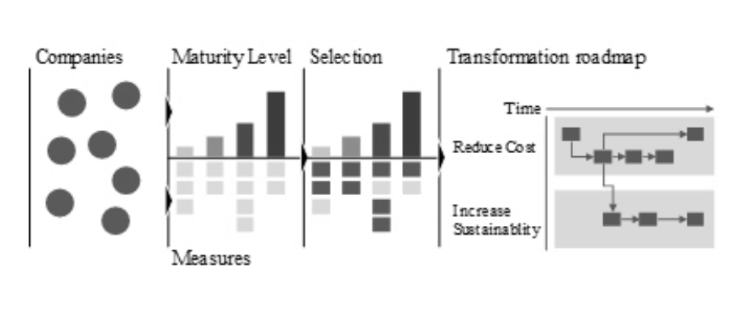
Fig12: A Four-step Digital Transformation (Stich et al., 2020).

5.2 Awareness of Digital Transformation
Raising awareness of digital transformation among SMEs is a prerequisite for digital transformation.To successfully communicate and implement the corporate strategy, it is crucial to ensure that there is a uniform understanding of digital transformation across the organisation. If the understanding is not aligned, there will be challenges in communicating and implementing the strategy within the company(Meyer & Peter, 2024). Successful digital transformation relies on SMEs fully understanding its value. If entrepreneurs misunderstand the costs and risks of digital transformation and fail to see the benefits, it may lead them to abandon the implementation of their digital transformation strategy(Jia et al., 2024). Employees will resist digital transformation in SMEs if they lack confidence in their ability to do so. (Chatterjee et al., 2022)

5.3 Improve the Institution （Institutional Theory）
Digital transformation is essentially an institutional change, which requires that the key role of institutions be fully recognised in DT. Therefore, to effectively promote digital transformation, it is necessary to first start from three main aspects: organisational form, infrastructure development and institutional construction, to improve and support the relevant system of DT(Hinings et al., 2018).

5.4 Establishing a Digital Department（RBV&DC Theory）
An organization's capabilities and resources are key to gaining a competitive advantage. Based on the resource-based view theory, establishing a specialized digitalization department is a vital measure in promoting the digital transformation of small and medium-sized enterprises.This allows for the focusing of resources and expertise to drive innovation and optimisation of the business in terms of technology and strategy. SMEs should establish a digitalization-focused department to tailor a successful digital strategy to their specific needs and features. (Chen & Hao, 2022). This department is a powerful engine for SMEs' digital transformation, handling challenges and opportunities in the digital era and supporting long-term success and sustainable development(Jacopo Brunelli, et al., 2017; Tanguy Catlin et al., 2017).

5.5 The leadership
A leader's style and capabilities directly impact the direction and outcomes of transformation. Leaders must set an example for transformation through their actions and decisions.
According to Lewin's Change Management Theory, leaders need to adopt an open and innovative leadership style(eg. transformational leadership and supportive leadership) to disrupt existing organizational structures and culture（”to unfreeze”） to pave the way for change.Therefore Leaders have significant influence in MSMEs as they are usually the main decision makers. They play a key role in driving employees to adapt to digital transformation. If these support and incentives are implemented inappropriately or at the wrong time, they may cause stress to employees, which in turn negatively affects job performance. Therefore, leaders must offer assistance and rewards appropriately and timely to positively influence employee performance (Thi Thu Thuy et al., 2023).
The level of awareness and digital literacy of leaders and top management directly determines a company's ability to digitally transform and reach digital maturity. Generative leaders with a high level of digital literacy can significantly improve a company's digital maturity through their advanced management methods and open communication style. Leaders should therefore encourage proactive participation and innovation among their team members, put people at the center of their efforts, and value the growth and development of their team members(Alma Çallı et al., 2022).
At the same time, transformational leaders are important in advancing digital transformation as they can effectively facilitate the transformation process. Therefore, when companies are committed to digital transformation, they should prioritise recruiting people with transformational leadership skills to take on more tasks and responsibilities related to digital transformation(AlNuaimi et al., 2022).
Transformational leadership, in emphasizing the importance and urgency of digital technologies, can lead to employees feeling uncertain and challenged, which in turn can lead to negative attitudes of resistance to change. People-centred leadership behaviours can effectively mitigate this. Therefore, adopting complementary leadership behaviours is an effective strategy to facilitate digital transformation in organisations(Weber et al., 2022, 2022)
Leaders need to enhance their digital skills to better understand technological trends and applications, thereby making wise decisions at the technological level. Digital leadership is extremely important in facilitating the digital transformation of an organization, it not only improves the digital management capability of the work and the overall digital maturity of the organisation but also helps employees to build up their confidence and competence in digital transformation. Therefore, enhancing leaders' digital skills during digital transformation can facilitate the digital evolution of business (Benitez et al., 2022; Borah et al., 2022).

5.6 Behavior of Employee
Employees is the core in the digital transformation of small and medium-sized enterprises, and their engagement and satisfaction significantly impact organizational performance. By enhancing employees' digital capabilities and engagement, as well as reducing their resistance to change, the probability of digital transformation can be effectively increased.
Studies indicate that the focus of digital transformation is not technology-centric but employee-centric. Ensure that employees are well prepared, learn new things and are engaged in digital transformation. Doing so can help the change go more smoothly(Ullrich et al., 2023).
Enhancing the personal skills and knowledge of employees is key in the digital transformation process. Companies need to train their employees in digital technologies and strengthen performance management. And hire experts who understand digital technology to support this transformation process(Leso et al., 2023).
Train employees on how to use various AI tools most effectively. Doing so will help them improve their self-confidence and engagement. At the same time, leaders need to support their employees emotionally and make them feel encouraged so that employees won't be resistant to using new technology(Abhari et al., 2021; Chatterjee et al., 2022).
In conclusion, in the digital transformation of SMEs, the first task is to raise the awareness of entrepreneurs and employees on the necessity and importance of digital transformation to reduce internal resistance. Enterprises should optimise at the organisational structure and system level by establishing a department dedicated to digital transformation. Highly focusing on the important role of leadership roles, transformational leaders should be fully utilised as drivers and complementary leaders should be engaged to achieve transformational and people-centred co-governance. In terms of employee management, strengthening skills training for employees and increasing their self-confidence and engagement are significant factors in the successful implementation of digital transformation.

6 Conclusion
Micro-behaviour and leadership in the implementation of digital strategies in SMEs, In SMEs this subjective assessment of the environment depends to a large extent on the perceptions of the company's leaders,.
The role of the individual in strategy development is highly deterministic, and personal digital leadership influences the level and approach to technology use in SMEs, therefore the style of leadership, and the corporate culture created by the leader, contributes to digital transformation. Research has shown that transformational leaders are more receptive to new ideas, more able to inspire their employees' potential to take on new challenges, and better suited to lead digital transformation.
Employees as the most important part of SMEs, employee satisfaction, engagement will affect the digital transformation of the enterprise. Research has shown that employee involvement in digital transformation will make employees share a sense of achievement and responsibility, which is more conducive to the digital transformation of an organisation.
Contribution：It examines the digital transformation of SMEs at both the leadership and employee levels, provides specific recommendations and action plans required for the practical implementation of digital transformation in SMEs, and summarises best practices for successful digital transformation for reference and adoption by SMEs to help them implement digital transformation smoothly and successfully.
Limitation :The study may have selected only SMEs in specific industries, sizes or geographical locations, which may limit the generalizability of the findings as SMEs in different industries and regions may face different digital transformation challenges. The results of the study may be somewhat localised and cannot simply be generalised to SMEs in other cities or countries. Differences in culture, regulations, market conditions and digital infrastructure in different regions may lead to limitations in the applicability of the research findings elsewhere.

7 Reference
Abhari, K., Ostroff, C., Barcellos, B., & Williams, D. (2021). Co-Governance in Digital Transformation Initiatives: The Roles of Digital Culture and Employee Experience. Hawaii International Conference on System Sciences. https://doi.org/10.24251/HICSS.2021.704
Abraham, T. O. O. (2019). The Interplay between Change and Project Management for Business Results. The University of Texas Rio Grande Valley.
Ali, M. H., Suleiman, N., Khalid, N., Tan, K. H., Tseng, M.-L., & Kumar, M. (2021). Supply chain resilience reactive strategies for food SMEs in coping to COVID-19 crisis. Trends in Food Science & Technology, 109, 94–102. Resilience. https://doi.org/10.1016/j.tifs.2021.01.021
Alieva, J., & Powell, D. J. (2023). The significance of employee behaviours and soft management practices to avoid digital waste during a digital transformation. International Journal of Lean Six Sigma, 14(1), 1–32. https://doi.org/10.1108/IJLSS-07-2021-0127
Alma Çallı, B., Özşahin, M., Coşkun, E., & Rıfat Arık, A. (2022). Do Generative Leadership and Digital Literacy of Executive Management Help Flourishing Micro and Small Business Digital Maturity? International Journal of Organizational Leadership, 11(3), 307–332. https://doi.org/10.33844/ijol.2022.60332
AlNuaimi, B. K., Kumar Singh, S., Ren, S., Budhwar, P., & Vorobyev, D. (2022). Mastering digital transformation: The nexus between leadership, agility, and digital strategy. Journal of Business Research, 145, 636–648. Perfromance. https://doi.org/10.1016/j.jbusres.2022.03.038
Altman, S., Valenzi, E., Hodgetts, R. M., & Hodgetts, R. M. (1985). Organizational behavior: Theory and practice. Academic Press.
Bekmukhambetova, A. (2021). Comparative Analysis of Change Management Models Based on an Exploratory Literature Review. New Horizons in Business and Management Studies, 98–110. https://doi.org/10.14267/978-963-503-867-1_10
Bellantuono, N., Nuzzi, A., Pontrandolfo, P., & Scozzi, B. (2021). Digital Transformation Models for the I4.0 Transition: Lessons from the Change Management Literature. Sustainability, 13(23), 12941. https://doi.org/10.3390/su132312941
Benitez, J., Arenas, A., Castillo, A., & Esteves, J. (2022). Impact of digital leadership capability on innovation performance: The role of platform digitization capability. Information & Management, 59(2), 103590. Perfromance. https://doi.org/10.1016/j.im.2022.103590
big5.cri.cn. (2022, November 25). Taiyuan to Develop into IT Industry Hub. https://big5.cri.cn/gate/big5/news.cri.cn/2022-11-25/49f88321-c2ab-619c-d02a-e61e9e6624c9.html
Bing Li. (2023, September 13). Taiyuan Selected as One of China’s First Pilot Cities for SME Digital Transformation [The People’s Government of Shanxi Province]. https://www.shanxi.gov.cn/ywdt/sxyw/202309/t20230913_9310235.shtml
Blanka, C., Krumay, B., & Rueckel, D. (2022). The interplay of digital transformation and employee competency: A design science approach. Technological Forecasting and Social Change, 178, 121575. https://doi.org/10.1016/j.techfore.2022.121575
Borah, P. S., Iqbal, S., & Akhtar, S. (2022). Linking social media usage and SME’s sustainable performance: The role of digital leadership and innovation capabilities. Technology in Society, 68, 101900. https://doi.org/10.1016/j.techsoc.2022.101900
Bughin, J., Deakin, J., & O’Beirne, B. (2019). Digital transformation: Improving the odds of success. McKinsey Quarterly, 11, 1–5.
Burns, J. M. (2010). Leadership (Harper Perennial political classics ed). Harper Perennial.
Byrnes, N. (2017). As Goldman Embraces Automation, Even the Masters of the Univers. MIT Technology Review, February(7), p.2017.
Cady, S.H., Jacobs, R., Koller, R., & Spalding, J. (2014). The change formula. OD PRACTITIONER, 46(3), 32–39.
Cameron, E. & Green, M. (2019). Making sense of change management: A complete guide to the models, tools and techniques of organizational change. Kogan Page Publishers.
Canhoto, A. I., Quinton, S., Pera, R., Molinillo, S., & Simkin, L. (2021). Digital strategy aligning in SMEs: A dynamic capabilities perspective. The Journal of Strategic Information Systems, 30(3), 101682. Perfromance. https://doi.org/10.1016/j.jsis.2021.101682
Cannavacciuolo, L., Ferraro, G., Ponsiglione, C., Primario, S., & Quinto, I. (2023). Technological innovation-enabling industry 4.0 paradigm: A systematic literature review. Technovation, 124, 102733. https://doi.org/10.1016/j.technovation.2023.102733
Chatterjee, S., Chaudhuri, R., Vrontis, D., & Jabeen, F. (2022). Digital transformation of organization using AI-CRM: From microfoundational perspective with leadership support. Journal of Business Research, 153, 46–58. Perfromance. https://doi.org/10.1016/j.jbusres.2022.08.019
Chen, P., & Hao, Y. (2022). Digital transformation and corporate environmental performance: The moderating role of board characteristics. Corporate Social Responsibility and Environmental Management, 29(5), 1757–1767. Perfromance. https://doi.org/10.1002/csr.2324
Cheng Shen. (2023, June 14). Two Departments to Organize and Carry Out SME Digital Transformation City Pilots. https://www.gov.cn/lianbo/bumen/202306/content_6886333.htm
chinanews. (2024, January 2). Shanxi Taiyuan: ‘Financial Technology’ Supports Small and Medium Enterprises in Digital Transformation [Sx.chinanew.com]. https://www.sx.chinanews.com.cn/news/2024/0102/228467.html
Correani, A., De Massis, A., Frattini, F., Petruzzelli, A. M., & Natalicchio, A. (2020). Implementing a Digital Strategy: Learning from the Experience of Three Digital Transformation Projects. California Management Review, 62(4), 37–56. https://doi.org/10.1177/0008125620934864
Elia, S., Giuffrida, M., Mariani, M. M., & Bresciani, S. (2021). Resources and digital export: An RBV perspective on the role of digital technologies and capabilities in cross-border e-commerce. Journal of Business Research, 132, 158–169. DT. https://doi.org/10.1016/j.jbusres.2021.04.010
EU SME Centre. (2023, August 24). SMEs in China: 2023 Policy Environment Report. EU SME Centre: China Market Research, Training, Advice | Get Ready for China. https://www.eusmecentre.org.cn/publications/smes-in-china-2023-policy-environment-report/
Frankiewicz, B., & Chamorro-Premuzic, T. (2020). Digital Transformation Is About Talent, Not Technology. Harvard Business Review, 6(3), 1–6.
Giesen, B., Goetze, D., & Schmid, M. (2013). Basale Soziologie: Theoretische Modelle. Springer-Verlag.
Gilley, A., Gilley, J. W., & McMillan, H. S. (2009). Organizational change: Motivation, communication, and leadership effectiveness. Performance Improvement Quarterly, 21(4), 75–94. https://doi.org/10.1002/piq.20039
govt.chinadaily. (2023, September 14). Taiyuan to pilot digital transformation of SMEs [Govt.chinadaily]. https://govt.chinadaily.com.cn/s/202309/14/WS650d6861498ed2d7b7e9c332/taiyuan-to-pilot-digital-transformation-of-smes.html
Grant, R. M. (1991). The Resource-Based Theory of Competitive Advantage: Implications for Strategy Formulation. California Management Review, 33(3), 114–135. https://doi.org/10.2307/41166664
Greenwood, R. (Ed.). (2008). The SAGE handbook of organizational institutionalism. SAGE.
Hall, B. H., & Rosenberg, N. (Eds.). (2010). Handbook of the economics of innovation. Vol. 1 (1. ed., reprinted, Vol. 1). North Holland.
Hayes, J. (2014). The theory and practice of change management (4th edition). Palgrave Macmillan.
Hinings, B., Gegenhuber, T., & Greenwood, R. (2018). Digital innovation and transformation: An institutional perspective. Information and Organization, 28(1), 52–61. Perfromance. https://doi.org/10.1016/j.infoandorg.2018.02.004
Hua Wen Ma. (2023, June 12). Notice on Initiating Pilot Projects for SME Digital Transformation in Cities [Www.gov.cn]. https://www.gov.cn/zhengce/zhengceku/202306/content_6886368.htm
Jacopo Brunelli, Vladimir Lukic, Tom Milon, & Marco Tantardini. (2017). Five Lessons from the Frontlines of Industry 4.0. BCG Global. https://www.bcg.com/publications/2017/industry-4.0-lean-manufacturing-five-lessons-frontlines
Jia, J., Xu, Y., & Li, W. (2024). A study on the strategic momentum of SMEs’ digital transformation: Evidence from China. Technological Forecasting and Social Change, 200, 123038. https://doi.org/10.1016/j.techfore.2023.123038
Joseph Galli, B. (2018). Change Management Models: A Comparative Analysis and Concerns. IEEE Engineering Management Review, 46(3), 124–132. https://doi.org/10.1109/EMR.2018.2866860
Kane, G. C., Palmer, D., Phillips, A. N., Kiron, D., & Buckley, N. (2015). Strategy, not Technology, Drives Digital Transformation. MIT Sloan Management Review.
Keenan, P., Powell, K., Kurstjens, H., Shanahan, M., Lewis, M., & Busetti, M. (2012). Changing Change Management: A Blueprint That Takes Hold. Boston Consulting Group.
Khurana, I., Dutta, D. K., & Singh Ghura, A. (2022). SMEs and digital transformation during a crisis: The emergence of resilience as a second-order dynamic capability in an entrepreneurial ecosystem. Journal of Business Research, 150, 623–641. DT. https://doi.org/10.1016/j.jbusres.2022.06.048
Kopelman, R. E., Prottas, D. J., & Davis, A. L. (2008). Douglas McGregor’s Theory X and Y: Toward a Construct-valid Measure. 2.
Kotter, John P. (2008). A force for change: How leadership differs from management. Simon and Schuster.
Kuhn, T. S., & Hacking, I. (2012). The structure of scientific revolutions (Fourth edition). The University of Chicago Press.
Lauer, T. (2021). Change Management: Fundamentals and Success Factors. Springer Berlin Heidelberg. https://doi.org/10.1007/978-3-662-62187-5
Leso, B. H., Cortimiglia, M. N., & Ghezzi, A. (2023). The contribution of organizational culture, structure, and leadership factors in the digital transformation of SMEs: A mixed-methods approach. Cognition, Technology & Work, 25(1), 151–179. https://doi.org/10.1007/s10111-022-00714-2
Lewin, K. & Cartwright, D. (1953). Field theory in social science: Selected theoretical papers. Harper.
Lugonja, D. (2020). Change Management as a Support to the Organizations’ Digital Transformation – State of the Art.
Matarazzo, M., Penco, L., Profumo, G., & Quaglia, R. (2021). Digital transformation and customer value creation in Made in Italy SMEs: A dynamic capabilities perspective. Journal of Business Research, 123, 642–656. DT. https://doi.org/10.1016/j.jbusres.2020.10.033
Matsunaga, M. (2024). Employee Uncertainty Over Digital Transformation: Mechanisms and Solutions. Springer Nature Singapore. https://doi.org/10.1007/978-981-99-8409-1
Mazzone, D. M. (2014). Digital or Death: Digital Transformation: The Only Choice for Business to Survive Smash and Conquer. Smashbox Consulting Inc.
McGregor, D. (1960). Douglas McGregor: Theory X and Theory Y. Organization Theory, 358(374), 5.
Meyer, J.W & Rowan, B. (1977). Institutionalized Organizations: Formal Structure as Myth and Ceremony. American Journal of Sociology, 83(2), 340–363. https://doi.org/10.1086/226550
Meyer, M. A., & Peter, M. K. (2024). Evolving marketing strategies for Swiss SMEs in the ICT sector: A marketing strategy canvas in support of digital transformation. International Journal of Technology Marketing, 18(1), 91–112. https://doi.org/10.1504/IJTMKT.2024.135672
Mittal, S., Khan, M. A., Romero, D., & Wuest, T. (2018). A critical review of smart manufacturing & Industry 4.0 maturity models: Implications for small and medium-sized enterprises (SMEs). Journal of Manufacturing Systems, 49, 194–214. SMEs. https://doi.org/10.1016/j.jmsy.2018.10.005
Morakanyane, R., Grace, A., & O’Reilly, P. (2017). Conceptualizing Digital Transformation in Business Organizations: A Systematic Review of Literature. Digital Transformation – From Connecting Things to Transforming Our Lives, 427–443. https://doi.org/10.18690/978-961-286-043-1.30
Moran, J. W., & Brightman, B. K. (2000). Leading organizational change. Journal of Workplace Learning, 12(2).
ndrc.gov.cn. (2023, April 12). Shanxi: Over Two Hundred Small and Medium Enterprises Can Enjoy Digital Transformation Services. https://www.ndrc.gov.cn/xwdt/ztzl/cjgyjjpwzz/dfjyhzf/202304/t20230412_1353523.html
Oakland, J. S., & Tanner, S. (2007). Successful Change Management. Total Quality Management & Business Excellence, 18(1–2), 1–19. https://doi.org/10.1080/14783360601042890
Ping An. (n.d.). China’s SMEs Need Financial and Technological Boost for Digital Transformation. PingAn. Retrieved 20 January 2024, from https://group.pingan.com/media/perspectives/China-s-SMEs-Need-Financial-and-Technological-Boost-for-Digital-Transformation.html
Pulido, F. L. P., & Taherdoost, H. (2023). Managing Change in the Digital Age: A Comparative Study of Change Management and Digital Transformation Models. 2023 4th International Conference on Electronics and Sustainable Communication Systems (ICESC), 983–989. https://doi.org/10.1109/ICESC57686.2023.10193166
Purba, C. B. (2021). Digital transformation in the Indonesia manufacturing industry: The effect of e-learning, e-task and leadership style on employee engagement. International Journal of Data and Network Science, 361–368. https://doi.org/10.5267/j.ijdns.2021.5.007
Qiao Do. (2023, April 11). Over 200 SMEs Set to Embark on Digital Transformation Trials. 微信公众平台. http://mp.weixin.qq.com/s?__biz=MzI1MzU4NTkyOA==&mid=2247712188&idx=3&sn=a37b9fbc2b320074f36d321b4617a68d&chksm=e9dfc2dbdea84bcd39760e4af12292ac0c733e9d94c1ed126063918a9879575847c127aab05c#rd
Raed, H., Qawasmeh, E. F., Alserhan, A. F., Ahmad, H., Hammouri, Q., Halim, M., & Darawsheh, S. R. (2023). Utilizing business intelligence and digital transformation and leadership to enhance employee job satisfaction and business added value in greater Amman municipality. International Journal of Data and Network Science, 7(3), 1077–1084. https://doi.org/10.5267/j.ijdns.2023.5.016
Ramadan, M., Bou Zakhem, N., Baydoun, H., Daouk, A., Youssef, S., El Fawal, A., Elia, J., & Ashaal, A. (2023). Toward Digital Transformation and Business Model Innovation: The Nexus between Leadership, Organizational Agility, and Knowledge Transfer. Administrative Sciences, 13(8), 185. https://doi.org/10.3390/admsci13080185
Schallmo, D., Williams, C. A., & Boardman, L. (2017). DIGITAL TRANSFORMATION OF BUSINESS MODELS — BEST PRACTICE, ENABLERS, AND ROADMAP. International Journal of Innovation Management, 21(08), 1740014. https://doi.org/10.1142/S136391961740014X
Senior, B., Swailes, S., & Carnall, C. A. (2020). Organizational change (sixth edition). Pearson.
Shan Yu. (2021, May 23). Sichuan: Promoting Digital Transformation of SMEs. https://www.gov.cn/xinwen/2021-05/23/content_5610499.htm
shanxi.chinadaily. (2023a, May 5). Old industries look to modern methods [Shanxi.chinadaily]. http://shanxi.chinadaily.com.cn/taiyuan/2023-05/05/c_883039.htm
shanxi.chinadaily. (2023b, December 28). Taiyuan advances development of 9 industrial chains. http://shanxi.chinadaily.com.cn/taiyuan/2023-12/28/c_953225.htm
ShanYu. (2021, September 14). Chongqing Launches a Specialized and Innovative ‘Little Giant’ Enterprise Service Action Plan to Help SMEs in Digital and Intelligent Transformation. https://www.gov.cn/xinwen/2021-09/14/content_5637131.htm
Sirkin, H.L, Keenan, P, & Jackson, A. (2005). The hard side of change management. Harvard Business Review, 83(10), 97.
stcn. (2023, October 25). TianYu Digital Technology: Creating ‘Arithmetic DDT’ and Strengthening the Advantage of ‘Data-Algorithm-Arithmetic Power’. [Www.stcn.com]. https://www.stcn.com/article/detail/1014466.html
Stich, V., Zeller, V., Hicking, J., & Kraut, A. (2020). Measures for a successful digital transformation of SMEs. Procedia CIRP, 93, 286–291. https://doi.org/10.1016/j.procir.2020.03.023
subsites.chinadaily. (2023, February 28). Taiyuan steps up efforts to develop digital economy. https://subsites.chinadaily.com.cn/shanxi/taiyuan/2023-02/28/c_864440.htm
subsites.chinadaily. (2023, June 14). Taiyuan industrial parks lauded for developing digital economy. https://subsites.chinadaily.com.cn/shanxi/taiyuan/2023-06/14/c_895789.htm
sx.chinanews. (2024, January 19). The Shanxi Taiyuan Xiaodian District Digital Economy Innovation Park • Peking University Science Park Digital Innovation Summit Forum. https://www.sx.chinanews.com.cn/news/2024/0119/228914.html
sx.news.cn. (2023, April 2). Shanxi Province Accelerates the Integrated Development of Informatization and Industrialization [Sx.news.cn]. http://sx.news.cn/2023-04/02/c_1129487545.htm
Tanguy Catlin, Johannes-Tobias Lorenz, Bob Sternfels, & Paul Willmott. (2017). A roadmap for a digital transformation. McKinsey. https://www.mckinsey.com/industries/financial-services/our-insights/a-roadmap-for-a-digital-transformation
Tao Wang. (2023, May 17). List of Provincial-Level Digital Transformation Promotion Centers in Shanxi Province. https://mp.weixin.qq.com/s?__biz=MzI1MzU4NTkyOA==&mid=2247717430&idx=3&sn=24b7cbed1aa2244c56ec0a44e18f2595&chksm=e9dfed51dea864477fb565341043ecdbad6ef983abb7601f5ac72190649b0053ac0083c10f93#rd
Teece, D. J. (2007). Explicating dynamic capabilities: The nature and microfoundations of (sustainable) enterprise performance. Strategic Management Journal, 28(13), 1319–1350. https://doi.org/10.1002/smj.640
Teece, D. J. (2018). Business models and dynamic capabilities. Long Range Planning, 51(1), 40–49. https://doi.org/10.1016/j.lrp.2017.06.007
Teece, D. J., Pisano, G., & Shuen, A. (1997). Dynamic capabilities and strategic management. Strategic Management Journal, 18(7), 509–533. https://doi.org/10.1002/(SICI)1097-0266(199708)18:7<509::AID-SMJ882>3.0.CO;2-Z
The Enterprise World. (2020, September 10). McGregor’s Theory of Motivation [The Enterprise World]. https://theenterpriseworld.com/mcgregors-theory-of-motivation/
The Kuhn Cycle. (n.d.). Thwink. Retrieved 24 December 2023, from https://www.thwink.org/sustain/glossary/KuhnCycle.htm
Thi Thu Thuy, N., Pham Thi Thanh, H., Thi Bich Ngoc, T., & Tran Si, L. (2023). Determinants of employee digital transformation readiness and job performance: A case of SMEs in Vietnam. Problems and Perspectives in Management, 21(4), 226–239. https://doi.org/10.21511/ppm.21(4).2023.18
Thileepan, J., & Raveendran, T. (2022). Impact of digital transformation on employee engagement at Ceylon Electricity Board in the Northern Province of Sri Lanka. Journal of Management Matters, 9(1), 53–81. https://doi.org/10.4038/jmm.v9i1.32
Ullrich, A., Reißig, M., Niehoff, S., & Beier, G. (2023). Employee involvement and participation in digital transformation: A combined analysis of literature and practitioners’ expertise. Journal of Organizational Change Management, 36(8), 29–48. https://doi.org/10.1108/JOCM-10-2022-0302
Vasi, M., Sansone, G., & English, V. (2024). Exogenous crises and SMEs resilience: The Dynamic Open Innovation Funnel. Technovation, 129, 102886. https://doi.org/10.1016/j.technovation.2023.102886
Weber, E., Büttgen, M., & Bartsch, S. (2022). How to take employees on the digital transformation journey: An experimental study on complementary leadership behaviors in managing organizational change. Journal of Business Research, 143, 225–238. Digital Transformation. https://doi.org/10.1016/j.jbusres.2022.01.036
Wen Hua Ma. (2023, October 29). China Initiates Implementation of SME Digital Transformation Pilot Projects in Cities [Www.gov.cn]. https://www.gov.cn/yaowen/shipin/202310/content_6912604.htm
Wernerfelt, B. (1984). A resource‐based view of the firm. Strategic Management Journal, 5(2), 171–180. https://doi.org/10.1002/smj.4250050207
Winasis, S., Djumarno, D., Riyanto, S., & Ariyanto, E. (2021). The effect of transformational leadership climate on employee engagement during digital transformation in Indonesian banking industry. International Journal of Data and Network Science, 91–96. https://doi.org/10.5267/j.ijdns.2021.3.001
Xiao Long He. (2023). Reshaping Growth 2023: Accenture China’s Corporate Digital Transformation Index. https://www.accenture.cn/cn-zh/insights/strategy/china-digital-transformation-index-2023
Xinhua. (2022, August 17). China to nurture over 4,000 SMEs as digital transformation models. https://english.www.gov.cn/statecouncil/ministries/202208/17/content_WS62fce02bc6d02e533532f51e.html
Xinhua. (2023, January 20). China’s major coal-producing province accelerates digital transformation. https://english.www.gov.cn/news/topnews/202301/20/content_WS63ca2c6cc6d0a757729e5ee6.html
Xinhua. (2024, January 19). Shanxi Province Specialized, Fined, Special, and New Enterprise Federation Establishes 6 Service Professional Committees [Xinhua.net]. http://www.sx.xinhuanet.com/20240119/3abdd941bab74159b3ea8655bca99acc/c.html
Yu Zhu. (2022, August 15). Notice from the Office of the Ministry of Industry and Information Technology and the Office of the Ministry of Finance on Carrying Out Pilot Work for Financial Support of SME Digital Transformation [Www.gov.cn]. https://www.gov.cn/zhengce/zhengceku/2022-08/17/content_5705771.htm

