ECIE4003

Additional Needs in Context

Portfolio

Student Number: 2416451

Element 1
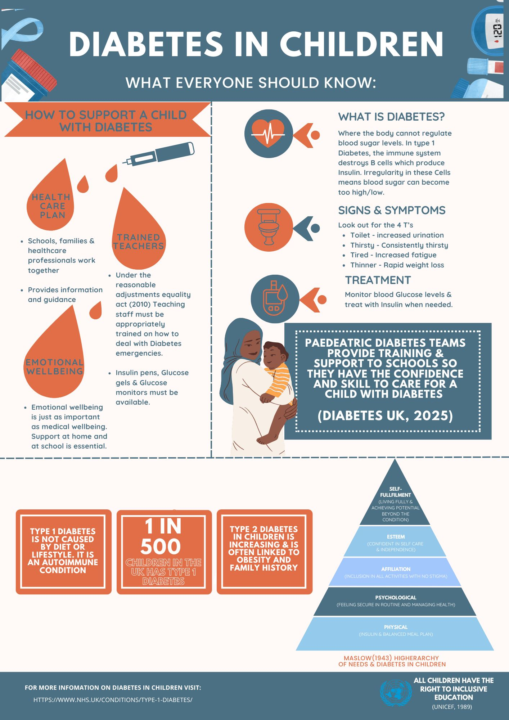
Reference list
Bates, B. (2023). Learning Theories Simplified. 3rd ed. London: SAGE.
Biious, R. (2021). Handbook of Diabetes. [online] Google Books. Available at: https://books.google.co.uk/books?hl=en&lr=&id=7RwsEAAAQBAJ&oi=fnd&pg=PR9&dq=diabetes++authour+bilous&ots=4N8m9VBB1Y&sig=DkLjpgue_AWu6yRoJ9WvgsBDo3M&redir_esc=y#v=onepage&q=diabetes%20%20authour%20bilous&f=false [Accessed 10 Sep. 2025].
Bilous, R. (2021). Handbook of Diabetes. [online] Google Books. Available at: https://books.google.co.uk/books?hl=en&lr=&id=7RwsEAAAQBAJ&oi=fnd&pg=PR9&dq=diabetes+&ots=4N8m9VzB0-&sig=4K2V_bWeTajN7H5JU8-Alz2rrhc&redir_esc=y#v=onepage&q=diabetes&f=false [Accessed 10 Sep. 2025].
Byrne, B. (2019). How inclusive is the right to inclusive education? An assessment of the UN convention on the rights of persons with disabilities’ concluding observations. International Journal of Inclusive Education, 26(3), pp.1–18. doi:https://doi.org/10.1080/13603116.2019.1651411.
Diabetes UK (2023). Diabetes UK - Know diabetes. Fight diabetes. [online] Diabetes UK. Available at: https://www.diabetes.org.uk/.
Malik, F.S. and Taplin, C.E. (2014). Insulin Therapy in Children and Adolescents with Type 1 Diabetes. Pediatric Drugs, [online] 16(2), pp.141–150. doi:https://doi.org/10.1007/s40272-014-0064-6.
Mohamed and Mohd, N. (2025). TEACHING STRATEGIES OF ABRAHAM MASLOW’S HIERARCHY OF NEEDS THEORY IN SPECIAL EDUCATION. Special Education [SE], [online] 3(1), pp.e0040–e0040. doi:https://doi.org/10.59055/se.v3i1.40.
NHS (2019). Type 1 diabetes. [online] NHS. Available at: https://www.nhs.uk/conditions/type-1-diabetes/.
Patterson, C.C., Harjutsalo, V., Rosenbauer, J., Neu, A., Cinek, O., Skrivarhaug, T., Rami-Merhar, B., Soltesz, G., Svensson, J., Parslow, R.C., Castell, C., Schoenle, E.J., Bingley, P.J., Dahlquist, G., Jarosz-Chobot, P.K., Marčiulionytė, D., Roche, E.F., Rothe, U., Bratina, N. and Ionescu-Tirgoviste, C. (2018). Trends and cyclical variation in the incidence of childhood type 1 diabetes in 26 European centres in the 25 year period 1989–2013: a multicentre prospective registration study. Diabetologia, [online] 62(3), pp.408–417. doi:https://doi.org/10.1007/s00125-018-4763-3.
Royal College of Paediatrics and Child Health (2020). Diabetes – RCPCH – State of Child Health. [online] stateofchildhealth.rcpch.ac.uk. Available at: https://stateofchildhealth.rcpch.ac.uk/evidence/long-term-conditions/diabetes/.
Singleton, S. (2015). Looking after schoolchildren with diabetes: Development of the Individual Healthcare Plan Article points. Journal of Diabetes Nursing, [online] 19(6). Available at: https://diabetesonthenet.com/wp-content/uploads/JDN-19-6-223-7.pdf.
UNICEF (2025). Inclusive Education. [online] UNICEF. Available at: https://www.unicef.org/education/inclusive-education.

Element 2
Essay - Explore the wide and complex spectrum of additional needs

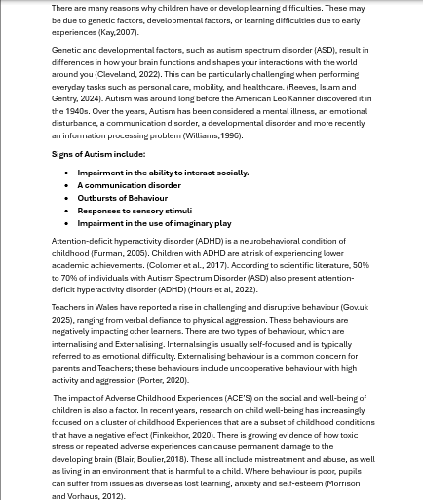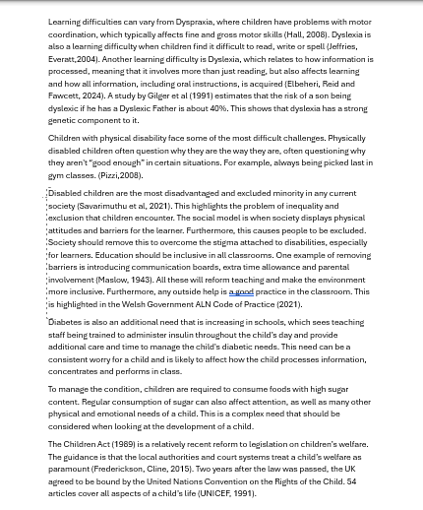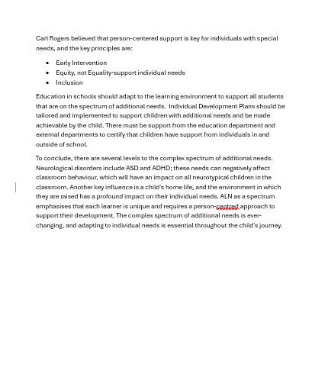

References

Boullier, M. and Blair, M. (2018). Adverse Childhood Experiences. Paediatrics and Child Health, [online] 28(3), pp.132–137. doi:https://doi.org/10.1016/j.paed.2017.12.008.
Bull, S. and Kay, J. (2007). Student Models That Invite the Learner In: the Smile Open Learner Modelling Framework Technical Report580. ResearchGate, [online] 17. Available at: https://www.researchgate.net/publication/228738851_STUDENT_MODELS_THAT_INVITE_THE_LEARNER_IN_THE_SMILI_OPEN_LEARNER_MODELLING_FRAMEWORK_TECHNICAL_REPORT_580 [Accessed 31 Oct. 2025].
Children Act (1989). Children Act 1989. [online] legislation.gov.uk. Available at: https://www.legislation.gov.uk/ukpga/1989/41/contents.
Cleveland, T.C. (2022). Center for Autism | Cleveland Clinic Children’s. [online] Cleveland Clinic. Available at: https://my.clevelandclinic.org/pediatrics/departments/autism.
Colomer, C., Berenguer, C., Roselló, B., Baixauli, I. and Miranda, A. (2017). The Impact of inattention, hyperactivity/impulsivity symptoms, and Executive Functions on Learning Behaviors of Children with ADHD. Frontiers in Psychology, [online] 8(540). doi:https://doi.org/10.3389/fpsyg.2017.00540.
Department for Education (2025). Government to Crackdown on Bad Behaviour and Boost Attendance. [online] GOV.UK. Available at: https://www.gov.uk/government/news/government-to-crackdown-on-bad-behaviour-and-boost-attendance.
Finkelhor, D. (2020). Trends in Adverse Childhood Experiences (ACEs) in the United States. Child Abuse & Neglect, 108(108). doi:https://doi.org/10.1016/j.chiabu.2020.104641.
Furman, T.M. (2015). The Deep Impact of Applied Behavior Analysis for Children with Autism Spectrum Disorder. Philosophy, Psychiatry, & Psychology, 22(4), pp.271–274. doi:https://doi.org/10.1353/ppp.2015.0043.
Gad Elbeheri, Reid, G. and Fawcett, A. (2024). Dyslexia in Many Languages. Routledge eBooks. Informa. doi:https://doi.org/10.4324/9781003408277.
Gilger, J.W., Pennington, B.F. and Defries, J.C. (1991). Risk for Reading Disability as a Function of Parental History in Three Family Studies. Reading and Writing, 3(3-4), pp.205–217. doi:https://doi.org/10.1007/bf00354958.
Gutman, L.M. and Vorhaus, J. (2012). The Impact of Pupil Behaviour and Wellbeing on Educational Outcomes. [online] dera.ioe.ac.uk. Available at: https://dera.ioe.ac.uk/id/eprint/16093/.
Hall, A. (2008). Specific Learning Difficulties. Psychiatry, 7(6), pp.260–265. doi:https://doi.org/10.1016/j.mppsy.2008.04.009.
Hours, C., Recasens, C. and Baleyte, J.-M. (2022). ASD and ADHD comorbidity: What Are We Talking about? Frontiers in Psychiatry, [online] 13(837424). doi:https://doi.org/10.3389/fpsyt.2022.837424.
Jeffries, S. and Everatt, J. (2004). Working memory: Its Role in Dyslexia and Other Specific Learning Difficulties. Dyslexia, 10(3), pp.196–214. doi:https://doi.org/10.1002/dys.278.
Lambert, N. and Frederickson, N. (2015). Inclusion for Children with Special Educational needs: How Can Psychology help? doi:https://doi.org/10.4324/9781315719962-14.
Maslow, A. (1943). A Theory of Human Motivation. [online] Psychological Review. Available at: https://psycnet.apa.org/record/1943-03751-001.
Pizzi, J. (2008). Challenges of Children with Physical Disabilities. [online] Available at: https://www.researchgate.net/publication/242600410_CHALLENGES_OF_CHILDREN_WITH_PHYSICAL_DISABILITIES.
Porter, L. (2020). Student Behaviour : Theory and Practice for Teachers. London: Routledge, Taylor & Francis Group.
Reeves, C. (2024). The Impact of School Challenges on Parental Employment among Families with Children on the Autism Spectrum. Disability & Society, pp.1–19. doi:https://doi.org/10.1080/09687599.2024.2313096.
Savarimuthu, M., Monisha, K., Innamuri, R., Tsheringla, S., Shonima, A., Mammen, P., Alwinneshe, M., Russell, S. and Kuppuraj, J. (2021). Effects of Educational Intervention (Paper B) on Attitudes towards Inclusive Education in School Teachers. Shanlax International Journal of Education, [online] 9(2), pp.141–149. Available at: https://files.eric.ed.gov/fulltext/EJ1287747.pdf.
UNICEF (1991). UN Convention on the Rights of the Child (UNCRC). [online] unicef. Available at: https://www.unicef.org.uk/what-we-do/un-convention-child-rights/.
Welsh Government (2021). The Additional Learning Needs Code for Wales 2021 WG21-23. [online] Available at: https://www.gov.wales/sites/default/files/publications/2024-04/220622-the-additional-learning-needs-code-for-wales-2021%20%282%29.pdf.
Williams, D. (1996). Autism: an inside-out Approach : an Innovative Look ... / Donna Williams. London: J. Kingsley Publ.

All About Me

Name: Child A
Dob: 23.06.19
20.10.25
Completed: Mrs Evans

What people like and admire about me.
Parent-Mum, I admire Child's imagination and her creative side. I admire her personality and how strong-willed she is when she wants something and isn't afraid to make her feelings known.

School
- I love talking about things that are important to me (Bunnies, Teddies).
- I love adult interaction
- I love playing with playdough and jigsaws
- I have a lovely smile

What is important to me
- Doing things on her terms
- Having an adult, especially during transition times
Important for
- Having a quiet space
- Giving her time to move from different areas
- Giving her time to calm down

How best to support me
Giving a Child A time to process instructions and follow accordingly.

Section 1C: Profile (About me)
What is important to the learner

- Having positive adult intervention
- I need routine
- Having a calm, quiet environment
- Lots of praise

What is important for the learner

- To have the chance to observe good role models
- To complete focused tasks during carpet time
- To work 1:1 or in small groups

What is working and should be built on

- Using a sand timer to show me how long an activity will take
- Praise and encouragement
- Having an adult to support me during transition throughout the day

What is not working and needs to change?
- Leaving Mum in the mornings and finding it difficult to regulate emotions
- Focusing and sitting when it's carpet time (leaving the carpet)
- Communicating with staff

Section 2A: Description of the child or young person’s additional learning needs (ALN)
Cognition and Learning
Child A finds it hard to focus and retain information,needing one-on-one support to complete tasks. While she can memorise some numbers and sounds,she struggles to use the information she has learned in her work.

Communication and Interaction
Child A speech is immature and often unclear,she quite often gets words mixed up and not able to speak in sentences.

Sensory and/or Physical
Child A finds the classroom environment difficult and can get distressed if there is a lot of noise.

Behaviour, Emotional and social development
Child A needs firm and consistent boundaries and can find it difficult to end a task that she likes doing. She will need lots of encouragement to help tidy up and not start playing with another activity. Child A will constantly look for adult attention and needs support to access the classroom environment appropriately. She can have poor attention and listening skills, and can get distracted quickly and finds it hard to engage in tasks.

Element 4
Discuss the potential support provided to your chosen pupil (utilising the key principles, approaches and policies that guide inclusive practice).
Based upon Section 2B IDP : Description and delivery of the child or young person’s additional learning provision (ALP)

Section 2B1: Description and delivery of the child or young person’s additional learning provision (ALP)
2B1.1) Intended outcome:  These outcomes should be SMART (Specific, Measurable, Achievable, Realistic,  Timebound). | Use a communication board
2B1.2) ALP to be provided:  This should include how often (daily, weekly); the type of support; who provides the support. The description of the Additional Learning Provision (ALP) should be very clear and precise, the above could then be split into smaller goals and targets. |  | 2B1.3) Should the ALP be provided in Welsh? | 2B1.4) Organisation/  Service to provide the ALP, (e.g. NHS, Inclusion Service, Specialist Teacher, etc.): | 2B1.5) Start date: | 2B1.6) End / Review date:
Simple cards related to Rabbits  Now and then |  | Yes / No | School | September 2025 | 8 Weeks
2B1.7) Rationale for the ALP listed above:
If there is a difference of opinion it should be recorded here e.g. a difference of opinion between the child, child’s parent or young
person and professionals. The section could explain how different opinions have been taken into consideration before a particular decision was reached.
Section 2B2: Description and delivery of the child or young person’s additional learning provision (ALP)
2B2.1) Intended outcome:  These outcomes should be SMART (Specific, Measurable, Achievable, Realistic,  Timebound). | Sit on the carpet for 2 minutes
2B2.2) ALP to be provided:  This should include how often (daily, weekly); the type of support; who provides the support. The description of the Additional Learning Provision (ALP) should be very clear and precise, the above could then be split into smaller goals and targets. |  | 2B2.3) Should the ALP be provided in Welsh? | 2B2.4) Organisation/  Service to provide the ALP, (e.g. NHS, Inclusion Service, Specialist Teacher, etc.): | 2B2.5) Start date: | 2B2.6) End / Review date:
-Mat  -Timer  -Member of Staff |  | Yes / No | School | September 2025 | 8 Weeks
2B2.7) Rationale for the ALP listed above:
If there is a difference of opinion it should be recorded here e.g. a difference of opinion between the child, child’s parent or young
person and professionals. The section could explain how different opinions have been taken into consideration before a particular decision was reached.
Section 2B3: Description and delivery of the child or young person’s additional learning provision (ALP)
2B3.1) Intended outcome:  These outcomes should be SMART (Specific, Measurable, Achievable, Realistic,  Timebound). | Regulate Emotions
2B3.2) ALP to be provided:  This should include how often (daily, weekly); the type of support; who provides the support. The description of the Additional Learning Provision (ALP) should be very clear and precise, the above could then be split into smaller goals and targets. |  | 2B3.3) Should the ALP be provided in Welsh? | 2B3.4) Organisation/  Service to provide the ALP, (e.g. NHS, Inclusion Service, Specialist Teacher, etc.): | 2B3.5) Start date: | 2B3.6) End / Review date:
-ELSA  -Colour Monster  -Worry Monster  -1:1 Support |  | Yes / No | School | September 2025 | 8 Weeks
2B3.7) Rationale for the ALP listed above:
If there is a difference of opinion it should be recorded here e.g. a difference of opinion between the child, child’s parent or young
person and professionals. The section could explain how different opinions have been taken into consideration before a particular decision was reached.
Section 2B4: Description and delivery of the child or young person’s additional learning provision (ALP)
2B4.1) Intended outcome:

These outcomes should be SMART (Specific, Measurable, Achievable, Realistic,
Timebound).
2B4.2) ALP to be provided:  This should include how often (daily, weekly); the type of support; who provides the support. The description of the Additional Learning Provision (ALP) should be very clear and precise, the above could then be split into smaller goals and targets. |  | 2B4.3) Should the ALP be provided in Welsh? | 2B4.4) Organisation/  Service to provide the ALP, (e.g. NHS, Inclusion Service, Specialist Teacher, etc.): | 2B4.5) Start date: | 2B4.6) End / Review date:
 |  | Yes / No
2B4.7) Rationale for the ALP listed above:
If there is a difference of opinion it should be recorded here e.g. a difference of opinion between the child, child’s parent or young
person and professionals. The section could explain how different opinions have been taken into consideration before a particular decision was reached.

