

Title - An investigation into the public’s opinion to the response of police forces’ in Wales and England to county lines: How do the public feel police forces in Wales and England have tackled the problem of county lines?
Student name - Jamie Davies
Student number - 1910640
Degree title - Professional Police Practice
I would like to take this time to thank my tutors at the University of Wales Trinity Saint David and my colleagues for their support throughout my three years of completing my degree as well as Dottie Davies.

Declaration
This work has not previously been accepted in substance for any degree and is not being concurrently submitted in candidature for any degree.
Signed: J Davies
Date: 13/03/2022

STATEMENT 1
This dissertation is being submitted in partial fulfilment of the requirements for the degree of BA.
Signed: J Davies
Date: 13/03/2022

STATEMENT 2
This dissertation is the result of my own independent work/investigation, except where otherwise stated.
Other sources are acknowledged by footnotes giving explicit references. A bibliography is appended.
Signed: J Davies
Date: 13/03/2022

STATEMENT 3
I hereby give consent for my dissertation, if accepted, to be available for photocopying and for interlibrary loan, and for the title and summary to be made available to outside organisations.
Signed: J Davies
Date: 13/03/2022

STATEMENT 4
I hereby give consent for my dissertation, if accepted, to be available on the university’s IT system to those who have consent to use the system.
Signed: J Davies
Date: 13/03/2022

Contents
Chapter 1 – 5
Introduction 5
Background 5
Research rationale 7
Aims and objectives 8
Structure 9
Conclusion 9
Chapter two – Literature review 10
Introduction 10
County Lines 10
Police Response to County Lines 12
Child Criminal exploitation 13
Vulnerable persons involved in county lines 14
Conclusion 15
Chapter 3 – Methodology 16
Introduction 16
The research onion 17
Research Philosophy 17
Approach 18
Strategy 18
Research strategy and choice 19
Time horizons 19
Techniques: Data collection and analysis 19
Data collection: 19
Reliability and validity: 20
Limitations: 20
Ethical considerations: 20
Conclusion 21
Chapter 4 – Data analysis and recommendations 21
Introduction 21
Data analysis 21
Demographics and Descriptive Statistics 22
Questionnaire Findings: 22
Age and gender of respondents: 22
Public’s perception on whether there is enough information available to the public regarding County Lines: 24
Public’s perception on whether they believe that County Lines is decreasing: 25
Persons who know someone affected by County Lines: 26
Public’s perception to Police Forces across England and Wales as a whole response to tackling the problem of County Lines: 27
Conclusion 29
Chapter 6 - Conclusion and Recommendations 30
Introduction 30
Main findings 30
Recommendations 31
Limitations 32
Future research 32
Conclusion 32
Bibliography 33

Figure 1 - County Lines drug supply routes. Source (Black, 2020). 6
Figure 2- Flow chart showing how county lines work. 7
Figure 3- Annotated diagram - The research Onion (Source: Saunders et al., 2015) 13
Figure 4 - A chart showing respondents gender 18
Figure 5- A graph showing the age of respondents 18
Figure 6 - A pie chart showing the number of respondents to the question and their answers 22

Chapter 1 –

Introduction
The purpose of this dissertation is to investigate the problem of County Lines and to provide an answer to the question: “An investigation into the publics opinion to the response of police forces’ in Wales and England to county lines: How do the public feel police forces in Wales and England have tackled the problem of county lines?” This chapter of the dissertation will provide the background and context for this dissertation and also explores the reasoning behind the researcher’s choice of topic and why it is so important within todays current climate.

Background
Over recent years, the rise in county lines has increased fourfold with it becoming a national issue. County lines has gone from different counties to crossing different country boarders. (Figure 1).
County lines is defined by national crime agency (NPCC) (2021), as “Gangs and organised criminal networks involved in exporting illegal drugs into one or more importing areas [within the UK], using dedicated mobile phone lines or other form of “deal line”. They are likely to exploit children and vulnerable adults to move [and store] the drugs and money and they will often use coercion, intimidation, violence (including sexual violence) and weapons.” County lines refers to the use of one single telephone number for ordering drugs which is operated from outside the area usually a city, this phone number then becomes the ‘brand’ for the gang often naming the number as something such as the ‘Billy line’. This differs to the traditional drug lines which are changed on a continuous basis to avoid law enforcement.

The National Crime Agency (NCA) circulated a request for information to police forces in England and Wales. The result revealed that 71% of police returns reported, established county lines activity, whilst a further 12% reported an emerging picture (within the last 6 months) (Black, 2020). This statistic alone shows the scale county lines has expanded. As of 2019 NCA stated that there is 1,000 county lines operating, with each line profiting over £800,000 annually (Public health England, 2021). County lines came to the attention of law enforcement in 2015 following a report completed by the National Police Chiefs Council (NPCC) (2015) found “over 180 urban drug-dealing gangs have expanded their activity into rural and coastal towns, pushing out local dealers or targeting the ‘space’ left by law enforcement action. County lines is an emerging national issue, which involves the exploitation of vulnerable young people and adults by violent gang members in order to move and sell drugs across the country.” Due to county lines being a national issue research has been under taken as to who it is effecting and how the lines are operating, research has been under taken by a number of government departments such as national crime agency and public health England. In 2020 Her Majesty’s Inspectorate of Constabulary and Fire and Rescue Services (HMICFRS) conducted a report titled ‘The police and National Crime Agency’s response to vulnerable people in ‘county lines’ drug offending’. Following the completion of this report by the HMICFRS, Her Majesty’s Inspector of Constabulary Phil Gormley stated “To tackle cross-border crime, there needs to be a cross-border response. Our inspection revealed that policing is currently too fragmented to best tackle county lines offending. Although we did see many excellent examples of collaboration, we concluded that the current approach does not allow for the level of coherence needed” (Gormley, 2020). In addition to this, individual police forces have also completed investigations into county lines but there is a clear lack of research into how the public believe police forces as a collective across England and Wales are tackling the issues of county lines and any collective results since the emergence of county lines in 2015.

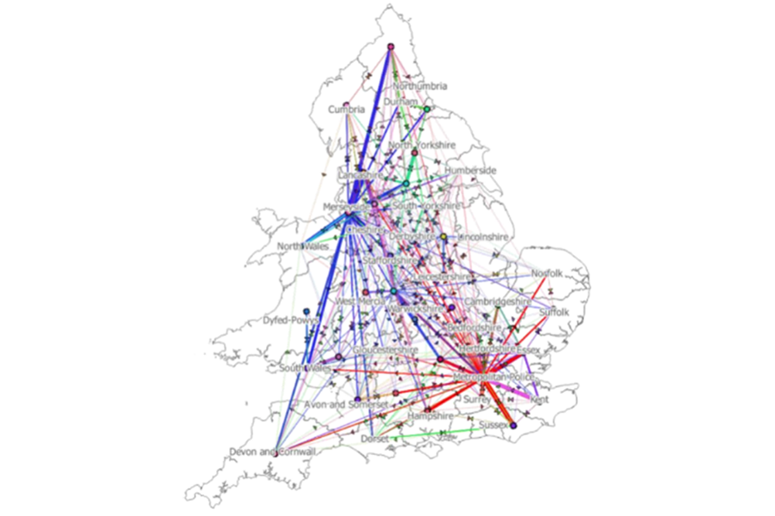

Figure 1 - County Lines drug supply routes. Source (Black, 2020).

Research rationale
The reasons for the researcher’s rationale to research this independent project is due to the ever increasing problem of County Lines. As the researcher has gone through their formative years in life, County Lines is a topic that has been ever present and has affected people of the same age as the researcher. The researcher knows people personally who has been affected by County Lines and third hand information of people who has been affected by County Lines. Furthermore County Lines is a topic that has dominated news and social media in an attempt to raise awareness of this ongoing problem which has influenced future career decisions and this project.
Although academic research as well as more elaborate professional bodies had conducted research into County Lines. As of 2015 the NPCC stated that county lines was emerging as a national issue, county lines start from large cities and towns such as London and Manchester with the NCA estimating that 283 lines originate in London (National crime agency, 2017). In addition to this, the researcher has identified a lack of research in regards to the question “An investigation into the publics opinion to the response of police forces’ in Wales and England to county lines: How do the public feel police forces in Wales and England have tackled the problem of county lines?” It is therefore the decision of this independent project to investigate this area and if possible contribute to this academic area of study, with the themes that have already been established in this chapter being further elaborator on in chapter two.
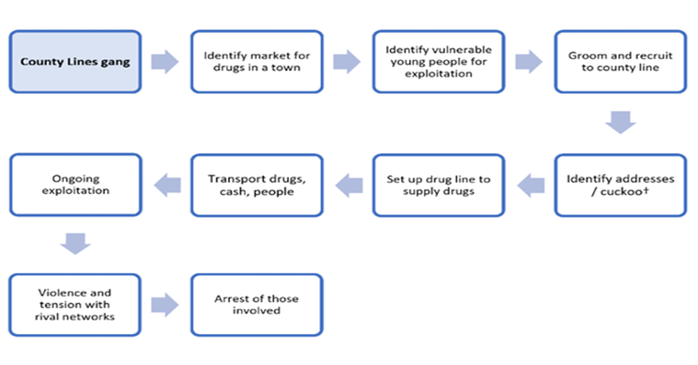
Figure 2- Flow chart showing how county lines work.
Source: (Public health England, 2021).

Aims and objectives
The researcher’s aim of this research project is: To understand the publics’ opinions to the response off Police Forces across the United Kingdom in regards to county lines. As well as: To potentially provide recommendations on how the Police Forces and the UK Government can provide a better response to tackle County Lines.
These aims will be achieved by completing the following objectives:
1) To critically research and analyse previous and current academic literature in order to obtain a greater understanding of County Lines and to establish how the Police Forces across the United Kingdom have responded to it.
2) To identify the most suitable research approach required to appropriately conduct the research project and the potentially sensitive topic of County Lines.
3) To conduct primary research in the form of questionnaires and analyse the data collected to better understand themes and the public’s opinions to UK police forces response to County Lines.
4) To provide recommendations surrounding the discovered key issues of UK police forces response to County Lines.

Structure
To ensure that each objective is successfully completed chapters will be devoted to each one. Chapter two of the project will analyse previous and current academic understanding of County Lines as well as any response from UK Police forces and whether the problem of County Lines is increasing.
Chapter three will identify the most appropriate research technique and methodology suited for the collection of primary data for this project.
Chapter four will analyse the data collected as a result of the method proposed in chapter three and then seek to identify common themes or understanding that has been drawn from the analysis.
Finally chapter five will conclude the project and achieve the final objective by addressing the implications of the research as well as providing recommendations based on the academic observations as a result of the project.

Conclusion
This first chapter has now successfully presented the background of County Lines and has outlined the core aim and objectives and the reason why the researcher has decided to explore this topic in greater detail in the form of this dissertation. The following chapter will attempt to critically analyse the academic literature available to the public that currently exist in this area.

Chapter two – Literature review

Introduction
This chapter of the dissertation seeks to provide analysis of key, relevant, authoritative and academically valued source of literature relating to the topic of county lines, police forces response to the impact of county lines and the publics opinion on the response from police forces in the UK to county lines.
This objective will be achieved by examining literature from the UWTSD e-learning online library database as well as an internet search engine called Google Scholar, this search engine allows the researcher to obtain information from academic and scholarly sources with information coming from academic journals expert and professional textbooks, research, government publications and other sources qualified to publish information regarding drug dealing, child exploitation and more specifically county lines.
Furthermore, to meet objective one of the dissertation which for reference is: “To critically research and analyse previous and current academic literature and understanding what County Lines is and how the Police Forces across the United Kingdom have responded to it”. The researcher will be conducting general research and information surrounding the drug dealing in the United Kingdom, including child exploitation and vulnerabilities of children who may be used in county lines.
The terms that were used to obtain information regarding this topic include: “county lines” “child exploitation” “drug dealing in the UK” “children vulnerabilities”.

County Lines
As defined by the National Police Chiefs Council (NPCC) (2018), “term used to describe gangs and organised criminal networks involved in exporting illegal drugs into one or more importing areas [within the UK], using dedicated mobile phone lines or other form of “deal line”. They are likely to exploit children and vulnerable adults to move [and store] the drugs and money and they will often use coercion, intimidation, violence (including sexual violence) and weapons”. Since this definition by the NPCC County Lines has become an important topic in policing and a large amount of research has been conducted around it by a number of academic scholars.
One example of research surrounding county lines is “The Changing Shape of Street-Level Heroin and Crack Supply in England: Commuting, Holidaying and Cuckooing Drug Dealers across ‘County Lines’” an article submitted by (Coomber and Moyle, 2017). The research conducted finds “Though data suggests that the tendrils of county lines are far more firmly rooted in markets characterized by closer proximity and ease of access (e.g. Swindon and Southend), county lines activity is still nonetheless beginning to seep into more distant drug markets”. (Coomber and Moyle, 2017).
This research is supported by (J Spicer, 2021) which states that “As a practice explicitly allied with ‘County Lines’, where drug dealers from urban hubs set up retail networks within provincial towns, it overlaps with concerns about recent drug markets evolutions, the apparent connection to serious violence and the wider association of crime and disorder with heroin and crack cocaine”. (J Spicer, 2021) which further goes onto state that research shows that “It is likely practically impossible to establish any accurate measure of the ‘real’ level of the cuckooing problem. It is also highly unlikely that police officers are capable of preventing it from occurring. Rather than relying on policing activities that might actually make the situation worse, to attenuate the real harms that people experience from exposure to the drug market, looking deeper at the structures that make them ‘vulnerable’ should be at the forefront of considering what truly effective responses to cuckooing might be”. This demonstrates the severity of the level of control individuals and gangs can place over the vulnerable and the concern over policing key elements of county lines.
Research conducted by (Robinson et al., 2018) states that “Beyond “street capital” or status rewards, criminally exploited youth allegedly receive tangible rewards for working County Lines, such as money, alcohol, drugs, and accommodation”. In addition to this, “Studies undertaken to date reveal young people become entrapped into working, with little remuneration, and the use of debt bondage to retain control” (Robinson et al., 2018). Further (Robinson et al., 2019) states there exists little knowledge about its operation outside of London and the English South Coast. Furthermore, we know little about who the actors in this world are, especially those who do not fit neatly into either victim or perpetrator categories, such as the drug runners who take part in out-of-town drug dealing through their own volition. This research outlines the reality of county lines and identifies how individuals can be coerced into working as part of the county lines and contributing to the wide scale criminal activity.
Bonning and Cleaver (2020) further supports the theory that county lines is well established throughout the United Kingdom “Although a relatively recent phenomenon the term ‘county lines’ is now firmly established within police and public vernacular, with a growing understanding of how county line drug networks operate emerging through nationally collated police data, with over 2,000 individual deal line numbers across the UK, linked to approximately 1,000 branded county lines identified”

Police Response to County Lines
There is little information published currently on Police forces across the United Kingdom’s response to county lines. Blakeburn and Smith (2020) published a Journal titled ‘Exploring the role of the British Transport Police in responding to ‘County Lines’ drug markets: Enforcement and safeguarding perspectives’. Blakeburn and Smith (2020) states that “This research has revealed that successful interventions are being made by members of staff on the railways, disrupting the activities of those involved in county lines and ensuring support is provided to those young people who are being coerced into becoming involved in these drug markets. This is an encouraging perspective and demonstrates that the work of the British Transport Police (BTP), to involve partner organisations in this activity, is yielding positive results.
(Olver and Cockbain, 2021), have released a paper regarding professionals view on responding to county lines. Their findings were taken from “six policing professionals from the West Midlands Police, West Midlands Regional Organised Crime Unit (ROCU), and the local division of British Transport Police. Their ranks ranged from Police Constable to Detective Chief Inspector”. They found the following from the study “All participants characterised disjointed information and intelligence-sharing–between and within organisations, locally, regionally, and nationally–as a key barrier to tackling county lines criminal exploitation. Although everyone mentioned the value of good information-sharing, police participants particularly stressed it. They stated that intelligence is not always entered in to both force databases and the centralised Police National Database (PND), leading some intelligence to ‘fall through the cracks’ (Olver and Cockbain, 2021). This shows that Police across the United Kingdom clearly feel their struggling to response adequately to county lines. This further backed up by (Olver and Cockbain, 2021) who stated that “Many challenges participants reported in responding to county lines have been comparatively well-documented for CSE, e.g. barriers around insufficient understanding, disjointed information-sharing and supporting individuals who may not self-identify as victims or want help from services”. However they did feel that their research was limited due to “Exploratory and focused on a modest sample of professionals largely from the criminal justice sector and one specific location, and as such should not be overextended” (Olver and Cockbain, 2021).

Child Criminal exploitation
Child Criminal Exploitation is used throughout in county lines for a number of different reasons and is key to the success of county lines all which have been identified by a number of different persons who have submitted academic papers.
(Robinson et al., 2018) state that “Child Criminal Exploitation (CCE) is strongly associated with County Lines because to mitigate risk to themselves, criminal gangs use children as young as 12 as runners to transport and distribute drugs using dedicated mobile phone “lines”.
“One unique aspect of County Lines is the use of a branded mobile phone “line” established in the market, to which drugs orders are placed by introduced customers. The line is commonly (but not exclusively) controlled by a third-party remote from the market, such an “elder” gang member, who, in turn, supervises his or her own “downline” of direct-sales people” (Robinson et al., 2018).
For police forces to disrupt county lines it is clear that they must focus on child exploitation which is driving county lines. (Brewster et al., 2021) states that “County lines is also increasingly a concern for child welfare agencies, as reports suggest children aged as young as seven are being used as ‘runners’ to move and sell drugs in areas far away from their homes”. County line gangs rely on young children who are easy to exploit and intimidate to run the drugs across the country. (Brewster et al., 2021) continues to state that “The participation of children and young people is often facilitated through the offer of money, luxury consumer items, clothes, drugs and accommodation. Debt bondage may be used to maintain control of victims, in which drug debts are used to manipulate and coerce young people to participate in county line operations”. (Windle, et al., 2020) state that “County line dealers seek to exploit children because they “represent a cheap, easily recruited workforce”.
The theory that county lines require the exploitation of children is also supported by (Robinson et al., 2018) who states that “Most young people in the Merseyside study owed something to a drug dealer. Debt, they argued, represented a specific realm of risk for any drug dealer. It was a causal factor in violence, with some respondents describing episodes of drug debt–related kidnapping, sexual violence, and torture. But because dealers utilised debt as a form of coerced recruitment into the trade (i.e., those who had accrued small debts were asked to sell drugs to pay them off, it was also an essential part of what made working the county lines appealing”

Vulnerable persons involved in county lines
County lines not only relies on child criminal exploitation but further relies on vulnerable in ‘cuckooing’. (Coomber and Moyle, 2018) state that ‘Cuckooing’ (named after the ‘parasitic’ nest stealing practices of wild cuckoos) describes the situation where a county lines dealer ‘takes over’ accommodation located in the provincial drugs market, using it as a local dealing base”. It is further stated by (Coomber and Moyle, 2018) “Although there are accounts of cooperation and ‘mutually beneficial relationships’ between dealers and residents (Moyle, forthcoming), this living arrangement has led many individuals to describe experiences of physical violence, intimidation, mental abuse and exploitation”.
Vulnerable persons are often cuckooed by the persons running the ‘lines’ these people are vulnerable for a number of different reasons whether it being addicted to drug or learning needs. (Moyle, 2019) referring to a female who went to buy heroin from a home run by county line members states that “In this situation, the young woman was said to be “begging, basically . . . begging for the [crack] pipe.” Additional instances of sexual coercion through blocking access to drugs were reported by four more women who became cuckooed in both Swindon and Salisbury. In these cases, in the face of the threat of and/or denial of drugs, due to their material circumstances, these women felt they had no alternative but to engage in sexual exchange as a means of paying off drug debts or “earning” more heroin or crack”
(Spicer et al., 2019) further support the theory that county line members target vulnerable persons by stating “Highlighting the way cuckooed victims are often seemingly specifically targeted, the county Lines dealers will specifically pursue ‘vulnerable individuals who attend recovery groups, dependency units, and areas associated with those experiencing problems’. Once cuckooed, victims effectively become imprisoned in their own homes.” (Spicer et al., 2019) further state that “Those affected by this form of cuckooing were often ‘classically’ vulnerable through characteristics such as mental illness, disability or old age. For example, one case involved a young runner befriending a retired man with mental health issues in a local coffee shop. Once access to his home was obtained it was swiftly taken over and used to house drugs, a sawn off shotgun and other runners. Another involved County Line dealers using a female accomplice to pose as a mother in desperate circumstances. Once a local resident became lured in by her, she proceeded to enable the dealers to take over the home”.
This research shows that county line members are targeting vulnerable person but no research shows how police have responded to the cuckooing.

Conclusion
To conclude it is clear that over the last 2 years there has been a large amount of academic research published regarding county lines and child exploitation which effectively allows county lines to thrive. Academics such as (Robinson et al., 2018) have published papers such as ‘Working County Lines: Child Criminal Exploitation and Illicit Drug Dealing in Glasgow and Merseyside’ which comments on how county lines are currently thriving across the United Kingdom but also refers to how these gangs are targeting and exploiting vulnerable children in a number of different ways, using gifts to entice them or drug debt to control them.
There has been a limited amount of research submitted regarding police forces across the United Kingdom and their response to county lines. Academics such as (Blakeburn and Smith, 2020) and (Olver and Cockbain, 2021) have submitted papers in regards to police forces responses to county lines. (Blakeburn and Smith, 2020) have focussed on one force being British Transport Police (BTP) who are nationwide and their disturbing these gangs on trains whilst further providing support to the young persons involved. (Olver and Cockbain, 2021) have released a paper of 6 professional police officers and their opinion as to the response of the police to the problem of county lines. Their findings from these police officers are that they are struggling to manage the problem of county lines nationwide and do not have adequate support or resources.
So despite there being a large amount of research published recently there still remains a gap in academic research into the public’s opinions of how police forces across the United Kingdom have responded to county lines.
This chapter has successfully completed objective one of the project. The next chapter of this dissertation will seek to identify the methodology that will be the most appropriate and suitable to conduct primary research surrounding observed gaps and witnessed within the literature review.

Chapter 3 – Methodology

Introduction
“Research is the process of inquiry and investigation in a systematic and methodical manner and increases knowledge” (Hussey and Collis, 2014). Academic research is vital in improving awareness, information and knowledge in subjects. “The general purpose of academic research is to investigate a research questions with a view to generating knowledge” (Hussey and Collis, 2014). Bell et al., 2019 further states that “Research has eight distinct characteristics:
1. Research originates with a question or a problem
2. The research goal must be clearly articulated
3. Research follows a specific format
4. Research usually divides the principal problem into more manageable sub-problems
5. Research is guided by the specific research problem, question or hypothesis
6. Research accepts certain critical assumptions and limitations
7. Research requires the collection and interpretation of data
8. Research is, by its nature”
There are two types of research primary research and secondary research. Bouchrika, 2021 defines them as “Primary research refers to research that has involved the collection of original data specific to a particular research project. When doing primary research, the researcher gathers information first-hand rather than relying on available information in databases and other publications. Secondary research involves the summary or synthesis of data and literature that has been organized and published by others. When doing secondary research, researchers use and analyse data from primary research sources”.
This chapter of the dissertation will attempt to answer objective two of the dissertation project which for reference is: “To identify the most suitable research approach required to appropriately conduct the research project and the potentially sensitive topic of County Lines”.

The research onion
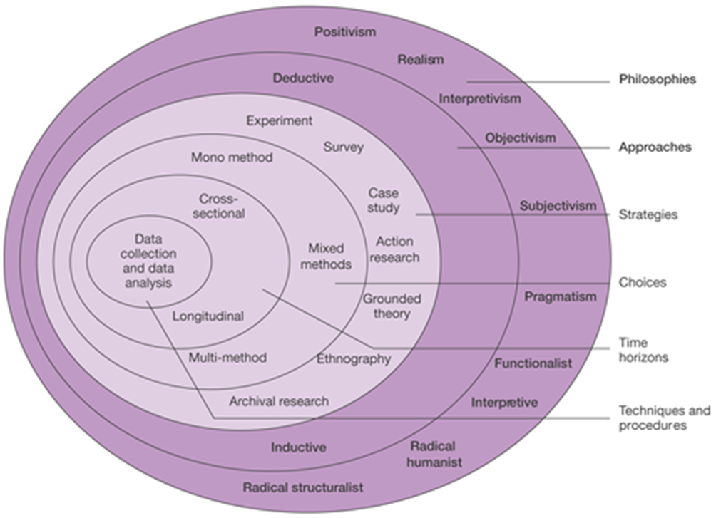
One of the most used research methods used in the collection of data and in academic writing is “The research onion” created by Saunders et al., (2015).

Figure 3- Annotated diagram - The research Onion (Source: Saunders et al., 2015)
The diagram shown shows the ‘research onion’ and the process that will be used for this dissertation with each of the layers on the ‘onion’ showing a specific research technique.

Research Philosophy
The research onion works from the outside in, the first layer of the onion is the ‘Research Philosophies’. “Research philosophy deals with the source, nature and development of knowledge. In simple terms, a research philosophy is belief about the ways in which data about a phenomenon should be collected, analysed and used” (Dudovskiy, 2018).
The subject that I have chosen to research will use the interpretive philosophy, the reason behind this decision is because a different range of answers could come from this research these answers could be subjective and the research requires the opinions of the general public and their views on how police have tackled the problem of county lines across the United Kingdom. Interpretive approach uses a naturalistic approach and the data is collected from such things as interviews, observations and questioners (Dudovskiy, 2018). I will handing out questionnaires which will be provided to members of the public for their perception of county lines and police forces response.

Approach
As shown in the ‘research onion’ there are two different research approaches available. (Streefkerk, 2019) states “The main difference between inductive and deductive reasoning is that inductive reasoning aims at developing a theory while deductive reasoning aims at testing an existing theory. Inductive reasoning moves from specific observations to broad generalizations, and deductive reasoning the other way around”. Due to this statement by Streefkerk an ‘inductive’ approach will be used for this research project.

Strategy
(Ibezimako, 2019) states “The Survey strategy is mostly used to observe contributing variables among different data. It permits the collection of vast data that will be used to answer the research question” I will create questionnaires and will be shared via the word publishing document and this will be posted on social media sites, this will allow me to gather a wide range of responses from a number of different members of the public ranging in ages. Questionnaires are a research tool that consist of a number of questions for the purpose of gathering information from different respondents. Questionnaires can be carried out face to face, by telephone computer or post they are relatively cheap can be a quick and efficient way of obtaining large amounts of information. (McLeod, 2018).

Research strategy and choice
As showing in Saunders ‘research onion’ there are there different choices of methods available when conducting research, Mono method, multi method and mixed methods. The method I will be using is mixed methods research (MMR), the mixed methods uses both quantitative and qualitative data. I will be using qualitative data in the form of research that has already been published in journals, governmental documents and research papers conducted by credited researchers, authors and government publicists. These are persons who have conducted research in the topic of county lines and the background of it and any prevention that has already been completed.
I will also be collecting quantitative data, this will be in the form of ‘questionnaires’, these questionnaires will be dispatched across ‘social media’ to members of the public. By using social media to dispatch this questionnaire it will allow me to reach a larger audience in the form of age, location across the United Kingdom gender and sexuality meaning I will get a large sample of different members of the British public.

Time horizons
The final section of Saunders ‘research onion’ is the time horizon, this part of the research onion provides the amount of time that I will allow myself to gather the research (Saunders et al., 2015). Due to my study only taking place over a short period of time, I will be using ‘cross-sectional’ time horizon, this will allow me to collect data and study it over a period of time (Melnikovas, 2018). This method also allows further research to be conducted on this topic should it be required.

Techniques: Data collection and analysis

Data collection:
The findings that I received from the primary data that I collected through questionnaires distributed on social media were inputted in to a software called ‘Microsoft excel’. The results were then displayed in graph form showing the amount of respondents who choose each answer on the survey.

Reliability and validity:
(Dudovsky, 2018) defines reliability and validity as “Reliability refers to the extent to which the same answers can be obtained using the same instruments more than one time. Validity of research can be explained as an extent at which requirements of scientific research method have been followed during the process of generating research findings”. There are different ways of validating data, Dudovsky, (2018) states that content validity, criterion-related validity, construct validity, internal validity, external validity, concurrent validity and face validity are all ways of validating data.

Limitations:
There has been limited limitations when conducting this research, however one was reaching a wide age of participants in answering the surveys. Due to social media being limited in the amount of persons it can reach because social media is a way of linking with people from around the word but you must have some sort of connection or know these people in some form for them to be on your social media, resulting in most participants being around the same age category.

Ethical considerations:
A project such as this that is studying county lines it is a sensitive topic due to the age and the vulnerabilities of the persons being used in county lines and a number of persons may be affected by county lines and the details of how county lines happen such as the use of exploiting young persons, violence and illegal drugs involved. Before starting this project a thorough ethics form was submitted to the University detailing each bit of the project, what I would be studying and how I would collecting the research, to ensure that the project was appropriate and approved by the University. Before any participants completed the questionnaires they were all made aware that they were not obligated to take complete the questionnaire, they were also made aware of how all answers they provided in the questionnaire would be used. The questionnaires do not require for participants to enter their personal details such as name, date of birth or addresses, it will ask however who the police force of their area is and their age category. Due to there being no personal details requested from participants there is no need for any of the information in the questionnaires to be kept confidential.

Conclusion
To conclude this chapter has successfully identified the methodology most suitable for this dissertation project and allowed me to answer objective two of the project. The next chapter of this dissertation will present and analyse the data that was collected from the questionnaires that were completed by participants.

Chapter 4 – Data analysis and recommendations

Introduction
The previous chapter of this dissertation reviewed the methodology used for the research project using the model created by Saunders, et al. (2015). This chapter of the dissertation will analyse and present the findings of the project that were collected from the primary research being an online survey. An online survey was created on ‘Survey Monkey’ the survey consisted of 10 questions and collected 16 respondents enabling the capture of the public’s opinion to Police Forces response to County Lines across the United Kingdom. In this chapter I will answer objective three of the dissertation project which for reference is: “To conduct primary research in the form of questionnaires and analyse the data collected to better understand themes and the public’s opinions to UK police forces response to County Lines”.

Data analysis
Data analysis requires the collecting and transforming of collected data in order to review and find patterns, where it is supportive to provide visual representations of findings for ease of comparison (Bryman and Hardy, 2009).
The questionnaire consisted of ten questions and was answered by eighteen different respondents using the online survey system, ‘survey monkey’. The surveys consisted of persons of different ages and gender. The aim of the survey was an attempt to understand the public’s opinions to UK Police Forces response to county lines. The data was analysed through Survey Monkey and the results placed into a graph using Microsoft Office Word to exhibit the respondent’s results. The data being collected and analysed through Survey Monkey provided a number of advantages for data analysis. It allowed respondents to provide a faster response time to the survey by the ease of its use. The tool made it easy to format and understand the data collected. It also allowed for easy sharing of the survey to participants via their social media accounts. Systematic data analysis tools such as Chi Square was not used due the difficulty of interpretation and the requirement for high respondent numbers.

Demographics and Descriptive Statistics
Participants in the surveys were categorised by their gender this was to investigate whether there are any significant differences in respondent’s views by gender. The survey was answered by eighteen respondents with eleven being male and seven being female, they were all over the age of eighteen. The survey was shared on social media platforms such as Facebook, Twitter and Whatsapp. It is vital that results of this research is presented, understandable, reliable and valid (Doig and Groves, 2006). The question regarding the respondent’s gender was included as it was interesting to see if gender has an impact on the effectiveness of the questionnaire provided to the public. Research conducted previously by Saleh and Bista (2017) found that women are more likely to participate within a questionnaire from the first time they see it, compared to men who are more likely to respond to a survey when being reminded. This is significant to my research due to the fact that my surveys could be answered by a higher majority of females affecting the overall results of my research.

Questionnaire Findings:

Age and gender of respondents:
When analysing the responses the majority of the respondents were over the age of 50 with 44% (8) of respondents being over 50. 6% (1) of respondents were aged between 31 and 35, 39% (7) being between the age of 25 and 30 and 11% (2) being between 18 and 24. The results provide a broad range of respondents from different ages, with the largest number of the respondents being over the age of 50. As previously stated above of the 18 respondents 61% (11) were male and 39% (7) being female which provides a fairly even response from males and females to this survey. An article produced by the Local Government Association, 2021 described that despite County Lines previously being predominantly male it now becoming more common for females to be affected. It is believed that females are less of a target of suspicion than males and they are increasingly being asked to carry drugs and weapons because they are less likely to be discovered by public services such as police. Further these females are then subject to violence, intimidation, grooming and young women have been raped and passed around dealers as “gift girls”. Due to the fact that both male and female are equally targeted by county lines gangs by having an even amount of male and female respondents is providing the best information for the project.

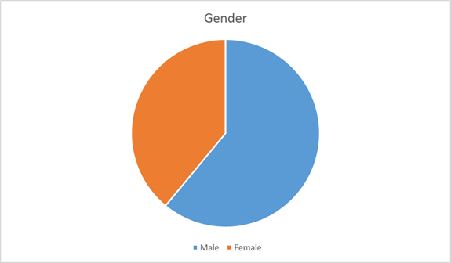

Figure 4 - A chart showing respondents gender

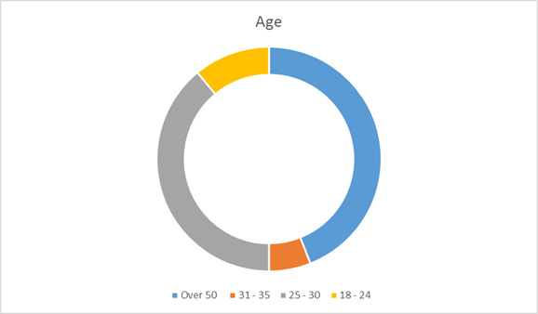

Figure 5- A graph showing the age of respondents

Public’s perception on whether there is enough information available to the public regarding County Lines:
The respondents were asked whether they were aware of County Lines 95% of respondents stated that they knew what County Lines were with 5% of respondents stating that they did not know what County Lines were. With only one respondent stating that they did not know what County Lines were it shows how large County Lines have become since the definition was developed. This result is expected, as stated County Lines has become a nationwide problem across the United Kingdom since 2014, with a large amount of multi-agency focus being placed on County Lines by actively targeting County Line gangs and education through police forces and schools and other agencies. The respondents were then asked do they believe that their police force has created enough public information regarding county lines. 28% of respondents believe that there was enough public information available, 50% believed there was not enough information and 22% were unsure if they thought there was enough information available regarding county lines. This is possible to be affected by location and the age of the respondents. The participants in this survey are represented by South Wales Police and Gwent Police both Welsh forces that do not represent any major cities other than Cardiff and Newport. Due to this County Lines as figure 1 shows the majority of lines are being run from large English cities to English towns, a smaller amount of lines are being run to Wales with the majority coming from cities such as Liverpool to North Wales whose force was not represented in the surveys answered by the respondents. Due to this it could be seen that even though County Lines is a national issue as stated by NPCC, South Wales Police as a police service do not see County Lines as a priority as they currently prioritise other violent crimes such as knife crime. This would mean that as a Police Force South Wales Police could be producing less public information regarding County Lines than a Police Force such as Merseyside due to County Lines being a larger problem in Merseyside Police Force area.
The second part that could possibly affect these results is the age of the respondents, with 44% of respondents being over the age of 50 and only 11% being aged between 18 and 24. Social media is now used by all Police Forces across Wales and England and is an appropriate way of providing information regarding topics such as County Lines. Beasley, (2021) states that “64% of all adults aged 45-54 and 51% aged 55-64 compared to 99% of 16-24 year olds area active on social media”. This shows that people over 50 are not as active on social media, this could lead to them believing that there is not enough public information being produced by Police Forces because they do not have access to the information available on social media. Further the persons who tend to be affected and targeted by County Lines are of the younger demographic therefor the information published by Police Forces could be targeted at them which would be distributed through channels such as schools, colleges and youth clubs this would mean that the majority of respondents in this project would not have seem the information that is distributed through the social media channels that Police services use.

Public’s perception on whether they believe that County Lines is decreasing:
The respondents were asked whether they believe that County Lines is decreasing, 11% of respondents answered yes that they believed County Lines was decreasing. 89% of respondents answered they survey with no they did not believe County Lines was decreasing. This data matches the data identified in the literature review that County Lines is not decreasing, as stated by Olver and Cockbain, (2021) in their article titled Professionals' Views on Responding to County Lines‐Related Criminal Exploitation in the West Midlands, UK. Child Abuse Review. However no amount of research can provide a real number of the persons involved in County Lines and whether County Lines is truly decreasing. The number of persons involved in County Lines depends on whether they are identified and classified as a person involved in County Lines and whether the children, young persons and vulnerable people involved will openly admit to what they are doing and that they are being exploited by criminals involved in County Lines.

Persons who know someone affected by County Lines:
When analysing the answers provided by the respondents, 33.3% of respondents answered that they knew a person affected by County Lines, with 66.7% of respondents answered that they did not know anyone affected by County Lines. This may not be a true and accurate picture due to the fact that people involved in County Lines may not disclose their activities to other people so the respondents to the survey may not have a true and accurate picture of what they perceive. This does not fit with the theme that County Lines is a growing issue where a growing number of persons are involved in County Lines due to more than 66% of respondents responding stating that they do not know someone affected by County Lines. As stated above with over 44% of respondents being over 50 years old this makes the result of only 33% of respondents knowing someone involved in County Lines more understandable due to County Lines being something that affects people of a younger age and the people over the age of 50 may not understand this growing issue. County Line gangs target youths and vulnerable persons, with the respondents over the age of 50 it is unlikely they would know a person involved in County Lines unless it was their child a friends family member or a vulnerable person or youth they know in a professional relationship such as a student they teach. If there was a larger respondents in the age category 18-25 it potentially be expected that there would be a larger amount of respondents who stated that they knew a person involved in County Lines.
The idea of the survey was to get a wide range of responses from across the United Kingdom so respondents reside in different Police Force areas. However due to the small amount of respondents the respondents were only from two different Police Forces being South Wales Police and Gwent Police. 95% of respondents reside in South Wales Police’s area and 5% of respondents residing in Gwent Polices area. The result of only 33% persons knowing someone affected by County Lines is expected after seeing the police forces in the respondents areas which were all Welsh police forces meaning that all the respondents reside in Wales. As per figure 1 the majority of County Lines start in large cities in England, cities such as Liverpool, London, and Manchester. If the there was a larger number of respondents from the police forces for these cities such as the Met Police, Greater Manchester Police or Merseyside Police the results for the question ‘Knowing someone affected by County Lines’ would have been expected to be much larger due to a large number of persons from these areas being affected by County Lines compared to people who live within the Rhondda Valleys.

Public’s perception to Police Forces across England and Wales as a whole response to tackling the problem of County Lines:
The respondents were then asked do they believe that their police force has created enough public information regarding county lines. 28% of respondents believe that there was enough public information available, 50% believed there was not enough information and 22% were unsure if they thought there was enough information available regarding county lines. This result from the responses collates with the second question where 33% of respondents believe that their local Police Force are tackling the problem of County Lines, 22% of respondents believe that their local Police Force are not tackling the problem of County Lines with 44% of respondents were unsure. If the respondents do not believe that there is enough public information regarding County Lines then they will not be sure if their local police force is tackling the problem out County Lines which as stated above just under 50% of respondents stated they were unsure.
When asked the same question regarding Police Forces across Wales and England after analysing the data 22% of respondents believe that Police Forces across Wales and England are doing enough when tackling the problem of County Lines with 44% believe that they are not doing enough. 33% of the respondents were unsure whether they believed that Police Forces across the United Kingdom were doing enough to tackle the problem of County Lines. This data again aligns with what is expected when 50% of respondents stated that they did not believe there was enough information being published regarding County Lines, there is not enough information being published for the respondents to understand what police forces across Wales and England are doing to target the problem of County Lines.
These results will be affected also by the lack of police forces represented in the survey respondents, the answer to ‘Public’s perception to Police forces in Wales and England Police Forces as a whole response to tackling the problem of County Lines’ will not be a true representative of police forces across Wales and England due to only two police forces being represented by respondents. If police forces such as the Met Police in London or Greater Manchester Police were represented by respondents it is possible that there would be a different result due to County Lines being a bigger problem in those areas due to this being where the lines start. The respondents were asked whether they believe that County Lines is decreasing, 11% of respondents answered yes that they believed County Lines was decreasing. 89% of respondents answered they survey with no they did not believe County Lines was decreasing.
This data matches the data identified in the literature review that County Lines is not decreasing, however no amount of research can provide a real number of the persons involved in County Lines and whether County Lines is truly decreasing. The number of persons involved in County Lines depends on whether they are identified and classified as a person involved in County Lines and whether the children, young persons and vulnerable people involved will openly admit to what they are doing and that they are being exploited by criminals involved in County Lines. Analysing the data 72% of respondents believe that the problem of County Lines is increasing, with 29% of respondents unsure whether the problem of County Lines is increasing or decreasing. 0% of respondents answered that they believe the problem of County Lines is decreasing. This fits in with the literature that has been produced in the fact that County Lines is a problem that is not decreasing and that Lines continue to grow spreading across Wales and England with new Lines appearing near weekly. These figures again link back to the police forces represented by the respondents. If there was respondents from larger city police forces such as Liverpool and London the results of this question could possibly be result in respondents stating that they believe police forces are doing enough to tackle the problem of County Lines as this is where the lines start and people residing in these areas can see the affect police have on tackling the source of the problem.
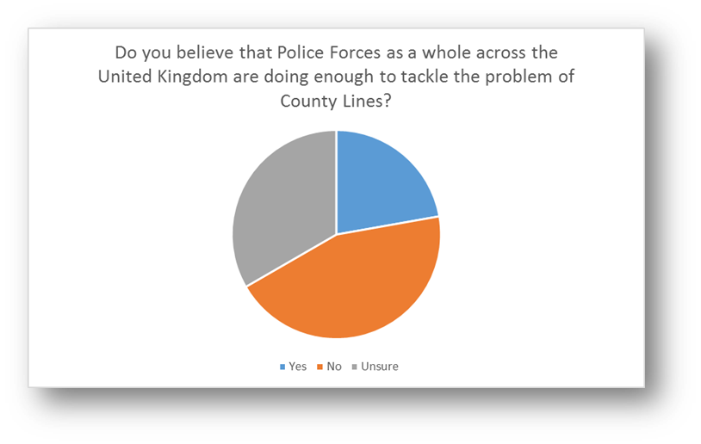

Figure 6 - A pie chart showing the number of respondents to the question and their answers

Conclusion
In conclusion the study identified the majority of my respondents above the age of 18 are aware of County Lines in the United Kingdom. The public’s perception is that there is not enough public information being produced regarding the issue of County Lines, furthermore the public do not believe that County Lines is decreasing. Approximately 33% of the general public will know someone affected by County Lines. The majority of the public are unsure whether they’re local Police Force are tackling the problem of County Lines but the majority of public do not believe that Police Forces across Wales and England are doing enough to tackle the problem of County Lines. Furthermore the results show that the majority of the public believe that the problem of County Lines is increasing. The publics opinions aligns with the literature review that the problem of County Lines across the United Kingdom is a growing issue which shows that Police Forces are struggling to control the ever growing issue of County Lines.
This chapter has successfully completed objective three of the dissertation project. Analysed the data and discovered the general public’s views on County Lines and Police Forces both locally and across Wales and England response to County Lines.

Chapter 6 - Conclusion and Recommendations

Introduction
The previous chapters of this dissertation has guided this research project through the introduction, research, planning and analysis phases of the research project. The most recent chapter of this project presents the analysis and findings of the primary data that has been collected through the qualitative surveys that were answered by a variety of members of the public. The previous project chapters have achieved the objectives I set out to complete and this final chapter will seek to achieve the final objective of this dissertation.
This chapter will provide a conclusion to answer the research question of “How do the public feel police forces in Wales and England have tackled the problem of county lines?”, as well as bringing attention to the highlight of both the limitations of this project but also the potential opportunities for future academic research surrounding this area.
This final chapter of the dissertation will week to answer objective four of the dissertation project which for reference is: “To provide recommendations surrounding the discovered key issues of UK police forces response to County Lines”

Main findings
As stated in chapter four the findings that that were found in the primary data from the surveys, support the established understandings that were highlighted in the literature analysed in chapter two.
The data shows that 95% of the respondents are aware of what county lines are, showing the amount of importance that the government have been placed on highlighting the problem of county lines this is consistent from the literature analysed. It appears that the problem of county lines is not decreasing and continuing to increase despite the amount of importance government is placing on it, this falls in line with the literature review as cited by Olver and Cockbain, (2021) ) in their article titled Professionals' Views on Responding to County Lines‐Related Criminal Exploitation in the West Midlands, UK and with the opinions of the survey respondents with 89% of respondents stating they believed the problem of County Lines was increasing. The data then continues to show that approximately one third of the public know someone affected by county lines. This would appear to align with the national average but is dependent on the respondent’s geographical location, with the majority of persons being recruited for county lines being from major cities such as London, Liverpool and Manchester as shown in figure 1.
The findings show that the public believe that Police Forces are not doing enough to tackle the problem of County Lines, this is both locally and nationally. This again falls in line with the literature review, J Spicer, (2021) states “It is likely practically impossible to establish any accurate measure of the ‘real’ level of the cuckooing problem. It is also highly unlikely that police officers are capable of preventing it from occurring. Rather than relying on policing activities that might actually make the situation worse, to attenuate the real harms that people experience from exposure to the drug market, looking deeper at the structures that make them ‘vulnerable’ should be at the forefront of considering what truly effective responses to cuckooing might be”. It shows that Police Forces are un-capable of preventing it occurring which will lead to the public believing that Police Forces are not doing enough.

Recommendations
The following recommendations are made on the perspective that I have drawn from the various findings and discoveries that I made whilst conducting the research project and the primary research gathered from a number of surveys answered by the general public.
Firstly, the UK government and Police Forces across the England and Wales as a whole need to do more to tackle the problem of County Lines. Throughout the literature was reviewed experts have concluded that the problem of County Lines is continue to grow in across England and Wales.
Secondly County Lines is a national problem, from the respondents in the surveys not all respondents are aware of what County Lines is. This clearly shows that not enough is being doing to promote the problem of County Lines and make the public aware of what County Lines is. This is backed up from the respondents further where 50% of respondents believed that there was not enough public information being released by Police Forces. Police Forces should use partner agencies such as schools and youth clubs to promote the signs of County Lines and spread awareness and education to the young people being affected by County Lines.
Furthermore UK Police Forces and the UK Government need to submit accurate figures in regards to County Lines and as to whether the problem out County Lines is increasing or de-creasing. In a survey completed by the NCA in 2017 out of 43 police forces across the UK 38 forces reported that there was evidence of county lines activity in their police force area. As of 2019 NCA stated that there is 1,000 county lines operating, with each line profiting over £800,000 annually (Public health England, 2021). This matches the results from the survey where 89% of respondents believed that County Lines was increasing.

Limitations
The biggest limitation of this project is the size of it, due to this project being an undergraduate there were a number of different ways this project could have progressed further but the word count of 10,000 words would not allow this.
Additional limitations to this project was the sample size of the collected primary data and the sensitivity of the data. The sample size was small and mainly from the same geographical area due to this project being completed in the middle of the global pandemic covid-19 the researcher was unable to hand out surveys in person, to homes or to persons residing in police forces outside of South Wales. So unless the respondents saw the surveys that were distributed via social media they would not be able to answer it. Further the topic of County Lines is fairly new, with the term ‘County Lines’ first being used in 2017. This means that there is a smaller amount of research that has been conducted and published by recognised researchers on this topic.

Future research
Due to the time restraints and completing this project whilst serving as a full time Police Officer only a small amount of this topic was able to be researched. County Lines is a UK wide issues and persons involved in County Lines are forever changing their tactics not to be caught meaning that the potential research that is available on this topic for future research is massive, should other researchers wish to do a study on this area.
A researcher could target specific police forces individually which will allow them to get a greater understanding of how County Lines is specifically affecting that Police Force giving a more accurate figure. Further a wider range of respondents from different Police Forces would provide a better understanding of how County Lines is affecting Police Forces across the United Kingdom.

Conclusion
This research project has successfully answered the research aims and objectives and answered the question ‘An investigation into the publics opinion to the response of police forces’ in Wales and England to county lines: How do the public feel police forces in Wales and England have tackled the problem of county lines?’
This dissertation has presented key findings surrounding, County Lines, the persons involved in County Lines, how Police Forces in the UK are tackling it and the public’s opinion on this.
Throughout the research project the goal has been to find the publics opinion to the UK Police Forces response to County Lines. Chapter one outlines the outside observations and the rationale for the project. Chapter two compiles the existing data and research that is available surrounding this topic. Chapter three outlines the most appropriate model for analysis and chapter four and five presents the findings of the research gathered and collected alongside proving recommendations.
To conclude this project properly would be to highlight the real issue of County Lines and how as evidenced throughout the project the problem of County Lines is a growing issue and effects some many vulnerable persons. It is important to make note that there is room for further research to be completed in this area that will help better understand this issue and the researcher feels that everyone would benefit if this were to happen.
Word Count - 9955

Bibliography

Blakeburn, M. and Smith, R., 2020. Exploring the role of the British Transport Police in responding to ‘County Lines’ drug markets: Enforcement and safeguarding perspectives. The Police Journal: Theory, Practice and Principles, 94(2), pp.239-256.
Bonning, J. and Cleaver, K., 2020. ‘There is no “war on drugs”’: An investigation into county line drug networks from the perspective of a London borough. The Police Journal: Theory, Practice and Principles, 94(4), pp.443-461.
Bouchrika, I., 2021. Primary Research vs Secondary Research: Definitions, Differences, and Examples. Research.com. https://research.com/research/primary-research-vs-secondary-research
Brewster, B., Robinson, G., Silverman, B. and Walsh, D., 2021. Covid-19 and child criminal exploitation in the UK: implications of the pandemic for county lines. Trends in Organized Crime, pp.p1-p24.
Bryman, A., Bell, E. and Harley, B., 2019. Business research methods. 5th ed.
Collis, J. and Hussey, R., 2014. Business research. Basingstoke: Palgrave Macmillan.
Coomber, R. and Moyle, L., 2017. The Changing Shape of Street-Level Heroin and Crack Supply in England: Commuting, Holidaying and Cuckooing Drug Dealers Across ‘County Lines’. The British Journal of Criminology, 58(6), pp.1323-1342.
Doig, B. and Groves, S., 2006. Japanese Lesson Study: Teacher Professional Development through Communities of Inquiry. Mathematics Teacher Education and Development, 13.
Dudovskiy, J., 2018. The Ultimate Guide to Writing a Dissertation in Business Studies: A Step-by-Step Assistance.
Hardy, M. and Bryman, A., 2009. Handbook of data analysis. London: SAGE Publications.
Ibezimako, C., 2019. Analysis of Saunders Research Onion. thisisthemind. https://thesismind.com/analysis-of-saunders-research-onion.
McLeod, S., 2018. Questionnaire: Definition, Examples, Design and Types. Simplypsychology.org. https://www.simplypsychology.org/questionnaires.html
Melnikovas, A., 2018. Towards an Explicit Research Methodology: Adapting Research Onion Model for Futures Studies. Journal of Futures Studies, 23.
Moyle, L., 2019. Situating Vulnerability and Exploitation in Street-Level Drug Markets: Cuckooing, Commuting, and the “County Lines” Drug Supply Model. Journal of Drug Issues, 49(4), pp.739-755.
Nationalcrimeagency.gov.uk. 2015. County Lines. [online] Available at: <https://www.nationalcrimeagency.gov.uk/what-we-do/crime-threats/drug-trafficking/county-lines> [Accessed 23 December 2021].
Olver, K. and Cockbain, E., 2021. Professionals' Views on Responding to County Lines‐Related Criminal Exploitation in the West Midlands, UK. Child Abuse Review, 30(4), pp.347-362.
Robinson, G., McLean, R. and Densley, J., 2018. Working County Lines: Child Criminal Exploitation and Illicit Drug Dealing in Glasgow and Merseyside. International Journal of Offender Therapy and Comparative Criminology, 63(5), pp.694-711.
Saleh, A. and Bista, K., 2017. Examining Factors Impacting Online Survey Response Rates in Educational Research: Perceptions of Graduate Students. Journal of MultiDisciplinary Evaluation, 13(2).
Saunders, M., Lewis, P. and Thornhill, A., 2009. Research methods for business students.
Saunders, M., Lewis, P. and Thornhill, A., 2015. Research methods for business students.
Spicer, J., 2021. The policing of cuckooing in ‘County Lines’ drug dealing: An ethnographic study of an amplification spiral. The British Journal of Criminology, 61(5), pp.1390-1406.
Spicer, J., Moyle, L. and Coomber, R., 2019. The variable and evolving nature of ‘cuckooing’ as a form of criminal exploitation in street level drug markets. Trends in Organized Crime, 23(4), pp.301-323.
Streefkerk., R., 2019. Inductive vs. deductive reasoning. Scribbr. https://www.scribbr.com/methodology/inductive-deductive-reasoning
Windle, J., Moyle, L. and Coomber, R., 2020. ‘Vulnerable’ Kids Going Country: Children and Young People’s Involvement in County Lines Drug Dealing. Youth Justice, 20(1-2), pp.64-78.

