University of Wales Trinity Saint David
Wales Institute of Science & Art



Engineering Technical Report
Workshop and Practice (ACHA4011)

Sam Stainsby
2305051
November 2023
Contents
1 Introduction 2
2 Health & Safety with Risk Assessments 3
3 Engineers Role in Society 4
4 Problem Solving 5
5 Team Structure 6
6 Personal Development Plan 8
7 Conclusion 10
8 Reference List 11

Introduction
During this report, the topics that will be covered are; Health & Safety with Risk Assessments, including the relevant health and safety legislations for an activity, and the risks involved with the activity; Engineers Role in Society, including two different organisations and their code of conduct for their engineers in terms of the multiple areas of responsibility; and Problem Solving, which will entail any options a team can use whilst problem solving.
There will also be two sections from the first person perspective, that being; Team Structure, a personal review of working in a team, and Personal Development Plan, which will have the use of a table for a development plan.

Health & Safety with Risk Assessments
In the University, there will have to be work done in the workshops for the engineering students. In the motorcycle workshop, there are multiple projects being conducted, one being rebuilding an old Yamaha.
In order to rebuild this motorcycle, different aspects have to be checked over and parts replaced, or maintained in other ways, for example bushings being changed; but one major part of the engine is the carburettor, which would have to be stripped down and cleaned to ensure that the engine runs smoothly. Whilst performing this task the risks have to be evaluated properly, as to not endanger anyone working on, or around, the workspace: some examples of these risks can be seen in the risk assessment matrix below:
Table 1: Risk Assessment Matrix
 | Negligible | Moderate | Severe
Likely | Grease from hands or stains | logging errors mistakes | Mechanical Injury
Possible | Scratching the external metals | Lack of PPE | Inadequate Ventilation
Unlikely | Incorrect Assembly | Fuel Leakage | Ignition of Fuel

Any work on the motorcycle, and in the workshop as a whole, should be done whilst following any legislations that apply. For example, the Control of Substances Hazardous to Health Regulations (COSHH) would have to be used whilst working on the carburettor, if there is any left over fuels, they can be counted as a hazardous substance, if accidentally inhaled, this can cause severe effects on the worker, as according to Public Health England, (2016), “Breathing in petrol fumes (not vehicle exhaust) may cause dizziness, drowsiness and headaches.”
Depending on the type of work being performed, you can use multiple types of PPE to halt the effects of any hazardous fumes, including respiratory protection; such as a half-face respirator with the appropriate filters, or eye protection; such as safety glasses or full-face shields to protect stop the fumes from damaging the eyes.

Engineers Role in Society
Two engineering organisations have published their codes of conduct to ensure the engineers understand how they will be expected to act in and around the companies they will be employed in. These two organisations being: IMechE (The Institute of Mechanical Engineers), and ICE (The institute of Civil Engineers). These codes cover multiple different aspects, including ethical standards and professional behaviour expected of the members.
As stated in the IMechE Code of Conduct “They shall comply with obligations for environmental protection.” (Institution of Mechanical Engineers (IMechE), 2021, p. 3). For a motorcycle engineer, the issue of fuels is a very big factor for the future of production and road-based motorcycles, There have been studies to show that liquefied petroleum gas (LPG) engines are similar in characteristics of a combustion engine, whilst having higher octane values. These LPG engines have significantly lower harmful emission outputs than that of a Spark-ignition (SI) engine (Nguyen & Nguyen, 2022, pp. 93-101).
Furthering this, in the ICE Code of Professional Conduct it states, “All members shall show due regard for the environment and for the sustainable management of natural resources.” (Institute of Civil Engineers, 2022, p. 8). In order to ensure the sustainability of the motorcycle production, various bio-based materials can be used, such as bioplastics which can be used in the manufacturing of fairings, body panels, and different interior parts.

Problem Solving
There are multiple issues that can arise in a project that can come to an engineering team at any time, including: in development, on the market, and even supplier issues during production. However, there are multiple ways a team can solve these issues.
- During the development of a project, the engineering team should be using different prototypes in order to improve their integration of components and different subsystems, and ensure that they work together as intended, and prototypes should be used as a way for the engineering team to see physically; how their project assembles and the interconnection of all its parts (Ulrich & Eppinger, 2015).
- After the product has already been sent out onto the market, an engineering team might encounter problems they did not plan for, which could cause them to recall the product, however one way to assist with this problem would be to implement a monitoring and gathering of feedback from consumers. This can help the team with upgrading and improving the already existing product.
- During the production of a product, an engineering team might encounter issues with the supplier of materials. The vulnerability concept as it is applied to production systems is defined as (Asbjørnslett & Rausand, 1997), “A strong and resilient system is able to support without perturbations or absorb a catastrophic failure and persist”. In order to complete a vulnerability analysis, multiple scenarios are created, with a list of all threats and the probability that they could occur. Then, a factors quantitative analysis will be applied, sorting threats and scenarios aligning with the different impacts on human resources, environment, trade and real estates.

Team Structure
During my time in college I had to work as a team with my peers on multiple occasions. One such occasion was when we were tasked with creating a sheet metal toolbox in the workshop. We were placed into a group of six and had to split roles between; Scribing and marking all sections of the part; bending and cutting the base; bending, cutting, and spot welding the end-plates; and bending, cutting and riveting the lid to the base. We separated into a cross-functional collaboration, as shown in figure 1, where two would scribe and mark, two would work on the end-plates (as they required the most time) and the last two would work on the base and the lid.
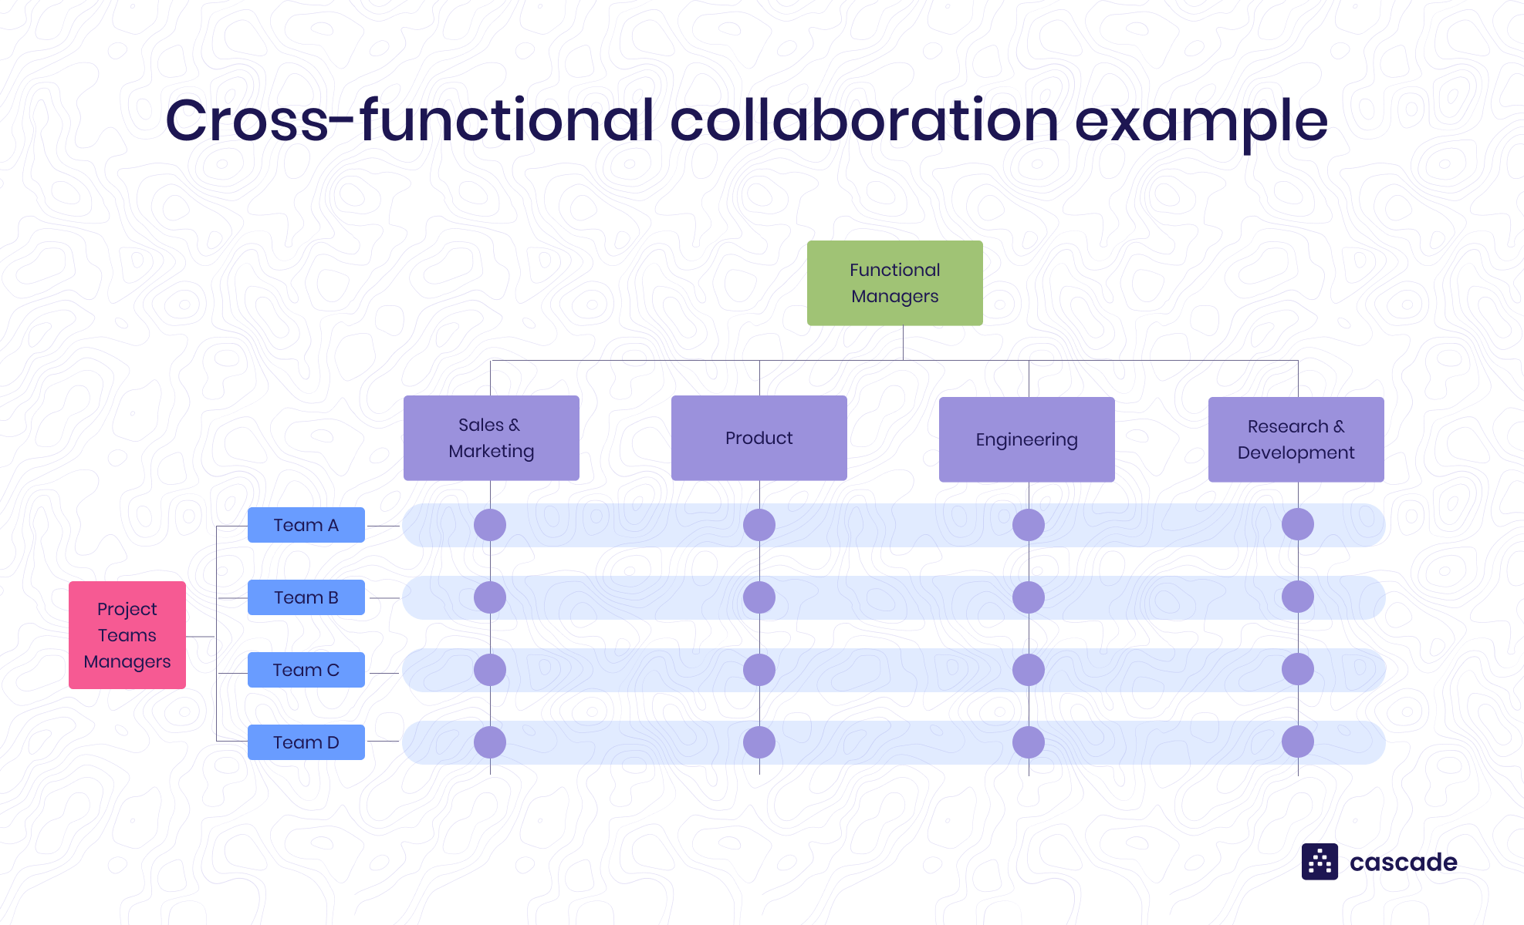
Figure 1: Example of a cross-functional organisation structure (Adapted from Cascade, 2023)
Positive Aspects:
∙ Collaboration worked very well; reporting to our lecturer after each session to inform of progress meant we were up-to-date on each sections progress,
∙ Separation into individual groups; getting the individual sections completed was much easier than working on the entire part ourselves,
∙ Knowing our own individual tasks caused less friction in the group; this is because we knew where we were and were not needed if any of our peers needed assistance in another section.
Negative Aspects:
∙ Communication could have been improved; though collaboration was smooth, we ran over ourselves by sometimes repeating markings that were unnecessary, and some changes were made to the initial design that were not made clear earlier.
∙ Time management needed improvements; even though we knew what point each group would be working on, and what they had achieved, we still ran behind schedule as some points (marking and scribing all sections and riveting the lid to the base) were required before any more work could be continued.
Another team structure that can be used would be a self-directed/self-managed team, according to Sigma Connected, “Most autonomous teams don’t have a hierarchy. Instead, they have the power to create processes and roles based on what is needed for the work at hand.” (Sigma connected, 2023, para 4). This would be useful in the team I was working with, as it would mean we could collaborate in more than a few areas, and simultaneously work together on smaller sections which would help improve accuracy.
It can also help communication, as it would mean that any changes performed to the original part drawing, would be shown to all group members and removing any confusion, which the a cross-functional collaboration did not as easily allow for.

Personal Development Plan
Long Term Goals (5 to 10 years)
∙ Working for MotoGP KTM Factory Racing,
∙ Specialised in powertrain systems or suspension technology,
Short Term Goals (0 to 5 years)
∙ Pass the undergraduate course,
∙ Working with a small racing team, either in club racing, or in the BSB paddock for experience,
∙ Working alongside other mechanics to get better knowledge of different systems on racing motorcycles (in general)
Goal | Objective | Resources Required | Measurement | Target Date
Pass university | Get through the first year | UWTSD provided materials |  | 2024-2026
Work with other mechanics | Part time in a garage, or helping in club racing | Some general experience of motorcycles, and connections |  | 2024
Working in a world championship setting | Pass the undergraduate course | Degree, long term experience in a racing environment, connections |  | 2035

Conclusion
To conclude, the engineers in all sectors of the industry must be able to show their knowledge and understanding of different risks, and any methods in preventing these risks, they must also be able to understand the impact that their work may have on the environment, and never knowingly damage the environment, as well as take into consideration any sustainability issues their project may have; whilst also adhering fully to their code of conduct and take any responsibility of negligence. An engineer must also be able to solve any difficult problems, using a wide range of methods, that can include working with other engineers, or the general public/consumers of their products to help with any future impacts they could be having on the environment or that of the institute they are in.

Reference List
∙ Briano, Enrico & Caballini, Claudia & Giribone, Pietro & Revetria, Roberto. (2010). ‘Objectives and perspectives for improving resiliency in supply chains’, WSEAS TRANSACTIONS on SYSTEMS. 9. Available at: https://www.researchgate.net/profile/Roberto-Revetria/publication/228462453_Objectives_and_perspectives_for_improving_resiliency_in_supply_chains/links/0912f5089ab452e173000000/Objectives-and-perspectives-for-improving-resiliency-in-supply-chains.pdf (Accessed: 24 November 2023).
∙ Cascade. (2023) ‘Cross-Functional Collaboration Overview + Examples’. Available at: https://www.cascade.app/blog/cross-functional-teams-drive-innovation (Accessed: 25 November 2023).
∙ ICE (Institution of Civil Engineers) (2022) 'Code of Professional Conduct', Available at: file:///C:/Users/samrs/Downloads/ice-code-of-professional-conduct.pdf (Accessed: 20 November 2023).
∙ IMechE (Institution of Mechanical Engineers) (2021) 'Code of Conduct', IMechE, Available at: https://www.imeche.org/docs/default-source/1-oscar/About-us/governance/code_of_conduct_02_03_02.pdf?sfvrsn=2 (Accessed: 20 November 2023).
∙ Needle,F. (2023), 'The Benefits of Customer Feedback', HubSpot, 24 August. Available at: https://blog.hubspot.com/service/benefits-of-customer-feedback (Accessed: 1 December 2023).
∙ Nguyen, T.T. and Nguyen, P.D. (2022) 'Energy for Sustainable Development', Available at: https://www.sciencedirect.com/science/article/abs/pii/S0973082622000205#preview-section-abstract (Accessed: 26 November 2023).
∙ Public Health England. (2016) ‘Compendium of Chemical Hazards’. Available at: https://assets.publishing.service.gov.uk/media/5a80257240f0b62302691c99/petrol_general_information.pdf (Accessed: 1 December 2023)
∙ The National Archives. (2002) ‘The Control of Substances Hazardous to Health Regulations’. Available at: https://www.legislation.gov.uk/uksi/2002/2677/regulation/7/made (Accessed 2 December 2023).
∙ Ulrich, K. T., & Eppinger, S. D. (2015) ‘Product Design and Development’, 6th edn. Available at: https://industri.fatek.unpatti.ac.id/wp-content/uploads/2019/03/202-Product-Design-and-Development-Karl-T.-Ulrich-Steven-D.-Eppinger-Edisi-6-2015.pdf (Accessed: 1 December 2023).

