Module Name: Analysing and Solving Problems
Module Code: ACCA 4019
Student Name: Mustafa AY
Student ID: 2513629
Group:2
Lecturer’s Name: Amitave Banik

Analysing and Solving Problem
2026
Table of Contents
Introduction 2
1. Deconstruct the Problem 2
1.1 MoSCoW Technique Requirement 2
1.2 Variables Identification 3
2. Proposed Solution 3
2.2 Flowchart 3
2.3 Flowchart Explanation 5
3. Reflection and Justification 5
3.1 Pattern Recognition 5
3.2 Abstract thinking 5
3.3 Sub-dividing 6
3.4 Justification of solution 6
3.5 Limitation 6
3.6 Assumption 6
4. Conclusion 7
References 7

Introduction
Collaborative learning is a vital aspect of universities because it enables individuals to acquire skills in various areas such as communication, collaboration, and problem-solving. The only challenge that students face is arranging a time for the meeting due to their conflicting schedules, jobs, and personal responsibilities, and this may not only prolong the meeting arrangement process but also delay the completion of the task. [1]
This report will address the issue of scheduling meetings and suggest an appropriate solution for the problem. The report will divide the problem into smaller categories, outline the requirements of the process, and provide a proper solution in the form of a flow diagram. [2] Moreover, the report will justify the chosen solution by analyzing its advantages and disadvantages.

Deconstruct the Problem
Being able to identify the problem and its crucial requirements is essential before working on the solution. Dividing the problem into smaller blocks allows to understand better what the system should carry out and how to do that. In this sections problem of scheduling meetings is examined using the MoSCoW method and important inputs, outputs and requirements of the resulting system are defined. [3]

1.1 MoSCoW Technique Requirement

The MoSCoW technique is used to identify and prioritise the requirements of the proposed meeting scheduling system. It helps separate the most important functions from the optional features, making it easier to develop an effective and practical solution.
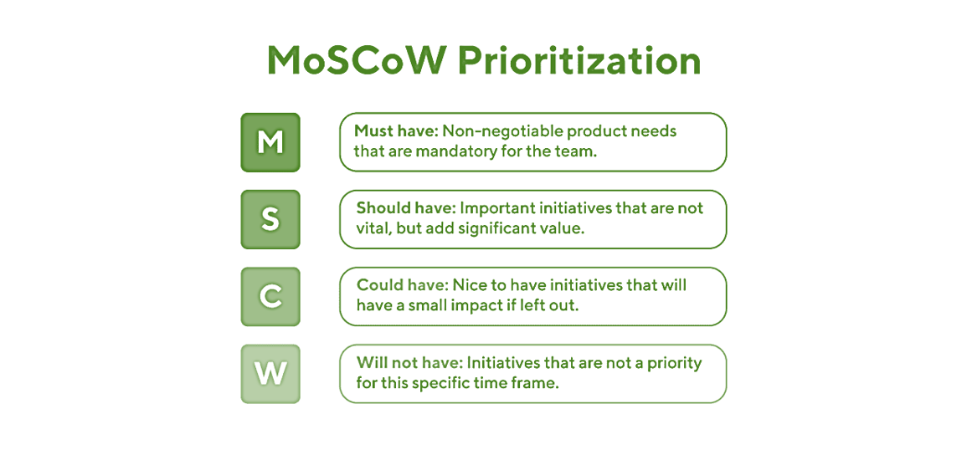
MoSCoW Category | Requirement
Must Have | The system must allow students to enter their available days and times.
Must Have | The system must compare all schedules.
Must Have | The system must display a common meeting time.
Should Have | The system should allow users to update their availability.
Should Have | The system should notify users if no common time is available.
Could Have | The system could suggest an alternative meeting time.
Could Have | The system could display a weekly calendar.
Won't Have | Online calendar integration will not be included in this version.

Variables Identification
It is essential to determine the list of variables required for the developing of the meeting scheduling system. Variables will save the input information, process it and output the final result of the application. Identifying the variables early enough, helps in structuring a clear solution.
Variable Name | Description | Data Type
studentName | Stores the student's name | String
availableDay | Stores the selected day | String
availableTime | Stores the available meeting time | String
groupMembers | Stores the number of group members | Integer
commonTime | Stores the common meeting time | String
meetingFound | Indicates whether a common meeting time is found | Boolean

Proposed Solution
Once the analysis of the problem and the identification of the system requirements are completed, a suitable solution can be arrived at. The proposed solution is an application that is designed to help students find a common meeting time based on their availability. The application will ease the scheduling tasks for members and minimise the number of conflicts between group members. The next figure provides a flowchart of how the proposed system will work.

Flowchart
The proposed solution is illustrated with the use of a flowchart, as the flowchart is a clear and easy way to explain the functionality of the meeting scheduling system. The flowchart introduces the major actions in the process, beginning with entering the students’ availability and concluding with having the results displayed. Moreover, it clarifies the working proportions of the system before the detailed explanation is provided. [4]
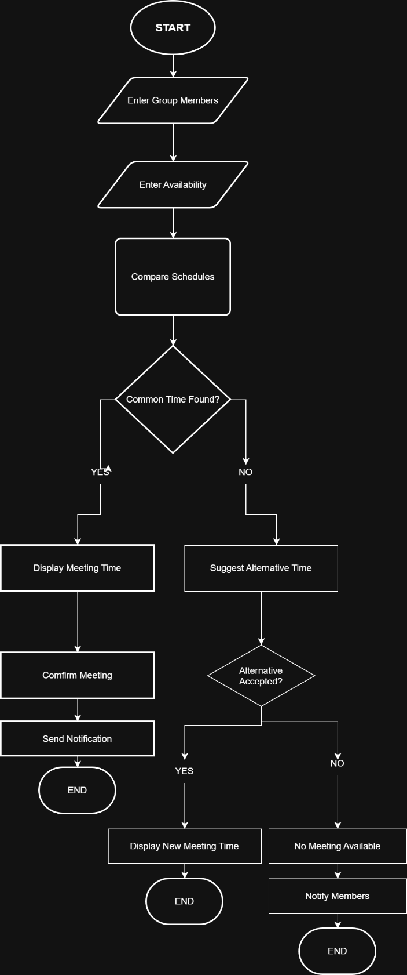

Flowchart Explanation
The flowchart demonstrates the process used in the suggested meeting scheduling system, in which the user first inputs the names of those in the group and then every group member submits their availability through the system.
In the next phase, the system checks all schedules for a common time. If a compatible time is identified, it will be recorded by the system and each participant will be notified of the newly agreed time.
In the final phase, if there is no common meeting time, the system will suggest another time to the users. It is up to the users to either accept or reject the new time, in which case the system will keep the users informed about the situation.
In conclusion, the flowchart illustrates a very straightforward process that supports students’ meeting organisation with fewer scheduling conflicts.

Reflection and Justification
In this part of the report, the writer discusses problem-solving techniques used throughout the report and the rationale behind choosing the suggested solution. The benefits of computational thinking methods in the development process are also described along with limitations and various assumptions surrounding the proposed system.

3.1 Pattern Recognition
The technique of pattern recognition has been used to assist in discovering recurring patterns in the task of scheduling meetings. The process entails every member of the group logging in to the system and entering the dates and times that they are available. The system works by checking the availability of all members of the group in the same way by checking whether all members are free for a meeting at the same time. If they are free, the meeting gets scheduled while if there is no common time available, the system finds another meeting time for those involved. [4]

Abstract thinking
The use of abstract thinking made it possible to concentrate only on the essential information for resolving the problem of scheduling meetings. The solution presented does not rely on any other information than the group members and their available dates/times. Other information about students, such as their personal/professional information, scores in courses, their contacts, etc, are no longer needed and therefore do not have any influence on the process of scheduling meetings. [5]

Sub-dividing
Sub-division was used to break the problem related to meeting scheduling into smaller and more feasible tasks. Instead of solving the problem at once, the suggested solution cuts it into several parts. Firstly, the system gathers group members' information and their availability. After that, it compares all schedules for finding the common time for a meeting. In case no suitable time is found, the system proposes the ambiguous time for a meeting and informs the users about the results. The division of the problem into smaller tasks made the solution more understandable and clear.

Justification of solution
The selection of the proposed solution is a straightforward and convenient way of resolving the difficulty of scheduling meetings. The system performs the task of finding out everyone’s availability automatically, hence eliminating the need for students to communicate back and forth about meeting arrangements.
Furthermore, the solution has an easy to grasp functionality, which follows a logical flow depicted in the flowchart. At the same time, the solution has many options for future development, such as the addition of the calendar feature and email notifications.

Limitation
While the solution proposed allows for effective planning of group meetings, it does have some limitations. This method relies on participants properly entering and updating their availability. If this does not happen accurately the suggestions made may not be valid. The solution requires internet access, which may not be available to everyone always. Last but not least this way only works for scheduling the meetings and does not take any other preferences into account.

Assumption
The proposed solution relies on certain assumptions. One of the assumptions is that group members have equal access to meeting scheduling system. It is assumed that the users provide correct data on their availability and change it when needed accordingly. In addition, it is assumed that the notifications sent by the system are being delivered to each user and they check the notifications regularly. Finally, it is also assumed that there are no technical issues hindering the scheduling process.

Conclusion
The problem of arranging meeting sessions for university groups with conflicting schedules has been looked at in the current report. Computational thinking techniques like abstraction, pattern recognition, and decomposition were used in the analysis process. In the end, a flowchart was developed to show the solution to the problem in a clear and simple manner.

The meeting scheduling system described in the report has the ability to help university students find the most appropriate meeting time simultaneously solving the problem of scheduling conflicts. Despite its disadvantages, the solution suggested in the report is quite practical and shows an opportunity to solve the task of meeting scheduling successfully.

References

[1] | Cambridge International, “Computational Thinking,” Cambridge University Press & Assessment, 2024. [Online]. Available: https://www.cambridgeinternational.org/. [Accessed 8 August 2026].
[2] | J. M. Wing, “Computational Thinking,” Communications of the ACM, vol. 49, no. 3, pp. 33-35, 2006.
[3] | C. S. Valerie Barr, “Bringing Computational Thinking to K–12: What Is Involved and What Is the Role of the Computer Science Education Community?,” ACM Inroads, vol. 2, no. 1, pp. 48-54, 2011.
[4] | Lucid Software Inc., “What is the Flowchart?,” Lucid Software Inc., 2024. [Online]. Available: https://www.lucidchart.com/pages/what-is-a-flowchart. [Accessed 8 August 2026].
[5] | BBC, “Computational Thinking,” BBC, 2024. [Online]. Available: https://www.bbc.co.uk/bitesize/guides/zp92mp3/revision/1. [Accessed 8 August 2026].

