Student Name: Ellis Phillips
P Number: 1903341
Programme of Study: Fine Art
Word Count: 1397
Tutors Names’: Rob Jones & Ryan L. Moule

Imperfect, Impermanent, and Incomplete
An exhibition exploring the notion of ‘Wabi-Sabi’.

Titled ‘Imperfect, Impermanent, and Incomplete’ my intention is to curate an exhibition displaying five pieces of work in collaboration with five artists. Imperfect meaning ‘containing problems’, impermanent meaning ‘not lasting forever’ and incomplete meaning ‘not finished’ (Cambridge Dictionary), the exhibition focuses on the traditional Japanese concept of Wabi-Sabi. In the book Wabi-Sabi: for Artists, Designers, Poets & Philosophers, the famous Japanese architect Leonard Koen describes Wabi-Sabi as ‘the beauty of things imperfect, impermanent, and incomplete, the antithesis of our classical Western notion of beauty as something perfect, enduring, and monumental.’ I believe this connotes that you should accept the imperfections and make the most of life.
The concept of Wabi-Sabi is important to be discusses in relation to today’s zeitgeist as we are at a time where recycling is crucial to the natural environment and the reduction of greenhouse gas emissions through the need of extracting. Do we really need to live in a world where ‘fast fashion’ impacts our choice of materialistic items? I believe that the theory of Wabi-Sabi could help many of us who ‘live in a state of constant longing, unsatisfied with what we have, striving to achieve an unattainable level of perfectionism’ to realise that beauty of everything doesn’t come from others opinions, but beauty comes from within our own opinions, ‘one man’s trash is another man’s treasure’ (Urquhart, H) and so therefore we should appreciate what we have in life. I feel that once we’ve understood this concept materialist items will become more precious to us and there will not be the need to buy items just because they have come into fashion but because they serve a need to us.
I propose that the audience that spectates my curation will come from there with an understanding of what Wabi-Sabi is and they will hopefully reflect upon their time there and possibly adapt some ways into their lifestyle to better help the environment.

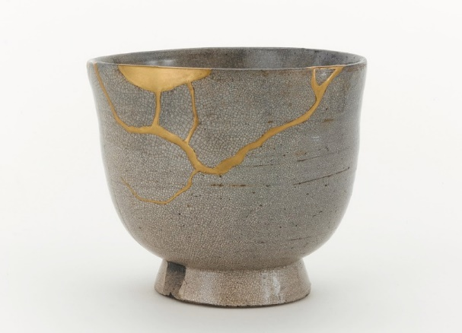
Fig One
This 17th century Edo period ceramic vessel made of stoneware with clear, crackled glaze, stained by ink will be central in my exhibition- Fig One. The 10.5x 12.2cm tea bowl will be standing on a tall, white plinth in the center of the room. This object helps to show the traditional Japanese ceramic repair, Kintsugi, literally meaning ‘to join with gold’ with Kin meaning golden and tsugi joinery (The Book of Life). It is believed that ceramics that become damaged should not be throw away but should continue to ‘attract our respect and attention and be repaired with enormous care’ (The Book of Life). I believe this helps us to understand that fault lines are everywhere in life and we should not be tempted to hide the flaws but to embrace the beauty and power. I have chosen to use this tea bowl in my curation as I believe it helps to understand care and love and can give us the confidence to respect what is vulnerable and imperfect in life. I think through reflection of looking at the piece we can understand that independence, growth and purpose are main factors given off by this style of work.

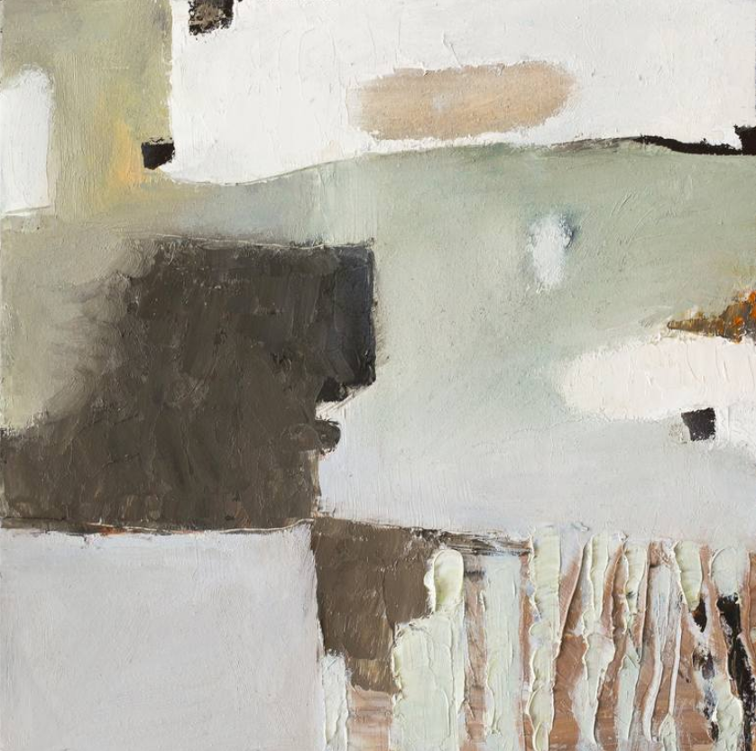
Fig Two

Displayed on the left-hand wall as you walk through the entrance will be an original painting by the contemporary artist Bo Kravchenko- Fig Two. The small 8x8” abstract painting of oil on textured gesso wood panels, titled ‘Wabi-Sabi #3’, will be featured in my curation to show ‘… nothing is perfect, nothing is permanent, and nothing is finished. Intuitively, we sense that things are most beautiful when they begin to wither’ (Kravchenko, 2018). I believe this abstract, minimalist piece of work displays a strong sense of Wabi-Sabi due to the way the artist had used substances to make the work appear old through weathering and discoloration, therefore reinforcing the suggestion of impermanence. The work looks to be eroding and worn out, therefore successfully highlighting the suggestion of Wabi-Sabi.

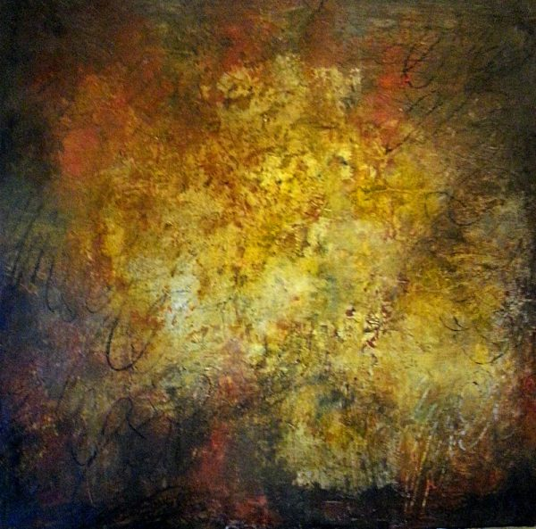
Fig Three

Serena Barton is a collage artist breaking ‘free from the focus of precision in her work and embracing Wabi-Sabi’ (Williams, B). I have chosen her 24x 24” work titled ‘Stendhal Syndrome’ to be displayed at my curation show as to me the juxtaposition of colours, shapes and designs gives off the inspiration of Wabi-Sabi. I feel that this work represents Wabi-Sabi through the beauty of quietness and beauty in simplicity. I feel the colours in the work give off the appearance of an old piece which helps to represent the beauty of age and impermanence. The title of the work ‘Stendhal Syndrome’ links to the condition of becoming overwhelmed when exposed to phenomena of great beauty. I think this is a huge contrast to Wabi-Sabi as Wabi-Sabi is more about embracing the imperfections in work rather than seeking perfection.

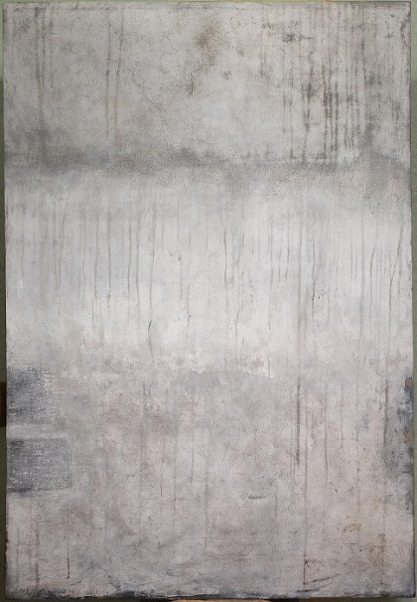
Fig Four

This minimal, abstract painting by interior artist Victoria Dorogyan will be hung on the wall to your immediate right, as you walk in through the entrance - Fig Four. The 51x 35” piece titled ‘Wabi-Sabi #7’ was made in 2018 using acrylic on fabric. The simplicity of this décor helps embrace authenticity through finding value in the lovingly weathered and lived in. The soft grey palette of natural shades helps to create a calming atmosphere. This minimal aesthetic piece helps us to understand that Wabi-Sabi tolerates simplicity and so organisation invites a sense of order and calm to a given space.

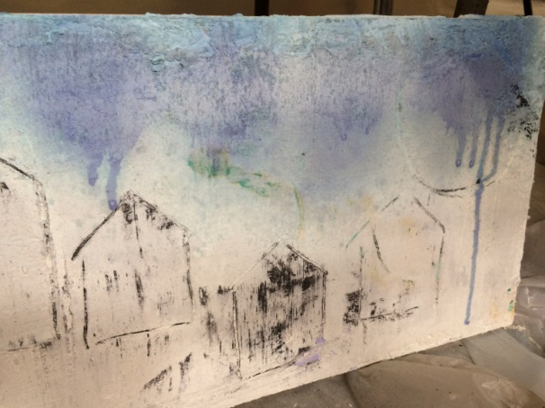
Fig Five

I will place this abstract piece titled Incomplete and Imperfect by artist Rene William on the left-hand wall, towards the right as you walk into the exhibition space – Fig Five. The work displayed shows shapes of what looks to be buildings’ outlines. Williams was once told to “stop” with her ink drawings by her art professor and to ‘let the art piece live the way it wants to live’ (Williams, R. 2016). I believe what was trying to be said was that although there could be more to the work, at its point there is enough, and so it is right, the way it is. I think the title is well suited to the work as it could be considered Incomplete with not having all of the expected necessary details in place and so would then be considered Imperfect denoting the progress is not completed at the time in question. I believe these concepts help us to understand that not everything is perfect in life and things are fine to be left incomplete, which is something Williams has managed to portray in her own work.

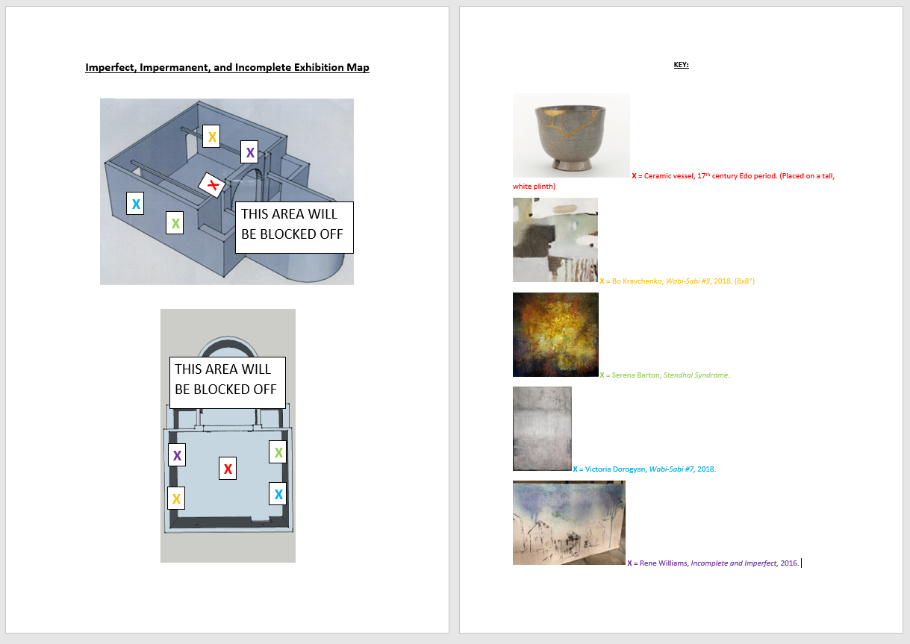
Fig Six

As depicted in figure six, my exhibition space is curated within the rectangular portion of the floorplan at the Mission Gallery. The four paintings will be hung on the walls as indicated above, with the ceramic vessel being central in the room, standing on a plinth. I liked the idea of placing the breakable vessel on a plinth instead of in a glass box as I believe it shows that we do not always need to be precautious and careful as things can be fixed if broken. I have envisioned that people will walk around the space in a clockwise motion, although, it doesn’t matter which piece of work is viewed first as they are all important within their own rights at portraying their own attributions to Wabi-Sabi. To demand attention the white cube aesthetic will be used in the exhibition to minimise distractions from the artworks. I believe a plain, rectangular room is important to my exhibition space as it helps to show that beauty can be found in simple shapes and sizes. The location of my exhibition, being at the Mission Gallery helps show purpose, due to the fact the building is an old churched, turned gallery, and so the grade II listed building gets a second life at being something else. I liked the fact that the outside architecture could be described as unique and beautiful, yet it can host itself to a regular rectangular room inside. Intentionally I have used works that I would not essentially consider ‘beautiful’ to hang in my own home, but I have used works that I believe leave meaning. I want people to come from the exhibition thinking of their own lifestyles and how a change of mindset could improve the rest of their lives by enjoying old things and giving it a new opportunity.

Figures
Fig. One: (17th Century) Tea bowl, White Satsuma ware [Ceramic] National Museum of Asian Art.
Fig. Two: Kravchenko, B. (2018) Wabi-Sabi #3 [Oil, wood on canvas]. Available at https://www.saatchiart.com/art/Painting-Wabi-Sabi-3/968944/6254237/view (Accessed on May 5th 2020)
Fig. Three: Barton, S. Stendhal Syndrome [Oil, cold wax, plaster on panel]. Available at https://serenabarton.com/ (Accessed on May 7th 2020)
Fig. Four: Dorogyan, V. (2018) Wabi-Sabi #7 [Acrylic and fabric]. Available at https://joseartgallery.com/artworks/paintings/Abstract-Wabi-Sabi-7/ (Accessed on May 8th 2020)
Fig. Five: Williams, R. (2016) Incomplete and Imperfect [Ink, charcoal, pastels] Available at https://renewilliamsart.com/ (Accessed on May 8th 2020)
Fig. Six: Exhibition Map [Digital Generated Image]

Bibliography
Avril, E. (2008) “The Aesthetics of Mended Japanese Ceramics” Available at https://museum.cornell.edu/exhibitions/aesthetics-mended-japanese-ceramics (Accessed on May 6th 2020)
Crossley-Baxter, L. (2020) “Japan’s Unusual Way to View the World” Available at http://www.bbc.com/travel/story/20181021-japans-unusual-way-to-view-the-world (Accessed on April 27th 2020)
David. (2015) “Demystifying Wabi-Sabi” Available at https://randomwire.com/wabi-sabi/ (Accessed on April 27th 2020)
Dayman, L. (2018) “Wabi-Sabi: The Japanese Philosophy of Embracing Imperfectionism” Available at https://savvytokyo.com/wabi-sabi-the-japanese-philosophy-of-embracing-imperfectionism/ (Accessed on April 27th 2020)
Koren, L. (2008) Wabi-Sabi: for Artists, Designers, Poets & Philosophers. Imperfect Publishing.
Kravchenko, B. (2018) “Wabi-Sabi #3 Painting by Bo Kravchenko” Available at https://www.saatchiart.com/art/Painting-Wabi-Sabi-3/968944/6254237/view (Accessed on May 4th 2020)
Williams, B. “Back Porch Inspiration | Wabi-Sabi Painting” Available at https://www.artistsnetwork.com/art-mediums/back-porch-inspiration-wabi-sabi-painting/ (Accessed on May 6th 2020)
“The Book of Life” Available at https://www.theschooloflife.com/thebookoflife/kintsugi/ (Accessed on May 5th 2020)

