Module: Research Methods for business

Module code: LCLM6004

Assignment Title: Component 1 Business Research Proposal
Evaluating the Impact of Customer Experience of Passengers Loyalty:
A Case Study of Turkish Airlines.

Student Name: Lika Keinasvili
Student ID: 21236482
Lecturer Name: Rameses Manalang

Table of content

1.Introduction and Problem Context 3
2. Research Aim, Objectives and Questions 4
3. Literature Review 5
4. Methodology 9
5. Business Relevance & Practical Implications 11
6. Timeline and Gantt Chart 12
References 13

1.Introduction and Problem Context
1.1 Background of the Study:
Customer experience has become a major strategic focus for airlines as passengers now expect reliable, efficient, and consistent services throughout their journey: booking, check-in, airport procedures, in-flight comfort, and communications during disruptions. Post-COVID-19 analyses of European aviation show significant recovery in air traffic, with airlines and airports emphasizing improved service standards to rebuild passenger confidence (EUROCONTROL, 2024). For a global carrier such as Turkish Airlines, comprehending how customers evaluate their experiences is crucial for sustaining competitiveness and fostering passenger loyalty in this evolving market environment.
1.2 Description of the Business Issue:
Despite its strong international presence, Turkish Airlines faces challenges in securing long-term passenger loyalty because travelers have many alternative airlines offering similar prices and routes. Passenger loyalty can easily decline when customers experience service issues such as delays, poor communication, lack of comfort, or inconsistencies between flights. Customer feedback platforms show that passengers frequently compare airlines based on service quality, and negative experiences often lead them to switch carriers (Skytrax, 2023). Understanding which elements of the customer journey contribute most to loyalty is therefore essential for identifying areas where Turkish Airlines may need to improve to remain competitive.
1.3 Rationale for Researching Customer Experience and Loyalty:
Exploring the relationship between customer experience and loyalty is important because loyal passengers generate repeat revenue, recommend the airline to others, and are less likely to switch to competitors. Many airlines now focus on improving service quality as a strategy to strengthen retention and reduce customer churn. Market analysis indicates that post-pandemic travelers place greater emphasis on customer experience factors such as reliability, comfort, and communication when choosing airlines (Statista, 2023). For Turkish Airlines, gaining insight into which aspects of the passenger experience have the greatest influence on loyalty can help shape service improvements and support more effective management decisions.

2. Research Aim, Objectives and Questions
2.1 Research Aim:
The aim of this study is to explore how customer experience influences passenger loyalty within Turkish Airlines. As the global airline industry becomes more competitive, the quality of customer experience has become a major factor shaping passengers’ preferences and repeat travel intentions. Customer experience encompasses a range of interactions, including the booking process, airport services, in-flight comfort, staff behavior, and communication. These interactions collectively shape passengers’ overall impressions of an airline. Recent studies show that a positive customer experience significantly strengthens loyalty by increasing satisfaction and trust in the airline brand (Xie, Zhang, and Morrison, 2020). Therefore, understanding how specific aspects of the experience affect loyalty outcomes is critical for identifying ways Turkish Airlines can enhance passenger retention.
2.2 Research Objectives:
This study is guided by several research objectives that aim to support a structured investigation into how customer experience influences passenger loyalty within Turkish Airlines. The first objective is to identify the key elements of customer experience that shape passengers’ perceptions of the airline, such as service reliability, staff behavior, comfort, and communication throughout the travel journey. Understanding these components is essential because passengers often evaluate service encounters holistically, and each interaction can influence their overall satisfaction. The second objective is to examine how satisfaction derived from these experiences affects loyalty behaviors, including willingness to fly again or recommend the airline to others. A further objective is to determine which aspects of the customer journey have the strongest influence on loyalty outcomes, allowing the airline to priorities improvements where they will be most effective. Research on services marketing emphasizes that service quality and customer experience are central drivers of satisfaction and loyalty across service industries, which supports the relevance of these objectives (Zeithaml, Bitner and Gremler, 2020, pp. 60–65).
2.3 Research Questions
Based on the research aim and objectives, this study is guided by the following research questions:
- Which components of customer experience (such as service quality, staff professionalism, comfort, and communication) have the greatest influence on passengers’ loyalty intentions?
- How does passenger satisfaction, formed through different aspects of the customer experience, affect loyalty behaviors such as repeat travel and recommendations?
- Which elements of the passenger journey may require improvement to strengthen loyalty among Turkish Airlines passengers?
- How can Turkish Airlines apply insights from customer experience to reduce customer churn and support long-term passenger retention?
These questions are informed by research showing that loyalty is shaped by a combination of psychological and experiential factors (Oliver, 2020, pp. 22–28).

3. Literature Review
3.1 Customer Experience in the Airline Industry

Customer experience in the airline industry refers to passengers’ overall evaluation of the service encounters they experience throughout their journey, including booking, check-in, airport interactions, and in-flight service delivery. These service encounters collectively shape passengers’ perceptions of the airline’s quality and influence their emotional responses to the travel experience. Wirtz and Lovelock (2021, pp. 38–52) emphasize that customer experience is built across multiple touchpoints, and each interaction contributes to overall satisfaction. In the airline context, factors such as service reliability, staff engagement, comfort, and communication during disruptions play a particularly important role. As competition in aviation increases, delivering a strong and consistent customer experience has become essential for airlines seeking to differentiate themselves and foster long-term passenger loyalty.

3.2 Passenger Satisfaction and Loyalty

Passenger satisfaction is widely recognized as a central determinant of loyalty in the airline industry. Satisfaction develops when an airline successfully meets or exceeds passengers’ expectations in areas such as service reliability, staff professionalism, cabin comfort, and communication. When these expectations are fulfilled, passengers are more inclined to repurchase, recommend the airline to others, and establish long-term relationships with the brand. Kotler, Bowen and Makens (2016, pp. 152–155) emphasize that high levels of satisfaction strengthen customer loyalty by enhancing perceived value and reducing the likelihood of switching to competitors. This highlights the importance of designing service experiences that continuously support satisfaction, particularly for full-service carriers like Turkish Airlines seeking to retain diverse international passengers.

3.3 Theoretical Perspectives
Passenger satisfaction is widely recognized as a central determinant of loyalty in the airline industry. Satisfaction develops when an airline successfully meets or exceeds passengers’ expectations in areas such as service reliability, staff professionalism, cabin comfort, and communication. When these expectations are fulfilled, passengers are more inclined to repurchase, recommend the airline to others, and establish long-term relationships with the brand. Kotler, Bowen and Makens (2016, pp. 152–155) emphasise that high levels of satisfaction strengthen customer loyalty by enhancing perceived value and reducing the likelihood of switching to competitors. This highlights the importance of designing service experiences that continuously support satisfaction, particularly for full-service carriers like Turkish Airlines seeking to retain diverse international passengers.

3.4 Conceptual Framework
The conceptual framework for this study proposes that customer experience influences satisfaction, which subsequently shapes loyalty behaviors. This reflects a well-established principle in services marketing that satisfaction mediates the relationship between service perceptions and behavioral intentions. According to Wirtz and Lovelock (2021, pp. 130–145), positive service encounters enhance perceived value, strengthen satisfaction, and increase the likelihood of loyal behavior, such as repeat purchases and positive word-of-mouth. Applying this framework to Turkish Airlines provides a structured way to analyse how different elements of the passenger journey contribute to satisfaction and loyalty outcomes.
The framework assumes two pathways:
- Direct effect: Customer Experience → Passenger Loyalty
- Indirect effect (mediated): Customer Experience → Customer Satisfaction → Passenger Loyalty
These relationships are illustrated in the conceptual model below:

Conceptual Framework Diagram:

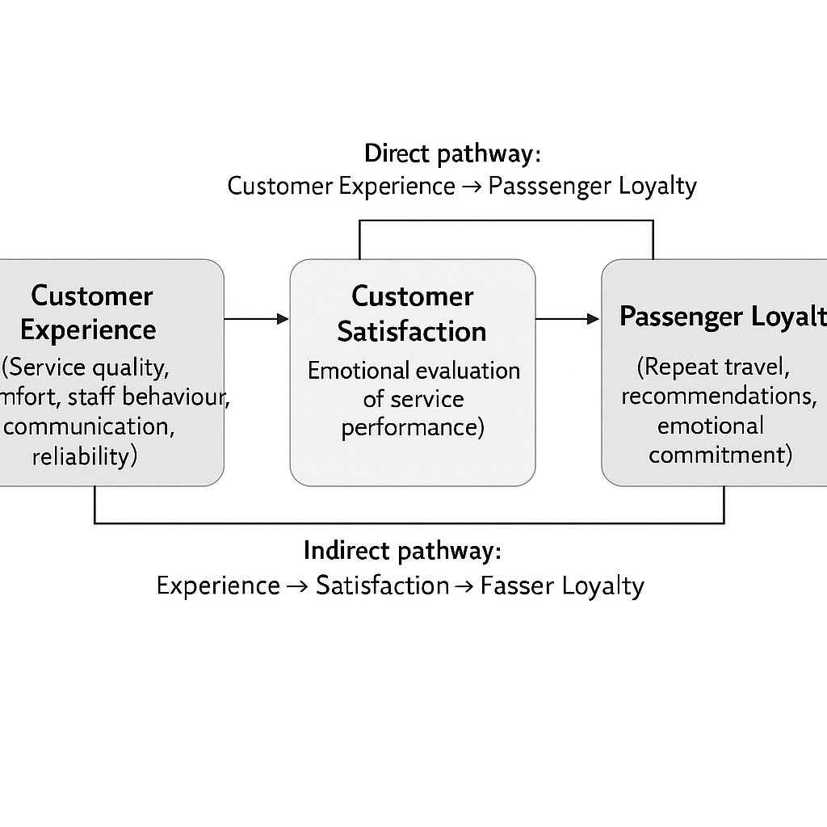Figure 1: Conceptual Framework developed by the researcher based on Wirtz and Lovelock (2021), Zeithaml, Bitner and Gremler (2020), and Oliver (2020)

Brief Explanation of the Diagram
The diagram illustrates that customer experience directly influences passenger loyalty, while also influencing loyalty through customer satisfaction. This means customer satisfaction acts as a mediating variable, explaining how positive experiences translate into long-term loyalty behaviors among Turkish Airlines passengers.
3.5 Research Gap
Despite extensive research on customer experience and loyalty in the airline industry, limited academic work examines these relationships specifically within Turkish Airlines. Much of the available literature focuses on general aviation trends or low-cost carriers rather than full-service international airlines. Wirtz and Lovelock (2021, pp. 50–55) emphasize that customer expectations vary across sectors, indicating the importance of sector-specific studies. Furthermore, few studies have applied well-established service quality frameworks directly to Turkish Airlines to investigate how experience shapes satisfaction and loyalty. This gap highlights the need for targeted research examining these relationships in the context of a rapidly expanding global airline.

4. Methodology
4.1 Research Approach
This study adopts a mixed-methods research approach to explore how customer experience influences passenger loyalty within Turkish Airlines. A mixed-methods design is appropriate because it allows the researcher to collect both numerical data through surveys and contextual insights through interviews. Quantitative data helps identify patterns and relationships between variables such as service quality, satisfaction, and loyalty, while qualitative data provides a deeper understanding of passengers’ perceptions and experiences. According to Creswell (2018, pp. 214–220), mixed-methods research enhances the validity of findings by integrating strengths from both qualitative and quantitative approaches. Using this approach enables a more comprehensive understanding of the factors shaping loyalty within the airline context.
4.2 Research Design
A cross-sectional research design will be used, involving data collection at a single point in time. This design is commonly applied in service and consumer behavior research because it allows for efficient analysis of attitudes and behavioral intentions within a defined period. Cross-sectional studies are particularly useful when examining relationships between variables such as experience, satisfaction, and loyalty without manipulating any conditions. Saunders, Lewis and Thornhill (2019, pp. 150–155) explain that cross-sectional designs are suitable for studies aiming to describe or explore relationships among variables within real-world organizational settings. This makes the design appropriate for the current study, which focuses on understanding loyalty drivers among Turkish Airlines passengers.
4.3 Data Collection Methods
Two data collection methods will be used: online questionnaires and semi-structured interviews.
Questionnaires will collect quantitative data related to passengers’ evaluations of service quality, satisfaction, and loyalty intentions. The questionnaire will include Likert-scale items measuring components such as reliability, staff behavior, communication, and comfort. This method allows the researcher to gather data from a larger sample and identify statistical relationships among variables.
Semi-structured interviews will collect qualitative data to explore passengers’ deeper experiences, expectations, and explanations for their loyalty behaviors. Interviews provide flexibility and allow participants to elaborate on their experiences in ways that structured surveys cannot. Bryman (2016, pp. 465–470) states that semi-structured interviews are valuable for understanding lived experiences and capturing detailed perspectives.
Using both methods ensures a well-rounded understanding of customer experience and loyalty.

4.4 Sampling Strategy
The study will use a non-probability purposive sampling strategy. Purposive sampling is appropriate when the research aims to gather insights from individuals with specific knowledge or experience relevant to the study—in this case, passengers who have previously travelled with Turkish Airlines. Saunders, Lewis and Thornhill (2019, pp. 315–317) note that purposive sampling is suitable for qualitative and mixed-methods research because it ensures that participants can provide rich and relevant data.
For the quantitative phase, a planned sample size of 30 questionnaire respondents will be used. For the qualitative phase, 5–7 semi-structured interviews will be conducted. This sample size is typical for small-scale academic research.
4.5 Data Analysis Methods
Quantitative data from questionnaires will be analyzed using descriptive statistics (such as means, frequencies, and percentages) to summaries responses. Additionally, correlation analysis will be used to explore the relationship between customer experience, satisfaction, and loyalty. These analyses will help identify which aspects of experience have the strongest influence on loyalty intentions.
Qualitative interview data will be analyzed using thematic analysis, which involves coding and categorizing the data to identify recurring themes. Braun and Clarke (2020, pp. 39–45) emphasize that thematic analysis is effective for interpreting qualitative data because it highlights patterns of meaning across participants’ responses. Combining statistical results with qualitative insights strengthens the overall depth and validity of the findings.
4.6 Ethical Considerations
Ethical procedures will be followed to ensure that participants are protected throughout the research process. Participants will be provided with an information sheet outlining the purpose of the study, their rights, and the voluntary nature of participation. Confidentiality will be maintained by anonymizing all data, and participants will be informed that they may withdraw from the study at any time without consequence. Bell and Bryman (2022, pp. 123–130) emphasize the importance of informed consent, confidentiality, and respect for participants’ autonomy within social research. These principles will guide the ethical conduct of the study.

5. Business Relevance & Practical Implications
5.1 Potential Impact of Findings on Business Practices
The findings of this research can support Turkish Airlines in strengthening its customer experience strategy by identifying the aspects of the service journey that most strongly influence passenger loyalty. Understanding which touchpoints—such as communication, staff behavior, or in-flight comfort—have the greatest effect on satisfaction; the airline can priorities improvements that deliver the highest impact. This may include targeted staff training, service redesign, or enhancements to communication during delays. Improving these areas can reduce customer dissatisfaction and increase repeat travel, ultimately supporting stronger financial performance and competitive advantage.
5.2 Informing Decision-Making, Management Strategies, and Industry Developments
The study’s insights can also support more informed managerial decision-making within Turkish Airlines. By recognizing how customer satisfaction mediates the relationship between experience and loyalty, managers can design strategies that focus on creating consistent and high-quality service encounters. This evidence can inform policy development, resource allocation, and long-term service management planning. Kotler, Bowen and Makens (2016, pp. 152–155) emphasize that prioritizing customer satisfaction creates sustained loyalty benefits, meaning that strategic investment in service experience can strengthen Turkish Airlines’ market position. Additionally, the findings may contribute to wider industry discussions on how full-service airlines can differentiate themselves in a competitive global environment

6. Timeline and Gantt Chart
This section outlines the planned schedule for completing the research project. A structured timeline helps ensure that each stage of the study—from preparation to data collection, analysis, and writing—is completed efficiently and within the required timeframe. The project spans an eight-week period, allowing adequate time for designing instruments, collecting data, analysing results, and finalizing the written report.
6.1 Project Timeline
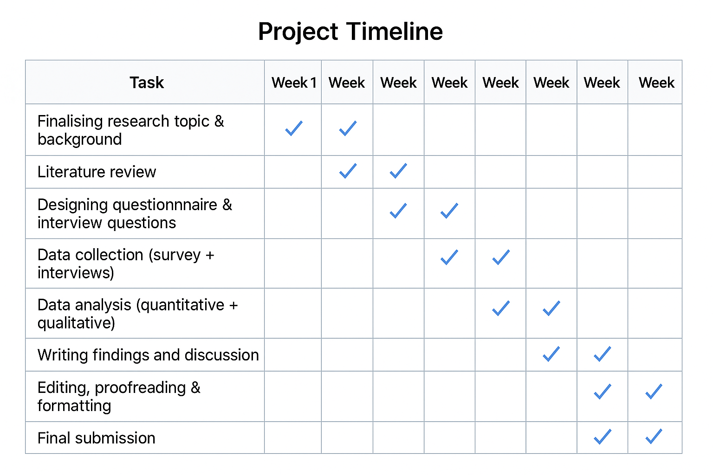
Figure 2: Project Timeline and Gantt Chart developed by the researcher.
6.2 Summary
The timeline demonstrates a logical progression of tasks, beginning with topic refinement and literature review, followed by designing the questionnaire and interview guide. Data collection and analysis are allocated dedicated periods to ensure accuracy and reliability. The final weeks are reserved for writing, revising, and preparing the final submission. This structured approach supports effective project management and reduces the risk of delays.

References
Bell, E. and Bryman, A. (2022). Business Research Methods. 6th edn. Oxford: Oxford University Press, pp. 123–130.
Braun, V. and Clarke, V. (2020). Thematic Analysis: A Practical Guide. London: Sage Publications, pp. 39–45.
Bryman, A. (2016). Social Research Methods. 5th edn. Oxford: Oxford University Press, pp. 465–470.
Creswell, J.W. (2018). Research Design: Qualitative, Quantitative, and Mixed Methods Approaches. 5th edn. Thousand Oaks: Sage Publications, pp. 214–220.
EUROCONTROL (2024) European Aviation Overview 2024. Brussels: EUROCONTROL. Available at: https://www.eurocontrol.int/sites/default/files/2024-12/eurocontrol-european-aviation-overview-12122024.pdf (Accessed: 1 December 2025).
Kotler, P., Bowen, J.T. and Makens, J.C. (2016). Marketing for Hospitality and Tourism. 7th edn. Harlow: Pearson Education, pp. 152–155.
Oliver, R.L. (2020). Satisfaction: A Behavioral Perspective on the Consumer. 3rd edn. New York: Routledge, pp. 22–28.
Saunders, M., Lewis, P. and Thornhill, A. (2019) Research Methods for Business Students. 8th edn. Harlow: Pearson Education, pp. 150–155.
Saunders, M., Lewis, P. and Thornhill, A. (2019) Research Methods for Business Students. 8th edn. Harlow: Pearson Education, pp. 315–317.
Skytrax (2023) Airline Ratings and Passenger Reviews: Turkish Airlines. Available at: https://www.airlinequality.com/airline-reviews/turkish-airlines/ (Accessed: 2 December 2025).
Statista (2023) Airline customer satisfaction and loyalty trends worldwide. Available at: https://www.statista.com/topics/1707/air-transportation/#topicOverview (Accessed: 1 December 2025).
Wirtz, J. and Lovelock, C. (2021). Services Marketing: People, Technology, Strategy. 9th edn. Singapore: World Scientific Publishing, pp. 38–52.
Wirtz, J. and Lovelock, C. (2021). Services Marketing: People, Technology, Strategy. 9th edn. Singapore: World Scientific Publishing, pp. 50–55.
Wirtz, J. and Lovelock, C. (2021). Services Marketing: People, Technology, Strategy. 9th edn. Singapore: World Scientific Publishing, pp. 90–102.
Wirtz, J. and Lovelock, C. (2021). Services Marketing: People, Technology, Strategy. 9th edn. Singapore: World Scientific Publishing, pp. 130–145.
Xie, C., Zhang, J. and Morrison, A.M. (2020) ‘Developing a model of passenger experience and loyalty in the airline industry’, Journal of Air Transport Management, 83, 101760. Available at: https://doi.org/10.1016/j.jairtraman.2019.101760

