Reflective Review of Learning Journey
Hannah Yarwood | Professional Career Development | 18th June 2019
Introduction – Professional Career Development

I started the course, Certificate of Higher Education Sills for the Workplace on the 29th April 2019 and one of the modules is professional career development. Since enrolling on the course, I have learned several different skills which are going to be able to assist me in expanding my knowledge, and creating better opportunities for myself, and hopefully climbing up the career ladder, and reaching a managerial position.
These include the SWOT Analysis and how to convert this (TOWS), SMART goals and objectives, Personal Development Plans.
Together with theories such as the hierarchy of needs and how three different theorists have expanded on these. I have learned about KOLB, and the Johari Window.
I have learned about the GO MAD Framework and different types of educating styles. Also about are VARK, Honey and Mumford, Myer Briggs. Also improving my knowledge about self-awareness and how to increase this.
During my assignment I will be demonstrating that I have understood all the different areas that have been taught during the lectures.

The SWOT analysis was created in the 1960’s by Albert S Humphrey. The SWOT analysis can be used in business when completing a project or in study. The purpose of the theory is for people to be able to establish their strengths, weaknesses, opportunities and threats.
Strengths and weaknesses are called internal factors, and opportunities and threats are external factors. Therefore you should be able to turn your weaknesses into strengths, and your threats into opportunities. This is called TOWS. TOWS assists you in understanding the strategic choices that you face.
When conducting a SWOT analysis, you need to ensure that you are asking yourself the right questions, as if a SWOT analysis is created and it is not helpful or does not produce realistic goals, it is not useful. It is suggested that when asking questions, you can consider:
- How can your strengths be used to create opportunities?
- How can you use your strengths to minimise or avoid threats?
- How can opportunities be used to deal with weaknesses you encounter?
- How can you decrease weaknesses and avoid threats?
Strengths | Weaknesses
Organised  Focused/Enthusiastic  Easily Adaptable to Change  Good Verbal Skills  Good Written Skills | Shy/lack confidence  Easily stressed  Easily Distracted  Poor Numeracy Skills
Opportunities | Threats
Meeting new people  Always able to attend training events/seminars  Different areas of law to practice  Always job opportunities | Legal Aid Cuts  New Government/Politics
I believe that I have several strengths these are being organised, focused, enthusiastic, easily adaptable to change and I have good communication skills. Whilst I do have strengths, I do have weaknesses which I have outlined above.
When practicing law, there are always opportunities available such as meeting new people who can assist you in expanding your knowledge and skills, they can also provide you with feedback on how you work, and if there is any way that you can improve.
Another advantage of working within law is that someone somewhere will always require a Solicitor, however Legal Aid Cuts can have a big impact when you are working in the private sector. As vulnerable people cannot access the legal system, and access the support that they rightfully deserve, and legal aid cuts can result in people losing their jobs.
During my time at University and learning about the SWOT analysis. I have also learned about the TOWS Matrix and by using the TOWS Matrix I have been able to understand how I can convert my weaknesses into strengths and my threats into opportunities, by doing this it has enabled me to ensure that I can establish where I can improve. I have learned how weaknesses sometimes aren’t always a weakness. Although threats cannot always be removed, they can be converted into opportunities or minimised.
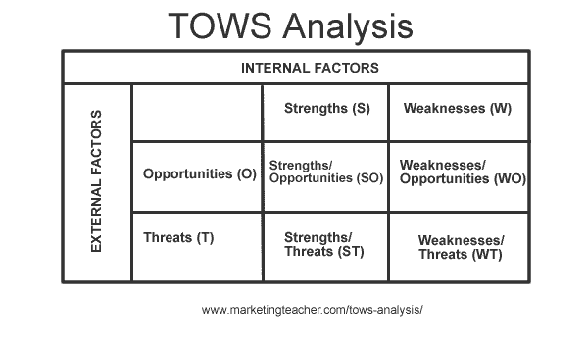

SMART
During lectures at University I have learnt about SMART goals. What SMART means:
S - Specific
M – Measurable
A - Achievable
R - Realistic
T - Time bound.
Using this acronym, I have been able to ensure that any goals I have set are SMART. This framework has taught me that making my goals specific, measurable, achievable and realistic it is likely that I am able to reach my goals within a reasonable timeframe. Before learning about SMART, I thought the goals I had set were clear, however since using SMART it has helped me to set more clear, achievable and achievable goals.
Learning Styles
Since studying different learning styles and completing questionnaires it has become clear that no two people learn the same way. Everyone has different ways of learning, and different ways to assist them in absorbing the information that they have learned.
It is suggested through the VARK learning style that people tend to learn in four different ways. These are Visual, Aural, Reading/Writing, Kinesthic.
I answered thirteen questions, and according to the questions my preferred learning styles are visual, aural and kinesthic. I am minded to agree with this assertion, as I prefer to be hands on and test things. For example, I prefer real life examples and I like to see things in the moment. Graphs, charts, and making detailed notes are very helpful to me, and how I learn. I also prefer to get involved into conversations with other learners to obtain their opinions, and I prefer to attend lectures or listen to speakers.
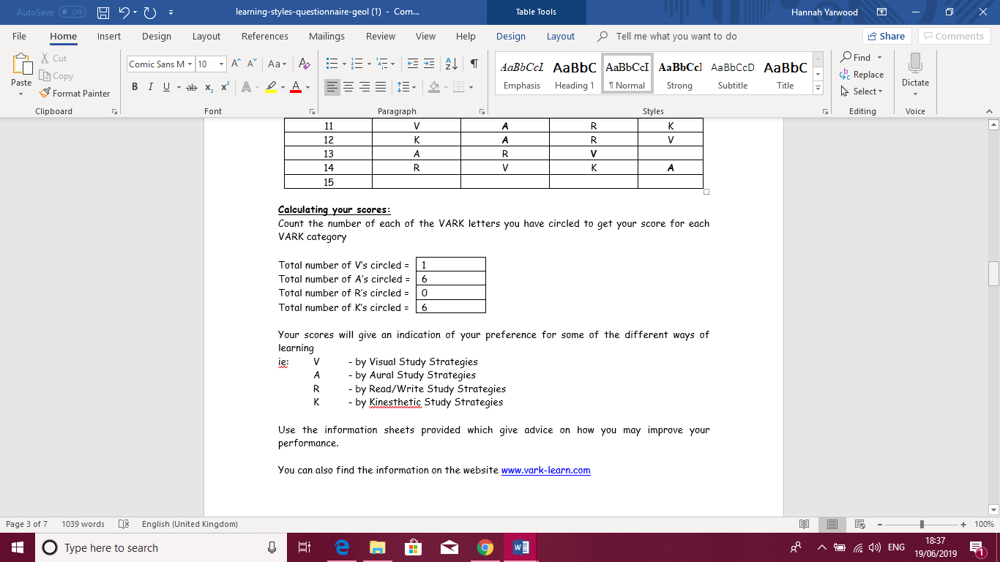Another learning style studied is Honey and Mumford. This learning style was based upon Kolb. Kolb’s theory was created on two levels. A four-stage cycle and four different learning styles. Kolb said, “Learning is the process whereby knowledge is created through the transformation of experience” (1984). This particular style was further developed by Alan Mumford and Peter Honey.
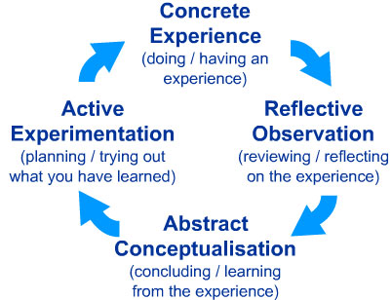
The four different learning styles are Activist, Theorist, Pragmatist and Reflector. In order to understand the different types of learning style and which one suits your preference and personality Honey and Mumford created a questionnaire. It is suggested by Honey and Mumford that once you understand your learning style you will be able to find yourself in a good position to do three useful things [quoting P. Honey]:
1. Becoming smarter and getting a better fit between learning opportunities and they way you learn best. Once you can understand how you learn best and what suits you, learning becomes effective and enjoyable. 2. If you expand the “band width” you can become an all round learner and by doing this you can become more versatile and learn from a range of different experiences. 3. If you improve your self awareness, learning skills and are aware of how you learn this can open a whole different way to self-scrutinise. It is suggested that if you find the ability to learn different styles you can become an effective learner.
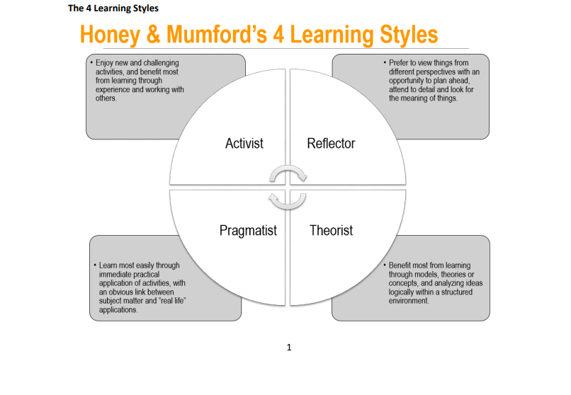

I completed the Honey and Mumford Questionnaire and it is suggested that I am an Activist. Activists tend to learn best by new experiences. Activists like to get involved in competitive team work activities, they enjoy the excitement and drama in things and tend to act now and think later. I believe that this is an accurate description of the way I enjoy learning, and the way I tend to learn.
GO M.A.D
The GO M.A.D framework stands for “Making a Difference”. GO MAD was created by Andy Gilbert. Initially Andy Gilbert created a passion statement and conducted research and carried out a study by finding three people who made a difference and his main researcher interviewed them. Andy Gilbert wanted to establish what the main things were that people who made a difference did to help people. The first two explained that it was their goal and what they wanted to achieve which assisted them in making a difference. The GO M.A.D Framework is below.
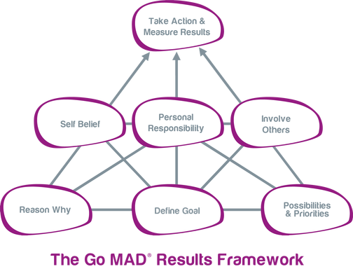
I have learned to apply the GO M.A.D Framework to assist me in achieving my goals, and helping me establish what it is I want to do, what I need to do, who I need to involve to assist me, and take responsibility to ensure that I understand what action I need to take to ensure I achieve the results and achieve my goals.
In the next three years I want to finish my university course, and have a full degree, and for me to do this I need to attend all of my university lectures, complete all my essays, ensure I am engaging in group discussions within lectures and requesting help when I need it to ensure I understand everything I am being taught.
In the next five years I want to move from being a paralegal, and I want to be employed as an Office Manager within a firm of Solicitors and in order for me to do this I firstly need to finish my degree, research what courses are available to me in order to become a qualified Office Manager. By applying GO M.A.D to my goal setting it can show me what courses are available to me, and what I need to do in order to achieve my goals.
Self Awareness
Self-awareness enables us to stand differently and identify the way we see ourselves. Self-awareness affects our attitudes and behaviours. It also shows how we see other people. Steven Covey said, “self-awareness becomes our map of the basic nature of mankind”.
Self-awareness enables us to improve our judgement and help us identify opportunities that may be available to us in relation to our personal and professional growth. It also allows us to see the development and growth of others.
It is suggested that there are five ways to increase self-awareness. This can be by meditating, writing down your plans and priorities, undertaking psychometric tests and profiling, asking friends who we trust for feedback, and getting feedback from work.
Personal Development Plan
When developing your skills and being in education there can be barriers and how you overcome these is how you are able to learn. As I am a full time mother, it can on occasion be difficult to find the time to study with no distractions. I have been out of education for a considerable period. Getting back into education writing assignments has been difficult for me however I have been able to overcome these barriers by attending lectures, discussing assignments with my peers, researching all the information within the module. I am also fortunate to have a good support network which has allowed me to engage in studying and attending lectures to progress my knowledge learn further. Since being in university I have been able to manage my time better, in order to find time to study and complete my essays.
Personal Development Plans assist you in doing a self-reflection and being honest about your strengths and weaknesses. You should be able to evaluate training that you have received and be able to consider your future development.
You should be able to complete a personal analysis, set goals, and set personal objectives. By completing a personal development plan, it has helped me to ensure that my goal is specific, establish what training may be useful, and setting dates to make sure certain tasks are set to ensure the result is met.
Johari
The Johari Window model is very useful when it comes to improving your self-awareness. The Johari Window was created by Joseph Luft and Harry Ingham in 1955. The Johari Window helps people influence their “soft skills”, behavior and interpersonal development. The framework has four regions.
- What is known by the person about themselves. This is called the open area.
- What is not known by the person about themselves, but what others know. This is called the blind area
- What is known by the person, but others are not aware of. This is called the hidden area.
- What is not known by the person about themselves and is also unknown by others. This is called the unknown area.
The Johari window helps people understand their relationships with themselves and others better.
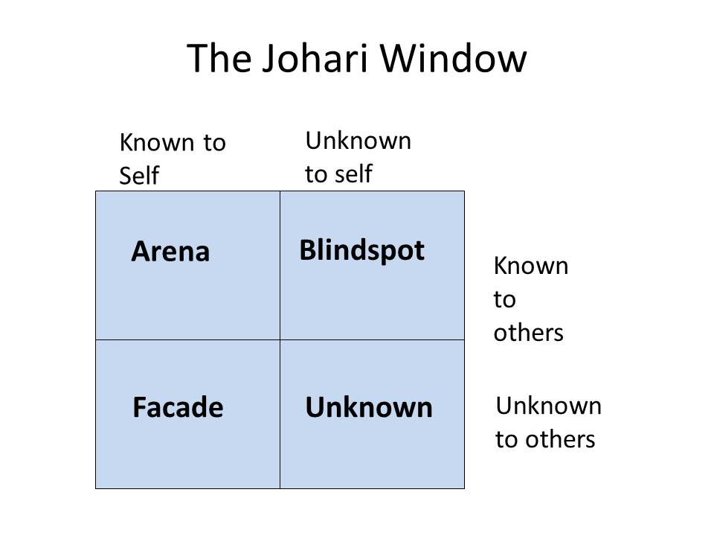
Conclusion
Overall, I have found being in University and undertaking the Professional Career Development module extremely helpful to my development and my chosen career path.
It has helped me set an end goal and keep this in sight. This module has helped me to understand what I want to achieve and how I want to progress in my career. I have learned several different things I probably would never have been aware of unless I competed this module.
Completing this module has assisted me in making sure my goals are SMART, realistic and well defined so that I do not put myself in a position where I set myself up to fail. It has opened me up to various learning styles and helped me understand how I learn best.

References
https://www.gomadthinking.com/about/our-story/
https://www.simplypsychology.org/learning-kolb.html
https://www2.le.ac.uk/departments/doctoralcollege/training/eresources/teaching/theories/honey-mumford
https://www.managers.org.uk/~/media/Files/Checklists/Personal-Development-Plan-Example-Guide.pdf
The Business Students Guide to Study and Employability – Peter Morgan.
https://www.businessballs.com/self-awareness/johari-window-model-and-free-diagrams/

