


MSc Industry 4.0 Advanced Manufacturing

Introduction to Industry 4.0

Module Code: ACPA7004

Assignment 1 - Written Report

Supervisor: Jaymie Phillips

Industry 4.0 Technology - Exploring the Impact on Manufacturing Efficiency

30th March 2022
Student: Gareth Gooding (2125561)
E-mail: 2125561@student.uwtsd.ac.uk




Industry 4.0 Technology
Exploring the Impact on Manufacturing Efficiency

Abstract

UKWDG is a company that has had limited development with regards to Industrial Internet of Things Opportunities. New technologies are available that can improve the Process and Efficiency of how the company operates.

This short report explores 2 Processes and how Industry 4.0 technologies can improve those processes.

Energy Efficiency is a key focus with the current Instability of the Energy Markets. The focus is to provide a Low-Cost solution to Energy Data tracking, which will allow UKWDG to scope Areas of Improvement. Industry 4.0 Smart Devices is an area of Opportunity discussed in this report.

The 2nd process involves product tracking with a Cost of Poor-Quality area of loss being Missing Items. The current manual barcode system is prone to errors, whereas an RFID technology is discussed in this report as a potential solution.

Introduction

This report will look at the Efficiency of 2 processes and what Opportunities for Improvement Industry 4.0 technology can provide.

This report is based on UKWDG (UK Windows and Doors Group Limited), which contains several sites performing different operations. The flagship site in Treorchy is the focus area for improvement due to it being the highest output site, delivering directly to customers.

UKWDG is a window and door manufacturer and distributor, primarily using materials such as uPVC and glass. The group incorporates several divisions which provide different functions.
- Duraflex produces uPVC Profiles using Extrusion technology
- Techniglass produces Insulated Glazed units using glass processing equipment
- The Treorchy facility fabricates windows and doors for New Build, Trade, Retail and Consumer markets, using uPVC profiles and Insulated Glazed units.

The Group has been developed over the last 20 years as a combination of companies of expertise in the industry.

This amalgamation of various companies leaves the business with a varied level of equipment, with regards to age and condition. With financial challenges in recent years investment for equipment or efficiency has been limited.

This report will focus on technologies that can improve the equipment or efficiency and act as a Benchmark standard for all sites to adopt. Cultural change resulting from these opportunities will enable the workforce to embrace further Industry 4.0 methods to drive continual improvement.

Process 1 – Energy Monitoring

Problem Statement

The current Global energy markets are turbulent due to crisis, change and uncertainty. UKWDG Energy Costs have increased by over 100% during 2021 and into 2022, as below:
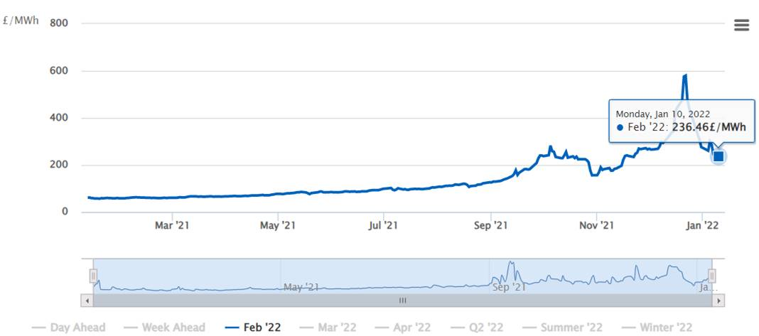

Strategic focus has been placed on Energy Efficiency to reduce impact of this increase. Large scale initiatives, such as a Gas Driven Generator Set have been initiated that will deliver large savings. Smaller scale projects are also required across all sites.

Scope of Opportunity
To enable the prioritisation of projects, data is required to indicate where the key Areas of Usage are. Energy Metering is limited, located only at the main network metering point at each facility. The proposal is to install Metering at strategic points to highlight key Areas of Usage, promote Energy Reduction Projects, and accurately track the performance of the projects. Adopting accurate tracking will improve project engagement with the availability of instance feedback.

Internet of all Things (IoT) technology such as LPWAN can be utilised to provide low-cost remote meters, that can transmit data to display devices.

What is LPWAN?
LPWAN is an acronym of Low Powered Wide Area Network. It is a type of wireless network that operates at low bandwidths over long distances. This Low Bandwidth reduces the power required, allowing battery operated IoT devices and sensors to be utilised. There are several manufacturers with similar technologies such as LoRaWAN, Sigfox and NB-IoT, which are considered as LPWANs, but vary on bandwidth, distance, and costs. A typical LPWAN network, utilising LoRaWAN, is shown below:
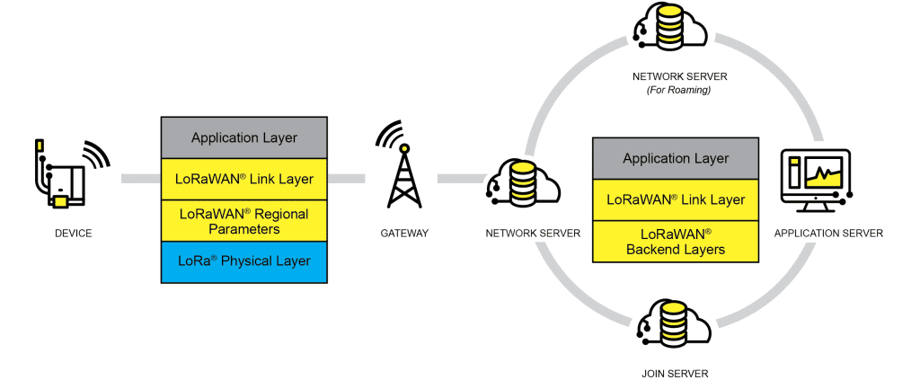
(Alliance, LoRa, 2022)

LPWAN is not as available as conventional ‘wireless device’, with the most popular range of devices still relying on data networks such as Wi-fi, 4G/5G, all of which need more power to operate.

Communications with an OEM of digital metering instruments – Lovato Electric – indicated that their range of products was still reliant on RJ45 wired technology to connect meters to the data logger hub. Options do include RS485 Ethernet/4G modems and GPRS 2G/3G Gateway modems at higher costs and as shown in network example below. (Lovato22, 2022)

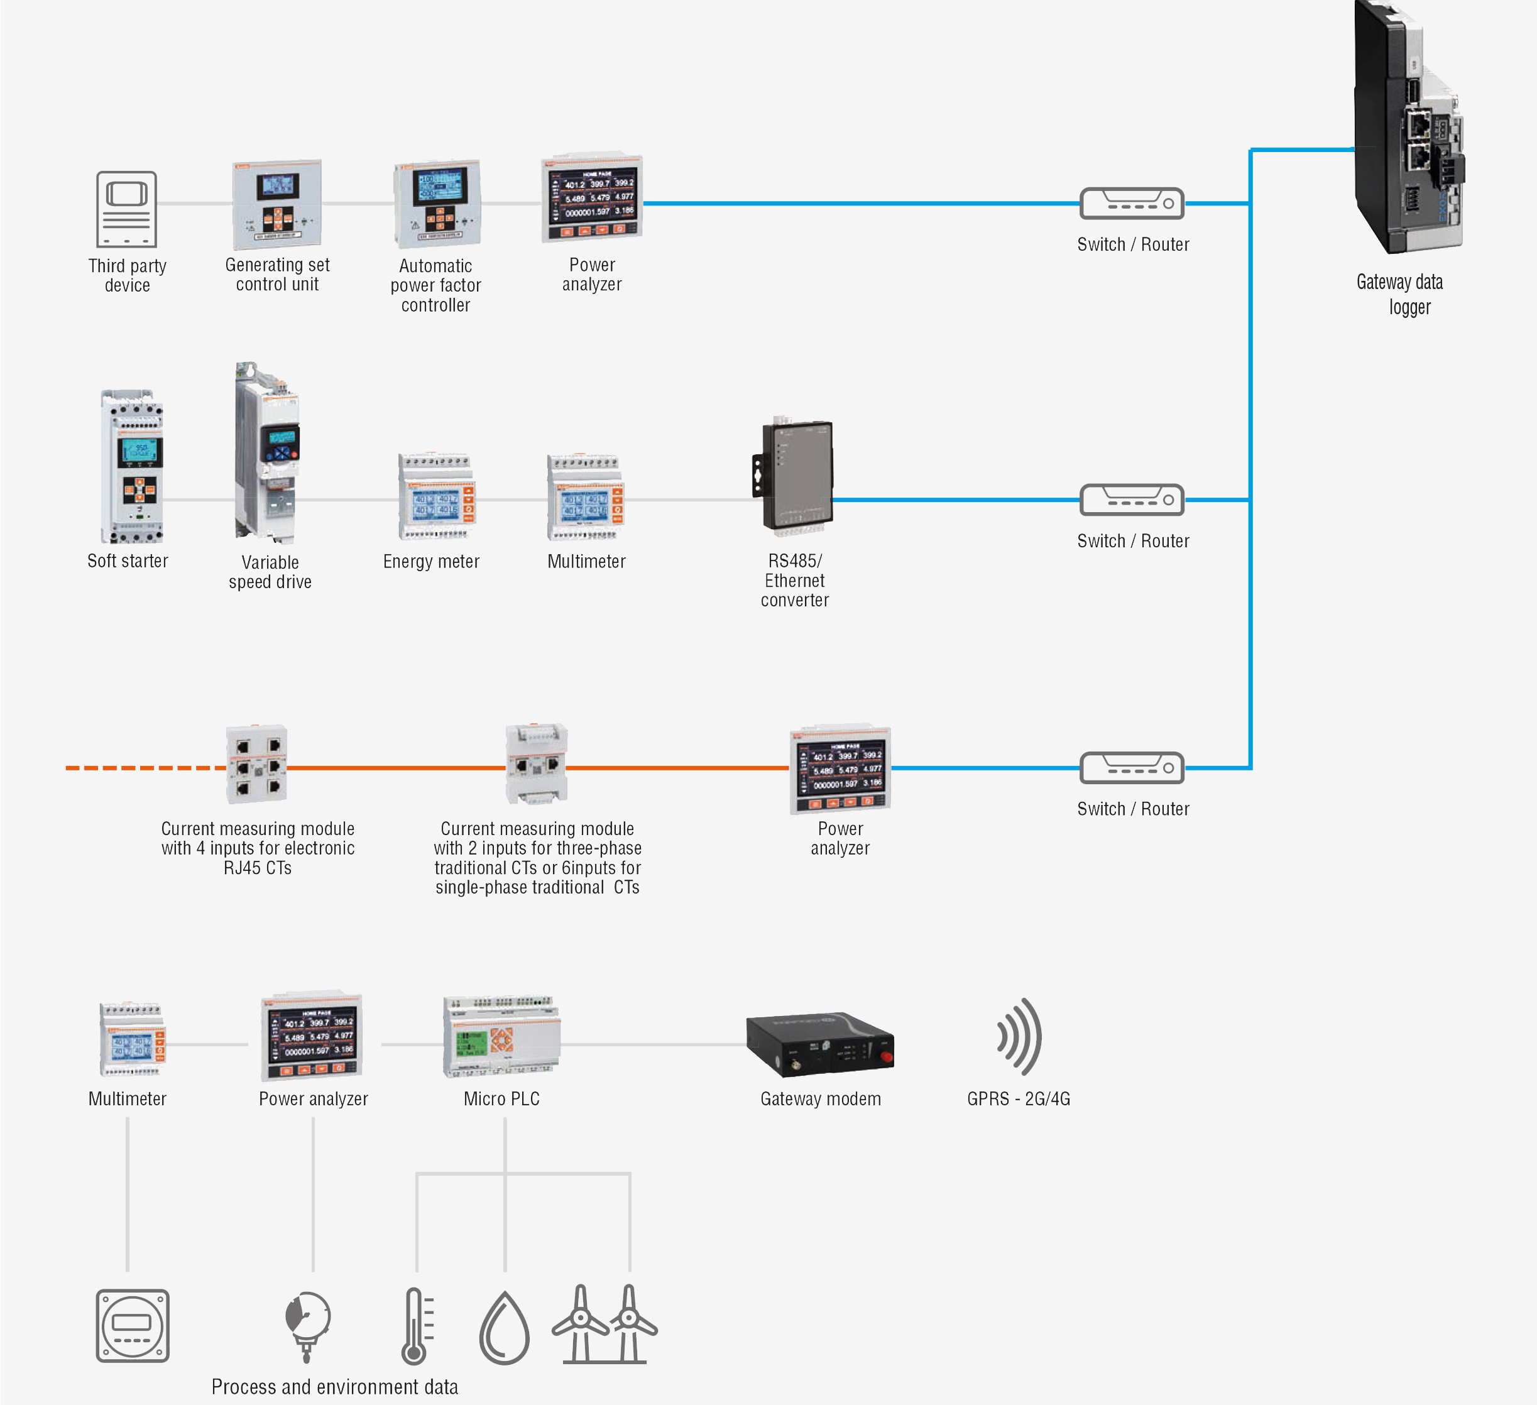
(Lovato Electric, 2022)

The UK Technical Manager confirmed that these were higher costing solutions, and that the Italian based research centre was in the Research and Development phase of LPWAN Devices, to design LPWAN devices to provide lower cost technology.

Researching smaller suppliers discovered an internet supplier (iot-shops) with examples of LPWAN Current Monitoring Meters, which should provide an opportunity to trial and test LPWAN technology in UKWDG, example below:
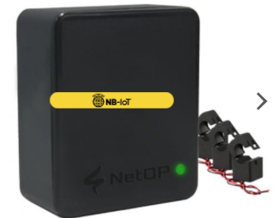
Price = £121.80

“NETOP 3 Phase Current Meter is a long-range wireless sensor which can be used for monitoring current usages. This sensor is fully compatible with LPWAN technology by using NB-IoT (Narrowband-IoT). The standard version of this sensor is powered by one replaceable 3.6 V AA sized battery” (iot-shops, 2022)

Despite the UK market still engaged in wired or Wi-fi technology, other countries are investing research and resources to LPWAN devices.

- China announced new policies in 2016 to combine the Internet with smart technology. They realised a Smart grid would promote a clean energy revolution. (Yonghua Songa, 2017).

- Indian smart metering deployment in rural and urban areas with short range IoT, has been researched and published. The research recommended a LoRaWAN technology solution, based on a Low-Cost Energy monitoring network in a village with the ability to be reviewed on mobile devices. (Jain, 2018)

Conclusions

Following the research mentioned above, this section will indicate the Opportunities for implementation and potential challenges.

Opportunities

With the requirement to monitor energy a LPWAN network is a Cost-Effective solution, and the NETOP meter is a potential solution. It could utilise a simple network that can connect numerous devices enabling Energy Monitoring across a UKWDG Facility. With the Gateway from device to Cloud we can remotely monitor all sites from one application.

Challenges

There are a limited number of devices on the market, with large OEMs still relying on higher powered networks, such as Wired or Wi-fi networks. The current age and technology of the UKWDG IT Infrastructure is varied. A capability study would be required to determine how much investment would be needed to adopt a LPWAN Technology.

Skills

The age and technology of the current IT Infrastructure has limited the IT Department’s knowledge and skill. LPWAN Training would need to be sourced to upskill the current IT Engineers.
Recommendation

Initiate a Project with key stakeholders in IT and Engineering. Conduct a site Survey in a high energy use facility, such as the UKWDG Glass plant, Techniglass. Pre-project activities would include a review of IT Infrastructure and what investment capital the project would require. Devices, such as the NETOP Current Transformer should be trialled to further explore the LPWAN solution. If unsuccessful a further consultation with Lovato/other OEMs will be carried out to determine the most suitable solution.

Process 2 – Product Tracking

At UKWDG windows and doors are processed via Order Batching to a Saw Centre. At the 1st step in the process at the Saw Centre Manual Barcodes are applied, then the product is transferred to the Welding and Cleaning process, where it is manually scanned. After this process it is manually scanned into QC and proceeding to Distribution via another manual scan. The product is again manually scanned at Point of Delivery. 4 Manual scans – allowing 4 opportunities for error. Scrap analysis below shows a typical week where ‘Missing item’ = 170 – not scanned correctly in the product movement process. Resulting cost = £297.50 per week, plus disappointed customers, which may have further implications.

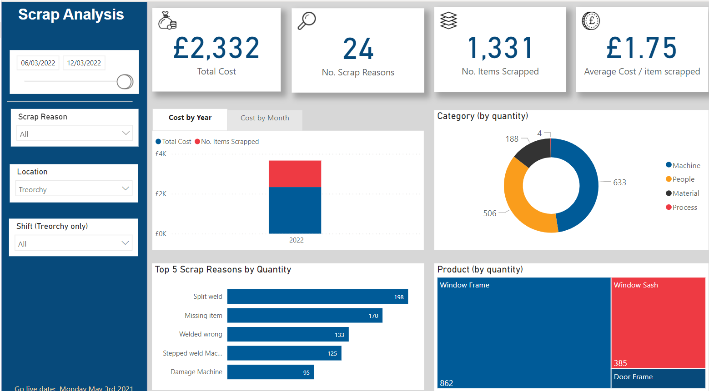

Scope of Opportunity
RFID tagging is a solution already used by others in the Fenestration industry. RFID tagging will enable accurate tracking through the Process. RFID tag would replace the Manual Barcode system. An RFID tag would be applied at the 1st Station in the Process. RFID Readers would be installed at further ‘Gates’ at each process step, tracking the product to final delivery with the Customer.

What is RFID?

RFID Stands for “Radio Frequency Identification”. Utilising Radio Wave technology. An RFID tag consists of a programmable integrated circuit and an antenna. An RFID Reader emits radio waves and when the RFID tag passes through the Reader the integrated circuit transfers data. The benefit of RFID technology is its versatility and reliability due to not needing line of sight or be visible. Types of tags commonly used are stickers, smart labels that can be stitched into clothing and keyring tags generally used in Access control. Each type carries a differing cost.

RFID Tags are also known as Transponders, and of 2 types – Passive and Active. Passive Tags rely on the RFID Reader to emit electromagnetic waves to enable signal communication. Active tags have integrated battery power sources, allowing self-generating communications with a larger range. Active tags are generally larger due to the integrated Power source.

RFID Readers have antennas that send requests for data to the RFID Transponder. The RFID Reader’s function is to translate the received information into the desired data format and communicate it to a Controller or Data end device.

Below is an example of shown on the SICK Website (OEM of sensor technology):

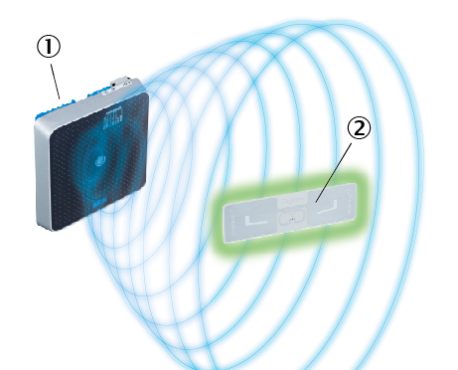
- RFID reader
- RFID transponder
(SICK AG, 2022)

Conclusions

Following the research mentioned above, this section will indicate the Opportunities for implementation and potential challenges.

Opportunities

The reliability and versatility of an RFID system will provide a system that cannot miss product movements, which removes the ‘Mis-scanning’ situation that currently occurs at UKWDG.
RFID Tagging is used in identical processes across the industry. A know installer of this technology is engaged at a feasibility stage of an RFID Tagging Project. Benchmarking can be carried out to ensure a low-risk implementation of the system.

Challenges

Skills and knowledge would be an area of focus. With external support available to implement the project, training would be part of the project. Competence from this training will allow this Technology to be used correctly.

Recommendation

RFID is a solution that can reduce the cost of missing products. A Project will be progressed, and RFID Stickers would be the focus, due to the lower costs. UKWDG have a relationship with Zebra, for the current barcoding system. The further step would be to contact the Zebra agent to determine a trial situation of RFID Sticker Printers, as below:
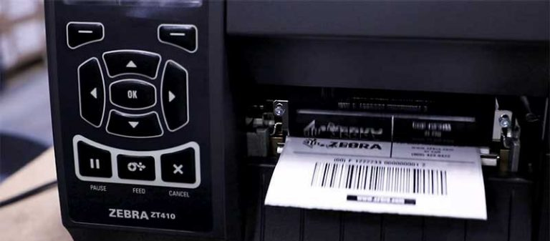
(Technologies, Zebra, 2022)
Concurrently M&J would be partnered to Benchmark a similar Fenestration RFID system, to develop a Project Plan and Feasibility study.

References
Alliance, LoRa, 2022. LoRa Alliance. [Online]
Available at: https://lora-alliance.org/about-lorawan/
[Accessed March 2022].
Jain, S., 2018. Smart Energy Metering using LPWAN IoT. In: ISGW 2017: Compendium of Technical Papers. s.l.:s.n., pp. pp.19-28).
Lovato Electric, 2022. Lovato Electric Synergy/Devices. [Online]
Available at: https://em.lovatoelectric.com/synergy/energy-monitoring/?lang=en#
[Accessed 2022].
Lovato22, 2022. Lovato Electric. [Online]
Available at: https://www.lovato.co.uk/New-DMG%e2%80%a6-series-of-power-analyzers/884/6681/sn
[Accessed 2000].
NETOP, 2022. iot-shops.com 3-phase current meter. [Online]
Available at: https://iot-shops.com/product/3-phase-current-meter-nb/?wmc-currency=GBP
[Accessed March 2022].
SICK AG, 2022. SICK: RFID Know-How: Identification using RFID technology. [Online]
Available at: https://www.sick.com/tr/en/topics-and-knowledge/rfid-know-how-identification-using-rfid-technology/w/rfid/
[Accessed 2022].
Technologies, Zebra, 2022. Zebra.com RFID Labels and Tags. [Online]
Available at: https://www.zebra.com/gb/en/products/supplies/rfid-labels-tags.html
[Accessed 2022].
Yonghua Songa, J. L. M. T. S. D., 2017. Clean Energy—Review. An Internet of Energy Things Based on Wireless LPWAN.

