

Student Name: VISHAL PARESHBHAI KATHIRIYA

Student ID: 2528421

Module Name: INTERNATIONAL MARKETING : PRINCIPLES AND PRACTICES

Module Code: LCMB7026

Lecturer’s Name: DR. PIYUMIKA GAMAGE

Word Count: 5438

Term 2

Executive Summary
Marketing helps an organisation to promote its products but when a company is present in multiple nations then its international marketing has to be changed as per local needs. The purpose of this report was to critically discuss the differences in international marketing strategies of chosen organisation Cadbury, in the home country of the UK and the host country of India. From the macro environment discussion it was found that Cadbury had to face difficulties due to differences slow economic growth and purchasing power of two countries. Because of these differences, the company had to differentiate the pricing and positioning of their products based on the local market needs. From the results of Hofstede's cultural analysis it was evident that the UK and India had a completely different cultures where UK had preferences for flat structure, higher individuality and leisure and India was completely different. Based on these differences Cadbury had to change its promotional aspect of the marketing strategy to find the collective social needs in India. From the segmentation, targeting and positioning analysis it was found that in both markets Cadbury positioned its product differently, as in the UK market it is positioned as high sustainable product and in the Indian market it was positioned as low-cost, high-quality product. From the 7Ps marketing analysis key differences in product, placement and pricing were found. Unethical practices was also found in the business practices of Cadbury where its Indian products were found to be contaminated with worms. In order to overcome these challenges recommendations to use blockchain, and QR code-based system were suggested which will increase the brand's transparency.

Table of Contents
1. Introduction 5
2. Background information about chosen organisation 5
3. Section 1 6
3.1 Comparative analysis of the market in UK and India 6
3.1.1 Macro environment analysis using PESTLE 6
3.1.2 Comparison of cultural factors in UK and India 10
3.2 Comparative analysis of STP 11
3.3 Comparative analysis of International Marketing Mix(7Ps) 14
3.4 Analysis of the market entry strategy of Cadbury in India 17
3.5 An evaluation of ethical issues related to marketing mix in India 18
3.5.1 Ethical Marketing Practices of Cadbury 18
3.5.2 Unethical Marketing Practices of Cadbury 19
3.6 Recommendations for international marketing strategies 19
3.6.1 Inclusion of blockchain to track supply chain to ensure product quality 19
3.6.2 Use of quick readable (QR) code based system to ensure transparency in product ingredients 20
3.6.3 Adoption of product development strategy from Ansoff Matrix for new healthy chocolate 20
4. Section 2 21
4.1 Introduction 21
4.2 Description 21
4.3 Feeling 21
4.4 Evaluation 22
4.5 Analysis 22
4.6 Conclusion 23
4.7 Action plan 23
5. Conclusion 24
6. Reference List 25

1. Introduction
As a result of globalisation the countries are getting connected with each other well through various forms and it is making organisations easier to expand and become international or multinational organisations. As per Kumar (2024), marketing is about promoting company’s products or services to the target audience and international marketing in this aspect to bring products and services international customers. Therefore, the aim of this report is to critically analyse the international marketing strategy of chosen Cadbury brand in home country of the UK and host country of India. Within the report’s scope a comparative analysis of the market, STP, 7Ps of marketing mix, market entry strategy, ethical issues related to marketing and recommendations will be discussed along with reflection on process of researching.

2. Background information about chosen organisation
Cadbury is a UK-based multinational confectionery company which is a part of Mondelēz International company. Cadbury was founded in 1824 by John Cadbury, and the first shop was opened in 93 Bull Street, Birmingham, England (Mondelēz International, n.d.a). In the last 200 years Cadbury has come a long way and the business has expanded into multinational business (Cadbury, 2026a). Figure 1 below shows that currently Cadbury has operations in over 40 countries and besides the home country of the UK other two biggest markets are India and Australia (Mondelēz International, n.d.b). Moreover, net revenue of the company has increased by $2,096 million or 5.8% from 2024 and it is as per 2025 data is about $38,537 million (Mondelēz International, 2025). Hence, it can be seen that from a small beginning the company has been able to expand its business into multiple host nations out of which India is a prominent one.
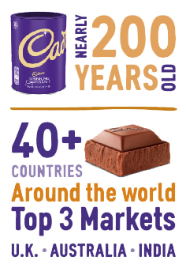
Figure 1: Key Statistics of Cadbury
(Source: Mondelēz International, n.d.b)

3. Section 1

3.1 Comparative analysis of the market in UK and India

3.1.1 Macro environment analysis using PESTLE
Analysis of the macro environment is critically important as it can help in providing a key understanding of the market and influence of different factors that can be favourable or unfavourable for the company. As per Sun et al. (2024), key elements of PESTLE are social, political, legal, economic, technological, and environmental. These elements can be discussed to find which of the factors are favourable and unfavourable for Cadbury.
Factors | UK | Impact | India | Impact
Political | - As per 2026 World Bank data UK’s political stability was reported at 76.78% which makes it a stable country (Trading Economics, 2026a). | Favourable because a stable government means less regulatory changes for Cadbury. | - Based on 2026 World Bank data political stability was identified at 35.55% which makes it a comparatively less stable country (Trading Economics, 2026b). | Unfavourable as it will mean frequent regulatory changes for Cadbury.
Economic | - GDP growth of the UK in 2025 was about 1.4% and inflation is about 3.9% (World Bank, 2026a). | Slow GDP growth in unfavourable for Cadbury as sales will slow down. | - GDP growth in 2025 was reported to be about 7.6% and inflation is at 2.4% (World Bank, 2026b). | Favourable because fast-growing economic activity will help in increasing sales for Cadbury.
Social | - UK has a total population of 69.48 million as per 2025 data (World Bank, 2026a). | Favourable, as it will mean more consumers for Cadbury | - Total population is about 1.46 billion as per 2025 data which is much higher comparatively (World Bank, 2026b). | Favourable because higher population will mean more potential customer for Cadbury.
Technological | - New technologies like 3D food printing is getting popular along with cellular agriculture (Food Safety Magazine, 2026). | Favourable, because it will help Cadbury to improve its production. | - Artificial Intelligence (AI) is being used to ensure quality and efficiency of food production (Jeevanandam, 2025). | Favourable because use of new AI technology will help Cadbury to ensure quality of products.
Legal | - UK Food Safety Act 1990 provides the framework to create legislation to ensure food safety, quality and labelling (Visit Britain, 2026). | Favourable as it will help Cadbury to be a responsible organisation. | - India’s Food Safety and Standards Regulation 2011 ensure safety of food produced in the country (Food Safety and Standards Authority of India [FSSAI], 2026). | Favourable because it will help Cadbury to be a more responsible company.
Environmental | - The UK aims to reach Net Zero carbon emission by 2050 (Parliament UK, 2026). | Favourable as it will help Cadbury to be a sustainable. | - India also aims to reach Net Zero goal by 2070 (Press Information Bureau [PIB], 2023). | Favourable as it will help Cadbury to be a sustainable.
Table 1: Macro Environmental Comparison of UK and India
(Source: Self-developed)

Analysis
From Table 1 above, the comparison of PESTLE forces in respect of both countries, some similarities can also be found. For example, UK and India both have disruptive and cutting-edge technologies that is favourable for Cadbury to further scale production and sales of the company. Moreover, UK has food safety regulations which ensures quality, labelling and safety (Visit Britain, 2026). Similarly, India has its similar food safety regulations which ensure food being produced in the country (FSSAI, 2026). Last similarity can be seen in both countries' environmental commitment to reach Net Zero which is also beneficial for companies like Cadbury which also focuses on being sustainable.
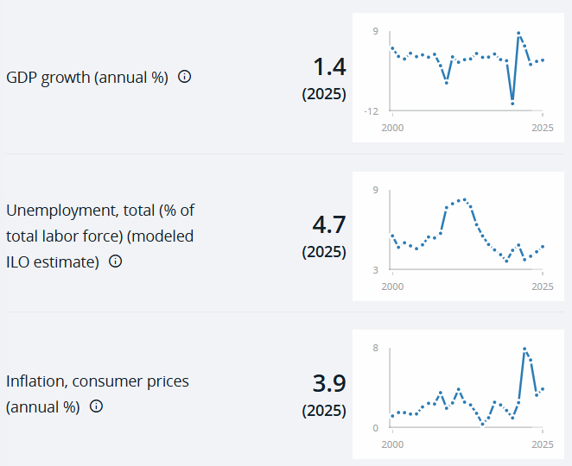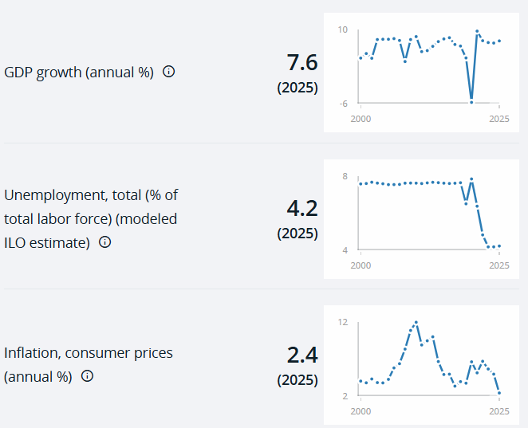
Figure 1: Economic Statistics of UK and India
(Source: World Bank, 2026a; World Bank, 2026b)
Besides the similarities among macro environmental factors, there are some differences. For example, comparatively, UK has a more stable political environment than India, and due to which the home country of Cadbury is more favourable as there will less changes in regulations. Moreover, as seen in Figure 1, UK has a lower GDP growth rate compared to India. As per 2025 data 1.4% is UK’s GDP and inflation rate is about 3.9% (World Bank, 2026a). Comparatively, 7.6% is India’s GDP rate and its inflation rate is 2.4 (World Bank, 2026b). Therefore, it can be argued that in terms of economic environment, India is more favourable to Cadbury compared to the UK. One more difference can be seen in terms of social environment where India with larger population is more favourable compared to the UK.

3.1.2 Comparison of cultural factors in UK and India
A multinational corporation (MNC) has to operate in different cultural scenarios as it has to engage in operations in multiple host countries. In this aspect national culture becomes a critical aspect which needs to be considered by companies like Cadbury which is an MNC and Hofstede’s cultural dimension model can be used. As per Amanor and Demi̇rel (2023), Hofstede’s cultural dimension model has six elements which are power distance, individualism, uncertainty avoidance, indulgence, motivation for success, and long-term orientation. Based on the definition and discussion of this theory it can be critically argued that standardisation of cultural aspects is one of its key advantages and it can help create cross-cultural awareness for businesses. On the other hand, it has some disadvantages, like it uses very old data sets to determine cultural aspects and it oversimplifies cultural traits (Amanor and Demi̇rel, 2023). Despite its limitations, in order to determine the cultural differences between India and UK, Hofstede’s model can be used as it gives a comprehensive understanding of the culture.
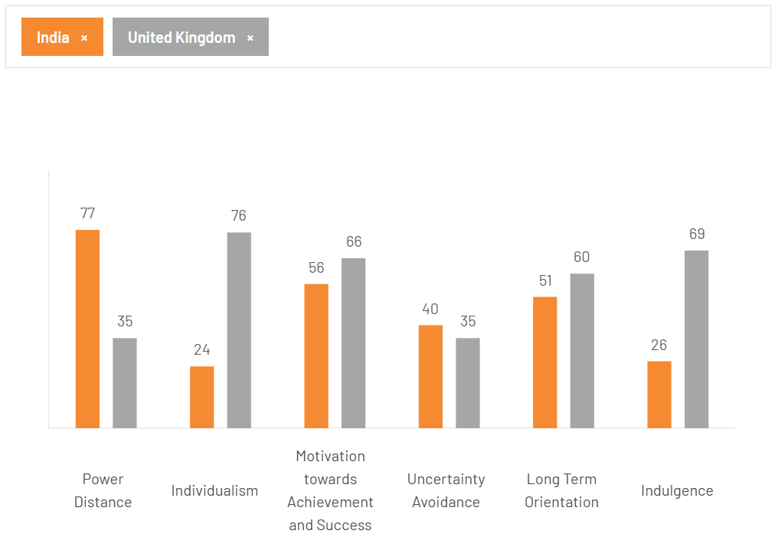
Figure 2: Hofstede’s Cultural Comparison Between India and UK
(Source: The Culture Factor, 2026)
Based on Figure 2 above, huge differences in both countries' culture can be seen in terms of power distance, individualism, and indulgence. India has a 77 score in power distance dimension which is much higher than 35 of the UK (The Culture Factor, 2026). This implies that Indian culture prefers hierarchical structure and UK believes in flat structure where differences in power are low. Therefore, Cadbury being from the UK will have to change its organisational structure from flat to hierarchical to meet cultural needs. Moreover, India’s 24 score in individualism compared to 76 of the UK shows preference for a collective society than individualistic society of the UK (The Culture Factor, 2026). Hence, Cadbury following host country’s cultural norms will have change marketing and organisational practices to meet the collective demand. In the indulgence dimension, India’s score is 26 and the UK has a score of 69, which implies that Indian people have limited emphasis on leisure compared to UK society (The Culture Factor, 2026). Hence, chocolate being a luxury item, Cadbury will have to face difficulties in selling them and they will need to target it as a necessary item. In other three dimensions, score are almost similar so big changes are required for those.

3.2 Comparative analysis of STP
Different markets have different cultural and economic differences and the same can be said about Cadbury's home country of the UK and host country India. In this aspect, segmentation, targeting and positioning (STP) become very critical for companies like Cadbury. As per Nursetyo and Dwiridotjahjono (2025), markets are segmented based on geography, demography, behaviour, and psychographic needs, whereas targeting is based on niche or mass market and positioning is based on perception. Based on these factors along with culture and economic differences STP of Cadbury in UK and Indian markets has been identified in Table 2 below.
Factors | UK | India
Segmentation | Geographic segmentation: About 95% of the United Kingdom consumers eat chocolate highest in the world (French, 2024).  Demographic segmentation: Children, teenagers and young adults as over 95% people eat chocolate (French, 2024).  Behavioural segmentation: People who are repeat buyers and seeking premium chocolate as 4 out of 5 UK people eat chocolate once a week (French, 2024).  Psychographic segmentation: Seeks premium experience and environmentally conscious consumers (French, 2024). | Geographic segmentation: Indian rural and urban areas (IMARC Group, 2026).  Demographic segmentation: Children, teenagers, young adults, older adults and low and middle-income group. Adults hold 45% of the market share (IMARC Group, 2026).  Behavioural segmentation: Festive shoppers, impulse shoppers and people who need chocolate to celebrate something. Also, about 45% of Indian adult group wants healthy chocolate (IMARC Group, 2026).  Psychographic segmentation: Young parents, and environmental conscious consumers who wants sustainable packaging (IMARC Group, 2026).
Targeting | Niche Targeting: Consumer spending in the UK has increased to £419,235 million in the first quarter of 2026 (Trading Economics, 2026c). Based on this increased consumer spending power Cadbury uses niche targeting strategy to target high-purchasing power individuals with high-quality chocolates. | Mass Market Targeting: The Indian confectionery market size as of 2025 is about ₹398.71 billion and with 4.99% CAGR by 2034 it will reach ₹618.10 billion (IMARC Group, 2026). Moreover, adults accounts for about 45% of the sales in India (IMARC Group, 2026). Hence, based on demand from all group Cadbury uses mass market strategy.
Positioning | Sustainable positioning: In the UK, Cadbury focuses on sustainable sourcing of Cocoa and aims to invest over $60 million more by 2030 to sustainable farming (Cadbury, 2026c). This shows the company focuses on positioning the product as sustainable. | Value-based positioning: Indian market is dominated by economically priced confectionery products which account for 49.6% of the market (IMARC Group, 2026). Hence, Cadbury in India focuses on pricing its products to provide best value for the customers.
Table 2: Comparative STP Analysis
(Source: Self-developed)
Analysis
From the comparative analysis of Table 2 above, in terms of market segmentation a similarity can be seen as both market segments focus on children and young people. However, differences can also be seen in the UK and Indian market segments of Cadbury. For example, as per above cultural analysis UK was found to have more indulge into enjoying life and based on their purchasing power Cadbury’s market segment was premium chocolate. In contrast, India having a low emphasis on indulgence, Cadbury focuses on mass market. Moreover, based on the UK cultural preference of individualistic society Cadbury uses niche market targeting strategy, whereas India being a collective society as mass market targeting strategy is used. One more difference is seen in case of positioning where based on sustainability preference products in the UK are positioned as sustainable. Indian market is price-sensitive as most products are economically priced (IMARC Group, 2026). Hence, in India based on its economic factors Cadbury positioned its chocolates as value-based product and Figure 3 shows the perceptual mapping differences.
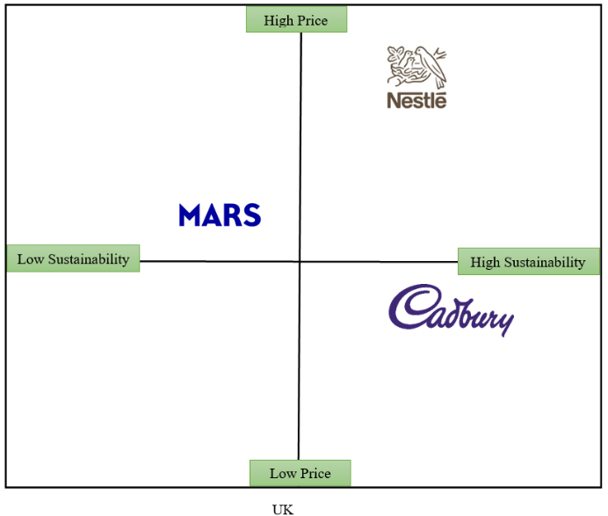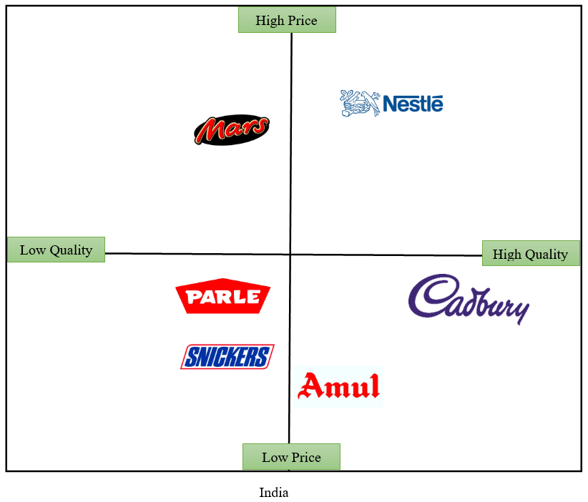
Figure 3: Perceptual Positioning Differences
(Source: Self-developed)

3.3 Comparative analysis of International Marketing Mix(7Ps)
MNCs, while operating in a culturally, and economically different country has to adjust their marketing practices to best suit the local needs. In the case of Cadbury in order to analyse its international marketing mix the 7Ps of marketing mix can be used in case of home country of the UK and host country of India. As per Nguyen et al. (2025), the elements of 7Ps of marketing mix are price, place, product, promotion, process, place, people and physical evidence. Table 3 below represents the differences and similarities of marketing mix between UK and Indian market for Cadbury.
Factors | UK | India
Product | Cadbury in UK has set up a £3.3 million new centre to shape the future of the brand and they are hiring testers to ensure premium quality (Olah and Lissaman, 2025). Hence, a standardised system for ensuring brand’s premium positioning can be seen in the UK. | Cadbury in India focuses on creating different products for different segments like Dairy Milk, 5Star, Perk, Oreo, Gems and Fuse (Mondelēz International, n.d.c). Hence, an adoption of differentiation strategy can be seen because of high diversity of Indian market.
Price | Mondelēz UK boss Louise Stigant, in an interview said that prices of products have been raised by 8% and people have to grow accustomed to a higher cost of living (Butler, 2024). This shows that company follows premium pricing. Hence, based on the purchasing power of customer adoption of premium pricing strategy can be seen. | Depending on the Indian customer’s purchasing power, Cadbury chocolate starts from ₹5 (Bigbasket, 2026). This implies that Cadbury follows a low-cost penetration pricing strategy. Hence, based on the purchasing power of host country consumer adoption of low-cost penetration pricing can be seen.
Place | Products in the UK are sold through supermarkets and well as company's website "Cadbury Gifts Direct" (Cadbury Gifts Direct, n.d.). Hence, both online and offline distribution strategies for product placement can be seen. This further shows standardisation practice where both options are considered. | In India, Cadbury products are available through 3 million mom-and-pop shops or offline retail stores which is the backbone of India's snacking culture (Mondelēz International, n.d.c). Hence, offline product placement is prominent part of Cadbury along with e-commerce like Bigbasket. This further shows an adoption of local market preference of offline placement.
Promotion | Cadbury in the UK uses social media marketing platforms like Facebook, X, Instagram and YouTube (Mondelēz International, n.d.d). Hence, use of digital marketing to target individuals can be seen. Because of the fact that UK is highly developed country where social media has higher penetration a standardised promotion campaign can be seen. | In India, Cadbury has been trying to become a household name and tries to replace traditional ‘meetha’ with campaigns like ‘Kuch Meetha Ho Jaaye” which focuses on mass marketing through traditional media (Mondelēz International, n.d.c). Because of the fact that India is a developing nation where internet penetration is moderate an adoption of local market preference for offline promotion through advertisement can be seen.
People | In the UK, Cadbury has over 4,000 employees across its 9 sites which include 6 factories, and research and development (R&D) sites (Mondelēz International, n.d.d). A standard practice can be seen. | In India, Cadbury has over 3500 people from diverse backgrounds out of which 66% are millennials, 20% Gen Z (Mondelēz International, n.d.c). Similarly a standard practice can be seen where people from diverse backgrounds are hired.
Process | In the UK, the company follows strict testing process to ensure quality as recently the company have hired about 48 people to taste chocolate (Olah and Lissaman, 2025). A standard process of quality testing can be seen. | In India, the company also focuses on quality with better ingredients and a sustainable production process (Mondelēz International, n.d.c). In a similar way a standard quality testing process can be seen.
Physical Evidence | The company is clearly distinguishable because of its iconic purple colour (Mondelēz International, n.d.b). A standard packaging and branding evidence can be seen. | In India, the company is also recognised based on the purple colour and it has 15 factories across the country (Mondelēz International, n.d.c). Similarly a standard packaging and branding practice is evident across all products.
Table 3: Comparative 7Ps Marketing Mix
(Source: Self-developed)
Analysis
Based on Table 3 above, similarities like in the marketing strategy like having the similar purple colour in packaging and focus on product quality ensuring process can be seen. In people-related strategy one more similarity can be seen where in both country they hires employees to fulfil organisational operations. One more similarity was that in both countries Cadbury uses online and offline product placement strategies. However, there are multiple differences, for example, based on the cultural preference in the UK company focuses on premium products whereas in India based on local market diversity product diversification can be seen. Additionally, depending on high purchasing power of UK consumers, product prices was increased by 8% (Butler, 2024). In contrast, for the products in India a lower pricing was adopted because of the economic condition of India as a developing country. As per above Hofstede’s cultural analysis, UK being a individualistic society it was found that Cadbury in the UK uses digital marketing to target individuals, whereas in India it uses mass marketing strategy of TV advertisements was adopted. Overall, the product positioning, pricing, promotion, and placement strategy adopted local market needs and in terms of people, process and physical evidence a standardised strategy was seen.

3.4 Analysis of the market entry strategy of Cadbury in India
Cadbury entered Indian market after a long time of its establishment in the UK. The company entered Indian market over 75 years ago in 1948 through establishing wholly owned subsidiary company called Mondelēz India (Mondelēz International, n.d.c). Rather than using other market entry strategies like franchise or licensing, Cadbury chose to enter Indian market on its own with a subsidiary brand. This method has some advantages as well as disadvantages which need to be discussed. Its key advantages are, low risk of internal uncertainty because same organisational practices can be transferred (da Silva, Ogasavara and Pereira, 2023). Moreover, having a wholly owned subsidiary helps in keeping the intellectual property secure as business would not have to share it with other third-party companies. Hindustan Unilever is one more similar successful example of wholly owned subsidiary which part of Unilever company which is also UK-based (Unilever, 2026). Hence, it can be said that the market entry strategy of using a wholly owned subsidiary is one of the popular strategies that MNCs adopt.
Besides the advantages there are some disadvantages or challenges associated with the wholly owned subsidiary entry strategy. For example, it may require high capital investment and may have risk of failure as the entering company may not have idea about local market needs. Additionally, according to Bhat et al. (2022), foreign companies can face discriminatory pressure from the host government to attain business approval. For example, in 2020, India announced new Foreign Direct Investment (FDI) policy which requires multiple approvals for the investors to open their subsidiaries (Department for Promotion of Industry and Internal Trade [DPIIT], 2020). Hence, it can be clearly identified that regulatory approval can be a critical disadvantage of this wholly owned subsidiary market entry strategy.

3.5 An evaluation of ethical issues related to marketing mix in India

3.5.1 Ethical Marketing Practices of Cadbury
As part ethical marketing practices ‘Cocoa Life’ campaign can be identified for Cadbury India. As per company report it has been running sustainable cultivation and sourcing of cocoa since last 60 years and it has been able to empower cocoa communities and protect forests in regions like Tamil Nadu, Kerala, Karnataka and Andhra Pradesh (Mondelēz International, n.d.e). Due to this sustainable farming, 10,000 farmers have been trained so far (Mondelēz International, n.d.e). Hence, this program can be linked to product and people factors of the marketing mix as it has made products sustainable and people highly skilled.
Another ethical marketing practice was its recent cultural promotional campaign ‘Kuch Meetha Ho Jayen’. This promotional campaign focuses on celebrating the generous instinct in people showcasing examples of moments that strengthen human relations (ET Brand Equity, 2018). Through this campaign the brand explored goodness in people and built its strong proposition among people's minds (ET Brand Equity, 2018). Hence, this successful campaign can be identified as an ethical application of brand promotional strategy from which is part of 7Ps of marketing mix.

3.5.2 Unethical Marketing Practices of Cadbury
There are some examples of unethical marketing practices by Cadbury in India which needs to be discussed. Diwali which is India’s biggest festival and one of the peak seasons for chocolate sales and customers from Mumbai reported finding of live worms inside Cadbury Dairy Milk chocolate bars (Journalism University, 2026). In India where the brand has over 70% of the chocolate market it was most devastating for the company and Maharashtra Food and Drug Administration (FDA) received complaints and found live and dead insects in the tested samples (Journalism University, 2026). This unethical marketing practice can be linked to product and quality management process-related issue from 7Ps of marketing mix.
One more unethical marketing practice was observed recently in case of Cadbury. In the social media people started tweeting using #BoycottCadbury where a screenshot was being shared that mentioned the use of gelatine which is used in products which is halal certified and it is derived from beef (Varma, 2022). After its going viral on the social media the company then had to come up with clarification that 100% of their products are vegetarian (Varma, 2022). Therefore, a lack of clarity on products can be seen which led to a promotional crisis. Hence, it can be determined as an unethical practice as the company had low transparency and it is linked to 7Ps of marketing mix.

3.6 Recommendations for international marketing strategies
Based on the above discussion in section 3.5.2 some of the key challenges for the company were found to be in ensuring product quality as in the past worm infestation has happened. Moreover, from the same section it was also found that the company have less transparency about the ingredients used in the product which hold cultural significance for local communities. These aspects need to be improved going forward with their international marketing strategies. Along with these aspects the company can also adopt product development strategy to meet health-conscious consumer trends. In these aspects the following recommendations can be adopted by Cadbury:

3.6.1 Inclusion of blockchain to track supply chain to ensure product quality
One of the key ethical challenges faced by Cadbury in India as per section 3.5.2 was worm infestation in the product which impacted brand reputation and product quality negatively. Blockchain uses decentralisation of data which makes it impossible to hack into and it can be used in tracking supply chain of products (Verma, 2026). This can be further used to develop a system in which both the customer and company can track the entire product life cycle across the supply chain and this data will be tamper-proof (Verma, 2026). In this aspect Cadbury can partner with a technology company like IBM to make the system. This can ensure that product has been going through proper quality check and cold chain which will ensure that product has not been contaminated. It will ensure quality of the chocolates and make the company be reputed as a transparent organisation and it will also improve customer perception. Hence, as a marketing recommendation, this product strategy will improve product quality going forward.

3.6.2 Use of quick readable (QR) code based system to ensure transparency in product ingredients
QR code-based system can be another useful strategy going forward to increase product ingredients-related transparency among customers because as per discussion in section 3.5.2 it was found as an unethical practice. A similar implementation has been seen in products of companies like Coca-Cola, Pepsi and Red Bull (Storyboard 18, 2026). This QR code provides an idea about 140 commonly used ingredients in beverages in the product which lets customers be aware of their health (Storyboard 18, 2026). Hence, a similar strategy can also be adopted by Cadbury which improve brand reputation going forward regarding their product quality and help the brand to be recognised as a transparent organisation.

3.6.3 Adoption of product development strategy from Ansoff Matrix for new healthy chocolate
Going forward customers in the confectionery market are going to demand for a healthier option as seen in the section 3.2 Indian market’s behavioural segmentation. As per a market study report, consumer behaviour is shifting rapidly toward healthier chocolate and their demand is for zero-sugar formulation (Deloitte, 2026). Hence, Cadbury can also be recommended to adopt a product development strategy to formulate new and healthier chocolate. As per the Ansoff Matrix, product development strategy helps in development of new products as per the market demand (Ferreira and de Sá Moscoso, 2024). Hence, based on the customer demand Cadbury needs to invest in research and development so that new zero-sugar chocolate can developed which has demand among customer going forward.

4. Section 2

4.1 Introduction
Reflection helps to look back at the past experiences and in this reflection I will also reflect on my research, analysis, and preparing the previous section. Gibbs' reflective cycle has six stages: analysis, description, feeling, evaluation, conclusion and action plan (Roedema et al., 2022). I have used this model to focus on my experiences in preparing this assessment in first section.

4.2 Description
This reflection is based on my experience in researching, analysing and preparing the previous sections of the assessment. For me, it was a practical experience as I was able to use my class-learnt academic theories practically in this assessment. For example, while discussing the macro environment in both countries, I remembered PESTLE framework which was taught in class. I remembered that this framework is helpful in identifying external environmental factors which can influence the business operations of any organisation. According to Sun et al. (2024), key elements of PESTLE are social, political, legal, economic, technological, and environmental. Besides this framework, I have used Hofstede's cultural theory to identify the differences between Indian and UK culture. I have also used the STP framework to identify the marketing position and 7Ps framework to identify marketing differences. The classroom discussion during the module proved to be very helpful in completing the above section of the assessment.

4.3 Feeling
During the research process of the previous part of the assessment at first I felt lost as there was a lot which needed to be found and I had limited experience in comparing two different countries. However, during the classroom discussion and activities some of my classmates showed me the process which they use to find required information. For example, one of my friend showed me how to use inverted quotation to find the exact information needed. During the task I actually used quotations to find relevant information from the external environment, cultural differences and target market. In this aspect learning advanced search methods helped me find relevant articles from Google Scholar related to Hofstede’s theory. Amanor and Demi̇rel (2023) have suggested that Hofstede’s cultural dimension model is focused on identifying national cultural differences. After successfully completing the above market research I felt happy as I was able to overcome my research related challenges.

4.4 Evaluation
My theoretical research section went very well because of my strengths or expertise in academic theory. Mostly, my experience in the framework or theoretical part in the above section went well. However, while finding the relevant statistical information about the STP in the UK and Indian market segment I felt difficulties due to my weakness in research skill. Nursetyo and Dwiridotjahjono (2025) suggested that markets for a company are segmented based on geography, demography, behaviour, and psychographic needs, whereas, targeting is based on niche or mass market and positioning is based on perception. Initially, I was unable to find relevant sources to identify the correct brand positioning in the UK for Cadbury. However, later on when I tried to find the promotional campaign differences in both markets I noticed that in the UK products are targeted based on their ingredients and sustainable aspect. In the Indian market, products were marketed based on emotion and cultural aspects along with economic conditions in mind. Then I found brand positioning differences and I presented it using perceptual map.

4.5 Analysis
Following my analysis, I have identified that the framework-related or theoretical part went very well because of my expertise in remembering theories and using it in practical situations. However, I felt a lack of research skill due to which my research process to find relevant information took a long time. For example, the theoretical discussion related to the 7Ps of marketing went very well. Nguyen et al. (2025) identified that elements of 7Ps of marketing mix are price, place, product, promotion, process, place, people and physical evidence. During the application of 7Ps of marketing mix I faced difficulties in finding evidence related to pricing strategy in both the market. As I had limited experience in this aspect I took me a long time to analyse the pricing strategy in the UK and I was able to identify that in the UK market Cadbury uses premium pricing. In contrast, in the Indian market based on its economic condition and purchasing power the brand has been using low-cost penetrative pricing strategy.

4.6 Conclusion
From the preparation of the previous section I was able to identify my strength in remembering academic theories and applying them in any real business case scenario. Moreover, I have also learnt the use of business management framework in a real scenario which in future also be helpful in my profession as marketing manager. I have learnt the actual use of the Ansoff Matrix which can be used to recommend strategies for companies. Ferreira and de Sá Moscoso (2024) have suggested that product development strategy of Ansoff Matrix helps in development of new products as per the market demand. In future, I will be focusing on improving my research skill so that I can be better prepared to conduct research on any given organisation or topic.

4.7 Action plan
I plan to acquire expert-level research skill using the following action plan I will focus on critical thinking, technical ability and data analytics:
Specific | Measurable | Achievable | Relevant | Time-bound
To improve my current research skill by focusing on critical thinking ability | Receiving the highest grade (distinction) in at least 2 similar research-based tasks | It is achievable because based on the suggestions and feedback from peers and supervisors I will improve my critical thinking ability | It is relevant because critical thinking helps in analysis of research data | Next 6 months
To improve technical skill to help improve my research ability | I will watch 2 YouTube videos weekly regarding how search for articles better to improve my technical capability | Watching YouTube videos I can follow the same process on my system to get better results | It is relevant because getting the appropriate search result will help in better assessment | Next 3 months
To improve data analytics ability to improve research skill | Complete at least 3 sessions in the online certification classes regarding data analytics | I will enrol myself in an online course on data analytics which is a key part of research | It is relevant because better analytics will result in better findings for assessments | In next 5 months
Table 4: Action Plan
(Source: Self-developed)

5. Conclusion
The aim of this report was to critically discuss the differences in international marketing strategies of Cadbury in home country of UK and host country of India. From the above discussion, it can be concluded that in macro environment Cadbury had to face difficulties due to differences slow economic growth and purchasing power of two countries. Due to which Cadbury had to differentiate the pricing and positioning of their products based on the local market needs. It was also found that in both markets Cadbury has positioned its product differently, as in the UK market it is positioned as high sustainable product and in the Indian market it was positioned as low-cost and high quality product. Unethical practices were also found in the business practices of Cadbury where its Indian products were found to be contaminated with worms and to overcome these challenges recommendations to use blockchain, QR codes and new product development were given.

6. Reference List
Amanor, S. and Demi̇rel, H.G. (2023) “The influence of Hofstede’s cultural dimensions on job satisfaction: A study of African expatriates in Turkey,” Anemon muş alparslan üniversitesi sosyal bilimler dergisi, 11(1), pp. 180–203. Available at: https://doi.org/10.18506/anemon.1345246.
Bhat, M.N., Ikram, F., Rahman, M.N. and Naeem, M.H. (2022) “Economic freedom of the world: Wholly owned subsidiaries and joint ventures as binary response,” Transnational corporations review, 1(1), pp. 1–18. Available at: https://doi.org/10.1080/19186444.2022.2127610.
Bigbasket (2026) Buy cadbury dairy milk chocolate bar 66 Gm online at best price of rs 5 - bigbasket. Available at: https://www.bigbasket.com/pd/20005974/cadbury-dairy-milk-chocolate-bar-63-g/ (Accessed: July 21, 2026).
Burnett, N. and Stewart, I. (2026) The UK’s plans and progress to Reach net zero by 2050, House of Commons Library. UK Parliament. Available at: https://commonslibrary.parliament.uk/research-briefings/cbp-9888/ (Accessed: July 21, 2026).
Butler, S. (2024) “‘When people want a treat they are looking for the cadbury they know’: Mondelēz UK boss louise stigant on changing times,” The guardian, 31 March. Available at: https://www.theguardian.com/business/2024/mar/31/when-people-want-a-treat-they-are-looking-for-the-cadbury-they-know-mondelez-uk-boss-louise-stigant-on-changing-times (Accessed: July 21, 2026).
Cadbury (2026a) The Cadbury Story Available at: https://www.cadbury.co.uk/about/history/our-story/ (Accessed: July 20, 2026).
Cadbury (2026b) Cocoa Life, 10 years focused on making Cocoa more sustainable Available at: https://www.cadbury.co.uk/about/impact/cocoa-life/ (Accessed: July 23, 2026).
Cadbury Gifts Direct (n.d) CLASS of 2026 GRADUATION Available at: https://www.cadburygiftsdirect.co.uk/ (Accessed: July 23, 2026).
da Silva, F.M., Ogasavara, M.H. and Pereira, R. (2023) “Institutional distances and equity-based entry modes: A systematic literature review,” Management review quarterly, 74(1), pp. 1723–1790. Available at: https://doi.org/10.1007/s11301-023-00346-4.
Deloitte (2026) Spotlight: Disruptors in the Chocolate Industry Deloitte Chocolate Study 2026. Available at: https://www.deloitte.com/ch/en/Industries/consumer/perspectives/the-chocolate-industry.html (Accessed: July 22, 2026).
Department for Promotion of Industry and Internal Trade [DPIIT] (2020) Consolidated FDI Policy Circular of 2020 Available at: https://www.dpiit.gov.in/static/uploads/2025/07/6457fc2703ee6082366c4a958b6473a8.pdf (Accessed: July 23, 2026).
ET Brand Equity (2018) “​​Cadbury dairy milk’s ‘kuchh meetha ho jaaye’ campaign shifts focus to ‘Acchai,’” ETBrandEquity, 20 July. Available at: https://brandequity.economictimes.indiatimes.com/news/research/advertising/cadbury-dairy-milks-kuchh-meetha-ho-jaaye-campaign-shifts-focus-to-acchai/65063775 (Accessed: July 21, 2026).
Ferreira, A.P.P.F.S. and de Sá Moscoso, M.M.B.P. (2024) “The importance of the ansoff matrix for the study of the information services market,” The canadian journal of Information and library science, 47(2), pp. 78–84. Available at: https://doi.org/https://doi.org/10.5206/cjils-rcsib.v47i2.17432.
Food Safety and Standards Authority of India [FSSAI] (2026) I. Food Safety and Standards Regulations Available at: https://fssai.gov.in/cms/food-safety-and-standards-regulations.php (Accessed: July 23, 2026).
Food Safety Magazine (2026) “UK FSA Identifies Emerging Food Technologies Shaping Future Food Safety Needs”, FoodSafetyMag, 16 March. Available at: https://www.food-safety.com/articles/11243-uk-fsa-identifies-emerging-food-technologies-shaping-future-food-safety-needs (Accessed: July 23, 2026).
French, R. (2024) Report: 95% of British consumers eat chocolate Available at: https://www.supplysidefbj.com/market-trends-analysis/report-95-of-british-consumers-eat-chocolate (Accessed: Aug 12, 2026).
IMARC Group (2026) India Confectionery Market Size, Share, Trends and Forecast by Product Type, Age Group, Price Point, Distribution Channel, and Region, 2026-2034 Available at: https://www.imarcgroup.com/india-confectionery-market (Accessed: July 23, 2026).
Jeevanandam, N. (2025) “Transforming india’s food industry: Impact of AI in 2025,” IndiaAI, 2 January. Available at: https://indiaai.gov.in/article/transforming-india-s-food-industry-impact-of-ai-in-2025 (Accessed: July 21, 2026).
Journalism University (2026) Cadbury’s crisis and comeback: Managing the worm infestation scandal. Available at: https://journalism.university/media-ethics-and-laws/cadbury-crisis-comeback-worm-infestation-management/ (Accessed: July 21, 2026).
Kumar, V. (2024) International marketing research. Springer Nature. Available at: https://www.google.co.in/books/edition/International_Marketing_Research/hw0TEQAAQBAJ?hl=en&gbpv=1&dq (Accessed: July 20, 2026).
Mondelēz International (2025) Annual Report 2025 Available at: https://ir.mondelezinternational.com/static-files/01542e43-4c7b-4410-9b7e-820b24804e2f (Accessed: July 23, 2026).
Mondelēz International (n.d.a) Cadbury Available at: https://www.mondelezinternational.com/our-brands/Cadbury/ (Accessed: July 20, 2026).
Mondelēz International (n.d.b) Cadbury Available at: https://www.mondelezinternational.com/assets/Our-Brands/Brands/Cadbury/cadbury_fact_Sheet.pdf (Accessed: July 23, 2026).
Mondelēz International (n.d.c) Our Business in India Available at: https://www.mondelezinternational.com/india/india-business/ (Accessed: July 23, 2026).
Mondelēz International (n.d.d) UNITED KINGDOM Available at: https://www.mondelezinternational.com/united-kingdom/ (Accessed: July 23, 2026).
Mondelēz International (n.d.e) 60 years of India Cocoa Program Available at: https://www.mondelezinternational.com/india/india-business/cocoa-life/ (Accessed: July 23, 2026).
Nguyen, K.M., Thi, L., Ngo, T.T., Thi, T., Dinh, P., Pham, H. and Nguyen, N.T. (2025) “The impact of 7Ps green marketing mix on customer commitment and willingness to pay a premium price: Evidence from Vietnam,” Journal of Promotion management, 31(4), pp. 578–619. Available at: https://doi.org/10.1080/10496491.2025.2484712.
Nursetyo, D.F. and Dwiridotjahjono, Dr.J. (2025) “Analysis of Segmentation, targeting, and positioning (STP) in Increasing sales volume at Imba coffee surabaya,” International journal of Social, economic, and business, 1(4), pp. 33–39.
Olah, M. and Lissaman, C. (2025) “Chocolate tasters join Cadbury owner’s new £3m research centre,” BBC, 15 July. Available at: https://www.bbc.com/news/articles/c1dn2e02zpdo (Accessed: July 21, 2026).
Press Information Bureau [PIB] (2023) Net zero emissions target Available at: https://www.pib.gov.in/PressReleaseIframePage.aspx?PRID=1945472&reg=48&lang=2 (Accessed: July 23, 2026).
Roedema, T., Rerimassie, V., Broerse, J.E.W. and Kupper, J.F.H. (2022) “Towards the reflective science communication practitioner,” Journal of Science communication, 21(4), pp. 1–20. Available at: https://doi.org/10.22323/2.21040202.
Storyboard 18 (2026) “Coca-Cola, pepsi, red bull to add QR codes linking to ingredient details,” Storyboard18, 23 June. Available at: https://www.storyboard18.com/brand-marketing/coca-cola-pepsi-red-bull-to-add-qr-codes-linking-to-ingredient-details-102092.htm (Accessed: July 22, 2026).
Sun, Z., Tavakoli, S., Khalilpour, K., Voinov, A. and Marshall, J.P. (2024) “Barriers to Peer-to-Peer energy trading networks: A Multi-Dimensional pestle analysis,” Sustainability, 16(4), p. 1517. Available at: https://doi.org/10.3390/su16041517.
The Culture Factor (2026) Country Comparison tool Available at: https://www.theculturefactor.com/country-comparison-tool?countries=india%2Cunited+kingdom (Accessed: July 23, 2026).
Trading Economics (2026a) United Kingdom - Political Stability And Absence Of Violence/Terrorism: Percentile Rank, Upper Bound Of 90% Confidence Interval Available at: https://tradingeconomics.com/united-kingdom/political-stability-and-absence-of-violence-terrorism-percentile-rank-upper-bound-of-90percent-confidence-interval-wb-data.html (Accessed: July 23, 2026).
Trading Economics (2026b) India - Political Stability And Absence Of Violence/Terrorism: Percentile Rank, Upper Bound Of 90% Confidence Interval Available at: https://tradingeconomics.com/india/political-stability-and-absence-of-violence-terrorism-percentile-rank-upper-bound-of-90percent-confidence-interval-wb-data.html (Accessed: July 23, 2026).
Trading Economics (2026c) United Kingdom Consumer Spending Available at: https://tradingeconomics.com/united-kingdom/consumer-spending (Accessed: July 23, 2026).
Unilever (2026) 1980 – 2010 – A bold change of strategy, Unilever. Available at: https://www.unilever.com/our-company/our-history-and-archives/1980-2010/ (Accessed: July 21, 2026).
Varma, A. (2022) “Boycott cadbury trends with old screenshot of Company’s australian website,” TheQuint, 30 October. Available at: https://www.thequint.com/news/webqoof/boycott-cadbury-trend-halal-australian-website-screenshot-fact-check (Accessed: July 21, 2026).
Verma, S. (2026) How blockchain and IoT is making supply chain smarter Available at: https://www.ibm.com/think/topics/blockchain-for-supply-chain (Accessed: July 23, 2026).
Visit Britain (2026) Food safety and hygiene Available at: https://www.visitbritain.org/business-advice/pink-book/food-safety-and-hygiene (Accessed: July 23, 2026).
World Bank (2026a) United Kingdom Available at: https://data.worldbank.org/country/united-kingdom (Accessed: July 23, 2026).
World Bank (2026b) India Available at: https://data.worldbank.org/country/india (Accessed: July 23, 2026).

