Name |  | Monica Cernat
Student number |  | 1913391
Module name |  | Effective Team Working and Communication
Module number |  | BMSW4002
Assignment title |  | Effective Team Working and Communication
Date | 7.05.2020 | Word count | 1917

Table of Contents
Communication 3
Importance of Communication 3
Effective Communication 4
Importance of the effective communication 4
Methods of Communication 5
Verbal communication 5
Nonverbal communication 5
Theories of communication 5
Shannon and Weaver Model of Communication 5
Schramm Model of Communication 6
Berlo’s Model of Communication 7
Communication at workplace 8
Bibliography 8

Communication

Communication is the process of starting a conversation and sharing to another person or persons your feelings, thoughts, ideas, basically sharing some information and understanding from one person to another one.

The scheme of the communication looks like this:
The recipient
The sender

The message

Figure 1

So basically, the sender is encrypting a message, which is transmitted to the recipient in some way, speaking or writing and the recipient is receiving the message encrypted. (What is Communication? Verbal, Non-Verbal & Written | SkillsYouNeed, 2020)

Importance of Communication

The communication is very important for everyone to understand the message which the sender is transmitting to the recipient or recipients. By having good communication skills allows you to be understandable of everyone around you, and yourself to understand the information which is transmitted back to you at a time. For example in a business, if you are not able to use your communication skills with all your employees, and they to be able to understand you, you are more predictable to lose the people and the business as well, because without communication, nothing is working and nothing can be solved.
According to (Communications: Process, Importance, Types, Barriers with Examples, n.d.), the importance of the communication it has different types.

- The first type of importance of the communication it would be the basis of Co-ordination. As a manager you have to be very understandable, you have to communicate with the employees, to explain them the organisation goals, to give them some models of your achievements. Also, if the employee does not understand anything from you, it means you are not able to be understandable and you don’t have the communications skills by your side. That’s why for a person to become a manager has to go through some courses for developing them speaking skills and communications skills.
- Fluent working. As a manager you have to coordinate the employees to work for the business needs, and by doing that you are able to make the business to don’t have that often problems and everything to work smoothly and efficiently. To be able to coordinate your employees, you need to have the communication skills, otherwise they wouldn’t understand anything, and they are not able to accomplish the job that needs to be done, so in short words the coordination is not possible without proper communication skills.
- The basis of decision making. Proper communication gives the appropriate information to the manager that is helping him for decision making. So in short words, if you as a manager don’t have the proper information for the communication, you are not able to make proper decisions, you don’t know what questions to put, to be perfectly informed about everything and why not in a meeting when you have to use all your communications skills to overturn objections, and accomplishing a task or one of your goals at work.
- Increases material efficiency. The manager gives instructions to the subordinates, and to be able to make that you need to have a good communication, because in the absence of the good communication skills you are not able to transmit the right message to the subordinates and to coordinate them properly.
- Increases cooperation and organizational place. The communication promotes the process of the cooperation and the understanding between colleagues, employees and managers. By having in the businesspeople who cooperates between each other and have communication, everyone at the workplace is happy and this can take the organisation to a peaceful workplace.
- Boosts morale of the employees. By having an efficient system of communication enables the management to motivate the employees, satisfy them wishes and motivate them to work in a happy environment, helps to keep them moral high and keeps the employees motivates to work to be able to achieve them goals.

Effective Communication

Effective communication is the verbal speech or the methods that a person is transmitting an information and the recipient absorbs all the information and understands it. So, in short words, the effective communication is very easy to see it at public speakers, because they have them communication skills very developed and they are sending a very useful message to all recipients that are presents to the public speaking.

Importance of the effective communication

Effective communication is a vital tool for every business owner, because helps you to be understandable in any conversation which you have, it’s easier for you when you are making a sell to seal the deal easier because of your effective communication skills, to put evidence the advantages of your company, helps you out to explain the company policy to the customers and clients.
It is very helpful for you in the conversations with you employees, because you can influence them, to help them in one way or another, to motivate them to find out what goals they have and to put in evidence that they can work on that and in the end to get as a reward hitting that goal.

Methods of Communication

Verbal communication

Verbal communication is the communication that is using any words to transmit a message to the recipient or recipients. The verbal communication is a very important in communication, because the recipient has to understand the entire message that receives it.
Verbal communication can be direct and indirect. The direct verbal communication is when we communicate with one or more persons face to face, and the indirect verbal communication is when we communicate with a person via writing.

Nonverbal communication

Nonverbal communication is the communication that everyone is using it every day, is the communication that doesn’t include words. The nonverbal communication includes the tone of voice, rate and volume of speech, how we articulate the words, rhythm, intonation and stress placed on words, facial expression, the amount of eye contact we have with, gestures, body language and posturing.

The verbal and nonverbal communication it is very important both communication methods to be used together to gain the attention of the people at the workplace, as a manager that’s why you have to speak loud and to use your body language, to gain more attention from the people and everyone to be able to understand you in every subject that you develop.

Theories of communication

Communication theory is the process that explains the production of the message, how the message is transmitted from the sender to the recipient, the methods which has been used to be transmitted the message and the meaning how they have been created.

Shannon and Weaver Model of Communication

Shannon was an American mathematician and electronic engineer and Weaver was an American scientist and both of them joined and wrote an article in “Bell System Technical Journal” called “A Mathematical Theory of Communication” also called as Shannon-Weaver model of communication”.
They have designed this theory to develop the effective communication between the sender and receiver, to improve the technical communication.

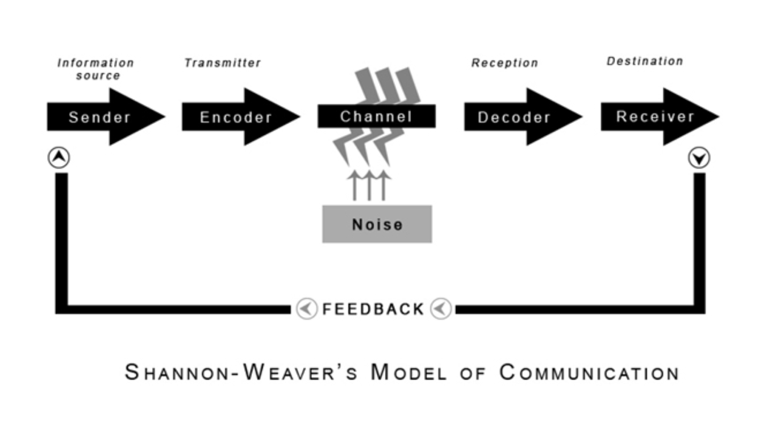
Figure 2

So, basically they had a theory that the Sender have the source of information and on the way to send the message to the receiver, the message needs to go through the Encoder which converts the message into signals and sends the signals to the Decoder which converts the signals into a message, as a opposite process of encode, and from there the message is finally arriving to the receiver.

Schramm Model of Communication

The Schramm model of communication has been proved that it is a Circular Model, so that it means the communication is something circular in the nature.
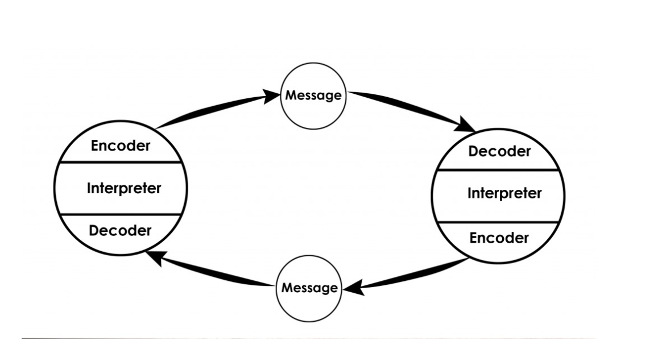

Figure 3
The model breaks the sender and receiver model in the way that the communication can to be seen in a practical way, not a traditional way. In this theory everything starts from the Encoder, that sends the message to the Interpreter, Interpreter is the moment when the person is analysing interpreting the message from the Encoder, and finally the message gets to the Decoder who receives the message. This is a process which is going on and on in a conversation.

Berlo’s Model of Communication

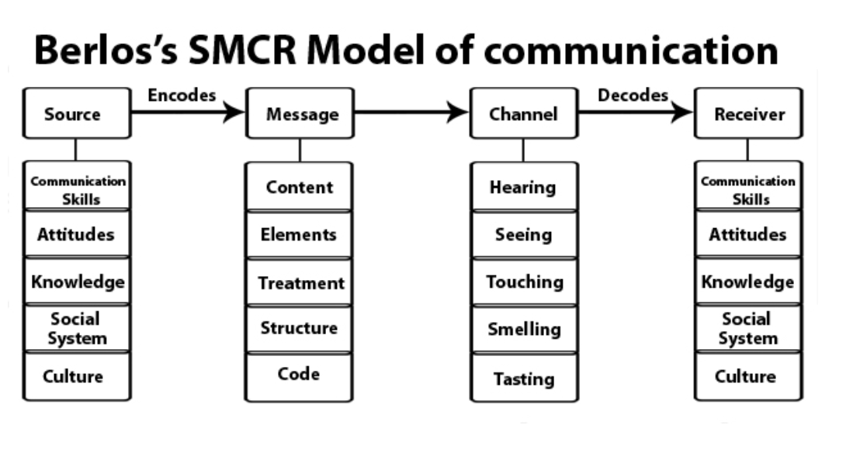
Figure 4

Berlo’s Model of communication follows the simplest form of the process of communication. The process starts from the source where the message is original from, and in the source are the communication skills, attitudes, knowledge, social system, culture which goes as encrypted message to the channel which decodes the message to get to the receiver which again needs the communication skills, attitudes, knowledge, social system, culture to be able to get the message .

From my point of view, all of theories are very précised and straight forward, but for me the best theory is the Shannon and Weaver Model of Communication, because the level of complicity is not that high and it is easier for me to understand the whole process of communication theory from them position.
Schramm Model of Communication and Berlo’s Model of Communication, from my point of view are a little bit complicated to be understandable, and me for example I had to read a lot more and to search from different sources to really get it and to be able to explain it.

Communication at workplace

The communication at the workplace is very important at the workplace because if you don’t have the communication skills, you are not understandable. In my case in the beginning when I’ve came here, I’ve started to work and because of the language barrier I wasn’t really confident on my level of communication skills and I wasn’t able to understand everything what I’ve been thought in my training days.
In the present, at my workplace my level of confidence is very high, I am happy that everyone communicates, that everyone is nice to you and it listen to you. And because of this module, I’ve been able now to understand why the effective communication is important at the workplace, especially for the managers that they are always interested in us, if we have any problem at work.

In the end, I would like to add that I am so happy that so far, I’ve been able to understand many things about what’s going around with any business, and this module helped me a lot to develop my communication skills and to be more understandable with the people around me, with the colleagues from the University or from work and even with my friends, I feel like I am definitely a different person, very communicative, with a high idea about what it really matters to have communication at the workplace.

Bibliography
Communication Theory. (n.d.). Retrieved from Communication Theory: https://www.communicationtheory.org
Communications: Process, Importance, Types, Barriers with Examples. (n.d.). Retrieved from Toppr-guides: https://www.toppr.com/guides/business-studies/directing/communication/
What is Communication? Verbal, Non-Verbal & Written | SkillsYouNeed. (2020). Retrieved from Skillsyouneed.com: https://www.skillsyouneed.com/ips/what-is-communication.html
Workplace Strategies for Mental Health. (n.d.). Retrieved from Workplace Strategies for Mental Health: www.workplacestrategiesformentalhealth.com/mmhm
Maund, Andrew, Michaela Schriek, Paul K. Tinkler, University of Wales Trinity Saint David, and Trinity College. Certificate in Higher Education : Skills for the Workplace Student Yearbook. London: Sage, 2017. Print.

