

HEALTH CARE SYSTEM ORGANISATION AND LEADERSHIP

Module code: LCHS7002
Title: Case Study Analysis Report: Case study 1: Infant Morphine Overdose Case Study (2023)

Student Name- Darshankumar Sureshbhai Patel
Student ID- 2515501

Table of Contents

Introduction 2
Main Body and Analysis 4
a. Identifying the Problem and Setting the System Context 4
b. Centralisation or Decentralisation within the Case Study 8
c. Leadership Theories and Application to the Case Study 11
d. Improvement, and Lessons Learned 14
Recommendation 17
Conclusion 18
References 20

Introduction
Background and purpose of the chosen case study
The selected case study 1 focuses on the importance of management and leadership styles for developing organisational effectiveness. The HNS of the UK has about 1.5 million staff and aims to foster diagnosis by about 77% (NHS, 2026). This high workforce and commitment require an effective management approach and an appropriate leadership style. The purpose of choosing case study 1 is to analyse leadership styles and organisational approaches for the determination of their effect on health and social outcomes.
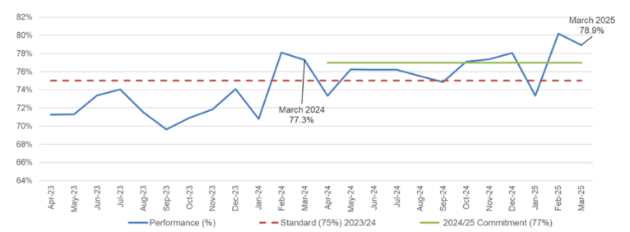
Figure 1: Faster diagnosis performance of the NHS
(Source: NHS, 2026)
Meaning of leadership
Leadership means influencing, guiding, and motivating others to achieve organisational goals. Leadership in health and social care promotes, supports, and sustains organisational goals and equality (Hawkes and Baru, 2024). Leadership has a positive effect on health outcomes and organisational performance. For example, effective leadership has enhanced patient satisfaction by about 80.1% in the UK, which has enhanced from 2023 (CQC, 2025). Moreover, about 45% of outpatients and 35% inpatients of the NHS were satisfied in 2023 (BBC, 2023). It has been identified that proper leadership can enhance patient satisfaction and health-related outcomes.
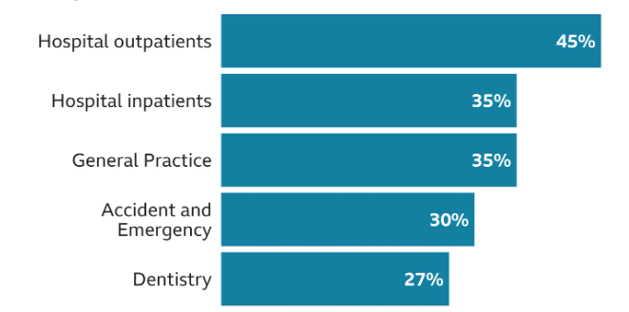
Figure 2: Patient satisfaction level at the NHS
(Source: BBC, 2023)
Centralisation, decentralisation, and key leadership theories
Centralisation refers to leadership approaches that are associated with senior management levels for making effective decisions. Decentralisation is associated with various levels of a healthcare organisation, and this is effective for reducing inequity and developing financial performance (Sapkota et al. 2023). On the other hand, leadership theories such as transformational, transactional, and situational also have significance for an effective healthcare setting. Transformational leadership theory is useful for the development of a patient safety culture through motivation and inspiration (Hamdan et al. 2024). Transactional leadership is useful for providing performance-based rewards, and situational leadership is useful for meeting the needs of healthcare professionals.
Selection of the right leadership style
Selection of the right leadership style is important for increasing patient satisfaction and mitigating crises. For instance, patient satisfaction is about 21% in the NHS, UK, due to waiting time and the shortage of employees (BBC, 2025). This is an indication that healthcare organizations need to implement an appropriate leadership style.
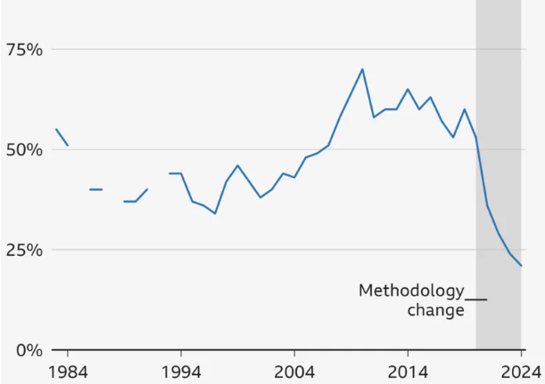
Figure 3: Patient satisfaction level at the NHS, UK
(Source: BBC, 2025)
Specification of points of the report
This report sheds light on case study 1 through the evaluation of management approaches and leadership styles. This report highlights identifying the problems and setting the system regarding the case study. Furthermore, this report focuses on centralisation and decentralization along with the application of leadership theories. This report also deals with improvement and lessons learned.

Main Body and Analysis

a. Identifying the Problem and Setting the System Context
Description of the central problem and the local context
The primary issue that is being identified in Case Study 1 is associated with medication administration and communication breakdown, as a problem of overdose morphine sulphate oral solution has happened, which is 20 times more than the normal dose (Northyorkshireccg.nhs, 2023). Such accidents usually happen when healthcare practitioners' coordination is low, and leadership is not good enough. Patient safety incidents continue to be a significant point of concern within the UK National Health Service (NHS) since the process of providing healthcare is intricate. NHS England received 809,103 incidents of patient safety in the period between July and September of 2025 (NHS, 2025). Moreover, medical-related problems comprise a high percentage of such events. Studies have shown that approximately 237 million medication errors are committed in the NHS in England annually, but even some have not led to serious injuries (Sps. NHS, 2025). These statistics explain the breakdowns in communication, excessive work, and lack of control in the complicated healthcare setting.
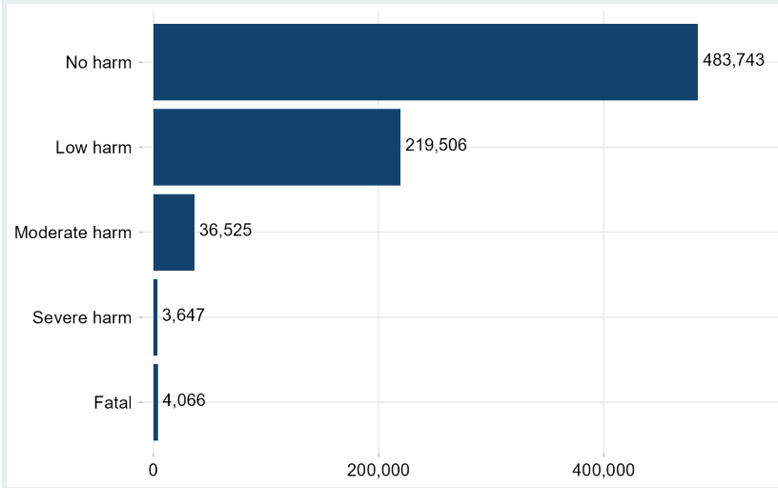
Figure 4: Patient safety incidents at the NHS
(Source: NHS, 2025)
Statistical context in terms of global and national
Failures in the healthcare system and patient safety incidents are considered significant issues. This issue has happened in the NHS, where the growing demand and workforce pressure add to the scope of the problems with operation and organisation. The NHS has approximately 1.55 million employees working in hospitals and community health services as of 2025 (Parliament, 2026). This might enhance the complexity of the healthcare services. Personnel pressures are high even with a high number of employees. Recent surveys show that 43.5% of NHS workers said that the number of staff in their organisation was insufficient to carry out their work well in 2024 (Statista, 2024). Such national statistics indicate that issues of communication breakdowns, delayed care delivery and lack of efficiency during the operations of the system are usually associated with systemic pressures. Thus, the problem in the case study represents more global concerns in health care systems in the UK and other countries.
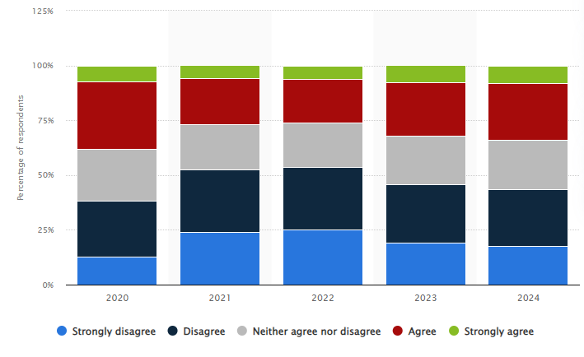
Figure 5: The NHS has a shortage of staff to provide services properly
(Source: Statista, 2024)
Influenced by the government and system weakness
The issue raised in the case study is part of the larger systemic deficiency in the healthcare system, especially in communication, leadership control, and organisational responsibility. Healthcare organisations operate under complex relations of various professionals, departments, and administrative systems. Critical processes, including medication administration, patient monitoring, and clinical decision-making, may suffer as a result of failure of the communication channels or the lack of leadership (Baxi et al. 2024). In the NHS, the problem is usually associated with the lack of workforce and rising service pressure. The NHS workforce, hospital and community health services are currently reported to employ around 1.38 million full-time equivalent employees (Parliament, 2026). With a high number of employees, the rate of vacancies in various healthcare positions, especially among nurses and medical staff, can seriously stress already employed people and decrease communication. Regarding the governance, it is possible to connect the problem with the local organisational governance, to implement safe clinical processes and efficient communication systems. The regional and national governance within the NHS also determines the operational performance by the policies and workforce planning, as well as the distribution of funds (NHS, 2025). As a result, the case study incident is not only a local operation failure but also a over-facing systemic pressure that takes its toll on the delivery of healthcare throughout the NHS.
Systems thinking and analysis of a rich picture
The key to interpreting complicated healthcare occurrences lies in the application of systems thinking. Systems thinking emphasises the examination of the mechanisms occurring within an interaction among people, processes, and organisational structures (Khalil and Lakhani, 2022). Within the framework of the case study, medication administration and communication errors can be interpreted as the combination of various factors, which are interconnected, and not a one-time mistake. An example is the healthcare delivery in the NHS, where people have to work in large multidisciplinary teams which cut across various departments and organisational levels. By 2025, the NHS will have over 1.55 million employees, which means that coordinating, communicating, and leading the workforce is crucial to successful healthcare delivery (NHS, 2025).
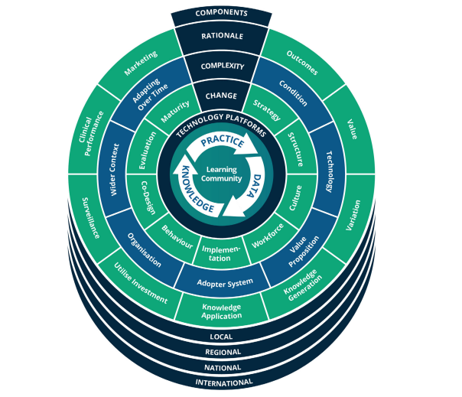
Figure 6: Systems thinking framework for healthcare
(Source: Foley and Vale, 2023)
A Rich Picture is a visual, graphical systems thinking tool which aids in depicting these complex associations. The stakeholders that would be incorporated in the Rich Picture in this case study would include patients, nurses, doctors, ward managers, and hospital administrators. It would also contain processes like administration of medication, communication channels, reporting, as well as clinical decision-making structures. With such a visualisation, one can distinguish multiple problems, such as the lack of communication among the staff, information delays, and interdepartmental interdependence. These interrelated factors go into a feedback loop either to promote safe care delivery or lead to system breakdowns. Thus, systems thinking and Rich Picture analysis may help healthcare leaders to gain more insight into the underlying causes of complex incidents in order to come up with more effective organisational improvements.
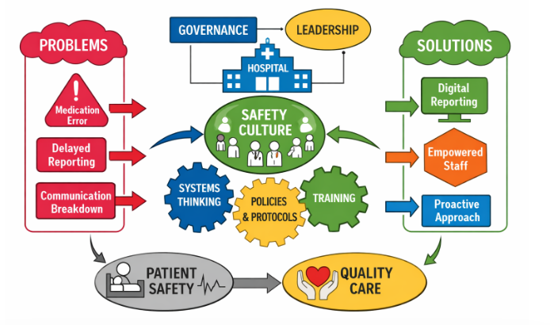
Figure 7: Rich picture
(Source: Self-created)

b. Centralisation or Decentralisation within the Case Study
Centralised system
Decision-making
The decision-making process in the National Health Service (NHS) is mainly centralised either at upper organisational tiers, especially at the national level (National Health Service England and the Department of Health and Social Care). These institutions make policies, funds and priorities that govern healthcare services in the nation. These directives are executed by the local NHS Trusts and hospitals, but do not give them much freedom regarding major financial or policy choices (Gov, 2025). This centralised administration is useful for the coordination of healthcare standards, guidelines for the delivery of services, and distribution of resources across the UK. In Case Study 1, top management or national health authorities are the ones who make the strategic decisions on matters like resource allocation, staffing setups, or priorities of the service frontline healthcare workers and not the healthcare workers. Decision-making becomes more concentrated by taking two or more opinions and using the information (Masic, 2022). By the year 2025, the NHS will have a workforce of about 367, 300 nurses with an equivalent of 153,600 doctors in hospitals and community health services (Parliament, 2026). This centralisation of decision-making is also a symptom of the size of the NHS.
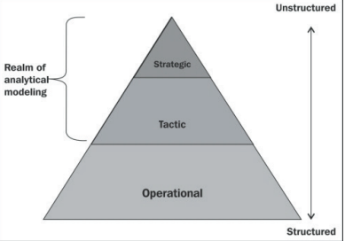
Figure 8: Three levels for concentrated decision-making
(Source: Masic, 2022)
Advantage
Consistency and standardisation are key advantages of centralised decision-making. Patient care policies, staffing policies, and service priorities can be implemented. In Case Study 1, the standard procedures are used to ensure the consistency of the quality of the services offered by various units. There are better associated with centralised decisions, which enable the distribution of resources.
Disadvantage
Decisions could not always be based on local requirements or operational reality. In the background of Case Study 1, frontline staff may have delays in making changes since approvals have to pass through the hierarchical structures. It may lower flexibility and reduce responsiveness to local challenges, leading to a decrease in efficiency of the services.
Decentralised system
Distribution of authority
Decentralisation in healthcare is a model of governance that allocates power and decision-making for delivering primary healthcare services (Khatri et al. 2025). In the case of the NHS, an example of decentralisation is the NHS Trusts, clinical departments, and ward-level management. In Case Study 1, this may include the ward managers or senior nurses intervening to correct any medication administration problem or lack of communication without seeking the authority of the higher management. The decentralised decision-making is also necessary due to the size of the NHS service demand. England's hospitals alone have recorded about 17.2 million hospital admissions (Ukdataservice, 2021). This shows a large number of patients in need of timely care and operational flexibility.
Advantage
Decentralised systems have one advantage, which is faster decision-making and greater responses to patient needs. Decentralisation enhances employee engagement and opportunities (Rafi’i et al. 2025). Case Study 1 is especially the case when timely presentation of clinical action and effective communication of the same is paramount to avoid a negative outcome for the patient.
Disadvantage
Decentralisation also poses some problems with consistency and accountability. In case of widely spread authority, various departments or teams might understand the policies in various ways, and this can be the reason for ineffective decisions. The inconsistent communication processes or limitations in leadership approaches would be a contributing factor to the occurrence of operational mistakes in the context of Case Study 1. Although decentralised authority enhances flexibility, effective governance and coordination are still needed in order to guarantee the safety of patients.
Critical analysis
Case Study 1 also demonstrates a hybrid form of both centralised governance and decentralised clinical decision-making. The centralised control in the NHS allows the coverage of the national policy, safety measures, and documentation to be followed in all healthcare organisations. Indicatively, NHS Trusts must disclose incidents of patient safety using the national monitoring systems. Recent NHS data has indicated that 768,682 patient safety incidents were reported by NHS Trusts alone in England, and 829,985 patient safety incidents were reported across the country between October and December 2025 (NHS, 2025). In Case Study 1, this kind of centralised monitoring assists in the provision of formal investigation of adverse events or communication failures, and organisational learning cannot be avoided.
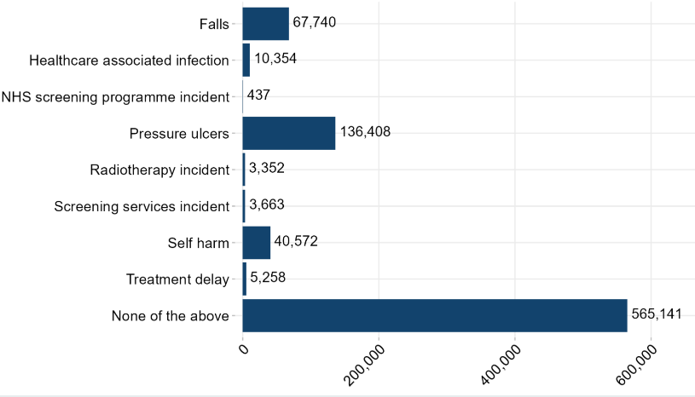
Figure 9: Patient safety incidents in the NHS
(Source: NHS, 2025)
Centralised decision-making might fast response to the crisis in complicated clinical conditions because decision-making is hierarchical. In cases where frontline staff have to follow a strict reporting and approval process, this can slow down instant decision-making approaches. These issues can be further enhanced by the healthcare activity in England. Governmental reviews show that the NHS manages around 600 million interactions with patients annually, whereas hospitals carry out approximately 3,000 official patient safety inquiries every year (Gov, 2025). This demand puts a lot of pressure on personnel and organisational systems.
These shortcomings are partially addressed by decentralised control at the clinical level, where nurses, along with ward administrators and multidisciplinary teams, can decide the urgent patient-care interventions. Such flexibility favours crisis management during instances of medication misjudgements, deterioration of a patient, or communication breakdown that was reported in Case Study 1. However, decentralisation will also introduce inequality in practice, where teams may have different understandings of policies. Enhancing the impact of centralised governance and appropriate measures is useful to assess the health and safety of patients and personnel.

c. Leadership Theories and Application to the Case Study
Overview of leadership theories
Leadership is an important aspect of healthcare organisations since leaders determine the performance of the staff, patient safety, and the quality of the services offered. The three leadership theories that are applicable in the analysis of Case Study 1 are behavioural leadership, situational leadership, and transformational leadership. Behavioural leadership is concerned with the visible behaviour for increasing managerial and leadership effectiveness (Hamlin et al. 2023). Situational leadership adopted by leaders can be altered to manage a crisis situation. Transformational leadership, however, is useful for job satisfaction and building teamwork (Gebreheat et al. 2023). Proper leadership has been closely associated with workforce performance and patient outcomes. As an example, available data on the NHS workforce shows that approximately 363,226 nurses and health visitors have been employed in England in 2023 (ONS, 2024). This indicates that appropriate leadership has become essential to organise large multidisciplinary units and ensure the presence of safe healthcare delivery.
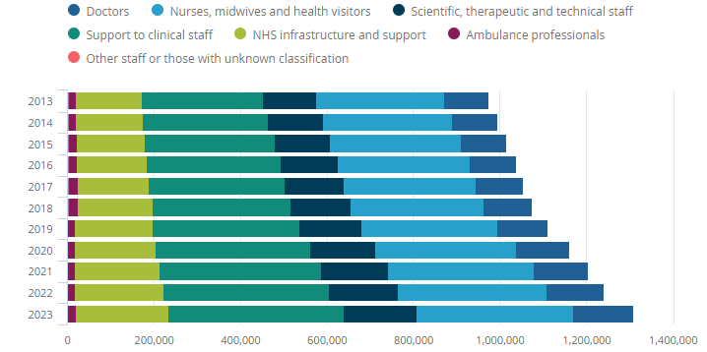
Figure 10: Full-time staff at the NHS
(Source: ONS, 2024)
Application of these theories to the case study
Case Study 1 provides the leadership situation that can be examined with the help of the behavioural, situational, and transformational leadership theories. The aspect of behavioural leadership focuses on the behaviour of the leaders, especially their functionalities to manage the staff, sustain communication, and accountability of the healthcare teams in the institutions. Leadership behaviour plays a significant role in improving culture and ethics (Ward et al. 2025). Effective behavioural leadership would involve proper supervision, effective communication habits and frequent monitoring of clinical procedures.
Situational leadership applies as well since the healthcare setting often demands leaders to change their way based on the situation. Leaders use a supportive style, or collaborative style, whereas a crisis demands quick decisions and strict guidance (Abuoun et al. 2025). Case Study 1 may present a scenario whereby leaders were forced to change their minds within seconds from regular management to crisis management so as to handle the incident.
Transformational leadership focuses on encouraging and psychologically empowering employees to enhance the quality of healthcare and organisational culture (Ibrahim et al. 2024). This type of leadership promotes teamwork and proactive problem-solving, which is critical towards avoiding operational failure. This fact is supported by the NHS workforce statistics, which revealed that more than 47,000 nursing roles were unoccupied in NHS England in 2023 (CQC, 2023). This might have added more stress to medical teams and demanded effective leaders.
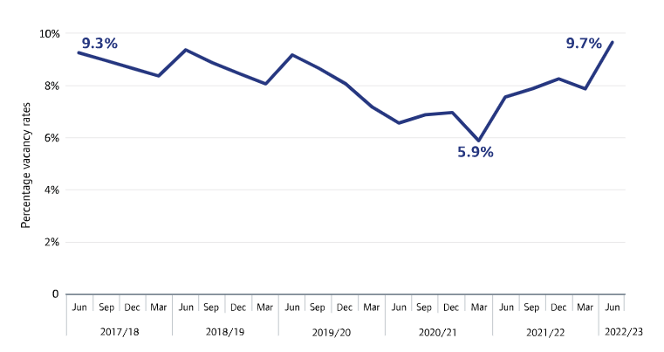
Figure 11: Vacancy at the NHS
(Source: CQC, 2023)
Effectiveness of leadership
The analysis of leadership efficacy in healthcare needs to focus on patient safety rates, employee engagement ratings, and handling high-risk clinical procedures. Case Study 1 specifically features a red drug incident, as it is one of the critical or high-risk drugs that should be administered strictly and under the supervision of senior clinical personnel. The drugs are regularly administered to the patient during emergency or special treatment. The effectiveness of leadership is important to enhance patient safety and the elimination of medication errors (Clack et al. 2025). The danger of medical errors is great if effective protocols, supervision, and communication systems are not put in place. The severity of the medication-related incidents is indicated by the evidence provided in the NHS safety reports. Furthermore, NHS Patient Safety statistics claim that there are approximately 237 million medication errors in England each year (BMJ, 2025). These statistics emphasise the need to use proactive leadership and a strong safety culture in medical institutions. The engagement data of staff also gives an insight into the effectiveness of leadership. According to the NHS Staff Survey 2023, approximately 71% of employees indicated they could report unsafe clinical practice (BMJ, 2024). Leadership contributes significantly to promoting open communication and reporting. Applying this to the red drug incident, the leaders in the organisation can maintain high safety standards, promote reporting of any incident and facilitate the learning processes by the staff to avoid medication errors in future.
Critical analysis and alternative approaches
Critical analysis of Case Study 1 indicates that the effectiveness of leadership lies in the capabilities of reacting proactively to the various problems. In case the leadership response was mainly reactive and dealing with issues once they arose, this may be a sign of inadequacy of organisational control and risk management. The pressure on healthcare systems like the NHS is very high, and in England, the volume of patients waiting in hospitals was about 7.6 million for treatments in 2024 (NHS, 2024). This demonstrates the overwhelming demands on the healthcare systems. The high demand for services also raises the significance of outstanding and effective leadership. Such situational scenarios might be ideal with alternative methods of leadership that would enhance organisational performance. As an example, a distributed leadership would enable frontline employees to make data-driven decisions for managing uncertainty (Colombari and Neirotti, 2023). whereas emotionally smart leadership would open the way to improved communication, support for the staff, and collaboration. These strategies are likely to make healthcare organisations more efficient in responding to crises, enhance cooperation among professionals and achieve better patient safety outcomes.
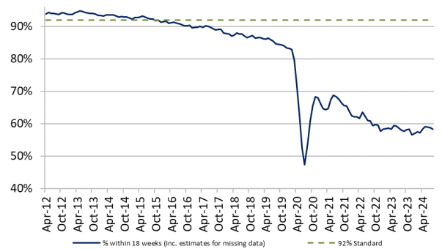
Figure 12: Missing trust among patients
(Source: NHS, 2024)

d. Improvement, and Lessons Learned
Leadership and governance interaction
Leadership and governance systems have a significant impact on the patient safety outcomes in healthcare organisations. The interplay between the leadership style and governance mechanisms in the case study helped in bringing out the witnessed issues, such as the medication incident with the red drug. Leadership and governance systems provide a framework for increasing healthcare's ability to improve outcomes (Kapologwe et al. 2023). Governance mechanisms are meant to create accountability, transparency, and structured reporting of clinical incidents. Whether leadership fails to strengthen these mechanisms, there are risks which may increase. Centralised governance can slow down the process of decision-making and make frontline staff reluctant to submit safety-related concerns in time. NHS data on patient safety depicts what is happening in the healthcare systems in terms of the magnitude of safety issues. One of the examples is that according to NHS England, around 829,985 patient safety incidents were reported during the months between October and December, 2025 (NHS, 2025). This proves that the number of risks that healthcare organisations should monitor and control is quite high.
Such cases involve errors in medication, lack of communication and problems in clinical processes which necessitate effective leadership management. The engagement of staff and reporting behaviour are also signs of leadership effectiveness. In line with the 2025 NHS Staff Survey, 33.71% of the staff had seen errors and missed incidents that might cause harm to either patients or staff (NHS Providers, 2026). It has been learned from such incidents that employees might think that there is poor accountability or poor feedback mechanisms. Leadership in the case study has been more reactionary than proactive. The leadership approach in the case study has not been aimed at preventing the occurrence of the medication incident, but has reacted to the incident by implementing effective governance systems. Poor channels of communication are also likely to have led to a similar incident. Heavy alignment of the leadership practices and governance structures might have enhanced the responsiveness of the organisation and reduced the risks to patient safety.
Identify missed opportunities and evidence-based solutions
In the case study, there are several lost opportunities that need to be avoided by better leadership and governance mechanisms that would have managed the situation with the red drug. The area of incompetence in the leadership oversight and the clinical governance structures was the issue of the timely identification and escalation of medication risks. In healthcare organisations that are largely hierarchical in their decision-making process. This might be due to a lack of clarity in the channels of communication or organisational culture does not favour the reporting process. It has been indicated that this type of reporting gap is still a problem in healthcare systems. The 2025 NHS Staff Survey contends that 86.16% of the staff reported that their organisation supports error reporting, but 67.30% of the same staff reported that their organisation takes effective action to ensure that similar incidents will not happen again (NHS Providers, 2026). This gap means that reporting systems cannot work without leadership's endeavour in learning and improvement.
These issues have several solutions that can be evidence-based. It is required to implement a digital reporting system for enhancing transparency and decreasing delays in reporting medication errors. These systems can provide a real-time display of occurrences, and these leaders are able to study trends and introduce preventive actions within a short time. Devolution of governance structures can enable the frontline clinical teams to react fast to the issue of medication safety without the need to wait for seniors. Transformational and emotionally intelligent leadership enhance positive leadership behaviour for achieving organisational goals (Vijai, 2025). The improvements can have tightened medication safety procedures and minimised the chances of a similar incident happening in the future in the context of the given case study.
Lessons learned
The case study offers some valuable lessons regarding the interaction of leadership style, structure of governance and feedback mechanisms of an organisation on the healthcare outcomes. One important lesson is that patient safety cannot only be achieved through clinical competence, but also proper leadership and governance structures that encourage transparency, accountability and continuous improvement. In cases where the system of governance is too centralised, a delay in decision-making based on the realities on the frontline may occur. A lack of responsiveness to the emerging risks may arise among the staff. According to WHO, medication error can cause harm to healthcare system and also enhance costs. Cost of medication error is about $42 billion USD per year (WHO, 2025). Such data might not result in any valuable organisational learning unless there is robust involvement of leadership.
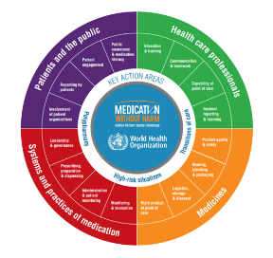
Figure 13: Strategic framework of WHO for patients’ safety
(Source: WHO, 2025)
The other important lesson is that of organisational culture. Personnel also need a sense of safety to report mistakes and engage in safety enhancement programs. The development of individual characteristics might be useful for increasing psychological safety and eliminating errors in healthcare services (Wawersik et al. 2023). Research on NHS organisations has revealed that leadership is a crucial factor that contributes to the culture, as the staff feel that there is no fear in raising concerns on matters concerning patient safety. In the case study, the requirements of the other healthcare organisations are efforts to have data-driven leadership and integrated governance systems. The leaders are also supposed to routinely examine data of incidents, survey findings, and safety audits to determine systemic risks. Also, it is possible to implement distributed models of leadership, which might allow empowering medical workers at various organisational levels to take action and promote safety enhancements. Finally, ongoing monitoring, reporting, and evidence-based leadership practices are also necessary to enhance accountability and other sustainable changes in patient safety outcomes.

Recommendation
Things should be done next
The organisation must focus on the short-term changes in patient safety governance, especially medication handling procedures that were identified as the priorities due to the red drug incident. A thorough safety audit, done by the leaders, should help to outline the missing links in the reporting system, clinical supervision, and channels of communication. The number of medication errors is about 34000 in the UK in 2024 (Cdn, 2024). It can be supported with evidence-based actions that should involve improving the system of incident reporting, the system of frequent monitoring of safety, and assessment of accountability forms. These evidence-based measures would enable the organisation to eliminate the systemic vulnerabilities, minimise the risk of medication mistakes and create a safer and less obscure healthcare setting.
Recommendation for the most effective leadership style(s) for sustaining improvement
The organisation ought to embrace transformational and distributed leadership styles in order to maintain long-term enhancement. Transformational leadership promotes motivation and cooperation among staff and innovation, which are needed to bolster patient safety culture (Rizkia et al. 2022). Distributed leadership will enable the frontline healthcare professionals in the decision-making process and fast response to the clinical risks. The results of evidence provided by the NHS Staff Survey 2023 indicate that, in teams where the leadership was encouraging of employees, employee involvement levels were elevated, and more or less three out of every five employees felt that they could play their part in enhancing their workplace. Incorporating transformational and distributed leadership approaches within the organisational framework, the organisation will be able to endorse proactive problem-solving, enhance accountability, and make the staff contribute to the safety initiatives to guarantee net gains in organisational performance.
Strengthening governance, communication, and systems integration
The restructuring of governance structures and communication should be improved so as to avoid similar cases in future. The integrated digital reporting systems should be implemented in the organisation to enable monitoring of medication errors and clinical incidents in real-time. It is also necessary to create regular multidisciplinary meetings of governance to address safety data and hold them accountable. There are indications that one of the primary causes of safety incidents is a communication breakdown. 1 in every 10 patients face health-related harm, and about 3 million deaths happen per year due to poor patient safety (WHO, 2023). Enhancing communication between the leadership teams, clinical staff, and departments will help make decisions more quickly and accurately coordinate their actions. The combination of governance, safety, and information systems will play a massive role in making the organisations more transparent and in improving patient safety.
Propose actions for technical and allocative efficiency
An increase in technical and allocative efficiency will aid the organisation in providing safer and more effective healthcare services. The technical efficiency may be improved through the implementation of electronic medication administration systems. It has also been indicated that digital medication systems could largely minimise errors in medication. The adoption of these technologies, together with enhanced workforce planning, will streamline the utilisation of the resources, enhance clinical performance, and enhance operational efficiency.
Include methods
The culture of constant learning and involvement of active stakeholders is necessary for continuous learning. Regular training programmes, safety workshops, and leadership development programmes can be introduced by the organisation. This might make sure that personnel are not ignorant of best practices in patient safety and governance. Along with this, patients, families, clinicians, and administrators should be informed about healthcare improvement by making decisions collaboratively. According to studies conducted by the Organisation for Economic Co-operation and Development (OECD), patient engagement programs have the potential to enhance satisfaction and the quality of healthcare by enhancing transparency and trust in the healthcare systems (OECD, 2025). The development of accountability fosters the spirit of innovation and ensures that the requirements of healthcare professionals are useful for continuous learning, co-production and stakeholder engagement.

Conclusion
Summarise the main findings
This discussion explored leadership behaviours and governance mechanisms that impacted the results provided in Case Study 1, specifically in reference to the red drug medication safety problem. The results imply that the problem growth was supported by the lack of strength in communication, slow reporting of the incidents, and the lack of leadership control. Leadership style and governance systems interaction was vital in determining the response organisations have towards safety risks. It is shown that reactive styles of leadership and the centralised decision-making style may restrain frontline staff involvement and reduce the process of detecting clinical risks. Statistics provided by patient safety monitoring systems also prove that medication errors are still a major problem in healthcare settings, and there is a need to enhance governance and safety culture. In general, the discussion highlights that leadership that is powered with clear governance structures and efficient reporting systems is instrumental to enhancing patient safety, organisational responsibility, and quality of healthcare services.
The importance of leadership, governance, and systems thinking
Leadership, governance and systems thinking are some of the key elements in effective healthcare management and patient safety enhancement. Effective leadership also implies that healthcare professionals work under a clear vision, accountability, and a supportive organisational culture. The governance structures are structures that offer the frameworks upon which risks are tracked, decisions are controlled, and the safety standards are ensured. Leadership and governance are, however, not enough in the absence of a systems thinking strategy which acknowledges the interdependence of healthcare processes, staff roles, and organisational structures. Systems thinking help leaders to understand and recognise how poor communication, reporting systems and hierarchies within organisational structure can react to cause undesirable results. A systems approach can make healthcare organisations stop engaging in reactive responses and pursue proactive measures to avert such incidents. Through combining leadership training, governance reformation, and outcomes-based decision-making, organisational resilience can be enhanced. This might also help to improve patient safety results.

References
Abuoun, W.A., El-Khawass, K. and Hussein, N., (2025). Crisis Management in Healthcare: The Impact of Hospital Leadership Styles on Navigating Challenges, Implementing Strategies and Achieving Outcomes. Egyptian Journal of Hospital Medicine, 101(1).
Baxi, V.V., Banerjee, S., Patel, M.A.R., Sinha, R. and Khan, S., (2024). Enhancing Patient Safety in Critical Care: Challenges, Strategies, and Emerging Innovations. Journal of Medical and Dental Frontiers, 2(1), pp.16-24.
BBC, (2023) NHS: Public satisfaction with health service drops to record low Available at: https://www.bbc.com/news/health-65093449 [Accessed on 27th March, 2026]
BBC, (2025) Public satisfaction with NHS hits record low Available at: https://www.bbc.com/news/articles/cd9l8v1vy0ko [Accessed on 27th March, 2026]
BMJ (2024) David Oliver: The NHS staff survey 2023 has depressing findings and worrying implications Available at: https://www.bmj.com/content/384/bmj.q588 [Accessed on 27th March, 2026]
BMJ, (2025) 237+ million medication errors made every year in England. Available at: https://www.bmj.com/company/%20newsroom/237-million-medication-errors-made-every-year-in-england/ [Accessed on 27th March, 2026]
Cdn, (2024) Medication Errors Available at: https://cdn.hc-uk.org.uk/cache/healthcare-conferences-uk/2024-conferences/10-oct/medication-errors/medication-errors-oct-2024.pdf [Accessed on 27th March, 2026]
Clack, L., Smith, J. and Charns, M., (2025). Defining and Measuring Organizational Transformation in Health Care: A Systematic Literature Review. Medical Care Research and Review, p.10775587251356130.
Colombari, R. and Neirotti, P., (2023). Leveraging frontline employees’ knowledge for operational data-driven decision-making: a multilevel perspective. IEEE Transactions on Engineering Management, 71, pp.13840-13851.
Cqc, (2023) Workforce Available at: https://www.cqc.org.uk/publication/state-care-202122/workforce [Accessed on 27th March, 2026]
CQC, (2025) More people reporting a better overall hospital experience Available at: https://www.cqc.org.uk/press-release/more-people-reporting-better-overall-hospital-experience-last-year-patient [Accessed on 27th March, 2026]
Foley, T. and Vale, L., (2023). A framework for understanding, designing, developing and evaluating learning health systems. Learning Health Systems, 7(1), p.e10315.
Gebreheat, G., Teame, H. and Costa, E.I., (2023). The impact of transformational leadership style on nurses’ job satisfaction: an integrative review. SAGE open nursing, 9, p.23779608231197428.
Gov, (2025) Review of patient safety across the health and care landscape Avaiable at: https://www.gov.uk/government/publications/review-of-patient-safety-across-the-health-and-care-landscape/review-of-patient-safety-across-the-health-and-care-landscape [Accessed on 27th March, 2026]
Gov, (2025) The regulation and oversight of NHS trusts and NHS foundation trusts Available at: https://assets.publishing.service.gov.uk/media/5a7b94daed915d41476214f8/regulation-oversight-NHS-trusts.pdf [Accessed on 27th March, 2026]
Hamdan, M., Jaaffar, A.H., Khraisat, O., Issa, M.R. and Jarrar, M.T., (2024). The association of transformational leadership on safety practices among nurses: the mediating role of patient safety culture. Risk Management and Healthcare Policy, pp.1687-1700.
Hamlin, R.G., Ruiz, C.E., Jones, J. and Patel, T., (2023). Toward a universalistic behavioural model of perceived managerial and leadership effectiveness for the health services sector. Health Services Management Research, 36(2), pp.89-101.
Hawkes, S. and Baru, R., (2024). Dismantling the structures of inequality: why we need feminist leadership in the health sector. bmj, 386.
Ibrahim, I.A., El-Monshed, A.H., Altheeb, M. and El-Sehrawy, M.G., (2024). Transformational leadership, psychological empowerment, and organizational citizenship behaviors among nursing workforce: A single mediation analysis. Journal of Nursing Management, 2024(1), p.9919371.
Kapologwe, N.A., Swai, I.L., Kesale, A.M. and Kengia, J., (2023). Leadership and Governance. In Leadership and Governance in Primary Healthcare (pp. 1-11). CRC Press.
Khalil, H. and Lakhani, A., (2022). Using systems thinking methodologies to address health care complexities and evidence implementation. JBI evidence implementation, 20(1), pp.3-9.
Khatri, R.B., Endalamaw, A., Erku, D., Wolka, E., Nigatu, F., Zewdie, A. and Assefa, Y., (2025). Contribution of health system governance in delivering primary health care services for universal health coverage: A scoping review. PloS One, 20(2), p.e0318244.
Masic, I., (2022). Medical decision making-an overview. Acta Informatica Medica, 30(3), p.230.
NHS (2025) Patient Safety Event Data Quarterly Publication Available at: https://www.england.nhs.uk/statistics/statistical-work-areas/patient-safety-data/2025-26/quarter-2-2025-26-july-august-september-2025 [Accessed on 27th March, 2026]
NHS Providers, (2026) NHS Staff Survey results 2025: what you need to know Available at: https://nhsproviders.org/resources/nhs-staff-survey-results-2025-what-you-need-to-know [Accessed on 27th March, 2026]
NHS, (2024) NHS referral to treatment (RTT) waiting times data Available at: https://www.england.nhs.uk/statistics/wp-content/uploads/sites/2/2024/10/Aug24-RTT-SPN-Publication-PDF-388K-v2.pdf [Accessed on 27th March, 2026]
NHS, (2026) Performance report Available at: https://www.england.nhs.uk/long-read/performance-report-24-25/ [Accessed on 27th March, 2026]
Northyorkshireccg.nhs, (2023) Serious Incident Case Study: Infant Morphine Overdose Investigation Summary & Learning Available at: https://northyorkshireccg.nhs.uk/wp-content/uploads/2023/09/11.07.23-NHS-NEY-INFANT-MORPHINE-OVERDOSE-CASE-STUDY.pdf [Accessed on 27th March, 2026]
OECD, (2025) Healthcare quality and outcomes Available at: https://www.oecd.org/en/topics/policy-issues/healthcare-quality-and-outcomes.html [Accessed on 27th March, 2026]
Ons, (2024) The healthcare workforce across the UK: 2024 Available at: https://www.ons.gov.uk/peoplepopulationandcommunity/healthandsocialcare/healthcaresystem/articles/thehealthcareworkforceacrosstheuk/2024 [Accessed on 27th March, 2026]
Parliament, (2026) NHS workforce: Size, characteristics and staffing levels Available at: https://commonslibrary.parliament.uk/research-briefings/cbp-10539/ [Accessed on 27th March, 2026]
Parliament, (2026) Size and characteristics of the NHS workforce Available at: https://commonslibrary.parliament.uk/research-briefings/cbp-10539 [Accessed on 27th March, 2026]
Rafi’i, M.R., Hanif, S.A.M. and Bin Daud, F., (2025). Exploring the link between healthcare organizational culture and provider work satisfaction: a systematic review. BMC health services research, 25(1), p.904.
Rizkia, D.G., Girsang, A.J., Kusumapradja, R., Hilmy, M.R., Pamungkas, R.A. and Dewi, S., (2022). The effect of interprofessional collaboration and transformational leadership on patient safety with work motivation as intervening variables. Riset: Jurnal Aplikasi Ekonomi Akuntansi dan Bisnis, 4(2), pp.039-053.
Sapkota, S., Dhakal, A., Rushton, S., van Teijlingen, E., Marahatta, S.B., Balen, J. and Lee, A.C., (2023). The impact of decentralisation on health systems: a systematic review of reviews. BMJ Global Health, 8(12).
Sps.nhs, (2025) Preventing errors on the medicine journey Available at: https://www.sps.nhs.uk/articles/preventing-errors-on-the-medicine-journey [Accessed on 27th March, 2026]
Statista, (2024) Share of NHS England staff who said there were enough staff at their organization to do their job properly from 202 to 2024 Available at: https://www.statista.com/statistics/883485/nhs-england-views-on-staffing-levels/ [Accessed on 27th March, 2026]
Ukdataservice, (2021) NHS Patient Survey Programme Available at: https://doc.ukdataservice.ac.uk/doc/8950/mrdoc/pdf/8950_ip20_statistical_release_v11.pdf [Accessed on 27th March, 2026]
Vijai, C., (2025). The Relationship between Emotional Intelligence, Transformational Leadership, and Organizational Culture. In Emotional Intelligence in the Digital Era (pp. 212-237). Auerbach Publications.
Ward, R., Devenish, S. and Miller, P.K., (2025). The LEAD (leadership experiences and direction) study: Exploring top-down cultures, everyday ethics and mutual influence in UK paramedics’ experiences of senior leadership. Paramedicine, p.27536386251412465.
Wawersik, D.M., Boutin Jr, E.R., Gore, T. and Palaganas, J.C., (2023). Individual characteristics that promote or prevent psychological safety and error reporting in healthcare: a systematic review. Journal of healthcare leadership, pp.59-70.
WHO (2023) Patient Safety Available at: https://www.who.int/news-room/fact-sheets/detail/patient-safety [Accessed on 27th March, 2026]
WHO, (2025) Medication Without Harm Available at: https://www.who.int/initiatives/medication-without-harm [Accessed on 27th March, 2026]

