

Changemakers: Building your Personal Brand for Sustainable Employment

(BMHP5015)

Student Name: Iqra Mohammad
Student Number: 2325946
Lecture name: Parese Ahmed

Component 1 – Portfolio

Table of Contents

Task 1 – Personal Brand 3
Task 2 - Network Map and Rationale 4
Task 3- Blog 5
Task 4- NHS Equality, Diversity and Inclusion Quiz 6
Task 5- A Letter to Yourself 8
Task 6- GANTT Chart (200 words equivalent) 9
Task 7- Making Changes- Report 10
Task 8- Self-Reflection 11
Reference List 13

Task 1 – Personal Brand



Developing a strong personal brand is essential in achieving my career goal of becoming a family support worker. A personal brand refers to the way an individual communicates their skills, values and professional identity to employers and wider networks (Indeed, 2023). For me the foundations of my personal brand are empathy, reliability, and effective communication. These qualities align closely with the role of a family support worker, who must build trusting relationships, advocate for families, and act as a reliable source of guidance and support.
To strengthen this personal brand, I must continue to develop professional credibility through relevant qualifications and practical experience, such as volunteering or shadowing within family and children services. In addition, creating a professional online presence, for example through LinkedIn, would allow me to showcase my commitment to supporting families and to connect with others in the sector. Networking with professionals and engaging in reflective practice will further enhance my brand by demonstrating authenticity and a willingness to learn. As CPD UK (2022) highlights, a consistent and authentic personal brand can make candidates more memorable and attractive to employers. By aligning my skills, values, and visibility, I can position myself effectively for success in family support work.

Task 2 - Network Map and Rationale
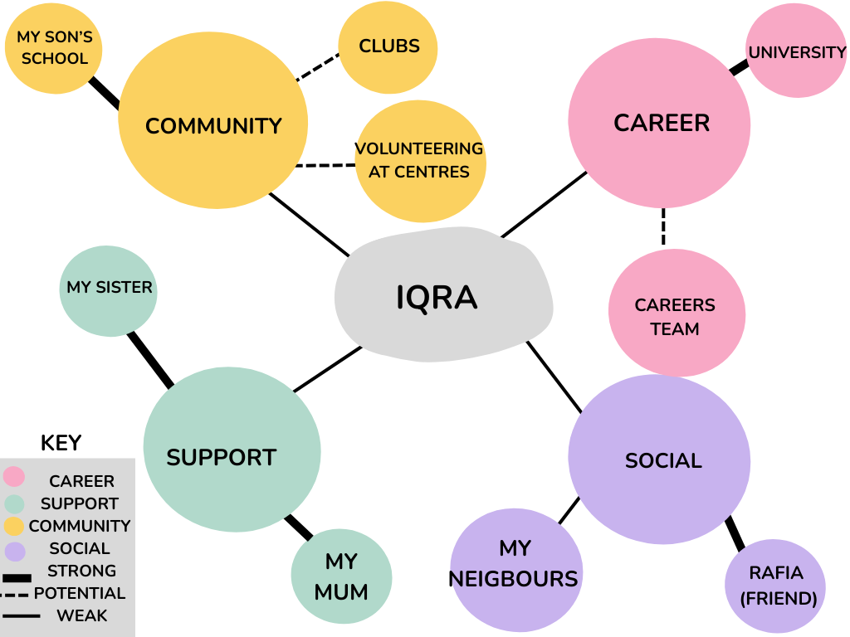

Networking is a crucial skill to develop, regardless of your industry or level of experience. Effective professional networking is built on trust and mutual support, and it can significantly impact the trajectory of your career. When approached strategically, networking allows you to cultivate relationships that are beneficial for both you and other professionals in your field. By building a strong professional network, you increase your chances of learning about job opportunities early and staying top of mind for anyone in your network who is looking to hire someone with your expertise and experience (Indeed, 2025).
My social network can be understood across four dimensions: career, support, social and community. The career dimension includes my university and careers team, which offer professional guidance and resources. The support dimension is represented by my mother and sister, who provide consistent emotional and practical assistance. Within the social dimension, neighbours and friends contribute to a sense of belonging and informal information sharing. Finally, the community dimension, which includes my son’s school, local clubs and volunteering, connects me with wider networks and opportunities relevant to my aspiration of becoming a family support worker.
A critical assessment of this network highlights strong bonding capital, particularly through family and friends, which provides resilience and stability. However, career progression requires further development of bridging capital by engaging with diverse professional and community groups and linking capital by strengthening ties with institutions such as voluntary organisations and my university. Enhancing these dimensions will create a more balanced and effective network to support both my personal well-being and employment goals.

Task 3- Blog


Introduction
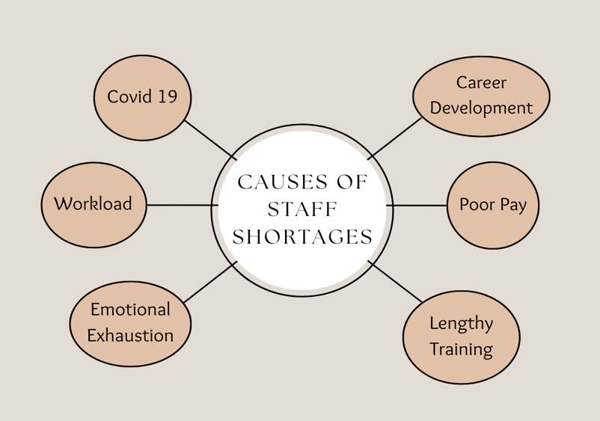
Staff shortages across the United Kingdom’s health and social care sector have become a critical and persistent challenge, significantly impacting the quality, safety, and compassion of care provided (NHS England, 2023). The recruitment and retention of sufficient staff remain difficult due to multiple contributing factors, including an ageing workforce, lengthy training pathways, and rising workloads. Furthermore, the lasting effects of the COVID-19 pandemic have left many employees physically and emotionally exhausted (The King’s Fund, 2023). In social care, issues of low pay, limited career progression, and insecure employment conditions have exacerbated workforce instability, increasing staff turnover and placing further strain on hospital discharge processes (Skills for Care, 2023).

Main Body
In response to these challenges, NHS England’s Long Term Workforce Plan (2023) outlines a 15-year vision aimed at expanding training capacity, modernising professional roles, and improving staff retention. The strategy centres on three key pillars: to train, retain, and reform. It emphasises the importance of cultivating home-grown talent and fostering supportive workplace cultures to ensure a sustainable workforce for the future. However, while the plan provides a necessary long-term framework, its benefits will take time to materialise, and immediate pressures on frontline services continue to be severe.

Recent evidence highlights the urgency of addressing these workforce pressures. According to a BMJ Group (2023) report, surveys of nearly 2,000 healthcare professionals reveal that workload intensity and work-related stress are the primary factors driving staff attrition. Certain roles, such as paramedics, face additional challenges including poor work-life balance and dissatisfaction with pay. While financial incentives may help alleviate some discontent, they do not fully address underlying issues such as burnout, excessive working hours, and chronic understaffing. Effective solutions must therefore target the root causes of workforce distress, focusing on reducing stress, enhancing staffing levels, and creating supportive, flexible, and psychologically safe work environments.
(Andrews, 2024)

Conclusion
Addressing workforce shortages in health and social care is essential to ensuring the long-term sustainability of both systems. Without a comprehensive and integrated approach that prioritises staff wellbeing, improves working conditions, and acknowledges the everyday pressures faced by healthcare professionals, the cycle of overwork and burnout will persist. Investing in people, through fair pay, professional development, and emotional support remains fundamental to maintaining the quality, safety, and resilience of care services across the UK.

Task 4- NHS Equality, Diversity and Inclusion Quiz
- What is the primary goal of the NHS Equality, Diversity, and Inclusion Improvement Plan?
The primary goal of the plan is to improve equality, diversity and inclusion across the NHS workforce and enhance staff’s sense of belonging, so they have a better experience at work (NHS England 2023).
- How does the NHS EDI Improvement Plan propose to tackle the gender pay gap?
The plan proposes that NHS organisations analyse pay gap data by protected characteristic (starting with gender and race) and develop and implement improvement plans to eliminate those gaps (NHS Employers 2025)
- What is meant by the term ‘intersectionality’ as used in the NHS EDI Improvement Plan?
In this plan, “intersectionality” means recognising that individuals have overlapping and multiple identities (for example gender, race, disability) and that multiple forms of disadvantage or discrimination can combine so you cannot address them by looking at a single characteristic in isolation (NHS England 2023).
- Why is it important for the NHS to create a psychologically safe work environment?
It is important because when staff feel they belong, can safely raise concerns, ask questions or admit mistakes (i.e., are in a psychologically safe environment), morale improves, and this leads to better patient care and outcomes (NHS England 2023).
- How does the NHS EDI Improvement Plan suggest improving the experience of internationally recruited staff?
The plan suggests implementing a comprehensive induction, onboarding and development programme for internationally recruited staff, as well as clear communication about employment conditions, supporting cultural awareness and equal access to development opportunities (NHS Employers 2023).
- What role does leadership play in advancing EDI objectives according to the NHS Improvement Plan?
Leadership plays a key role by ensuring that board members, chief executives and chairs have specific, measurable EDI objectives, are held accountable and use data and lived experience to drive inclusive culture and fair outcomes (NHS Employers 2023).
- Identify one way the NHS EDI Improvement Plan aims to reduce health inequalities within the workforce.
One way the plan aims to reduce health inequalities is by developing and implementing improvement plans such as ensuring line managers hold regular well-being conversations with their teams and partnering with community organisations to improve employment opportunities (NHS Employers 2023).
- Why does the NHS EDI Improvement Plan emphasise the importance of collecting and analysing data on protected characteristics?
The NHS EDI Improvement Plan emphasises collecting and analysing data on protected characteristics to identify inequalities in recruitment, retention, and career progression, enabling targeted interventions. This helps ensure fairness, compliance with the Equality Act 2010, and a more inclusive workforce (NHS England, 2023).
- Explain how flexible working policies can contribute to equality and inclusion in the NHS workforce.
Flexible working policies help by widening access to roles, supporting people with caring responsibilities or other constraints (thus reducing disadvantage) and making it easier for a more diverse workforce to participate and progress (NHS Employers 2025).

- What is one strategy mentioned in the NHS EDI Improvement Plan to combat bullying and harassment in the workplace?
One strategy is to review data on bullying, harassment, discrimination and violence by protected characteristic; set reduction targets; review disciplinary/employee-relations processes for equity and fairness; and provide comprehensive psychological support for victims (NHS Employers 2023).

Task 5- A Letter to Yourself
Dear Me
I remember the day when Dad had his stroke. The shock, fear, and deep sadness seemed to fill every part of your world. You tried to remain strong for everyone around you, yet inside you felt powerless and uncertain about how to cope. Watching someone you love to become suddenly vulnerable left you struggling to manage your emotions and make sense of what was happening.
Looking back now, I wish you had understood how important emotional intelligence was during that time. The ability to recognise and manage your emotions would have allowed you to process your feelings rather than suppress them. According to HelpGuide (2025), emotional intelligence involves understanding, using, and managing emotions in positive ways to relieve stress, communicate effectively, empathise with others, and overcome challenges. If you had recognised that feeling scared and overwhelmed was a natural human response, you could have shown yourself greater compassion and acceptance.
Resilience would also have been a valuable support. It would have reminded you that recovery takes time and that each difficult day was helping you build inner strength and patience. By seeking support from others, allowing yourself to rest, and focusing on small moments of progress, you would have found more stability and hope.
If I could offer you one piece of advice, it would be to be kind to yourself. You did the best you could during an incredibly challenging time. Each moment of pain and uncertainty helped shape your empathy, resilience, and ability to face adversity with courage.
With love
Your Self

Task 6- GANTT Chart
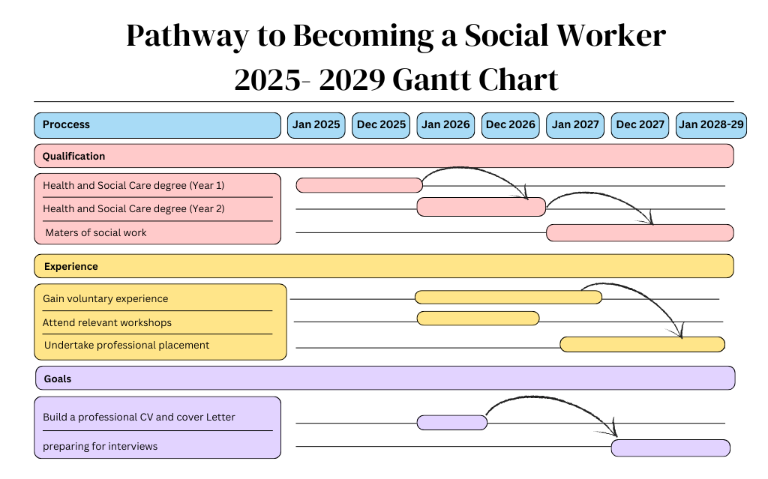
Task 7- Making Changes- Report
Report on Implementing a Staff Wellbeing and Mental Health Support Programme
As the manager of our care home, I would like to introduce a staff wellbeing and mental-health support programme to help reduce stress, improve morale, and promote a more positive working environment. Care work is emotionally demanding, requiring staff to manage challenging situations while providing compassionate care, making support for staff wellbeing vital (CareHome.co.uk, 2025).
To guide this change, I will use Kotter’s 8-Step Change Model (1996). The first step will be to create awareness of why this change matters by sharing staff survey results and national data on burnout in health and social care. Next, I will build a small working group of staff champions to help design the programme. The plan will include access to wellbeing workshops, reflective practice sessions, and confidential counselling support. Regular meetings and feedback will help embed these initiatives into the care home culture.
Key skills needed include empathy, communication, leadership, and collaboration. These will ensure staff feel valued and involved throughout the process. Possible barriers include stigma around mental health, time constraints, and scepticism about whether the programme will make a difference. To overcome these, I will promote openness, ensure protected time for participation, and demonstrate commitment through consistent follow-up.
By prioritising staff wellbeing, we can build a more resilient workforce, reduce absenteeism, and ultimately enhance the quality of life for both staff and residents.

Task 8- Self-Reflection
Reflection on Learning Using Gibbs’ Reflective Cycle (1988)
During this module, I developed a stronger understanding of how I respond to challenges, communicate with others, and manage professional responsibilities. Using Gibbs’ Reflective Cycle (1988) helps me explore my learning and how it will influence my future practice.
1. Description
I took part in activities focused on building my personal brand and preparing for employment in health and social care. I learned about the value of personal and professional networking, which is essential in a field centred on communication. I also used Canva for the first time to create posters and charts, which was challenging at first. Learning to make a Gantt chart helped me understand how to plan tasks and visualise the steps required to become a social worker.
2. Feelings
Initially, I felt stressed and unsure about using Canva or making a Gantt chart. I worried my work might look unprofessional. Over time, my confidence grew, and I became proud of what I created. Gaining these skills made me feel more prepared for university work and my future career.
3. Evaluation
The biggest challenge was learning Canva from scratch, but with practice it became manageable. Understanding networking was also valuable, as relationship-building is essential in health and social care. The Gantt chart helped break long-term goals into smaller steps, making them easier to achieve.
4. Analysis
This experience showed me that personal branding involves recognising and communicating my strengths and values. My initial struggles with Canva taught me that patience is key when learning new skills. The Gantt chart highlighted the importance of planning, especially when working toward long-term goals like becoming a social worker.
5. Conclusion
Overall, this module was a meaningful learning journey. I gained confidence with Canva, understood the importance of networking, and learned how planning tools support my academic and professional development.
6. Action Plan
To build on this progress, I will continue using Canva, growing my professional network, and using Gantt charts for other purposes. I will also apply reflective models like Gibbs to support my ongoing development.

Reference List

Andrews, T.R. (2024) Tackling Staff Shortages in UK Hospitality: 5 Tips to Boost Recruitment and Retention. Talking Hospitality Blog, 28 October. Available at: https://www.talkinghospitality.com/blog/tackling-staff-shortages-in-uk-hospitality-5-tips-to-boost-recruitment-and-retention/ (Accessed 7 November 2025).
BMJ Group (2023) Work stress, workload, understaffing driving out health professionals from NHS. Available at: https://bmjgroup.com/work-stress-workload-understaffing-driving-out-health-professionals-from-nhs/ (Accessed 15 October 2025).
CareHome.co.uk (2025) Have you got what it takes to work in the care industry in the UK? [online] Available at: https://www.carehome.co.uk/jobs/advice/have-you-got-what-it-takes-to-work-in-the-care-industry-in-the-uk (Accessed 27 October 2025).
CPD UK. (2022) Personal branding is more important than ever – here’s why. Available at: https://www.cpduk.co.uk/news/personal-branding-is-more-important-than-ever-here-s-why (Accessed 10 October 2025).
Gibbs, G. (1988) Learning by Doing: A Guide to Teaching and Learning Methods. Oxford: Oxford Polytechnic.
HelpGuide.org (2025) Improving Emotional Intelligence (EQ): Manage Emotions to Build Better Relationships and Achieve Success. Available at: https://www.helpguide.org/mental-health/wellbeing/emotional-intelligence-eq (Accessed 22 October 2025).
Indeed. (2025) How to build a personal brand. Available at: https://uk.indeed.com/career-advice/career-development/personal-brand-building (Accessed 5 October 2025).
Indeed. (2025) What is social networking and why is it important? [online] Available at: https://www.indeed.com/career-advice/finding-a-job/social-networking (Accessed 5 October 2025).
Kotter, J. (1996) Leading Change. Boston: Harvard Business School Press.
NHS Employers. (2023) ‘NHS equality, diversity and inclusion (EDI) improvement plan’, 23 June. Available at https://www.nhsemployers.org/articles/nhs-equality-diversity-and-inclusion-edi-improvement-plan (Accessed 26 October 2025).
NHS Employers. (2025) ‘Bridging the gender pay gap’. Available at https://www.nhsemployers.org/publications/bridging-gender-pay-gap (Accessed 27 October 2025).
NHS England (2023) NHS Equality, Diversity and Inclusion Improvement Plan. Available at: https://www.england.nhs.uk/long-read/nhs-equality-diversity-and-inclusion-improvement-plan/ (Accessed 27 October 2025).
NHS England (2023) NHS Long Term Workforce Plan. Available at: https://www.england.nhs.uk/long-read/nhs-long-term-workforce-plan-2/ (Accessed 5 October 2025).
NHS England (2023) NHS equality, diversity and inclusion (EDI) improvement plan. Available at: https://www.england.nhs.uk/publication/nhs-edi-improvement-plan/ (Accessed 28 October 2025).
Skills for Care (2023) Retaining more people. [online] Available at: https://www.skillsforcare.org.uk/About-us/Our-policy-positions/Capacity/Retaining-more-people.aspx (Accessed 5 October 2025).
The King’s Fund (2024) Staff shortages: what’s behind the headlines? Available at: https://www.kingsfund.org.uk/insight-and-analysis/blogs/staff-shortages-behind-headlines (Accessed: 3 October 2025).

