

Postgraduate/Distance Learning
Assignment coversheet & feedback form

THIS SHEET MUST BE THE FIRST PAGE OF THE ASSIGNMENT YOU ARE SUBMITTING (DO NOT SEND AS A SEPARATE FILE)

For completion by the student:
Student Name: Rhian Herbert

Student University Email: 1402931@student.uwtsd.ac.uk
Module code: HPCA7015  Module title:  Foundations in Cultural Astronomy and Astrology | Student ID number:  1402931 | Educational support needs:  No
Assignment title: Essay based on a Sky Journal.

Assignment due date: 28 November 2024
This assignment is for the 1st 2nd x 3rd 4th 5th 6th module of the degree
I confirm that this is my original work and that I have adhered to the University policy on plagiarism.
Signed ……………………………………………………………
Email submission:if you are submitting this form via email, please tick this box ☑︎
(as a substitute for your signature) to confirm that you agree to the above declaration.

Assignment Mark
1st Marker’s Provisional mark
2nd Marker’s/Moderator’s provisional mark
External Examiner’s mark (if relevant)
Final Mark

NB. All marks are provisional until confirmed by the Final Examination Board.

For completion by Marker 1 :
Comments:

Marker’s signature: |  | Date:
For completion by Marker 2/Moderator:

Comments:

Marker’s Signature: | Date:
External Examiner’s comments (if relevant)

External Examiner’s Signature: | Date:

Assignment : Essay Based on Sky Journal
Rhian Herbert: Word Count 1992
‘To think is to walk among clouds.’ Discuss this statement from Alexandra Harris as it relates to your sky journal observations. Harris, Alexandra. Weatherland: Writers & Artists under English Skies. London: Thames & Hudson, 2015, p.245.

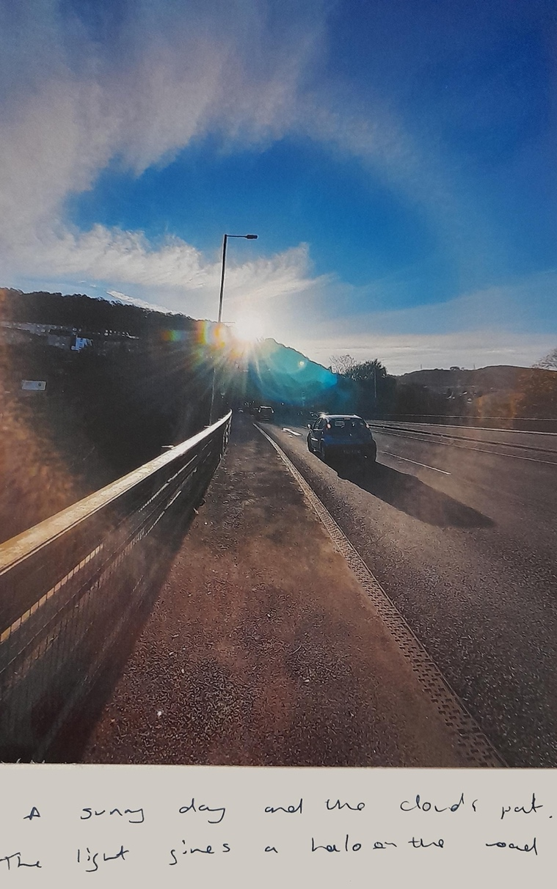
Figure 1. Light Halo, Pontypridd Interchange, September 2024.

Alexandra Harris writing in Weatherland claimed, ‘To think is to walk among clouds’. During the time I kept my Sky Journal I observed the clouds with this statement in mind. For my Sky Journal I had hoped to look at the stars but unfortunately the weather meant that I needed to rethink my strategy, so I switched to clouds as during my observations I often saw gloomy and grey skies. I started observing in late September and continued to the end of October.

Our skies have long held a fascination for many over centuries, and clouds are no exception. As Richard Hamblyn writing in his book Clouds: Nature and Culture notes,
‘Clouds have been objects of delight and fascination throughout human history’. Clouds are often a source of interest to consider when we observe the sky, as Harris notes, clouds are ‘constantly revised and never finished.’ For me, I admit I quickly realised after I'd started that I often take photographs of the sky with the clouds but usually I edit out man-made features unless there's a reason to include them. In fact, my phone camera reel is full of photographs of the sun glinting through clouds illuminating a space. What I often edit out I is the parts that I see as ugly or mundane, making them less aesthetically pleasing.

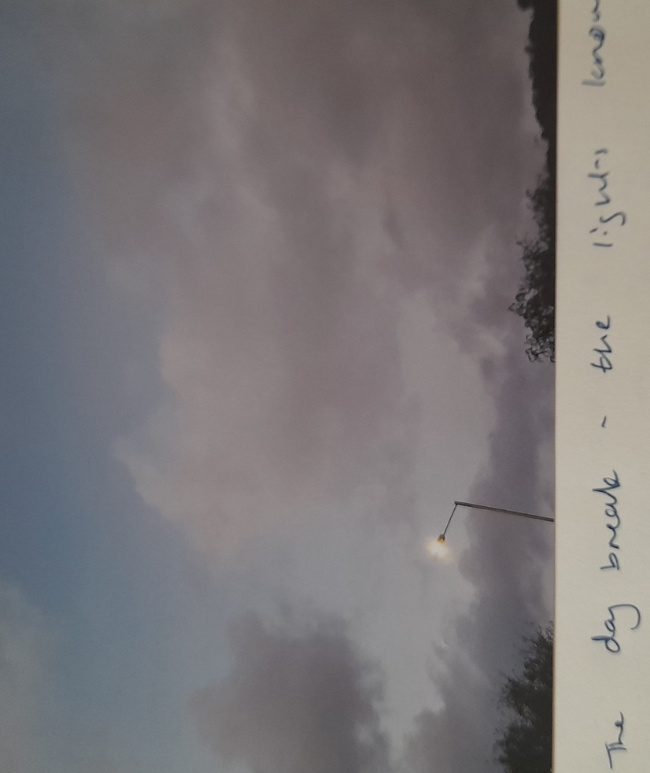
Figure 2. A Halo Around The Streetlight, October 2024.

Initial Considerations

I decided that as my topic had been pre-selected by the change in the weather, I would take my photographs and include the urban elements that I am usually quick to exclude. Suddenly a sky of grey was offset by the illumination of a streetlight or some other artificial item, giving the image a different presence. Nature and man-made elements were combining and creating something unusual, and some of the images I took would have had less impact without the presence of something that humanity had put there. Figures two and three are perfect examples of this; figure two, a lamppost almost haloed by the clouds above, it was only after I took the photograph I noticed the clouds seemed to give space to the lamppost, choosing to shade their colours around it. Figure three meanwhile is both an incredibly bleak photograph but also filled with hope. The lone light offset with the work being undertaken on the hill behind brings an enormous sense of relief to residents. During 2020 a landslip occurred sending debris down the hillside into the valley below. Fear of coal tip slippage is very real in the south Wales valleys, the image gives more poignancy than I expected.

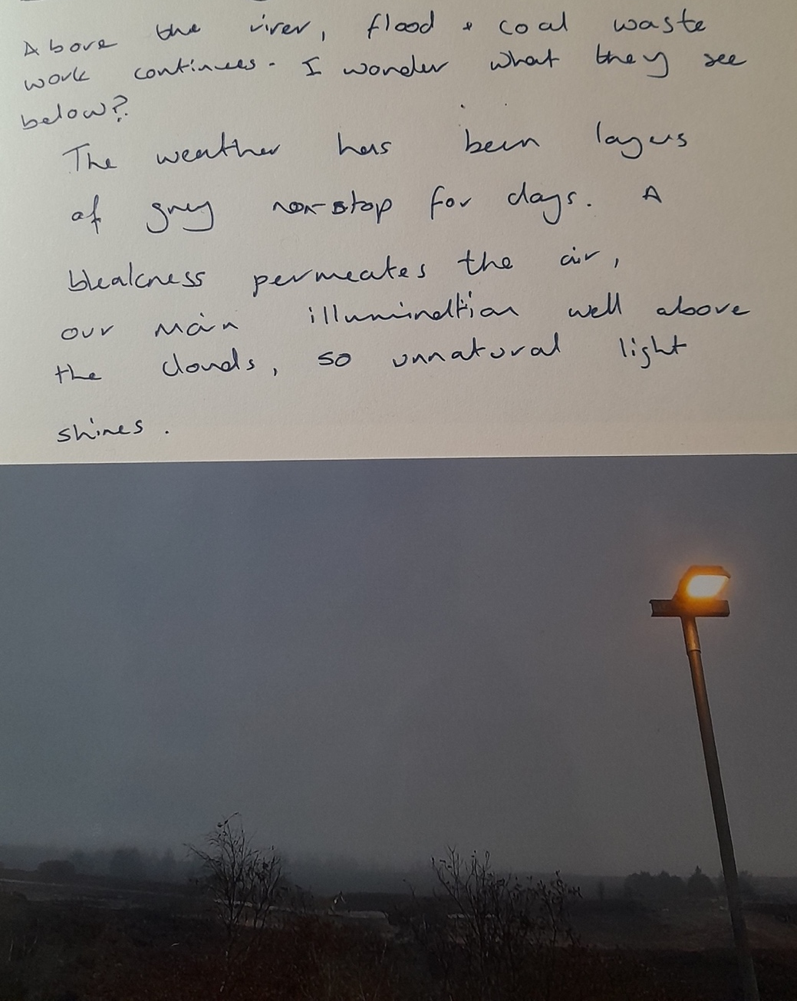
Figure 3. Looking Up At Tylorstown Tip, October 2024.
Interpretations And Moments
My images reminded me of poems unexpectedly. Wordsworth came to mind as I took an image of a quiet road interchange. No one was paying attention to the lonely cloud seemingly on a separate level to its other streaky cloud companions. ‘I wandered lonely as a cloud’ Wordsworth wrote, floating ‘high o’er vales and hills’. As Harris notes, clouds ‘and inspiration go together in romantic culture’ however, ‘the association is counter intuitive’ because in the United Kingdom ‘it runs against our practical experience’.

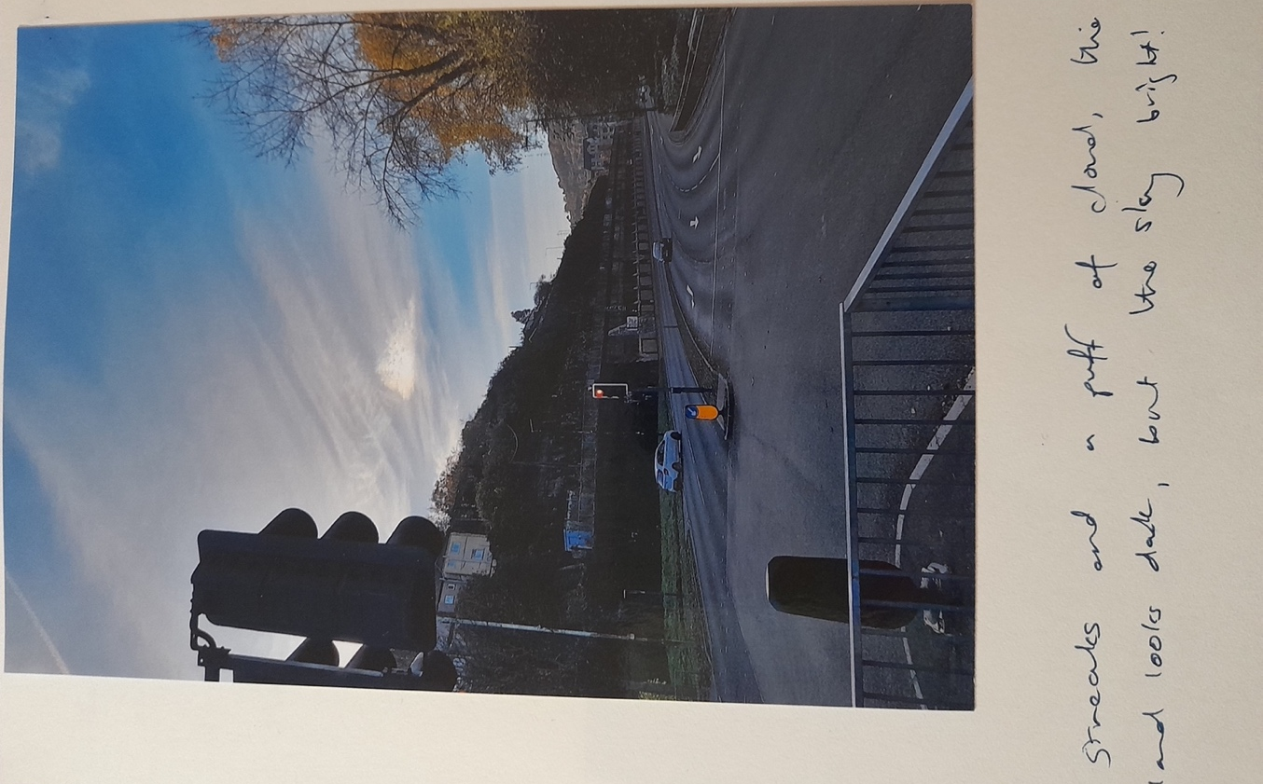
Figure 4. A Lonely Cloud, Broadway interchange, Pontypridd, October 2024.

Poetry appeared in all manner of moments for me. James Thomson was probably not thinking of wet streets, with takeaways opening their doors for the evening rush, but his words about the moon, reminded me somewhat literally of the sun illuminating the sky. With the light ‘breaking through the scattered clouds’ creating a ‘crimsoned’ outline for anyone to look up and enjoy. Perhaps not his meaning, but in the moment it felt apt nonetheless.

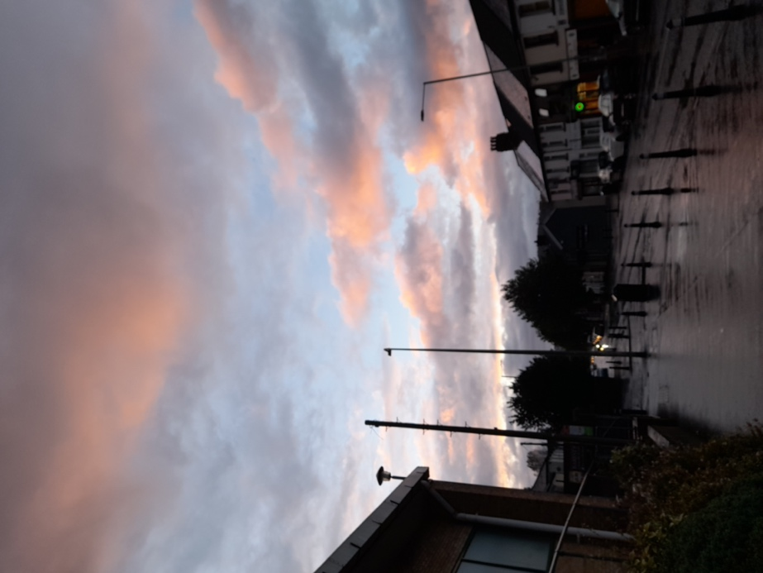
Figure 5. Evening, Broadway, Treforest, October 2024.

Or maybe Keats is more appropriate, with his clouds in ‘the soft-dying day’ possessing a ‘rosy hue’. These photographs stood out as the weather was still unpredictable. Many of my images were of grey streets, grey skies and a melancholia and grimness that impressed upon me. Much like Keats’ own experience, where he found himself ‘blind in mist’, amongst these moments, the cold and damp permeating, all I wanted to do was head home.

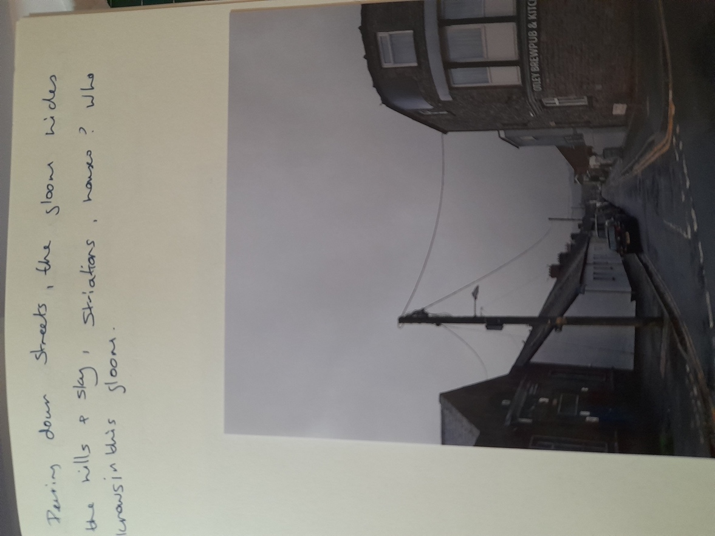
Figure 6. Treforest, October 2024.

Despite the gloom, there was still poetry that seemed appropriate, as I walked I felt like I became the protagonist in Blake’s The Secrets of the Earth. ‘She wandered in the land of clouds through valleys dark, listening’. Whether night or day the gloom seemed to linger on, my notes in my Sky Journal spoke of how the days seemed to merge as figures six and seven shows.

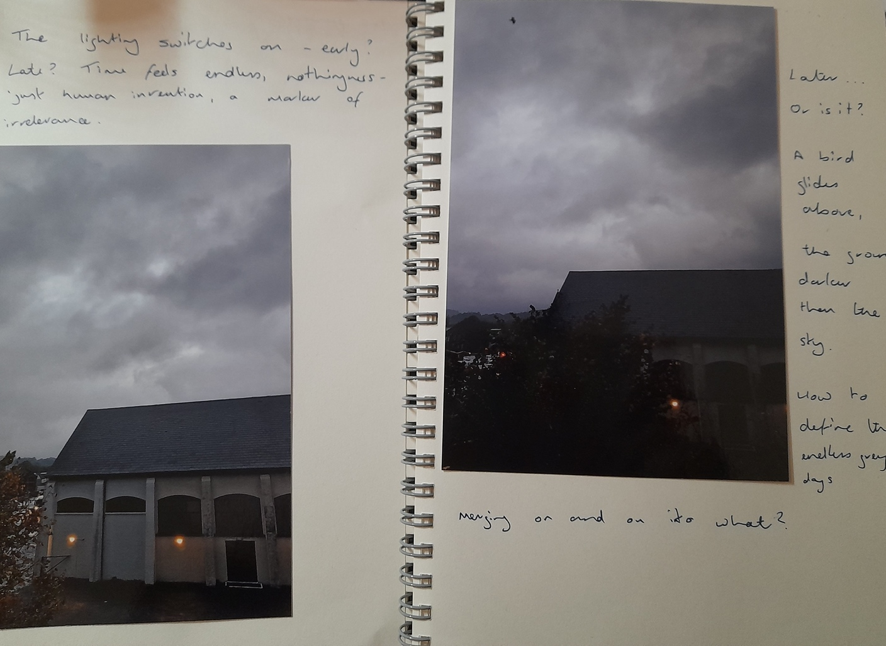
Figure 7. Catholic Church Hall, Treforest, October 2024.

On Clouds

Whilst clouds have often inspired artists, there is of course the science behind them. Hansen states at ‘any given time, about two-thirds of Earth's surface is covered’ by cloud. The Met Office explains they form ‘when there is too much water vapour… The water vapour (gas) then condenses to form tiny water droplets’ and it is the water that we see. Prosaic but interesting; as a child I imagined the huge chimneys at industrial sites made clouds, belching out toxic smoke high above, finding beauty in the ugliness of what they called progress.
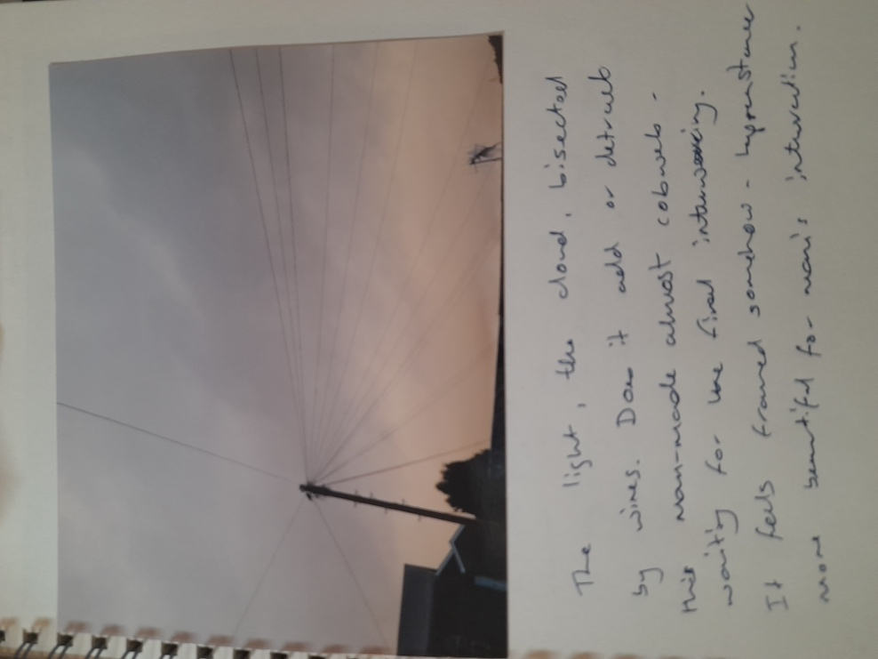
Figure 8. A Bird On The Wire, Treforest, October 2024.

However, in my Sky Journal the inclusion of the manmade features gave more poetic interpretations, as figures eight and nine show. Here, the wires almost slice through the cloud, framing the sky like some sort of unfinished spider’s web. Figure nine looked like the lights were spilling secrets of all the things they’d seen that day, watched over by benevolent, indulgent clouds as they did so.
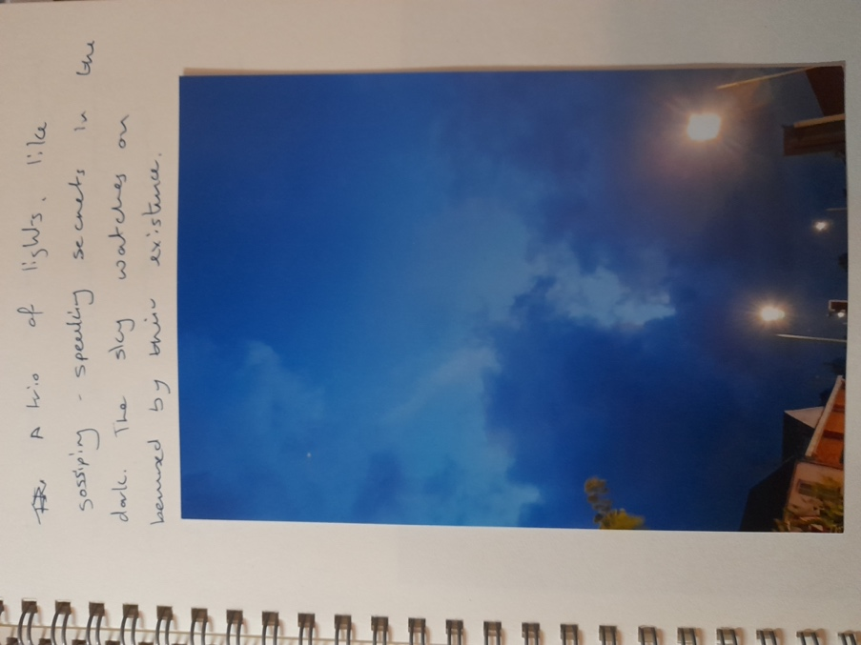
Figure 9. Gossiping Streetlights, Treforest, October 2024.

Misty Wanderings
Fanciful notions aside, my walks continued, surrounded by the urbanisation of the area that has changed with the needs of progress. Part of the Taff Trail, now a walking/cycle path, was once an old slipway that belonged to the A470. Suddenly, despite the traffic on the other side of the fence, you are sandwiched between the river far below and the trees on the hill above.
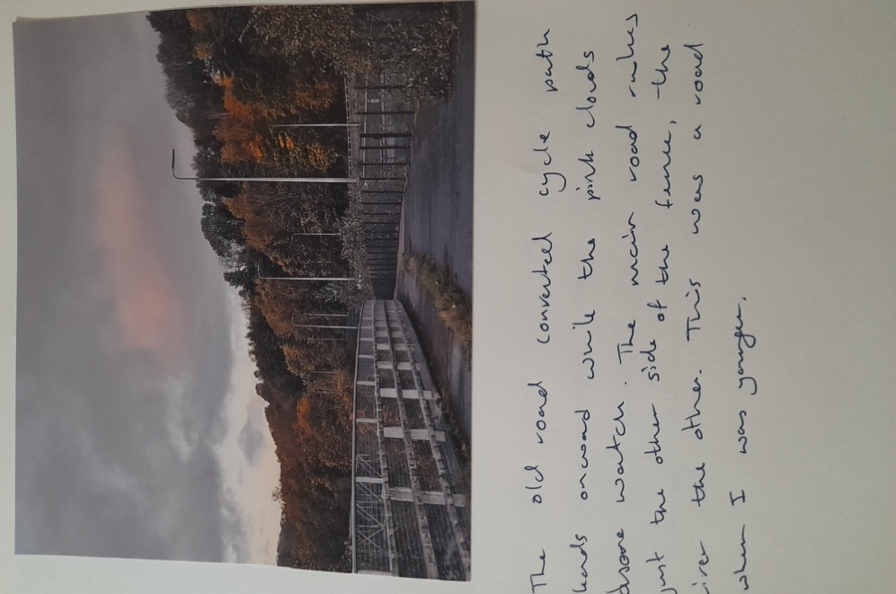
Figure 10. Taff Trail Heading North, October 2024.

The views up and down the river allow for some fantastic images, with clouds in the distance. According to Harris, the Anglo-Saxons ‘imagined thoughts being made from clouds’, and walking these paths, certainly allows the walker to pause and ponder as the world rushes past.
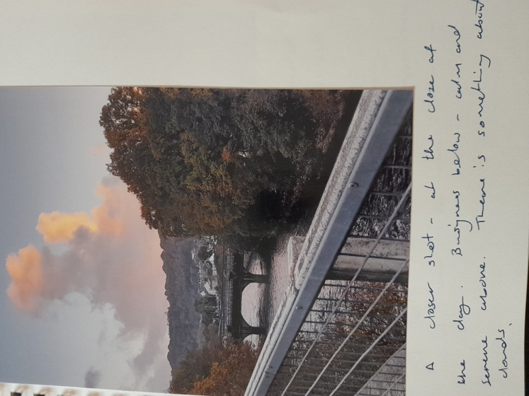
Figure 11. Taff Trail Looking South, October 2024.

Of course, clouds have long inspired artists, one of the more famous being Caspar David Friedrich. His Wanderer Above the Sea of Fog is a perfect example of his work with clouds. According to Norbert Wolf, ‘The mist illustrates the cycle of nature’.
Figure 12. Wanderer Above the Sea of Fog.

Wolf elaborates, ‘Friedrich’s more forceful cloud formations are… the result of his own reflections and aims’. As Friedrich himself explained to the Russian poet Zhukovsky, ‘I must surrender myself to what surrounds me, unite myself with its clouds’, he continued, ‘I need solitude in order to communicate with nature.’ Hamblyn claims that for Friedrich, ‘clouds were banners of creative and contemplative freedom’. Harris believes that for both Friedrich and Keats, ‘mist is an accurate figuration’ for ‘all mental life’.

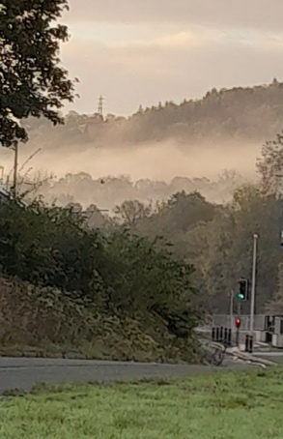
Figure 13. Green Light To Misty Adventure, Treforest, October 2024.

Figure thirteen is a close-up image, but the camera resolution and a shaky hand didn’t do the picture justice. Nonetheless it felt as though the green light was beckoning the willing to travel onward into the unknown mists, ‘uniting with the clouds’, just beyond the other side of the river, perhaps a ‘glorious’ adventure, or even a ‘nightmare’.

A Change in the Weather

Eventually the weather changed for my observations and the skies became less predictable, one morning, sun, the next, rain. A favourite space was walking over the River Taff, looking south. Again, here the 2020 storms had an impact, the bridge and the road you see at the edge of figure fifteen were all flooded, the houses awash. The floodwater was too much for the bridge, and after inspection it was condemned. The replacement opened over two years later.
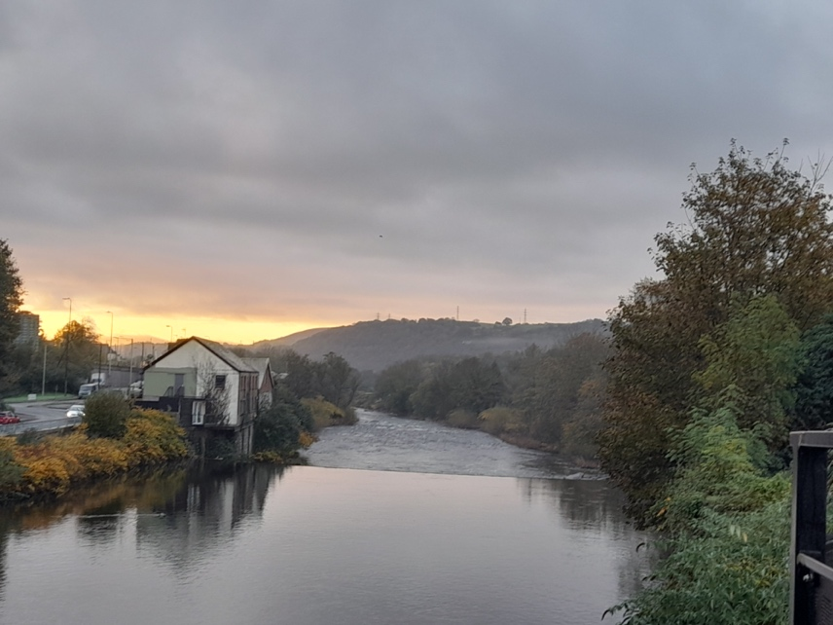
Figure 15. Looking South Down The River Taff, Sunrise To The East, Treforest, October 2024.

William Morris’s poem Summer Dawn seemed appropriate as I watched the sun,

the morning light slips,
Faint and grey ‘twixt the leaves of the aspen,
Betwixt the cloud-bars,
That are patiently there waiting for the dawn:
Patient and colourless, through Heaven’s gold
Waits to float through them along with the sun.

the evocative words, echoing as the river meanders under the bridge, onwards to Cardiff.
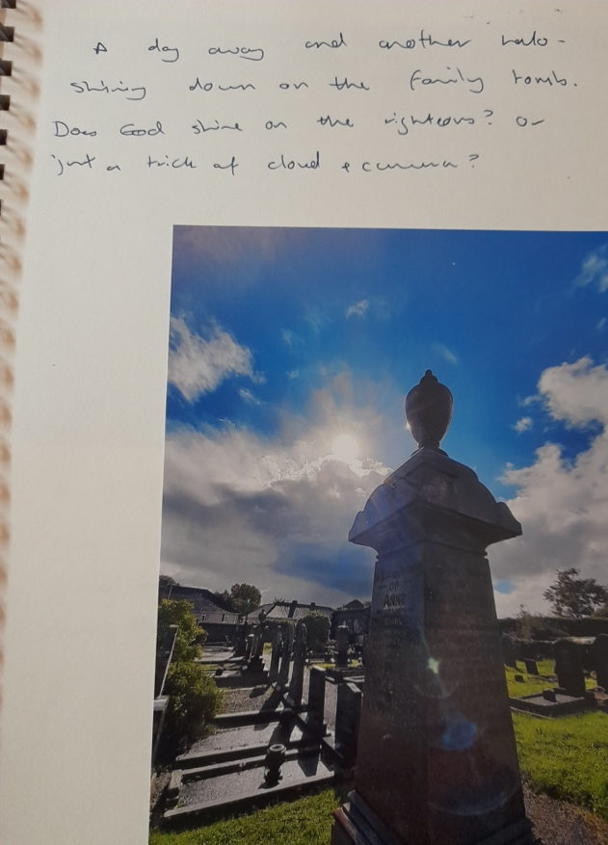
Figure 16. Cemetery off Hall Street, Ammanford, October 2024.

Sometimes I went further afield. A trip to visit family meant a walk to the cemetery where my ancestors were buried, my camera documenting the sun but not the rain that soaked me less than half an hour later. My comment in my Sky Journal ruefully asking ‘Does God shine on the righteous? Or just a trick of cloud and camera?’ as I reminisced about the trip and my thoughts of walking near where my ancestors lay. I realised that I often take pictures of the sky illuminating a space that has deep meaning for me, after all as Hamblyn notes, ‘clouds have always been more than merely meteorological’ as they possess ‘rich cultural and emotional associations that extend far beyond their fleeting atmospheric lives.’

Final Thoughts

The majority of my images were taken relatively close to where I live and work. In a way they've been part of a journey that I've been on for the last few years, where I have been reflecting on my life circumstances and re-walking the paths that I have walked for many years, considering the changes and looking at the sky at the same time. Clouds and the sky seem to give me a sense of place and belonging. They can speak of mystery, discovery and wonders beyond. I realised as I was looking back at the images I had, clouds can offer us something that we cannot define, a timelessness, an element that appears as the light of the sun illuminates the clouds.

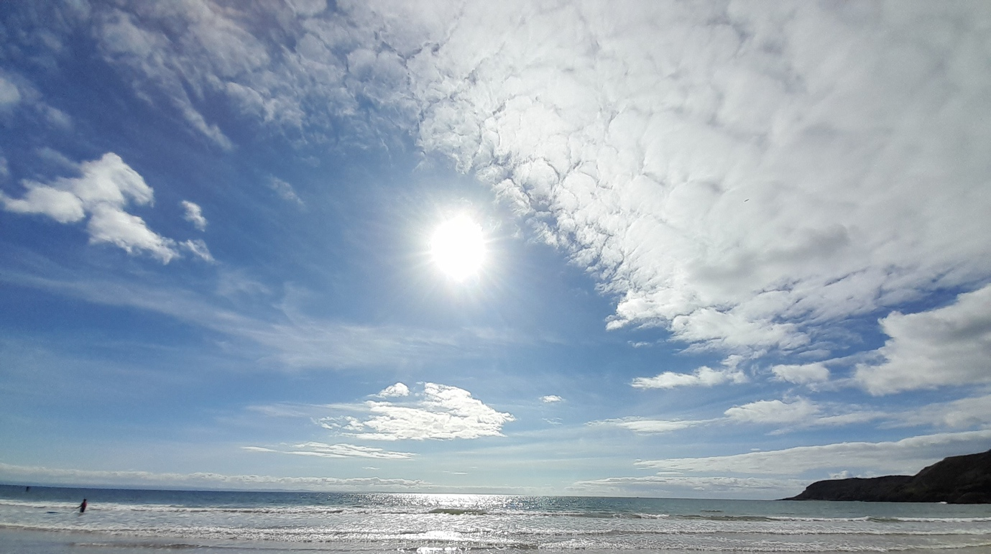
Figure 17. Looking Out To Sea, Gower Peninsula, October 2024.

As I considered my images, my Sky Journal and the feelings I had whilst creating them I recognised that it brought upon me thoughts of time and how our environment changes, how we adapt, remake and re-evaluate, and all the while from high above the clouds are both separate and still very much part of everything that's going on around us. My final picture is one more typically found on my camera reel, taken while standing in the sea, having the waves wash over my feet and staring at the horizon in the distance. Breathing in the sea air and having the sun beat down on me. Helping me to clear my mind and my thoughts. If there is one thing I have learned from this project it is the clouds allow me to pause and ponder and there is beauty in that. ‘To think is to walk among clouds’ indeed.

References:

BBC, Storm Dennis: Why Wales Is Prone To Landslides’, (2020), <https://www.bbc.co.uk/news/uk-wales-51546971> [accessed 26 November 2024]
Blake, William, ‘The Secrets of the Earth’, in The New Oxford Book Of English Verse 1250-1950, ed. by Helen Gardner (Oxford University Press: 1972)
Caspar David Friedrich, Wanderer Above The Sea Of Fog, [Oil on canvas] , (c.1818), <https://www.hamburger-kunsthalle.de/en/caspar-david-friedrich> [accessed 16 November 2024]
Hamblyn, Richard, Clouds: Nature And Culture, (London, Reaktion Books, 2017)
Hansen, Kathryn, ‘A Celebration Of Clouds From Space Earth Has An Elegant Atmosphere’, NASA Earth Observatory, 2016 <https://earthobservatory.nasa.gov/features/CloudsGallery> [accessed 16 November 2024].
Harris, Alexandra, Weatherland : Writers and Artists under English Skies (London ; Thames & Hudson, 2016)
Herbert, Rhian, Sky Journal, (2024)
Keats, John, ‘To Autumn’, in The New Oxford Book Of English Verse 1250-1950, ed. by Helen Gardner (Oxford University Press: 1972)
Met Office, What Are Clouds And How Do They Form?’, [n.d.] <https://www.metoffice.gov.uk/weather/learn-about/weather/types-of-weather/clouds/what-are-clouds-and-how-do-they-form> [accessed 16 November 2024]
Morris, William, ‘Summer Dawn’, in The New Oxford Book Of English Verse 1250-1950, ed. by Helen Gardner (Oxford University Press: 1972)
Thomson, James, ‘The Autumnal Moon’ , in The New Oxford Book Of English Verse 1250-1950, ed. by Helen Gardner (Oxford University Press: 1972)
Rhondda Cynon Taf County Borough Council, ‘The New Castle Inn Bridge Opens To Pedestrians And Cyclists This Week’, [n.d.] https://www.rctcbc.gov.uk/EN/Newsroom/PressReleases/2024/February/ThenewCastleInnBridgeopenstopedestriansandcycliststhisweek.aspx#:~:text=The%20Castle%20Inn%20Footbridge%20replacement,Welsh%20Government%20in%202023%2F24
Rhondda Cynon Taf County Borough Council, ‘Tylorstown Landslip Remediation Process’,(2024), <https://www.rctcbc.gov.uk/EN/GetInvolved/TylorstownLandslip/Tylorstownlandslipremediationprocess.aspx> [accessed 16 November 24]
Wolf, Norbert, Caspar David Friedrich, (Koln: TASCHEN GmbH,2003)
Wordsworth, William, ‘Daffodils’, in The New Oxford Book Of English Verse 1250-1950, ed. by Helen Gardner (Oxford University Press: 1972)

Bibliography:
Aveni, Anthony, ‘Sky: Myths and Symbolism’, Encyclopedia of Religion, (2005) 8425–32
Campion, Nicholas, History of Western Astrology. Volume II, The Medieval and Modern Worlds (London ; Continuum, 2009)
Daston, Lorraine, ‘Cloud Physiognomy’, Representations (Berkeley, Calif.), 135.135 (2016), 45–71 <https://doi.org/10.1525/rep.2016.135.1.45>
Gunzburg, Darrelyn, ed., The Imagined Sky : Cultural Perspectives (Sheffield: Equinox, 2016)
Sztuka, Izabela Maria, and Simone Kühn, ‘Blue Skies: Does the Visual Composition of Sky Guide Subjective Judgments of Naturalness in the Environment?’, Environmental Research, 262.Pt 2 (2024), 119845- <https://doi.org/10.1016/j.envres.2024.119845>
Weightman, Barbara A, ‘Sacred Landscapes and the Phenomenon of Light’, Geographical Review, 86.1 (1996), 59–71 <https://doi.org/10.2307/215141>

Alexandra Harris, Weatherland, (London: Thames & Hudson, 2016), p. 247.
Richard Hamblyn, Clouds: Nature And Culture, (London: Reaktion Books, 2017), p.10.
Harris, Weatherland, p. 237.
Rhondda Cynon Taff County Borough Council, ‘Tylorstown Landslip Remediation Process’, (2024), <https://www.rctcbc.gov.uk/EN/GetInvolved/TylorstownLandslip/Tylorstownlandslipremediationprocess.aspx> [accessed 16 November 24].
‘BBC, Storm Dennis: Why Wales Is Prone To Landslides’, (2020), <https://www.bbc.co.uk/news/uk-wales-51546971>[accessed 26 November 2024].
William Wordsworth, ‘Daffodils’, in The New Oxford Book Of English Verse 1250-1950, ed. by Helen Gardner (Oxford University Press: 1972), p. 506.
Harris, Weatherland, p. 246.
James Thomson, ‘The Autumnal Moon’ , in The New Oxford Book Of English Verse 1250-1950, ed. by Helen Gardner (Oxford University Press: 1972), p. 249.
John Keats, ‘To Autumn’, in The New Oxford Book Of English Verse 1250-1950, ed. by Helen Gardner (Oxford University Press: 1972), p. 611.
Harris, Weatherland, p. 246.
William Blake, ‘The Secrets of the Earth’, in The New Oxford Book Of English Verse 1250-1950, ed. by Helen Gardner (Oxford University Press: 1972), p. 485.
Kathryn Hansen, ‘A Celebration Of Clouds From Space Earth Has An Elegant Atmosphere’, NASA Earth Observatory, (2016) <https://earthobservatory.nasa.gov/features/CloudsGallery> [accessed 16 November 2024].
Met Office, ‘What Are Clouds And How Do They Form?’, [n.d.] <https://www.metoffice.gov.uk/weather/learn-about/weather/types-of-weather/clouds/what-are-clouds-and-how-do-they-form> [accessed 16 November 2024].
Harris, Weatherland, p. 247.
Norbert Wolf, Caspar David Friedrich, (Koln: TASCHEN GmbH,2003), p. 58.
Caspar David Friedrich, Wanderer Above The Sea Of Fog, [Oil on canvas] , (c.1818), <https://www.hamburger-kunsthalle.de/en/caspar-david-friedrich> [accessed 16 November 2024].
Wolf, Caspar David Friedrich, p. 62.
ibid, p. 47.
Hamblyn, Clouds: Nature And Culture, p. 58.
Harris, Weatherland, p. 247.
Wolf, Caspar David Friedrich, p.47.
Harris, Weatherland, p. 247.
Rhondda Cynon Taf County Borough Council, ‘The New Castle Inn Bridge Opens To Pedestrians And Cyclists This Week’, [n.d.] <https://www.rctcbc.gov.uk/EN/Newsroom/PressReleases/2024/February/ThenewCastleInnBridgeopenstopedestriansandcycliststhisweek.aspx#:~:text=The%20Castle%20Inn%20Footbridge%20replacement,Welsh%20Government%20in%202023%2F24>.
William Morris, ‘Summer Dawn’, in The New Oxford Book Of English Verse 1250-1950, ed. by Helen Gardner (Oxford University Press: 1972), p. 734.
Hamblyn, Clouds: Nature And Culture, p. 9.
Harris, Weatherland, p. 247.

