BA (Hons) International Hotel Management

BMIH5006
Sustainable Hospitality & Tourism Management

Assignment 2
The future of hospitality and is it profitable to be green?

Student name: Shah Mohammed Shahjahan Ali
ID: 2118400
Lecturer Name:Katherine Roberts

Table of Contents
Introduction 3
Relevance of the Statement 4
The Role of Finance in the Hospitality Industry 4
Business Responsibility and Consumer Demand 5
The Triple Bottom Line: A Framework for Sustainability 5
Butler's Tourism Sustainability Model 6
Doxey's Irridex Model: A Framework for Assessing the Environmental Sustainability of Tourism" 8
Data and Industry Examples 10
Recommendations for Future Development for Sustainable Tourism and Hospitality. 10
Conclusions 12
Reference list 13

Introduction
The paper examines the future of hospitality and tourism, a profitable and sustainable industry. The cry for corporate accountability has become stronger, so we examine whether Milton Friedman's concept of profits above all else is still applicable. We examine the changing role of finance, its synergy with sustainable practices, and the importance of financial resiliency in an industry tied to finance. Consumer preferences increasingly force corporations to embrace green practices. This consumer-driven shift towards greener options has transformed the sector. We use Doxey's Irridex Model, the Triple Bottom Line, and industry exemplars to inform plans to create a more sustainable, successful hospitality business.

Relevance of the Statement
Milton Friedman's view that an organisation’s fundamental goal is to increase profits is still valid, but it has expanded to include social and environmental obligations. Profit remains a key goal, but it now includes social and environmental rewards (Ballantyne and Packer, 2016). This transformation is a response to changing customer attitudes, legal restrictions, and the understanding that firms may help solve global problems like climate change and social inequity (Anand and Sen, 2017). Today's firms realise that sustainable practices can boost long-term profitability by lowering operational costs, recruiting eco-conscious customers, and boosting brand recognition. Friedman's focus on profit is still relevant, but it also includes sustainability. This paradigm shift shows Milton Friedman's relevance in a changing world businesses that balance financial and environmental responsibilities are more likely to succeed (Sharma, 2017). Finance has played a significant impact on every operation.

The Role of Finance in the Hospitality Industry
Finance shapes the hospitality industry's operations and strategies in many ways. Sustaining and expanding enterprises in this industry requires several crucial finance elements:
- Financial Resiliency: Economic fluctuations and external shocks like natural catastrophes and pandemics can hit the hospitality industry. The industry's resilience and ability to overcome these problems depend on good financial management (Luthans et al., 2018). Long-term survival requires appropriate reserves and a solid financial strategy.
- Continuous infrastructure and innovation investment requires finance: Hotels, restaurants, and other amenities are built and maintained. Technology and customer experience improvements like digital booking systems and environmental efforts require funding.
- Cost Control: Hospitality financial management requires cost control. Profitability depends on managing labour, utilities, and supplies (Petersen and McFarlane, 2018). Sustainable practices like energy-efficient technologies can save operational expenses over time.
- Profit Maximization: Hospitality companies prioritise profit and make financial decisions accordingly. Pricing, revenue management, and marketing improve financial performance.

Business Responsibility and Consumer Demand
Modern hospitality increasingly combines business responsibility with consumer demand. Hospitality companies are operating and marketing differently as consumers value enterprises' environmental and social responsibility (Korstanje, George, and Nedelea, 2020).
Consumer-Driven Duty: Consumers now consider how their purchases affect the environment and community. They favour values-based enterprises, which encourages hospitality companies to be responsible. Reduce trash, use local and sustainable products, and conserve energy and water.
Brand Image and Loyalty: Social and environmental responsibility boosts brand image and client loyalty (Mardani, 2020). Companies that care about the environment and their communities are more likely to win customers.
Competitive Edge: Hospitality organisations that take corporate responsibility generally have an advantage (Tromans, 2021). In a competitive market, they can charge more for eco-friendly or socially responsible services, increasing profits.
Laws and regulations: Regulation and compliance are rising as company responsibility grows. Proactively responsible companies can adjust to changing laws.

The Triple Bottom Line: A Framework for Sustainability
The Triple Bottom Line (TBL) framework, established by John Elkington, provides a complete paradigm for evaluating and attaining sustainability in the hospitality business. Profit, people, and the environment are all intertwined, and this concept highlights the necessity to strike a balance among them.
Profit: This metric emphasises sustainability, an ever-important aspect of the hospitality business. TBL understands the importance of a healthy bottom line for its survival, expansion, and capital expenditures (Getz and Petersen, 2018). It's not just concerned with short-term financial gains but also takes into account broader social and environmental considerations.
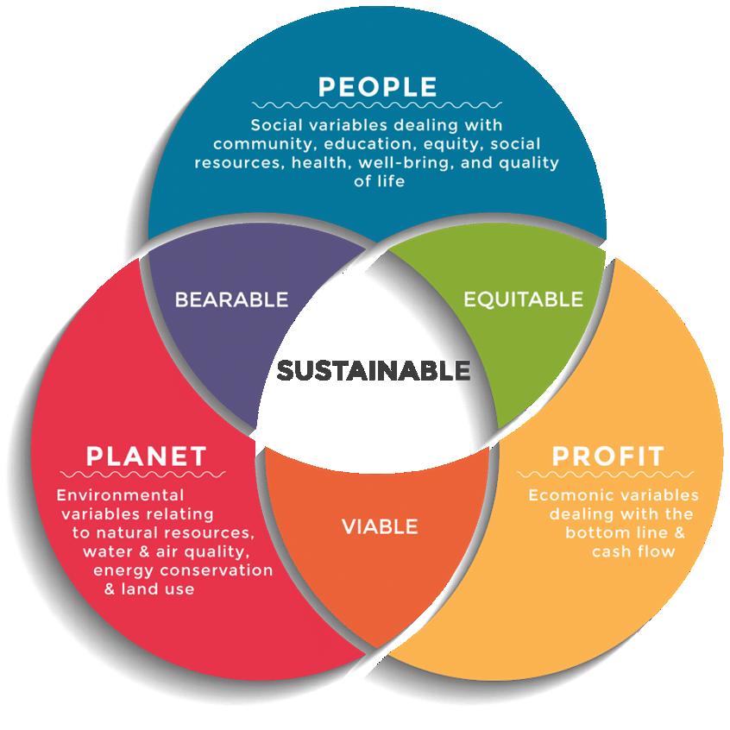
Figure 01: Triple Bottom Line: Framework (Author).
People: TBL stresses the value of contributing to the greater good. This involves thinking about how its business impacts the lives of its staff, neighbours, and patrons (Chon, 2019). Fair employment practises, community development and cultural appreciation are all essential components of this metric.
Planet: The environmental benefits of TBL in the hospitality industry are substantial. It necessitates eco-friendly practices including reduced waste, conserved energy, and ethical sourcing. Hospitality firms may help make the world a better place by reducing their carbon footprint.

Butler's Tourism Sustainability Model
Richard W. Butler's Tourism Area Life Cycle (TALC) model helps explain tourist destination development and hospitality industry impact.
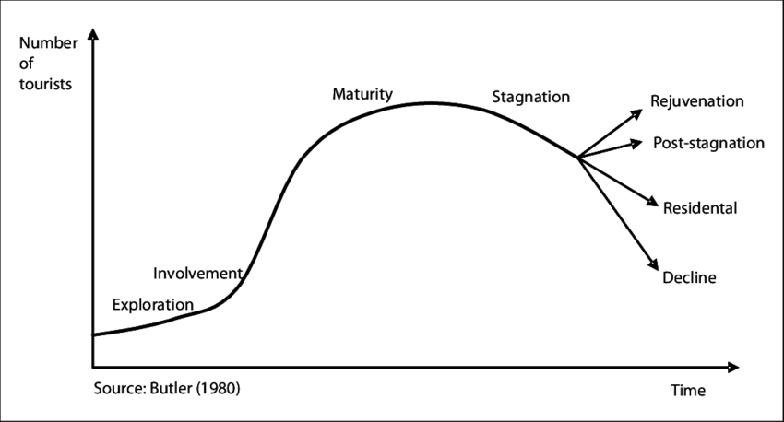
Figure No 02. Butler's Life Cycle Model (Butler, 2016).
The model defines various destination life cycle stages with distinct characteristics and implications:
- Exploration: Initial destinations are unexplored and lack infrastructure. Small, locally-owned hotels provide little hospitality (Behrmann et al., 2016). Businesses target niche adventure and nature tourist markets.
- Engagement: Visitors rise as word of the destination's attractions spreads. Hotels and resorts grow. The hospitality industry caters to many travellers with different tastes.
- Development: Destination growth is rapid. Demand drives infrastructure and service improvements (Korstanje, George, and Nedelea, 2020). The hospitality business grows as large hotels, restaurants, and entertainment alternatives are built.
- Consolidation: The destination matures with a strong tourism infrastructure. Competition and saturation may plague the hospitality business as it grows (Tiebout, 2020). Diversification is needed to meet changing tourist tastes.
- Stagnation: This stage may see the destination lose appeal owing to overdevelopment and environmental challenges. The hospitality business must maintain infrastructure and recruit new markets.
- Rejuvenation or Decline: Destinations may rebrand redevelop or decline if difficulties are not addressed, depending on management plans (Spencer, 2017).
Hospitality businesses must know where destinations are in this life cycle. Market demographics, visitor preferences, infrastructural development, and environmental sustainability must be considered while tailoring their strategy to the destination (Wickham, Donnelly, and French, 2021). To assure destination sustainability, the hotel industry can use the TALC model to make investment, marketing, and service decisions.

Doxey's Irridex Model: A Framework for Assessing the Environmental Sustainability of Tourism"
To evaluate tourism's environmental impact, Doxey's Irridex Model is useful. This Stephen L. Doxey model helps tourism and hospitality stakeholders identify and manage tourism's environmental irritants (Doxey, 2022). The importance of Doxey's Irridex Model in promoting environmental sustainability in tourism is examined here.
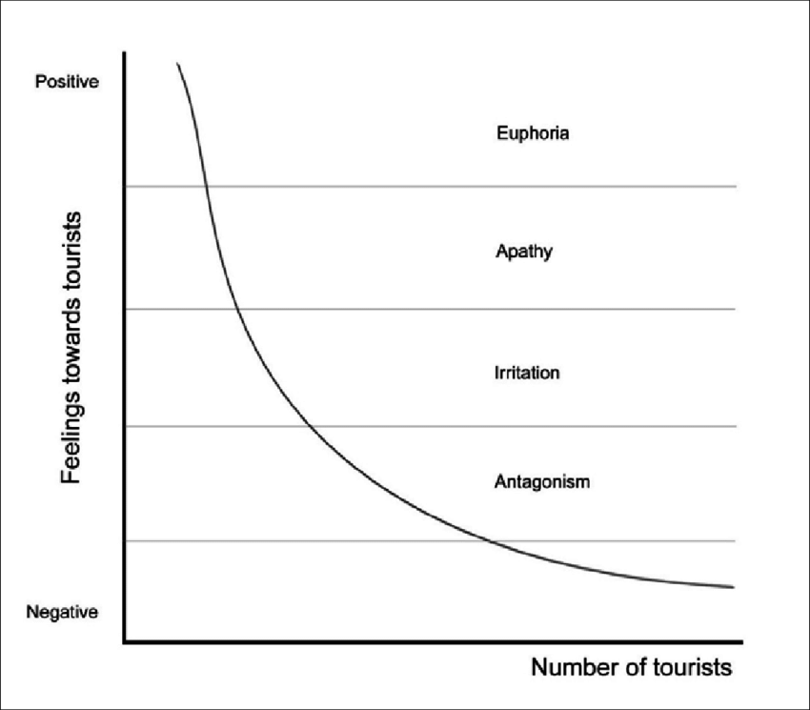
Figure 03. Doxey's Irridex Model (Doxey, 2022).
Doxey's Irridex Model explained: Doxey's Irridex Model assumes that locals may grow more annoyed as tourist places become more popular and crowded. The approach classifies tourism impacts into four stages:
- Euphoria: Initial tourism development enthusiasm.
- Apathy: Locals may be indifferent to tourism now.
- Annoyance: Tourism causes congestion, environmental damage, and cultural decline (Bailey and Konstan, 2018).
- Antagonism: inhabitants may develop strong anti-tourism feelings, leading to protests or backlash.
Environmental Sustainability Importance
- Early Issue Detection: Doxey's Irridex Model helps destinations identify environmental degradation. Early detection helps develop sustainable practices before problems become unmanageable.
- Engagement in the community: Communities and tourism firms may work together to prevent negative effects and provide sustainable solutions for residents and visitors by recognising the phases of irritation (Wickham, Donnelly, and French, 2021).
- Long-term planning: The approach encourages locations to evaluate tourism development's long-term effects (Cooper, 2021). They can sustain tourism growth and protect the environment by resolving irritations early.
- Policymaking: Doxey's Irridex Model can inform tourist policy by governments and local authorities. This includes visitation restrictions, environmental protection, and infrastructure improvements.

Data and Industry Examples
1. Costa Rica's Ecotourism Success: Sustainable tourism is typically modelled after Costa Rica. Through eco-friendly practices and environmental conservation, the country has attracted environmentally-minded travellers (Pagiola, 2019). The Costa Rican Tourism Board reported that 6.3% of the country's GDP came from tourism in 2019, and eco-certified hotels have grown, proving the viability of being green.
2. AccorHotels' Planet 21 Challenge: The Planet 21 programme from AccorHotels, one of the world's major hotel groups, promotes ethical sourcing and water and energy conservation (Costa and Costa, 2022). By the end of 2019, 70% of Accor's hotels were participating in Planet 21 and reduced water and energy use by 4.4%, demonstrating sustainability's economic benefits.
3. Airbnb Sustainable Travel Initiatives: Airbnb promoted eco-friendly hosting and responsible tourism with sustainability programmes (Gretzel et al., 2015). Airbnb's 2020 Environmental and Social Governance Report found that travellers want more sustainable accommodations and experiences, increasing demand for eco-friendly listings.

Recommendations for Future Development for Sustainable Tourism and Hospitality.
Strategic Planning: Long-term sustainability planning should follow the Triple Bottom Line (TBL) concept. When making decisions, consider environmental, social, and economic concerns and set goals for each. Keep these plans updated to adjust to new situations.
Education and Training: Staff training and awareness programmes help employees understand and adopt sustainable practices (Batabyal, 2018). Inform visitors about responsible tourism through in-house programmes and room materials.
Community Engagement: Involve local communities in tourism development and decision-making. Ask them about sustainability efforts that benefit the industry and residents.
Technology and Innovation: Use green technologies and creative ideas to lessen environmental effects (Pellissier, 2020). This includes energy-efficient systems, trash minimization, and responsible tourist digital platforms.
Certifications and Standards: Sustainability certifications like Green Key, EarthCheck, and LEED should be obtained and promoted. Standards boost credibility and attract eco-conscious travellers.
Eco-Friendly Infrastructure: Energy-efficient buildings, renewable energy, and water-saving devices should be funded (Petersen and McFarlane, 2018). These lower operational expenses and improve client satisfaction.
Market Responsiveness: Monitor customer trends and adapt offerings to changing tastes. Monitor demand for eco-friendly travel.
Advocacy and Policy: Promote sustainable tourism and hospitality policies with governments and industry associations. Help create eco-friendly regulations.
Measure and Report: Regularly evaluate and report your operations' environmental and social implications (Getz and Petersen, 2018). Reporting transparency shows sustainability and helps discover improvements.

Conclusions
Finally, the hotel and tourism industry's future depends on its capacity to balance profitability and environmental and social responsibility. Milton Friedman's business-driven philosophy remains vital, but profit now includes people and the planet. Numerous instances show the industry's role in environmental sustainability and green initiatives' profitability. Costa Rica, AccorHotels, and Airbnb show that sustainability can boost profits and satisfy eco-conscious travellers. Sustainable tourist development requires analysing and managing environmental impacts, according to Doxey's Irridex Model. This concept and the Triple Bottom Line can help the industry plan for economic growth, social responsibility, and environmental protection. Businesses must adapt and invest in responsible practices to thrive in this changing industry driven by customer demand for sustainability. Sustainable, responsible, and lucrative tourism is hospitality's future.

Reference list
Anand, S. and Sen, A. (2017). Human Development and Economic Sustainability. World Development, 28(12), pp.2029–2049.
Bailey, B.P. and Konstan, J.A. (2018). On the need for attention-aware systems. Computers in Human Behavior, 22(4), pp.685–708.
Ballantyne, R. and Packer, J. (2016). Visitors’ Perceptions of the Conservation Education Role of Zoos and Aquariums: Implications for the Provision of Learning Experiences. Visitor Studies, 19(2), pp.193–210.
Batabyal. (2018). Managing Sustainable Tourism Resources. IGI Global.
Behrmann, M., Avidan, G., Marotta, J.J. and Kimchi, R. (2016). Detailed Exploration of Face-related Processing in Congenital Prosopagnosia: 1. Behavioral Findings. Journal of Cognitive Neuroscience, 17(7), pp.1130–1149.
Butler, R. (2016). The tourism area life cycle. Clevedon; Buffalo: Channel View Publications.
Chon, K. (2019). The role of destination image in tourism: A review and discussion. The Tourist Review, 45(2), pp.2–9.
Cooper, C. (2021) Essentials of tourism. Third edition. London: SAGE.
Costa, and Costa, C. (2022). Sustainability and competitiveness in the hospitality industry (Costa & C. Costa, Eds.). Business Science.
Getz, D. and Petersen, T. (2018). Growth and profit-oriented entrepreneurship among family business owners in the tourism and hospitality industry. International Journal of Hospitality Management, 24(2), pp.219–242.
Goodland, R. (2022). The Concept of Environmental Sustainability. Annual Review of Ecology and Systematics, 26(1), pp.1–24.
Korstanje, George, B., and Nedelea, A. (2020). Strategies for promoting sustainable hospitality and tourism services. IGI Global. Gretzel, U., Sigala, M., Xiang, Z. and Koo, C. (2015). Smart tourism: foundations and developments. Electronic Markets, [online] 25(3), pp.179–188.
Mardani, B. (2020). Impact of Brand Image, Trust and Experience on Repurchase Intention, Mediated by Brand Loyalty. Journal of Advanced Research in Dynamical and Control Systems, 12(4), pp.547–552.
Pagiola, S. (2019). Payments for environmental services in Costa Rica. Ecological Economics, [online] 65(4), pp.712–724.
Pellissier, R. (2020). A CONCEPTUAL FRAMEWORK FOR THE ALIGNMENT OF INNOVATION AND TECHNOLOGY. Journal of technology management & innovation, 3(3).
Petersen, I.R. and McFarlane, D. (2018). Optimal guaranteed cost control and filtering for uncertain linear systems. IEEE Transactions on Automatic Control, 39(9), pp.1971–1977.
Sharma, K.K. (2017). Tourism and socio-cultural development. New Delhi: Sarup & Sons.
Spencer, R. (2017). Development Tourism. Tourism Planning & Development, 15(3), pp.277–292.
Tiebout, C.M. (2020). A Pure Theory of Local Expenditures. Journal of Political Economy, 64(5), pp.416–424.
Tromans, A. (2021). Competitive edge. Nature, 428(6983), pp.609–609.
Wickham, Donnelly, T., and French, L. (2021). Strategic Sustainability Management in the Event Sector. Event Management, 25(3), 279±296.

