Laura Jane Evans
Death and Dying: HPHI5013
Exam

How effective were medieval representations of the differences between hell and purgatory?

In the medieval mind hell and purgatory provided separate processes for the soul that to the modern person may seem the same. In both areas’ individuals are guaranteed to suffer to some degree but in the medieval mind it is an anticipated suffering that can either cleanse ones soul or condemn another, and justly so. In this essay we will be exploring the similarities that link these sister concepts and what difference the processes made in the medieval idea of the afterlife and how these ideas are represented.
The term sister concepts in this context describes how the concepts of hell and purgatory work together and how one was created first and then was later used to create the other. Hell, as a place for damned souls to suffer for their sins, was created before purgatory. Purgatory was established in order to ‘fill in the gaps’ between heaven and hell. A place to answer for sins that were unavoidable at times. So how was this difference conveyed to a medieval audience? Visual representations of the last judgement show a clear distinction between heaven and hell. In the Last Judgement scene [Fig. 1], we see a clear border between those that are judged fit for heaven and those that are flung down into hell. There is no space in between the two destinations. On the other hand, this representation of hell does not tell us much about the inner working of these areas. We are only shown the entrance, we have no idea what punishments the people are being punished for or any real sense of identity among them. Fra Angelico’s depiction of hell in the last judgement [Fig. 2], is more developed and provides categorised spaces for punishments. The people being punished are given some form of identity regarding appearance and occasionally a crown however, they are stripped naked. This dehumanises them, makes them equal in their shame and torture. The punishment is not unique to the individual but unique to the individual sin. There is no sense of varying degrees of sin or that this influences their punishment. Hell appears to be experienced as a group and removes the idea of identity and self. These are key aspects in purgatory that will be discussed later.
Purgatory as a space between heaven and hell can be seen in a depiction of a Purgatorial Ladder found in Surrey [Fig. 3]. Purgatory is represented as a ladder between heaven and hell, with souls attempting to reach heaven. The ladder is not easy to climb, and the image shows a larger number of people falling into hell. Some are guided by angels, symbolising the heavenly aspirations for every individual soul. However, there are souls being plucked from the ladder by demons. In a corner of hell we can see a tree. This could be interpreted as the tree of life which the fruit was taken from, implying that everyone is susceptible to sin, and it is far easier to sin. In the Revelation of the Monk of Eynsham, we are given detailed descriptions of individuals sins and punishments now customised to the individual. For example, a knight is attacked by a bird of prey perched on his arm in relation to his over indulging in falconry. The text also describes how the pain of the punishment matches the severity of the sin, and the time spent suffering eases as the individual confesses. The pain experienced in purgatory is contrasted with hell because there is an end to the pain. Through their own humility and faith, the souls may eventually reach heaven. “And through faith that they would eventually attain the joy of heaven they bore their burdens lightly”, (Revelation of the Monk of Eynsham). Another contrasting motif of purgatory is that help is available to the soul, through the prayer and masses of the living and on rare occasions from the saints. The alcoholic goldsmith worshipped and favoured St Nicholas and calls on him to help him through purgatory, “And when I find my torments to be unendurable, he comes to me and comforts me and brings me relief from my pain”. Knowing that the saint is there for him and that eternal joy is attainable the goldsmith endures the pain of purgatory (Revelation of the Monk of Eynsham). The concept of purgatory being a transitory space for the soul is a common motif in medieval literature. During visions individuals are often guided on a journey through purgatory and can walk the same path as the souls there. In visions of hell the individual travels through hell but the souls do not appear to travel through. Souls are placed in allotted areas and punished there for eternity, they do not travel from A to B in the same fashion as the souls in purgatory. The journey through purgatory is often associated with pilgrimage, at the end of both journeys the soul is spiritually enlightened and are both seen as rights of passage. A knight called Owen after returning from the Crusades decides to go to St Patricks Purgatory in order to cleanse himself of the sins he committed for the Holy Land. He is taken on a journey through purgatory and returns cleansed (Carol G. Zaleski).
Although the outcomes and destinations of purgatory and hell are different, they do share similarities. In the revelations of the Monk of Eynsham the goldsmith describes having to swallow red hot coins as a punishment for being greedy. This punishment is a common motif for the greedy, it is found in visions of hell as well as in Fra Angelico’s depiction of hell. In one compartment we see the demons heating up the coins and then forcible pouring them down the sinners’ throat. The punishment itself is what identifies the sin in this image which implies that the punishment was an already established motif among medieval audiences. Describing the same punishment in both visions of hell and purgatory may have been to legitimise the account. Both areas are also associated with fire. Fire is used by God in the bible to punish the cities of Sodom and Gomorrah and is appropriate punishment for the damned. However, fire has another connotation of purifying and cleansing which the function of the purgatorial fire is. This can be seen also with Moses and the burning bush, Moses is there to act out Gods vengeful wishes on the Egyptians but at the same time free the Jews from slavery (Alan E. Bernstein). Medieval representations of hell and purgatory would have been easily translated to a medieval audience who had established the symbolic code within the images and texts. The message of salvation that is found in purgatory is clear and the journey the soul takes from imperfect to perfect. Suffering and salvation go hand in hand in medieval minds, Jesus suffered during the crucifixion and was later welcomed into heaven. The passion can be interpreted as an example to medieval audiences of the faith required to suffer in order to gain eternal joy.

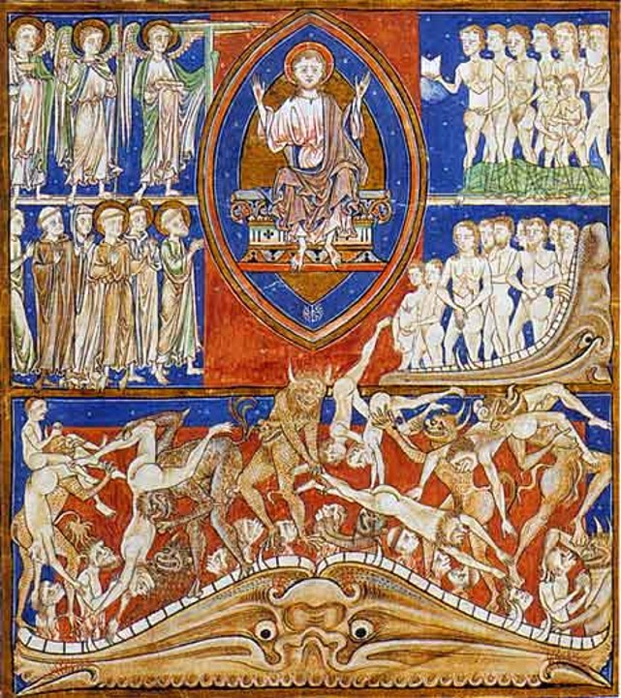
The Last Judgement.
Trinity Manuscript. [Fig. 1]

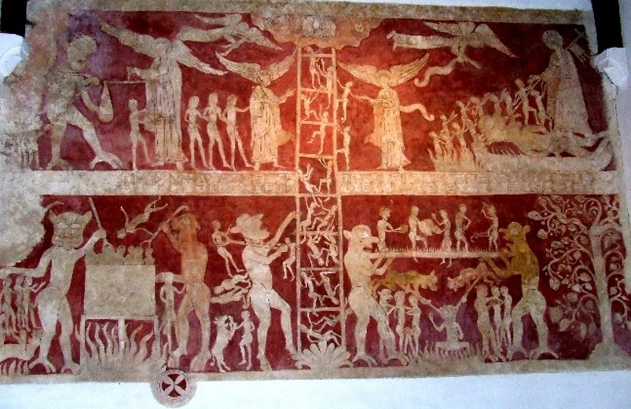
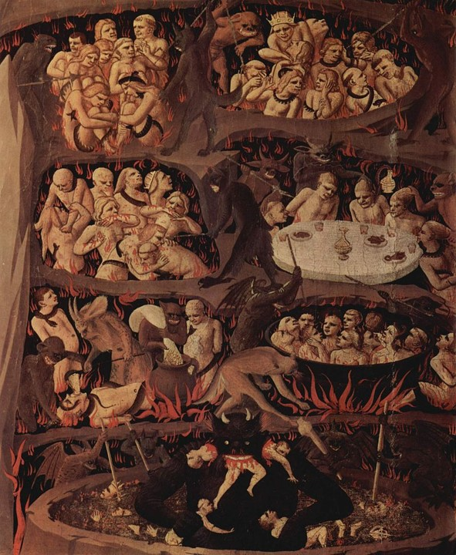
Purgatorial Ladder.
Chaldon, Surrey. [Fig. 3]
Hell, by Fra Angelico, 1431. [Fig. 2]

